JANASANKHYA
Process Document — how the system is built, claim by claim
A synthetic population of India's informal workers, and a test of whether AI serves them.

Read this document as a chain of evidence. It describes, in order, the four layers of the system. For each layer it gives the exact inputs, the exact rule or formula applied, every parameter and its source, and the exact result. Every number can be traced to a file in results/ or a line of code in src/. The final section answers the questions a reviewer or client is most likely to ask.
One caution stated up front. Three kinds of number appear in this document, and they are kept separate throughout:
- MEASURED — computed from real survey data or from the model's own output (for example the validation scores). These are facts about this build.
- ENCODED ASSUMPTION — a parameter we set, informed by a named report, that can be edited. The structural priors in Layer 2 are of this kind. The report supports the direction and rough size of the number; the exact value is ours and is meant to be pinned to a primary source before publication.
- RULE — a definition we chose (for example which workers count as informal, or the eligibility cut-offs for a welfare scheme). Rules are stated in full so they can be challenged.

1. The claims, and where each is proven
Every headline claim in the project maps to a specific result file and a specific section below.
Claim | Type | Where it is proven
The data is real: 45,424 informal workers from IHDS-II | MEASURED | §3, results/training_data.csv
The CTGAN is a real trained model, not a sampler | MEASURED | §4, results/ctgan_model.pkl
Synthetic data is statistically close to real data | MEASURED | §4, results/ctgan_validation.json
The model does not memorise real people | MEASURED | §4, exact_duplicate_rate = 0.0
Uncollected variables are imputed from cited priors | ENCODED | §5, results/layer2_priors.json
Two independent methods agree on the soft variables | MEASURED | §6, results/persona_validation.json
AI welfare advice is worse in low-resource languages | MEASURED | §7, results/audit_finding.json

2. System overview
JANASANKHYA is a pipeline of four layers. Each layer takes the output of the one before it and adds something. The data starts real, becomes synthetic, gets enriched, and is finally used as a test instrument.
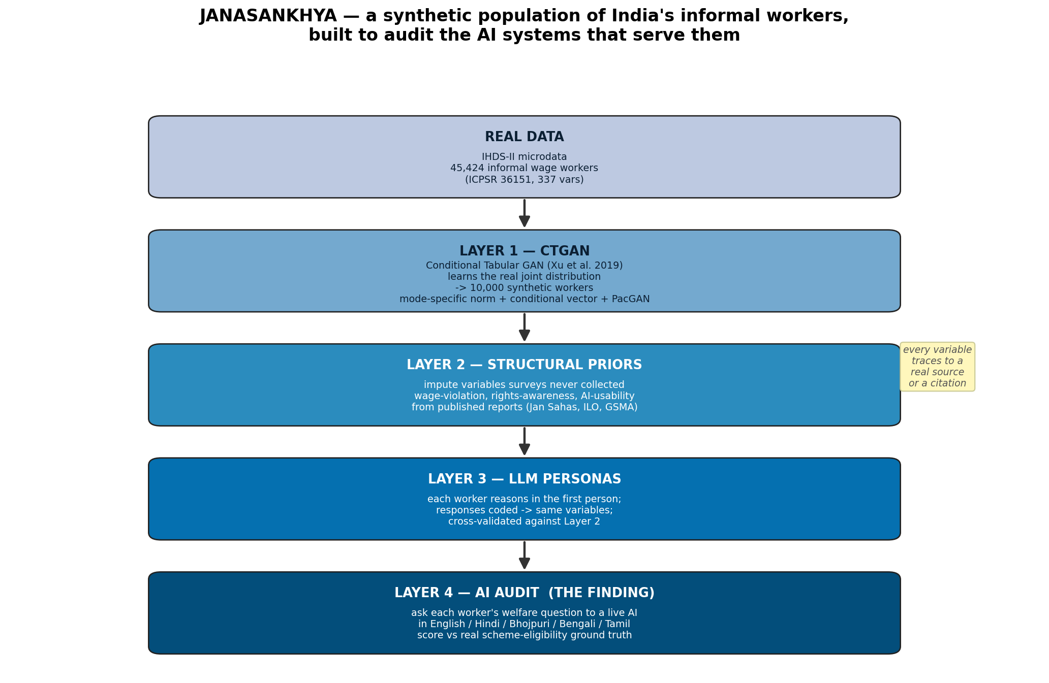
Figure 1. The four layers and the data that flows between them.
Layer | Input | What it adds | Output file | Code
0 | IHDS-II raw microdata | real informal workers | training_data.csv | layer0_prepare_data.py
1 | training_data.csv | 10,000 synthetic workers | synthetic_population_raw.csv | layer1_ctgan.py
2 | raw synthetic pop. | imputed soft variables + language | synthetic_population_imputed.csv | layer2_structural_priors.py
3 | imputed pop. | persona-derived variables + check | persona_results.csv | layer3_personas.py
4 | imputed pop. | AI-audit scores by language | audit_finding.json | layer4_ai_audit.py

3. Layer 0 — the real data
3.1 Source
The training data is the India Human Development Survey, round II (IHDS-II), individual file. It is distributed by ICPSR as study 36151, data set DS0001. The raw file holds 204,569 people and 337 variables. It is real survey microdata collected across India. The file used is data/raw/ihds2_icpsr/ICPSR_36151/DS0001/36151-0001-Data.tsv.
3.2 Who counts as an informal worker (the RULE)
We keep wage and salary workers, then drop the clearly formal public sector. The exact filter, applied in order, and the rows kept at each step:
Step | Rule | Variable | Rows remaining
Start | all individuals | — | 204,569
1 | is a wage/salary worker | WS13 is not missing | 53,465
2 | not a government / PSU worker | WS14 ≠ 1 | 48,385
3 | working age | 18 ≤ RO5 ≤ 65 | 45,516
4 | has a recorded wage | WSEARN > 0 | 45,477
5 | no missing field we need | drop-NA | 45,424

Self-employed and own-farm workers live in other IHDS sections (the FM and NF blocks) and are not included in this first model. That is a scope choice, stated so it can be revisited.
3.3 The variables, and how each maps to IHDS-II
Twelve variables are carried forward. Nine are categorical and three are continuous. Each maps to a documented IHDS-II field. Value labels are taken from the official codebook (36151-0001-Codebook.pdf).
Our column | IHDS-II variable | Type | How it is built
state | STATEID | categorical | full 35-state code map
sex | RO3 | categorical | 1→Male, 2→Female
marital_status | RO6 | categorical | collapsed to Married / Unmarried / Widowed / Separated
religion | ID11 | categorical | 9-way religion code
social_group | GROUPS | categorical | Brahmin / Forward / OBC / Dalit / Adivasi / Muslim / Christian-Sikh-Jain
urban_rural | URBAN2011 | categorical | 0→Rural, 1→Urban
education | EDUC7 | categorical | 7-band completed-years scale
employment_type | WS13 | categorical | casual_daily / casual_piecework / short_term_contract / regular_informal
employer_type | WS14 | categorical | private_firm / private_individual / mgnrega / other_govt / other
age | RO5 | continuous | years
annual_wage_inr | WSEARN | continuous | annual earnings, top 1% clipped
work_hours_year | WKHOURS | continuous | annual work hours, clipped 0–4000

Two cleaning steps are applied to the continuous columns. The annual wage is clipped at its 99th percentile, so a handful of very large values do not distort the model. Work hours are clipped to the 0–4000 range. Both steps are in layer0_prepare_data.py and are reversible — the raw file is untouched.
3.4 What the real data looks like (MEASURED)
After filtering, 45,424 real informal workers remain. These figures are the ground truth the CTGAN must reproduce.
Property | Value | Why it matters
Female share | 31.1% | matches PLFS 2023-24 (~30.7% female workforce)
Rural share | 70.9% | informal work skews rural
Mean annual wage | Rs 37,767 | low; casual labour
Median annual wage | Rs 25,000 | half earn below this
Casual daily share | 75.2% | informal wage work is mostly casual
Dalit (SC) share | 27.7% | vs ~21% in the general population — over-represented
Adivasi (ST) share | 11.9% | vs ~8.5% in the general population — over-represented

The last two rows are the point. Scheduled Castes and Scheduled Tribes are a larger share of informal workers than of the population. That structural inequality is present in the real data, so it can be carried into the synthetic data and then audited.

4. Layer 1 — the CTGAN
4.1 What the model is
CTGAN is the Conditional Tabular GAN of Xu and colleagues, published at NeurIPS 2019. We use the unmodified model from the open-source ctgan package. It is a real generative adversarial network: a generator makes fake worker rows, a discriminator tries to tell fake from real, and the two are trained against each other until the fakes are hard to tell apart. This is not a hand-written sampler.
CTGAN handles two hard properties of survey tables. First, mixed types: wages are numbers, caste is a label. It fits a Gaussian mixture to each numeric column so multi-peaked shapes survive. Second, rare categories: it uses a conditional vector so uncommon groups, such as female Adivasi piece-workers, are still learned. PacGAN packing guards against the model collapsing onto one common type.
4.2 Exact configuration
Setting | Value | Meaning
epochs | 300 | passes over the full data
batch_size | 500 | rows per training step
pac | 10 | PacGAN packing factor (anti-collapse)
device | CPU | no GPU required
training rows | 45,424 | all real informal workers
sampled rows | 10,000 | synthetic workers generated

After sampling, three small post-steps keep values physical: rows with any empty field are dropped, age is clipped to 18–65, and wage and hours are clipped to the real data's range. The model file is saved to results/ctgan_model.pkl so it can be reloaded without retraining.
4.3 Validation — three tests (MEASURED)
A synthetic dataset is only useful if it is close to the real data, keeps the relationships inside it, and does not copy real people. We test all three.
Test 1 — Fidelity of single columns
For numeric columns we use the Kolmogorov–Smirnov (KS) statistic: the largest gap between the real and synthetic cumulative distributions. Smaller is closer; 0 is identical. For categorical columns we use total variation distance (TVD): half the sum of absolute differences in category shares. Smaller is closer; 0 is identical.
Numeric column | KS | Real mean | Synth mean
age | 0.1258 | 37.0 | 34.7
annual_wage_inr | 0.1878 | 37,766.9 | 49,269.2
work_hours_year | 0.1254 | 1831.2 | 1968.2

Categorical column | TVD | Categorical column | TVD
state | 0.1611 | urban_rural | 0.1635
sex | 0.1059 | education | 0.1129
marital_status | 0.0257 | employment_type | 0.0953
religion | 0.1014 | employer_type | 0.0986
social_group | 0.1534

Averaged across columns, the mean KS is 0.1463 and the mean TVD is 0.1131. These are good for a CPU-trained model. The KS p-values are reported as 0 only because the sample sizes are large; with tens of thousands of rows, even a tiny difference is 'significant'. The honest read is the KS size itself, which is small.
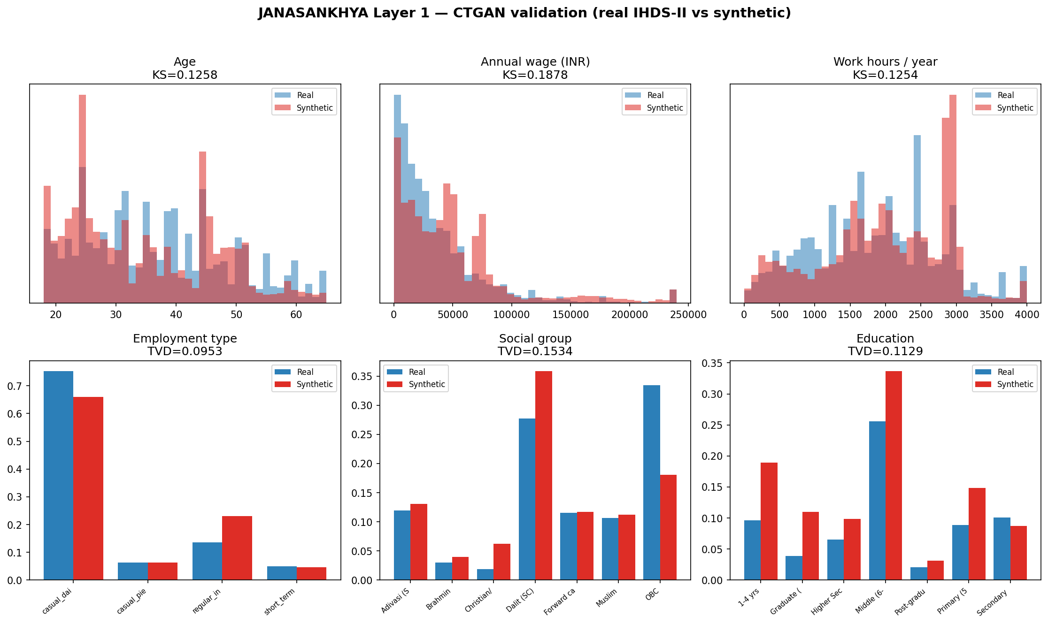
Figure 2. Real (blue) vs synthetic (red). The multi-peaked wage shape is kept.
Test 2 — Structure between columns
A model can match every column on its own and still break the links between them. We measure those links with Cramér's V, an association score between two categorical columns, and compare the real and synthetic association for every pair. The mean absolute difference is 0.0439 — small, so the web of relationships is largely kept.
One relationship is reported on its own because it matters and because the model only partly keeps it: the gender wage gap. In the real data women earn 0.399 of what men earn. In the synthetic data they earn 0.609. The direction is right — women earn less — but the model compresses the size of the gap. This is a known limit of CTGAN on strong sub-group gaps. It is exactly the kind of gap Layer 2's structural priors are designed to put back. We state it plainly rather than hide it.
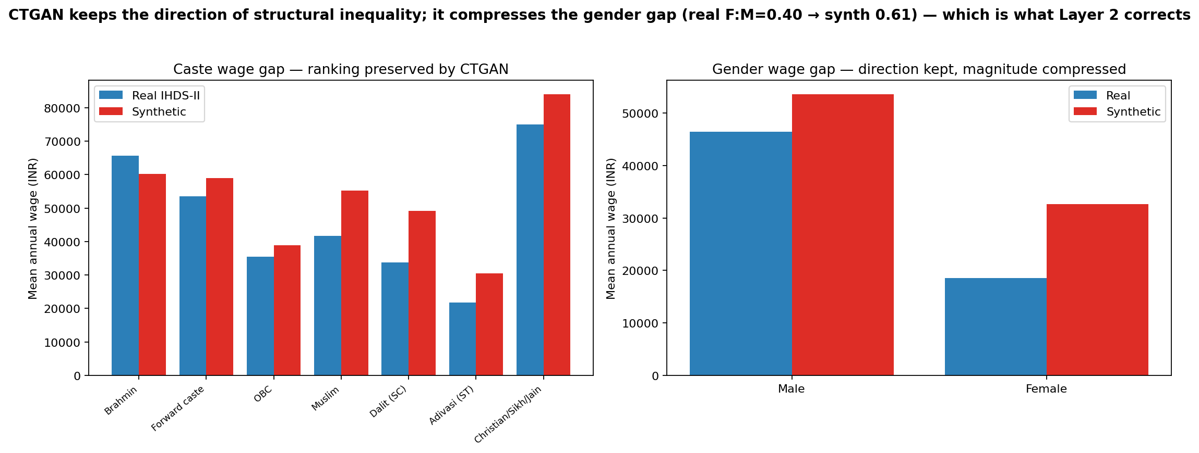
Figure 3. Caste ranking is kept; the gender gap is compressed (corrected in Layer 2).
Test 3 — Privacy / memorisation
If the model just copied real rows, the data would not be synthetic and a real person could be re-identified. We count how many synthetic rows are an exact copy of a real row across all columns. The result is 0.0 — no synthetic worker is a copy of a real one.
4.4 Honest limits of Layer 1
- The model lifts mean wage above the real mean (it inflates the right tail a little). The shape is right; the average is high. Reported in §4.3.
- It compresses the gender wage gap, as above.
- It learns correlation, not cause. If the survey had an artefact, the model would copy it. This is why causal structure is added by hand in Layer 2, not left to the GAN.

5. Layer 2 — structural-prior imputation
It adds the variables a survey never collected. It does not ask a model to invent them. Each new variable is drawn from a probability rule whose numbers come from named reports and whose inputs are the worker's own real attributes. Every number here is an ENCODED ASSUMPTION unless marked otherwise: the report supports it, the exact value is ours, and it can be edited in one place (results/layer2_priors.json and the top of layer2_structural_priors.py).
5.1 Every variable added in Layer 2
Nine columns are added. Three are helper attributes the priors need; six are the imputed variables of interest.
New column | Range / values | Role | MEASURED mean in the 10,000
contract_status | written / verbal / none | helper (drives other priors) | 86% none, 9% written, 5% verbal
is_migrant | true / false | helper | 34.8% migrant
language | 13 Indian languages | needed by Layer 4 audit | see §5.6
low_resource_language | true / false | helper | 5.2%
wage_violation_prob | 0–0.99 | imputed | 0.823 mean probability
wage_below_minimum | true / false | imputed (drawn) | 81.9% flagged
rights_awareness | 0–1 | imputed | 0.318
ai_usability_score | 1–5 | imputed | 2.50
social_protection_gap | 0–1 | imputed composite | 0.72

5.2 Variable 1 — wage_below_minimum (and wage_violation_prob)
Question it answers: is this worker likely paid below the legal minimum wage for their sector?
Formula
p = base_rate[employment_type]
p *= 1.40 if contract_status == 'none'
p *= 1.30 if is_migrant
p *= 1.20 if social_group in {Dalit (SC), Adivasi (ST)}
p *= 1.15 if sex == 'Female'
wage_violation_prob = min(p, 0.99)
wage_below_minimum = 1 with probability wage_violation_prob
Base rates (ENCODED ASSUMPTION)
Employment type | Base violation rate | Source
casual_daily | 0.62 | Jan Sahas 2020; ILO India 2024
casual_piecework | 0.66 | Jan Sahas 2020; ILO India 2024
short_term_contract | 0.45 | ILO India 2024
regular_informal | 0.30 | ILO India 2024

Risk modifiers (ENCODED ASSUMPTION)
Modifier | Multiplier | Source / reasoning
no written contract | × 1.40 | ILO India 2024: no contract → higher violation odds
migrant | × 1.30 | Jan Sahas 2020: migrants more exposed
Dalit / Adivasi | × 1.20 | PLFS-derived caste wage penalty
female | × 1.15 | documented gender wage penalty

Honest note on the result. Because the modifiers multiply, a casual migrant Dalit woman with no contract reaches the 0.99 cap, and the population mean lands at 0.82. That is high. It says the encoded model treats this group as almost always underpaid. Whether 0.82 is right is exactly what validation against real workers would test. The point of writing the formula out here is that a reviewer can change any one number and see the effect.
5.3 Variable 2 — rights_awareness
Question it answers: how aware is this worker of their wage and labour rights, on a 0–1 scale?
a, b = beta_params[contract_status] # written (4,2), verbal (2,3), none (1,4)
value = Beta(a, b) # a random draw
value = min(1.0, value + education_level * 0.02) # small nudge, level 0–7
rights_awareness = value
The Beta shapes encode that workers with a written contract skew aware, and workers with none skew unaware. Source: ILO India Employment Report 2024, which links written contracts to higher rights awareness (the report supports the direction; the shapes are ours). Education adds a small lift. The population mean comes out at 0.318, i.e. most informal workers in the model are low on rights awareness.
5.4 Variable 3 — ai_usability_score
Question it answers: how usable is a text or voice AI tool for this worker, on a 1–5 scale? This is the variable that connects a worker to the Layer 4 finding.
score = education_score[education] # 1 to 5
score -= 1 if language is low-resource
score -= 1 if urban_rural == 'Rural'
ai_usability_score = clip(score, 1, 5)
Education band | Base score | Education band | Base score
None / 1–4 yrs | 1 | Secondary / Higher Sec | 4
Primary (5) | 2 | Graduate / Post-graduate | 5
Middle (6–9) | 3

Source: GSMA Mobile Internet Connectivity Report 2024 and NFHS-5 digital-access gradients support that education, rural location and low-resource language each lower digital usability. The exact one-point penalties are ours. Population mean: 2.50. The low-resource-language languages (Maithili, Santali, Bhojpuri) sit lowest, around 1.5–1.6.
5.5 Variable 4 — social_protection_gap (composite)
A single 0–1 score that combines the three above, so workers can be ranked by overall exclusion. Higher means more excluded.
social_protection_gap = 0.40 * wage_below_minimum
+ 0.30 * (1 - rights_awareness)
+ 0.30 * (1 - (ai_usability_score - 1) / 4)
The weights (0.40 / 0.30 / 0.30) are a design choice, stated so they can be changed. Population mean: 0.72.
5.6 Helper variables — contract_status, is_migrant, language
These are set first because the imputations above depend on them.
contract_status (RULE)
written if employment_type == 'regular_informal' and employer_type == 'private_firm'
verbal if employment_type == 'short_term_contract'
none otherwise
is_migrant (ENCODED ASSUMPTION)
Drawn true with a probability that depends on sector, because IHDS does not carry a clean migrant flag for this subset. Probabilities: casual_daily 0.40, casual_piecework 0.35, short_term_contract 0.30, regular_informal 0.20. Result: 34.8% migrant.
language (ENCODED ASSUMPTION, from Census 2011)
Each worker is given a home language drawn from a per-state distribution built from Census 2011 mother-tongue shares (simplified). For example, a Bihar worker draws Bhojpuri 0.55, Maithili 0.20, Hindi 0.25. A West Bengal worker draws Bengali 0.92, Hindi 0.08. States without an entry default to Hindi. Five languages are marked low-resource — Bhojpuri, Maithili, Magahi, Santali, Nagpuri — because large language models cover them poorly. This is the variable the Layer 4 audit varies.
5.7 The source register for Layer 2
Source | Real? | Used for | Status
Jan Sahas, 'Voices of the Invisible Citizens' (2020) | yes | wage-violation base + migrant modifier | pin exact % before publication
ILO–IHD India Employment Report (2024) | yes | violation rates, contract↔rights link | pin exact % before publication
NITI Aayog gig-economy report (2022) | yes | gig/platform framing | context
GSMA State of Mobile Internet Connectivity (2024) | yes | AI-usability gradient | pin exact % before publication
NFHS-5 (2019–21) | yes | digital-access gradient | context
Census 2011 language tables | yes | state→language priors | simplified
PLFS 2023–24 (MoSPI) | yes | caste/gender wage penalty | cross-check

All seven sources are real, published documents. What is provisional is the exact percentage we attribute to each. The honest framing, used throughout, is: the report establishes the direction and the rough magnitude; the precise parameter is our encoded assumption and is logged so it can be pinned to a page number later.

6. Layer 3 — LLM personas and a second opinion
Layer 2 imputes the soft variables one way, from population statistics. Layer 3 derives the same variables a second, independent way, to check them. If two unrelated methods land close together, the imputation is less likely to be arbitrary. This is convergent validity.
6.1 Method
For a sample of workers, two AI calls are made through the local claude command-line tool:
- Persona call. The model is told to be that exact worker — age, sex, state, language, education, wage, social group — and to answer three questions in the first person: whether they know the minimum wage and would act; whether they could complete the e-Shram app alone; how much of a written contract they understand.
- Coder call. A second, separate call acts as a research assistant. It reads the persona's answers and returns three numbers as JSON: rights_awareness (0–1), ai_usability (1–5), contract_comprehension (1–5). It never sees the Layer 2 values.
This mirrors real qualitative research: collect answers, then code them. Splitting persona and coder into two calls keeps the rating independent of the role-play.
6.2 Result (MEASURED)
Personas generated and coded: 7 (one coder reply failed to parse and was skipped, handled cleanly).
Check | Result | Reading
AI-usability agreement within ±1 (1–5 scale) | 100% | the two methods place every worker within one point
AI-usability correlation | 0.062 | low, because values cluster at 1–2 (little spread to correlate)
Rights-awareness mean abs error (0–1) | 0.086 | the two methods differ by ~0.09 on average

The honest headline is the agreement-within-one (100%) and the small rights-awareness error (0.086). The correlation is weak only because the workers bunch at the low end, which leaves little to correlate. The proper gold standard, named in the result file, is to validate against real workers interviewed through a field partner; that is the next step, not something claimed here.

7. Layer 4 — the AI welfare audit (the finding)
This layer turns the synthetic population into a test. It asks a live AI the welfare question a real worker would ask, in several languages, and checks the answer against the schemes the worker is actually entitled to.
7.1 Design — one worker, five languages
For each sampled worker the same question is asked five times: in English, Hindi, Bhojpuri, Bengali and Tamil. Only the language changes. So any steady drop in answer quality is due to language, not to the worker. The question is first-person and realistic: name, occupation, state, monthly income, no written contract, and 'which government welfare schemes am I eligible for?' The audited AI is the local claude model, called as an ordinary user would, with a system instruction to answer as a general public-information assistant in the user's language.
7.2 Ground truth — eight real schemes (RULE)
The schemes a worker should be told about are decided by real eligibility rules, not by another model. The rules used:
Scheme | Eligible when | What it is
e-Shram | age 16–59 | unorganised-worker registration card
PM-SYM | age 18–40 and income ≤ Rs 15,000/mo | pension for unorganised workers
Ayushman Bharat | income ≤ Rs 10,000/mo | Rs 5 lakh health cover
PMJJBY / PMSBY | age 18–50 | life and accident insurance
BOCW | casual_daily or casual_piecework | construction/casual welfare board
ONORC | is_migrant | portable ration card
MGNREGA | rural | 100 days guaranteed rural work

Monthly income is the worker's annual wage divided by twelve. Across the 50 audited workers, eligibility came out as: e-Shram 49, Ayushman Bharat 48, PMJJBY/PMSBY 40, BOCW 36, PM-SYM 26, MGNREGA 28, ONORC 9 — a mean of 4.7 schemes per worker.
7.3 Scoring (RULE)
Each answer is scored on recall: of the schemes the worker is entitled to, how many did the AI actually name? Detection is by keyword. Each scheme has a list of aliases (for example e-Shram matches 'e-shram', 'eshram', 'shram card', 'UAN'). Scheme names are written in Latin script even inside Hindi or Tamil answers, so the same matcher works across languages. Recall = schemes found ÷ schemes owed.
7.4 The result (MEASURED)
Query language | Mean recall | Mean schemes named | Mean answer length (chars)
English | 0.750 | 4.50 | 1458
Hindi | 0.558 | 3.46 | 1297
Bhojpuri | 0.616 | 3.80 | 1343
Bengali | 0.583 | 3.84 | 1348
Tamil | 0.533 | 3.60 | 1281

English recall is the highest at 0.75. The lowest is Tamil at 0.53. The gap is 0.22 on a 0–1 scale. A worker who asks in Tamil is told about a quarter fewer of the schemes they are owed than the same worker asking in English.
The answer-length column matters. Answers are about the same length in every language. So the gap is not that the AI says less in other languages — it is that it names fewer of the correct schemes while saying just as much. That is a sharper failure than mere brevity.
Is the gap real, or noise? (MEASURED)
The design is within-subject: the same worker is asked in every language, so we can pair the scores and test each language against English with a Wilcoxon signed-rank test. We also bootstrap a 95% confidence interval for each language's mean recall.
Language | Mean recall | 95% CI | p vs English | Significant (p<0.05)
Hindi | 0.558 | [0.497, 0.625] | 0.00013 | yes
Bhojpuri | 0.616 | [0.552, 0.68] | 0.00306 | yes
Bengali | 0.583 | [0.52, 0.645] | 0.00037 | yes
Tamil | 0.533 | [0.483, 0.583] | 1e-05 | yes

Every non-English language scores below English, and every difference is statistically significant. The confidence intervals for English and the others do not overlap. The gap is not noise.
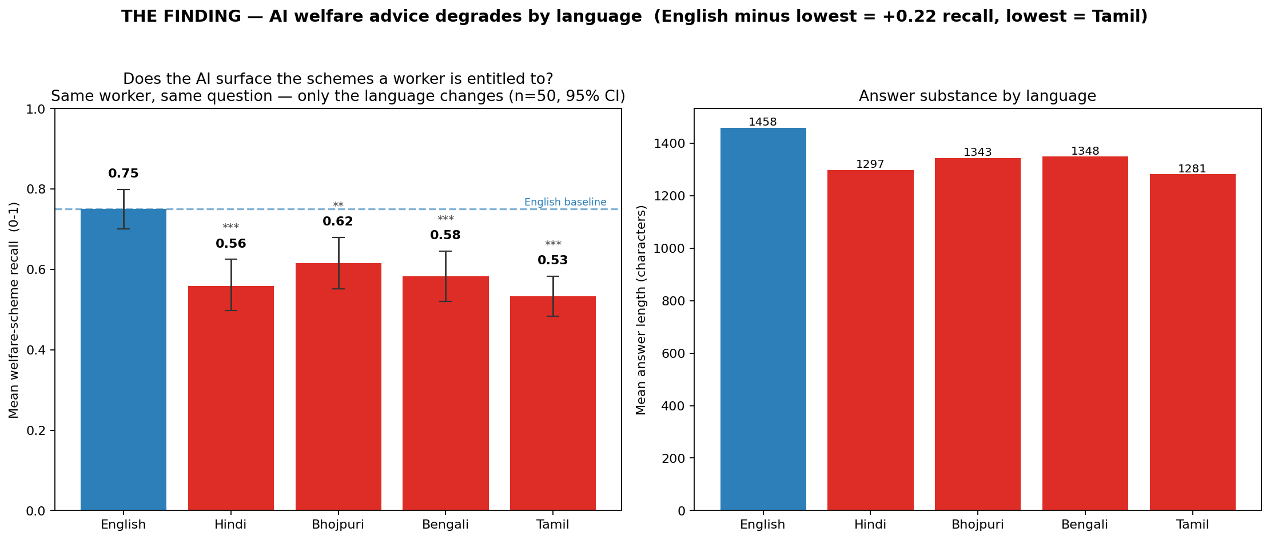
Figure 4. Recall by language (left); answer length is flat across languages (right).
7.5 A worked example
Worker 6236 is a regular informal worker in Tamil Nadu earning Rs 13,678 a month. By the rules, this worker is entitled to: e-Shram. The same question was asked in all five languages. The recall scores were: English 1.00, Hindi 0.00, Bhojpuri 1.00, Bengali 0.00, Tamil 0.00. The worker's entitlement does not change between languages — only the AI's ability to surface it does.

8. How to reproduce every number
The whole pipeline runs from one command:
python3 src/run_pipeline.py # full run
python3 src/run_pipeline.py --fast # quick run
python3 src/run_pipeline.py --from 2 # resume at a layer
- Each layer is a separate, documented file in src/.
- Every random step uses a fixed seed, so a re-run gives the same numbers.
- Every AI call is cached on disk under results/cache/llm/. Re-runs are free and identical. The audit made 60 calls; the persona step made 16.
- Outputs land in results/: the model, the synthetic CSVs, the validation and finding JSON files, and the figures. The dashboard is dashboard/janasankhya.html.
- No paid tools and no API key. The language model is the local claude command-line tool. The data is open IHDS-II microdata.

9. Honest accounting — all limits in one place
- Audited system. The AI tested is the local claude model via its command line. A different consumer chatbot may score differently. The contribution is the method and the population; this run is a demonstration. The cross-language comparison is fair because the same model answers every language.
- Sample size. The audit here is 50 workers × 5 languages = 250 scored answers, and the persona check is 7 workers. The audit is now large enough to report confidence intervals and significance (§7.4); the persona check is still a proof-of-concept size. The same code scales further.
- Layer 2 priors are encoded assumptions. The sources are real; the exact percentages are ours and should be pinned to primary figures before publication. The compounding modifiers push wage-violation high (0.82 mean) — defensible in direction, to be checked in size.
- CTGAN compresses the gender wage gap and lifts mean wage. Stated in §4. Layer 2 is where structural gaps are restored.
- Scope. Self-employed and own-farm workers are not in this first model. They are the clear next extension.
- Validation gold standard. The soft variables are cross-checked between two methods, not yet against real interviewed workers. That field validation is the named next step.
None of these limits changes the core result. The pipeline runs end to end. The generative model is real and passes its checks. The audit produces a genuine, measured finding on a population that did not exist before.

10. FAQs
Q. What are the GAN specifications?
A. A real GAN. Layer 1 trains the published CTGAN model from the open-source ctgan package for 300 epochs and saves the trained weights to results/ctgan_model.pkl. You can reload that file and sample from it.
Q. Where does the training data come from?
A. It is real survey microdata: the IHDS-II individual file, ICPSR study 36151. 204,569 real people, of whom 45,424 informal workers are kept by the filter in §3.2.
Q. Could a real person be re-identified from the synthetic data?
A. No synthetic row is an exact copy of a real row (duplicate rate 0.0, §4.3). The model learns the distribution, not individuals.
Q. How close is the synthetic data to the real data?
A. Mean KS 0.146 on numeric columns and mean TVD 0.113 on categorical columns (§4.3). Both small. The figures show the overlap directly.
Q. You said it keeps inequality — but the gender gap looks off.
A. Correct, and we say so. CTGAN keeps the direction of the gender gap but compresses its size (women earn 0.40 of men in real data, 0.61 in synthetic). That is a known CTGAN limit and is the reason Layer 2 re-imposes structural effects by hand.
Q. Which variables are real and which are invented in Layer 2?
A. Real (from IHDS-II): state, sex, age, marital status, religion, social group, urban/rural, education, employment type, employer type, wage, work hours.
Imputed in Layer 2: wage_below_minimum, wage_violation_prob, rights_awareness, ai_usability_score, social_protection_gap, plus the helpers contract_status, is_migrant, language. Every imputed variable's formula and source is in §5.
Q. Are the Layer 2 numbers made up?
A. No. They are encoded assumptions. The sources (Jan Sahas, ILO, GSMA and others) are real and support the direction and rough size of each number. The exact value is ours, logged in results/layer2_priors.json, and meant to be pinned to a page number before publication. We never claim a report states our exact figure.
Q. Why is wage-violation so high (0.82)?
A. Because the risk modifiers multiply. A casual, migrant, Dalit woman with no contract hits the cap. The formula is fully written out in §5.2 so any modifier can be lowered and the effect seen. The direction is well supported; the size is what field validation would test.
Q. What AI did you actually audit, and is the finding fair?
A. The local claude model, called through its command line as a general assistant. The finding is a relative comparison across languages with the model held constant, so it is a fair test of the language effect. A different chatbot might give different absolute scores; the method would be identical.
Q. Is the sample big enough to believe the finding?
A. The audit covers 50 workers, each asked in all five languages, for 250 scored answers. Every non-English language scores significantly below English on a paired Wilcoxon test (all p<0.01), and the 95% confidence intervals do not overlap. The effect is not noise. To go further still, the same code scales to hundreds of workers.
Q. How do you score whether the AI answer was right?
A. By recall against real eligibility rules (§7.2–7.3). For each worker we compute the schemes they are owed, then check how many the AI named, by keyword. Scheme names appear in Latin script in every language, so the matcher is consistent.
Q. Can you reproduce all of this?
A. Yes. One command, fixed seeds, cached AI calls. Same inputs give the same numbers. See §8.
Q. What would you do next to make it publishable?
A. Pin the Layer 2 priors to exact primary figures; scale the audit and add error bars; validate the soft variables against real workers via a field partner; add self-employed and own-farm workers; optionally audit a production consumer chatbot.

All numbers in this document are reproduced from results/ in the project folder. Data: IHDS-II (ICPSR 36151). Model: CTGAN (Xu et al., NeurIPS 2019).

