CASHFLOWIQ
(Smart Financial Management System for SMEs)
A Project Report
Submitted in partial fulfilment of the Requirements for the award of degree of
BACHELOR IN INFORMATION TECHNOLOGY
BY
Name: Nawaaz Khan
UID: 24BIT029
Under the esteemed guidance of Prof Mr. Wilson Rao
Co-ordinator
and
Ms. Bertilla Fernandes
Assistant Professor

DEPARTMENT OF SOFTWARE DEVELOPMENT
JAI HIND COLLEGE

(Empowered Autonomous) MUMBAI, 400020
MAHARASHTRA
2026-27

JAI HIND COLLEGE
(Empowered Autonomous)
MUMBAI, 400020 MAHARASHTRA

DEPARTMENT OF SOFTWARE DEVELOPMENT

CERTIFICATE

This is to certify that the project entitled, “CashFlow IQ” is bonafied work of Nawaaz Khan bearing UID (24BIT029) submitted in partial fulfillment of the requirements for the award of degree of BACHELOR IN INFORMATION TECHNOLOGY from Jai Hind College Autonomous (University of Mumbai).

Internal Guide Coordinator

Date External Examiner

College Seal

DECLARATION

I hereby declare that the project entitled, “CashFlow IQ” done at Jai Hind College, has not been in any case duplicated to submit to any other university for the award of any degree. To the best of my knowledge other than me, no one has submitted to any other university.

The project is done in partial fulfilment of the requirements for the award of degree of BACHELOR IN INFORMATION TECHNOLOGY to be submitted as final semester project as part of our curriculum.

Name and Signature of the Student

ACKNOWLEDGEMENT

I would like to express my thanks to the people who have helped me most throughout my project. I am grateful to my guide Ms. Taiba Habshi for nonstop support for the project. I can’t say thank you enough for her tremendous support and help.
I owe my deep gratitude to our HOD of SOFTWARE DEVELOPMENT Department Mr. Wilson Rao who took keen interest in our project work and guided us all along till the completion of our project work by providing all the necessary information for developing a good system.
At last, but not least I want to thank all my friends who helped/treasured me out in completing the project, where they all exchanged their own interesting ideas and thoughts and made this possible to complete my project with all accurate information. I wish to thank my parents for their personal support or attention who inspired/encouraged me to go my own wa
ABSTRACT
CashFlowIQ is an all-inclusive financial management solution designed to help Small and Medium-sized Enterprises (SMEs) manage their business finances effectively. Most SMEs use manual records and tools to track their income, expenditure, budgets, and financial reports, which makes it hard for them to get a clear and prompt picture of their financial status. CashFlowIQ solves this problem by offering an integrated platform that allows managing financial records, budgets, performing analysis and making reports, as well as giving insights about finance through AI assistance.
The software enables businesses to log and organize their transactions, develop and control their budgets, and get a visual representation of their financial performance through dashboards and analysis graphs. The module of AI-assisted analysis gives insights and advice about finances based on financial data, making it easier for entrepreneurs to recognize patterns in spending and make informed decisions. Additionally, the reports in PDF and CSV formats help keep business records and perform additional analysis. To fit the Indian SMEs' needs, CashFlowIQ supports localization to the Indian Rupee (₹) currency and Indian number format.
CashFlowIQ employs modern architecture of a web application: frontend in React, backend in FastAPI and database in PostgreSQL. A secure login process and role-based access controls have been put in place to safeguard the financial data and create an independent administrator environment. Application settings are also available in the system for handling preferences and configuration.
Validation of the finished system was done using unit, integration, and system testing. Implementation of the system has shown that CashFlowIQ is able to provide a SME with a centralized and secure platform for managing their finances, budgets, business performance, and financial reporting.

INDEX
Sr No |  |  | PARTICULARS | PAGE NO. | DATE
1 |  |  | INTRODUCTION | 1-6 | 4-12-2025
 | 1.1 |  | Background | 1
 | 1.2 |  | Objectives | 2
 | 1.3 |  | Purpose, Scope, and Applicability | 3
 |  | 1.3.1 | Purpose | 3
 |  | 1.3.2 | Scope | 3
 |  | 1.3.3 | Applicability | 3
 | 1.4 |  | Achievements | 4
 | 1.5 |  | Organization of Report | 5
2 |  |  | SURVEY OF TECHNOLOGIES | 7 - 10 | 13-12-2025
3 |  |  | REQUIREMENT AND ANALYSIS | 11-31 | 28-12-2025
 | 3.1 |  | Problem Definition | 11
 | 3.2 |  | Requirement Specification | 12
 | 3.3 |  | Planning and Scheduling | 14
 | 3.4 |  | Software and Hardware Requirements | 15
 | 3.5 |  | Preliminary Product Description | 16

 | 3.6 |  | Conceptual Models | 17 | 11-12-2025
 |  | 3.6.1 | Gant Chart | 17
 |  | 3.6.2 | Pert Chart | 19
 |  | 3.6.3 | Event Table
 |  | 3.6.4 | Entity Relationship Diagram | 20
 |  | 3.6.5 | Class Diagram | 21 | 21-12-2025
 |  | 3.6.6 | Object Diagram | 22
 |  | 3.6.7 | Use Case Diagram
 |  | 3.6.8 | Activity Diagram | 23
 |  | 3.6.9 | Sequence Diagram | 24 | 26-12-2025
 |  | 3.6.10 | State Flow Diagram | 25
 |  | 3.6.11 | Context Diagram | 26
 |  | 3.6.12 | Data Flow Diagram | 27 | 31-08-2024
 |  | 3.6.13 | Component Diagram | 29
 |  | 3.6.14 | Package Diagram | 30
 |  | 3.6.15 | Deployment Diagram | 31
 |  | 3.6.16 | Database Schema Design
4 |  |  | SYSTEM DESIGN | 32-54 | 14-01-2026
 | 4.1 |  | Basic Modules | 32-45
 | 4.2 |  | Data Design | 46-47
 |  | 4.2.1 | Schema Design
 |  | 4.2.2 | Data Integrity and Constraints
 | 4.3 |  | User Interface Design | 48-50
 | 4.4 |  | Security Issues | 51-53
 | 4.5 |  | Test Cases Design | 54

5 |  |  | IMPLEMENTATION AND TESTING | 55-65 | 21-01-2026
 | 5.1 |  | Implementation Approach | 55-56
 | 5.2 |  | Coding Details and Code Efficiency | 57-60
 |  | 5.2.1 | Code Effeciency
 | 5.3 |  | Testing Approach | 61-65
 |  | 5.3.1 | Unit Testing
 |  | 5.3.2 | Integration Testing
 |  | 5.3.3 | System Testing
 | 5.4 |  | Modifications and Improvements | 66
6 |  |  | RESULTS AND DISCUSSION
 |  | 6.1 | Test Reports
 |  | 6.2 | User Documentation
7 |  |  | CONCLUSION | 67-68 | 28-01-2026
 | 7.1 |  | Conclusion | 67
 | 7.2 |  | Limitations of the System | 67
 | 7.3 |  | Future Scope of the Project | 68

INTRODUCTION

  - - BACKGROUND

Small and Medium Businesses (SMBs) are an important part of any country’s
economy; however, many of them cannot control their finances properly
because of their lack of resources and the inability to hire professional financial
analysts like CFOs. Mostly businesspersons use manual bookkeeping and basic
accounting systems that simply keep track of all the operations performed and
do not give any smart financial insights or suggestions.

Nowadays, thanks to the development of Artificial Intelligence (AI), businesses
have the ability to automate financial analysis, monitor cash flow, get personal
recommendations, and forecast their future financial performance. Thanks to
AI-powered financial assistants, businesspersons are able to make decisions
based on financial information despite their ignorance in finance.

The proposed platform CashFlowIQ, is a fully-fledged AI-powered financial
intelligence tool for small and medium businesses. It provides its users with the
ability to manage their financial data safely, monitor incomes and expenditures,
visualize their business results in real-time, get financial recommendations
generated by AI, and forecast future cash flow.
  - OBJECTIVES -

The main objectives of CashFlowIQ are:

• Creating a safe web-based system for financial management of SMBs.

• Creating AI-based financial analysis and recommendations by applying
latest methods of Artificial Intelligence.

• Recording and managing transactions of income and expenditures for
SMBs.

• Visualization of financial results using dashboards and reporting.

• Predicting the cash flows in the future on the basis of financial history of
SMBs.

• Reminding about GST deadlines and payments.

• Implementing the secure authentication and access control by Business
Users and Administrators.

• Easing the financial decision-making process by having user-friendly
interface.
1.3- PURPOSE, SCOPE AND APPLICABILITY

1.3.1- PURPOSE

CashFlowIQ's purpose is to aid business owners in efficiently managing their
finances without the need for financial knowledge by utilizing financial records
and Artificial Intelligence. The tool generates information from the records
that aids in improving the profitability of the users, managing expenses, and
planning future financial decisions.

1.3.2- SCOPE

The scope of CashFlowIQ in the same format is:

CashFlowIQ is designed as a comprehensive financial management platform that helps Small and Medium-sized Enterprises (SMEs) manage their income, expenses, budgets, financial analysis, and reporting effectively.

Its scope includes:
· Secure user registration and login
· Role-based security for Business Users and Admins
· Management and tracking of income and expenses
· Financial dashboard with data visualization
· AI-based financial analytics and suggestions
· Financial projections and forecasting
· GST and payment reminder system
· Generation of financial reports
· User profile management
· Admin dashboard for user and system management
· Secure data storage using PostgreSQL
· A responsive web application accessible through web browsers

The platform is designed to provide SMEs with a centralized solution for managing their financial activities. By offering automation, financial insights, reporting, and AI-based suggestions, CashFlowIQ helps businesses make informed financial decisions and manage their finances more efficiently.

1.3.2- APPLICABILITY

CashFlowIQ is made for those companies and individuals who need a smart financial management tool. The software can be used by:
Small & Medium Businesses (SMBs)
Start-ups
Retail Outlets
Freelancers
Tuition Centers and Coaching Institutes
Service-Based Businesses
Consultants
Individual Owners
Account Managers
Business Administrators
This software is ideal for those businesses that need a less costly way to manage their finances, keep a track of their business performance, and get financial insights provided by AI without hiring a full-time CFO.
1.4- ACHIEVEMENTS

CashFlowIQ has been able to develop a financial management system for
Small and Medium-sized Enterprises (SMEs). This system acts as a platform
where the business finances of SMEs can be managed and enables them to
make better financial decisions.

The achievements of the CashFlowIQ project include:
. Transaction Management: SMEs will be able to enter, update, categorize, and
manage their income and expenses.
. Budget Management: Budgets can be created, and spending according to
budgets can be monitored.
. Financial Dashboard: Income, expense, savings, and performance of finances
can be managed in the form of a financial dashboard.
. Analytics & AI Insights: Data about finances can be viewed in the form of
graphs and AI-based insights can be generated.
. Reporting and Export: Financial data may be prepared and exported in PDF
and CSV file formats for accounting purposes and further analysis.
. Indian Rupee Localizations: The solution uses Indian Rupee (₹) currency
formatting and numbers as per Indian conventions, thus making it suitable for
India’s SME market.
. Admin Module: An additional role-based admin system was developed to
manage users, transactions, reports, and analytics at the system level.
. Settings Module: Application settings like look and feel, notifications, etc. may
be managed using the settings module.
. Security: Authentication and role-based security were used to ensure security
of business and financial data.
. Database Integration: Database system PostgreSQL was added to provide
persistence for application data.
. Testing: All major components were tested at unit, integration and system
level to test functionality and robustness.
In summary, CashFlowIQ met its goal of developing an integrated solution for
financial tracking and budgeting.

1.5- ORGANIZATION OF REPORT

The report contains six chapters, which include the whole process of
developing CashFlowIQ.

. Chapter 1: Introduction
Includes an introduction to CashFlowIQ, problem statement, project goals,
scope of the project, significance, achievements, and structure of the report.
. Chapter 2: Literature Review
Deals with existing solutions to financial management problems, SME
financial management, and related technologies that are used in the creation of
CashFlowIQ.
. Chapter 3: System Analysis and Design
Provides information about the system requirements, functional and non-
functional requirements, architecture, database design, and main system
components.
. Chapter 4: System Implementation
Focuses on the implementation of frontend, backend APIs, PostgreSQL
database, authentication, transactions management, budgeting, analytics, AI
analysis, reporting, settings, and Admin Module.
. Chapter 5: Testing and Results
Includes the testing strategy, including unit, integration, and system testing.
In addition, the chapter also provides information about the results of testing
and functioning of the created modules.
. Chapter 6: Conclusion and Future Enhancements
Presents the conclusion about the finished project, evaluation of achieved
goals, limitation, and suggestions for future enhancements of CashFlowIQ.

SURVEY OF TECHNOLOGIES

INTRODUCTION
In order to design and implement CashFlowIQ, it is necessary to apply the
modern web technologies that will help create a safe and scalable financial
management system. The selected technologies include the following functions:
user authorization, transaction handling, financial analysis using AI, and cloud
database management.

2.2 FRONTEND TECHNOLOGY – REACT.JS

React.js is an open-source JavaScript library that enables users to create a responsive and interactive User Interfaces (UIs). React makes use of reusable components and Virtual DOM for faster rendering.

Benefits:

• Faster rendering

• Reusable components

• Responsive UI

• Easy integration with APIs

2.3 BACKEND TECHNOLOGY – FASTAPI (PYTHON)

FastAPI is a high-performance open-source web framework that is designed to
build Web APIs.

Benefits:

• High Performance

• Ease of development

• Validation capabilities

• Auto Swagger documentation

2.4 PROGRAMMING LANGUAGE – PYTHON

Python will be used for building the backend logic and AI-driven financial
analysis.

Benefits:

• Simplicity

• Large amount of AI and data science libraries available

• Good database connectivity

• Platform-independent

2.5 DATABASE – POSTGRESQL

It is a robust relational database system that stores user data, finances, budgets,
and other types of reports.

Strengths:

• Secure and Reliable

• ACID compliant

• High Performance

• Complex SQL Queries Support

2.6 AUTHENTICATION – FIREBASE AUTHENTICATION

Firebase Authentication provides authentication through email/password-
based login and user management.

Benefits:

• Authentication is secure

• Easy to integrate

• Password encryption

• Session management of users

REQUIREMENT AND ANALYSIS

3.1- PROBLEM DEFINITION

Financial management is usually challenging for Small and Medium Businesses (SMBs). This is attributed to limited financial capabilities and the absence of financial knowledge on how to manage finances. In most firms, people adopt manual ways of accounting for finances or the adoption of accounting software which simply helps in capturing financial figures without making any intelligent recommendation. It is costly to have a professional CFO in a firm.
Some of the problems that entrepreneurs face include:
• Poor management of cash flow.
• The inability to capture incomes and expenditures.
• Poor forecasting.
• Missing out on GST payment times.
• Procrastination in business decisions due to poor insights on financial matters.
• There is no proper way to monitor the financial performance of a firm.
Through CashFlowIQ, there will be an AI-driven financial management solution that captures financial transactions, analyzes financial figures, predicts cash flows, and gives financial intelligence.
3.2 – REQUIREMENT SPECIFICATION
FUNCTIONAL REQUIREMENTS

User Module
• User Registration

• Login/Logout Facility

• Forgot Password Facility

• Profile Update Facility

Dashboard Module
• Financial Dashboard

• Income vs. Expense Charts

• Cash Flow Details

• Monthly Report

Financial Management Module
• Add Income

• Add Expenses

• Edit/Delete Transaction Facility

• Transaction Categorization Facility

Analytics Module
• Financial Performance Analytics

• Income and Expense Trend Analysis

• Category-wise Expense Analysis

• Interactive Financial Charts

• Monthly and Overall Financial Insights

Budget Management Module
• Create Budget Facility

• Set Category-wise Budget

• Track Budget Progress

• Budget vs. Actual Expense Analysis

• Budget Limit Monitoring

AI Financial Advisor Module
• AI-based Financial Advisory Service

• Cash Flow Forecasting

• Expense Analysis

• Profitability Recommendation

Report Module
• Monthly Report

• Profit & Loss Report

• Transaction Report

Admin Module
• Admin Login Facility

• Manage User Facility

• Manage Businesses Facility

• Platform Analytics

• System Settings

Non-Functional Requirements

Performance
• Response Time < 3 Seconds.
• Facility to handle multiple users simultaneously.
• Efficient database queries and data processing.
• Fast loading of dashboards, charts, and reports.

Security
• JWT-based Authentication.
• BCrypt Password Hashing for secure password storage.
• Role-Based Access Control (RBAC).
• Protected API endpoints and secure user sessions.

• Input validation to prevent invalid or unauthorized data access.

Reliability
• Correct financial calculations and data consistency.
• Proper error handling and validation.
• Reliable database connectivity and transaction management.
• Consistent system operation during normal usage.

Usability
• User-Friendly and easy-to-use interface.
• Responsive Web Design.
• Clear navigation between different modules.
• Simple forms with validation and error messages.
• Indian Rupee (₹) currency and Indian number format support.

Maintainability
• Modular and organized code structure.
• Reusable React components and utility functions.
• Easy modification and addition of future features.

Scalability
• Architecture designed to support future growth.
• Ability to add new modules without major changes to the existing system.
• Future facilities such as Bank Integration, OCR-based bill scanning, and Mobile Application support.

Compatibility
• Supports modern web browsers.
• Can be accessed on desktop and laptop devices.
• Responsive interface adaptable to different screen sizes.

3.2 PLANNING AND SCHEDULING

PROJECT SCHEDULE

PHASE | ACTIVITIES | DURATION (WEEKS)
 | Requirements gathering, problem identification, project planning, feasibility study
  Phase 1: Requirement Analysis & Planning
  1 week
 |  | 1 Week
  Phase 2A: System & UI Design
  System architecture, database schema design, wireframes, UI/UX design
  Phase 2B: Frontend Development
  Developing the user interface using React also including authentication and dashboard screens
  2 Weeks
  Phase 2C: Backend Development
  Developing APIs, authentication, business logic and database integration using FastAPI
  2 Weeks
  Phase 3A: Financial Management Module
  Income, expenses, transaction categorization and financial record management
  2 Weeks
  Phase 3B: Budget & Analytics Module
  Budget creation and tracking, financial analytics, charts and performance insights
  1 Week
  Phase 3C: AI Financial Advisor Module
  AI-based financial insights, expense analysis, profitability recommendations and cash flow forecasting
  1 Week
 | Monthly reports, Profit & Loss reports, transaction reports and PDF/CSV export | 1 Week
  3D: Report Module
 |  | 1 Week
  Phase 4A: Admin Module
  Admin authentication, user management, business management and platform controls
  Phase 4B: Testing & Integration
  Unit testing, integration testing, bug fixing and system validation
  1 Week
  Phase 5: Documentation & Final Submission
  User documentation, project report, final improvements and project submission
  1 Week

TOTAL DURATION: 13 WEEKS

PERT CHART
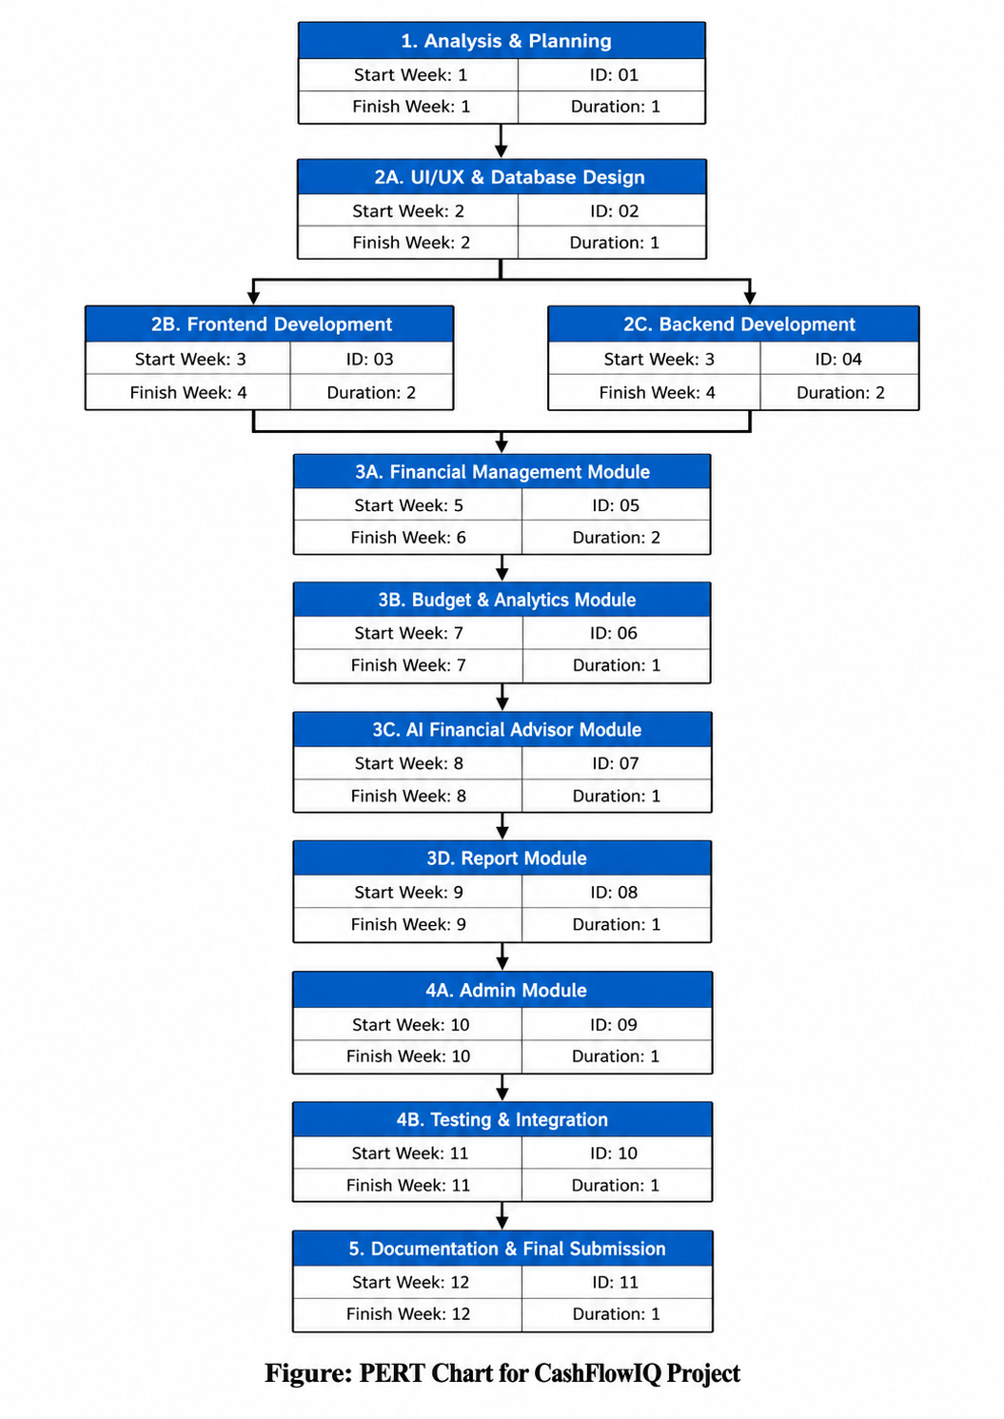

GANTT CHART

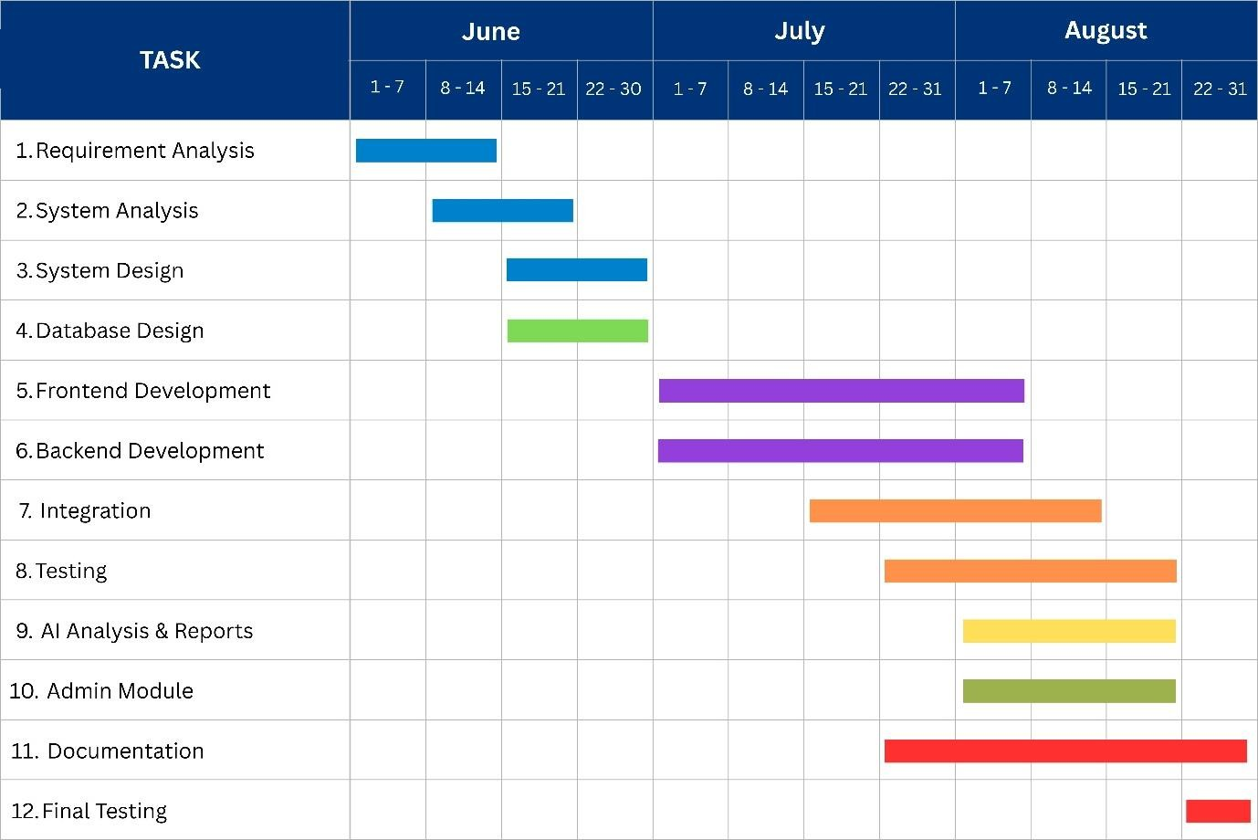

EVENT TABLE

Event No. | Event Description
E1 | Project Started
E2 | Requirement Analysis Completed
E3 | Technology Survey Completed
E4 | UI & Database Design Completed
E5 | User Authentication Module Completed
E6 | Financial Transaction Module Completed
E7 | AI Integration Completed
E8 | Dashboard Development Completed
E9 | Testing Completed
E10 | Project Successfully Deployed

3.4- SOFTWARE AND HARDWARE REQUIREMENTS:

SOFTWARE REQUIREMENTS

SOFTWARE | PURPOSE
Windows 10/11 | Operating System
Visual Studio Code | Cursor Code Editor
React.Js | Frontend Development
Typescript | Frontend Programming
Tailwind CSS | UI Styling
Fastapi | Backend Development
Python 3.13 | Backend Language
Postgresql | Database
Sqlalchemy | ORM
JWT | User Authentication
Bcrypt | Password Encryption
Google Gemini API | AI Financial Analysis
Chrome / Edge | Web Browser

HARDWARE REQUIREMENTS

HARDWARE | MINIMUM SPECIFICATION
CPU | Intel core i5 13400
Motherboard | Gigabyte B760 Ds3H AX DDR4
Ram | Corsair Vengeance LPX 16 GB  DDR4 3200Mhz

3.5- PRELIMINARY PRODUCT DESCRIPTION:

INTRODUCTION

CashFlowIQ is an AI-powered web application for financial management
developed to help small and medium businesses to efficiently manage their
financial activities. The system lets users input income and expenses, monitor
cash flow, generate financial reports and get AI-driven financial advice. It offers
a safe and easy-to-use platform that aids in making financial management
easier and supports better business decision-making.

PRODUCT OVERVIEW
• Business User
Business users can sign up. Securely log in to their accounts to manage their financial information. They can add, edit and categorise transactions, including income and expenses. This helps them keep a organised record of their cash flow.
Users can access a dashboard that gives a clear view of their financial position. The dashboard shows metrics, charts and summaries. They can also generate reports to look at income, expenses and overall cash flow performance over specific time periods.
A key feature, in CashFlowIQ is its AI-powered financial insight system. It uses the Gemini AI API to analyse data. This helps the application offer observations, financial advice and cash flow predictions. Business users can use this to spot patterns understand future cash flow situations and make better decisions.

• Administrator (Admin)
The administrator is responsible, for managing and monitoring the operation of the CashFlowIQ system. Admin users can manage business user accounts monitor system activities and oversee the functioning of the application.The administrator also helps maintain the security and reliability of the platform by monitoring user activity and managing system-level operations.
A key feature of CashFlowIQ is its AI-powered financial insight system. Using the Gemini AI API the application can analyse financial data to provide intelligent observations, financial advice and cash flow predictions. This helps business users identify patterns understand potential future cash flow situations and make more informed decisions.

Important Features
• User Registration and Secure Login
• Profile Management
• Income and Expense Management
• Financial Dashboard
• Cash Flow Forecasting
• Artificial Intelligence-based Financial Adviser
• GST and Payment Reminder
• Financial Report Generation
• Admin Dashboard
• User Management
• Analytics

Architecture of the System
The product is built according to the client-server architecture model:
• The business user will access the app via a web browser.
• The frontend (React.js) interacts with the FastAPI backend.
• The backend handles user requests and stores data in PostgreSQL.
• Financial data is analyzed by means of Gemini AI API that will give predictions and recommendations.
• The administrator panel helps monitor users and control the system.

Expected Benefits
• Makes it easier for small businesses to manage their finances.
• Eliminates human error in accounting.
• Offers artificial intelligence-based financial information.
• Helps in managing cash flow.
• Aids in making decisions on finance.
• Creates visual dashboards and reports.
• Ensures data security using authentication and encryption.

3.6- CONCEPTUAL MODELS:

    - EVENT TABLE:

Sr.  No | Event | Trigger | Source | Use Case | Response | Destination
1 | User  Registration | User clicks Register | Business User | Register User | Validate details, create account, save to database | Login Page
2 | User Login | User enters valid credentials | Business User | Login | Authenticate user and generate JWT token | User  Dashboard
3 | Admin Login | Admin enters  valid credentials | Admin | Admin Login | Authenticate admin | Admin  Dashboard
4 | Add Income | User clicks Add Income | Business User | Manage  Transactions | Save income record | Database
5 | Add Expense | User clicks Add Expense | Business User | Manage  Transactions | Save expense record | Database
6 | View  Dashboard | User selects Dashboard | Business User | View  Dashboard | Display charts and financial  summary | Dashboard Screen
7 | Generate AI Advice | User clicks Analyze | Business User | AI Financial Analysis | Generate AI insights and  recommendations | AI Results Screen
8 | Cash Flow Prediction | User requests prediction | Business User | Cash Flow Prediction | Calculate and display forecast | Dashboard
9 | Generate  Financial  Report | User selects  Generate  Report | Business User | Generate Reports | Create downloadable report | Reports Page
10 | Update  Profile | User edits profile information | Business User | Manage  Profile | Save updated  profile | User Profile
11 | Manage Users | Admin  selects User Management | Admin | Manage Users | View, activate, deactivate or delete users | Admin  Dashboard
12 | View  Platform  Analytics | Admin opens Analytics | Admin | View  Analytics | Display platform statistics | Admin  Dashboard
13 | Logout | User/Admin clicks Logout | Business  User /  Admin | Logout | End session and clear authentication | Login Page

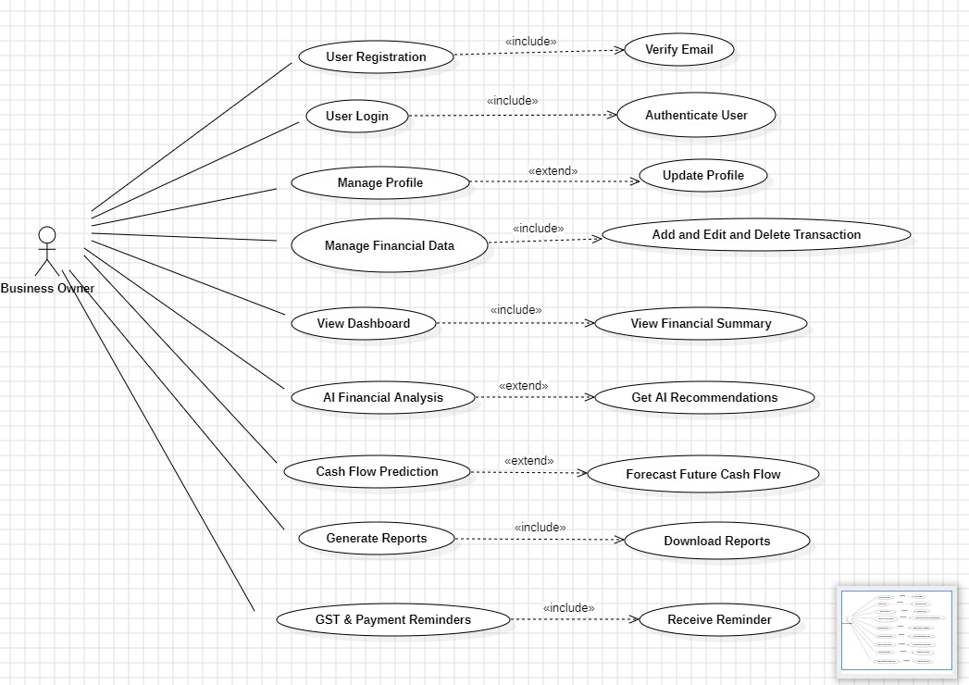
    - USE CASE DIAGRAM

3.6.3 ENTITY RELATIONSHIP DIAGRAM

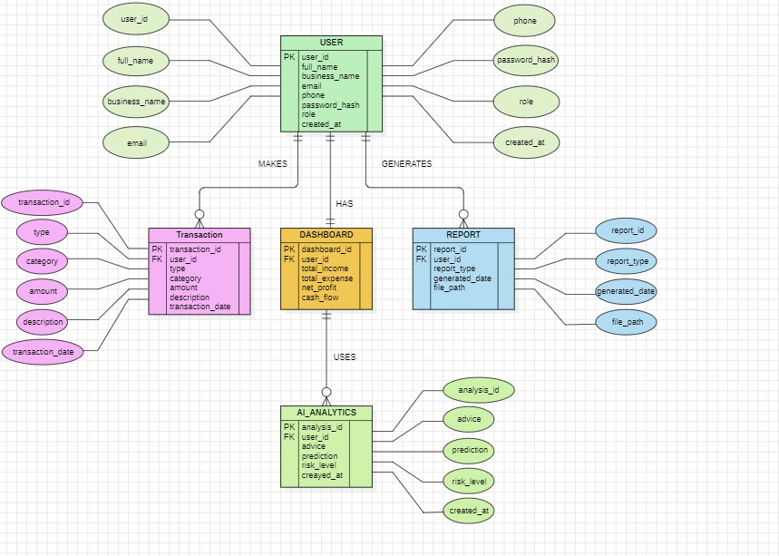
3.6.4 CLASS DIAGRAM:

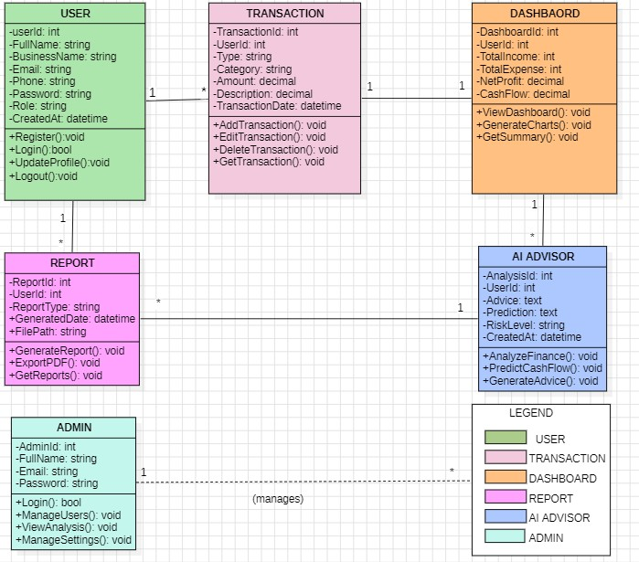

3.6.5 OBJECT DIAGRAM:

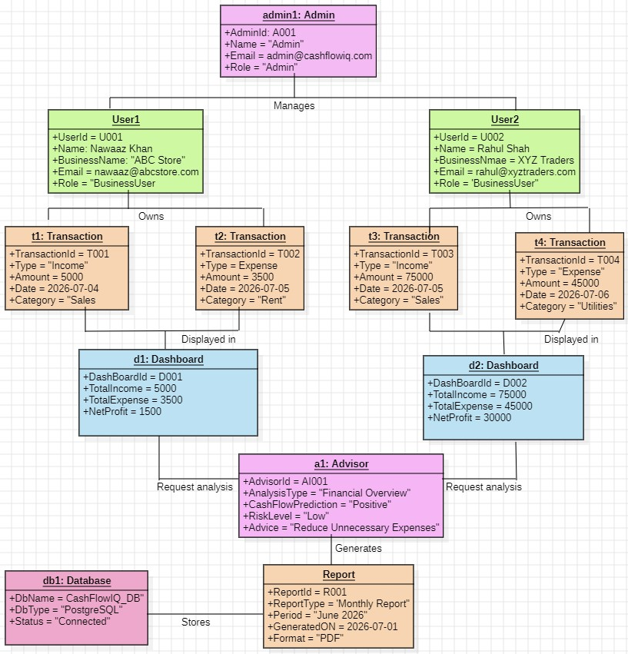

    - ACTIVITY DIAGRAM:

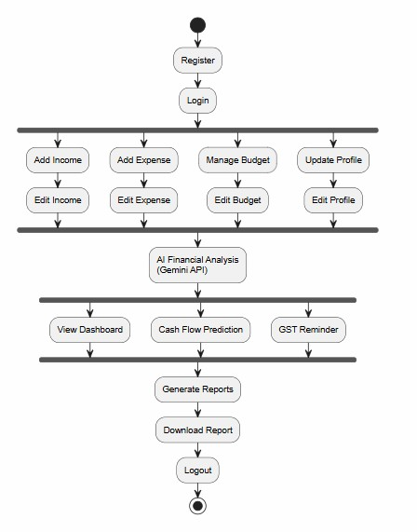
3.6.7 SEQUENCE DIAGRAM:

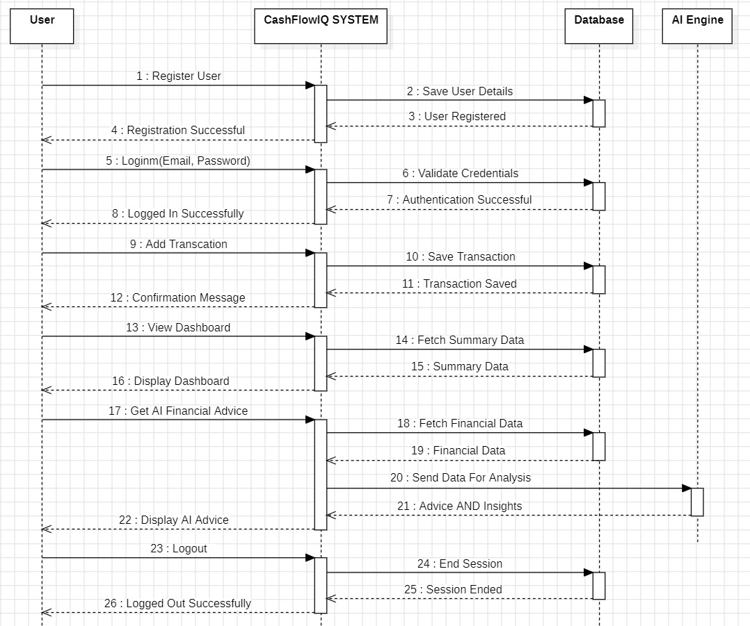

3.6.8 STATE FLOW DIAGRAM:

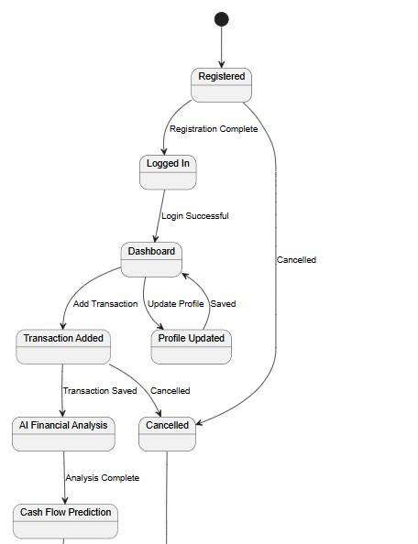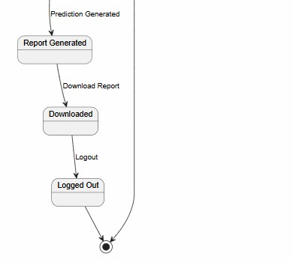

3.6.9 DATA FLOW DIAGRAM:

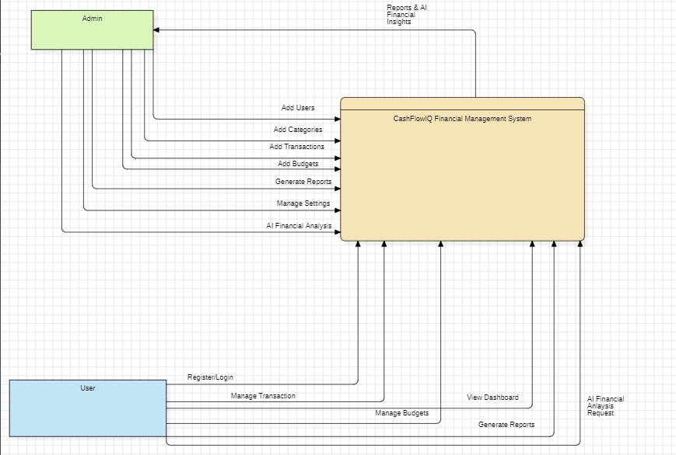

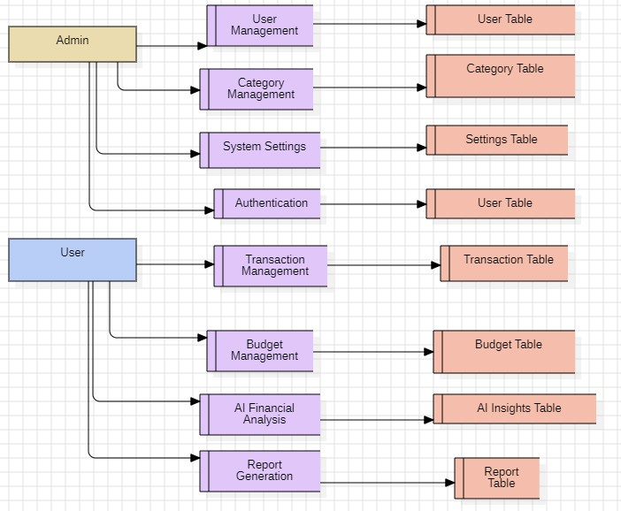
    - COMPONENT DIAGRAM:

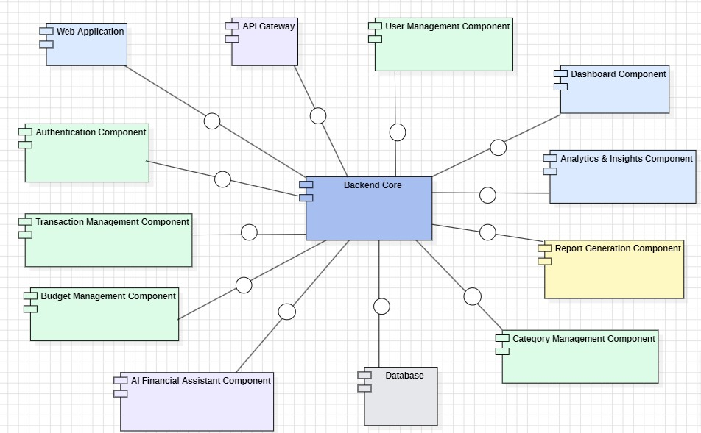
    - PACKAGE DIAGRAM:

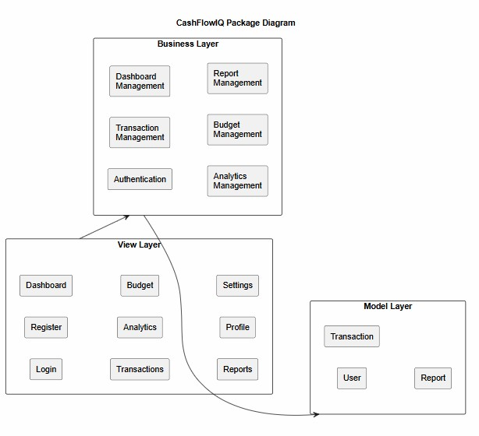

    - DEPLOYMENT DIAGRAM:

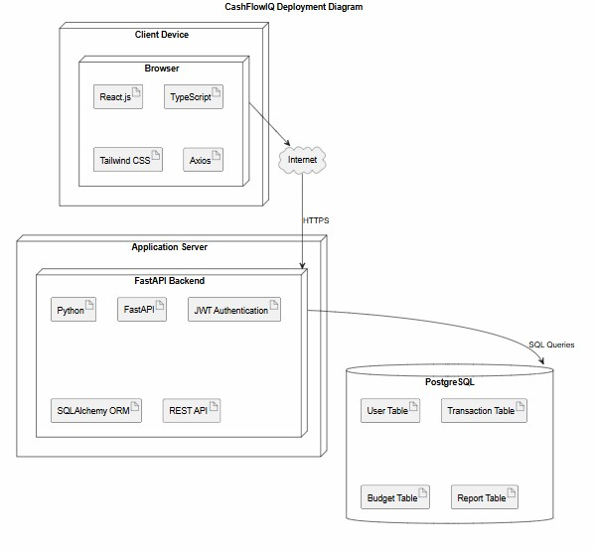

SYSTEM DESIGN:

  - BASIC MODULES:

The CashFlowIQ framework is modularized into a few modules in order to ensure modularity, maintenance, and easy future development. Each of these modules does one task in collaboration with other modules via secured APIs.

Module 1: User Authentication & Management

Description:
It includes user registration, login, authentication, and profile management
processes. The passwords are encrypted by bcrypt, and JWT tokens are used
for authentication purposes.

Tasks:
• User Registration
• User Login
• JWT Authentication
• Profile Management
• Access by Role (User/ Admin)

Module 2: Financial Transactions Management
Description:
It enables users to add, manage, and keep track of their financial transactions.

Functions:
• Add Income
• Add Expense
• Update Transactions
• Delete Transactions
• Transactions History

Module 3: Dashboard & Reporting
Description:
Financial data is shown in form of graphs and card summaries.

Functions:
• Total Income
• Total Expense
• Balance
• Monthly Reports
• Financial Graphs

Module 4: AI Financial Analysis
Description:
Analyzes financial records and provides useful insights to users.

Functions:
• Spending Pattern Analysis
• Expense Categorization
• Financial Suggestions
• Savings Recommendations
• Cash Flow Analysis

Module 5: Admin Module
Description:
Allows the administrator to monitor and manage the entire system.

Functions:
• Manage Users
• View System Statistics
• Delete Suspicious Accounts
• Monitor Transactions
• Generate Reports
4.2 DATA DESIGN:

The application employs PostgreSQL as the back-end relational database that will hold the information about users, finances, authentications, and other system data.

The database design is done according to normalization rules to eliminate
redundancy.
Main Tables
• Users
• Transactions
• Categories
• Admin
• Reports (Generated)

Relationships in Database
• One User can have many Transactions.
• Each Transaction belongs to one User.
• Transactions belong to Categories.
• Admin can have many Users.

4.2.1 SCHEMA DESIGN

Table: Users
Field Name | Data Type | Size | Constraints | Description
id | Integer | - | Primary Key | Unique User ID
full_name | Varchar | 100 | Not Null | User Name
business_name | Varchar | 100 | Not Null | Business Name
email | Varchar | 100 | Unique | Email Address
phone | Varchar | 15 | Unique | Mobile Number
password_hash | Varchar | 255 | Not Null | Encrypted Password
role | Varchar | 20 | Default User | User Role
created_at | Timestamp | - | Default  Current Time | Registration Date

Table: Transactions
Field Name | Data Type | Size | Constraints | Description
transction_id | Integer | - | Primary Key | Transaction ID
user_id | Integer | - | Foreign Key | User Reference
title | Varchar | 100 | Not Null | Transaction Title
type | Varchar | 20 | Not Null | Income/Expense
amount | Decimal | 10, 2 | Not Null | Transaction Amount
category | Varchar | 50 | Not Null | Transaction Category
description | Text | - | Optional | Remarks
transaction_date | Date | - | Not Null | Transaction Date

Table: Categories
Field Name | Data Type | Size | Constraints | Description
category_id | Integer | - | Primary Key | Category ID
category_name | Varchar | 50 | Unique | Category Name

Table: Admin

Field Name | Data Type | Size | Constraints | Description
admin_id | Integer | - | Primary Key | Admin ID
username | Varchar | 50 | Unique | Admin Username
email | Varchar | 100 | Unique | Admin Email
password_hash | Varchar | 255 | Not Null | Encrypted Password

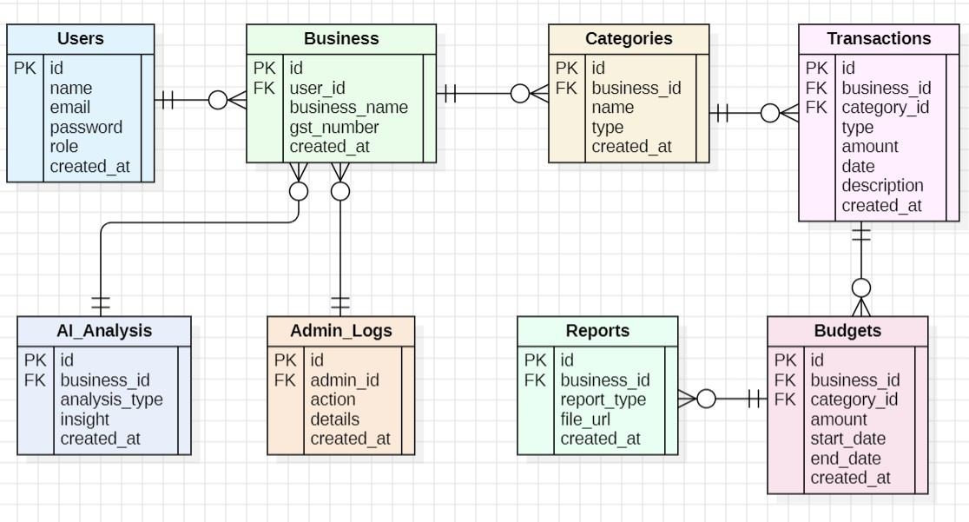

4.2. DATA INTEGRITY AND CONSTRAINTS

The CashFlowIQ system makes sure that the data is correct, by using checks on both the end and the backend. These rules help keep the information accurate and the same all the time. The data stored in the database is reliable because of these checks.

Data Integrity Measures
- All users must sign up using an email address and phone number that are unique to each user.
- Passwords are encrypted and then stored in the database.
- Each transaction is linked with the authenticated user via the User ID that is unique to each user.
- The budget is linked to the user via foreign keys.
- AI analyses and reports are generated based on the financial information of the authenticated user.

Database Constraints
- Primary Key: Each table (Users, Transactions, Budgets, Reports) contains a unique primary key (id).
- Foreign Key: Relationships are maintained using user_id to ensure data consistency.
- Unique Constraint: Email addresses are unique to prevent duplicate accounts.
- NOT NULL Constraint: Mandatory fields such as Full Name, Email, Password, Transaction Amount, Budget Amount, and Category cannot be left empty.

Validation Constraints:

- The amount for the transaction should be greater than zero.

- The amount for the budget should be greater than zero.

- The end date for a budget should be greater than or equal to the start date.

- Emails should be in the right email format.

- Password should fulfill all security requirements.

Data Validation

In addition, the application implements client-side and server-side validations to ensure that data
entered into the database is valid and complete. The system will reject any invalid request.

4.3 USER INTERFACE DESIGN (WIREFRAMES)

Authentication

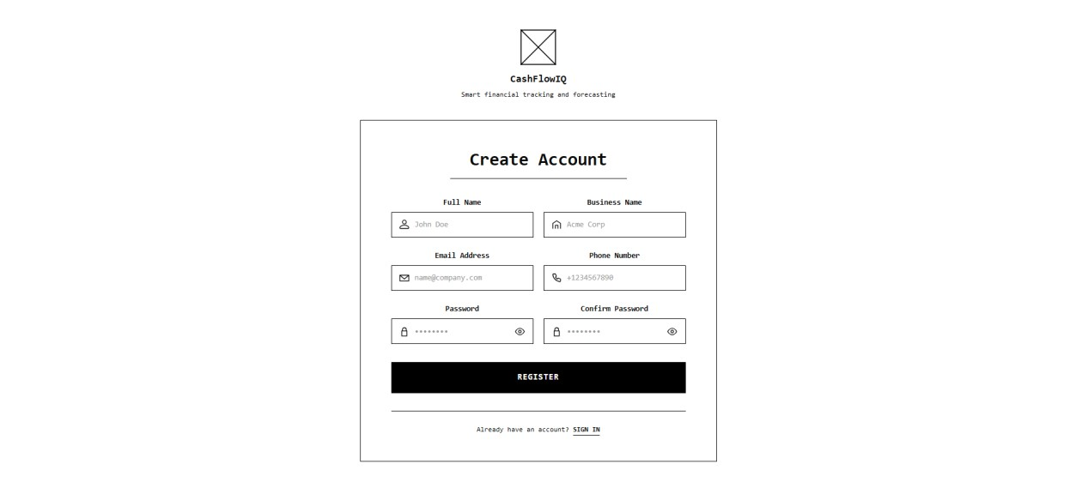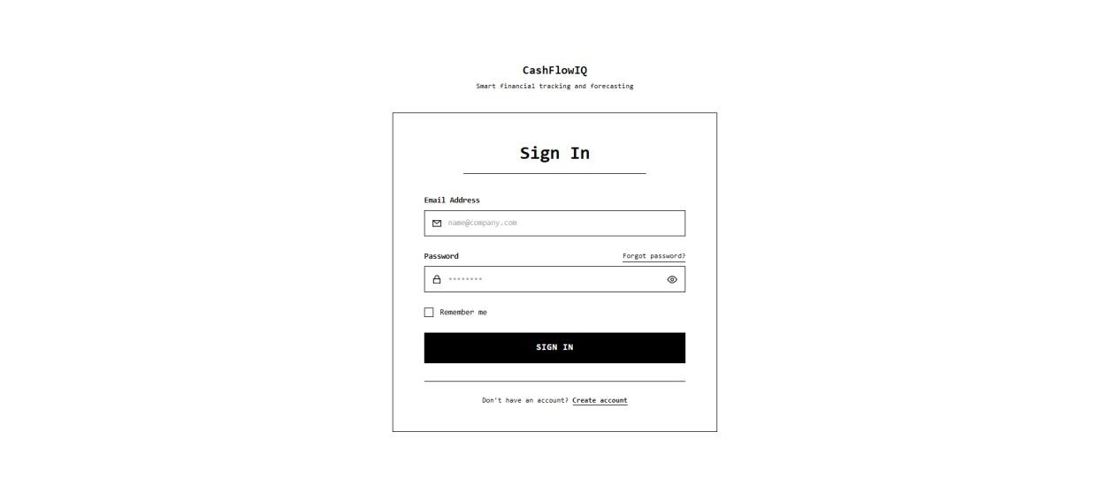

DASHBOARD

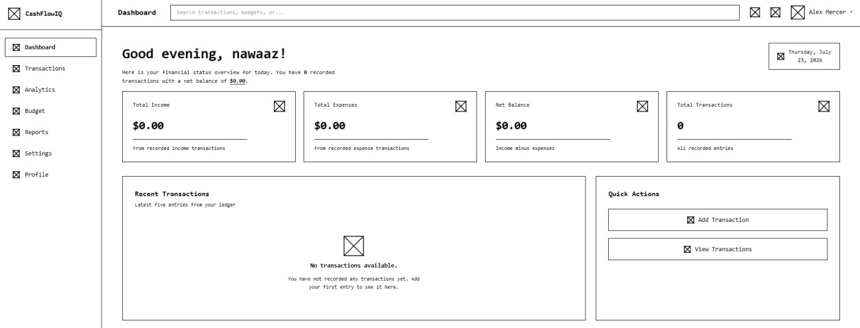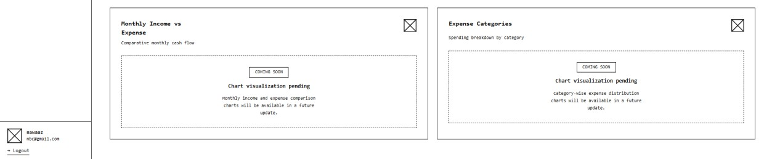

TRANSACTION
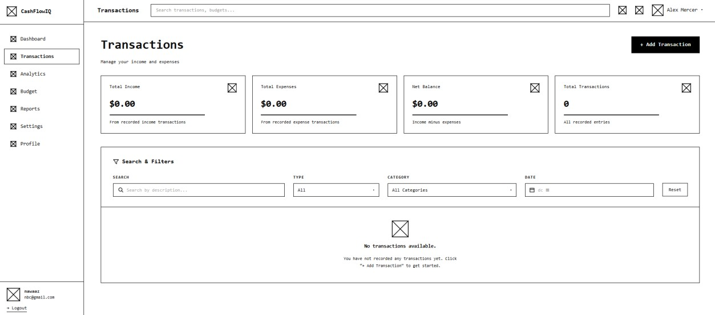

4.4 SECURITY ISSUES
CashFlowIQ has numerous security features to secure user accounts and sensitive information.
AUTHENTICATION
• User session authentication is done using JWT (JSON WebToken).
• Authenticated users only can access secured modules like Dashboard, Budget Management, AI Analysis, Reporting, and Profile.
PASSWORD SECURITY
• User passwords are encrypted through secure password hashing.
• Passwords in plain text are never saved into the database.
• The password changing function checks the current password before changing it.
AUTHORIZATION
• Each API call validates the user's JWT token.
• The user can access only his transactions, budgets, reports, and AI calculations.
• Unauthorized attempts to access are refused with corresponding HTTP status codes.
INPUT VALIDATION
• All the user input data is checked both on the front and back end.
• Incorrect data and invalid requests are refused before processing.
DATABASE SECURITY
• Database transactions use SQLAlchemy ORM, which lowers chances of SQL injection vulnerabilities.
• Database relationship ensures referential integrity between users and financial records.

API SECURITY
• API endpoints have been secured to accept only valid JWT tokens.
• Critical tasks like account update and password change need authentication.
DATA PRIVACY
• Financial data of each user is isolated from other users.
• All insights and reports created using AI are generated only on the basis of the data of the authenticated user.
• No financial data is sent to any external AI service, all calculations based on AI are done locally in the application.
ERROR HANDLING
• The system provides safe error messages without giving any sensitive data related to the server/database.
• Exception handling is used effectively to ensure stability of the application.

4.5 TEST CASES DESIGN
USER TEST CASE

Test Condition | Input Selected | Expected | Actual
User  Registration | Valid Name,  Email,  Phone,  Password | New user account created successfully | Pass
User Login | Registered  Email &  Correct  Password | User redirected to  Dashboard | Pass
Invalid Login | Wrong  Email or  Password | Incorrect email or password message displayed | Pass
Add Income  Transaction | Salary,  ₹50,000,  Income | Transaction saved and dashboard updated | Pass
Add Expense  Transaction | Food, ₹2,500,  Expense | Expense recorded and balance updated | Pass
Edit Transaction | Modify amount/cate gory | Transaction updated successfully | Pass
Delete Transaction | Select existing transaction | Transaction removed and totals recalculated | Pass

Search Transaction | Search by title | Matching transaction displayed | Pass
Filter Transactions | Type = Expense | Only expense transactions displayed | Pass
Dashboard  Summary | Existing transactions | Income, Expense,  Balance and Total  Transactions calculated correctly | Pass
Recent Transactions | Last five transactions | Latest five records displayed | Pass
Analytics Page | Open  Analytics | Charts and financial insights displayed correctly (or  placeholders if not yet implemented) | Pass
Budget Module | Set monthly budget | Budget saved and progress calculated | Pass (after implementation)
Reports Module | Generate monthly report | Report generated successfully | Pass (after implementation)
Export Report | Click Export  PDF/Excel | Report downloaded successfully | Pass (after implementation)
AI Financial  Insights | Existing transaction history | AI recommendations generated based on spending patterns | Pass (after implementation)
Profile Update | Change user details | Profile updated successfully | Pass
Logout | Click Logout | Session cleared and redirected to Login  page | Pass
Unauthorized  Access | Access  /dashboard without login | Redirected to Login page | Pass
Database Storage | Save transaction | Transaction persisted in PostgreSQL | Pass

ADMIN TEST CASE
Test Condition | Input Selected | Expected | Actual
Admin Login | Valid Admin Email & Correct Password | Admin successfully logged in and redirected to Admin Dashboard | Pass
Invalid Admin Login | Wrong Admin Email or Password | Incorrect email or password message displayed | Pass
Admin Dashboard | Login using Admin credentials | Platform statistics and administrative options displayed correctly | Pass
Manage Users | Open User Management | List of registered users displayed successfully | Pass
View User Details | Select a registered user | Selected user details displayed correctly | Pass
Manage Businesses | Open Business Management | List of registered businesses displayed successfully | Pass
View Business Details | Select a business | Selected business information displayed correctly | Pass
Platform Analytics | Open Platform Analytics | User, business and system statistics displayed correctly | Pass
System Settings | Open System Settings and update settings | Updated system settings saved successfully | Pass
Unauthorized Admin Access | Normal user attempts to access Admin Dashboard | Access denied or user redirected from the Admin area | Pass
Admin Logout | Click Logout | Admin session cleared and redirected to Login page | Pass

5 IMPLEMENTATION AND TESTING
5.1 INTRODUCTION
This chapter shows the implementation of the CashFlowIQ Financial Management System. It explains how the frontend, backend, and database components were integrated to develop a financial management application.
5.2 Input and Output Design Implementation
Input Design
The system accepts user inputs through frontend designed using React. Input validation is performed on both the client side and server side to ensure accurate data entry.
Major Input Forms
• User Registration
• User Login
• Add/Edit Transaction
• Create Budget
• Profile Update
• AI Analysis Request
• Report Generation
Output Design
The system displays financial information using dashboards, tables, charts, and reports.
Major Outputs
• Dashboard Overview
• Transaction History
• Budget Summary
• AI Financial Insights
• Analytics Charts
• Financial Reports (PDF/CSV)
• User Profile
5.3 Database Implementation
CashFlowIQ uses PostgreSQL as the relational database management system while FastAPI manages database interactions through REST APIs.
The major database tables are:
• Users
• Transactions
• Budgets
• Reports
5.4 TABLE STRUCTURE
Table / Entity | Table / Main Purpose
Users | Stores user and admin account information, authentication details and roles.
Transaction | Stores income and expense transactions created by users.
Budget | Stores user budgets, spending limits and budget progress details.
Analytics | Stores or processes financial performance data used for charts, trends and business insights.
Reports | Stores information related to generated financial reports.
AI Insights | Stores AI-generated financial analysis, insights and recommendations.
Settings | Stores user preferences and application settings.
Admin | Stores actions of the admin.

5.5 Code Module
The CashFlowIQ system is divided into different modules.
MODULE 1: USER AUTHENTICATION
• Registration
• Login
• JWT Authentication
• Profile Management
MODULE 2: DASHBOARD
• Financial Summary
• Income & Expense Cards
MODULE 3: TRANSACTION MANAGEMENT
• Add Transaction
• Edit Transaction
• Delete Transaction
• Transaction History
MODULE 4: ANALYTICS
• Income vs Expense Charts
• Cash Flow Analysis
• Category Analysis
MODULE 5: BUDGET MANAGEMENT
• Budget Creation
• Budget Tracking
• Budget Progress
• Budget Alerts

MODULE 6: AI FINANCIAL ANALYSIS
• Financial Health Score
• AI Recommendations
• Cash Flow Prediction
• Category Analysis
• AI Summary
MODULE 7: REPORT GENERATION
• Monthly Report
• Yearly Report
• Income Report
• Expense Report
• Budget Report
• AI Summary Report
• PDF Export
• CSV Export
MODULE 8: SETTINGS MANAGEMENT
• User Preferences
• Currency Settings
• Application Configuration
• Notification Settings
• Account Settings

MODULE 9: ADMIN PANEL
• User Management
• Report Management
• System Monitoring

5.6 SYSTEM IMPLEMENTATION
The frontend was developed using React. The backend was implemented using FastAPI, while PostgreSQL served as the database of the project.
Key implementation features include:
• Secure user authentication
• Transaction management
• Budget monitoring
• AI-powered financial analysis
• Financial report generation
• Interactive dashboard and analytics
• Responsive user interface
The backend APIs were tested using Swagger (OpenAPI), while PostgreSQL data was managed through pgAdmin.

5.2 Coding Details and Code Efficiency
An easy coding methodology has been followed while building the CashFlowIQ app to achieve maintainability, scalability, and readability. The frontend and the backend have been separated for a a clear distinction between the user and the business logic.

For the frontend, React and TypeScript have been used. Pages and components have been arranged depending on the purpose of the particular element, such as authentication, transaction, budget, analytics, report, settings, and administration. Reusable components and utility functions have been utilized wherever possible.

Python and FastAPI were the chosen programming languages for the backend development. In this case, different modules have been created for API routes, database models, schema, authentication, and the business logic. SQLAlchemy has been used to interact with the PostgreSQL database to perform database actions by using the Python models.

APIs have been used to facilitate the communication between the frontend and backend of the application. Mechanisms for authentication and authorization have been put in place to ensure that only authorized resources are accessed. Role-based access control has been used to separate the functionality for an administrator from the functionality of SME users.The modular design of the app will make the system easier to maintain and add new features without changing the existing modules.

5.2.1 Code Efficiency

In the development of CashFlowIQ, the code efficiency has been kept in mind. Reusable components have been used in the application along with utility functions that are centralized, which helps avoid code duplication.

On the frontend, reusable formatting functions have been designed in order to avoid repeating the same formatting operation again in several modules. Similarly, reusable components were created to promote code reuse as well as maintaining consistency in the user interface.

In the backend, SQLAlchemy ORM has been used to effectively handle the database operations and avoiding the repetitive use of SQL queries. Relationships in the database and database models help maintain the consistency in data.FastAPI can help in efficiently handling requests and automatic data validation through Pydantic schemas, thus helping in reducing unnecessary processing.
Keeping the frontend, backend database models, API routes and utility functions separate helps keep the code organized. This way of working makes the code easier to maintain. It makes it easy to test, debug, change and add features related to medium enterprises.

5.3 TESTING APPROACH
The CashFlowIQ application was tested using to ensure that every module functions are working correctly, integrates smoothly, and meets the overall system requirements. Three levels of testing were carried out: Unit Testing, Integration Testing and System Testing. Each level focused on finding and fixing errors before the application was finalized.The testing made sure that the application is reliable, safe and easy to use for Medium Enterprises. CashFlowIQ is reliable, safe and easy to use for Medium Enterprises.
5.3.1 Unit Testing
Unit testing was carried out to verify the functionality of individual modules independently. Each component was tested separately to ensure that it performed its intended function correctly. Modules such as User Authentication, Transaction Management, Budget Management, AI Analysis, Report Generation, Settings, and Admin Dashboard were tested individually. Input validation, API responses and user interface components were verified and all identified issues were corrected before integrating the modules.
5.3.2 Integration Testing
Integration testing was performed after combining the frontend and backend modules. The communication between the React frontend, FastAPI backend and PostgreSQL database was tested to ensure smooth data exchange. API endpoints were checked using Swagger UI, while frontend service was tested to confirm proper interaction with backend APIs. Integration testing also validated user authentication, transaction synchronization, report generation, AI analysis and role-based access control between the Admin and User modules.
5.3.3 System Testing
System testing was conducted on the fully integrated CashFlowIQ application to evaluate its overall performance and functionality. All features, including user registration, login, transaction management, budget tracking, AI financial analysis, report generation, settings management, and the admin dashboard were tested under real-world scenarios. The application was also tested for responsiveness, data accuracy, security and usability. The testing confirmed that the system met the functional requirements and provided a stable and reliable financial management solution for Small and Medium Enterprises (SMEs).

5.4 MODIFICATIONS AND IMPROVEMENTS
During the development and testing of the CashFlowIQ, multiple enhancements and modifications yuryrwere made to improve the quality of the system. At first the application was developed using the basic modules required for effective financial management. With the development progress some improvements were made in response to the testing results and requirements. For example, the currency format was modified from the Dollars symbol ($) to the Indian Rupees symbol (₹) and Indian number formatting was implemented to better fit the application to the Indian SME market. Some modifications and improvements were done in the Settings module to give more control over the appearance and notifications of the application. Moreover, the theme management was modified in order for the Light and Dark mode throughout the application. The module of Reports was enhanced to support the export of financial information in two formats – PDF and CSV. Some necessary modifications were done to make the process of data extraction safe and the currency format correct in exported reports. One of the significant improvements that were made is implementation of the separate module for the Admin Module. The administrator gets a separate interface to monitor users, transactions, reports, and system analytics. In addition, role-based access control was implemented to keep the administrative functionality separate from the interface of the SME user. Also there were some improvements in validation, error handling, code reuse and user interface organization.

6 RESULTS & DISCUSSIONS
CODES:
FRONTEND
- main.tsx
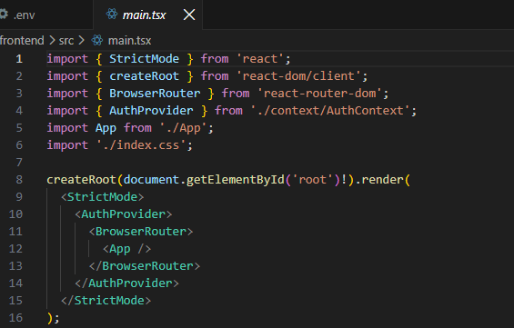
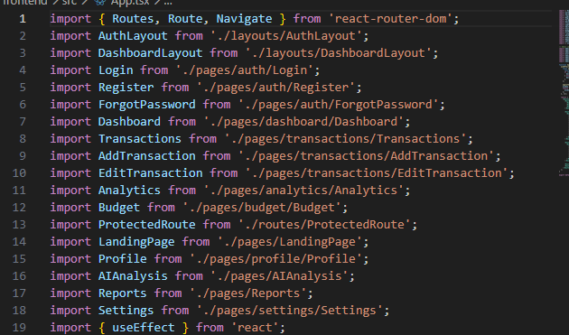
- App.tsx
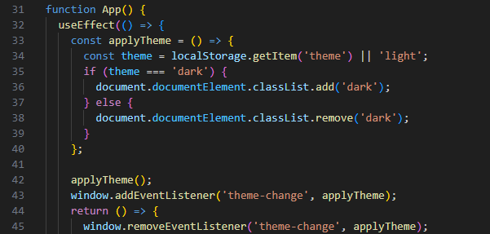
3. Login.tsx
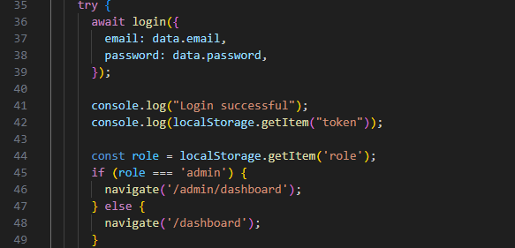
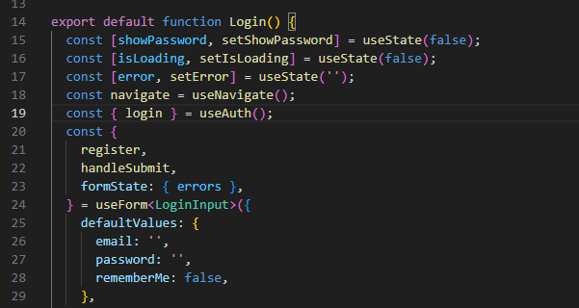

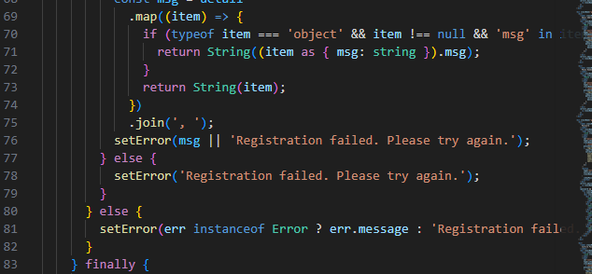
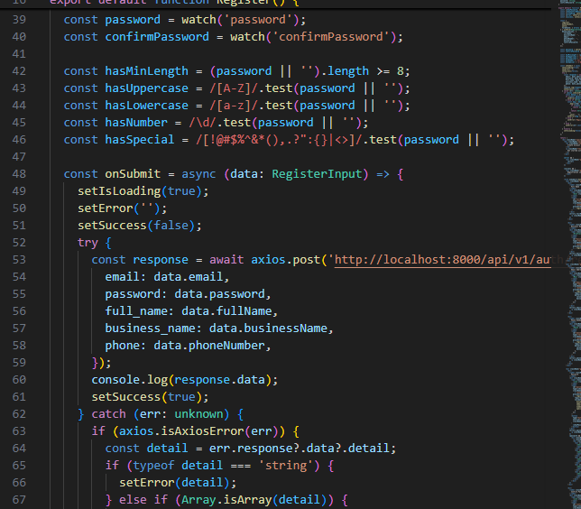
4. Register.tsx

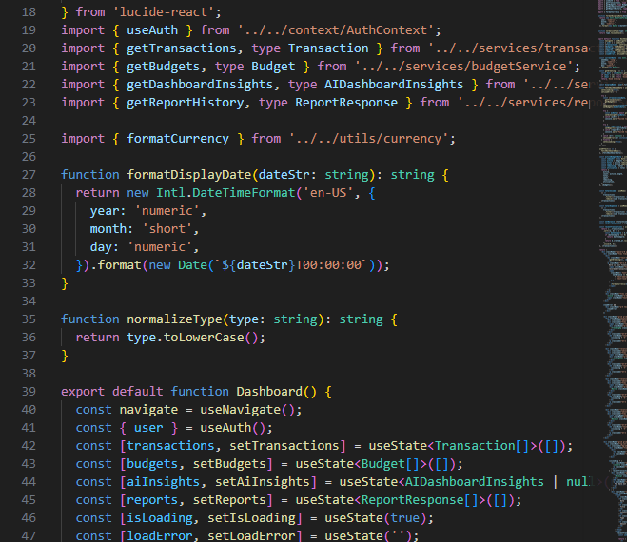
5. Dashboard.tsx

6. Transactions.tsx
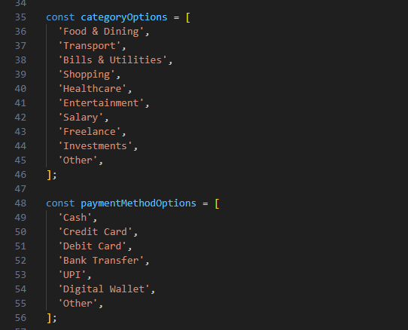
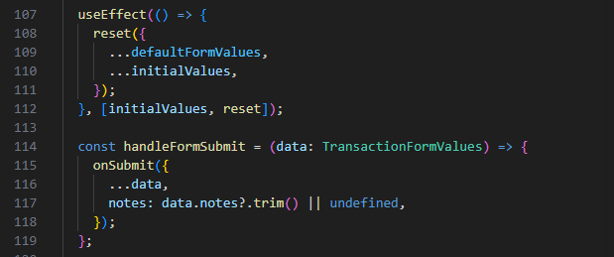

6.1.1 Login
The user first access the Login page. Registered users can enter their email and password to access the system. After successful authentication, the user is redirected to the main dashboard.
Steps:
- Enter the registered email address.
- Enter the password.
- Click the Login button.
- The system redirects the authenticated user to the Dashboard.
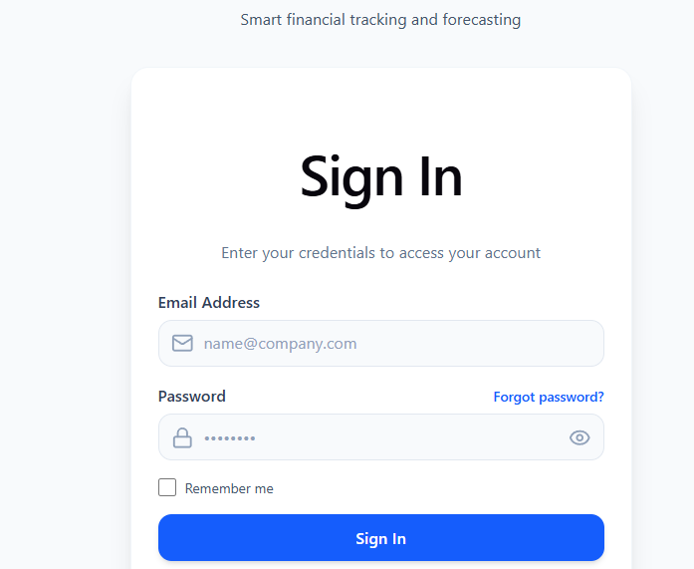

6.1.2 Dashboard
The Dashboard gives a snapshot of the financial status of the user. The financial summary includes the total income, total expenses, balance, transaction history, and financial graph. This page enables the organization to quickly know the financial status of their business.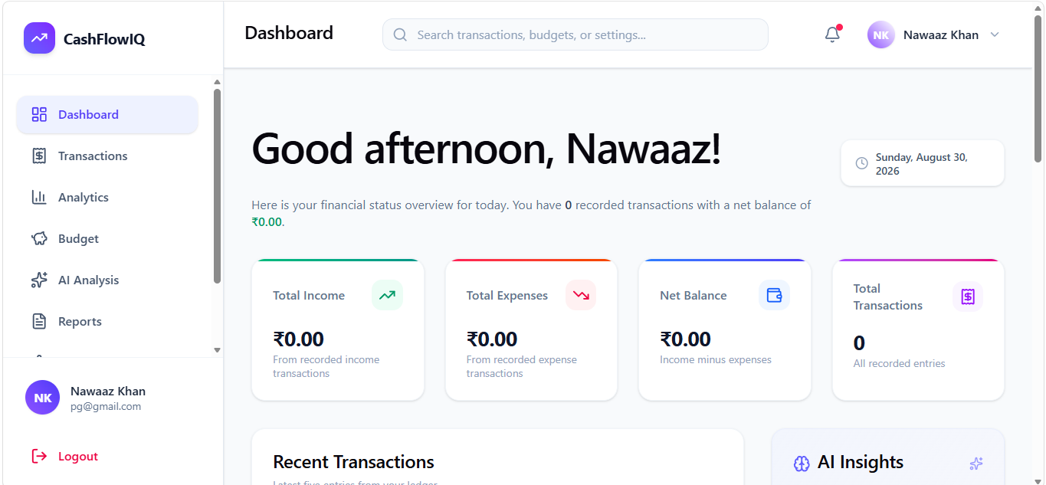

6.1.3 Transaction Management
Transaction Management component helps the SME enter and manage transactions. The user is able to create transactions for income and expenses through entering information such as title, category, amount, description, and the date of the transaction. It is also possible to view, edit, or delete existing transactions.
Steps:
- Open the Transactions module.
- Click Add Transaction.
- Enter the required transaction details.
- Select whether the transaction is Income or Expense.
- Save the transaction.
- The transaction is stored and reflected in the financial records.
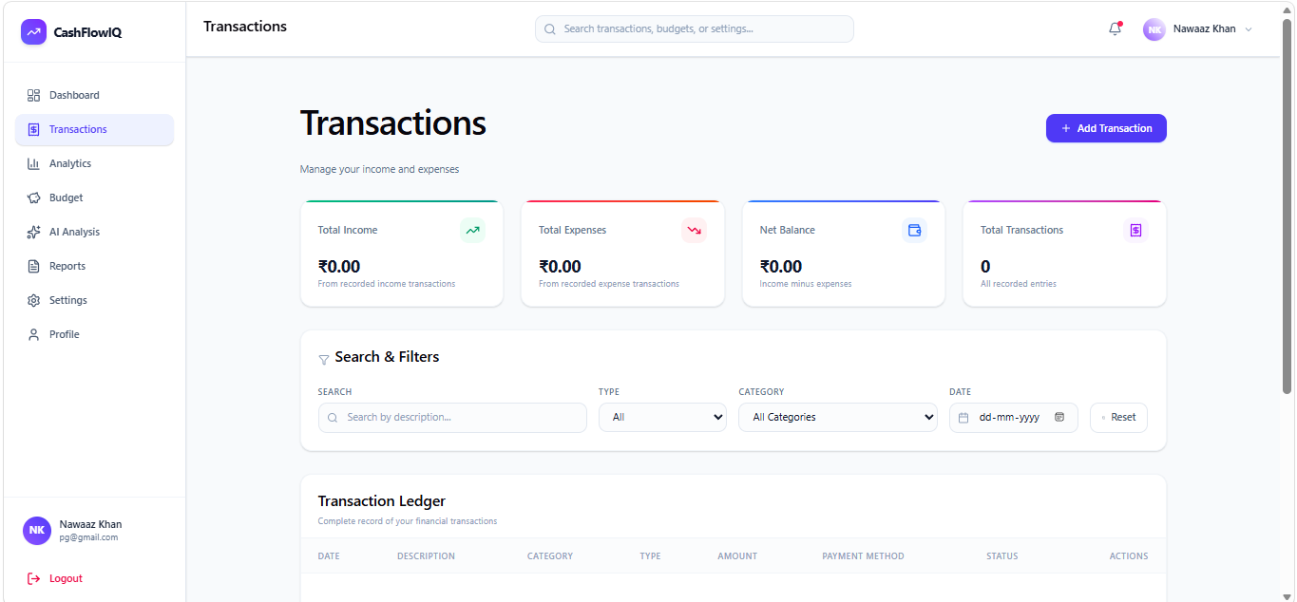
6.1.4 Analytics
The Analytics module holds the financial information in graphical form. This tool will assist the SMEs in analyzing the income, expenditures, expenditure areas, and financial performance. The graphical presentation of the data will make it easy for business owners to recognize any patterns in the finances.
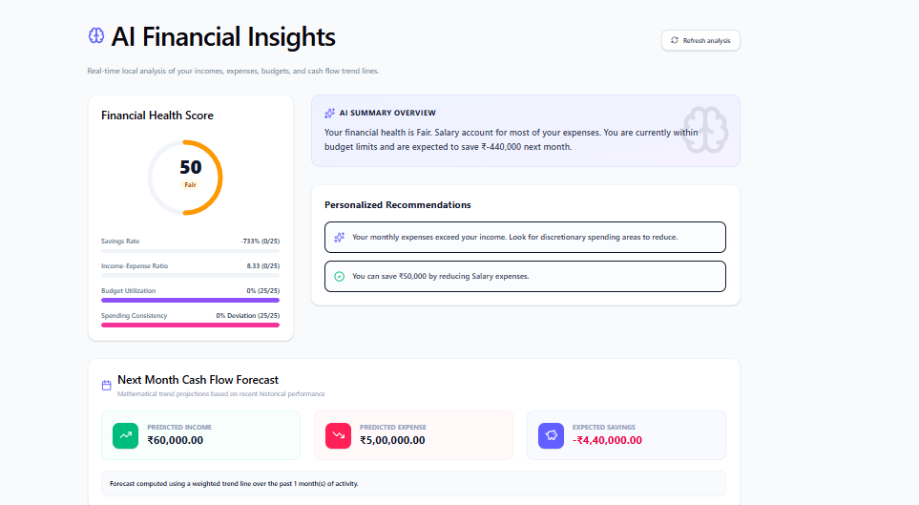
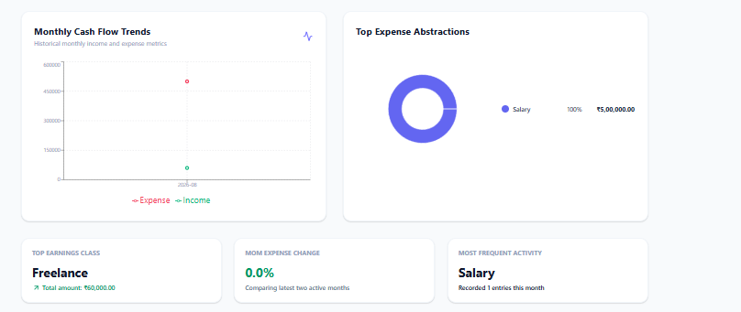

6.1.5 Budget Management
The Budget module enables SMEs to create and monitor budgets. Users can define a budget amount and track their spending against the allocated amount. The system visually displays budget progress, helping businesses identify whether their expenditure is within the planned budget.
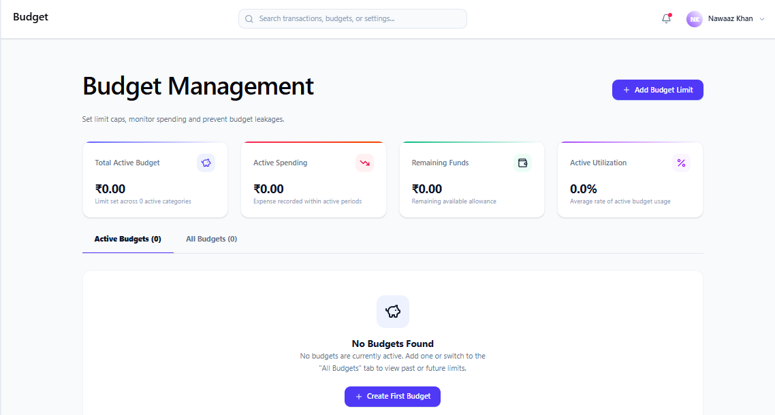
6.1.6 AI Financial Analysis
The AI Analysis module provides financial insights and recommendations based on the available financial data. It helps SMEs in identifying spending patterns and understanding areas that may require financial attention.
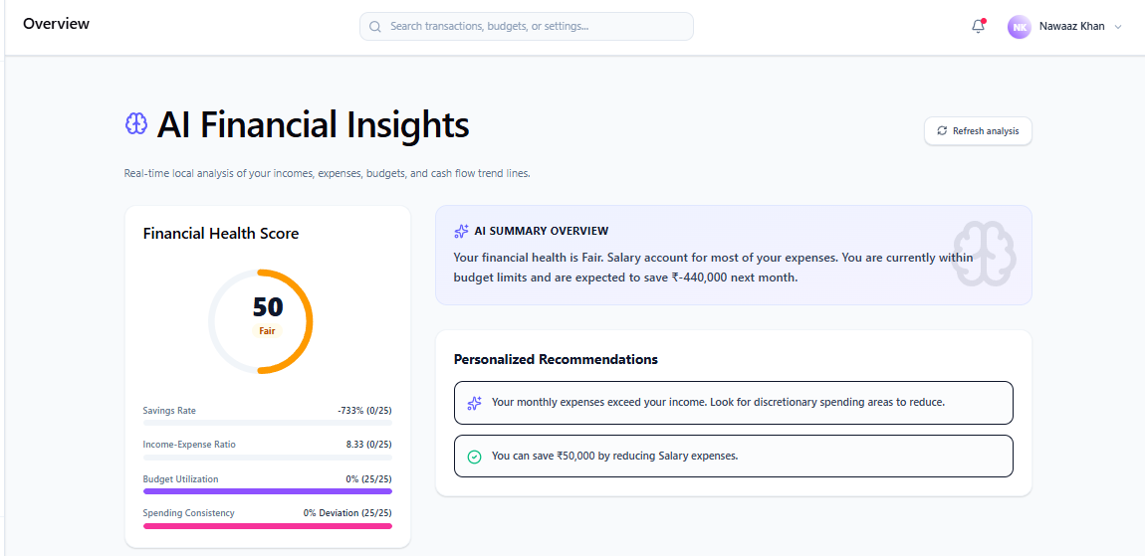

6.1.7 Reports
Reports Module provides the facility for creating and viewing financial reports through the data available in their business. Reports can be downloaded in PDF and CSV formats.
Steps:
- Open the Reports module.
- Select the required report or financial information.
- Choose the export format.
- Click Export PDF or Export CSV.
- The report is generated for further use or record keeping.
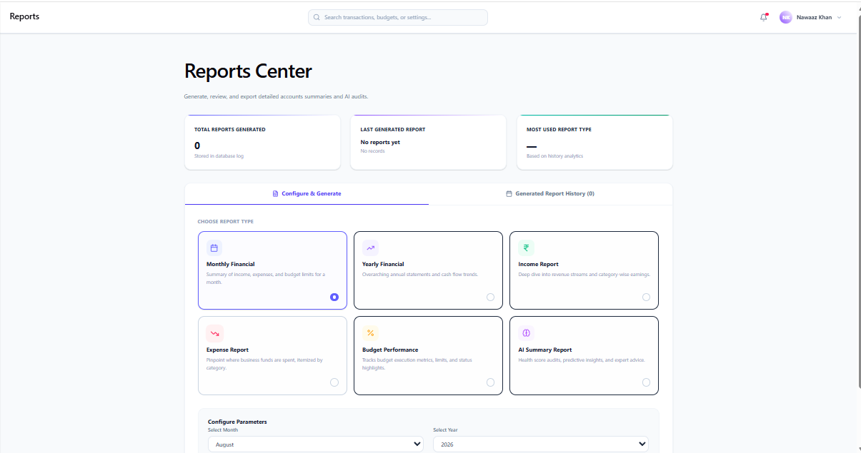
6.1.8 Settings
The Settings module allows users to manage application preferences and configurations. Features include appearance preferences, notification settings, application information, and other available system configurations.
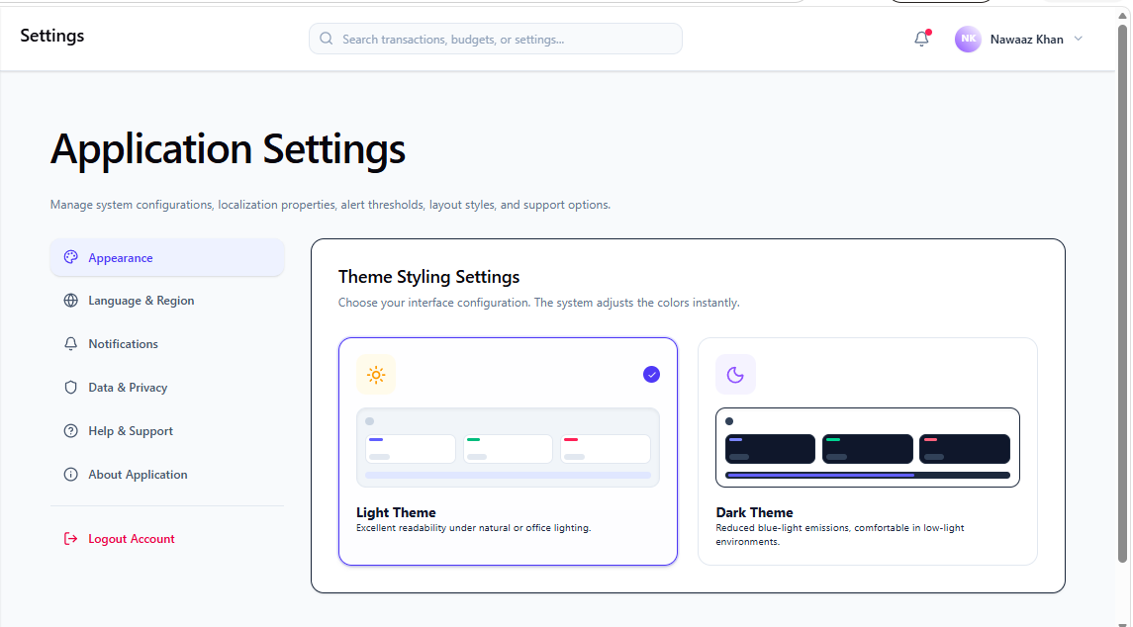

6.1.9 Profile Management

The Profile tab gives the user the ability to see and modify their personal and business data. The user will be able to change his name, email address, phone number, and other account details through this feature.

6.1.10 Admin Module
The Admin Module is an module offered in CashFlowIQ and used only by the administrators. The Admin Dashboard features several functions such as monitoring, management, report generation, analytics, and parameter settings. The admin can perform all these administrative tasks through the administrative pages, which are not accessible to the SMEs.

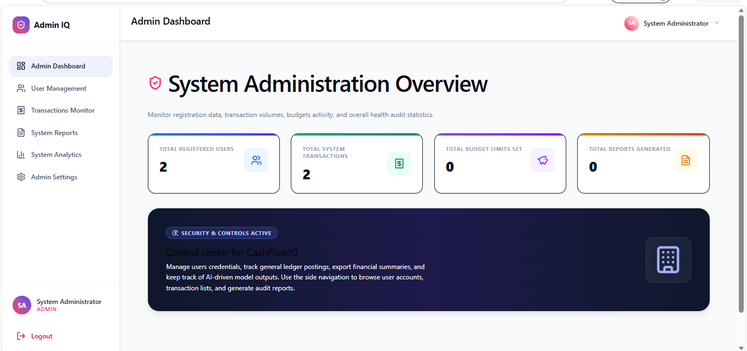

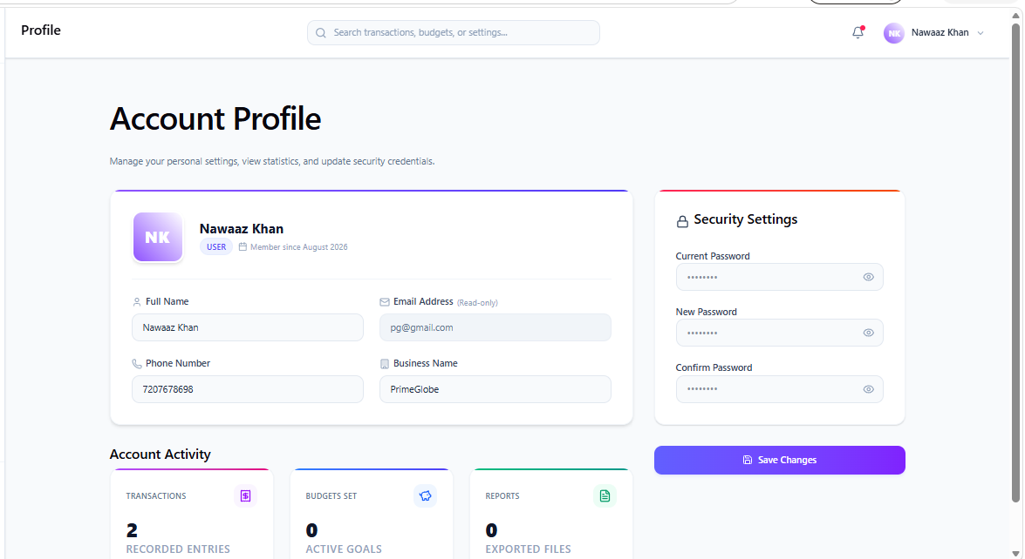
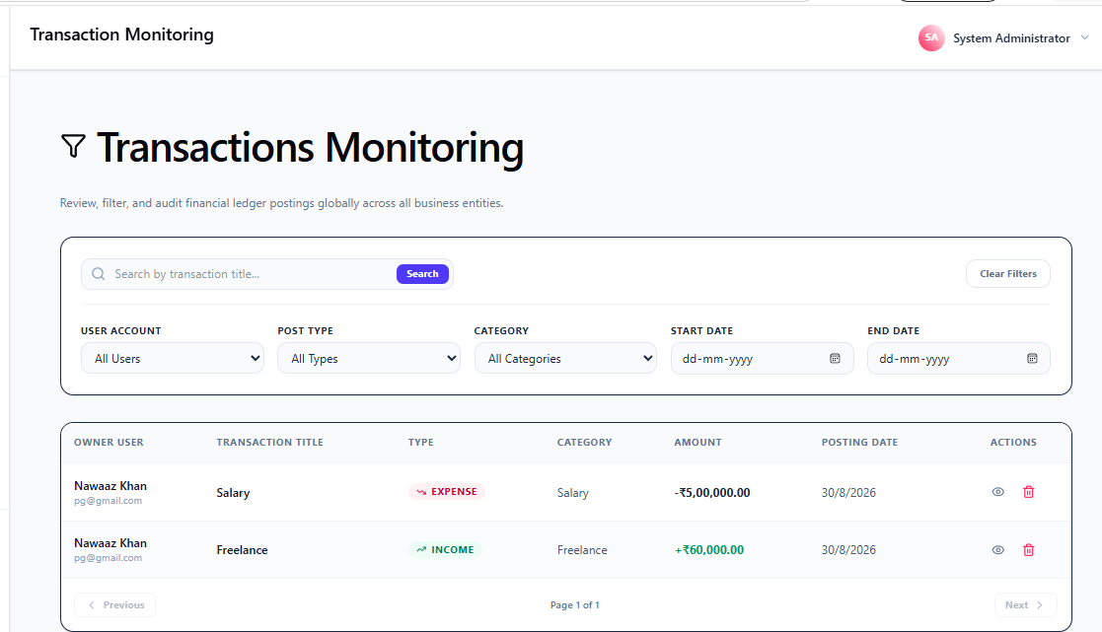
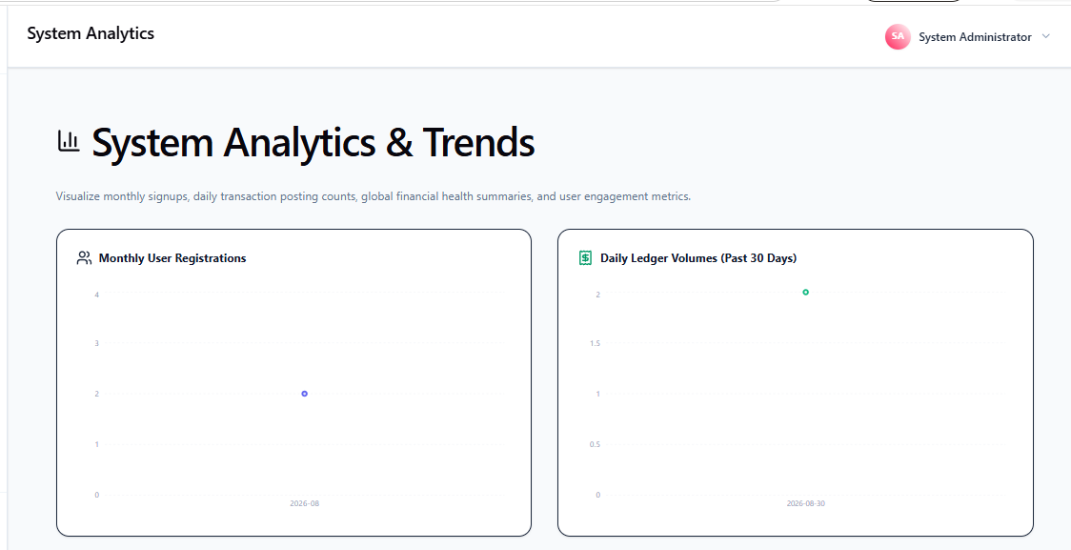

7 CONCLUSION

7.1 CONCLUSION

The CashFlowIQ software has been successfully implemented to serve as an easy-to-use tool for financial management for users and SMEs. The system includes the key financial operations
such as transaction processing, budget monitoring, financial analytics, reporting, and financial advice from artificial intelligence. The system was created taking into account simplicity, usability, security and accessibility. The system offers registration and login options, tracking the income
and expenses of the user, creating budgets, financial analysis, and creating reports in PDF and
CSV formats. Moreover, all the financial operations of the system include formatting in Indian Rupee (₹) format. Thus, the system can be used in India. Role-based access allows implementing
a separate administrative environment formanaging the users, transactions, reports, and
system-wide analytics. Automatic API documentation using Swagger makes it easier to
test the backend services. Overall, CashFlowIQ serves as a useful platform for financial management.

7.2 LIMITATIONS OF THE SYSTEM
With the current system, users have to enter income and expense transactions manually. Direct integration with banks and payment platforms is not available. No automatic transactions are supported. Any financial recommendations made with the help of AI are dependent on the transaction data that is available. Larger datasets and advanced machine learning models can further enhance the cash flow forecasting and financial analysis capabilities. Currently the system is developed mainly as a web application, there is no specific app for mobile devices. Customization and export options for reporting can be further expanded. The use of multi-currency and international financial support may be enhanced. System may need further optimization and infrastructure to support a large number of users accessing the system at once.

7.3 FUTURE SCOPE OF THE PROJECT
• The system can be further extended with the help of secure bank account connections via banking/financial APIs, enabling automatic imports of transactions.
• A mobile application for Android and iOS platforms can be created for users to manage finances using mobile phones.
• The AI module can be improved by adding features like forecasting and spending predictions as well as personalized budgeting suggestions.
• Automated transactions categorization can be implemented to lower the need of manual data entry by users.
• Notifications can be added via email/SMS/push notifications for budget limitations, suspicious expenses, payment reminders, and monthly finance reports.
• The system can be placed in the cloud environment to work for multiple businesses/users simultaneously.

7.4 BIBLIOGRAPHY

