ASSIGNMENT 1

Abhishek Saha 11500221009

Q1. Write a Java program to convert temperature from Fahrenheit to Celsius degree

Code:
class A {
public double f;
public void convert(double f){
double c;
c = (f-32)/(1.8);
System.out.println(f + " F ==" + c + " C");
}
}

public class temp{
public static void main(String[] args){
A obj = new A();
obj.f = 200;
obj.convert(obj.f);
}
}

Output:
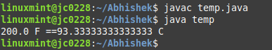

Q2.Write a Java program to convert minutes into a number of years and days.

Code:
class minutes{
public int min;
public void minutes(int min){
int yr, day;
yr = min / 31536000;
day = (min%31536000)/86400;
System.out.println(min + "mins == " + yr + "year and " + day + "days" );
}

}

public class year{
public static void main(String[] args){
minutes obj = new minutes();
obj.min = 63331200;
obj.minutes(obj.min);
}
}

Output:
