Assignment – 1B
Abhishek Saha PCC-CS593 11500221009

Q3. Write a java program to take two numbers from user and print the sum, multiply, subtract, divide and remainder.
Code:
import java.util.Scanner;

class Calculate{
int addition(int a, int b){
System.out.println("The addition of" +a+" "+b+" is"+(a+b));
}
int subtraction(int a, int b){
System.out.println("The subtraction of" +a+" "+b+" is"+(a-b));
}
int multiplication(int a, int b){
System.out.println("The multiplication of" +a+" "+b+" is"+(a*b));
}
int division(int a, int b){
System.out.println("The division of" +a+" "+b+" is"+(a/b));
}

}

public class calc{
public static void main(String[] args){
int a,b;
Scanner sc = new Scanner(System.in);
System.out.print("Enter the 1st num - ");
a = sc.nextInt();
System.out.print("Enter the 2nd num - ");
b = sc.nextInt();
Calculate c = new Calculate();
c.addition(a,b);
c.subtraction(a,b);
c.multiplication(a,b);
c.division(a,b);
}

}

Output:

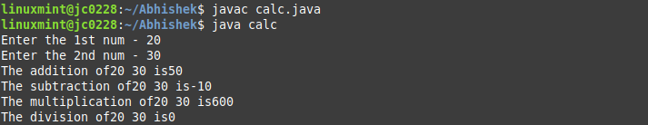
Q4. Write a program to print the area of a rectangle by creating a class named 'Area' having two methods. First method named as 'setDim' takes length and breadth of rectangle as parameters and the second method named as 'getArea' returns the area of the rectangle. Length and breadth of rectangle are entered through keyboard.

Code:

import java.util.Scanner;

class Area{
public int l,b;
public void setDim(int a, int b){
this.l = a;
this.b = b;
}
public void getArea(){
int ar;
ar = this.l*this.b;
System.out.println("The area is - "+ar);
}
}

public class rectangle{
public static void main(String[] args){
Scanner sc = new Scanner(System.in);
int a,b;
System.out.print("length - ");
a = sc.nextInt();
System.out.print("breadth - ");
b = sc.nextInt();
Area ar = new Area();
ar.setDim(a,b);
ar.getArea();
}

}

Output:
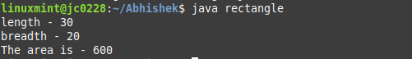

Q5.Create a class named 'Student' with String variable 'name', integer variable 'roll_no' and double variable 'YGPA'. Create object of the class by taking user input.

Code:
import java.io.BufferedReader;
import java.io.IOException;
import java.io.InputStreamReader;
class Student {
String name;
int roll;
double ygpa;
Student (String name, int roll, double ygpa){
this.name = name;
this.roll = roll;
this.ygpa = ygpa;
}
public void display(){
System.out.println(this.name);
System.out.println("Roll: "+this.roll);
System.out.println("YGPA: "+this.ygpa);
}
}
public class Stu {
public static void main(String args[]) throws IOException {
BufferedReader reader = new BufferedReader(new InputStreamReader(System.in));
System.out.println("Enter name: ");
String name = reader.readLine();
System.out.println("Enter roll: ");
int roll = Integer.parseInt(reader.readLine());
System.out.println("Enter ygpa: ");
double ygpa = Double.parseDouble(reader.readLine());
Student obj = new Student(name,roll,ygpa);
System.out.println("Student Details:");
obj.display();
}
}

Output:
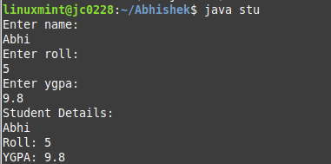

Q6. Print the average of three numbers entered by user by creating a class named 'Average' having a method to calculate and print the average.

Code:
import java.util.Scanner;

class Average{
void cal_avg(int a, int b, int c){
float av = (a+b+c)/3;
System.out.println("The average of "+ a + " " + b + " " + c +" is - " + av);
}

}

public class avg{
public static void main(String[] args){
int a,b,c;
Scanner sc = new Scanner(System.in);
System.out.print("Enter the 1st no. - ");
a = sc.nextInt();
System.out.print("Enter the 2nd no. - ");
b = sc.nextInt();
System.out.print("Enter the 3rd no. - ");
c = sc.nextInt();
Average x = new Average();
x.cal_avg(a,b,c);
}
}

Output:
