Introduction
A standard piece of equipment in an electronics lab is a Function Generator. A function generator creates variety waveforms (called functions) at variable frequencies.
In this lab you will build a function generator using a Pico W that you will use in future labs.

Design of Function Generator
To make a function generator, first you need a way of creating continuous analog output. This is done using a DAC (Digital to Analog Converter). There are many DAC breakout boards you can use with microcontrollers. However, if you program in micropython, the microcontrollers are too slow to make waveforms faster than about 2 kHz.
Fortunately several people in the huge community of microcontroller/micropython users came up with a very clever solution for the PicoW: An R-2R DAC ladder coupled with two special features of the PicoW, pio and dma.

The R-2R Ladder
The R-2R ladder is a parallel device, which means that the data the microcontroller is sending has multiple, simultaneous data output lines. Figure 1 shows a 4-bit R-2R DAC. The simultaneous data input lines are D0 – D3. Each of these can take on the values of either Vcc or 0.
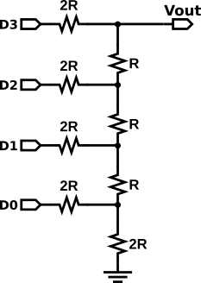Figure 1: A four-bit R-2R DAC. Eack of the digital outputs, D0 - D3 can take on the values of 3.3V or 0V.
You can analyze this circuit by setting all of the digital inputs to zero except one, and calculating Vout. Then you can use the principle of superposition to write the final Vout for any set of digital input values.
The easiest way to proceed is to use Thevenin’s theorem, Any network of voltage sources and resistors can be simplified to one voltage source in series with one resistor.
You can also use Thevenin’s theorem on a piece of a circuit, then successively on more and more of a circuit until you have the whole circuit analyzed.

Calculating The Thevenin Values
I will use the circuit in Figure 1 as an example.
First, we set D0 to Vcc, and the rest of the D’s to ground.
Second, we highlight the bottom part of the circuit, inside the red line, and we will analyze this part first.
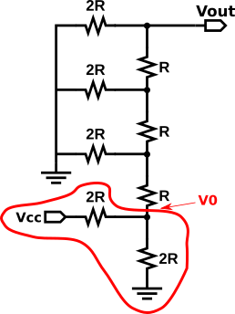Figure 2: Start by setting D0 to Vcc, and the other digital inputs to ground. Next analyze the subcircuit in red.
Voltage: Analyze the circuit using the normal rules for resistor circuits. This is just a 50% voltage divider, so V₀ = ½ Vcc.
Resistance: Set Vcc to ground and calculate the equivalent resistance between V0 and ground. In this case two resistors of value 2R in parallel have an equivalent resistance of R.
Result: The circuit in red has a voltage source of ½ Vcc, and a series resistance of R.

With the red circuit replaced by its Thevenin equivalent, the circuit has reduced to the one in Figure 3.
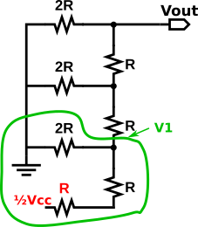Figure 3: With the red circuit replaced by its Thevenin's equivalent, now analyze the green circuit.
Next analyze the circuit circled in green. Since the two resistors R are in series, they can be replace by one resistor of value 2R.
Now the green circuit is like the red circuit in Figure 2, so V₁ = ¼ Vcc.
You can see this clever circuit is designed so you can keep working up the ladder, each time dividing the previous voltage by half.
Finally for this four-bit DAC, Vout = ¹⁄₁₆ D0, where D0 = either 0 or Vcc.

Bit D1: Now we have to analyze what the effect of D1 is on Vout. Like before, set D0 = Vcc, and the other digital inputs to ground. This gives us the circuit in Figure 4. The two bottom resistors are two 2R resistors to ground, so they are equivalent to an R resistor to ground. That is then in series to an R resistor, so the three bottom resistors are equivalent to a 2R resistor to ground.
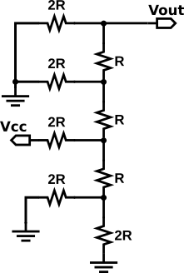Figure 4: Analyzing D1. The bottom three resistor ae equivalent to a 2R resistor to ground.
At this point the circuit, Figure 5, is similar to Figure 2 with one less “ladder rung”.
The analysis can be carried out as before with the result
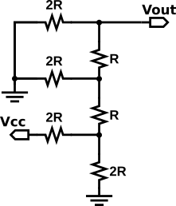Figure 5: The D1 circuit after replacing the bottom three resistors in Figure 4. This is similar to Figure 2, but with one less level.
V_{out} = ⅛ D1, where D1 = either 0 or Vcc.

You can see the pattern develop and guess (correctly) V_{out} = ¼ D2, and V_{out} = ½ D3.
The magic of superposition. Superposition states that the voltage across an element in a linear circuit is the algebraic sum of the voltage across that element due to each independent source acting alone. Since Vout is the voltage across the whole ladder, we can sum the contribution from each digital input. This gives
V_{out} = ½ D3 + ¼ D2, + ⅛ D1 + ¹⁄₁₆ D0.
This is exactly what makes it a binary DAC. The output for 0xf is ¹⁵⁄₁₆ V_{cc}. The output for 0x0 is 0 V. _{There} are 16 steps from 0 to ¹⁵⁄₁₆V_{cc} in steps of ¹⁄₁₆ V_{cc}. The smallest step is called the LSD or Least Significant Digit.

Voltage & Time Digitization and DAC Resolution
This example is a 4-bit DAC. The voltage steps are 1/16th the total range of the DAC. You can easily see this by looking at the waveform with an oscilloscope. Instead of a nice smooth curve, you see a series of steps going up and down. Each step is one LSB (Least Significant Bit) in size. How can you do better? Add more inputs to the DAC.
The whole structure can be extended by adding four more R-2R sections and digital inputs to make an 8-bit DAC. This is what you are building in the DAC Project.
Why 8-bit? Because 8-bits gives you enough resolution to make a waveform that looks like a decent sine (or other type of) wave. I know sounds like a subjective judgment, but it comes from experience. You will see as you use the DAC that there are also “jumps” or “steps” in time called time digitization. The time digitization is set by how fast your microcontroller is, so a good engineering principle is to try to design your DAC so that the time and voltage digitization have about equal effects on the waveform generation.

Building the Function Generator
The PCB (Printed Circuit Board) for the DAC is shown in Figure 6. All of the components will be mounted on this side, the front, of the PCB. The quick way to tell the front is that it has the board name, FuncGen_24a in the lower right corner. The Pico W and the op amp are not soldered to the board, but mounted in sockets. The finished board is in Figure 7. Figure 6 shows a finished PCB, except for the three connector sockets not yet done.
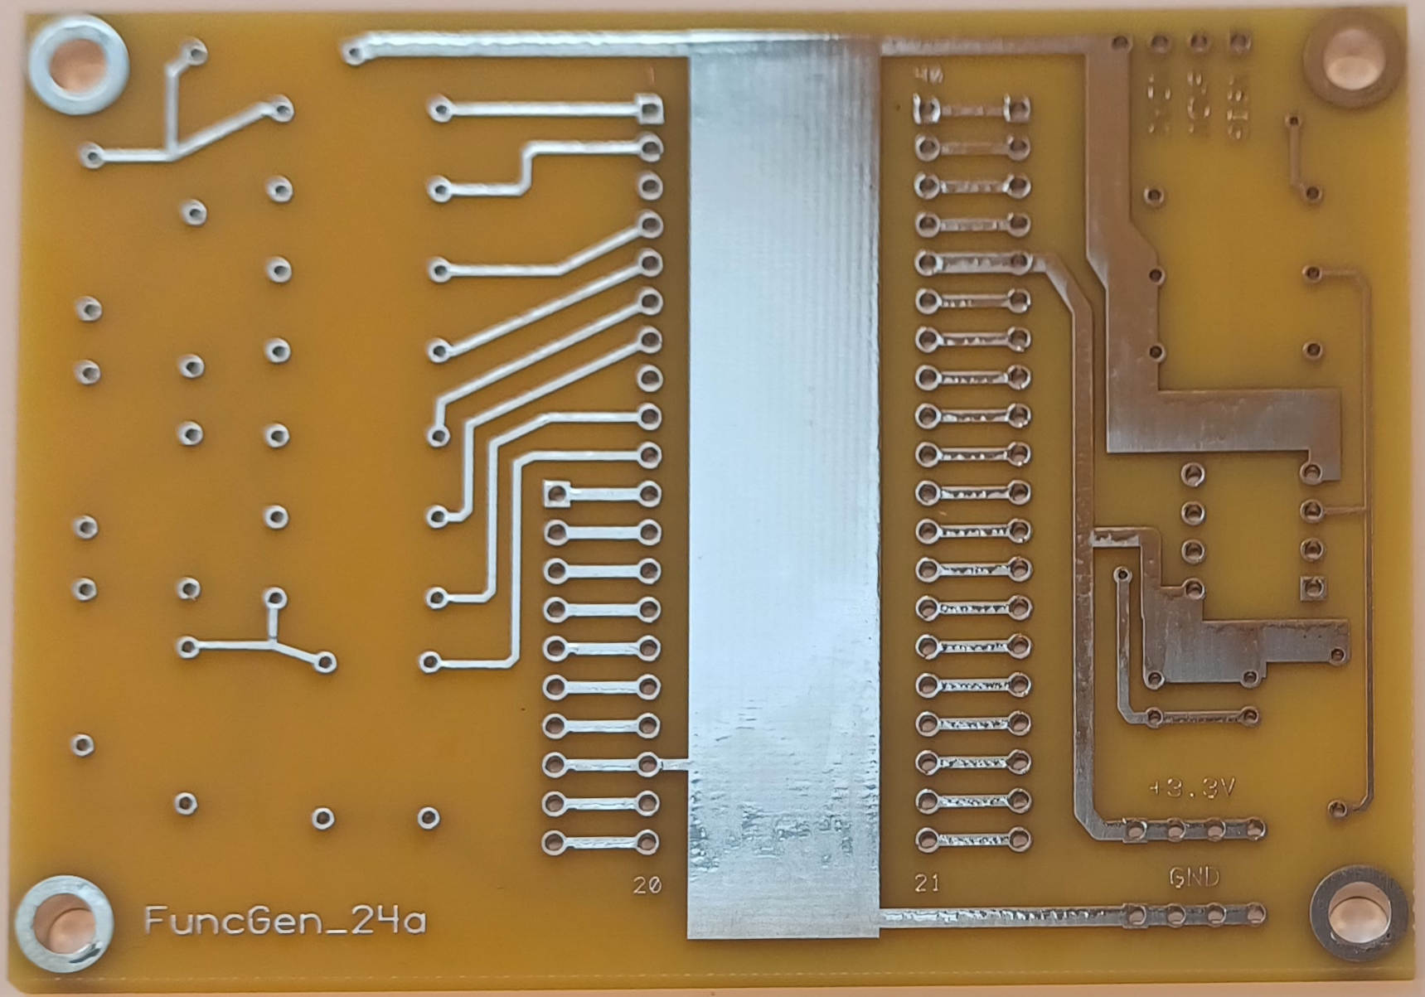Figure 7: The DAC PCB.
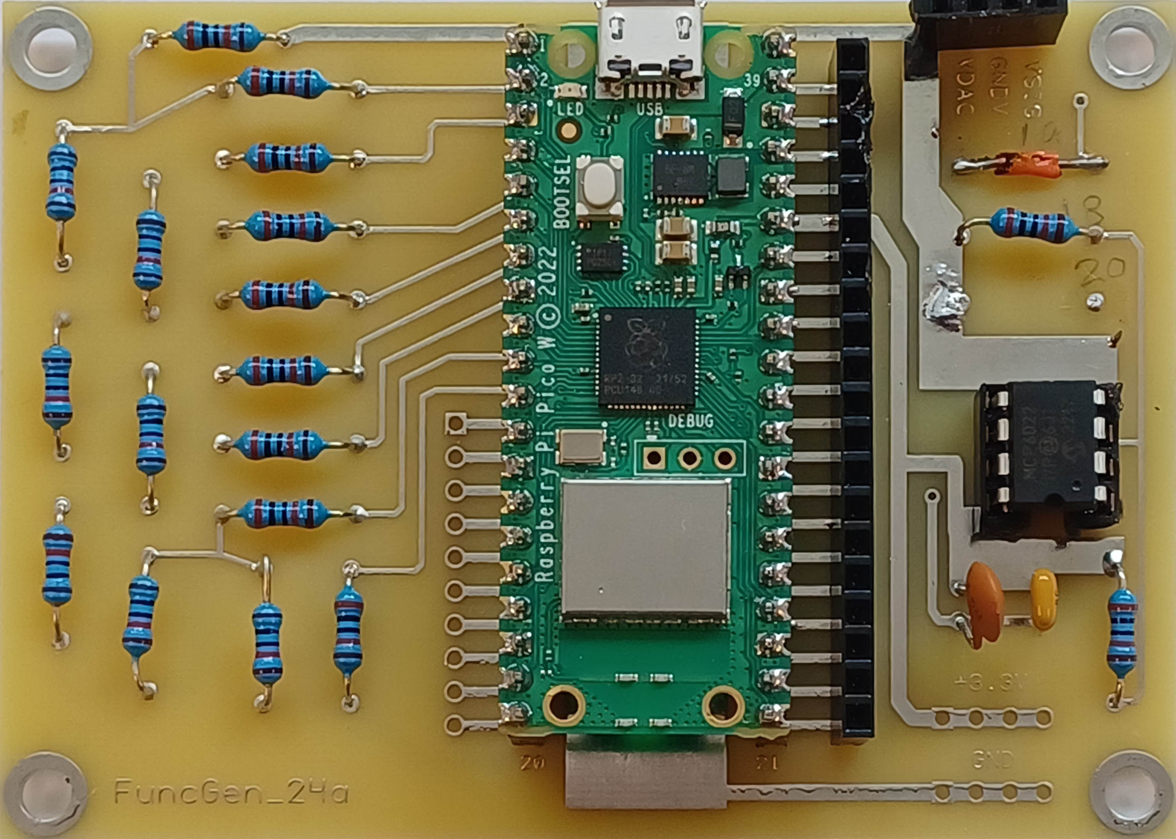Figure 6: Finished PCB. The Pico W and the op amp are mounted in their sockets.

It is hard to see the color codes on the resistors, so you can use Figure 8 to help place them.

Note that R19 is missing. It is replaced by a wire just above R18. Below R18 are two pads that are not used.
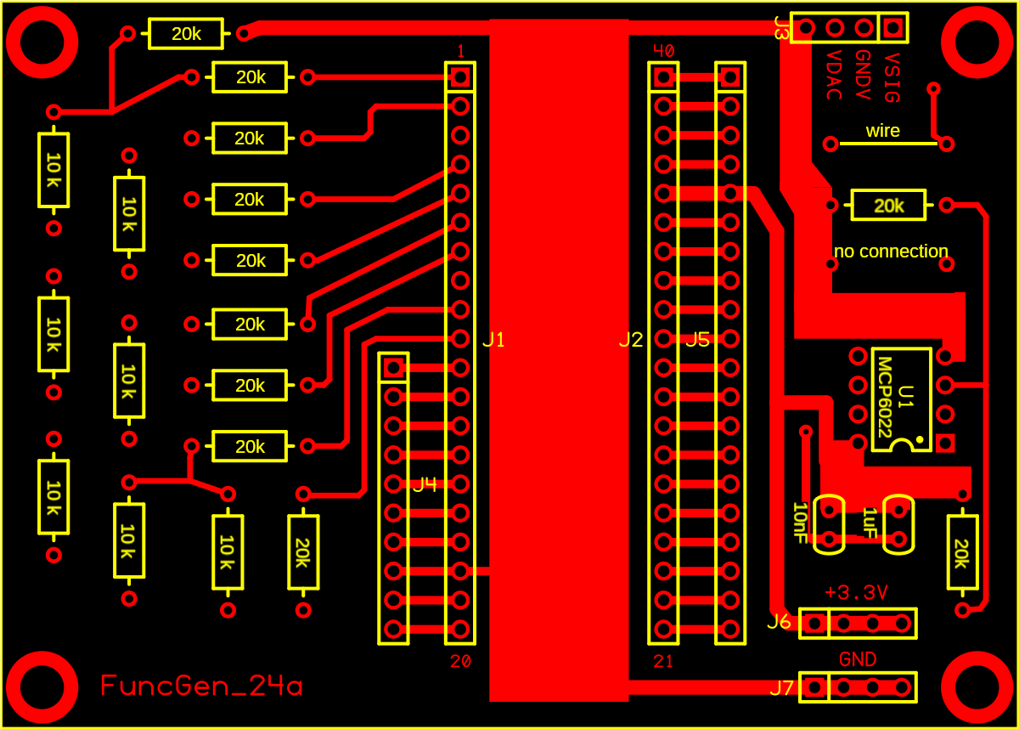Figure 8: A key to placing components on the PCB.

Assembly.
- Start by mounting the resistors. Pay close attention to the values!!!
- Bend the leads so the wires can fit through the mounting holes.
- Put the wires through the holes and pull the wires from the opposite side until the resistor is close to the PCB.
- Flip the board over and solder the wires to the pad.
- Clip off the extra wire.
- I usually do two to four resistors at a time.
- For the Pico W sockets, plug the Pico W into the sockets then place the sockets in the PCB. Then solder them in place.

Programming the Pico W
- Take a new Pico W and load MicroPython on it as before.
- Make a folder for storing the MicroPython code.
- Download the files main.py and Func_Gen.py from

Using the Waveform Generator
Plug the waveform generator into you laptop and use Thonny to connect to it. Note you can make sine waves with a starting frequency, ending frequency, number of frequencies. There are foir outputs from the function generator, Signal (VSIG), Virtual Ground (GNDV), DAC voltage do not use! (VDAC), and Ground (GND.) Since the Pico W runs on positive 3.3 V, the function generator makes a signal ground half way between the Vcc and GND. Relative to GNDC, the sine waves are an AC (Alternating Current) signal. If you measure using ADC both SIG and GND_S and subtract them, you can measure the signal as an AC signal.

