Introduction
An important technique in experimental physics labs is the counting of particles or photons (which are particles, too!) Counting is a direct result of the quantization of matter and energy. In this lab we will build a detector for alpha particles, one of several forms of what is commonly known as radiation.
Radiation, as we will use the term, refers to particles or photons that have energies great than 10 keV (kilo-electron-volts.) There are three main sources of radiation: radioactive decays in the background environment, events from space (also called cosmic rays), and man-made sources.
In this lab, your detector will measure radiation from a man-made source and the background.

Nuclear Radiation
Some isotopes of elements have unstable nuclei that spontaneously decay. The time scales for decay vary enormously from femtoseconds to billions of years. The typical energies involved in nuclear decay are millions of electron-volts (MeV’s). This is a million times more energy per event than a typical chemical energies! There are four main types of nuclear decay particles we can detect: alpha (α) particles, beta particles (β), gamma rays (γ), and neutrons.
Alpha particles are bare Helium nuclei consisting of two protons and two neutrons. They have a charge of +2e where e is the charge of an electron. Alpha particles interact very strongly with matter, so they do not penetrate very far. As they pass through matter, they knock electrons off of atoms leaving ionized atoms along their path. In air they have an average distance of only several centimeters. They eventually come to a stop acquiring two electrons and become an atom of Helium. They cannot penetrate skin, so alpha emitters are only a hazard if they are ingested.
A common source of environmental alpha particles is the element radon (Rn) which is a gas created from the decay of uranium or other heavy elements in the environment. Radon is commonly given off by geological rocks. In western Pennsylvania there can be high levels of these elements, and radon can accumulate in basements and poorly ventilated houses. We will try to measure background radon emission in this lab.
A beta particle can be either an electron or a positron (a positive electron). Electrons, or β- originate in the nucleus of an atom that undergoes radioactive decay by changing a neutron into a proton. Positrons are a β+ particle which originates when a proton changes into a neutron inside a nucleus. The most common beta particles are electrons. Beta particles are 8000 times lighter than an alpha, and more penetrating, but their range in tissue is still limited. Like alpha particles, beta particles leave a trail of ionized atoms along their path. Although lower energy beta particles are generally a hazard only if taken into the body, high energy beta particles represent an external radiation hazard and can produce significant skin damage. Beta particles can pass through a sheet a paper or thin clothing, but are stopped by a thin layer of aluminum foil, plastic, or glass.
Gamma rays are electromagnetic radiation, similar to visible light, but at a much higher energy. They are given off by the nucleus of an atom as a means of releasing excess energy, and is often simultaneously released when a nucleus undergoes decay by emitting an alpha or a beta particle. Gamma rays are particles (quanta) of energy that have no charge or mass and can travel long distances through air (up to several hundred meters), body tissue, and other materials. Gamma rays also knock electrons off of atoms leaving a trail of ionized atoms. Gamma rays are extremely penetrating and represents an external hazard to a body. Thick layers of concrete, lead, steel and other comparable shielding materials are necessary to stop the penetration of gamma rays.
Neutrons have no charge, so they do not interact electromagnetically with an atom, and high energy neutrons are very penetrating. Neutrons can be produced by the fissioning or splitting of atoms. Some transuranic atoms such as certain isotopes of plutonium and curium fission spontaneously, i.e., the fission process occurs without the need for additional neutrons to initiate the process. Neutrons are hard to detect because they do not make ionized paths as they travel through matter. We will not detect any neutrons. Shielding for high energy neutrons generally consists of materials having high concentrations of hydrogen including water, concrete, sheets of paraffin, and plastic.

Cosmic Rays
The term cosmic ray has historical roots. It turns out that most cosmic rays that interact with the Earth are created by the Sun, so they are not interstellar or cosmic. A significant fraction of cosmic ray com from astronomical sources. The most energetic do originate from cosmic sources. Cosmic rays mostly consist of extremely high energy electrons and protons.
When cosmic rays hit the Earth’s atmosphere, they generate showers of all of the above particles plus some exotic, very short-lived particles like muons, pions, and many more. Most of the exotic particles decay so quickly into ordinary particles that only alphas, betas, gammas and neutrons are detected on the surface of the Earth. The exception are the muons. Muons are like electrons except the mass is 200 times larger. This makes them more penetrating than electrons and positrons. The other significant difference for cosmic ray muons is that they they have average energies of about 2 GeV, that is 2 billion electron volts! This makes then extremely penetrating. In fact muons scream right through a six story building and are easily detected in a basement lab! The muon flux at the Earth's surface is such that a single muon passes through an area the size of a human hand every second!

Detection of Alpha Particle by Photodiodes
A photodiode is the opposite of an LED. In an LED you make a current flow and it gives off light. In a photodiode light is absorbed and the result is a current, called the photocurrent. They basically the same type of device, in fact, LED’s can be used as light detectors. We will see shortly, that alpha particle hitting a photodiode can give a pulse of current.

Diversion into Solid State Quantum Physics
The development of semiconductor devices, diodes, transistors, computer chips, etc. is one of the triumphs of quantum physics. Many people consider the invention of the transistor the greatest invention of the 20th century.
The discovery from quantum physics the enabled semiconductor devices is that electrons are fermions, that is that each discrete quantum state can only contain one electron. Next, you can solve for the quantum states of a periodic solid. For metals the quantum states get partially filled with the valence electrons of the atoms and the result is that the electrons are freely shared among all of the atoms in the solid. These energy levels are called the conduction band. This free sharing of electrons is what give rise to the familiar properties of metals, such as electrical conductivity, and being shiny.
Semiconductors have a different story. The valence electrons completely fill the quantum states, so they cannot move around freely. These states are called the valence band. However there is a small energy gap between the valence bands and the next states up, the conduction band. Room temperature provides enough energy for some of the electrons to populate the conduction band, leaving empty spaces, called holes in the valence band. Through the weirdness of quantum physics, these hole behave like positively charged electrons. Both the holes and the electrons are free to move in the atomic structure, so the material is called a semiconductor because it does conduct electricity, but poorly, and the conductivity is temperature dependent.
The best example of a semiconductor is silicon. It has four valence electrons per atom and the same crystal structure as a carbon diamond. The difference is that the band gap in a diamond is 5.5eV, but in silicon is only 1.2 eV.
Now for more weirdness.

In the late 1940’s and 1950’s it was discovered that you intentionally add a small amount of impurities to silicon, it acts like pure silicon with an excess electrons, called an n device, or an deficit of electron which cause holes in the material that act like positive electrons, called a p device. They discovered life gets interesting when you make a junction where an n-material is grown on top of a p-material, Figure 1.
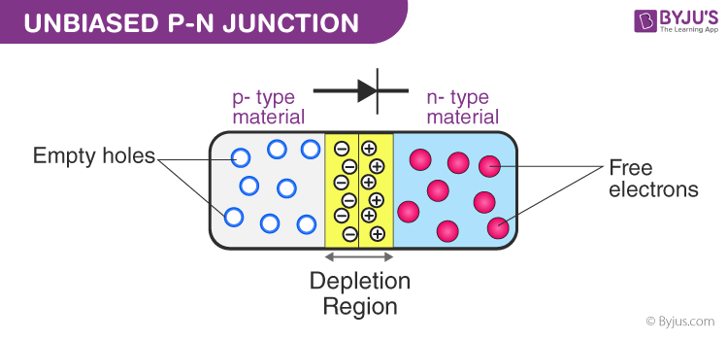Figure 1: A p-n junction. The contact region forms a depletion region.
At the junction, electrons diffuse into the p-region to fill holes and holes diffuse toward the n-region trying to accept electrons.

However this mutual diffusion creates an electric field that opposes diffusion. When an external voltage is put across the device, if the p-side is more than ΔV higher than the n-side current can flow, but if the p-side is less than ΔV or negative, no current flows. This device is a diode. Current can only flow in one direction in a diode.
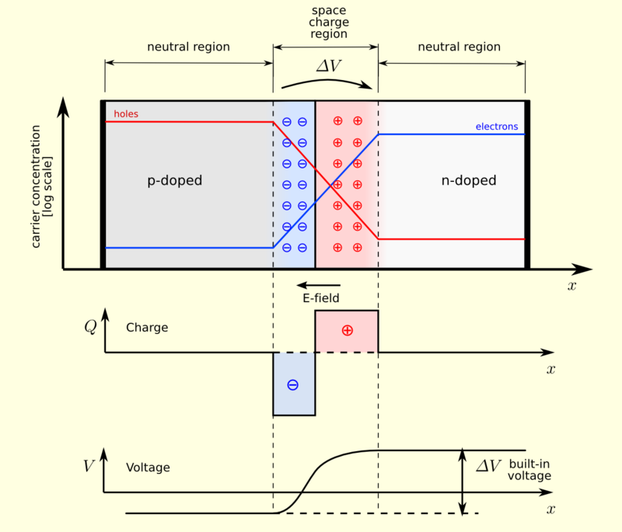Figure 2: The diffusion of electrons and holes sets up an electric field and therefore a voltage difference between the ends of the device.
Now for the sensor part. When a photon or ionizing particle of sufficient energy strikes the diode, it creates an electron–hole pair. If the absorption occurs in the junction's depletion region, these carriers are swept from the junction by the built-in electric field of the depletion region. Thus holes move toward the p-region, and electrons toward the n-region, and a photocurrent is produced. Note that this current flows in the opposite direction that a diode conducts. The current is directly proportional to the number of photons per second incident on the photodiode.

Photodiodes as Alpha Particle Detectors
When alpha particles strike the active area, they are absorbed and almost all of their energy goes into creating about one million electron-hole pairs. This pulse of current can be seen with an oscilliscope.
A convenient source for alpha particles is a ²⁴¹Am source from a smoke detector. The ²⁴¹Am emits alpha particles with an energy of 5.486 MeV 85% of the time. A rough estimate of the signal can be made: 100% of the alpha energy is deposited in the photodiode creating electron-hole pairs of energy about 3.5 eV. That is about 1.6 x 10⁶ electron-hole pairs or about 2.5 x 10⁻¹³ C. The photodiode has an internal capacitance of 20 pF. This capacitor discharging these pairs through a 10 MΩ resistor give a time constant of 4 x 10⁻⁴ s (400 μs) and a voltage of V_{α} = 13 mV. This is a signal that is easy to detect.
The challenge for this project is to design a low voltage circuit powered by the 3.3 V of the microcontroller that will convert the current pulse of the alpha particles to a 3.3 V digital pulse the microcontroller can count. I have found that 60 Hz noise is a large noise source for this project.

Detector Circuit
The circuit is shown in Figure 3. The supply voltage, V_{DD}, is the 3.3V regulated output from the microcontoller. The bypass capacitors are a 1 μF tantalum and a 100 nF ceramic capacitor. The first op amp is a transconductance amplifier with a gain of 10 V/μA. The resistor and capacitor make a high-pass filter with a cutoff frequency of about 1 kHz. This keeps 60 Hz noise out of the signal.
Typical alpha particle pulses have an amplitude of about 1 V as shown in Figure 4. The second op amp has a gain of 10. It boosts the pulse all of the way to 3.3 V. An example of a typical signal at Test Points 1 and 2 (TP1 & TP2) is shown in Figure 4a. The signal at TP2 is also the input to the Pico W.
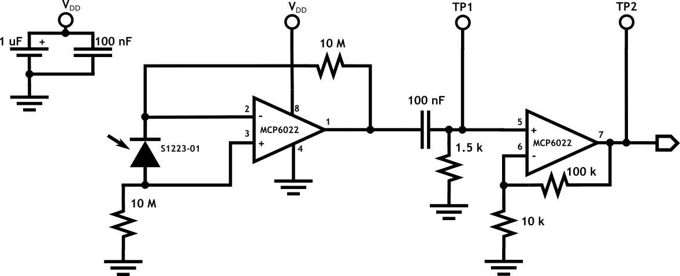Figure 3: Schematic for analog detection of alpha particles. The bypass capacitors and photodiode are mounted near the op amp. The photodiode has the glass window removed.

Figure 4: Schematic for wiring the PC board.

Soldering the PC Board
The circuit is tricky to wire on a breadboard, so I had a PC board made for the Alpha Detector. Here is a drawing of the top of the PCB.
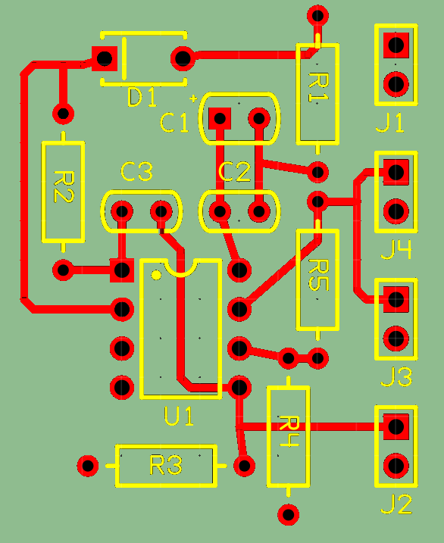Figure 5: Top of PCB. The black circles are where there are holes for mounting the components.
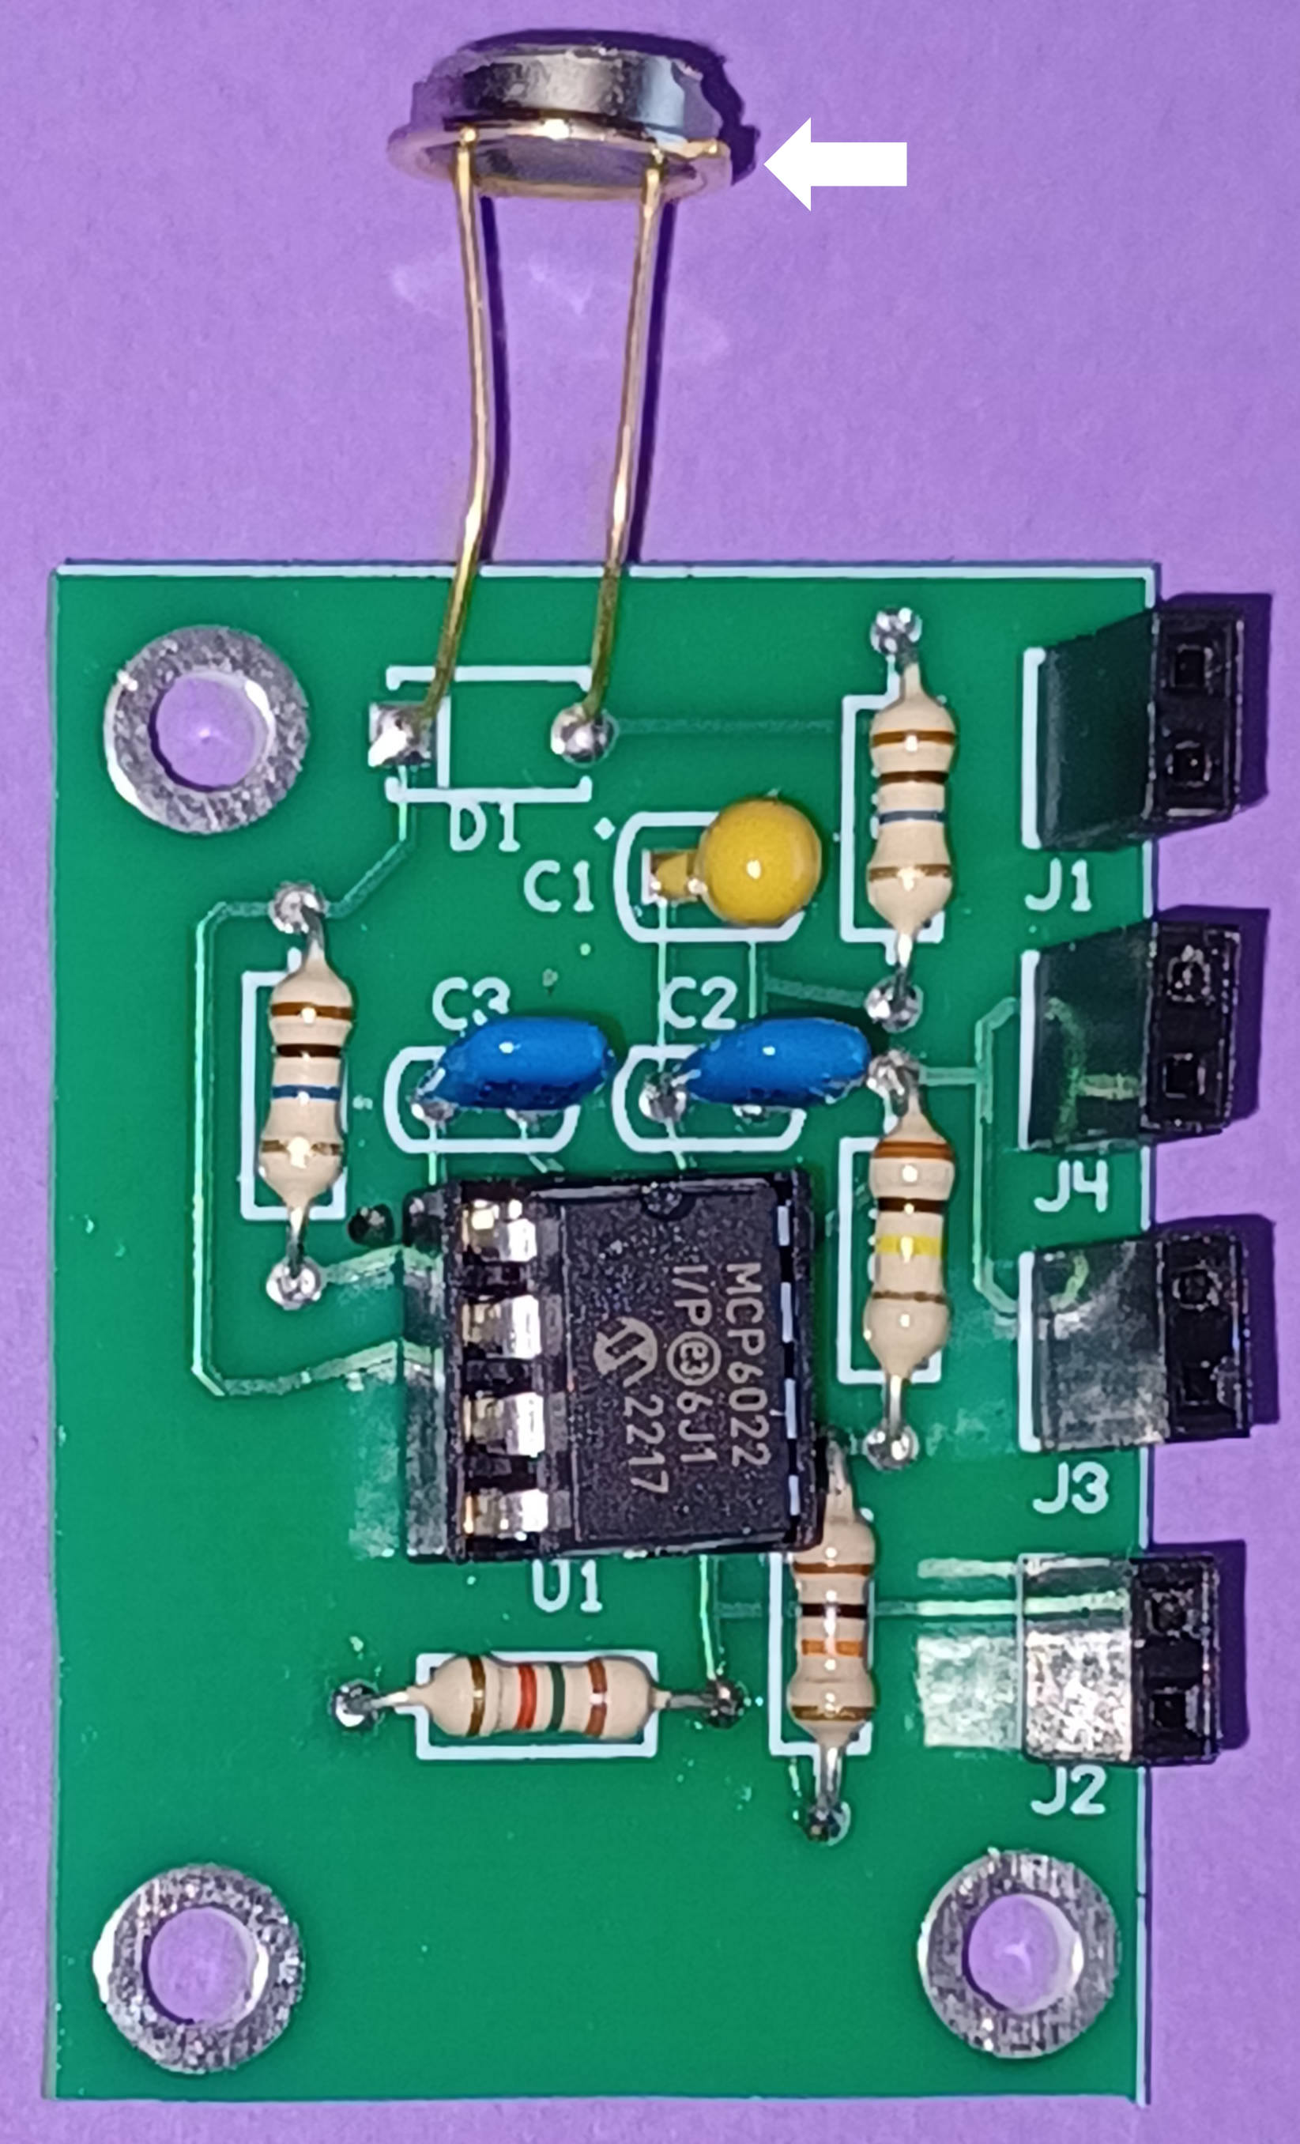Figure 6: Photo of assembled PCB. The arrow shows the tab on the photodiode.
Notes:
- For resistors, it does not matter which way the resistor is mounted.
- For capacitors C2, C3, the direction does not matter.
- Capacitor C1 does have to be soldered in correctly. On the capacitor has a line and the + sign marked on it that has to be in the + hole.
- Solder the IC socket in with the cut out as shown.
- The diode orientation does matter. The white arrow in the photo shows which side the tab on the photodiode is mounted.

Testing the Circuit
You have to be very careful when wiring this PCB. For the four 1x2 connectors, the pin near the bottom of the Figure is ground. The upper side of each connector (note the pad is square) is either 3.3V or the TP output.
Connecting the PCB
- Unplug the Pico W from your laptop.
- Wire 3.3V from the Pico W to the top socket of J1 and GND from the Pico W to the bottom socket of J1.
- Clip Channel 1 of the oscilloscope to J2. The probe connects to the top socket and the ground alligator clip to the bottom.
- Clip Channel 2 of the oscilloscope to J3.
- Turn on the oscilloscope. Turn on both Channel 1 and 2. Set both channels to DC input, 500 mV per division, and the zero to -3 divisions.
- Plug the Pico W into your laptop and check the oscilloscope. Use Ch. 1 to check that pin 8 of the IC is at 3.3 V and pin 4 is ground.
- Connect Ch. 1 back to TP1.
- Cover up the Pico W and PCB box. If it is dark enough, Ch. 1 and Ch. 2 should be less that 500 mV.
Figure 7 shows the signals from an alpha particle. TP1 is the output of the first op amp, and the second is from TP2. The pulse from the first op amp has an amplitude of about 500 mV. The output from the second op amp, TP2, is over amplified, so it is clipped at the supply voltage of 3.3 V. The signal from TP2 is wired to a digital input of the Pico W. The signal into the pico W is saturated at 3.3 V. The width of the pulse is about 10 μs. A second pulse is also captured at the very right of the figure.
Figure 7: Oscilliscope capture. The orange is from TP1 and the cyan from TP2.

Wiring for the Detector
Finally to finish wire the second TP2, J4, to the Pico W. You only need to wire the top socket. Pick a GP pin on the Pico W and record which pin you use because you will need it for your code.
Tape the ²⁴¹Am very close to the photodiode. Close the box to keep light out.

Coding the PicoW
Software Goal: Count the number of detections per minute and both print it out and save it to a file on the Pico W.

Details to Work Out:
- Wire the output of the detector circuit, TP2, to a digital pin on the Pico W.
- The program should define that Pin object for input.
- Write an Interrupt Service Routine (ISR) that increments a count variable. Define the count variable outside of the ISR. The ISR should declare the variable as global.
- Attach the ISR to the Pin.
- The main part of the program should loop once per second. Each loop should print and write the count variable, then set the variable to 0.

Testing Your Device
When your program is working it should print out the counts recorded in every 1 second interval.

Finishing the Code
You need to modify to print the average counts per second and standard deviation of the counts per second every second. Your code should look something like the code below.

# Variables for average and standard deviation
counts = 0
# Cumulation
n_sec = 0
total_counts = 0.0
total_counts_sq = 0.0

# Main loop. Type ^C to stop
while True:
sleep_ms(1000) # Sleep for 1 second
counts_now = counts
counts = 0

n_sec += 1
total_counts += counts_now
total_counts_sq += counts_now**2
avg_now = total_counts / n_sec
std_now = sqrt(total_counts_sq / n_sec - avg_now**2)
print(f"{counts_now}, {avg_now}, {std_now}")

# Done

Experiment 1 – Counting Alpha Particles
Take data for at least 15 minutes. Copy and paste the output from Thonny into a text app. Edit the top and bottom of the data so that every line either begins with a ‘#’ or is a line with three comma separated numbers. Save the data in a CSV file.
Plot the count data as a histogram. For Poisson distributed counts, the standard deviation should be close to the square root of the average. Output those values on your final plot.

Experiment 2 – Counting Radon Emission
The radioactive gas radon can be emitted by the rock formations a building is built on. Exposure to elevated radon levels can cause lung cancer. This is especially a problem in western Pennsylvania because of the geology of the area.
You can concentrate radon using a vacuum cleaner sucking air though a coffee filter. Radon sticks to dust in the air, so the filter paper can collect a large sample of dust. Over time the counts from the filter paper decrease because of the 3.5 day half-life of radon and the filter paper losing the dust.

Disclaimer: The detector you built is not calibrated and should not be use to evaluate the hazard of radon levels.
This should work better if you collect air from the basement of a building.
- Put one layer of a coffee filter over the tube of a vacuum cleaner. Tape it so it won’t get sucked in.
- Turn on the vacuum cleaner for 15 minutes.
- Keep track of which side of the filter paper was facing out!
  - Quickly remove the filter paper,
  - go back to the lab,
  - trim it to fit in the box, and
  - put the outside face of the filter paper facing the photodiode.
  - Cover the box.
- Collect 15 minutes of data, cut and paste it into a file with the time and date part of the filename.
- Repeat for 90 minutes.
- Plot the average counts versus time.

