Introduction
This is the first lab not based on the book Getting Started with MicroPython. In this lab you are going to explore some of the common usages of capacitors in circuits. One use is to use an RC circuit to time events or set the oscillation time of a circuit. A second usage is to filter signals in frequency, and a third usage is to decouple DC, AC, and noise signals from each other. This covers a lot of territory, so let’s get started!

Capacitors for Timing
Capacitors store charge and the basic formula is
Eq. 1
where V is the voltage across a capacitor in Volts (abbreviated V), Q is the charge on the capacitor in Coulombs (abbreviated C), and C is the capacitance value in Farads (abbreviated F.) It turns out 1 F is a very large capacitor. The capacitors we will use are in the ranges of µF, nF, or pF. When a current runs into a capacitor, charge accumulates in it and the voltage across it increases. Consider the following circuit
Challenge:
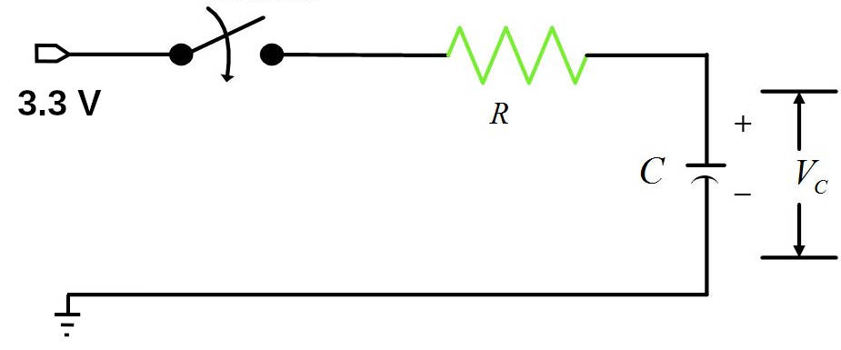Figure 1: A charging RC circuit. If Vc starts at zero when the switch is closed, the capacitor will charge and Vc will increase. Note 3.3V is also called Vcc.
- If R = 100 kΩ and C = 100 μF, what will the initial current be?

- What do you think the maximum Vc will be when the capacitor is fully charged?

The Charge – Discharge Function
You should have seen the formula for a capacitor charging of discharging through a resistor
Eq. 2
where .
Challenge:
- Find the value of τ in seconds for the Challenges above.

- Find the values for V₀ and V₁ for the circuit in Figure 1 when the switch is closed.

You are going to make an oscillator. Consider the circuit in Figure 2 (but don’t build it yet.) You will drive the circuit with a digital output, and read V_{C} with an ADC input. You need to write a program that:
- Turns on the digital output.to 1
- When V_{C} = ⅔V_{CC}, set the digital output to 0
- When V_{C} = ⅓V_{CC}, turn the digital output back 1.
- Repeat infinitely
Figure 3 shows what the waveform should look like, but t_on and t_off will be equal.
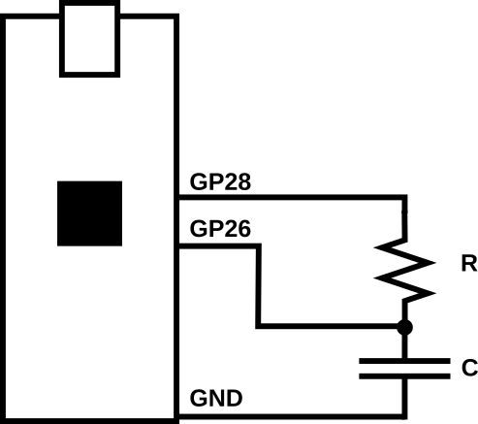Figure 2: The oscillator circuit. GP28 is a digital output and GP26 is an ADC input.
Super Challenge:
- How long will it take the RC circuit to charge from ⅓V_{CC} to ⅔V_{CC}?
- What will T be in terms of R, C, and V_{CC}?
- For R = 100 kΩ and C = 100 μF, what will T be?

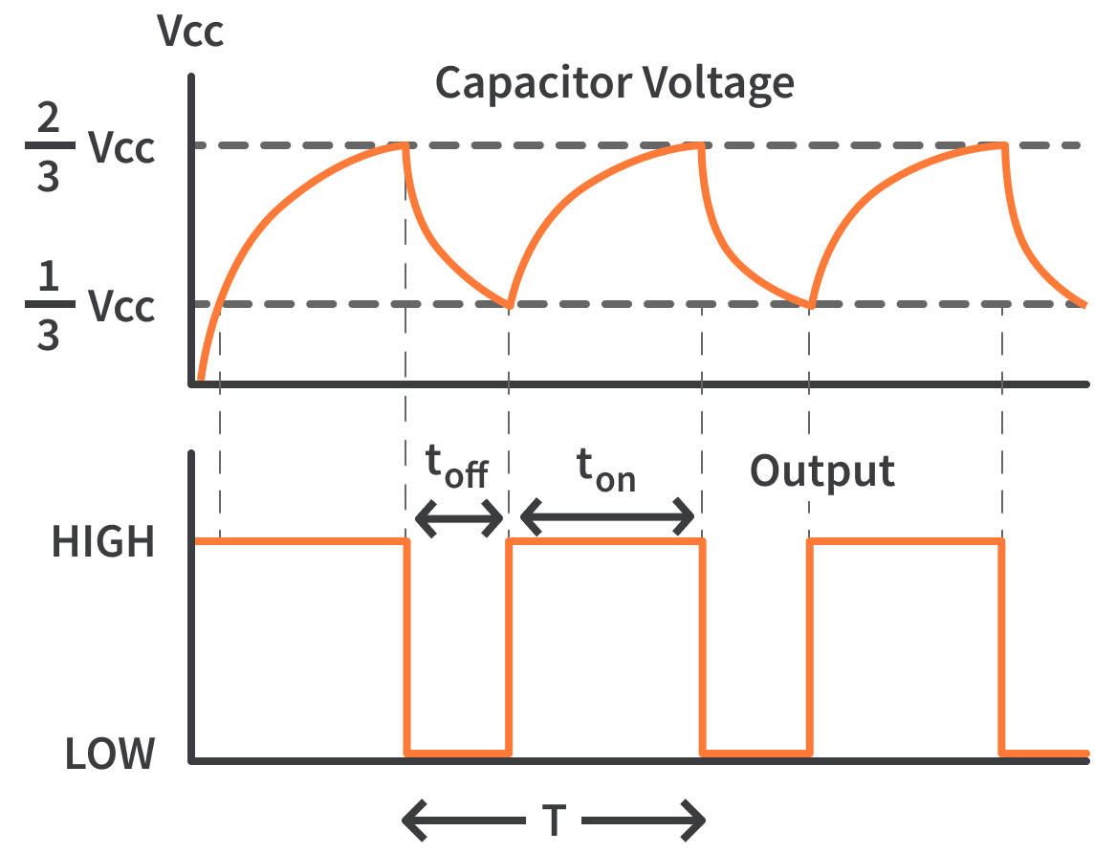Figure 3: The charge-discharge curve for the ocillator. You must make t_on and t_off equal.

Building Your Oscillator
1) Build the oscillator circuit with the components above, program the PicoW, and measure its frequency using an oscilloscope. In the space below, analyze your data and compare it to your calculated T. What is the percentage difference?

2) Change the components to make a 1 kHz oscillator. Is the result within the tolerance of the components?
Show your work below.

To Continue …
The next lab is about using capacitors to filter signals in frequency. However, first you need to take a diversion to build a Function Generator. You will use it to make sine waves at different frequencies and measure how an RC filter affects that signal.
So now you will change gears to do Function Generator project.

Materials
- Pico W on a breadboard.
- A 100 kΩ resistor
- A 100 μF capacitor
- Variety of resistors and capacitor for students to try to make a 1 kHz oscillator.
- An oscilliscope.

