Introduction
This is lab is about the second usage of capacitors, to filter signals in frequency.

Frequency Filters with Resistors and Capacitors.
Simple circuits, like Figure 1, have a very important usage – they only allow certain frequencies though to V_{OUT}. This particular circuit only allows low frequencies to pass through to V_{OUT}. Very often when you are working with a signal, it is mostly near some frequency. If you have noise present, it usually has many frequencies present. Electronically you can eliminate noise from your measurement by using a frequency filter.
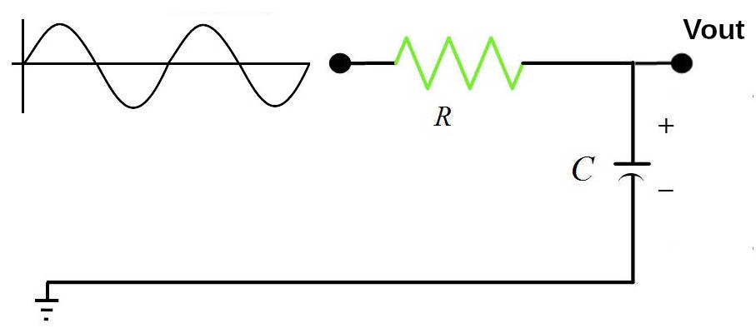Figure 1: An RC low pass filter. The sine wave is both negative and positive.
In this lab you will use the function generator you built to provide sine waves of varying frequencies to the RC filter, then use the ADC of the Pico W on the Function Generator to measure the amplitude of the sine wave at V_{out}.

R-C Filter Analysis
The concept of impedance extends resistance to AC (Alternating Current) frequencies and to capacitors and inductors. The familiar rules for combining series and parallel resistor to get an equivalent resistance, work the same if you use impedance instead of resistance. The impedance of a capacitor of value C is
Eq. 3
where Z_{C} is the impedance, j is the pure complex number , f is the frequency in Hz, and C is the capacitance in Farads. Notice two important differences from resistance. First, the impedance is frequency dependent, and second, it is complex. The impedance is useful because it can be used just like resistance in familiar series and parallel formula. The circuit in Figure 1 is a voltage divider. For resistors the output voltage would be
Eq. 4
where R₁ is the upper resistor and R₂ the lower. For the circuit above, replace R₁ with R and R₂ with .
Eq. 5
It takes a bit of algebra to make the denominator real, but the result is
Eq. 6
The transfer function is defined as
Eq. 7
This function is usually described by the magnitude and the phase. The magnitude is where ⊹ means complex conjugate. Again after some algebra, you get the final important answer that the amplitude of the transfer function is
Eq. 8
In the space below do the algebra to show Eq. 8 from Eq. 7

The phase is
Eq. 9
Challenges:
- What is the limiting value of the magnitude as f →0? As f →∞? When f = 1 / 2π RC?

- What is the limiting value of the phase as f →0? As f →∞? When f = 1 / 2π RC?

- What is the instructor’s quick way of reasoning through what a capacitor does in an AC circuit as f →0? and f →∞?

- Why is this called a low-pass filter?

Last observation: Note that the combination occurs several times in the formulas and it has to be a unitless quantity. The combination , then has to have units of 1 / Hz. The quantity is defined as the characteristic frequency of the filter, f₀. Eq. 7 & 8 can then be written
Eq. 10
The phase is
Eq. 11
Now it is easy to see when , the amplitude is and the phase is -45º.
Filters are usually discussed in term of power, not voltage amplitude. The power is proportional to, so when , the power is ½.

Exercise: Plot versus f on the graphs below for f₀ = 1 Hz.. The first graph is linear, but the second graph is log-log.
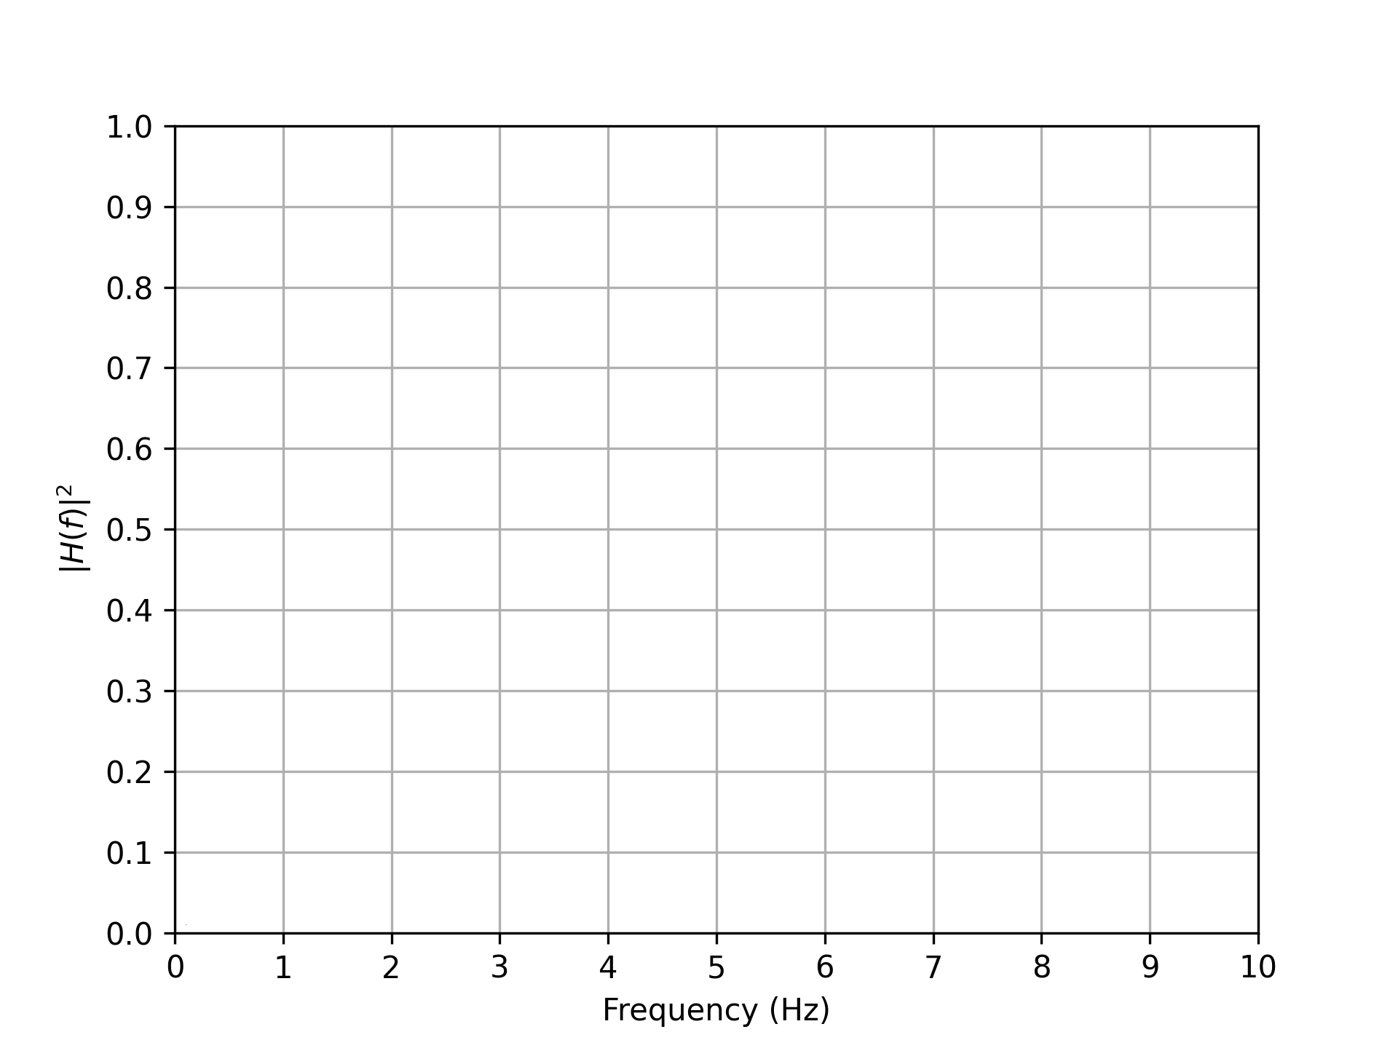

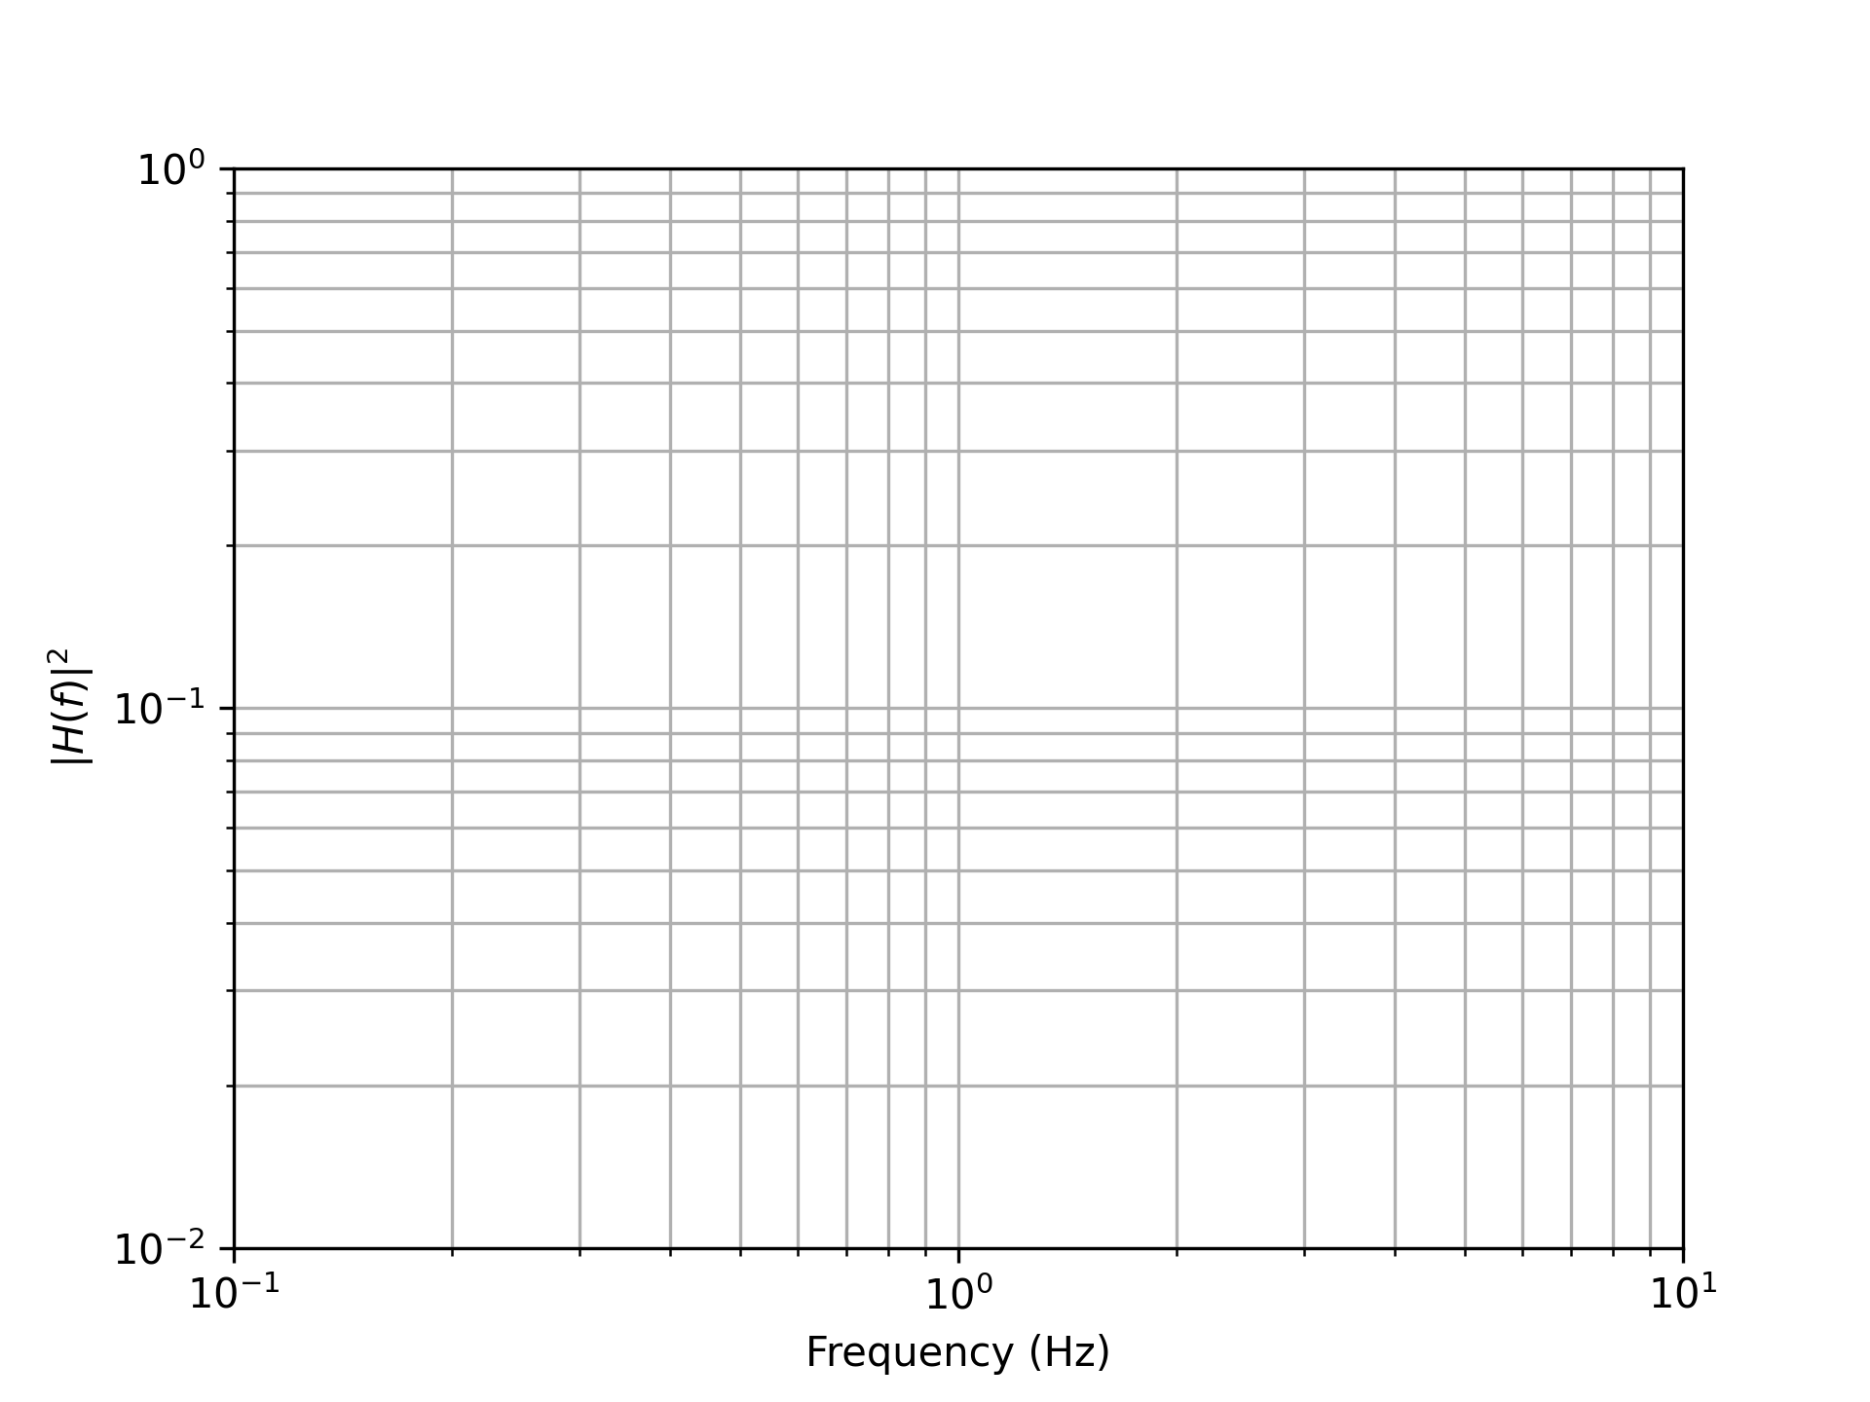
You should be able to see why a log-log plot is used – most of the graph is nearly straight lines.

C-R Circuit
Consider the circuit in Figure 3. In this case
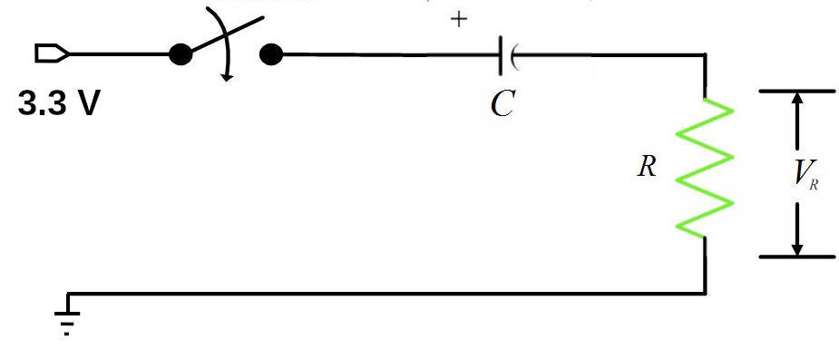Figure 2: A "C-R" circuit. This can be analyzed as a voltage divider, but using the impedance for the capacitor.
Eq. 12
The algebra is still a mess, but the result is
Eq. 13
The phase is
Eq. 14
Note: the fraction is reversed in the phase and without a minus sign.

Challenge (his should be easy now!)
- What is the limiting value of the magnitude as f →0? As f →∞? When f = f₀?

- What is the limiting value of the phase as f →0? As f →∞? When f = f₀ ?

- Why is this called a high-pass filter?

Exercise: Plot for the low pass filters on the two graphs above. Make sure you label your graphs.

Exercise: Measuring Filters
Goal: to build these two filters and test them using the PicoW Function Generator.
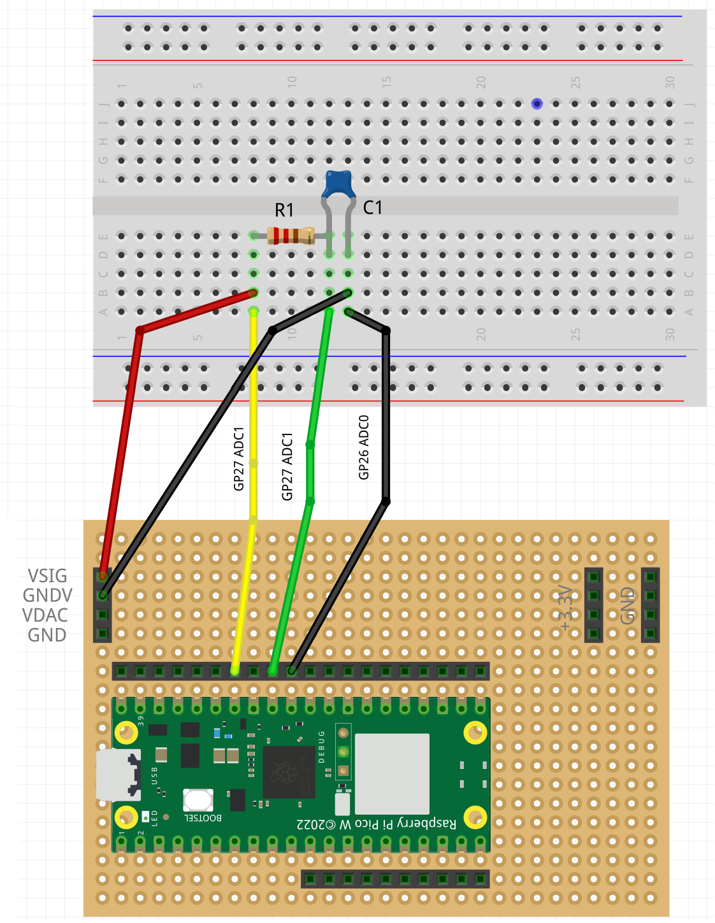Figure 3: The Fritzing view of the circuit with the FuncGen board and the low pass filter.
Build the low pass filter on a breadboard and connect the circuit to the Pico W on the DAC board. See Figure 3 for the wiring.

2. Wire the Circuit
We want the cutoff frequency, f₀ to be about 1 kHz. Use f₀ = 1 kHz, and R = 10 kΩ to calculate the capacitor value. From the assortment of capacitors and resistors, choose the closest value. There are many more resistor values than capacitor values, so once you choose a capacity value, recalculate the resistor value and find the closest value. Calculate the expected f₀ below with your choice of R1 and C1.

Expected f₀:

1. Load the Code to Step Frequency.
We will use the same file AWG_Sines.py that we used in the Function Generator project.
We are going to build a filter with f₀ about 1 kHz. It is good to make measurements from to 10 f₀ (100 Hz to 10 kHz). A general principle of experimental design, is whenever your experimental variable varies by more a factor of three, use logarithmic spacing. So we should use the logarithmic spacing option in the code.

2. Collect the Data. Like in the Function Generator project, to collect the data, first clear the screen in the Shell wind, then run the program. When it is done, in the shell window type <Ctrl>A to select all of the text, then <Ctrl>C to copy it. Open a text editor and type <Ctrl>V to paste the output. Next you have to edit the text so the only text left in the file are the columns of data and any comment lines that begin with a # character.

3. Write Program to Process and Print the Data
You need to program PicoW to output a sine wave, then, for each frequency step, read the values with the DAC for multiple periods of the sine wave, both before and after the RC filter.
This time, however, instead of printing the DAC data, you want to calculate and print the amplitude of the filter’s transfer function.
For an AC signal of amplitude V₀ , the AC RMS amplitude is defined as
Eq. 15
For discrete data, you can calculate this using the formula below.
Eq. 15
and V_{avg} is the average of the sine wave.

Programming Trick
It is common to calculate the RMS value of periodic data. You can do this by keeping a running sum of the data values and the squares of the data values. From these two sums you can calculate the average of the data and the RMS deviation from the average.
Here is a code fragment that does this. You will have to adapt it to your particular case:

# The number of data points to take is n_points

data_sum = 0.0
data_square = 0.0
for i_point in range(n_points):
data = get_data()
data_sum += data
data_square += data**2
data_average = data_sum / n_points
data_rms = math.sqrt(data_square / n_points - data_average**2)

Summary
You want your program to:
- Step through frequencies.
- At each frequency take data and calculate the average and RMS for both the input and output of the filter circuit.
- Print the frequency, average, and RMS for the input to and the output from the filter.
- You should save this data in a CSV file.

Analysis
Every time you take data you need to plot and analyze it. Refer to the Python Skills assignment to plot your data. You should plot the RMS versus frequency on both a linear and a log frequency scale. Also, each plot should include a model line of |H(f)| using Equation 8 and the actual R and C values you used for your filter.
The plot is the main analysis you do, but you have to summarize in sentences what you conclude in the space below. Include numbers!
Low-Pass Filter Conclusions:

Repeat with an RC High Pass Filter

Component Values:
Calculated f₀:

High-Pass Filter Conclusions:

Final Questions
- If you wanted to remove the DC level from a signal, what filter would you use?

- If you want to filter high frequency noise from the power to a component, what filter would you use?

Materials List
- Pico W with completed DAC board. (Do the project Function Generator first.)
- Resistors: 10 kΩ,
- Capacitors: 1.6 x 10⁻⁸ F = 16 nF = 16000 pF = 0.016 uF. Use 10 nF or 22 nF.
- May need other miscellaneous capacitors and resistors.

