Introduction
Op amps are a gift from God.
Op amps are integrated circuits which have small amplifiers of very high gain, more than 1,000,000! A one microvolt signal would get amplified to 1 volt! The ones we use in this lab have 8-pins and two op amps in the same small integrated circuit.
You almost never need to amplify a signal a million times, so why so much gain? Then answer is: you use negative feedback that subtracts part of your original signal from itself to reduce the gain. Why? Negative feedback circuits that give stable outputs.
Negative feedback is a gift from God.

Basic Op Amp Wiring and Rules
The schematic symbol of an op amp is shown in Figure 1. The op amp circuits you will use in these labs will operate as single supply op amps, meaning the negative supply is ground and the positive supply is the operating voltage of the microcontroller, 3.3V.
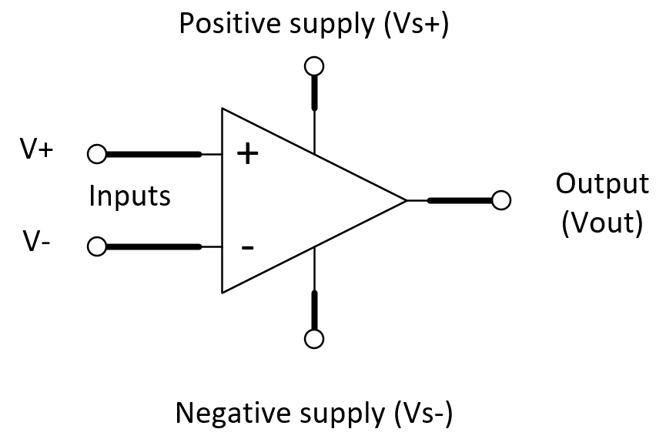Figure 1: The basic op amp schematic. We will usually use 3.3V as the positive supply and GND as the negative supply.

The Voltage Follower
Figure 2 shows the simplest op amp circuit, the voltage follower or buffer. The negative feedback changes Vout until the difference between V₋ and V₊ is zero. Then V_{out} equals V_{in}.
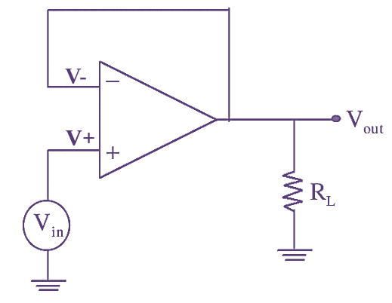Figure 2: The voltage follower. The negative feedback makes V- equal to V+, so Vout equals Vin.
Whenever V₋ is less than V_{in}, the op amp outputs more voltage which increases V_{out} and because of the feedback wire, V₋. When V_{in} is greater, the opposite happens. The op amp will quickly settle down, then V_{out} equals V_{in}. (There are cases where it doesn’t settle down, but those are a more advanced topic.)
Why would you want to just follow a voltage? The main reason is this circuit has a very small output impedance. This means if the load resistance, R_{L} changes, V_{out} does not change. A second related reason is this circuit has a very large input impedance. A large input impedance means no current flows into the op amp inputs, so connecting an op amp to a circuit does not affect the circuit you connect it to. The voltage follower is a sneaky way to spy on a circuit without affecting it, and the load after the op amp also does not affect your spying. * Perfect *
When you built the Waveform Generator the op amp was a voltage follower, so the voltage out should stay constant when you use it to drive another circuit.

The Two Rules of Op Amps
- Negative feedback make V₋ equal to V₊.
- No current flows into or out of either input.
That’s it. That is where all op amp designs start.
Warnings: These rules are little lies, but they are good lies. They will get you along way. Op amps usually have a small voltage offset between V₋ and V₊ so the negative feedback stops when V₊ plus V_{off} equals V₋. Usually V_{off} for op amps are in the millivolt to microvolt range. There is also a small amount of input current. Depending on the op amp this can range from microamps to femtoamps. Finally, the op amp gain gets less with frequency, so there is some frequency above which the negative feedback is not enough to stabilize the circuit.

Single-Supply Circuits and Virtual Ground
When working with a single supply circuit, there is a problem dealing with AC signals. AC signals oscillate around 0V and thus have positive and negative voltage with respect to ground. The solution is to build a voltage follower at exactly ½V_{supply}. You did this in the Function Generator. The MCP 6202 is a dual op amp meaning that one IC actually has two op amps on it. Go back and look at the schematic for the Function Generator and you should see two op amp circuits. On looks like Figure 3. Resistors R19 and R20 are equal, so the voltage going to V+ is ½ 3.3 V. That is the voltage we want for our virtual ground. There is a single wire giving feedback from the output to V₋, so this circuit is a voltage follower.
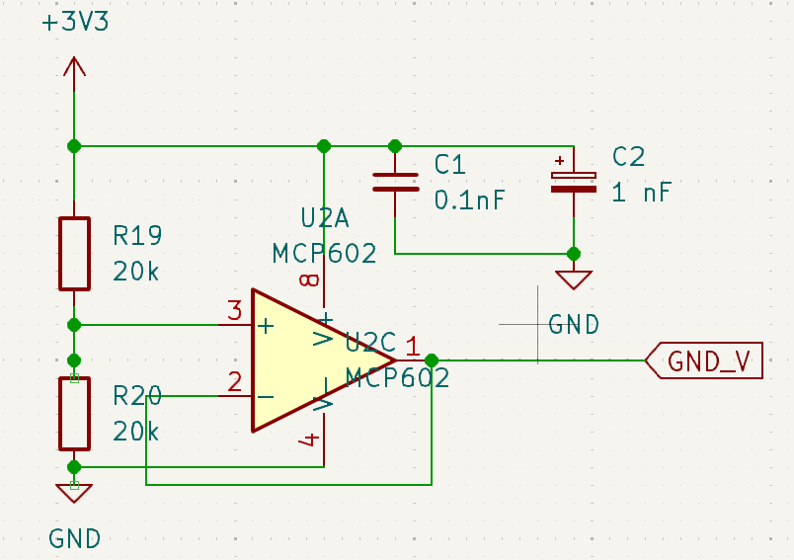Figure 3: From the Function Generator schematic. This is a voltage follower that creates a virtual ground.
You will use the virtual ground, VGND in this and other labs.

Application – Measuring Light with an LED
You are familiar with LED producing light, but they also can be used as light sensors. Take a red LED and hook it up to an oscilloscope probe. Clip the Channel 1 probe to the longer lead, the anode, and the ground clip to the shorter lead, the cathode. Note that there is a small flat space on the cathode side of the LED.
Set up the scope MEASURE to show the Mean and Freq of Channel 1.
You should see a signal with a ragged signal of 60 to 120 Hz. This is light from the room lights. There should also be a mean value. Cover and uncover the LED and watch the values. Below record the Mean and RMS signal with the LED uncovered, then covered up. How big is the signal from the room lights? How would you measure that?

The Rest of the Story: The way a photodiode works is that it absorbs a photon which releases electron-hole pairs in the junction of the LED. These pairs flow as current, so the photodiode acts like a light dependant current source, not a voltage source. When you connect the scope probe (or a voltmeter) across an LED you are probably measuring the photocurrent through the impedance of the scope. The actual current is very tiny.
Solution: Use a opamp to convert the photocurrent into a voltage. This is called a transimpedance amplifier, A current to voltage converter. Light causes a backward current that flows toward ground. Ignore the capacitor and calculate the gain of the amplifier in V/A using the op amp rules.
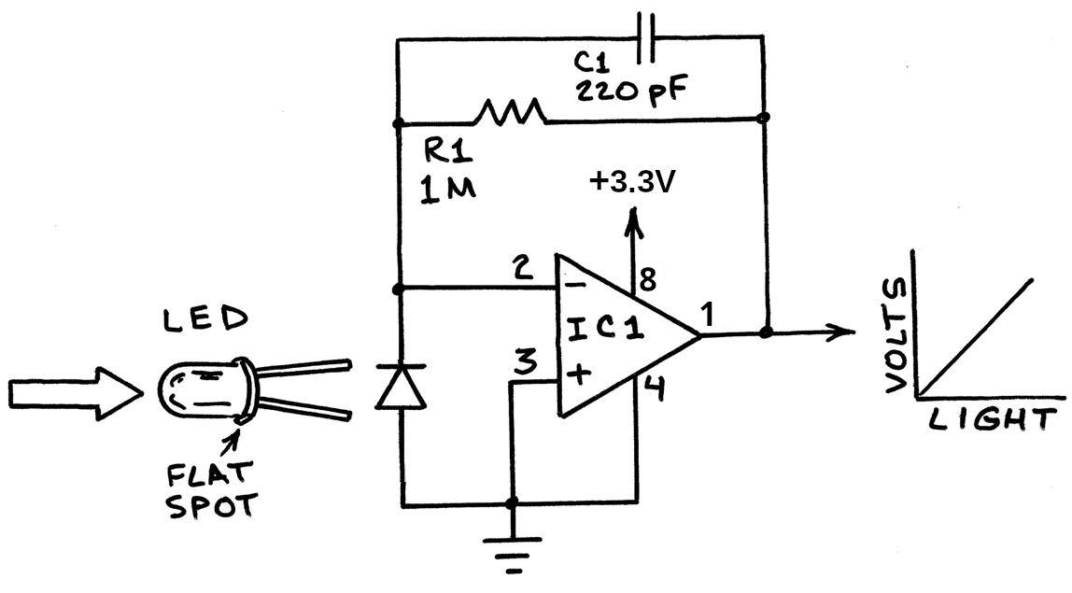Figure 4: A transimpedance amplifier for a photodiode.

Got an answer? Put it in more useful units using 1 MV/A = 1 V/μA.

The purpose of the capacitor is to reduce the gain at high-frequencies. This is needed to make the op amp circuit stable. Calculate f₀ for the low-pass filter in the feedback loop in the space below.

Build the circuit on breadboard and power using the 3.3V and GND from the Pico W. Test your light sensor by covering and uncovering it. Adjust the feedback resistor to get about 0.5 volts from the room light. Make a table of the output in different lighting conditions. (Like on window sill in direct sunlight, in a dark room, …)

What applications can you think of for this circuit?

Amplifiers
Probably the well-known usage of op amps is to amplify a signal. The key concept is to use feedback to set thee gain and make the amplifier stable. The two common op amp circuits are the inverting and noninverting circuits. The gain of the circuit is given by the resistors in the circuit.
Here are the two circuits
Both circuits have their uses. Since we are working with a single-supply op amp, we have to use the non-inverting circuit. Wire the second op amp of the MCP6022 as a non-inverting amplifier of gain 2. Use a 100 kΩ resistor for R1.
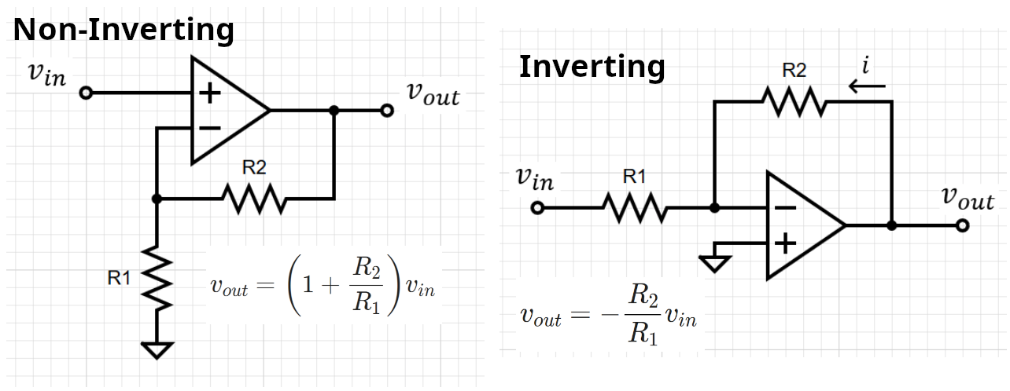Figure 5: The two most common op amp amplifiers circuits, non-inverting and inverting.

Add A Non-Inverting Amplifier
Wire the output from the LED circuit to the input of the second op amp in a non-inverting configuration. Try setting the gain to 2. Compare the outputs of the two op amps on the oscilliscope.
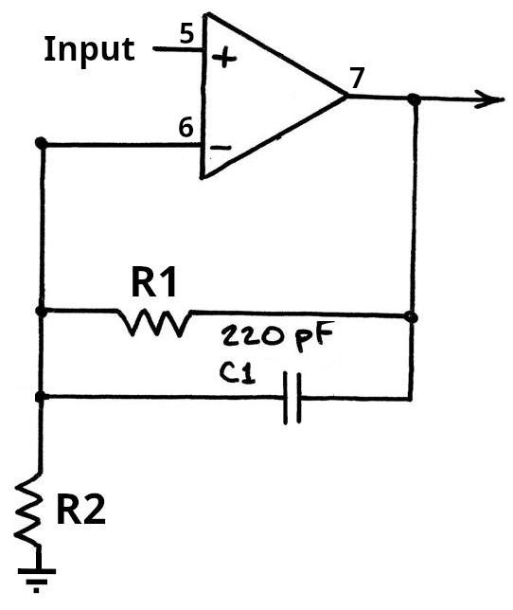Figure 6: A non-inverting amplifier for the photodiode output. The capacitor is optional; it may reduce noise. Gain = 1 + R1/R2
Describe the results below (use quantitative values.)

