

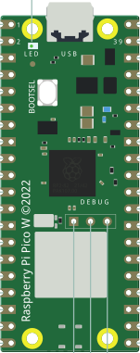
Differences Between the Pico and Pico W
The Pico W microcontroller is almost identical to the Pico with the addition of WiFi/BLE (Bluetooth, Low Energy.) The figure below is the Pico W. Note that the empty area at the bottom of the Pico that has a logo, on the PicoW has the metal WiFi/BLE module.
There is also an important change to controlling the LED on the Pico W. For the Pico, it is controlled by pin 25. For the Pico W, that pin is used to control the WiFi/BLE. The simplest fix is to use LED instead of 25 in your MicroPython code. This change also works if you have a Pico. In my edits to the book, I will make this change in the code.

Soldering Pins to the Pico W
You will get a better result by using a breadboard see the bottom of pg. 12 and Figure 1.9. Read pp. 13 – 16 on soldering.
My rule for soldering each pin is
1. Hold the tip of the soldering iron to simultaneously to the pin and the board.
2. Count slowly, “One steamboat, two steamboat, three steamboat.
3. Now touch the solder simultaneously to the pin and the soldering iron and let a couple of mm of solder to melt into the joint.
4. Remove the solder wire and count to three steamboat while keeping the soldering iron on the pin and board! You should see the solder wick (soak into) the joint.
5. Remove the soldering iron and let cool for three steamboats.

