Introduction
There are many systems where you can count individual events analyze the data for the average or energy, or other statistics. Examples of experiment that involve counting are photons in light, radioactive decay, and cosmic rays. This document develops some basic ideas, statistics and methods that are common for many experiments that involve counting. We will look at background radiation for our first experiment. This radiation is called high energy radiation because it involves light and particles that are often a million times more energetic that a chemical reaction.

Types of Radiation
There are two sources for background radiation, nuclear events that take place in the environment and “cosmic rays” that come from space.

Nuclear Radiation
Some isotopes of elements have unstable nuclei that spontaneously decay. The time scales for decay vary enormously from femtoseconds to billions of years. The typical energies involved in nuclear decay are millions of electron-volts (MEV’s). This is a million times more energy per event than a typical atomic electron event! There are five main types of particles we ca detect: alpha (α) particles, beta particles (β), gamma rays (γ), and neutrons.
Alpha particles are bare Helium nuclei consisting of two protons and two neutrons. They have a charge of +2e where e is the charge of an electron. Alpha particles interact very strongly with matter, so they do not penetrate very far. As they pass through matter, they knock electrons off of atoms leaving ionized atoms along their path. Even in air with a typical they have an average distance of only several centimeters. They eventually come to a stop acquiring two electrons and become an atom of Helium. They cannot penetrate skin, so alpha emitters are only a hazard if they are inside the body.
A common source of environmental alpha particles is the element radon which is a gas created from the decay of uranium or other heavy elements in the environment. In western Pennsylvania there can be high levels of these elements, and radon can accumulate in basements and poorly ventilated houses.
A beta particle can be either an electron or a positron (a positive electron). Electrons, or β- originate in the nucleus of an atom that undergoes radioactive decay by changing a neutron into a proton. Positrons are a β+ particle which originates when a proton changes into a neutron. The most common beta particles are elecrons. Beta particles are 8000 times lighter than an alpha, and more penetrating, but their range in tissue is still limited. Like alpha particles, beta particles leave a trail of ionized atoms along their path. Although lower energy beta particles are generally a hazard only if taken into the body, high energy beta particles represent an external radiation hazard and can produce significant skin damage. Beta particles can pass through a sheet a paper or thin clothing, but are stopped by a thin layer of aluminum foil, plastic, or glass.
Gamma rays are electromagnetic radiation, similar to visible light, but at a much higher energy. They are given off by the nucleus of an atom as a means of releasing excess energy, and is often simultaneously released when a nucleus undergoes decay by emitting an alpha or a beta particle. Gamma rays are particles (quanta) of energy that have no charge or mass and can travel long distances through air (up to several hundred meters), body tissue, and other materials. Gamma rays also knock electrons off of atoms leaving a trail of ionized atoms. Gamma rays are extremely penetrating and represents an external hazard to a body. Thick layers of concrete, lead, steel and other comparable shielding materials are necessary to stop the penetration of gamma rays.
Neutrons have no charge, so they do not interact electromagnetically with an atom, and high energy neutrons are very penetrating. Neutrons can be produced by the fissioning or splitting of atoms. Some transuranic atoms such as certain isotopes of plutonium and curium fission spontaneously, i.e., the fission process occurs without the need for additional neutrons to initiate the process. Neutrons are hard to detect because they do not make ionized paths as they travel through matter. We will not detect any neutrons. Shielding for high energy neutrons generally consists of materials having high concentrations of hydrogen including water, concrete, sheets of paraffin, and plastic.

Cosmic Rays
The term cosmic ray has historical roots. It turns out that most cosmic rays that interact with the Earth are created by the Sun, so they are not interstellar or cosmic. Cosmic rays mostly consist of extremely high energy electrons and protons.
When cosmic rays hit the Earth’s atmosphere, they generate showers of all of the above particles plus some exotic, very short-lived particles like muons, pions, and many more. Most of the exotic particles decay so quickly into ordinary particles that only alphas, betas, gammas and neutrons are detected on the surface of the Earth. The exception are the muons. Muons are like electrons except the mass is 200 times larger. This makes them more penetrating than electrons and positrons. The other significant difference for cosmic ray muons is that they they have average energies of about 2 GeV, that is 2 billion electron volts! This makes then extremely penetrating. In fact muons scream right through the top five floors of Fisher Hall and are easily detected in our Lab on the second floor!

Detecting Nuclear Decays and High Energy Particles
One detection method for alpha, beta, and gamma radiation is a Geiger tube. A Geiger tube is a cylinder filled with a low pressure of gas with a wire down the middle acting as a high voltage, positive anode. Before a particle is detected, a Geiger tube acts like a capacitor with a voltage and a separation of charge. When nuclear radiation penetrates the tube, it will ionize some atoms in the gas. Then the freed electrons accelerate toward the anode. As they accelerate, they, in turn, knock off more electrons from gas atoms, those atoms in terms knock off more electrons resulting in a fast cascade of current. This pulse usually lasts around 50 microseconds. The Geiger tubes in the detectors we will use have a very thin window at one end. This allows alpha particles to be detected through this window. Since beta particles, gamma rays, and muons are more penetrating, they can be detected from the window or through the side of the Geiger tube.
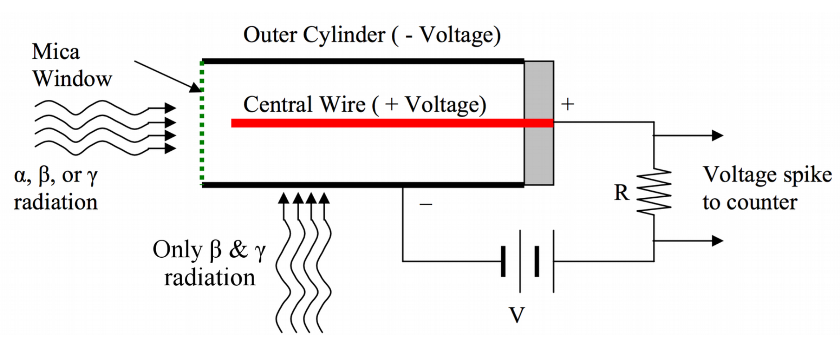Figure 1: Geiger counters have an anode centered in a tube filled with low pressure gas. Muons also trigger the Geiger counter.
A Geiger tube detector has two circuits, one to provide the high voltage to the anode, and one to detect the current pulses and condition them into nice digital signals.

Taking Lab Notes
In CoCalc, each person should create a project named AdvLab, then in that project make a folder named Geiger Counter. Finally create an jupyter notebook named Lab Notes. You will use that jupyter notebook to take notes.
Make your Partner a Collaborator, if applicable. To make someone a collaborator, click the Settings icon in your folder tab in the top toolbar, then in the right column click Add new collaborators. Then do the obvious.

Your Detector
You will use a commercial Geiger counter, the RM-60 from Aware Electronics, and interface it to a Teensy microcontroller The output of the RM-60 is a 5 Volt signal with a 50 μs negative pulse for every count detected. The RM-60 needs 5 V to power it. It also draws 0.2 mA when the detection rate is a few CPM (Counts Per Minute) and a maximum of 5 mA at a high count rate. This voltage and current is easily supplied by a Teensy. The RM-60 is easily wired to a Teensy. The wiring is as follows (see the label on the RM-60.)
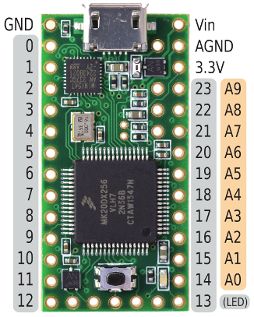Figure 2: The Teensy 3.2 pin out. The gray pins are programmable as digital pins. Vin is 5V when the Teensy is powered by USB.
- Green wire (5V) to Teensy Vin.
- Yellow wire (GND) to Teensy GND (not AGND.)
- Red (Sig) to Digital 2. (Not Analog 2!)
- Black (Signal GND) to Teensy GND.
Wire the Geiger counter to a Teensy, except look at the signal with an oscilloscope. Connect the red wire to the scope probe and clip the scope ground wire to the black wire. You should see see pulses from the Geiger counter. Once you get the scope adjusted and see pulses, stop and document have you have done. If you plug a USB drive in the scope, you can actually capture one of the pulses. If you select Hold on the scope, you can save it to the USB drive, then transfer it to your laptop and then to your CoCalc project and insert it into your lab notes. Go ahead and work on this.

The Teensy Geiger Software
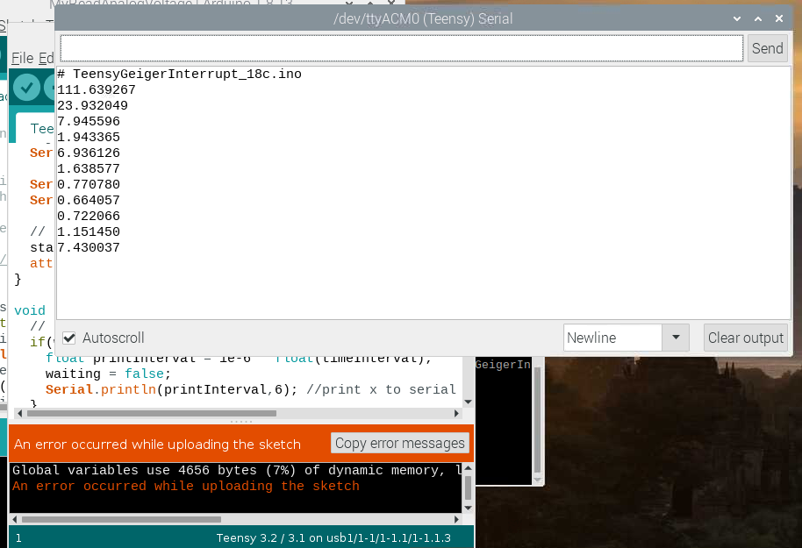
The best data to take with the Teensy is the time between Geiger tube counts. The Teensy has a time resolution of about 1 μs, so since the pulses are 50 ms long, this is good enough resolution for our purposes.
Since we want to know exactly when a count arrives at the Teensy, we will use an Interrupt Service Routine or ISR. When an interrupt occurs on a processor, the processor stops what ever it is doing and calls a special function, the ISR. The ISR does its processing, then the processor picks up where it left off. An ISR should be very short and efficient and should quickly return. An example of the output is shown in the figure.
Here is the design for our Teensy code.
- setup() - Every Teensy program needs this function. It is called once when the Teensy starts up or is reset. This function sets up the Teensy pins, initializes the USB connection to the laptop, sets up the ISR, and prints out other information to the USB.
- loop() - This function is called over and over as long as the Teensy is running. For our program, it should check if a count came in. If it did, the function should print the time between counts on the USB.
- getTime() - This is the ISR. When it is called you know that a count occurred. This function should get the current value of the time, and save it in a global variable.
The ISR should use the function micros() to get the time the pulse comes in. The function micros() is an Arduino function to get the time in microseconds since the Arduino last restarted. The resolution is 1 μs for the Teensy. The ISR calculates the time in μs since the last pulse, then saves that in a variable and returns. This timer rolls over every 2³² microseconds or about 71 minutes, so the software has to figure out when the counter rolls over and correct for the rollover.
Meanwhile the main event loop, loop(), checks if the time variable has changed value. If it has, it converts the time interval to seconds and prints the time interval to the serial output of the Teensy.
The Teensy code is in Appendix I.

The RPi Software
The Teensy program outputs a single column of numbers that are the inter-event times. This is the raw datra we will analyze. You can see the data streaming in the Arduino IDE Serial Monitor. You can cut and paste the data from the Serial Monitor into a data file, or …
You want to capture the data and save it to a file, so you need a Linux program to do that. Like is usually the case, such a program already exists. You can use minicom, a terminal program.

minicom Usage
The program minicom connects a terminal window to a serial device, like a Teensy.
- Install minicom on your RPi by opening a Terminal and typing
sudo apt install minicom
- Answer yes.

Connect with minicom
Quit Arduino IDE.
- Type minicom -D /dev/ttyACM0 in the Terminal (or whatever tty device the above procedure showed the Teensy used.) This command connects minicom to the device after -D. Typical output is
Welcome to minicom 2.7.1
OPTIONS: I18n
Compiled on Aug 13 2017, 15:25:34.
Port /dev/ttyACM0, 15:58:08
Press CTRL-A Z for help on special keys
B01, 0.34
B11, 1.46
B01, 1.06
B10, 1.30
B10, 0.64
B01, 1.58
B10, 0.38
- So mincom immediately connects!
- The magic keystroke you need to control minicom is <ctrl>A . This puts minicom into the command mode.
- To exit type <ctrl>A , then Q , then confirm.
- To get help, type <ctrl>A + Z .
Capturing Output
- You can start minicom in the capture mode by typing, for example,
minicom -D /dev/ttyACM0 -C 2021-02-08-1622.csv
- All of the output from the Teensy will go to the file 2021-02-08-1622.csv . This was the date and time when I used this command.
- Note: You should always enforce a file naming solution that includes a date and time. The format above has the feature that alphabetical order is also chronological order. The dashes make the name more readable.
- A better and even fancier way to start minicom is with
minicom -D /dev/ttyACM0 -C `date +%Y-%m-%d-%H%M`.csv
- This automatically starts storing the output of the Teensy in a file with the current date and time. The funny backticks are a bash shell way of running another command and substituting the output of that command in the middle of the current bash command.
- Try these bash commands to familiarize yourself with the date command:
date
date +%Y
date +%Y-%m-%d-%H%M
a = `date +%Y-%m-%d-%H%M`.csv
echo $a
- What is going on? Type man date and look through the date man pages to try to figure out.
minicom Commands
- To stop minicom, type <Crtl>A then X , then <Return> to confirm quitting.
- To stop and start saving the output to a file (called capturing), type <ctrl>A L . Then enter the capture file name.

Appendix I – Teensy Code
/*
GeigerInterrupt_v18c

This sketch counts the number of microseconds since the last interrupt,
then prints that data to Serial.

*/
static char pgm[] = "TeensyGeigerInterrupt_18b.ino";

const int INTERRUPT_PIN = 2; // Pin Digital 2
static unsigned long HALF_MAX = 2^31; // need to fix rollover

// variable to be updated by the interrupt
volatile unsigned long startMicroseconds = 0;

// time interval to be printed
volatile unsigned long timeInterval;

// flag to signify a pulse came in
volatile bool waiting = false;

void setup() {
// sleep for 3 seconds so user can open serial monitor
delay(3000);
//enable interrupt 0 which uses pin 2
//jump to the increment function on falling edge
Serial.begin(115200); //turn on serial communication

Serial.print("# ");
Serial.println(pgm);

// grab the current microsecond counter
startMicroseconds = micros();
// attach BUTTON 2 interrupt handler
attachInterrupt (INTERRUPT_PIN, saveInterval, FALLING);
}

void loop() {
// if a reading is waiting to be printed
if(waiting){
float printInterval = 1e-6 * float(timeInterval);
waiting = false;
Serial.println(printInterval,6); //print x to serial monitor
}
// Delay 1 microsecond
delayMicroseconds(1); //pretend to be doing something useful
}

// Interrupt service routine. Gets called when a pulse comes in
void saveInterval() {
// Get current time
unsigned long currentTime = micros();
unsigned long currentInterval;
// Check for usec rollover (once every 70 minutes)
if(currentTime < startMicroseconds){
Serial.println("# Rollover");
currentInterval = (currentTime+HALF_MAX) - (startMicroseconds-HALF_MAX);
} else {
// Calculate this current interval since last click
currentInterval = currentTime - startMicroseconds;
}
// Save current time to restart interval
startMicroseconds = currentTime;
// save interval
timeInterval = currentInterval;
waiting = true;

return;
}

