ITC 2017 Documentation –AAO

Elaina A. Hyde

13 March 2017

**Current status of Magellan ITC’s**

Magellan PANIC = retired

[www.lco.cl/telescopes-information/magellan/instruments/panic/panic-online-documentation/ir-exposure-time-calculator](http://www.lco.cl/telescopes-information/magellan/instruments/panic/panic-online-documentation/ir-exposure-time-calculator)

MagIC, IMACS & LDSS

Exposure time calculator for direct imaging

Covers: MagIC-E2V, MagIC-SITe,LDSS3,IMACS f/4, IMACS f/12 Instruments

[www.lco.cl/telescopes-information/irenee-du-pont/website/direct-ccd-manuals/exposure-time-calculator](http://www.lco.cl/telescopes-information/irenee-du-pont/website/direct-ccd-manuals/exposure-time-calculator)

Megacam

Imaging exposure time calculator

Filters u,g,r,i,z

<https://www.cfa.harvard.edu/mmti/megacam/obs-manual/exptime.html>

MIKE

No official calculator but there is a website that has produced a plot using 2” slit in 0.7” seeing that will allow you to mathematically estimate an exposure time. See:

[www.ucolick.org/~rab/MIKE/usersguide.html](http://www.ucolick.org/~rab/MIKE/usersguide.html)

Fire – no calculator

MagAO – has links for VisAO & Clio2 but they are broken

M2FS & PISCO - TBA

FourStar

J,H,Ks,J1,J2,J3,HsH1,1.18 2.09 Filter exposure time calculator

Instrumentation.obs.carnegiescience.edu/FourStar/calc.html

**New Code for ITC**

-tar file received from Francesco Di Mille= magsnc.zip = cgi version of python scripts for developing Magellan ETC

-currently should work with a few options of grisms

-interpolation of the spectra and sky emission modelling are not robust

-there was originally a plan to use observed spectra of the sky but this has not been implemented. There is instead a high resolution spectra taken with the VLT in use.

-requires: Python, numpy, scipy, and webserver

**Basic install of tar file:**

1. Unzip files in your CGI-BIN folder
2. Change shebang in image.py and magellan_etc.py from #! /Library/Frameworks/EPD64.framework/Versions/Current/bin/python to the correct path of the python interpreter on your server. The path is hardcoded because the webserver has to be able to find the right the one.

**Contents:**

data/ image.py, magellan_etc.py, snc_tools.py

Main run file = *magellan_etc.py*

This file is formatted for a web-browser, the internal server will access it to produce the webform.

Calculations = *snc_tools.py*

This file preforms the astronomy calculations used by the ITC.

Transfer information = *image.py*

This file pulls out the information and creates the graphs.

**Setting up the Webserver=TomCat**

Before running configure JAVA_HOME environment, set to base path of JDK or:

./configure --with-java=/usr/java

Script in python can run as cgi script. The python interpreter mod_wsgi goes from a regular apache webserver. The aaolxn apache webserver is wsgi.load and was setup by Simon O’Tool with .ht access.

WSGI application script file=wsgi_app.py

mod_wsgi requires application entry point to be called ‘application’

Environment variable for apache needs to be set as:

/etc/apache2/sites-available

We also require mod_env for the variables that the webserver sends to every CGI program that is run. These are stored in a hash %ENV:

Apache mod_env

#LoadModule env_module modules/mod_env.so

🡪 see .conf file

To access the logfile for apache on aaolxn:

$tail –f /var/log/apache2/error.log

.htaccess

This file must be created and exist in the main directory:

/var/www/html/ehyde/magsnc

Options +ExecCGI

Add Handler cgi-script .py

By default Apache will ignore .htaccess directives. To allow the .htaccess file to be read edit:

/ect/apache2/sites-available/default

in:

<Directory /var/www/>……

AllowOveride None 🡪 AllowOveride All

</Directory>

see also:

/etc/apach2/sites-enabled/000-default.conf

/etc/apache2/apache2.conf

Instructions can be found at:

<https://help.ubuntu.com/community/EnablingUseOFApacheHtaccesFiles>

**Command Line Trouble Shooting**

To execute the magellan_etc.py set:

$ export QUERY_STRING = “”

$ ./magellan_etc.py

to produce the webform on the command line

**Working ITC Location**

Currently we have the ITC running from ‘aaolxn’, the internal only region of the AAO. The web browser output currently lives at:

aaolxn/ehyde/magsnc

Preferences updated for all files as:

chmod a+r magnsnc/

chmod a+x magsnc/

All code has been converted to python3, a common conversion:

sys.stdout.buffer.write (b”Content-Type: image/png\r\n\r\n”)

replaces print statement: print “Content-Type: image/png\n”

the end header “\r\n\r\n” is added to end header and signal that the body is coming.

Currently working settings:

|  |  |  |  |
| --- | --- | --- | --- |
|  | Elliptical galaxy | Sc galaxy | Star A0 |
| Mike-Blue |  |  |  |
| IMACSgrism 300R | X | X | X |
| Mike-Red |  |  |  |
| MAGE |  |  |  |
| IMACSgrism 200 | X | X | X |
| IMACSgrism 300b | X | X | X |

Outputs: Webform requires an input for object, magnitude, disperser, slit, seeing, airmass, sky brightness, band, and exposure time. Provided you choose one of the combinations that are working from the table above the ouput is a plot of counts versus angstroms image produced on website after all form settings are filled in gives counts and sky.

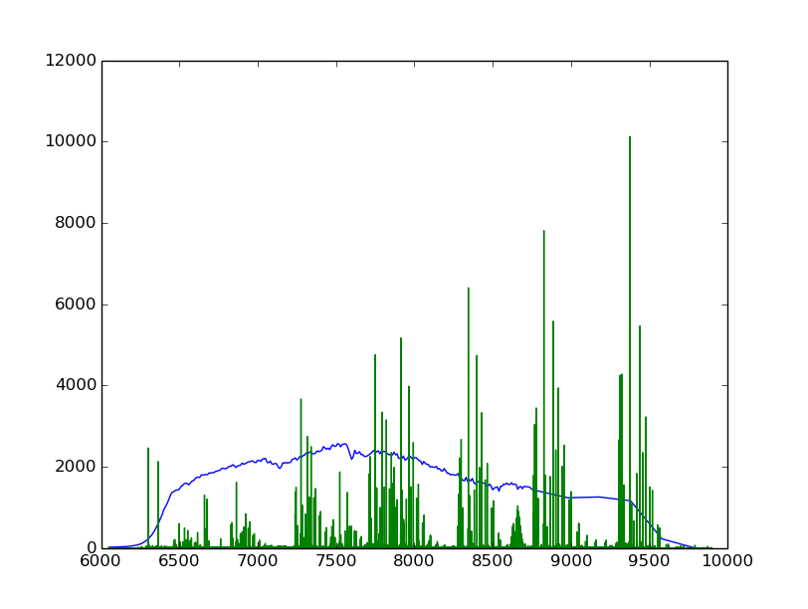

Note on Exptime: The control over counts/Angstrom is given by the exptime but the spectra noise does not vary in this code.

**Future Work:**

There is a version of this code being worked on by Guillermo Blanc with files from Konstantina Boutsia. The webform does not currently work but is hosted at:

[www.lco.cl:443/gblanc/lcoetc/lcoetc_sspec.html](http://www.lco.cl:443/gblanc/lcoetc/lcoetc_sspec.html)

The following new files could be implemented into our ITC.

New zeropoints: zeropoint.zip

🡪 Corrects zeropoints for LDSS, MAGE and MIKE

New Spectrophotometric standards from Konstantina

🡪MIKE, LDSS, MAGE, IMACS