|  |
| --- |
| **Fake Currency Detection** |
|  |
| ***A report submitted in partial fulfilment of the***  ***requirement*** ***for the award of degree of***  ***BACHELORS OF ENGINEERING***  ***in***  ***COMPUTER SCIENCE ENGINEERING*** |
|  |
| ***By*** |
| **Student Names:** Kritika Ruhela **UID:** 23BAI70138  Jyoti 23BAI70615  Shalok Dadhwal 23BAI70607  Ansh23BAI70068  Ishant Singh 23BAI70084  Devanshu Sharma 23BAI70183 |
|  |
| ***under the guidance of***  ***Dr. Harjeevan Singh*** |
| ***Assistant Professor*** |
|  |

**Computer Science Engineering**

**UIE, Chandigarh University**

|  |
| --- |
| **Acknowledgment**  We appreciate that we have such an opportunity to express our great gratitude and respect to the people who helped us during the completion of our B.E. project. Without their support and encouragement, it was not possible for us to complete the project successfully.  It is difficult to overstate my greatest gratitude to my project mentor Dr. Harjeevan Singh and our  honourable HOD mam Dr. Urvashi Garg. Firstly, we would like to thank him for guiding and inspiring us patiently throughout our study period. Secondly, we highly appreciate his encouragement and support in our project work, which helped us build confidence and courage to overcome difficulties. Finally, we are grateful for his great insights and suggestions and for devoting so much time to the completion of the project.  Many thanks go to our other class teachers who have given their full effort in guiding the team in achieving our goal as well as their encouragement for completing the project timely. Our profound thanks go to all our classmates, especially to our friends for spending their time in helping and giving support whenever we needed it in our project.  At last, we would like to thank our family members and God for supporting and motivating us for completing this project.    **Abstract**  **About problem**  **Problems faced by Fake Currency**  The stability of the global economy depends on the smooth and seamless functioning of million activities. And when counterfeit currency enters circulation, the losses incurred can go beyond monetary terms. They can impact a wide range of sectors across the globe, including  Economic Peace: When counterfeit currency enters the economy, it diminishes the value of real money distorting the inflation rates which causes the markets to destabilize and also hampering trade. This will result in eroding the public trust in the financial systems and governing policies of the state.  **About proposed Solution**   * The application will prove very beneficial to detect fake currency. * The application is user friendly and easily accessible. * It will save time, reduce the effort of the user. * Provide cheaper and accurate systems to the user which can be easily accessible and give accurate recognition of currency notes. * It can be applicable to every economy level.   The proposed system can identify the legitimacy of a banknote by checking for specific security features such as watermarks, latent images, security threads, etc. Identification of counterfeit banknotes is done using machine learning techniques. The methodology involves extracting and encoding these security features.  **About Results**  REAL LIFE APPLICATION  While it is still standard practise in daily life to conduct transactions with actual money by handling and counting notes by hand, automated equipment such as ATMs and banknote counters are required for large-scale and secure transactions.  We can also have automated ticket selling machines at metro and railway stations that we may use while travelling. This can be widely applied in those systems, but there is always the risk of fraud because there is no human interaction.  Fake cash is one of the most common forms of fraud. As humans, we can tell the difference between genuine and counterfeit money, but how should a machine do so? As a result, we used PCA to capture the differences between the genuine and false images. |

**Table of Contents**

Acknowledgment i

Abstract ii

List of Figures iv

List of Tables………………………………………………………………………………v

Chapter 1: Introduction

1.1 Introduction 7

1.2 Objectives 8

Chapter 2: Analysis Of Project

2.1 Data Description 9

2.2 Requirement Analysis 9-10

2.3 Features of Currency 10-11

2.4 Required Algorithm 11-12

2.5 Flowchart 12

2.6 Workflow of Proposed System 13

Chapter 3: Results and Discussion

3.1 Results and Discussion results: 14

Chapter 4: Conclusion

4.1 Advantages 15

4.2 Restriction 15

4.3 Future Scope 15

**References** 16

**List of Figures**

Fig 2.1: All security features of Indian currency 2000

Fig 2.2: Security Thread

Fig 2.3: Block Diagram of Fake Currency Detection

**List of Tables**

Table 2.1: Dataset[Accessed 20 November 2023]

Table 2.2: Hardware Requirements

Table 2.3: Software Requirements

**Chapter One**

**Introduction**

**1.1 Introduction**

Money can serve as the driving force behind any economic activity associated with manufacturing, circulation, consumption, etc. Capital information can be used to save money and make investments. Money is essential for everything in today's dynamic culture. There are also other factors that are shrinking the economy as it advances. One of those things is the creation and use of counterfeit currency. Due to the widespread use of counterfeit currency in the economy, the typical person is the group most negatively impacted by this activity. Everyone is afraid of accepting banknotes in the denominations of Rs. 500 and Rs. 1,000 because the bulk of them are nearly hard to distinguish from genuine banknotes, from gas stations to the neighbourhood vegetable seller. The issue of counterfeit money is one that is discussed and debated throughout the world. Banks lost Rs. 16,789 crores in the most recent fiscal year due to frauds. The Reserve Bank reported that "the amount that has been lost on account of frauds in the year 2016–17 was Rs. 16,789 crores," which was in accordance with the fraud monitoring report made by various banks and financial institutions. According to the RBI's (Reserve Bank of India) annual report for 2021–22, there was an increase in the number of counterfeit notes found in the denominations of Rs. 10, Rs. 20, Rs. 200, Rs. 500 (new design), and Rs. 2,000, respectively, of 16.4%, 16.5%, 11.7%, 101.9%, and 54.6%.[51] Inflation is the typical impact of counterfeiting on the economy. The only tool now available to the average person to identify fake money is the Fake Note Detection Machine. The majority of the time, this machine is only found in banks, which are not always accessible to the regular person. In order to prove the viability of suggested solutions to a particular problem, a lot of experimental work is required in the field of digital image processing.

It includes operations whose inputs and outputs are images and operations that extract properties from photos, including the identification of specific objects. The watermark on fake currency is created using opaque ink, white solution, and stamping with a dye that has a picture of Mahatma Gandhi engraved on it. Visitors are the most susceptible to phony currency because they lack the knowledge necessary to distinguish between fake and genuine currency notes. These people will benefit from automatic currency identification using image processing techniques. Also, it can be helpful in other workplaces. The devised system to verify the 2000-rupee Indian currency notes. It will organize the predetermined arrangement of information and pre-process the digital images before differentiating in monetary forms. The approach for detecting Indian currencies suggested in this article is practical and affordable. The user can determine whether the cash note is authentic or phony at the conclusion of the process.

**1.2 Objectives**

1. To examine the various security components of Indian currency notes.

2. Using a scanner or camera to gather paper money.

3. To extract characteristics from the captured image by cropping and segmenting it.

4. Creating a feature localization algorithm.

5. Designing an extraction and recognition of features.

6. To determine the right money denomination.

7. To distinguish between authentic and fake money notes

**Chapter Two**

**Analysis Of Project**

**2.1 Data Description:**

The banknote-authentication dataset is used to distinguish between genuine and counterfeit banknotes. Images of real and fake banknote-like specimens were used to extract data from the photos. These photos were processed and number of lines on a thin strip are measured. A compressed version of the dataset from Kaggle was used in this experiment. There are 100 samples total. The model has been trained using 2000-rupee notes of cash from India.

To determine the dataset's input/output behaviour for the system, an experiment was run. The sample dataset utilized in the experiment is named and provided below:

|  |  |  |  |
| --- | --- | --- | --- |
| Dataset | Source | Items | Type |
| Indian Currency notes of 2000-rupee | Kaggle | 50 | Image database |

Table 2.1: Dataset[Accessed 05 February 2023]

**2.2 Requirement Analysis:**

The implementation requirement details are given in this section. Requirement Analysis method is intended in such a way that it takes fewer resources to figure out work correctly. The minimum needs that we’d like to take care of: The system would require a minimum of 4 GB (Gigabyte) of RAM (Random Access memory) to run all the options sleek and unforeseen. It wants a minimum of 2 GHz (Gigahertz) processor to run the system smoothly. The system can be operated by common people as well as commercial people.

**Hardware Specification:**

|  |  |
| --- | --- |
| Processor | 2GHz Intel |
| Storage | 512GB |
| RAM | 4GB |

Table 2.2: Hardware Requirements

**Software Specifications:**

|  |  |
| --- | --- |
| Operating System | Windows 7,8,10,11 |
| Programming Language | Python |
| IDE(Integrated Development Environment) | Google Collab |

Table 2.3: Software Requirements

**Python:**

Python is an interpreter, object-oriented, high-level, dynamically semantic programming language. It is particularly desirable for Rapid Application Development as well as for usage as a scripting or glue language to tie existing components together due to its high-level built-in data structures, dynamic typing, and dynamic binding. Python's straightforward syntax prioritizes readability and makes it simple to learn, which lowers the cost of program maintenance. Python's support for modules and packages promotes the modularity and reuse of code in programs. On all popular platforms, the Python interpreter and the comprehensive standard library are freely distributable and available in source or binary form. [41]

**Python Libraries:**

**OpenCV:**

OpenCV is a sizable open-source library for image processing, machine learning, and computer vision. It now plays a significant part in real-time operation, which is crucial in modern systems. With it, one may analyze pictures and movies to find faces, objects, and even human handwriting. To install OpenCV run the command - pip install opencv-python. Python is able to handle the OpenCV array structure for analysis when it is integrated with different libraries, such 23 as NumPy. We use vector space and apply mathematical operations to these features to identify visual patterns and their various features. [42]

**NumPy:**

Many mathematical operations can be carried out on arrays with NumPy. It provides a vast library of high-level mathematical functions that work on these arrays and matrices, as well as strong data structures that ensure efficient calculations with arrays and matrices. To install NumPy run the command - pip install numpy. [43]

**Google Collaboratory:**

Collaboratory, or “Collab” for short, is a product from Google Research. Colab allows anybody to write and execute arbitrary python code through the browser, and is especially well suited to machine learning, data analysis and education. More technically, Colab is a hosted Jupyter notebook service that requires no setup to use, while providing access free of charge to computing resources including GPUs.

**2.3 Features of Currency**

ll features of Indian currency 2000 showing in fig

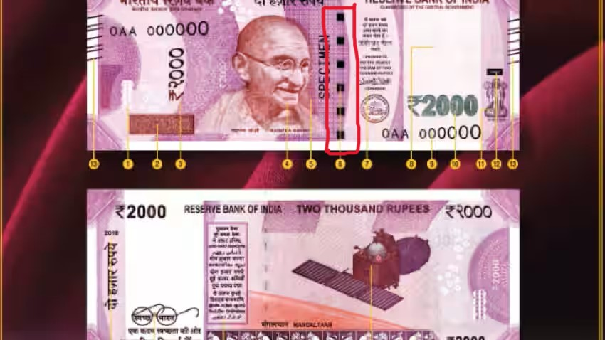

Fig 2.1: All security features of Indian currency 2000[3]

**Security Thread:**

When held up to the light, the security thread, which has "RBI" and "Bharat" inscribed on it continually, can be seen at the left side of the watermark. The photo of the Mahatma has a security thread on one side.



Fig 2.2: Security Thread[1]

**2.4 Required Algorithm:**

**Image acquisition:**

The act of obtaining an image from sources is known as image acquisition. Hardware systems like cameras, encoders, sensors, etc. can be used to do this. It is without a doubt the most important phase in the MV (Machine Version) workflow because a bad image would make the workflow ineffective as a whole. As machine vision systems don't study the acquired digital image of the object and not the object itself, acquiring an image with the proper clarity and contrast is crucial. A set of photo-sensitive sensors turn an object's incoming light wave into an electrical signal during the image acquisition step. These little components provide the function of accurately describing the object to your machine vision algorithms. It's a frequent fallacy that with an MV system, choosing the correct colors is crucial. However it's not always the case. Colors frequently increase noise and make detection more challenging. The main objective of an image acquisition system is to increase contrast for the important features. The ideal image is one in which the camera can clearly see the object of interest. [45]

**Image Segmentation:**

Image segmentation is a technique for breaking up a digital image into smaller groupings called image segments, which reduces the complexity of the image and makes each segment more easily processed or analyzed. Technically, segmentation is the process of giving labels to pixels in an image in order to distinguish between objects, persons, or other significant aspects. Object detection is a frequent use of image segmentation. It is usual practice to first apply an image segmentation method to discover things of interest in the image before processing the complete image. The object detector can then work with a bounding box that the segmentation algorithm has previously established. By stopping the detector from processing the entire image, accuracy is increased and inference time is decreased. A crucial component of computer vision technologies and algorithms is image segmentation. It is employed in a variety of real-world contexts, including as face identification and recognition in video surveillance, medical image analysis, computer vision for autonomous cars, and satellite image analysis.[48]

**Feature Measurement:**

The process of "feature detection" involves computing abstractions of image data and locally determining whether or not each image point contains an image feature of a specific type. A fundamental aspect of image processing is feature detection. This means that it is typically done as the initial operation on an image and checks each pixel to see if a feature is present there. If this is a component of a bigger algorithm, the algorithm will usually just look at the image where the features are. The term "feature description" refers to a technique for describing the local attributes of an image at identified key points in an image. These algorithms take advantage of key points discovered in the image data to extract interesting information. The information produced by these feature description techniques is frequently organized by encoding it as the constituent parts of a single vector, or feature vector. A feature space is the collection of all feasible feature vectors. [49]

**Finding Correlation:**

For finding Correlation of two images we have to follow this steps:

1. Load two images and extract their pixel-by-pixel information

2. Normalize and down sample the pixel information

3. Calculate cross-correlation using the processed pixel information

4. Generate visual summaries of cross-correlation, highlighting areas of maximum image overlap. [50]

**2.5 Flowchart:**

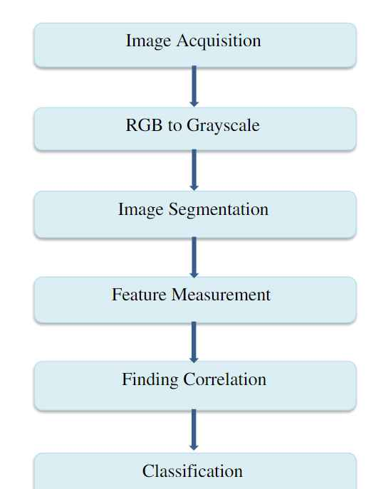

Fig 2.3: Block Diagram of Fake Currency Detection

**2.6 Workflow of Proposed System:**

**1. Image Acquisition:** The model receives the image. Images should be present: the note you're trying to identify and its real-world counterpart. Picture capture of an Indian banknote with a basic digital camera or scanner.

**2. RGB to GRAYSCALE:** Acquired picture is A GRAYSCALE image is created by converting an RGB image. The RGB image is dense and noisier. Instead of processing three components R (Red), G (Green), and B, the image is reduced in size and gains easy-to-process intensity information when it is converted to gray scale (Blue).

**3. Segmentation:** Gandhi Ji's image and a narrow strip image are cropped from the original image. The observe and reverse aspects of the Indian paper currency will be clipped and split. The technique of segmenting an image into separate segments and sets of pixels is done digitally. It is also known as "picture thresholding," where a threshold is set and, if a specific pixel's value exceeds it, the pixel turns white; otherwise, it turns black.

**4. Feature Measurement:** Feature measurement is done to measure the number of lines on a thin strip. This is a really lengthy process.

**5. Finding Correlation:** We find correlation between Gandhi Ji’s image on the real note & fake note using distance-weighted algorithm. If the outcome is greater than 0.5 then we will consider it legitimate otherwise the currency is fake.

**6. Classification:** Finally, we will classify the image as real or fake.

**Chapter Three**

**Results and Discussion**

**3.1 Results and Discussion Results:**

There are other ways to detect if the money is phony or not, but they all follow the same basic stages. Image capture, edge recognition, segmentation, grayscale conversion, and feature extraction are among them. Most of the articles use MATLAB as their computation tool, however we ultimately used OpenCV and Python as our programming language. To perform comparisons and determine the outcome, a number of characteristics that identify genuine currency apart from counterfeit ones are taken into account.

We are aware that these tools are used at banks and businesses to help identify counterfeit money, but the average person who lacks these resources is susceptible to this. Our goal is to offer a low-cost system with quick computations that can make decisions in a matter of seconds. The entire process ought to function for Indian denomination 2000. It would be simple for the general public to use, relatively portable, and reasonably priced. The model has some limitations. We can get at most 81% of accuracy which may be sufficient. However, it is still more precise than human detection. It can currently be utilized as an additional tool to lessen human mistake. Additionally, the model's accuracy can be increased any further with more data and better analysis.

Accuracy: The percentage of accurately classified data samples over all the data is known as accuracy. Accuracy can be calculated by the following equation. [52]

Accuracy = (TP+TN)/(TP+FP+TN+FN)

**Chapter Four**

**Conclusion**

**4.1 Advantages**

* The application will be very helpful in identifying counterfeit money.
* The software is simple to use and accessible.
* It will lessen the user's effort and save time.
* It provides the user methods that are more affordable, accurate, and give accurate recognition of money notes.

**4.2 Restriction:**

* This project cannot be able to detect the currencies whether it is fake or not, of other countries except India.
* This project is only able to detect the currencies whether it is fake or not with denomination 2000 of Indian rupees.

**4.3 Future Scope**:

* This project cannot be able to detect the currencies of other countries except India. So in the future we can make this project possible to detect the currencies of other countries also.
* This project is only able to detect the currencies whether it is fake or not with denomination 2000 of Indian rupees. So in the future we can make it possible that it will detect the currencies with all denomination.
* In this project, we worked using a few features of the currencies. So in the future we can be able to work with all features of currencies to increase the accuracy of the project.

**References**

* [1] S. R. Darade and G. Gidveer, “Automatic recognition of fake indian currency note,” in 2016 international conference on Electrical Power and Energy Systems (ICEPES). IEEE, 2016, pp. 290–294.
* [2] B. P. Yadav, C. Patil, R. Karhe, and P. Patil, “An automatic recognition of fake indian paper currency note using matlab,” Int. J. Eng. Sci. Innov. Technol, vol. 3, pp. 560–566, 2014.
* [3] A. Zarin and J. Uddin, “A hybrid fake banknote detection model using ocr, face recognition and hough features,” in 2019 Cybersecurity and Cyberforensics Conference (CCC). IEEE, 2019, pp. 91–95.
* [4] M. S. Veling, M. J. P. Sawal, M. S. A. Bandekar, M. T. C. Patil, and M. A. L. Sawant, “Fake indian currency recognition system by using matlab.”
* [5] F. A. B, P. Mangayarkarasi, Akhilendu, A. A. S, and M. K, “Fake Indian currency note recognition,” vol. 7, pp. 4766–4770, 2020. [Online]. Available: https://www.irjet.net/archives/V7/i5/IRJET-V7I5915.pdf