For the purpose of comparing our Polarisation Rotated with Phase Conjugate Feedback and Noise (PRPCFN) system with the Polarisation Rotated Optical Feedback with Noise (PROFN) system, we consider and investigate the dynamics of these two systems using parameters used by Chi-Hak in his ﻿*Sustained Oscillations Accompanying Polarization Switching in Laser Dynamics* paper. This is where,

Now comparing our two systems, we find that the two systems share the same kind of dynamics, however we discover new dynamics in our PRPCFN system that are not present in the PROFN system. Particularly, when we have asymmetric square-waves, the high-frequency oscillations present on the vertical polarisation becomes more pronounces and quickly dominate the square-wave oscillations.

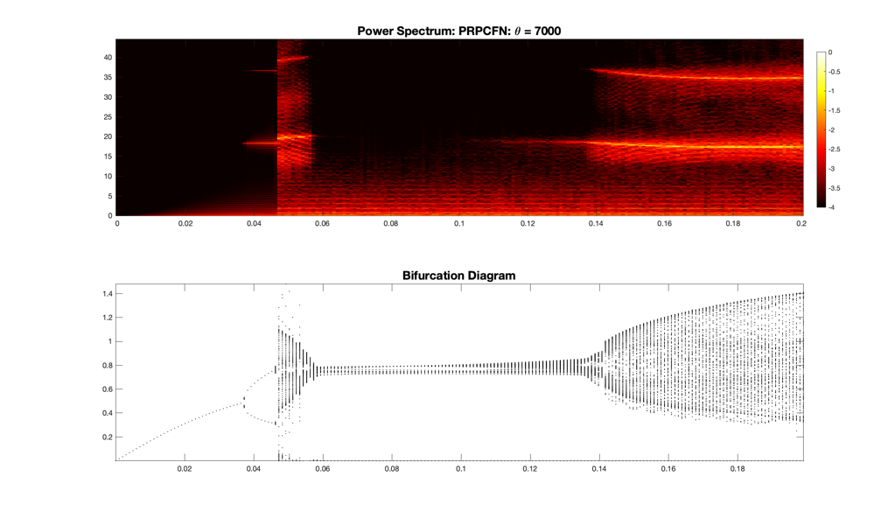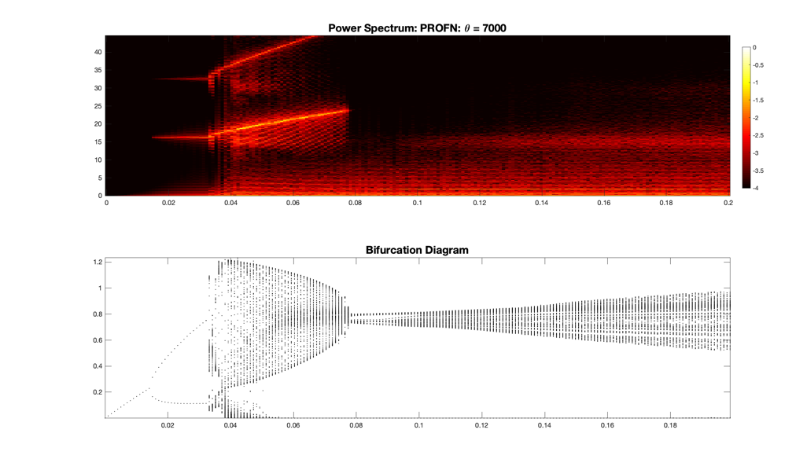

**Figure 1** (left) and **Figure 2** (right) show the bifurcation structure and the power spectrum for the PROFN and PRPCFN systems, respectively.

We report that the two systems share similar dynamics. Both systems bifurcate from a steady state solution into oscillating solutions with frequency equal to the relaxation oscillation frequency (, RO), before transitioning to square-wave solutions.

The PROFN system’s solution transitions from oscillations at the RO, to anti-phase square-waves with oscillations at RO, where the frequency of the oscillations increase with the feedback parameter (), to the point where . Beyond, as the feedback parameter increases, the amplitude of oscillations on the asymmetric transient state starts to increase.

Alternatively, with the PRPCFN system, the system transitions from oscillatory solutions (at ) to square-waves with fast oscillating transient states, that with the increasing feedback parameter stabilises to quasi-steady square-waves. As the feedback parameter continues to increase, the amplitude of fast oscillations on the vertical polarisation square-waves increase, and the frequency of these fast oscillations () decrease and approach the relaxation oscillation frequency (, see figures below – and note the behaviour of the time traces as increases).

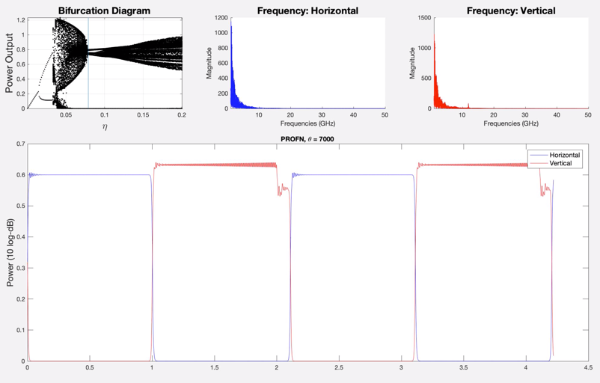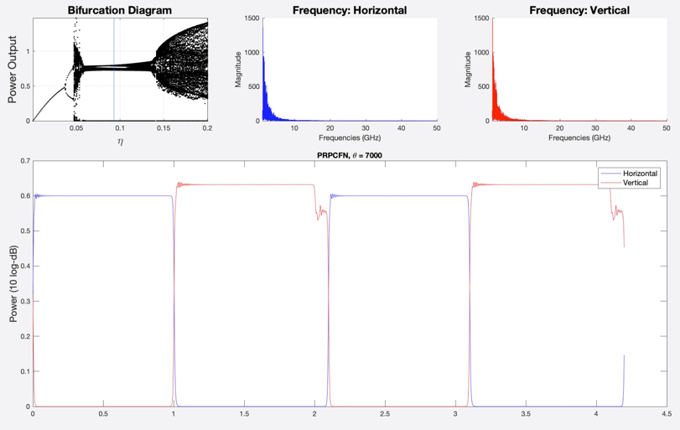

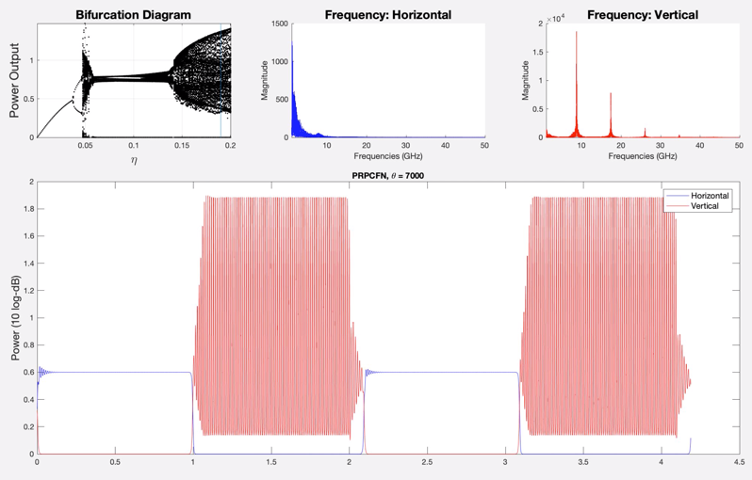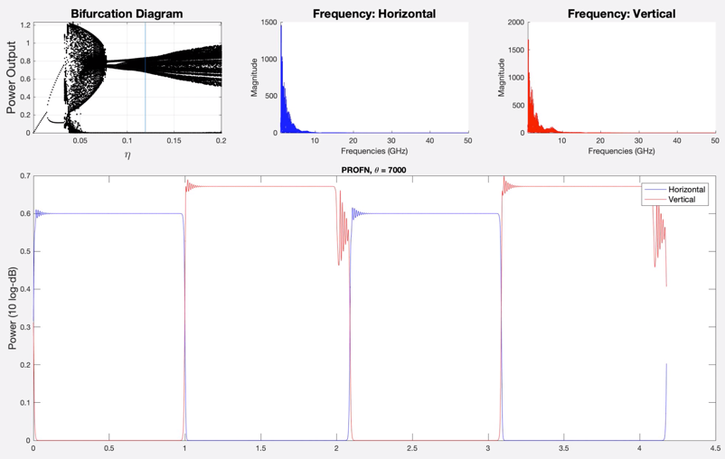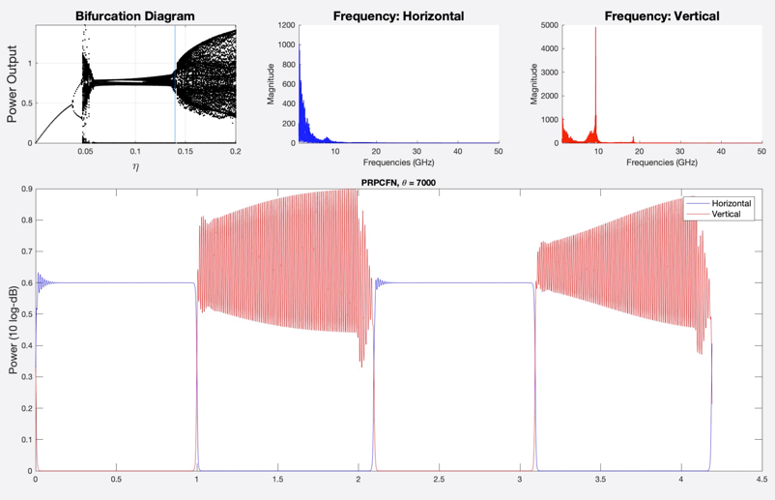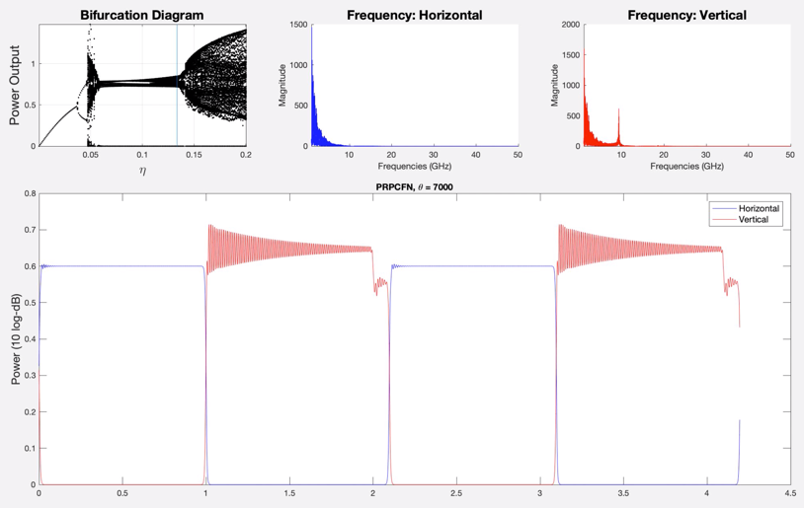

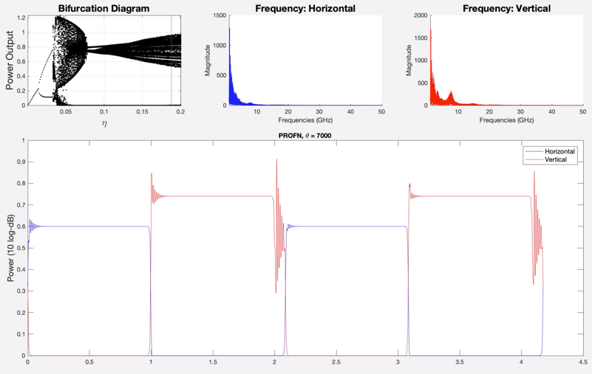

Asymmetric transient state

Figure 3: Comparing the time trace solutions of the PROFN system (left-hand side) to the PRPCFN system (right-hand side) for later values of feedback parameter (). Notice the new dynamics.