**High Frequency Nonlinear Dynamics and Optical Chaos from a Laser Diode with Optical Feedback**

Neco Kriel

Queensland University of Technology, Brisbane, Australia

1. **Introduction**

Semiconductor lasers (SLs) are a subset of laser diodes that have been extensively studies since the first demonstration of laser oscillations in 1960. Particularly, SLs are laser diodes that are electrically pumped in order to achieve population inversion so that through stimulated emission we may maintain amplification. Attention has been particularly drawn to SLs for their ability to provide insight into nonlinear and chaotic dynamics, and further promising technology with applications in image sensing, fibre optic communication, and spectroscopy. These applications in particular prove to have viable potential for vastly improving communication capabilities and security, and therefore the development and understanding of this technology is extremely useful.

While the application of optical fibre is mostly hidden, due to their attractive characteristics their use and implementation are vast and rapidly growing. More broadly, laser diodes, almost uniquely, possess the property of being extremely perceptible to optical perturbations, which leads to the ability to achieve quite high modulation of the laser. In combination with optical fibre, it is possible to direct and guide the laser light produced from SL laser diodes, resulting in superior methods for telecommunication compared with standard methods. Optical fibre in combination with laser diodes provide advantages in long distance communication, especially because of their ability to achieve low losses of information over long distances and having a high insensitivity to perturbations caused by external sources. Due to the impulse of interest and development of this technology, a growing global implementation of optical fibre has led to most forms of networks transitioning to the superior communication method, specifically residential networks through the ‘*Fibre To The Home’* initiative.

It is possible to observe that by coupling a laser to optical fibre, the laser diode may be led to dynamical regimes where the light is completely unstable. Depending on the intensity of the laser, it may be possible to observe periodic oscillations with many frequencies or even chaotic solutions. It is understood that these behaviours are driven by a phenomenon termed optical feedback, due to the reflectivity of the surface which the laser is connected to. While the chaos may appear random, it is understood through chaos theory that this behaviour is indeed deterministic, and that a when a system has enough dimensions, it may have the potential to bifurcate into complex dynamics, such as chaotic solutions.

1. ***Semiconductor Laser Principle Dynamics***

Light Amplification by Stimulated Emission of Radiation (LASER) is the phenomenon where coherent light is driven by stimulated emission in an active medium. The optical transitions that take place and the energies of electrons in the medium are closely related. The state with the lowest energy is most stable, and therefore electrons in a SL tend to stay in the state with the lowest energy. Electrons transition from low to high energy states when excited, before spontaneously relaxing to a lower state within a certain lifetime, emitting a photon in the process. These emissions of photons can be induced via pumping either an optical light source or bias current. Specifically, through stimulated emission, the photons emitted have the same wavelength, phase, and propagation direction as the input photon. It follows that the laser light produced is highly monochromatic, bright, coherent, and directional.

Semiconductor Lasers act as a feedback-loop system that consist of an active material an optical resonator. The active layers generate spontaneous emission, and the resonator confines the photons produced, progressively amplifying the photon’s population through stimulated emission. Once the rate of photons produced in the cavity exceeds the rate of photons absorbed, the laser reaches its threshold, and emits a coherent beam of light.

* 1. **Absorption: $E_{1}→ E_{2}$**
* An electron is in the ground state
  + A photon hits the atom and is absorbed
  + Its energy results in the electron becoming excited and jumping to the excited state
  1. **Spontaneous Emission: $E_{2}→ E_{1}$**
* An electron is in the excited state and spontaneously relaxes and jumps to the ground state
  + Emits a photon of energy with random direction and phase
  1. **Stimulated Emission: $E_{2}→ E_{1}$**
* An electron is in the excited state
  + A photon hits the atom, however is not absorbed
  + The electron relaxes to the ground state, releasing its energy in the form of a second photon with the same phase and direction as the first

1. **Lang-Kobayashi Equations**

In 1980, Lang and Kobayashi proposed equations to describe the behaviour of lasers with delayed feedback, modelling semiconductor lasers with external optical feedback. Their infamously simple, yet realistic Lang-Kobayashi (LK) model describes a semiconductor laser’s electric field and excited carrier density in the active medium with deterministic rate equations.

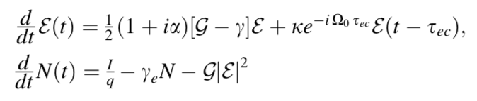

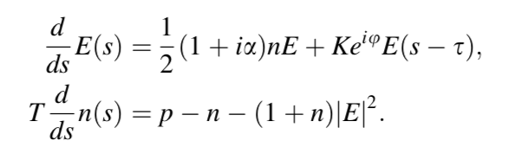It is convenient to reduce the model into a dimensionless form, which is better suited for numerical analysis. The non-dimensionalization process reduces the number of parameters in the model, and typically the dimensionless parameters’ magnitudes are smaller too.

$T$ is the time scale parameter, $\tau$ is the time delay, $\mu$ is the gain saturation, $\kappa$ is the feedback rate, $\rho$ is the pump parameter, $\alpha$ is the linewidth enhancement factor, $\phi$ is the feedback phase. Note that the pump parameter has been shifted so that when it is zero, it corresponds to the laser threshold.

It is important to note, that while the LK model is defined by deterministic rate equations, SLs demonstrate quite a few dynamical effects that are driven by stochastic forces. In particular, there are two natural sources of noise in laser devises. The first of these sources is the fluctuations in inversion caused by the discreteness of photons’ and electrons’ charge, and the second is the fluctuation in the complex amplitude caused by spontaneous emission of photons. Since “shot noise” is usually not an important dynamical behaviour, it is not considered, however, the spontaneous emission of photons is modelled by a complex Gaussian white noise included as a term in the LK model.

One of the main features of the LK model is that it explicitly considers the delayed complex electric field that feeds back into the laser after a round trip in the external cavity after a period $\tau$. This delay creates a system with the possibility of very complicated behaviour, particularly, a system that is capable of sustaining chaotic regimes.

By modifying the LK model, it’s possible to define new systems considering different experimental setups. Investigating these systems are of particular value, as researchers have been actively tasked with attempting to theoretically (numerically) explore and analyse new experimental results. In the following section we consider many of these systems.

1. **Modified Lang-Kobayashi Equations**

**4.1. PROF System**

**4.2. PCF System**

* 1. **PRPCFUF System**
  2. **PRPCF System**

1. **Chaos**