Cell Inform vs Mask overlay Intensity Calculation

Benjamin Green – 04/18/2019

The first thing I tried was to make sure that the mean values corresponded correctly to the total values/area values, these are the image files called “Inform Evaluation”.

MSE = 1/n * sum(y-x)

And the slope corresponds to a linear fit

Y = mx +b

Second I checked that the mean value in inform corresponded to the intensity under the mask/ sum of pixels in the mask and plotted the results as “Inform vs. Mask”

Y = Inform Mean value

X = intensity under the mask/ sum of pixels in the mask

C:\Users\bgreen42\AppData\Local\Microsoft\Windows\INetCache\Content.Word\Mean EntireCell InForm vs. Mask Evaluation of Image 1.tif

There was some jitter in the data so that not all values were exact. I assumed this was due to rounding error. I rounded the values off at 3 decimal places and redid the calculations, shown below as “Entire Cell Inform vs. Mask Evaluation of Image 1_2”.

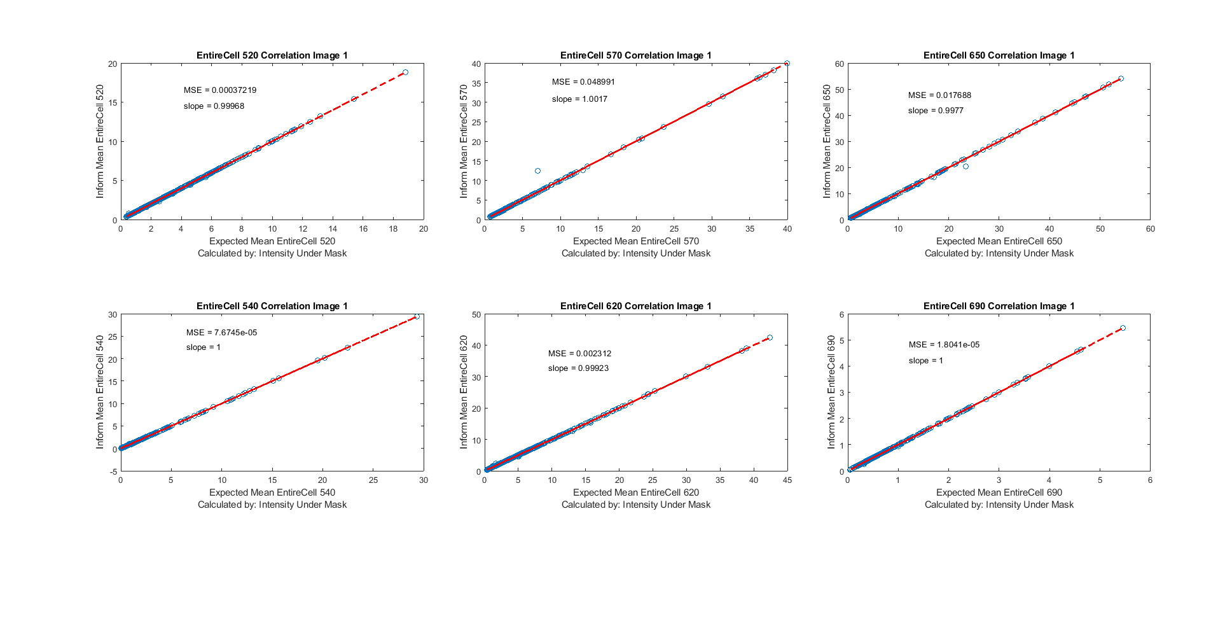

This reduced the MSE to 0 for all measurements except Entire Cell. Some of the data points were significantly different (circled above). Next, I found the cells with a difference in Y-X > 1 and displayed that in the tiff “cellmorethan1”. There was only one cell of this type which was the outlier in both 570 and 650 circled in the result above. I found that this cell and most other cells with this large of a difference were cells I had to close to calculate the intensity inside that cell (which was only done for EC).

C:\Users\bgreen42\AppData\Local\Microsoft\Windows\INetCache\Content.Word\cellmorethan1.tif

In order to get a more accurate measurement, I added the values for the cytoplasm, membrane, and nucleus to get “Entire Cell Inform vs. Mask Evaluation of Image 1_3”.

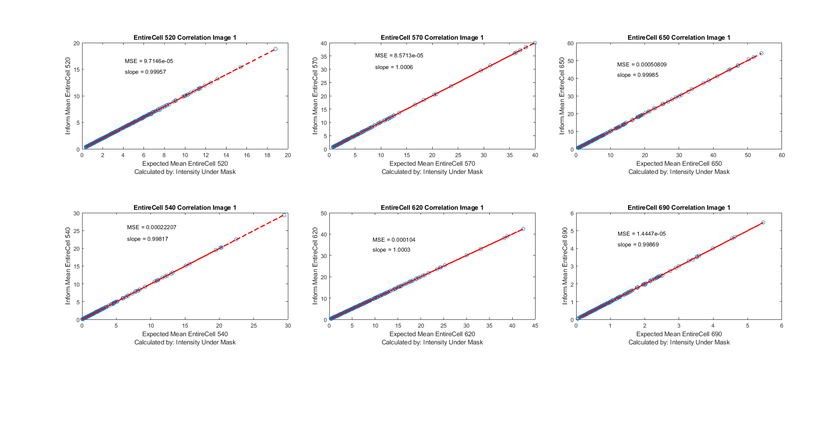

In these graphs there was a significant reduction in most MSE measurements and slight improvement in the slope (closer to 1). However, there was still some difference in values which I cannot account for. So I found all the edge cases and removed them (“cellonedge”). Then I displayed the same correlation, there was a reduction in the MSE to ~0. (“Entire Cell Inform vs. Mask Evaluation of Image 1_4”).

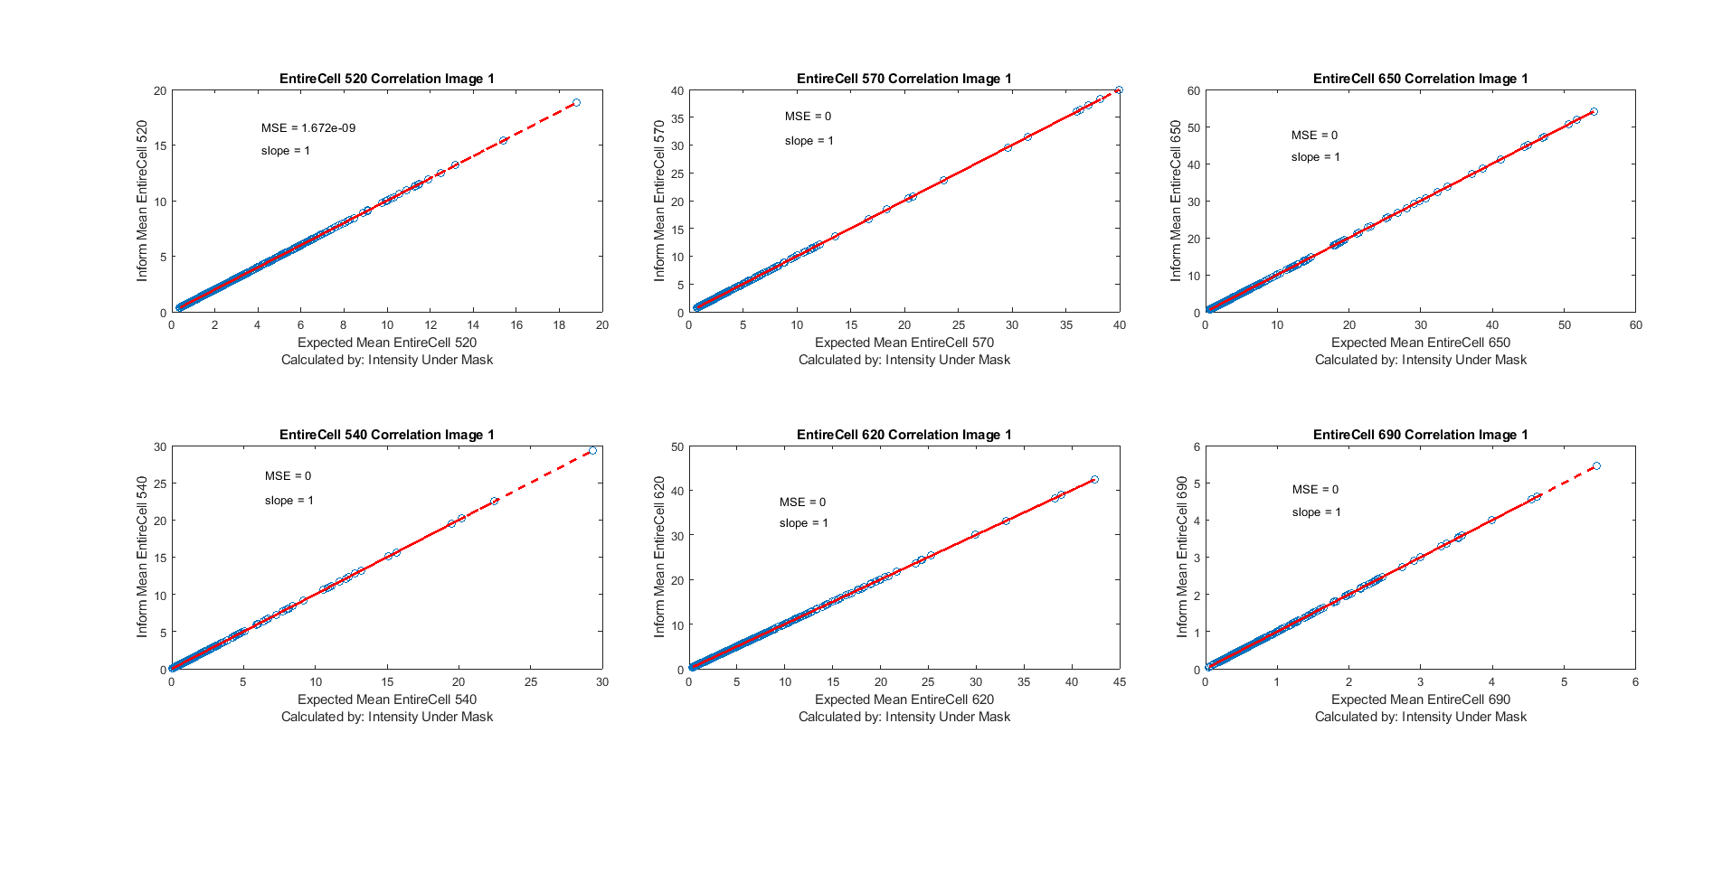

In summary, I am still unsure how inForm calculates values for edge cases. However, since this data should be in the 20% overlap I am not sure if these slight differences in intensity values on the edge will make a difference for us.