**Segmentation Tool**

Created by: Benjamin Green - 03/24/2020 (Last Edit: 05/15/20)

Section 1 - Background:

Robust cell segmentation in mIF imagery is vital for assessing the performance of different biomarkers in the TME. However, commonly available software for segmentation is both inefficient and inaccurate. We aim to develop new algorithms for cell segmentation, either through machine learning or neural network methods. In order to train a neural network and assess the accuracy of any new approach to segmentation we will need a large dataset of ‘ground truth’ annotated cell objects. The manual annotation of every cell in hundreds of images required for a comprehensive ‘ground truth’ dataset is an exhaustive and time consuming process.

Here we present a tool to aid in the development of such a ‘ground truth’ dataset for mIF images to hopefully alleviate some of these travails. The tool compares cells identified in Seyoun Park’s super pixel cell segmentation to those identified by the so-called ‘multi-pass’ inForm cell segmentation. (We use SP and IF respectively to denote the two algorithms throughout). The tool displays matching cell pairs, determined by per pixel overlap, back to the user one at a time in a user interface (UI). The user is prompted to select which version performed more correctly, along with a number of other different options described herein. This document begins with a description on the workflow steps take in the UI, then designates the necessary directory structure of the image outputs, provides a step-by-step instruction for using the tool, and finally defines the comparison output files.

Section 2 - Workflow:

This section will be used to described the computational steps taken by the tool for preprocessing as well as a full description of all buttons and their functionality. Details on inner workings for obscure steps are included in this section. For simple step-by-step directions see Section 4 on usage, also be sure to review Section 3 on folder structure.

To begin the user opens the UI, shown below to provide context for the rest of this section.

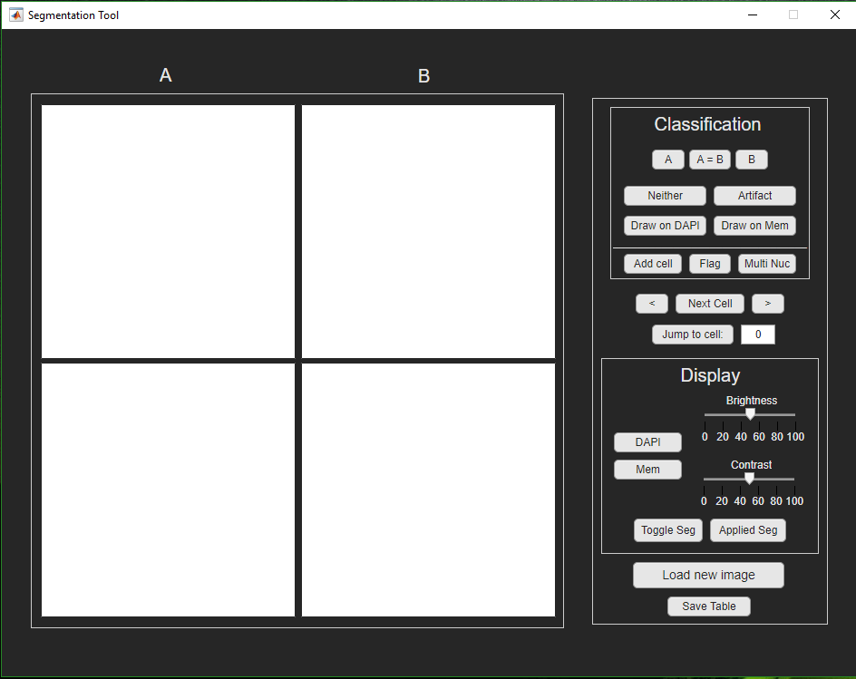

Figure 1: User interface when is it first opened.

After the tool is open, the user will select the ‘Load new image’ button. Next, the user will navigate to either the ‘superpixel’ or the ‘inForm’ segmentation output images. The tool will read the specified image, then search for and load the corresponding image from the alternative approach. For the software to find the appropriate files, the images should be laid out in the file structure detailed in Section 4. If the software cannot find the appropriate files it will send back an error message to the user, stating the attempted path which failed.

After the tool appropriately finds and reads the image files, the tool will search for a preexisting comparison result image file and csv, detailed in section 5 below. If these files do not exist, it will compute the overlapping pairs, as indicated in Figure 2 below, and save an initial copy of the comparison image\ csv file.

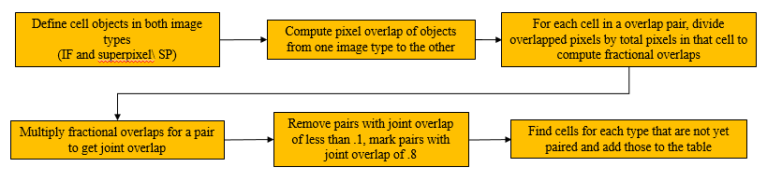

Figure 2: Workflow for defining the cell object overlapping pairs between the two image types IF & SP.

After the computation of overlaps, the tool displays the overlapped cells one pair at a time. An example is shown in Figure 3 and described by the caption.

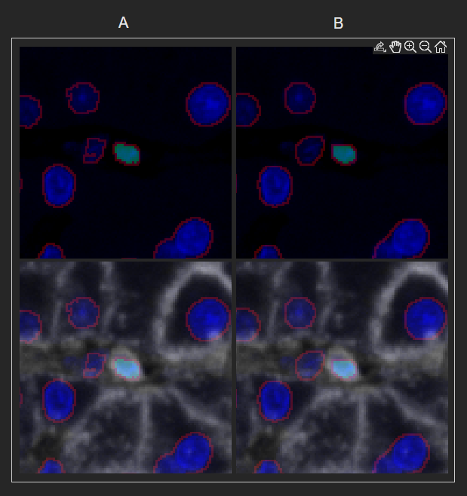

Figure 3. Display of the cell pair. The code randomly displays the cell object from one of the two algorithms on the left, as A, and the cell object from the other segmentation algorithm on the right, as B. The cell segmentation for all cell objects in the respective algorithms are outlined in red, the cell of interest has a green mask over it. The masks can be toggled on and off in the UI, described below. On the top two images, only the DAPI is displayed. On the bottom two images both the DAPI and the membrane stain layers are shown. The display settings can also be altered.

The visual display of the UI can be modified by the display options on the right of the UI, shown in figure 4 and with options described in the corresponding caption.

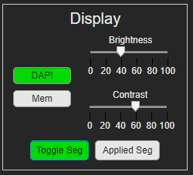

Figure 4: Display options for the UI. The brightness and contrast of the DAPI or Membrane layers can be changed, but not both at the same time. Changing the DAPI values changes in the DAPI in all images. The segmentation can also be toggled on and off. The ‘Toggle Seg’ button toggles on and off the segmentation of the respective algorithm for A or B. The ‘Applied Seg’ button toggles on and off the cell segmentation applied up to that point so that the user can see how things are progressing. This is updated in real time as the user selects options defined below. Only one segmentation mask can be applied at a time.

The user selects the best case segmentation for each cell; if neither cell is acceptable, the user can draw their own segmentation before moving to the next cell. There are also options for the user to select both segmentation were correct, neither segmentation was correct or specify that the object identified was an artifact of the tissue. These options are shown the panel to the right of the UI and in Figure 5 below.

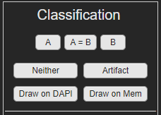

Figure 5. Classification Options for the user. The user can specify if A was correct, B was correct, A=B or both are correct, Neither option was correct, there was an artifact in the tissue and this cell should not be included. The user can also draw a segmentation on the DAPI only image (Draw on DAPI) or on the DAPI and membrane image (Draw on Mem). One and only one of these options can be selected.

The user may also specify a ‘Flag’ variable; so that when the images are passed on, cell pairs can be reviewed for a given case. In addition, the cell pair can receive a ‘Multi Nuc’ flag, meaning that objects are part of a multi nucleated cell. The user will also have the option to add cells to the image, these cells are added to the end of the output table and the objects written into an output label matrix TIFF file. Often this is useful when a cell is over segmented in both segmentation approaches, or both approaches completely miss an object. These options are displayed in a subsection of the ‘Classification’ section.



Figure 6: The Add cell, Flag, and Multi Nuc options for the cell pair. All or none of these options may be used for a given cell pair.

When the ‘Add cell’ option is selected, the main window is grayed out and a new window appears. If it is the first time the user has selected ‘Add cell’ helpful hints are shown to aid in the drawing process. The hints dialog and UI after the hints dialog is close is shown below.

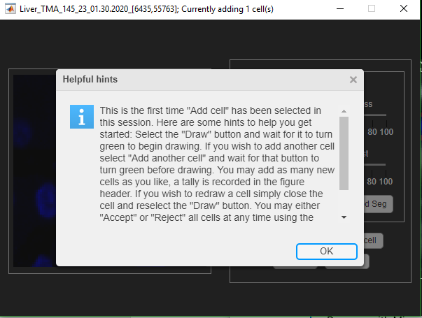 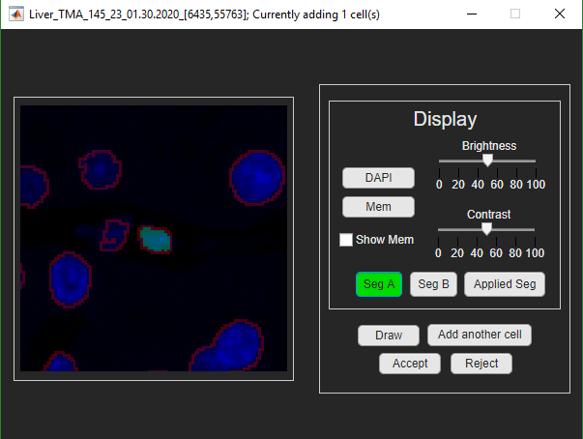

Figure 7: The 'Add cell' window . The dialog on the left appears the user first time the user selects the 'Add cell' button in a given session. The Window on the left shows the UI, which is very similar to the main window. The ‘Seg A’ and ‘Seg B’ allow the user to see segmentations of either algorithm. The ‘Draw’ button must be selected to draw. The ‘Add another cell’ allows the user to add cells. The number of cells are tracked in the title of the UI window. The user my either ‘Accept’ the segmentation or ‘Reject’ the segmentation. A confirmation dialog opens in either case. The user has two options when ‘rejecting’, either to reject only the last cell drawn and return or reject all drawn cells and return. To redraw, the user must simply close their current drawn object with a right click and click ‘Draw’ again. Upon clicking the red ‘X’ the UI closes and all drawn cells are rejected.

To move on to the next cell pair the user has 4 options. Move one cell to the left or right, to jump to the next cell pair for review, or to jump a specified cell. The jump to next cell for review is especially useful when moving around between already reviewed cells, when a user is finished they select this button and are immediately ready to review the next ‘un reviewed’ cell pair. This is the advised method to move on to the next cell for review.

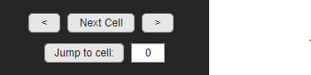

Figure 8: The options to move onto the next cell pair. Go one cell up or down one cell pair in the cell pair count '<', '>', go to the next cell pair that has not yet been reviewed, jump to a specified cell pair.

When the user finishes reviewing all cell pairs in the image. A dialog will open telling the user that they are finished and that they will now review the whole image. After the user selects ‘OK’, the user will begin to look over the whole image with the applied segmentation. If the user has not used the ‘Add cell’ window in this session the dialog with drawing directions will appear to provide helpful hints for drawing. There is also a view option which subtracts all the pixels from the image which are inside defined or accepted cells. With these views the user can add additional cells to make sure that there are no remaining cells in the image which have not yet been identified. These cells are again added to the bottom of the table and are added to the segmentation views in real time. When the user is finished they can either accept or reject the current cells similar to the ‘Add cell’ windows. Finally the tool saves the comparison image and the comparison table. These windows are shown below in Figure 9.

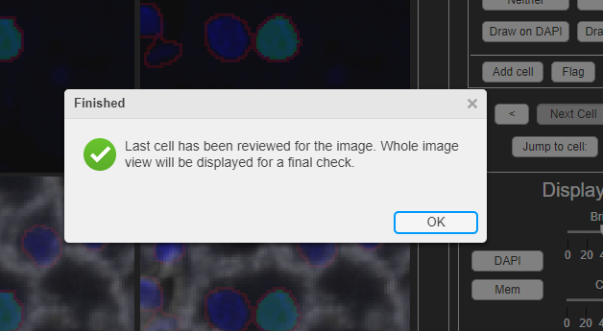 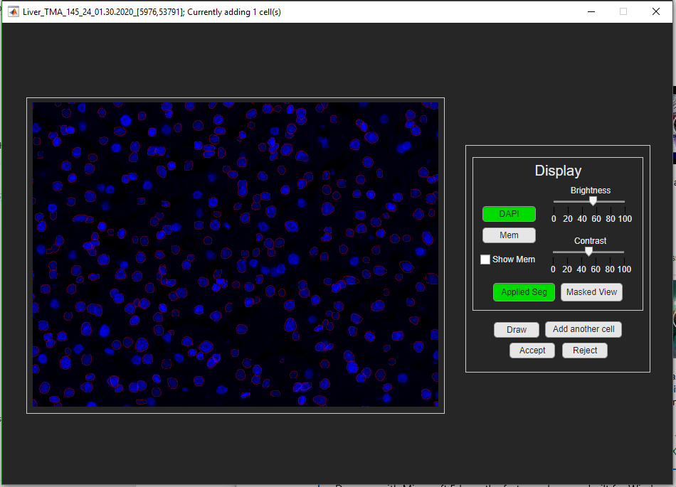

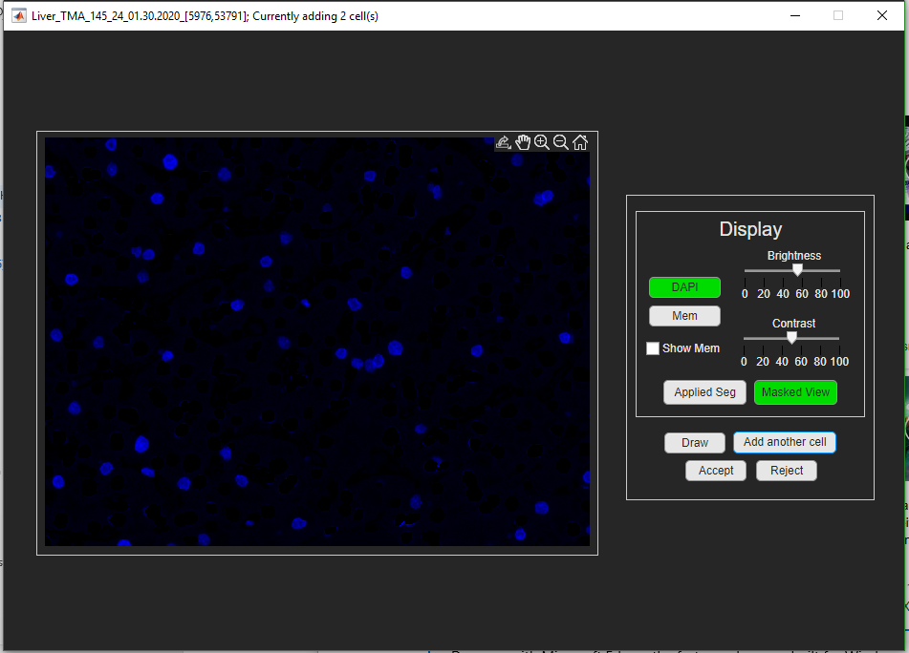 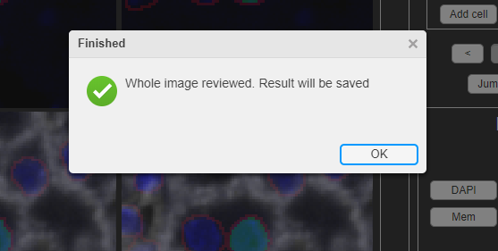

Figure 9: In order from left to right, top to bottom. (1) The initial finishing dialog, telling the user that they will review the whole image. (2) A zoomed in section of the image with the ‘Applied Seg’ toggled on. (3) That same section of the image with the ‘Masked View’ applied, for this image we fill in the cell objects and subtract those pixels from the view. Anything that remains has not yet been assigned a segmentation. (4) The final finishing dialog telling the user that the software will be saved.

In step 5 on Figure 2 above, we estimated the cell object pairs (between IF and SP) with a joint overlap (jo) of over .80 (anywhere between 80% to 100% of the identified pixels are overlapping). In this case, it is highly likely the object is the same and is identified correctly in both approaches; we can randomly accept either the IF or the SP cell segmentation approach as the true cell object without user input. This assumption reduces the number of reviewed cell pairs anywhere from 500 to 1500 cells and tends to work quite well over a large number of cells, some examples are shown below.

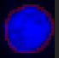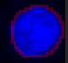

A

B

A

B

Figure 10: Two examples of cell pairs which have a joint overlap of .8 or greater.

However, this assumption should be reviewed on image to image basis to assure validity. For this, 20% of cell pairs with a joint overlap of greater than .80 are randomly selected and distributed throughout the other cell pairs marked for review. If the user, reviews more than 20% of these randomly chosen pairs as non-equivalent then the above assumption, that the .8 jo cells accurately identifies the same cell object, is false. As such the user is prompted with the dialog in Figure 11 and the rest of the .8 jo cells are added back into the list for review. The cell objects are also removed from the ‘applied segmentation’ view. This disagreement is measured each time the user uses the ‘Next cell’ button.

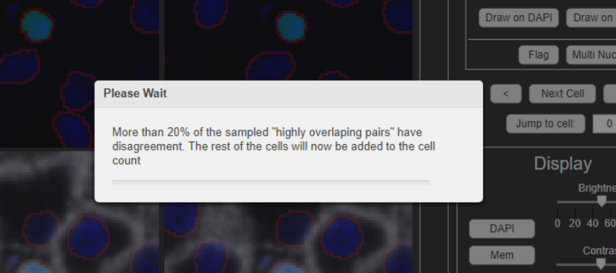

Figure 11: Dialog that pops up when the user has selected more than 20% of the highly overlapped pairs as having some kind of disagreement, (defined as not A=B). The tool will remove the cell pairs from the applied seg and add those cell pairs to the list to be reviewed.

Section 3 - Installation:

Download the installer located here:

\\halo1\Taubelab\Ben\Code\SegmentationTool\dist\SegmentationTool_installer.exe

To run the installer after downloading, simply double click the installer icon. When the installation window opens, click through the installation dialog. Be sure accept the prompt to download ‘Runtime’ if you do not already have this version of runtime installed on your machine. It is best to allow the installer to create a desktop shortcut. Otherwise the program can be run by double clicking on the executable which, unless the default installation path is changed during installation, should be located at:

“C:\Program Files\Astropath\SegmentationTool\application\SegmentationTool.exe”.

Section 3 - File Structure:

The program relies that the images files are set up in a unique file structure which is modeled after the Clinical Specimen directory structure, in order to find the corresponding inform images.

In summary, there should be two adjacent directories for a given slide as follows:



Each folder should contain their own respective ‘Component_Tiffs’ folder, the images for each algorithm should reside in their respective folder.

As a more distinct definition for this structure we first split the directory tree into 4 main parts which will be labeled “root”, “slideID”, ”SP_tree”, and ”IF_tree”.

<root>\<slideID>\<SP_tree>\<SP_Image> **OR** <root>\<slideID>\<IF_tree>\<IF_Image>

EX. “\\bki04\Segmentation\TMAs\Liver_TMA_145_23_01.30.2020\superpixel\Component_Tiffs\Liver_TMA_145_23_01.30.2020_[6435,55763]_component_data_seg.tif”

<root>: “\\bki04\Segmentation\TMAs”

<slideID>: “Liver_TMA_145_23_01.30.2020”

<SP _tree>: “superpixel\Component_Tiffs”

<SP _Image>: “Liver_TMA_145_23_01.30.2020_[6435,55763]_component_data_seg.tif”

For the corresponding inForm image, replace the <SP_tree> with the <IF_tree> as follows:

EX. “\\bki04\Segmentation\TMAs\Liver_TMA_145_23_01.30.2020\inform_data\Component_Tiffs\Liver_TMA_145_23_01.30.2020_[6435,55763]_component_data_**w_seg**.tif”

<root>: “\\bki04\Segmentation\TMAs”

<slideID>: “Liver_TMA_145_23_01.30.2020”

<IF_tree>: “inform_data\Component_Tiffs”

<IF_Image>: “Liver_TMA_145_23_01.30.2020_[6435,55763]_component_data_**w_seg**.tif”

**Note: Be sure to use the component_data_*w_seg*.tif for the IF image or the software will throw an error.**

Section 4 - Usage:

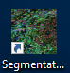4.1 Launching and getting started

1. Launch the program either by double clicking on the icon: or by locating the SegmentationTool.exe (see above in *Installation*).



* 1. An icon will appear on the windows tool bar:

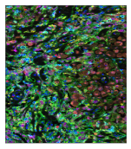

* 1. a loading visual will appear on the desktop:
  2. The visual and icon may disappear then the app will open. This may take a few minutes and is normal.

1. Click on the ‘Load new image’ button:
2. A windows file explorer should open, navigate to either the <SP_tree> or <IF_tree>folder and open the <SP_Image> or <IF_Image> of interest.
3. If the file structure was set up appropriately, the program will find the corresponding segmentation output image, otherwise it will throw an error.
4. The segmentation overlap on the images will be computed or, if it exists, the corresponding overlap image and .csv file comparison will be loaded for the image.
5. The first cell for comparison will appear in the UI as a set of four images.
   1. The top images will contain only the DAPI signal, the bottom images will contain the DAPI and the Membrane signal
   2. On the left will be used to display the machine learning or superpixel segmentation and the right will be used to display the inform segmentation

4.2 Selecting a segmentation approach

Once the first cell appears, the figure title will be populated with the image name and the cell pair count.

1. Select one of the 7 options in the classification box on the right panel (only one can be selected at a time and when selected the option will turn green):



* 1. ‘A’: the image segmentation on the left or ‘A’ side panel is more correct
  2. ‘B’: the image segmentation on the right or ‘B’ side panel is more correct
  3. ‘A=B’: both segmentations are correct
  4. ‘Neither’: This cell is thrown out for some other reason, both segmentations failed and a new cell cannot be drawn on
  5. ‘Artifact’: The segmentation is a result of image artifact and not an actual cell
  6. ‘Draw on DAPI’: this option allows for drawing a segmentation on the ‘B’ panel DAPI only image. (Drawing explained below)
  7. ‘Draw on Mem’: this option allows for drawing a segmentation on the ‘B’ DAPI + Membrane image. (Drawing explained below)

1. Select ‘Next cell’
   1. This jumps to the next cell that has not yet been reviewed
      1. Sometimes this means skipping cells



4.3 Additional movement buttons

1. ‘<: this goes back one cell in the numeric ordering (shown in the figure header at the top of the page)
2. ‘>’: this moves forward a single cell and a single cell only in the numeric ordering. This differs from the ‘Next cell’ button by ignoring which cells have already been checked off.
3. ‘Jump to cell’: this button jumps to the cell pair entered in the input box beside it. This can be used to ask for confirmation or review the segmentation of a given cell pair.

4.4 Display buttons

1. The brightness and the contrast of the DAPI and Membrane can be scaled separately. Select the marker of interest, then vary the appropriate parameter with the slider. Only one option can be selected at a time. When the option is selected the button turns green.



1. ‘Toggle Segmentation’: Toggles the segmentation on and off for all four image stamps. The segmentation show is the original segmentation for either ‘A’ or ‘B’ respectively.
2. ‘Applied Seg’: Toggles the already applied segmentation on and off for all four image stamps. This shows the reviewed cells or the cells in the joint overlap group (if it has not been removed).

4.5 Additional flagging buttons

Any combination of these options can be applied to a give cell pair.



1. ‘Flag’: adds a review flag to this cell. When the segmentation is finished and handed off for statistics or review by another person they can review these cells for edits.
2. ‘Multi Nuc’: Indicates that the cell pair is part of a multi nucleated cell
3. ‘Add cell’: allows the user to add a new cell, see below

4.6 Add cell window

1. Opens the ‘Add cell window’, the main app will be shaded in and not usable when this window opens.
   1. The first time this option is selected the following dialog with directions appears over the window.



* 1. Follow these directions to use:
     1. Click on the ‘Draw’ button and wait for it to turn green in that UI to draw a cell.
     2. To add a new cell click ‘add another cell’, wait for that button to turn green then draw another cell
        1. there is no need to click draw again
     3. The segmentation and display settings are all the same as before
        1. except now there is an option to toggle only the membrane stain (with ‘Show Mem’ check box), ‘Seg A’ and ‘Seg B’
        2. note that the applied segmentation is updated in real time.
     4. To redraw a cell, close the current cell by right clicking in the drawing window (see 4.7 for additional drawing notes), then click on the ‘Draw’ button again
     5. The number of cells drawn are recorded in the window header



1. Once finished adding cells, select either ‘Accept’ to accept all drawn cells or ‘Reject’ to reject drawn cells. A confirmation dialog will open either way
   1. Reject confirmation dialog options
      1. for the reject dialog, if only one cell is drawn the dialog just asks for confirmation
      2. for the reject dialog, if more than one cell is drawn the dialog asks if all drawn cells should be deleted or only the last cell drawn

4.7 Drawing feature

When one of the drawing options is selected

1. Move the cursor over the corresponding image (DAPI or Membrane + DAPI).
2. There are two options for drawing the segmentation.
   1. Click and drag
      1. Left click and hold
      2. then drag around the cell to draw (while holding the left mouse button)
      3. Release the left click ***and*** right click to end the segmentation
   2. Create waypoints
      1. Left click once on the segmentation
      2. release
      3. Then move the mouse and left click again
      4. Do this all the way around the cell, creating ‘waypoints’
      5. right click on the mouse to end the segmentation

4.8 Additional notes for segmentation selection

- We are segmenting the nuclei only at this point

- If one of the two segmentations are correct select that segmentation before rejecting or drawing a new segmentation.

- Since the cells are usually order by location, segmentation on adjacent cells may show up in sequential ordering. Often this means that over-segmented or under-segmented examples are directly next to each other. If one of the approaches correctly defines the over-segmented cell, *it is safe to reject the second cell that appears or select the correct version again.*

EX.

Cell1: Cell2:

4.9 Highly overlapping pairs

When the overlaps are computed, some of the cells are computationally determined to be the same cells, these are the so-called ‘highly overlapping pairs’. It is assumed that these objects, because of their agreement are correctly identifying the cell of interest. A random sample of these pairs are filter back into the cells for review to assess the viability of this criteria for each image. If 20% of these sampled pairs have disagreement (were not defined as ‘A=B’) then this dialog will appear and the rest of these highly overlapped pairs are added back in for the user to review. The cell objects are also removed from the applied segmentation.



4.10 Finishing an image

1. When all cells in an image are reviewed, a prompt will open telling the user that all cell pairs have been review and that it is now time to review the whole image
   1. click ‘ok’
2. A new window will open, as below, which shows the whole image with similar drawing features as the ‘Add cell’ window. You will be able to see the applied segmentation on the whole image and identify any cells that may have been missed by both algorithms.



* 1. if you have not used the ‘Add cell’ button in this session the dialog from 4.6.1.a will appear.

1. There will be an additional option for a ‘Masked View’, this subtracts the ‘applied seg’ cells out of the view, leaving only pixels that have not been segmented. This view is very helpful in identifying missed objects



1. Add all the additional cells desired until the whole image has been identified.
2. Select ‘Accept’ to accept all cells or ‘Reject’ to reject them
   1. see 4.6.1 for more info on these options

Section 5 - Saving and Output:

5.1 Saving and closing

There are a few ways to save progress.

1. The first way is to select the ‘Save Table’ button at the bottom of the right panel: 
2. The second way is during the closing of the app. Close the app by clicking the ‘X’ in the upper right corner. A new closing dialog will appear:

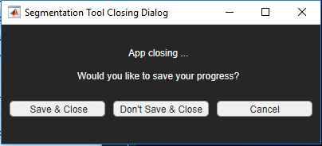

* 1. ‘Save & Close’: saves progress and closes the app
  2. ‘Don’t Save & Close’: will not save progress and closes the app
  3. ‘Cancel’ or clicking the ‘X’ from this box will cancel the closing dialog and return to the app for segmentation

1. The UI will also save the current result if a new image is loaded into the UI

When the tool saves, a saving progress bar will open over the UI. The UI will not be usable while the save is operating and will appear greyed out. Wait for the UI to finish saving before closing or logging off.

5.2 Image Output

The tool saves two files, both files are labeled with the file indication ‘comparison_seg_data’ after the image name. The first file is a csv file with 14 column headers, the second is a tiff file with 2 image layers.

1. Csv file:
   1. This file contains information on each cell object in the image
   2. Column description:
      1. IF_cellid
         1. Description: Numeric cellid from the IF_cellid label matrix
         2. Data type: Uint16
      2. IF_X_centroid
         1. Description: X value for the centroid of the IF cell
         2. Data type: Float32
      3. IF_Y_centroid
         1. Description: Y value for the centroid of the IF cell
         2. Data type: Float32
      4. SP_paired_w_IF
         1. Description: the corresponding SP cellid that is paired to this IF cellid
         2. Data type: Uint16
      5. SP_cellid
         1. Description: Numeric cellid from the SP_cellid label matrix
         2. Data type: Uint16
      6. SP_X_centroid
         1. Description: X value for the centroid of the SP cell
         2. Data type: Float32
      7. SP_Y_centroid
         1. Description: Y value for the centroid of the SP cell
         2. Data type: Float32
      8. IF_paired_w_SP
         1. Description: the corresponding IF cellid that is paired to this SP cellid
         2. Data type: Uint16
      9. pairid
         1. Description: the new unique cellid given to cell pairs in the table
         2. Data type: Uint16
      10. IF_level
          1. Description: the corresponding image segmentation type for the InForm segmentation a cell comes from.
          2. Data type: Uint8
          3. Opts:
             1. 1: immune cell segmentation layer
             2. 2: tumor cell segmentation layer
      11. joint_overlap
          1. Description: joint fractional overlap, from multiplying the fractional overlaps of each type or IF_frac * SP_frac
          2. Data type: Float32
      12. class_selection
          1. Description: which segmentation is saved in the final result
          2. Data type: Uint8
          3. Opts:
             1. (0): not yet defined
             2. (1): Inform type
             3. (2): super pixel type
             4. (3): drawn on
             5. (4): joint overlap over .8 and set NOT to review
             6. (5): reviewed as both
             7. (6): added \ new cell
             8. (-1): neither segmentation chosen and not drawn
             9. (-2): artifact
      13. cell_check
          1. Whether or not that cell will be reviewed
          2. Data type: Uint8
          3. Opts:
             1. (0): do not review (see (4) in class selection)
             2. (1): review
             3. (2): joint overlap over .8 and set to review

Note: Cells can be repeated for each corresponding cell they overlap over 10% with, so all overlapped cells are included.

1. TIFF file
   1. This file contains 2 label matrices to be used in conjunction with the csv file to produce the final segmentation result or for display in the UI
   2. Data type: Uint16
   3. Opts:
      1. Cell objects that were draw in the UI, values correspond to the pairid’s in the table above
      2. The applied segmentation matrix, a binary mask only used to create a visual display

5.3 Rebuilding the label matrix

To rebuild the label matrix one must read in the superpixel segmentation mask and the inform segmentation mask. Select the cells for each pairid using corresponding cell selection value. For IF or SP use the cellid values to located to cells. For drawn cells, use layer 1 of the ‘comparison_seg_data.tif’ image. Currently this is done in numeric pairid order, meaning that if a cell later in the pairs, overlaps with another, it will override the previous pairid.