Images are stolen grom the git scm book. read the full story there!

Concepts / Theory

txt diffs
working (ONLY!) on txt - based files
diff on txt files
→ format intelligently
→ stay with it (no reformating)
→ → agree on "code style"

BUT:
Git doesn't store deltas, git stores entire shapshots

not like this:
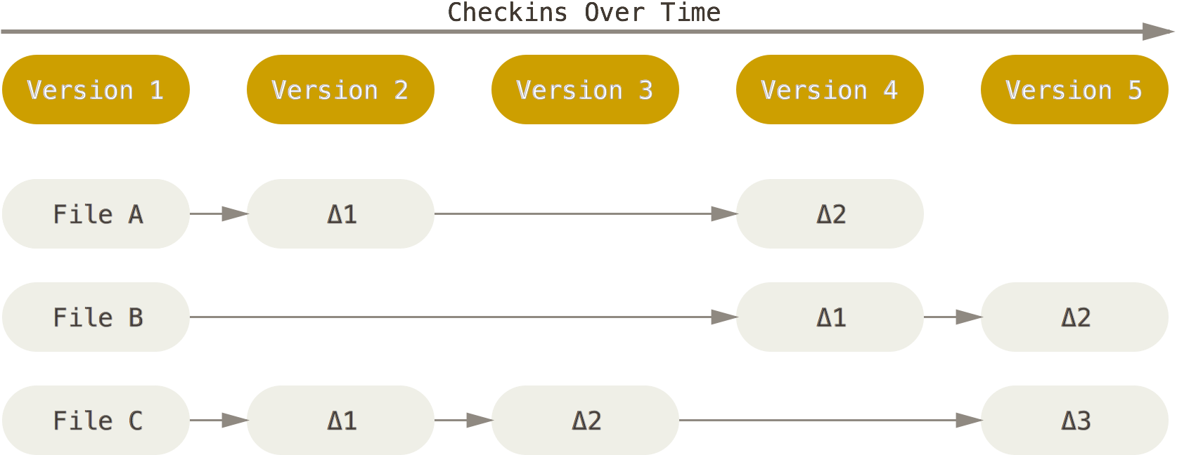

but like this:
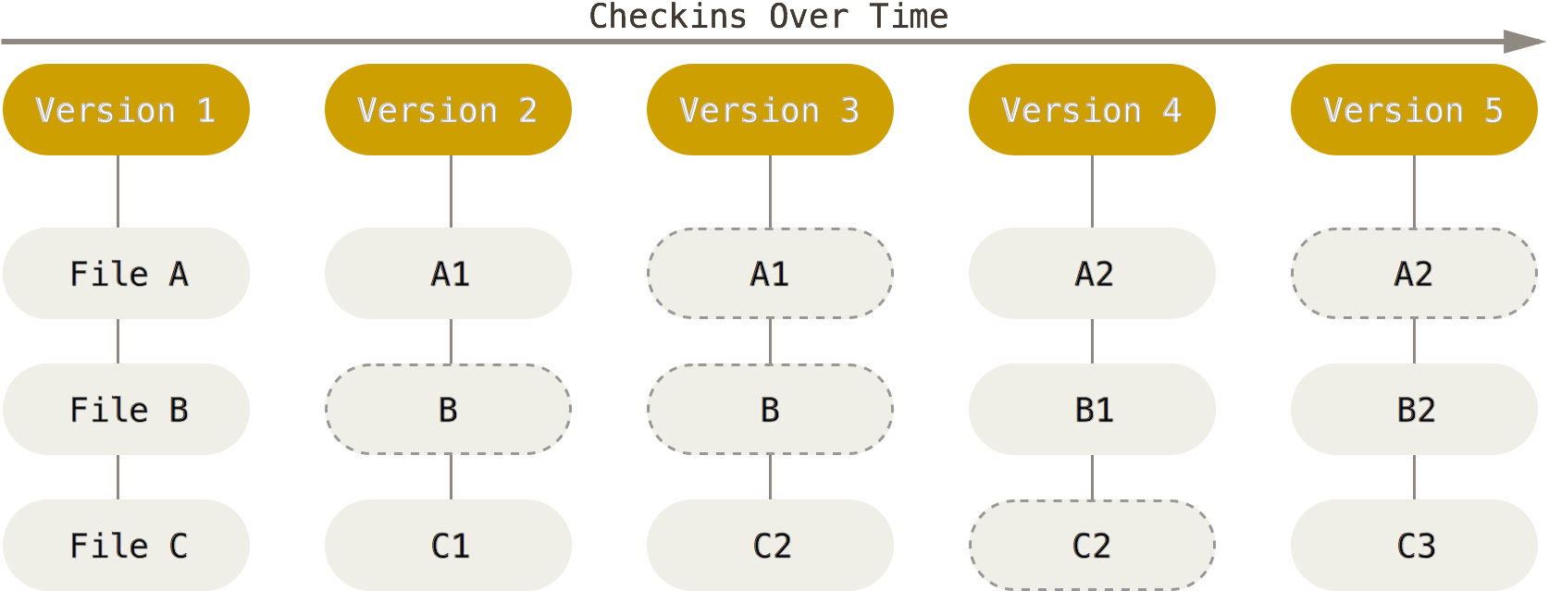

→ avoid binary files / large txt files that change often (images, datafiles) !!!! (use .gitignore for them)

Status of a file:
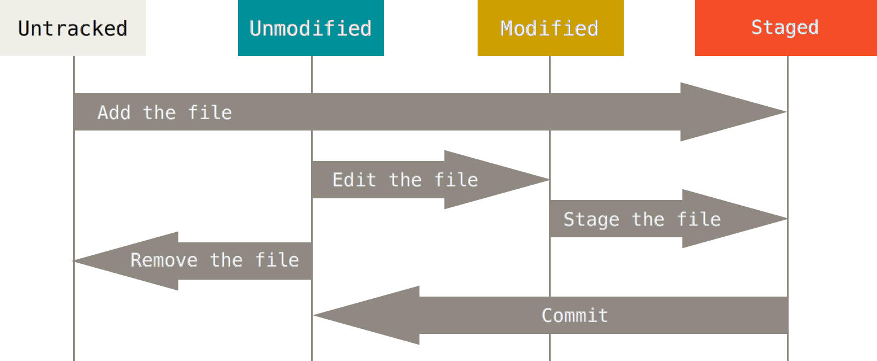
check the overall status with
git status
Additionally a file can be ignored completely, if its listed on .gitignore. Details later.

The three states (+stash)

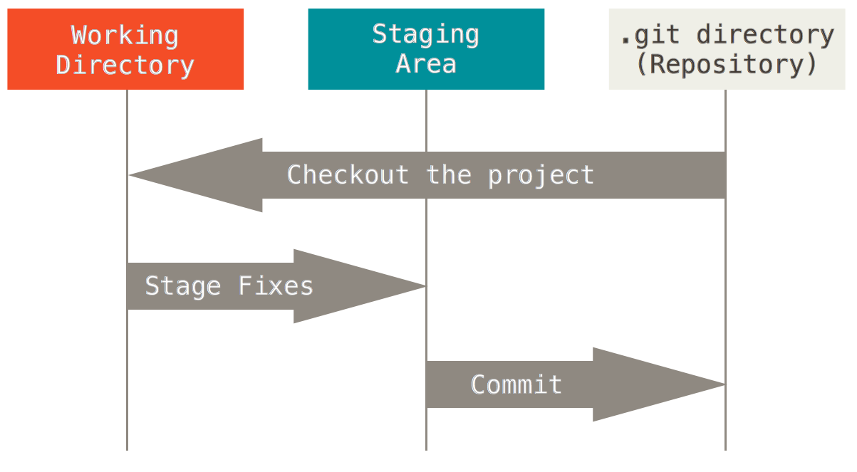
Bare vs NonBare repro

History of States / Versions / Commits:

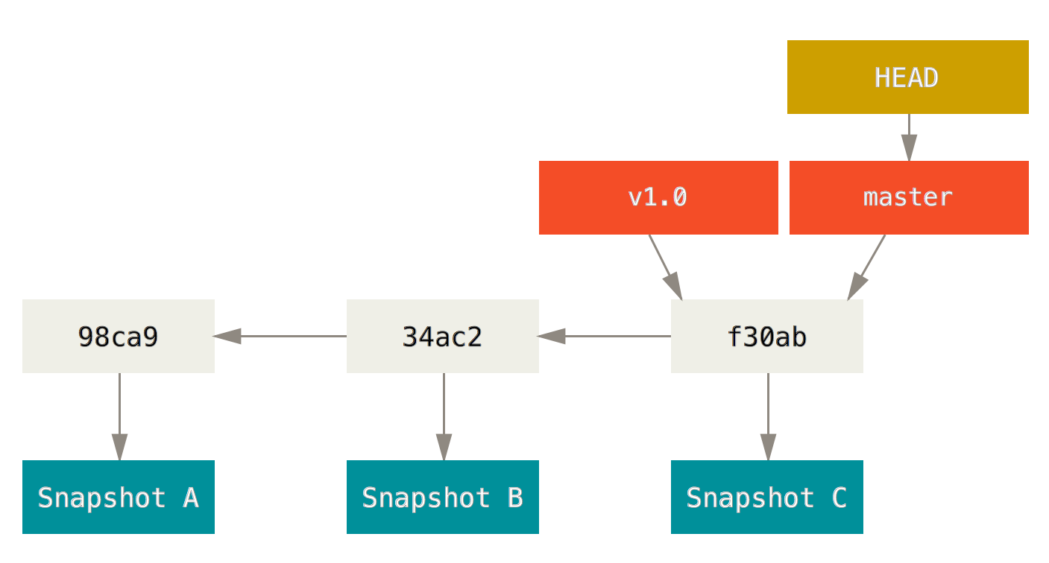
This is a branch → branch named "master" (is default name)
tags mark specific points in the branch "v1.0"
branch name always points to the last commit in a line
HEAD always points to the top of the current branch, the one you checked out and are working on.
→ there can be more than one branch!
→ and thats a good thing!!! (do it often)

Using branches

Create branch
use this to create a new branch named "testing"
git branch testing

thats what you usually do if you would create a copy / folder "my_project_v2" in pre git times...

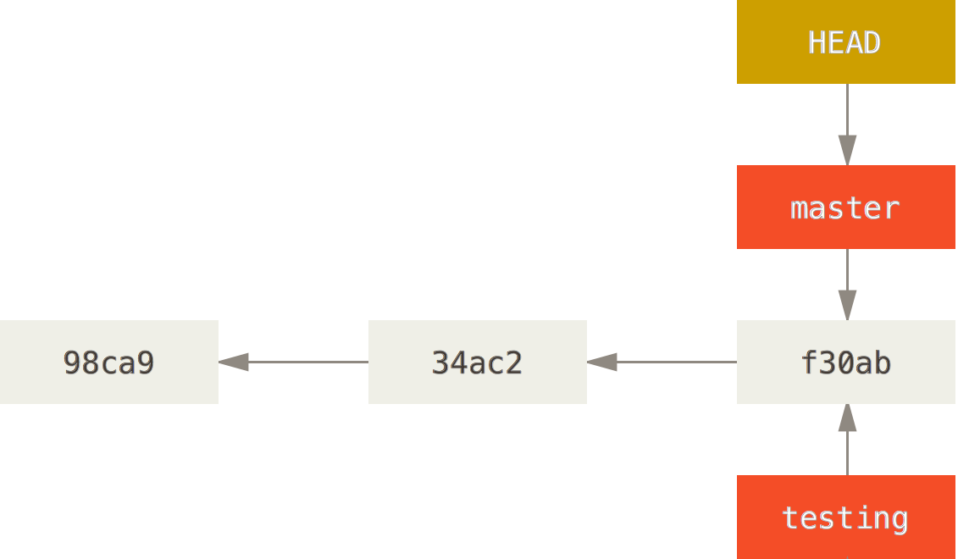

Switch branch
git checkout testing

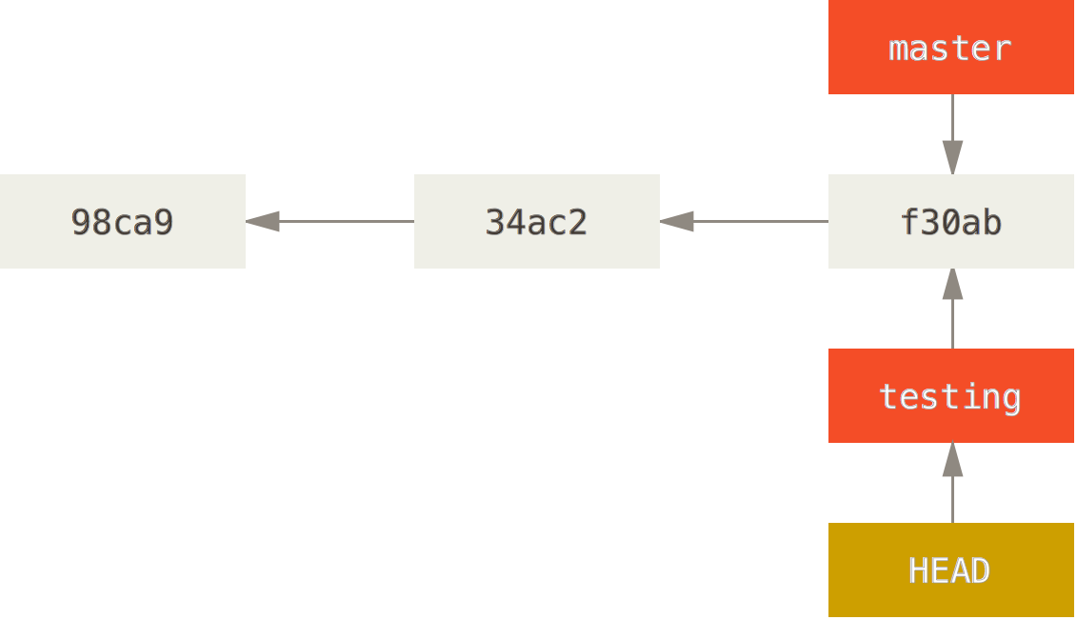

edit a file, make a new commit:

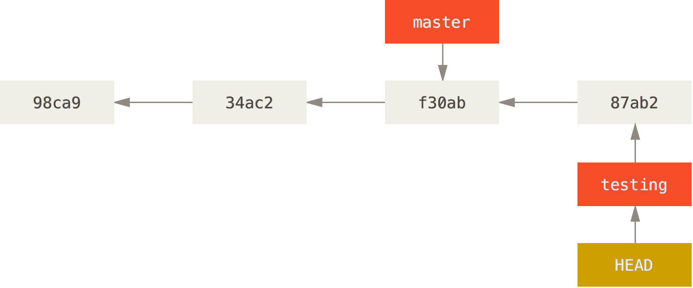

you can switch branches at any point:
git checkout master
Note that ALL your files in the working directory get changed!!

See branches
Check the log / branching history of the project in command line / gui
git log # cli
gitk --all # gui

Merging branches
You merge a branch INTO the current one:
git checkout master # change the current
git merge iss53 # merge iss53 into current=master
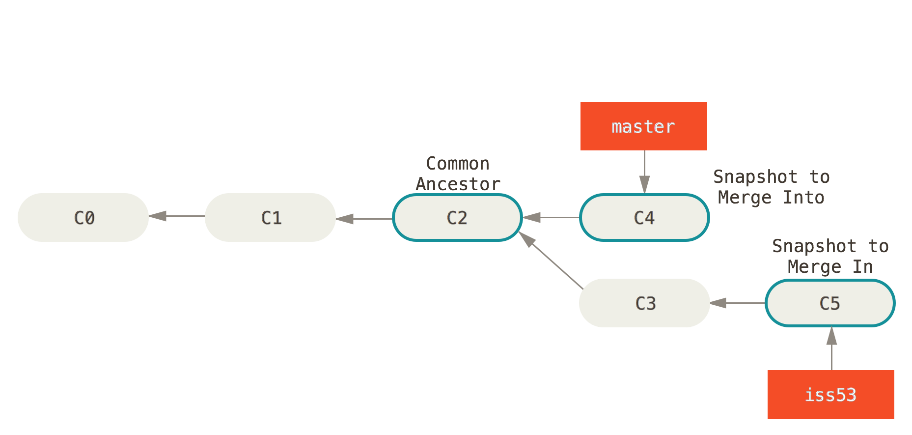

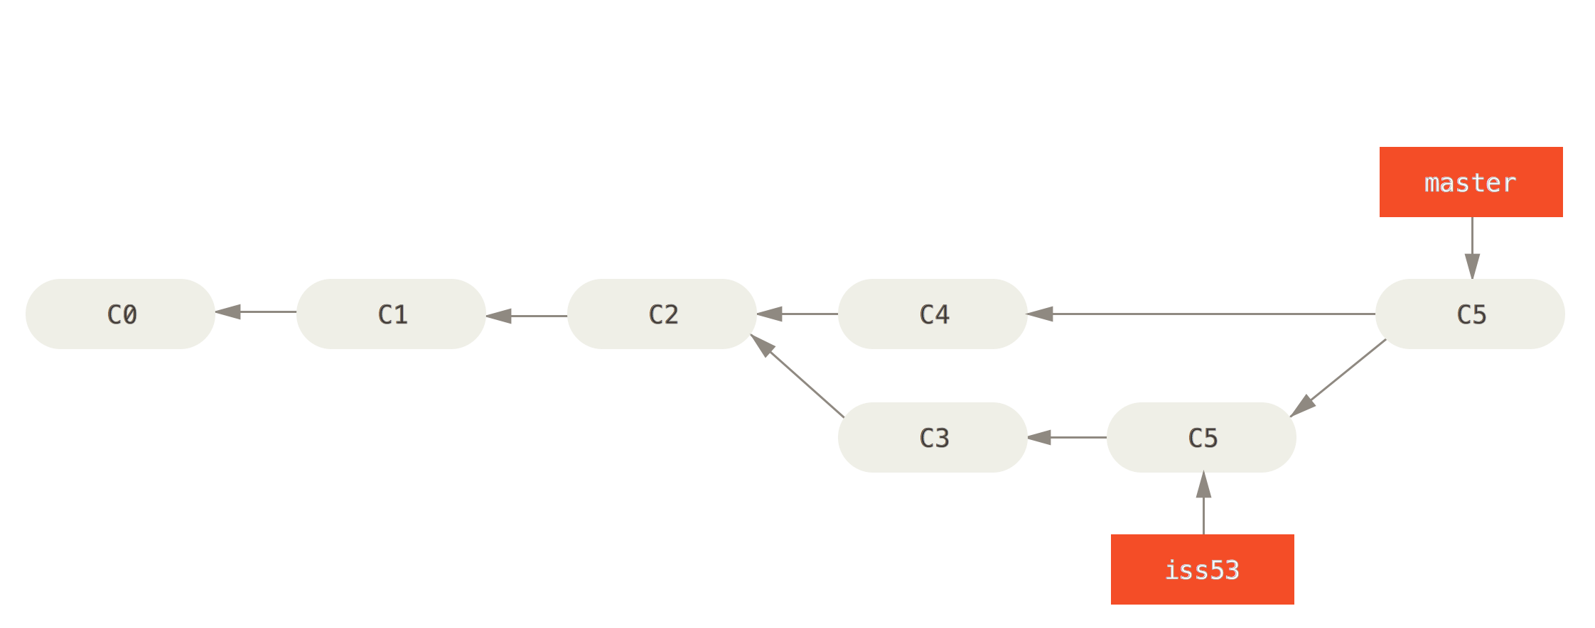

Merge conflict
In case of conflicts (both C4 and C5 changed the same file) → merge conflict
start the merge.
Edit the file manually or use a gui mergetool like kdiff3, meld by typing:
git mergetool
A file with conflict looks like:
[...]
<<<<<<< HEAD:index.html
I, user1 wrote this line
=======
I, user2 wrote another line
>>>>>>> iss53:index.html
[...]
Choose one version, delete the lines with <<<< ==== >>>>

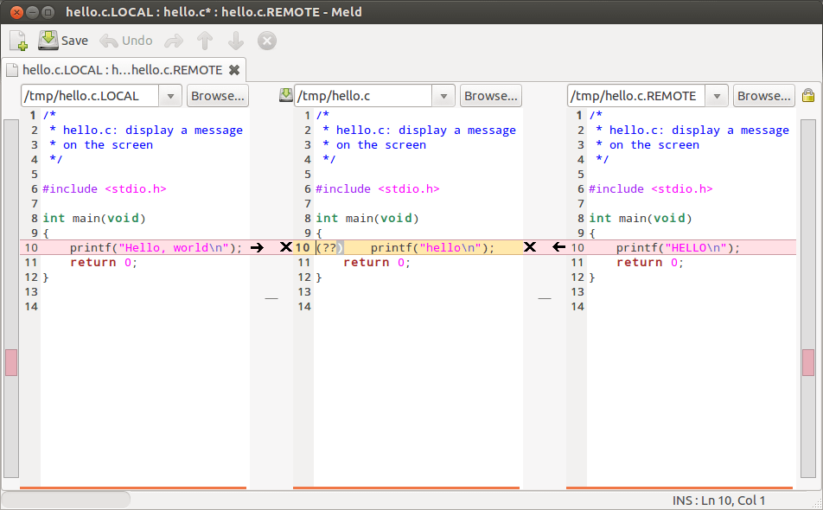

Do git status, fix files iteratively until everything is fixed. then commit.

Remove branch
At the end, or if an experiment didn't go well, you can delete old / merged or unused branches:
git branch -d iss53

Using branches
from here: http://nvie.com/posts/a-successful-git-branching-model/
Simple model:
Use "master" branch with dynamically created feature branches to try out stuff. if it works, merge the branch. if not, delete it...

More complicated setup: master, develop, feature branches

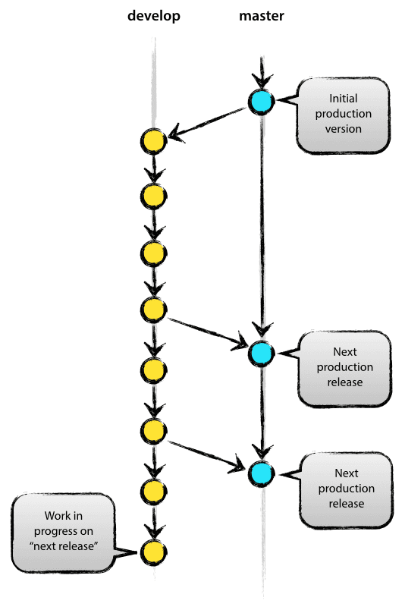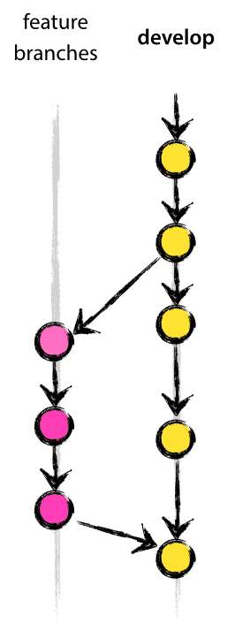
Using fast forward --ff vs not using it –no-ff while merging
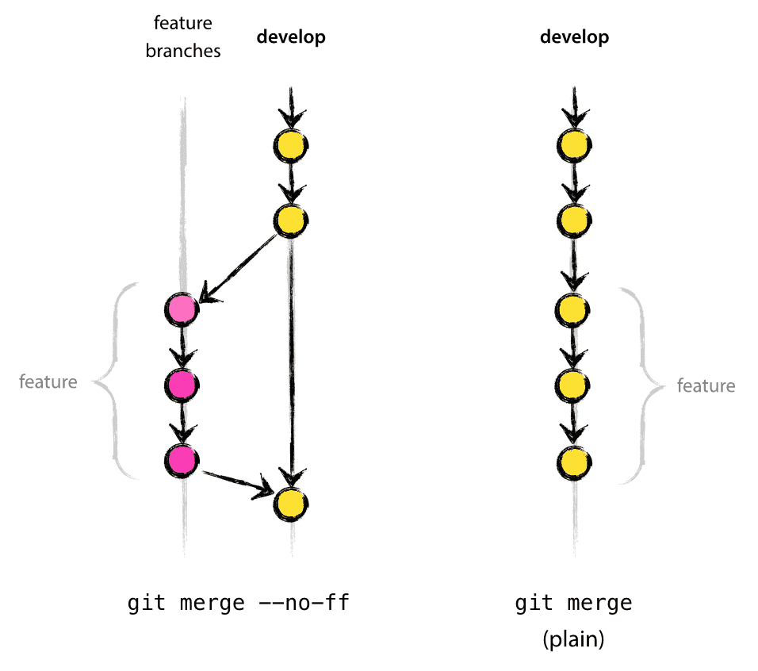

Undoing / correcting things

Only do changes to the history if you didn't share (push) anything yet.

Best to NEVER rewrite the history...

Quick fix if you forgot to add one file for a commit or want to change the commit message:
git commit -m 'initial commit'
git add forgotten_file
git commit --amend -m "new commit message"

Revert a file:
git checkout -- CONTRIBUTING.md

and ALL your local changes are gone!

Using remotes
Branches can be in your local repo, but also on someones else computer:
Starting with a copy of a remote repository:
git clone https://github.com/<username>/<project> <local_folder>
Git clone makes a local copy, and create a remote named origin.

Or add a remote repro after you created your own:
git remote
git remote -v

git remote add [remote_name] https://github.com/<username>/<project>
Get the updates from a remote, don't do anything
git fetch [remote_name]
Get the updates from a remote, and automatically merge the branch:
git pull [remote_name] [branch_name]
Publish your changes to a remote
git push [remote-name] [branch-name]
Inspect a remote:
git remote show [remote]
Track a remote branch:
git checkout --track [remote]/[branch]

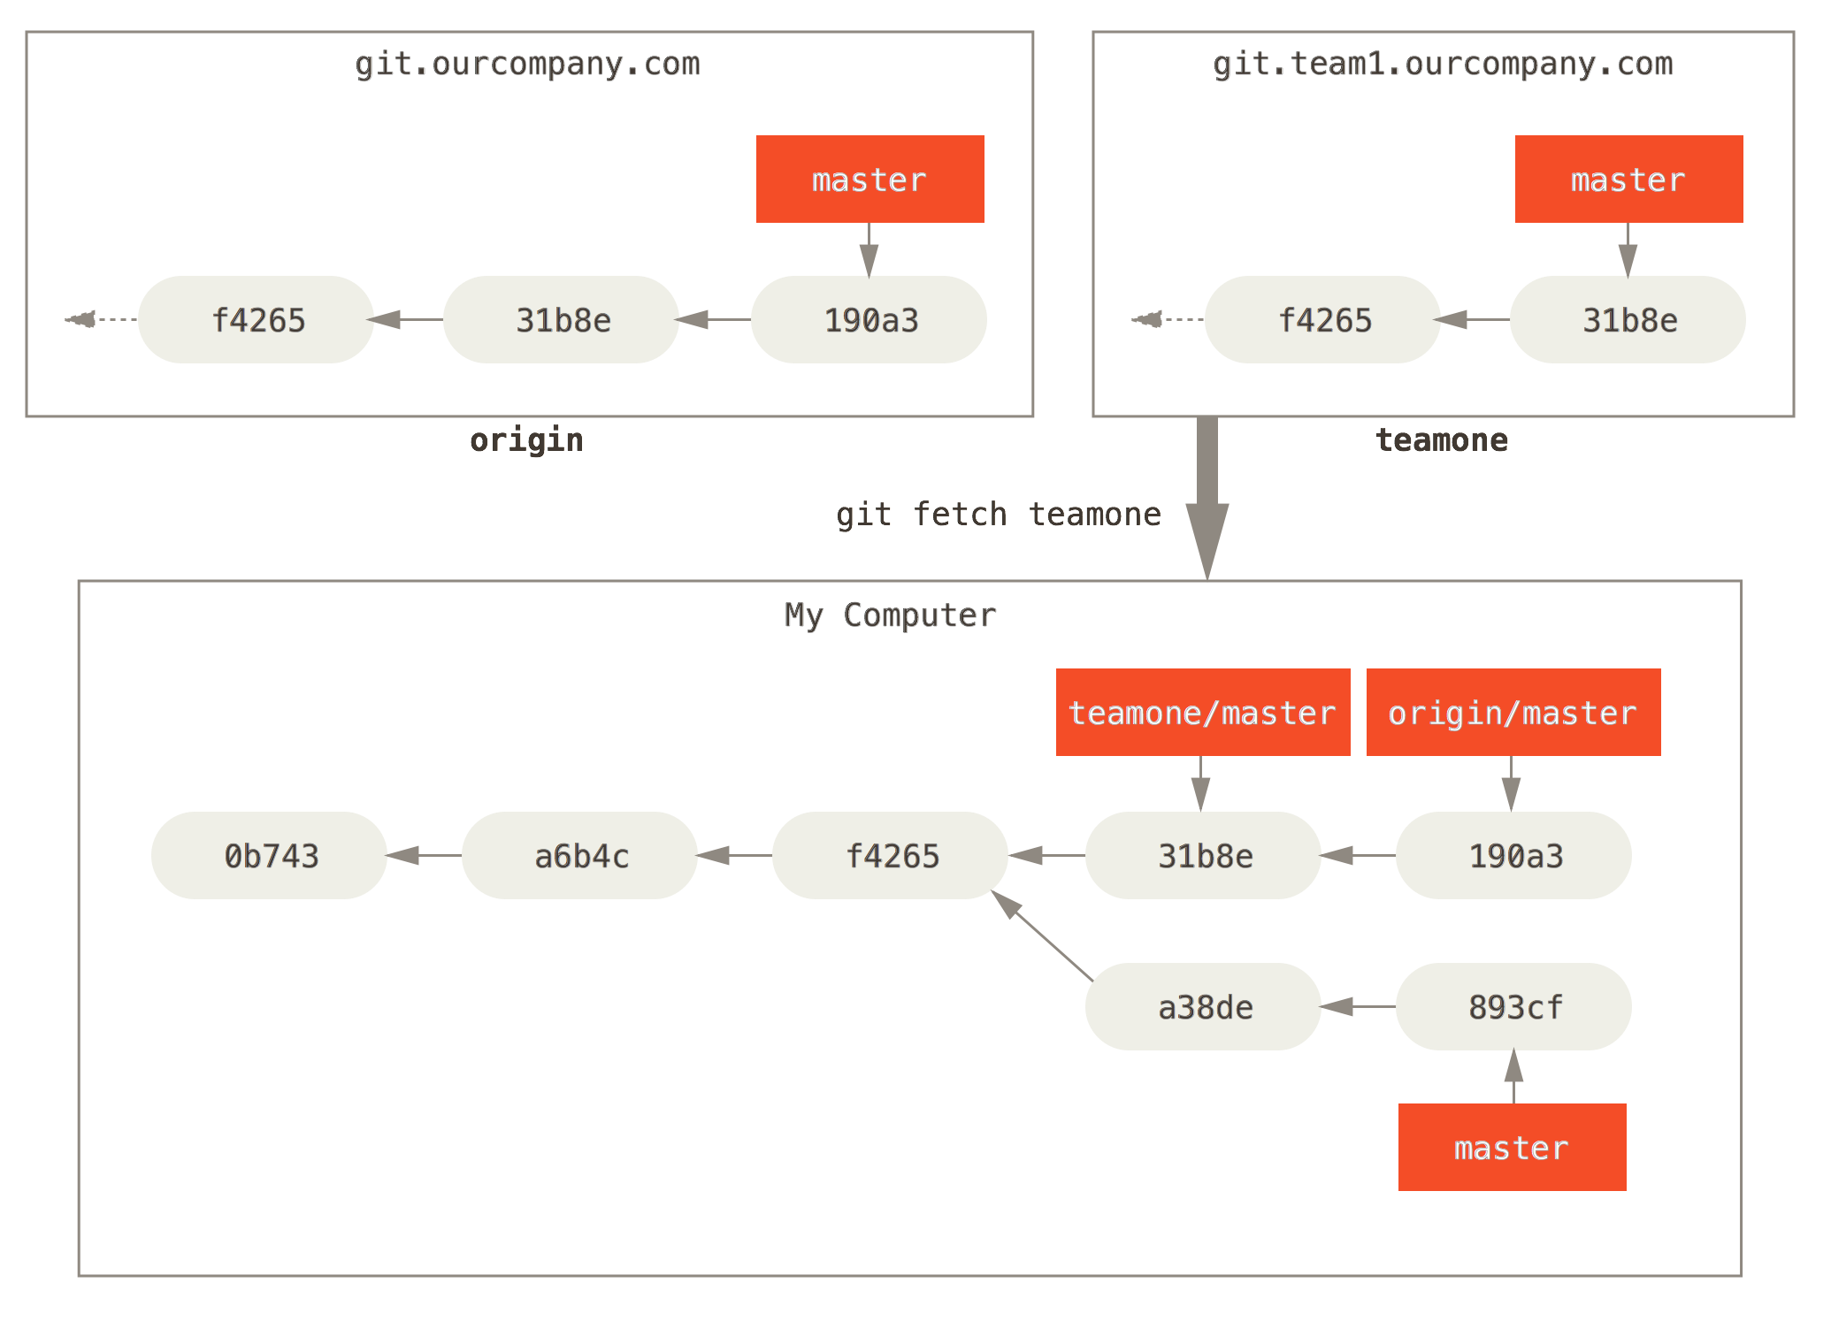

Distributed workflows
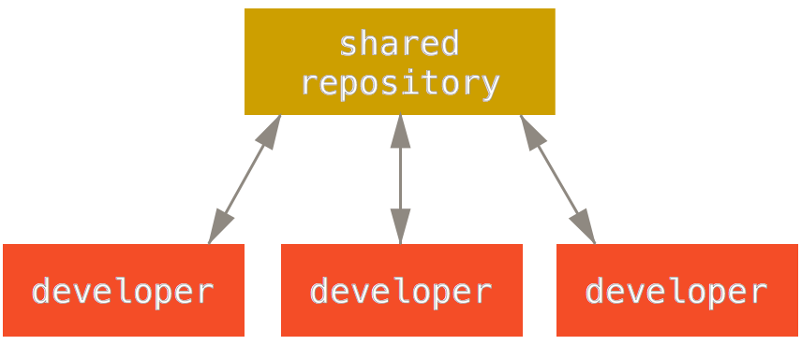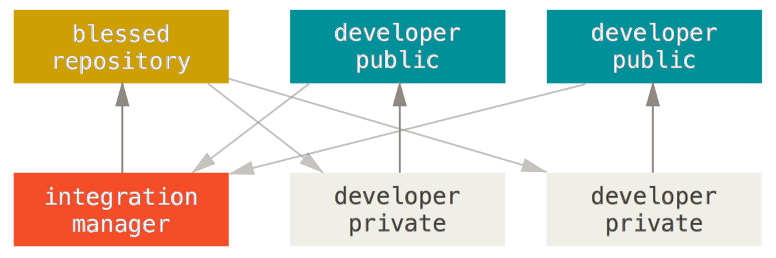

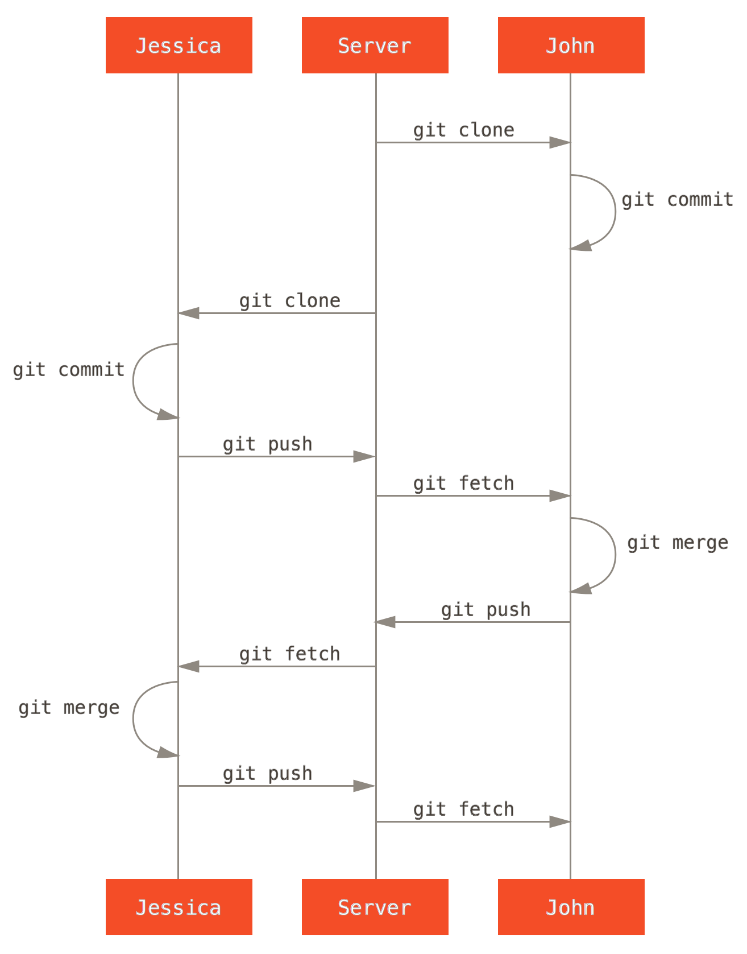

GitHub Setup
Central repro vs Forks / Pull request vs remotes

General Hint / get help
RTFM!
https://git-scm.com/book/en/v2
and for allem use:
git status
and read what’s written on the screen!!!

get help!
git help <command>
git <command> --help

First steps

Make config
git config --global user.name "<name>"
git config --global user.email <email>
change the default text editor (for example use kate for a simple graphical)
and disable fast forwarding:
git config --system core.editor <editor>
git config --global --add merge.ff false
The configs are saved in
<my_project>/.git/config # project specific config
~/.gitconfig # User-specific settings
(--global flag)
$(prefix)/etc/gitconfig # System-wide settings
(hardly ever used)
Set mergetool (use kdiff3 or meld):
git config --global merge.tool kdiff3

start from scratch

local first
start a new project on your computer / local:
cd ~/my_project
git init
Create files. By default you should always have README.md, LICENSE, .gitignore
echo "#Mein Project" > README.md
echo "This work is under WTFPL" > LICENSE
nano .gitignore
In the .gitignore file, you can list files, that should be ignored by the version tracking. You should list there all files that are artificially generated out of other files. (For example compiled programs, pdf and intermediate files out of latex documents… Google for example for latex gitignore to get a template.)

Add the new files to be versoin tracked:
git add .
Make your first commit:
git commit -am "Init of project"

then connect to github:
[create repro in github]
git

Github first
same as "Start from someone else"

Start from someone else

cd <projects>
git clone https://github.com/<username>/<project> <local_name>

Cheat sheet:
http://ndpsoftware.com/git-cheatsheet/previous/git-cheatsheet.html

First Aid
