Image p. 12/19

<https://image.slidesharecdn.com/dlmmdcud1l03imageclassificationonimagenet-170427160933/95/image-classification-on-imagenet-d1l3-insightdcu-machine-learning-workshop-2017-2-638.jpg?cb=1493309687>

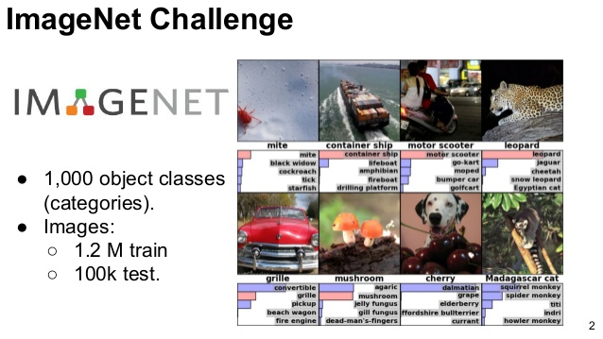

https://adriancolyer.files.wordpress.com/2016/04/imagenet-fig4l.png?w=600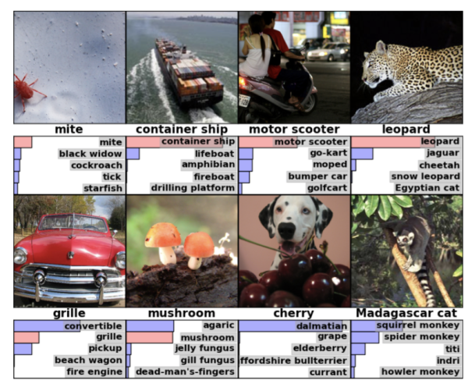

https://i.stack.imgur.com/jKR0a.jpg

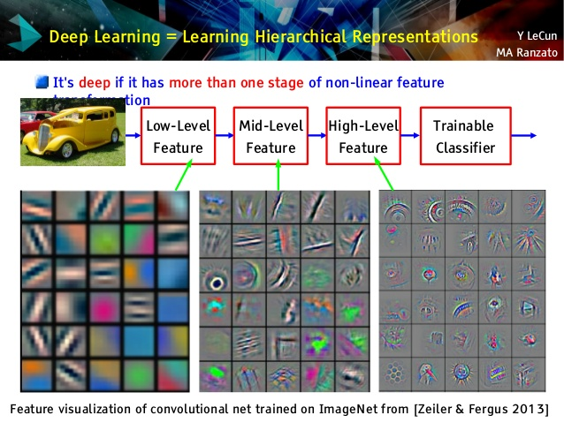

https://www.import.io/wp-content/uploads/2017/06/Import.io_quote-image2-170525.jpg



https://th.bing.com/th/id/OIP.lG_6q2wMbzyeSAz4apLLtAHaDt?pid=Api&rs=1

