Image p. 12/19

<https://image.slidesharecdn.com/dlmmdcud1l03imageclassificationonimagenet-170427160933/95/image-classification-on-imagenet-d1l3-insightdcu-machine-learning-workshop-2017-2-638.jpg?cb=1493309687>

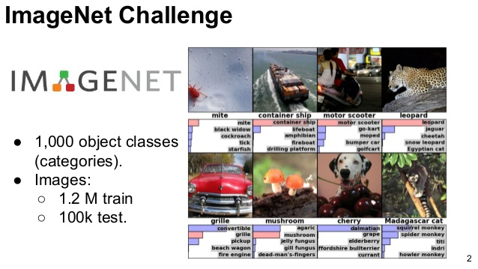

<https://www.bing.com/images/search?view=detailV2&ccid=G8jKIPXj&id=1C2345467544CA715AE3F964AC1A1851D61572EC&thid=OIP.G8jKIPXjoI_WivkDFUPlZQHaHZ&mediaurl=http%3a%2f%2fknowm.org%2fwp-content%2fuploads%2fScreen-Shot-2015-08-14-at-2.44.57-PM.png&exph=494&expw=495&q=mnist+digits+dataset&simid=608014038987113980&ck=C398A5DFA87F5502C00E95E73EFAD630&selectedIndex=0&qft=+filterui%3alicenseType-Any&FORM=IRPRST>

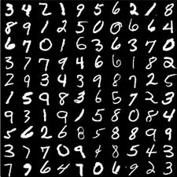

https://adriancolyer.files.wordpress.com/2016/04/imagenet-fig4l.png?w=600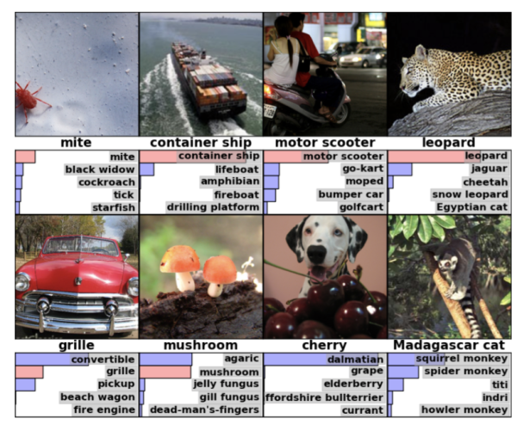

https://i.stack.imgur.com/jKR0a.jpg

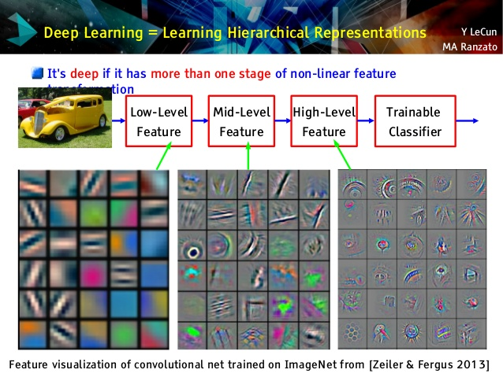

https://www.import.io/wp-content/uploads/2017/06/Import.io_quote-image2-170525.jpg



https://th.bing.com/th/id/OIP.lG_6q2wMbzyeSAz4apLLtAHaDt?pid=Api&rs=1

