Java and JavaFX Configuration
I used Java JDK 25 and JavaFX 25.0.4 to create an application that displays four randomly selected playing cards.
Java Installation and Compiler Versions
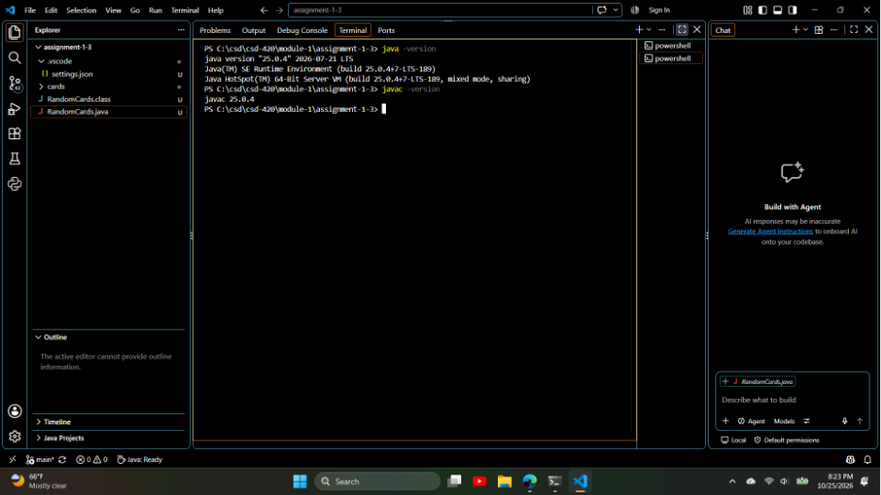

JavaFX Application
My program displays four randomly selected cards from a standard deck of 52 cards. It uses JavaFX layouts and image controls to display the cards.
JavaFX Application Running
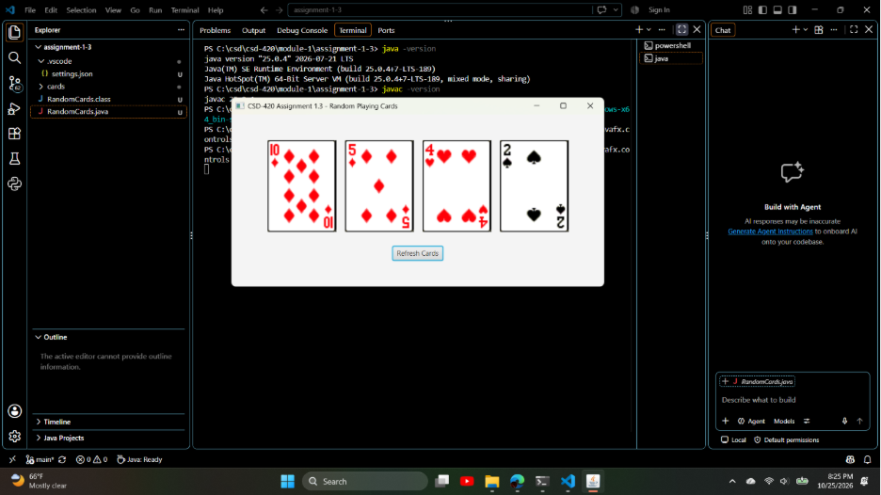

Refresh Button and Lambda Expression
The Refresh Cards button uses a lambda expression to update the displayed cards. The program shuffles a deck of 52 cards and selects four distinct cards for each display.
Playing Cards After Refresh
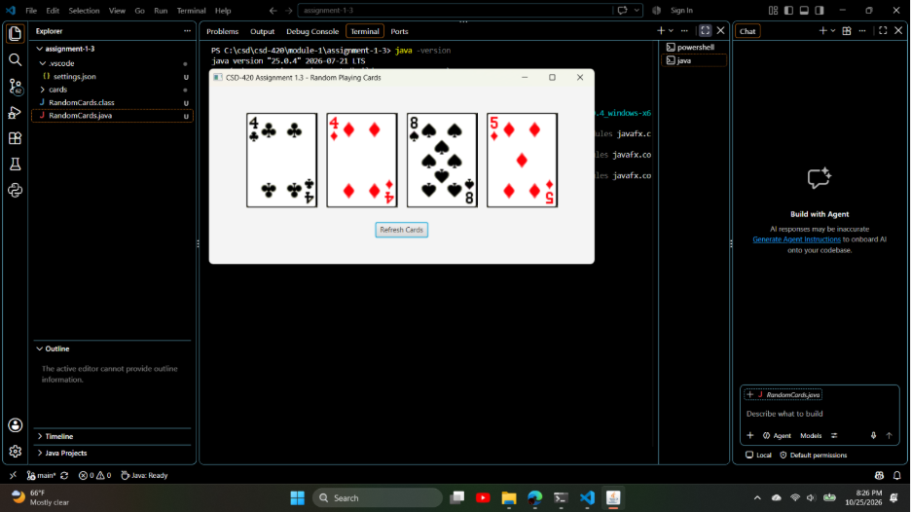

Successful Compilation and Execution
The application was compiled and executed using Java JDK 25 and JavaFX 25.0.4.
PowerShell Compilation and Execution
