Title of test doc

this is a subtitle

paragraph text of doc line 1

line 2

line 3

line 4

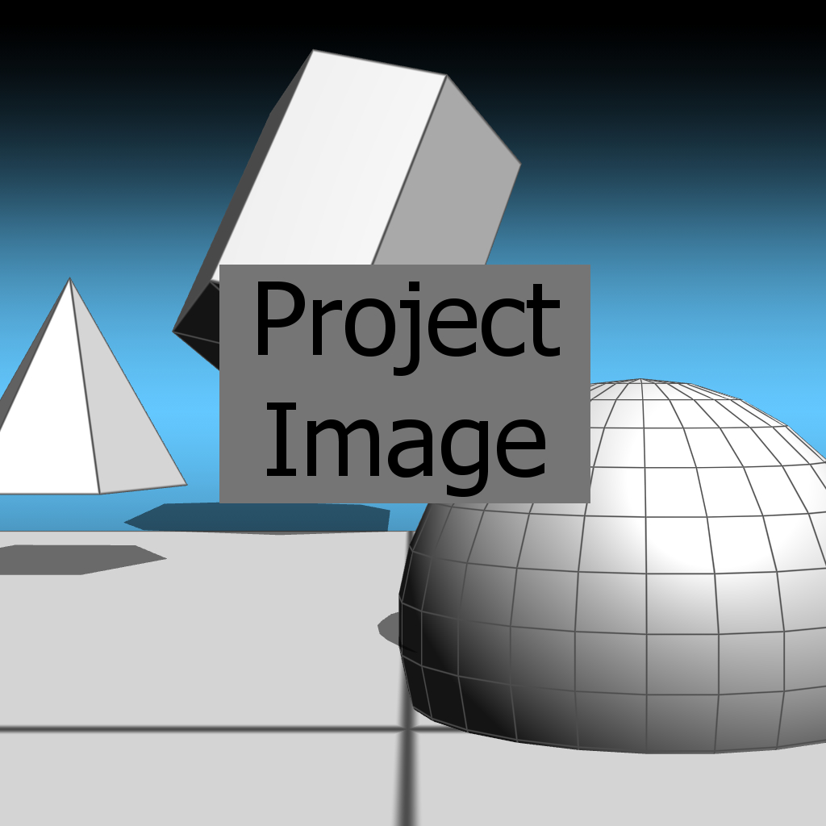

|  |  |  |  |  |
| --- | --- | --- | --- | --- |
| MERGERD CELL | | | | |
| A1 | A2 | A3 | A4 | A5 |
| B1 | B2 | B3 | B4 | B5 |
| C1 | C2 | C3 | C4 | C5 |