Crop Disease Diagnostic Tool

Project Documentation

Mbarara University of Science And Technology

Database Programming

Table of Contents

Project Overview 2

Group Members 2

Technical Scope 3

Technologies Used: 3

System Requirements 3

Problem Statement 3

System Architecture 3

Presentation Layer 3

Application Layer 4

Data Layer 4

Database Structure 4

Core Tables 4

Junction Tables 5

Management Tables 5

Diagrams 6

Context Diagram Level 0 6

Context Diagram Level 1 7

# Project Overview

The Crop Disease Diagnostic Tool is a web-based application designed to help farmers identify and manage crop diseases. The system provides an intuitive interface for symptom-based disease diagnosis, comprehensive disease information, and treatment recommendations.

# Group Members

|  |  |  |  |
| --- | --- | --- | --- |
| No | Name | Reg No | Role |
| 1 | **SEMPALA DANIEL** | **2023/BCS/118/PS** | Team Lead & Backend Dev |
| 2 | **ASINGWIIRE MARVELLOUS** | **2023/BCS/038/PS** | Frontend Dev |
| 3 | **MURUNGIKA ALLAN** | **2023/BCS/081/PS** | Database Design |
| 4 | **KAMPIKAHO TURYAMANYA** | **2023/BCS/057/PS** | System Analysis |
| 5 | **BUWULE SOLOMON FORTUNE** | **2023/BCS/049/PS** | UI/UX Design |
| 6 | **ALOYSIUS OWEN JUUKO** | **2023/BCS/022/PS** | Backend Dev |
| 7 | **MUSASIZI ANTHONY** | **2023/BCS/082/PS** | Testing |
| 8 | **NATWIIJUKA GIFT SABIITI** | **2023/BCS/096/PS** | Documentation |
| 9 | **MANZI COMFORT** | **2023/BCS/073/PS** | Frontend |
| 10 | **KOMUGISHA SAFRAH** | **2023/BCS/162/PS** | Database |

# Technical Scope

## Technologies Used:

* Frontend: HTML5, CSS3, JavaScript, Bootstrap
* Backend: PHP
* Database: MySQL
* Development Tools: Visual Studio Code, WAMP
* Version Control: Git

System Requirements**:**

* + Web Server: Apache
  + PHP Version: 7.4 or higher
  + MySQL Version: 5.7 or higher
  + Modern web browser with JavaScript enabled

# Problem Statement

Agriculture faces significant challenges due to crop diseases that can devastate yields and farmer livelihoods. Key issues include:

* + Difficulty in accurately identifying crop diseases
  + Limited access to agricultural experts
  + Delayed disease detection leading to crop losses
  + Lack of immediate access to treatment information
  + Need for a centralized knowledge base for disease management

# System Architecture

The system follows a three-tier architecture:

## Presentation Layer

* + User Interface components
  + Forms for symptom input
  + Disease information display
  + Treatment recommendations interface

## Application Layer

* + Disease diagnosis logic
  + User authentication
  + Session management
  + Data validation and processing

## Data Layer

* + MySQL database
  + Data access objects
  + Query processing
  + Data storage and retrieval

# Database Structure

## Core Tables

**users**

* + id (PK)
  + username
  + email
  + password
  + created_at

**crops**

* + id (PK)
  + name
  + scientific_name
  + description
  + common_varieties
  + created_at

**diseases**

* + id (PK)
  + name
  + scientific_name
  + description
  + severity_level (enum: Low, Moderate, High)
  + treatment_info
  + prevention_info
  + created_at

**symptoms**

* + id (PK)
  + name
  + description
  + severity (int)
  + created_at

## Junction Tables

**disease_symptoms**

* + disease_id (FK)
  + symptom_id (FK)
  + weight (int)

**diagnosis_symptoms**

* + diagnosis_id (FK)
  + symptom_id (FK)
  + severity_level (int)

## Management Tables

**growth_stages**

* + id (PK)
  + name
  + description
  + duration_days
  + created_at

**recommendations**

* + id (PK)
  + disease_id (FK)
  + recommendation (text)
  + type (enum: Prevention, Treatment, Management)
  + priority (int)

**diagnoses**

* + id (PK)
  + user_id (FK)
  + crop_id (FK)
  + disease_id (FK)
  + growth_stage
  + confidence
  + additional_details
  + created_at
  + status (enum: identified, unidentified)

# Diagrams

## Context Diagram Level 0

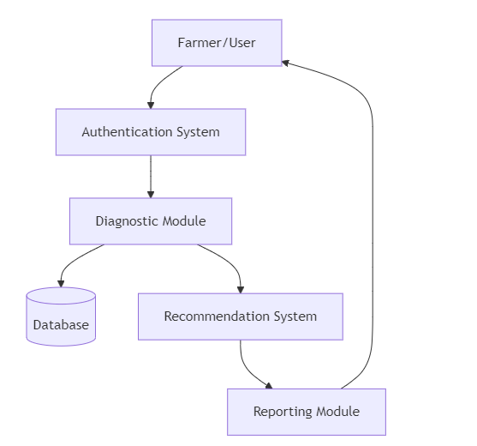

## Context Diagram Level 1

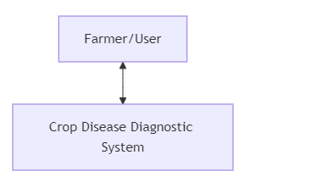

## UML Diagrams

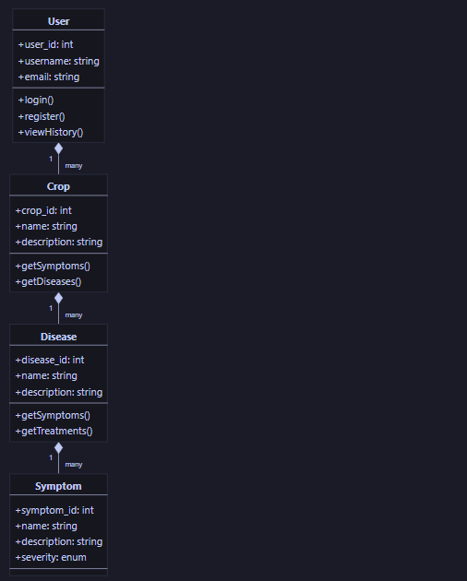

## Entity Relationship Diagram (ERD)

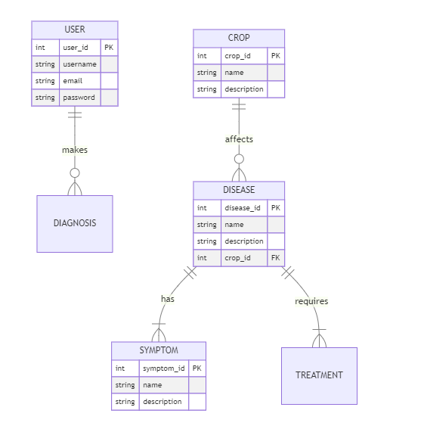

## Flowcharts

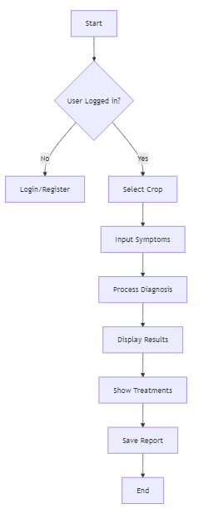

# Core Functionalities

## User Authentication

* + Secure login and registration system
  + Password encryption
  + Session management
  + User profile management

## Disease Diagnosis

* + Symptom-based diagnosis using weighted algorithm
  + Support for multiple symptoms selection
  + Growth stage consideration
  + Confidence score calculation
  + Image-assisted diagnosis (future enhancement)

## Crop Management

* + Comprehensive crop database with 20+ crops
  + Scientific names and common varieties
  + Growth stage tracking
  + Crop-specific disease susceptibility information

## Treatment Recommendations

* + Prioritized treatment suggestions
  + Preventive measures
  + Management practices
  + Organic and chemical treatment options
  + Success rate indicators

## Reporting System

* + Diagnosis history
  + Treatment tracking
  + Export functionality (PDF reports)
  + Statistical analysis of diagnoses