**改变实部：**

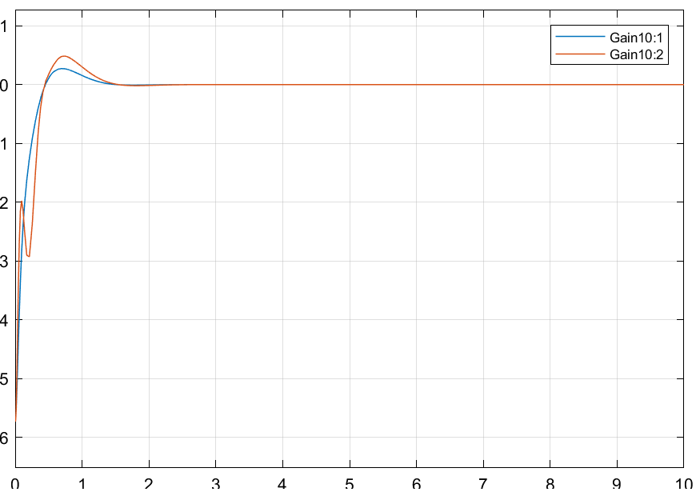P1=[-20+3i,-20-3i,-80-1i,-80+1i];

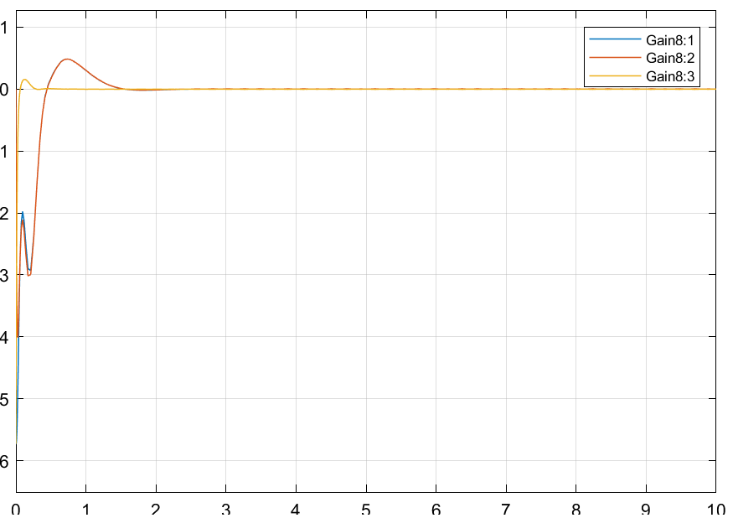

P1= [-10+3i,-10-3i,-80-1i,-80+1i]

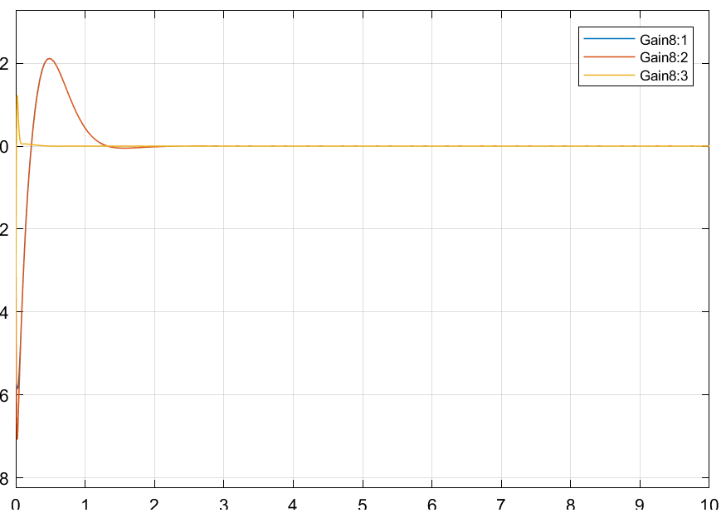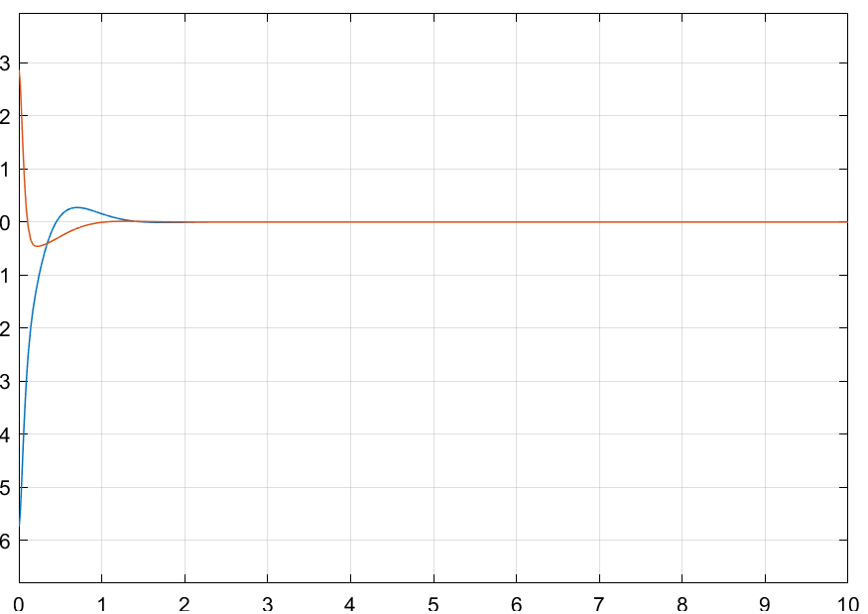

P1=[-5+3i,-5-3i,-80-1i,-80+1i];

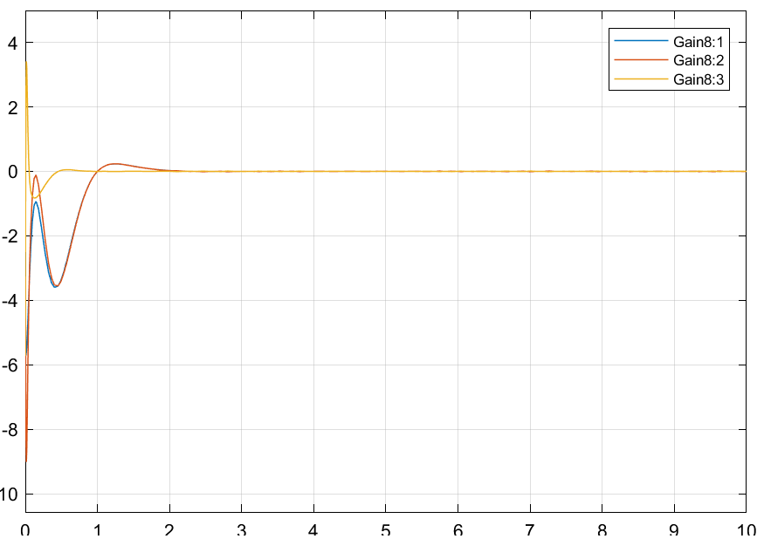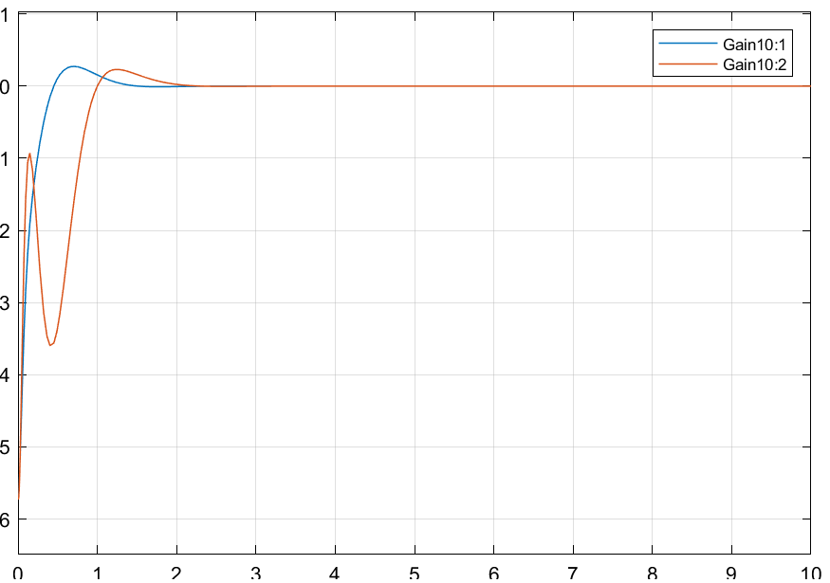

**改变虚部：**

P1=[-20+3i,-20-3i,-80-1i,-80+1i];



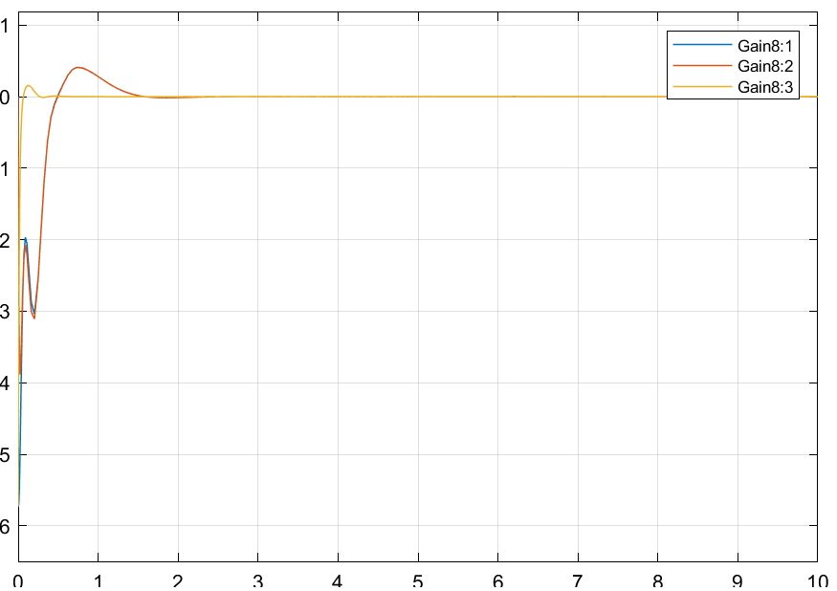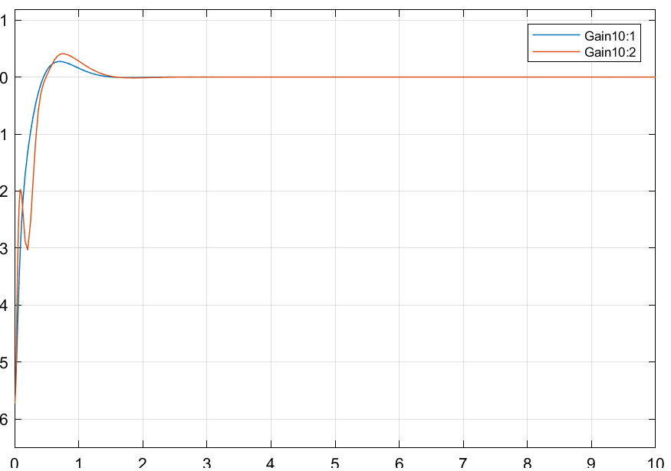P1=[-20+5i,-20-5i,-80-1i,-80+1i];

P1=[-20+10i,-20-10i,-80-1i,-80+1i];

