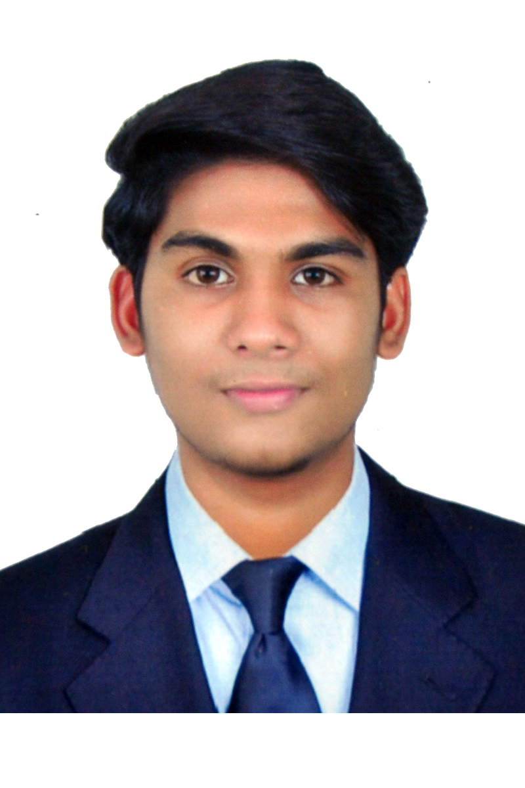
Mervin Abraham

Email: mervinabraham@gmail.com
Mobile: +91-8301884290 (M)

CAREER OBJECTIVE

To build a career in the field of Computer Networking, System Administration, Cloud Computing and Application development by converting innovative ideas into fruitful results in order to update myself with the latest technologies and work closely with a team of highly experienced professionals.

EXPERIENCE

Organization | Designation | From | To
Infosys BPM | Process Specialist  (Cisco WebEx) | 28th Aug 2018 | 10th May 2019
NTT DATA Information Processing Services Pvt Ltd. | Client Tech Support Associate  (Honeywell) | 27th mar 2017 | 28th may 2018
Concentrix Daksh Pvt Ltd | CRM Operations  (Etisalat UAE) | 2nd May 2016 | 8th Dec 2016

TECHNICAL SKILLS

EBFHFHFHFHFHFHF

- Create server instances and management.
- Linux shell scripting.
- Database and S3 storage architecture.
- Work on load balancer and cloud watch.
- Docker, Github and Jenkins .
- Sound knowledge in System Administration (Installing and Configuring Windows server 2012
- Administering Windows Server 2012
- Configuring Advanced windows server 2012
- Computer Hardware & Networking
- Expertise in Windows 8, 2008 server and 2012 server
- Good knowledge in ethical hacking.
- Cloud Computing Concept.
- MS Office.
Certifications: Amazon Web Service (AWS)
DevOps
Certifications from Tecmax, Bangalore.
Microsoft Certified System Administrator [MCSA]
Microsoft Certified Solution Expert [MCSE]
Certifications at CMS Info Systems Pvt. Ltd. Trivandrum
Cisco Certified Network Associate [CCNA] - YouTube.
Computer Networking from Udacity.
Business Concepts – LinkedIn Learning.
Roles and Responsibilities

EBFHFHFHFHFHFHF

- Troubleshooting L1 issues and Active Directory Configuration
- Telecommunication queries.
- Mobility problem resolution.
- Expertise in Lync, Outlook, VPN
- Configuring Cisco Anyconnect with Symantec PKI Client.
- Expertise in Router Configuration and troubleshoot.
- Air watch and MFA Configuration.
- Enabling and disabling management console services.
- Uses MS Terminal Services Client to connect through RDP.
- Run check in Tracer logs and MSinfo32.
- Check trace route to measure the delay of packets across the network.
- Very good Customer interaction skill.
- Easily adaptable and ability to work well with people.
- Logical thinking and continual learning.
- Deliver quality of work.
- Active Directory user configuration.
- Expert in Cisco WebEx product and CMR cloud.
- Knowledge in SIP calling and h.323 Unified communication protocol.
- Part of Customer Service Management
- Worked on customer credit and refund in WebEx Enterprise Account.
- Site configuration for WebEx.
- Recognizing the root cause analysis of telepresence devices.
- Cisco board troubleshooting.
- Assistance in mass deployment of Scripts to cloud.
ACHIEVEMENTS
ACHIEVEMENTS

- Participation in “Hack-Tricks”, A National Level Workshop in Ethical Hacking & Cyber Security”, held at St. Xavier’s Catholic College of Engineering organized by Wegilant Net Solutions Pvt. Ltd., Mumbai.
- Participation in “Android Application Development” (WAND-13) held at Anna University, BIT CAMPUS, Tiruchirappalli.
- Participation in “Ethical Hacking” workshop held at SRM University, Chennai.
- Presentation on Cloud Computing for symposium held at Sun College of Engineering and Technology.
- Worked in a four member team for beta testing of Cisco’s upcoming ticketing software called Azra.
- Chosen for one day Workshop conducted at Cisco Park Bangalore on Customer Service Management.
- Worked with a team in Infosys to build the work flow and quality norms of Cisco process in a creative manner using art and craft.

EDUCATIONAL QUALIFICATIONS

Qualification | Institution | Board/University | Mark | Pass out
BE  (Computer Science & Engineering) | Sun College of Eng. & Tech, Nagercoil. | Anna University,  Chennai | 61% | 2015
S.S.C.E | Sree Narayana Public School, Konni. | Central Board of Secondary Education. | 70% | 2011
S.S.E | Mount Bethany Public School, Pathanamthitta. | Central Board of Secondary Education | 85% | 2009

---------------------------------------------------------------------------------------------------------------------------------------------

