ADWORDS CAMPAIGN DETAILS
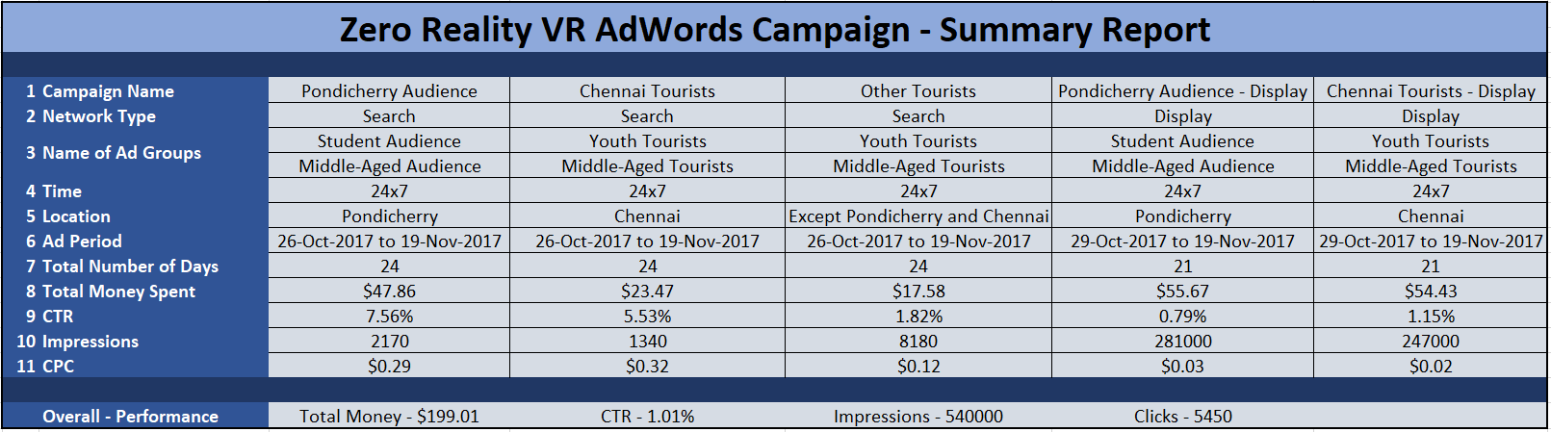

ADWORDS ADGROUP DETAILS
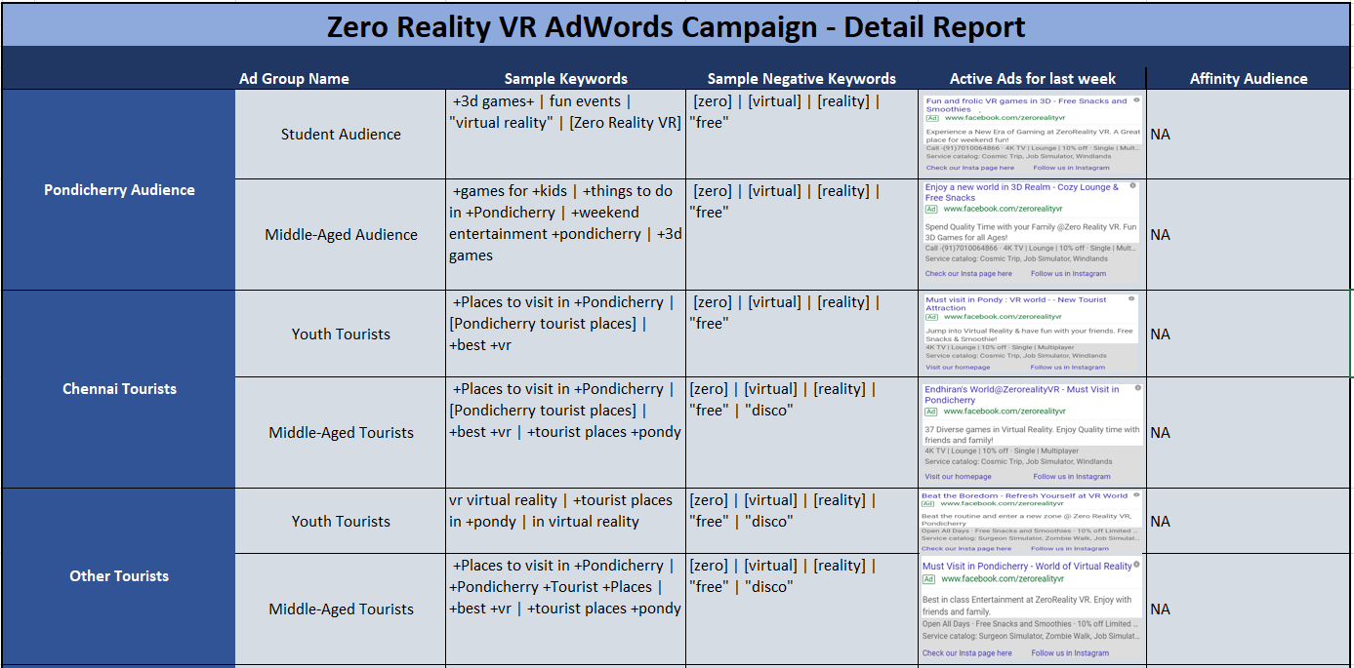

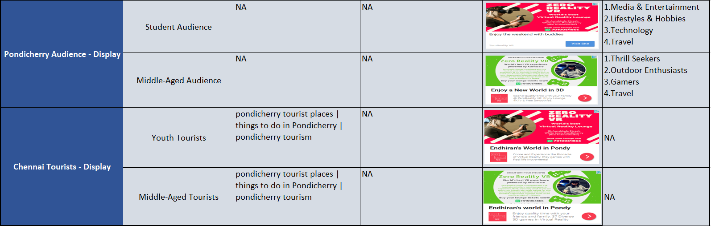

FACEBOOK STRUCTURE
