WindFarm Research Group In ASTU

1. 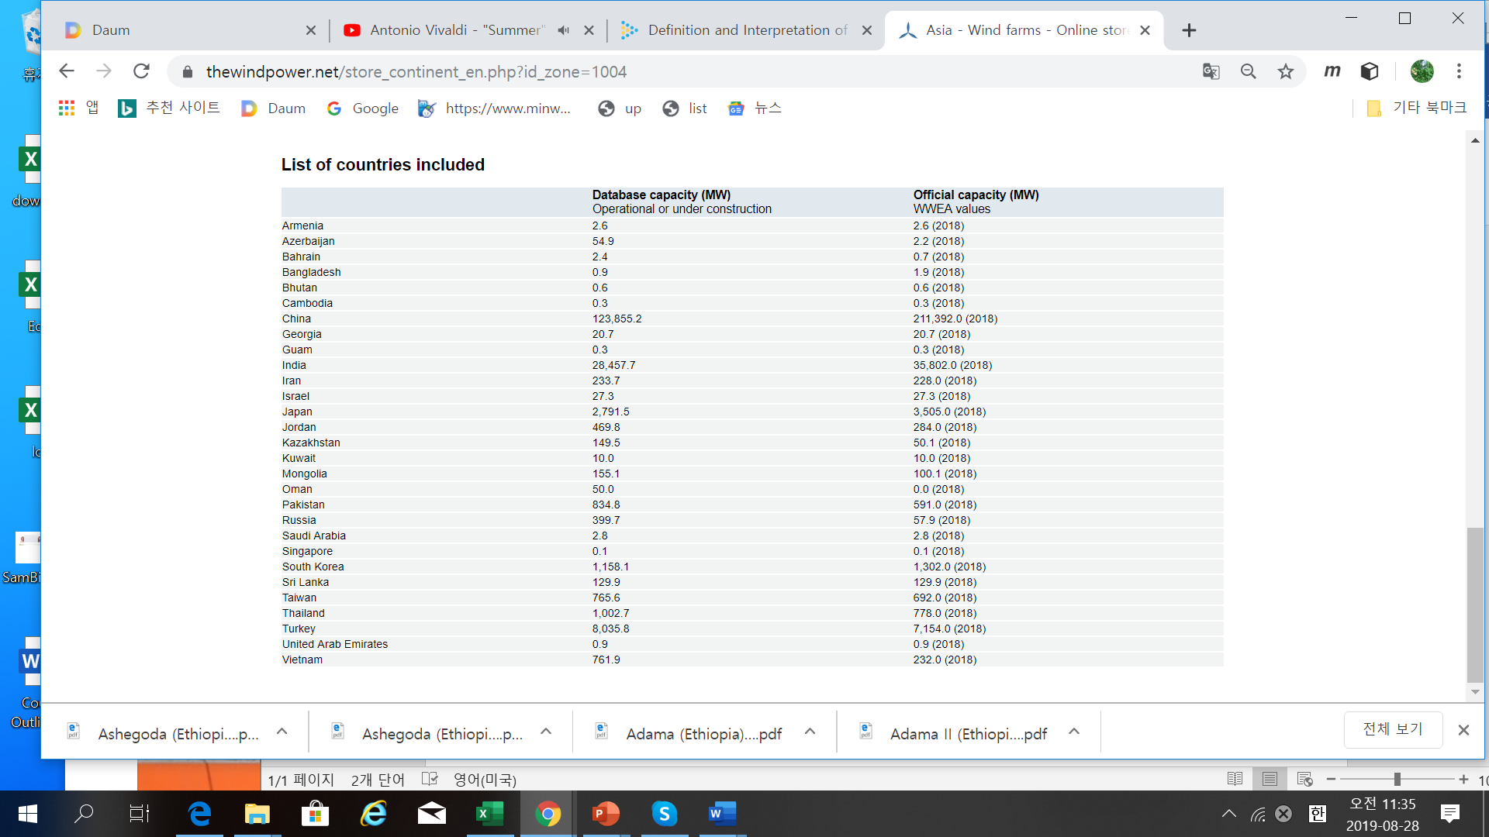Windfarm Status in worldwide

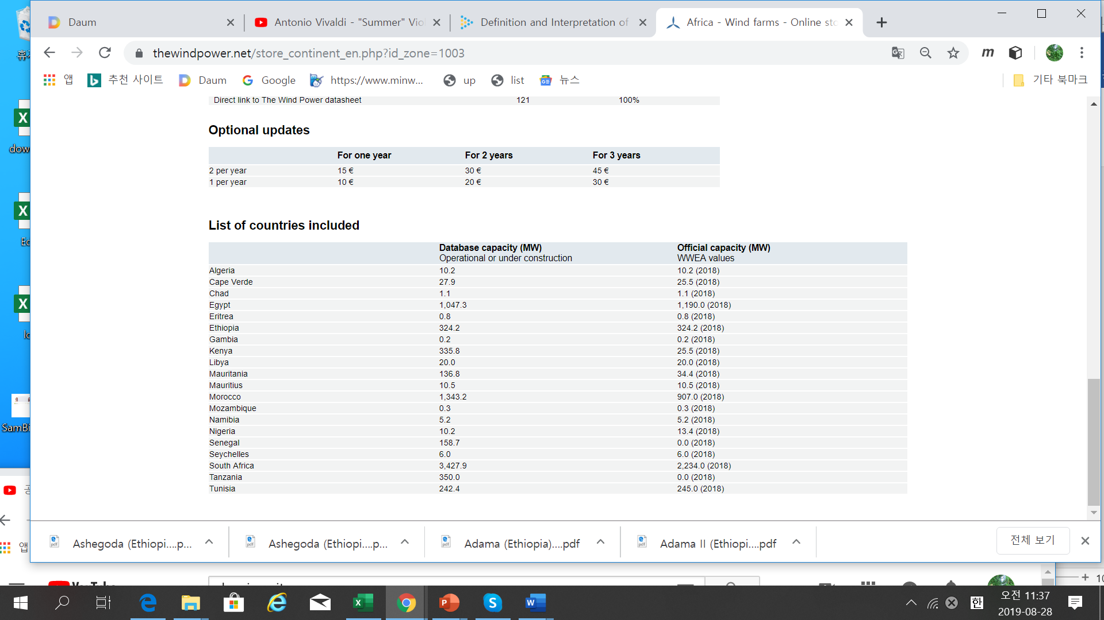

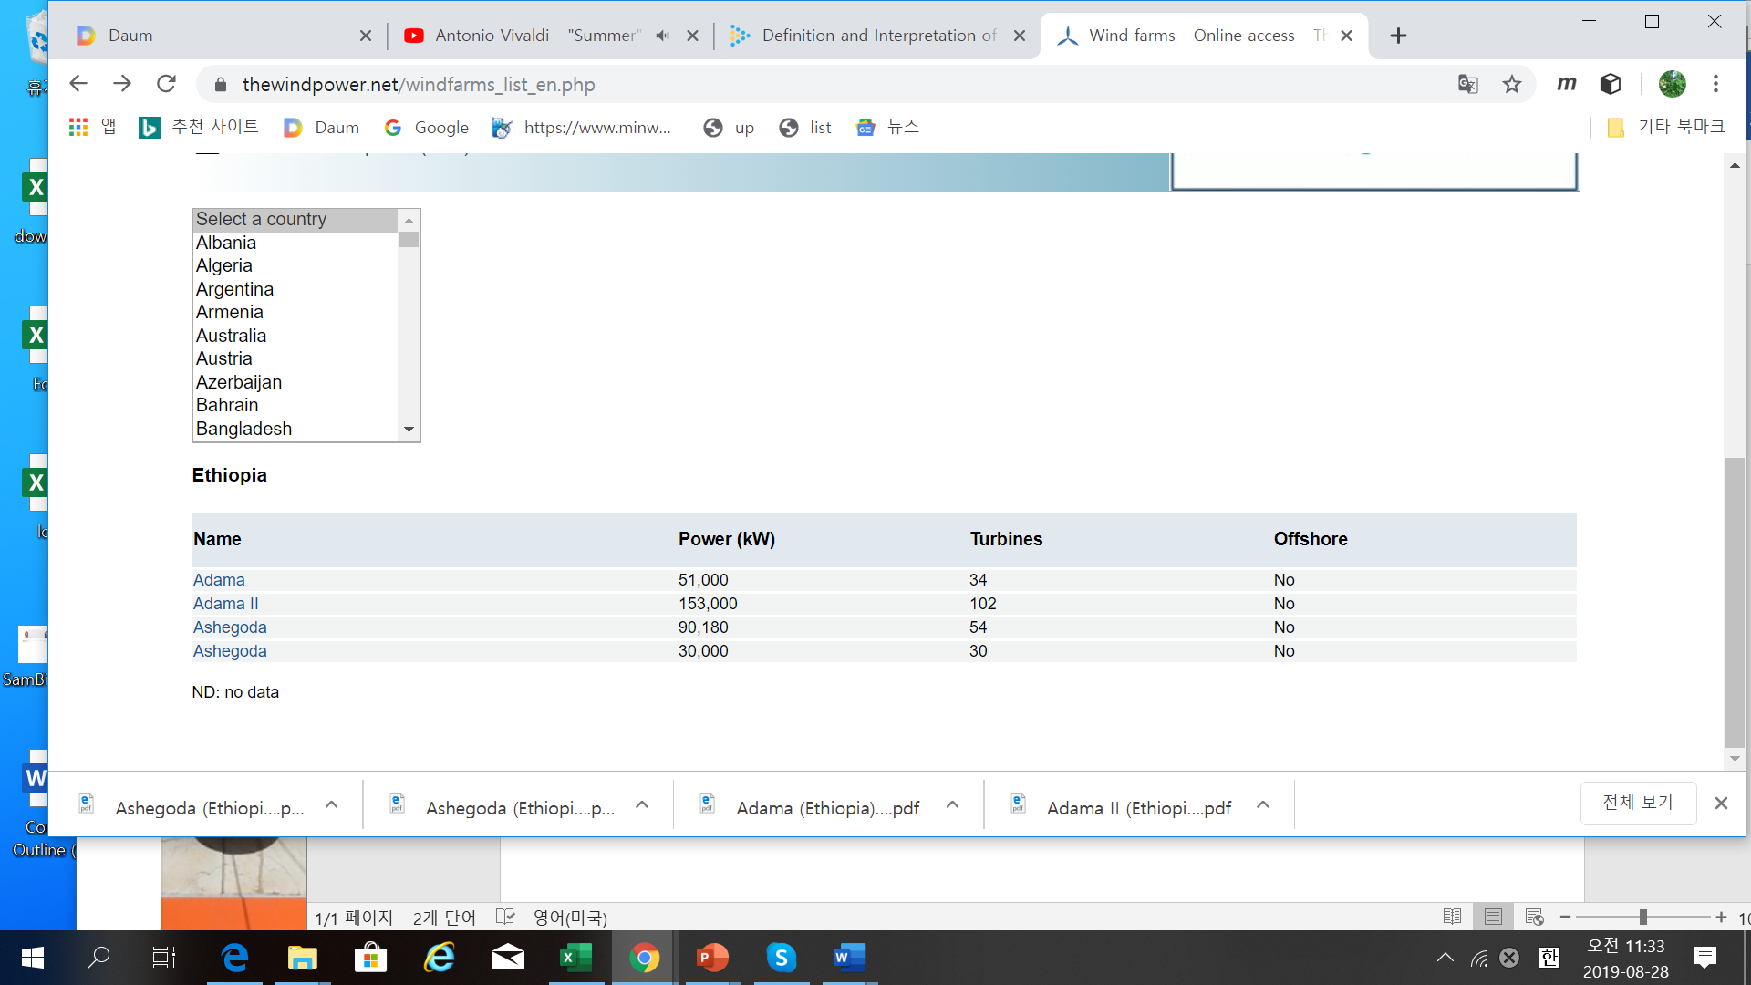

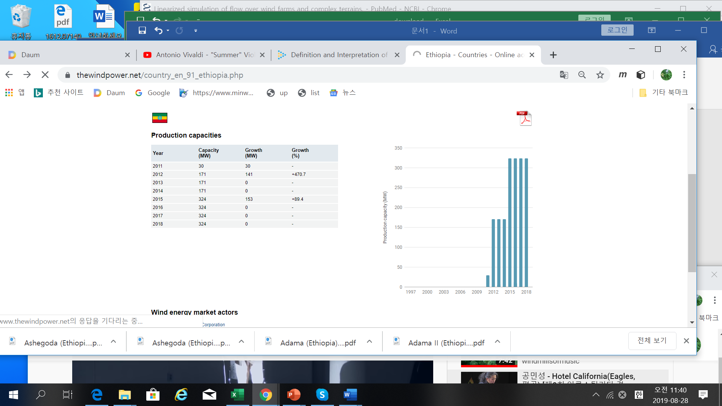

1. Ethiopia Wind Energy Environment

* Wind Source

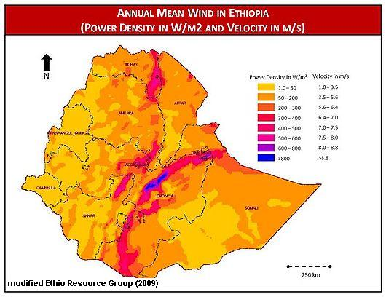

* Temperture / Rainfall

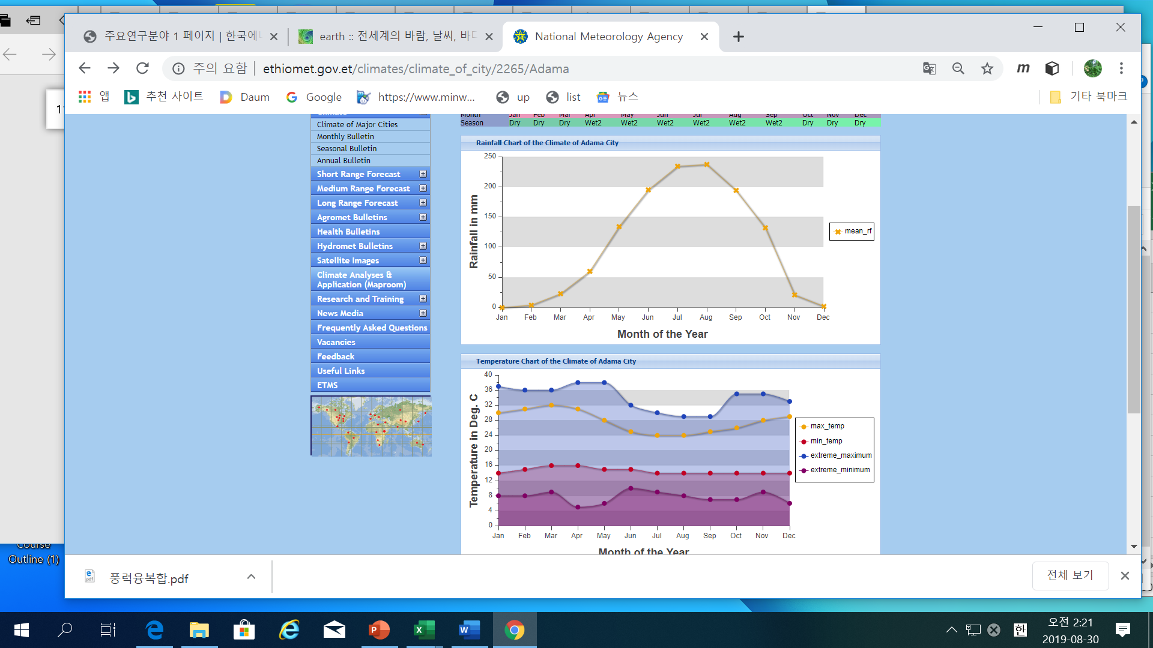



* Alternative energy sources-Wind Energy

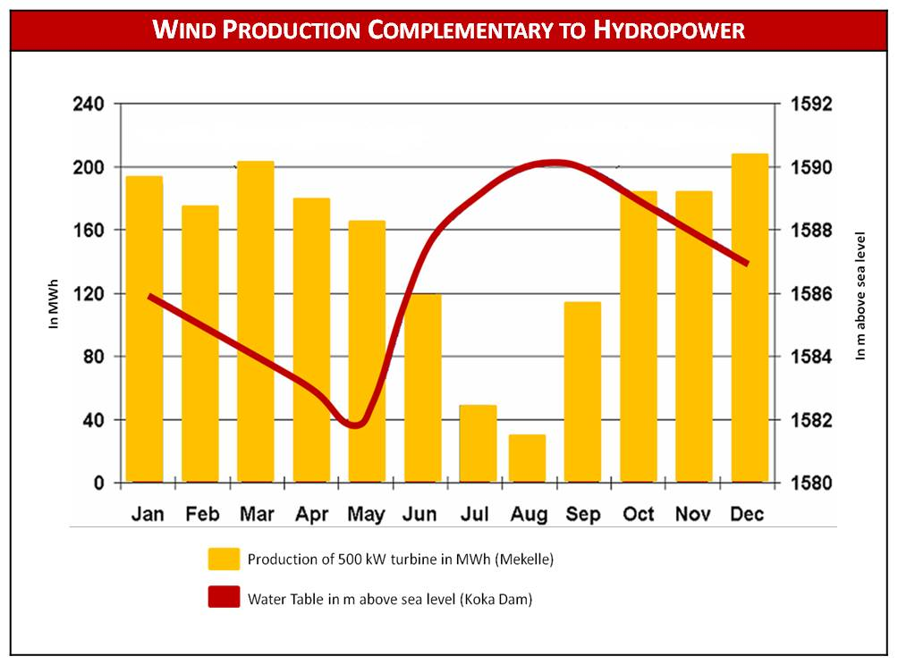

1. Windfarm Study Group
   1. BackGround

* Worldwide study is being done for windfarms as a whole of wind turbines
* In Adama the two big windfarms are deployed and operated at present
* ASTU may be the best university to study and may be capable to research windfarms

due to the regional vicinity and experts

* 1. ASTU windfarm Objective :

1. Increase the efficiency of th WindFarms in Adama
2. **Set up and implement wind turbines in ASTU(Milkias)**
3. Increase the capabilities for windfarms to be competitive to the world
4. Suggest the guide line for the windfarms
5. Co-research with foreign research centers
6. WindFarm Study Group Hierarchies
7. Windfarm modelling
8. Windfarm Sensitivity Analysis
9. Windfarm Control

%% Suggestion (Dr.Dereje)

-Formal Research Proposal:

+ Department 🡪 School

-Proposal Issued

+Grnat will be provided for research gruop

External Organization

* Windfarm Factory
* National Metrology Agency

Adama WindFarm Center

* Internal program management
* External co-work

Modeling

* Distributed system
* Neural Network
* National Metrology Agency

Control

* Droop control
* Non-linear Control (Quasilinear)
* Supervisory /distributed control

Sensitivity

* Local / Global sensitivity analysis
* Sobol/ FAST/Morris Methods
* National Metrology Agency

1. Reference : present Resarch
2. **WindFarm modeling**

* “Turbulence and **entrainment lengthscales** in largewind farms”, 2017, Denmark
* “Modelling turbulent boundary layer flow over fractal-like multi scale terrain using large-eddy simulations and analytical tools”,2016, Denmark
* “Windfarms in complex terrains :an introduction”, 2017, Sweden
* “Linearized simulation off low over wind farms and complex terrains”,2017,Sweden
* “Wind Farm Layout Sensitivity Analysis and Probabilistic Model of Landowner Decisions”,

USA

1. **Windfarm Control**

-“**Quasilinear Control** of Wind Farm Power Output”, 2015, USA

-“Simulation and Optimization of windfarm controllers”, 2004, Denmark

-“A wind farm control strategy for power reserve maximization”, 2018, Spain

-“Wind farm models and strategies”, 2005, Denmark

-“Totorial of Wind Turbine Control for Supporting Grid Frequency through Active Power Control”, 2012, USA

1. **Wind farm sensitivity**

-“Sensitivity study of a wind farm maintenance decision – A performance and revenue analysis”, 2018, Spain/UK/Netherland

-“Sensitivity Analysis of Wind Plant Performance to Turbine Design Parameters: A systems Engineering Approach “, 2014, USA

-“**Global Sensitivity analysis** of wind turbine output”, 2013, Canada**(summary and GSA introduction abalable to S.Kim)**

-“Sensitivity study of a farm maintenance decision- A performance and revenue analysis”,2018, Spain/UK/Netherland

-“Sensitivity Analysis of Wind Characteristics and Turbine Properties on Wind Turbine Loads”,2016, USA