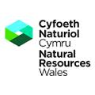 | 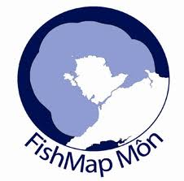
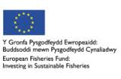 | 

FishMap Môn Guidance Tool
User Guide

TABLE OF CONTENTS

1 Overview 3
2 The Interface 4
2.1 Changing the underlying Map 4
2.2 Navigating around the Map 6
2.2.1 The Navigation Tool 6
2.2.2 Searching 6
2.3 Adding other Map Layers 6
2.4 Displaying Detailed Map Information 8
2.5 Selecting FishMap Môn Results 8
2.6 Create your own Fishing Scenario 9
2.7 Exporting your Current Scenario 11

Overview
FishMap Môn is a pilot project initiated by Countryside Council for Wales now run by Natural Resources Wales working in partnership with fishermen’s associations to help establish the sustainability of fisheries in the project area (the inshore waters around Anglesey, in North Wales). As a pilot project, FishMap Môn will engage with the local fishing industry in trialling approaches of collecting and mapping information on fishing activity and combining it with existing data on habitat type and sensitivity.
Fishing activity data has been collected by means of computer-based interviews of local fishermen. This information has been processed to determine the intensity of the overall fishing activity occurring within the Project area for various fishing gear types. Due to the confidentiality agreement that governs access to the fishing activity data collected within the project, data is summarized to a 1-km resolution for public release. Fishing activity information is combined with existing knowledge about the marine habitats and their sensitivities to fishing activities using mapping approaches.
The project is funded by the European Fisheries Fund and the Welsh Assembly Government and will help achieve the vision of the Wales Fisheries Strategy - to “support the development of viable and sustainable fisheries in Wales as an integral part of coherent policies for safeguarding the environment.”
FishMap Môn allows the visualization of habitat and fishing information, and the simulation of fishing scenarios in the area/s of interest, investigating the sensitivity of impacted habitats and providing guidance to a range of stakeholders with their decision making processes for sustainable fisheries management
Due to the sensitivity of the data the fishing area extents and data have been generalised to a one kilometre grid.
Note: Users who have been issued with a password are able to Sign in in order to access more detailed data.

The Interface
When you first browse to the FishMap Môn web site http://fishmapmon.naturalresourceswales.gov.uk/ you will see a fairly blank map zoomed out to the full extents of the geograhical area covered by this project e.g.

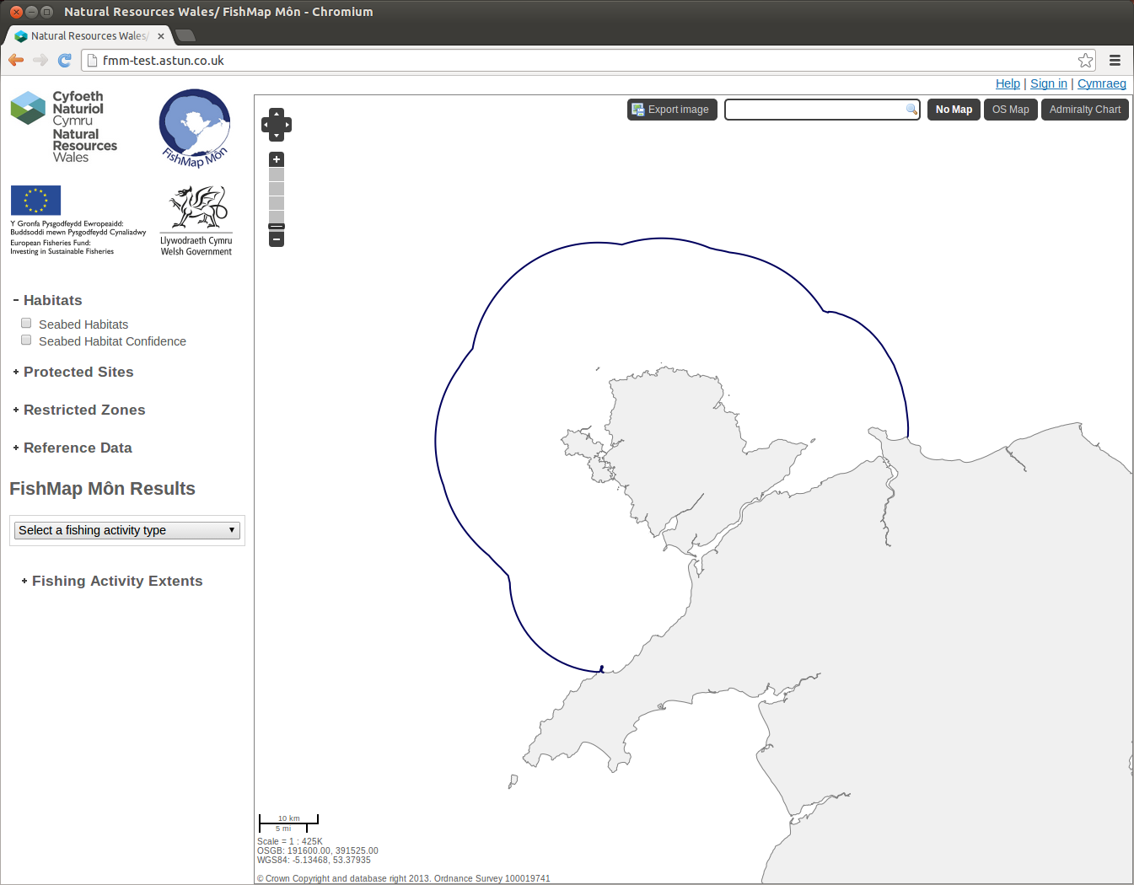

Changing the underlying Map
If you look at the top right hand corner of the map you will see three buttons; the highlighted button will be the current view which in this case is No Map:
- No Map – this just displays the basic coast line and the 12 mile fishing limit.
- OS Map – displays Ordnance Survey maps
- Admiralty Chart – displays Admiralty Charts
The following two screenshots show the other map options.
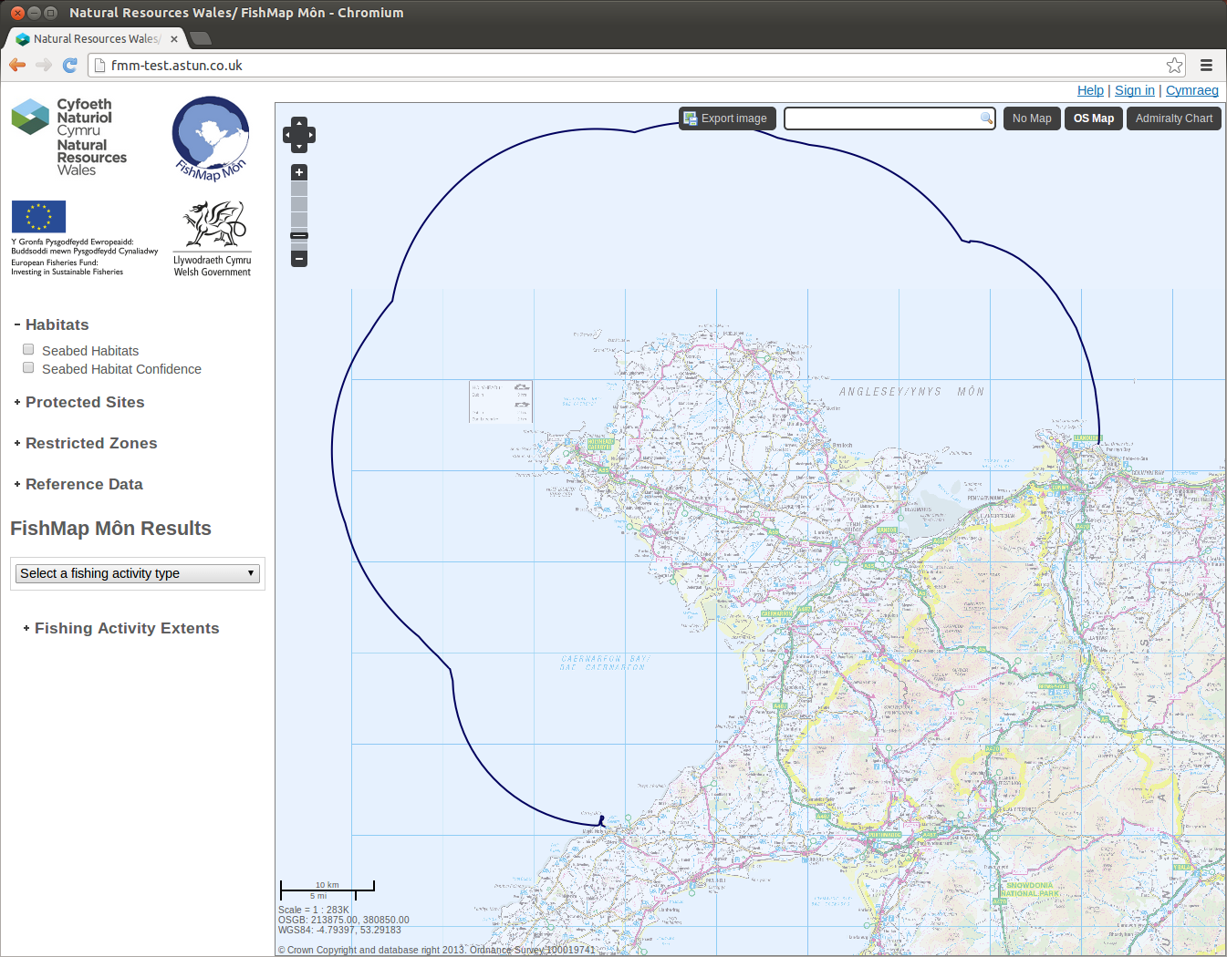
Ornance Survey base mapping
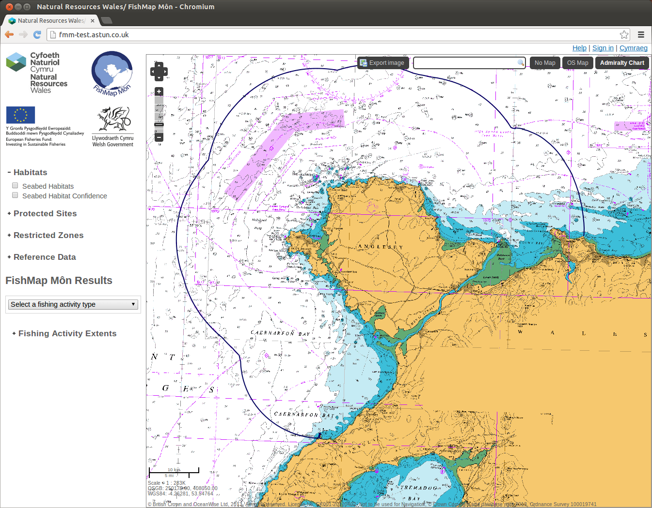
Admiralty Chart base mapping

Navigating around the Map

The Navigation Tool
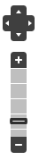 | The Navigation Tool allows you to zoom and scroll by pre-set units.  There are also various mouse shortcuts such as:  - If you hold down the shift key you will be able to perform a marquee selection, draw a rectangle, to zoom into a particular area of the map.  - You can use the scroll bar on your mouse to zoom in and out.  - If you click and hold the left mouse button you can drag the map to scroll.

Searching
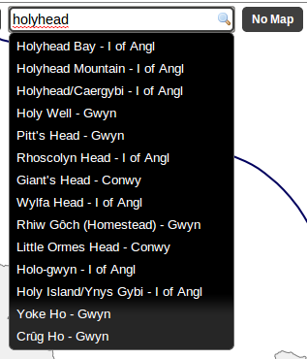 | If you start typing in the Search box you will see a list appear from which you may make a selection. The map will then be positioned with your selection at the centre of the map.

Adding other Map Layers
When FishMap Môn first opens the Habitats group will be expanded showing two different entries of:
- Seabed Habitats – displays the seabed habitats.
- Seabed Habitat Confidence – displays the confidence in the accuracy of the seabed habitat.
To display the Seabed Habitats information simply click in the box to the left of the entry e.g.
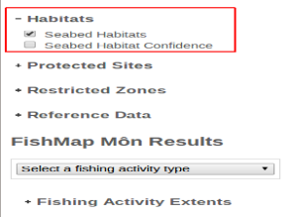
When you check the entry the respective map layers are displayed together with a Legend explaining all the colours e.g.
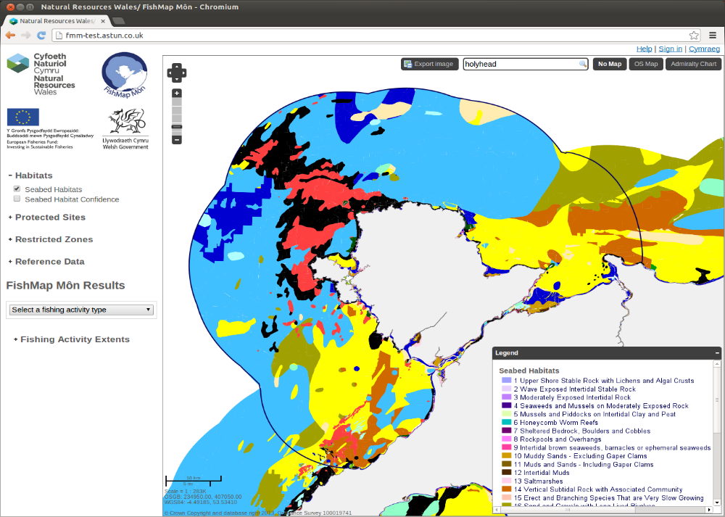
The Map layers have been grouped into various categories.
- Habitats
- Protected Sites
- Restricted Zones
- Reference Data
To expand a group to display the individual map layers available click on the plus sign to the left of the group heading e.g.
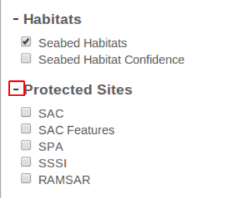
Once you have expanded the group you can select the individual layer you wish to be displayed on the map. You may select multiple layers to be displayed at the same time but be careful as the map can become overcrowded. To remove a layer from the map uncheck the box beside the layer that you wish to remove.
To hide the layers in a group click on the minus sign.

Displaying Detailed Map Information
If you wish to display more detailed information about an area on the map simply click on the map and an Information dialog will be displayed e.g.
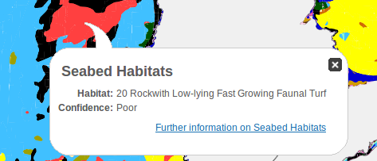
Here you can see the type of habitat and also the confidence value for this. Click on the cross to remove the information box.

Selecting FishMap Môn Results
This is where you can select to display the results of the fishing activity data that had been collected. First you need to select an activity type from the selected list e.g.
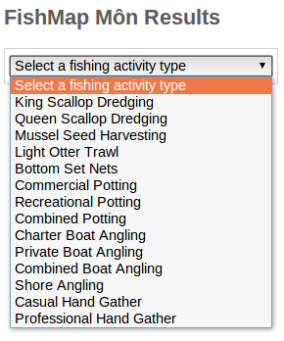
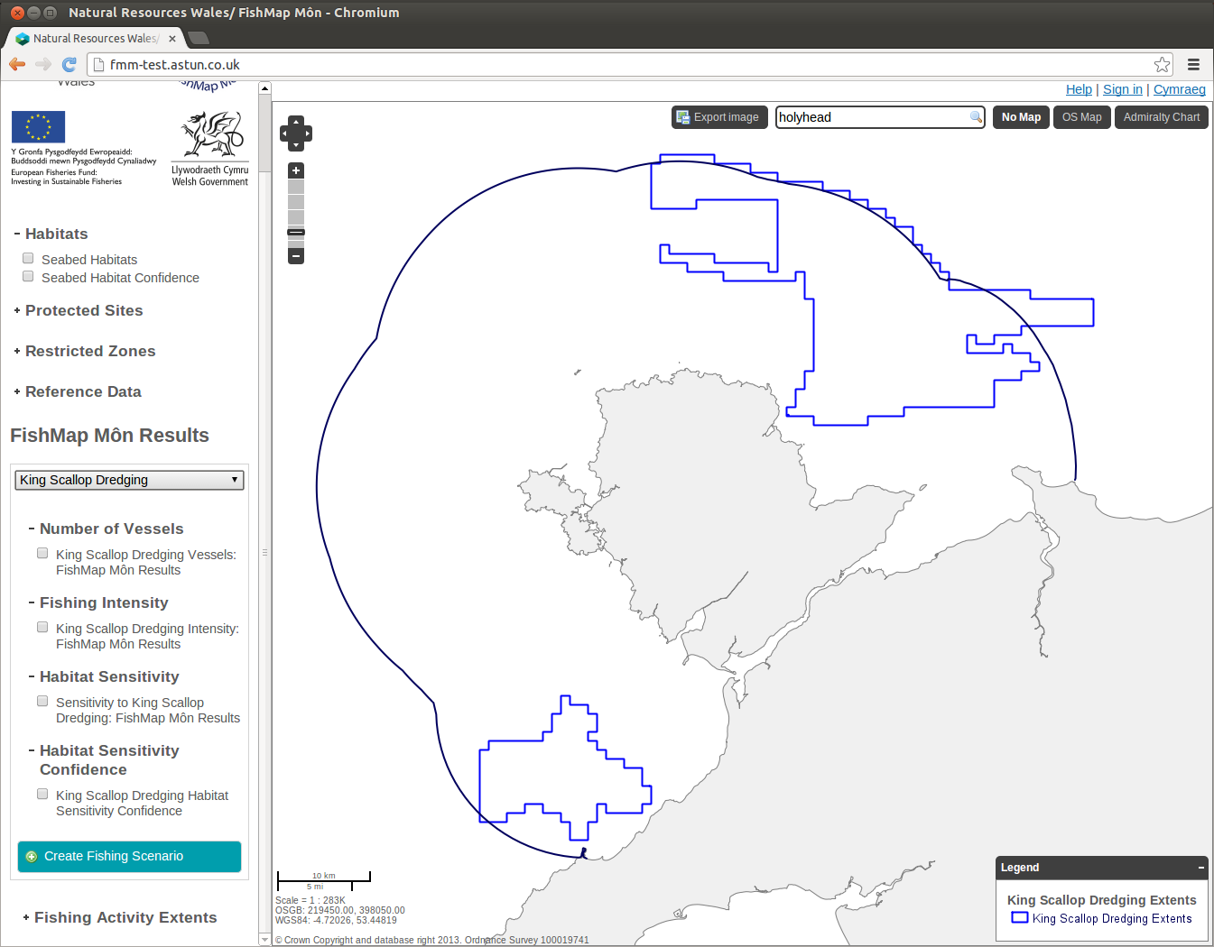 | Once you have selected an activity type the Fishing Activity Extents i.e. the area where this type of fishing is found, will be drawn on the map.  ⬅===  Also a list of map layers related to this fishing activity displayed in the left hand panel. Click in the box beside the layer name to display that layer on the map.  ⬅===

Create your own Fishing Scenario
If you wish you can create your own Fishing Scenario and display it on the map. First you need to select the Type of fishing activity for which you wish to create your own scenario. This is described in the previous section on Selecting FishMap Môn Results.
Once you have selected a Fishing Activity Type you will see a button for creating your own scenario e.g.
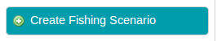
Click on this button and you will then be asked to draw an area on the map e.g.
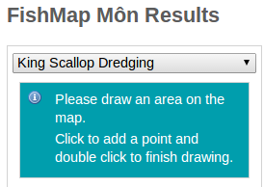

In order to draw your area more acurately you may wish to zoom in or pan the map to the location required. To draw the area click with your mouse on the map and keep clicking to draw a polygon area. To finish drawing double click and the polygon will turn red as shown in the following screenshot.
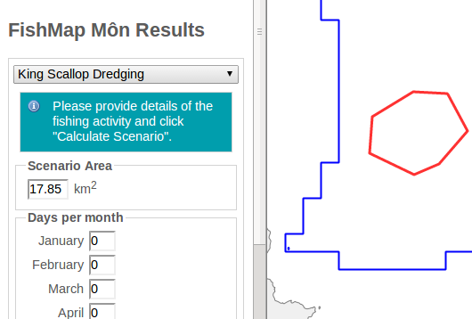

Once you have drawn your area you will then be able to provide details of your fishing activity by entering information into the boxes provided. Use the scroll bar, if required, to enter all of the information.
If you wish to start again click the Clear Scenario button or to calculate your own scenario click the Calculate Scenario button. These buttons may be found at the bottom of the data entry boxes e.g.
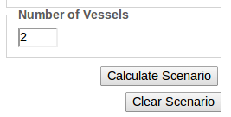
Once you click the Calculate Scenario button the results will be displayed on the map.
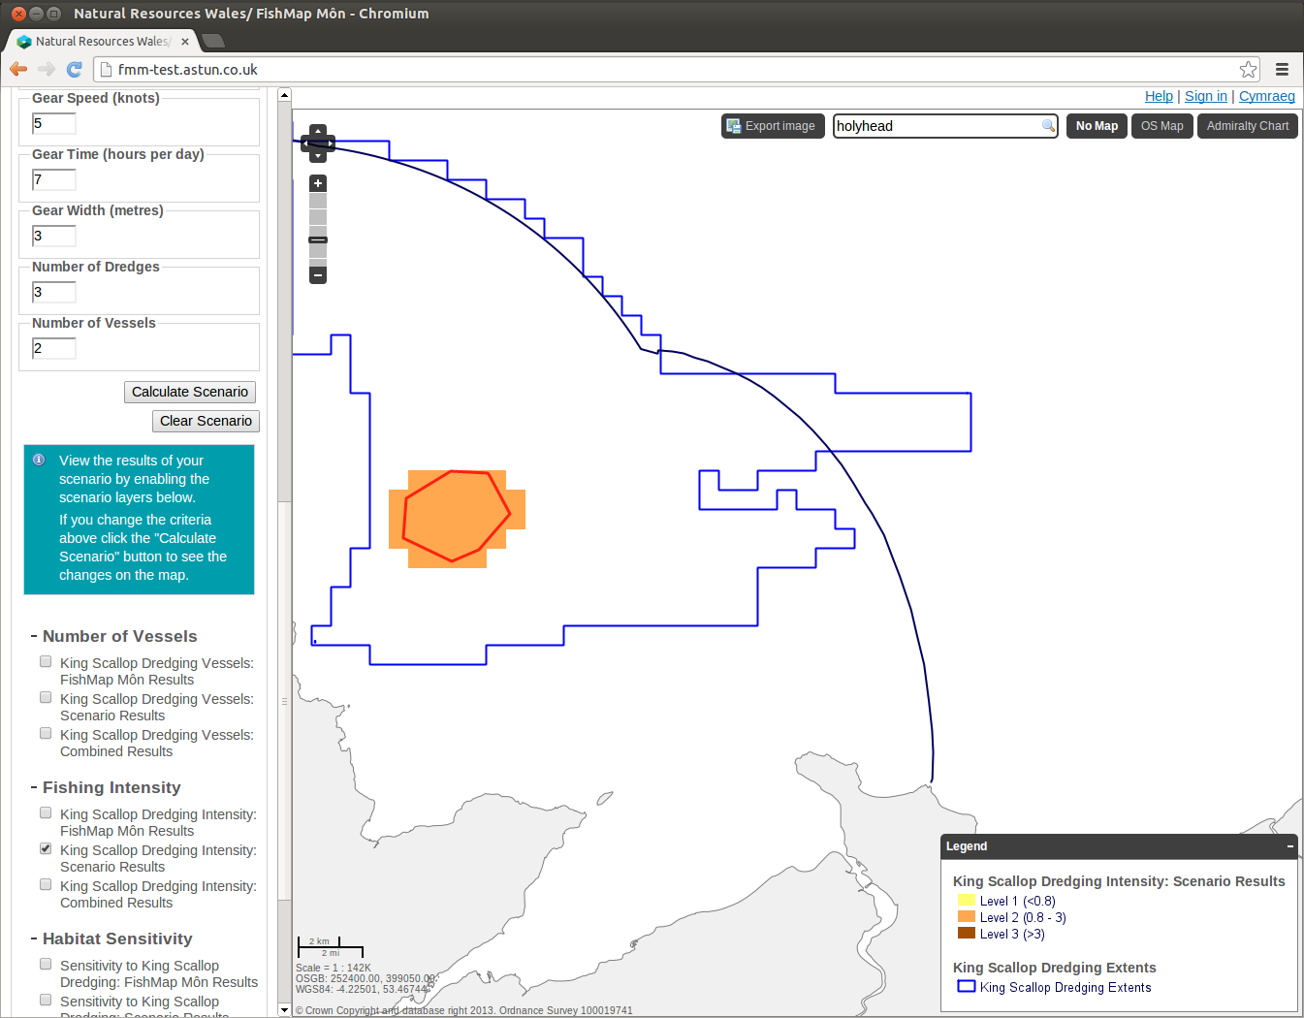
If you wich to change any of the criteria simply update the information and then click the Calculate Scenario button again to see the changes on the map.
Now you can choose to display:
- the results from your scenario,
- the FishMap Môn results
- a combination of the two.
Enable the scenario layers that you wish to display by clicking in the box beside the relevant entry.
If you wish to display the detailed information for your scenario, click on the area that you have drawn on the map and an information box will be displayed with the details e.g.
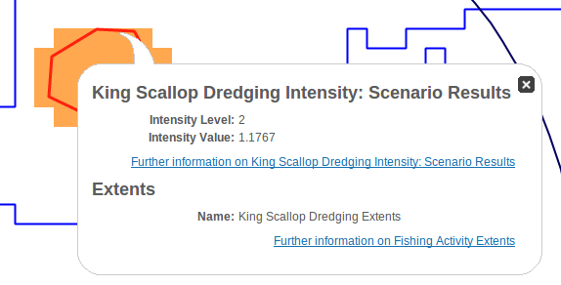
Click on the cross to remove the information box.
You cannot save your scenario but you can export it as an image. Please see the following section on Exporting your Current Scenario for details.

Exporting your Current Scenario
If you wish to keep a copy of your current map selections, and scenario if you have created one, then you can export this as an image. Click on the Export image button that you will see at the top of the page e.g.
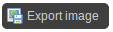
When you click on this button you will see a Please wait.. message whilst the image is being generated. When the image has been created you will see a Download image link e.g.
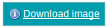
Click on this link to download the generated image.
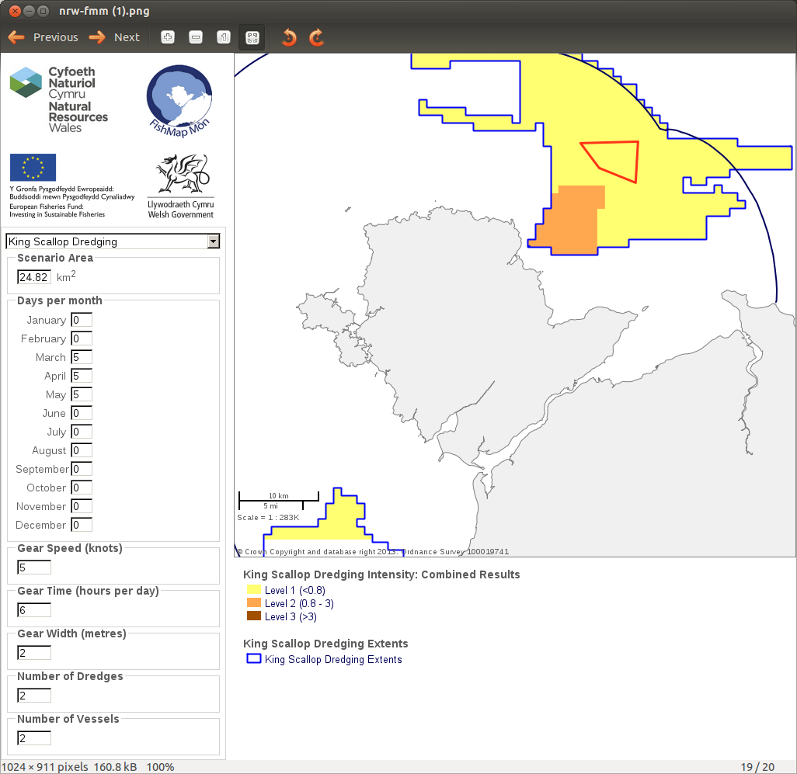
As you can see from our example, if you have created a scenario all of this information will be included in the image. You can then choose to right click on the image and Save As the format you require.

