CRM Build Spec
Unified CRM for AstonomiQ, Astura, Headwy
One platform, three brands. Every lead, contact, and company carries a brand tag (AstonomiQ / Astura / Headwy). One database, one login, one admin panel. Filters and reports split by brand.

1. Data model
- Three core entities: Lead, Contact, Company. All carry a brand tag.
- Lead links to one Contact and one Company.
- Contact links to one Company. One Company has many Contacts and many Leads.
- No duplicate company entry. Fill once, reuse.
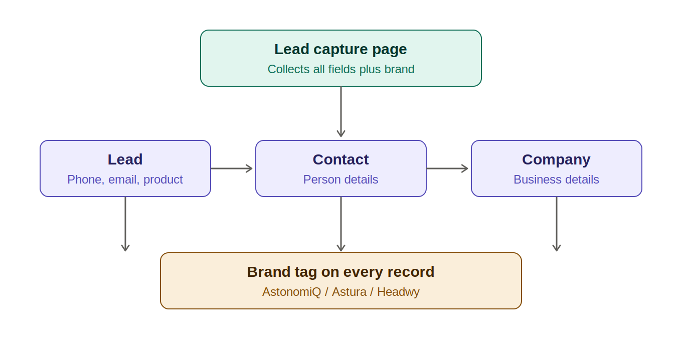

Lead fields
Field | Type / note
Lead name | text
Phone (primary) | number, required
Contact numbers | up to 4
Email id | email, required
Location / address | text
Product pitched | dropdown
Brand | dropdown: AstonomiQ / Astura / Headwy, required
Lead source | dropdown: website, referral, call, campaign, walk-in
Lead owner | user reference
Stage | dropdown (see section 3)
Created date / last activity | auto timestamp
Custom fields | admin-configurable, no code

Contact fields
Name, designation, phone numbers, email, address, company reference, brand tag.

Company fields
Company name, industry, website, address, brand tag.

2. Lead capture page
- Public web form, shareable and embeddable.
- Captures: name, 4 contact numbers, email id, location address, product pitched, brand (dropdown).
- On submit: creates Lead + Contact + Company in one step.
- Duplicate check by phone and email before create.
- New lead drops into Leads Inbox.
- Auto-assign by brand, product, or location. Round-robin option. Manual reassign.

3. Pipeline and lead cycle
- Default stages: New, Contacted, Qualified, Proposal sent, Negotiation, Won, Lost. Renamable and reorderable per brand.
- Kanban board: leads as cards in stage columns, drag to move.
- Funnel chart with stage counts and drop-off. Filter by brand, owner, product, date.
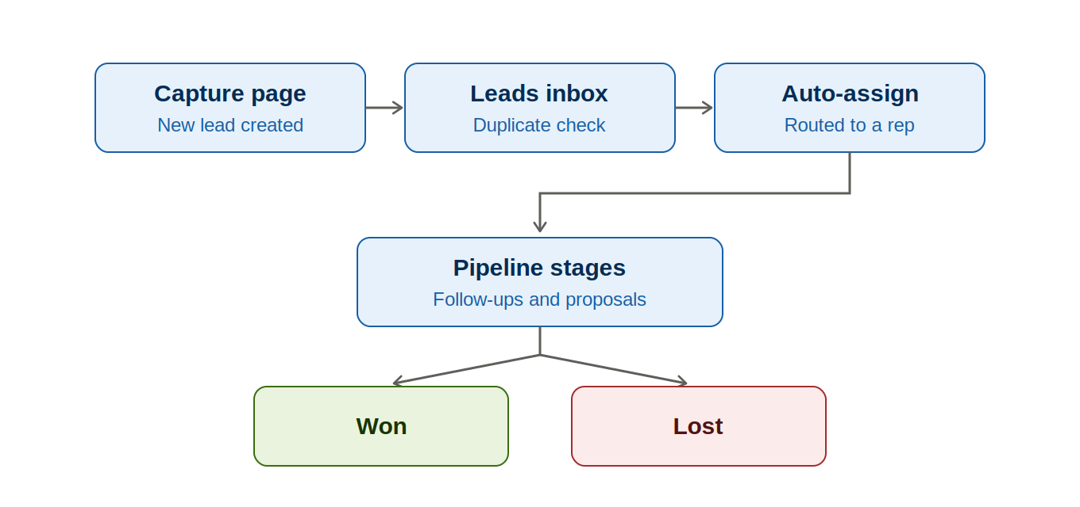

Comments and follow-ups
- Comment on any lead. Log call, email, meeting note.
- Set follow-up with date and time. Reminder to owner when due.
- Activity timeline per lead, newest first.

Proposals
- Reusable proposal templates, linked to a lead.
- Line items: description, quantity, rate. Amount auto-totals.
- Taxes (GST or other) as percent or fixed. Show subtotal, tax, grand total.
- Export PDF. Status: draft, sent, accepted, rejected.

Dashboard and reports
- KPIs: total leads, leads by stage, leads by brand, conversion rate, pipeline value, top sources, tasks due today.
- Filter dashboard by brand and date range.
- Reports by source, owner, brand, product, stage, value. Export Excel and PDF.

4. Users, roles, access
Role | Access
Admin | Full control, settings, all brands, all data
Manager | Team leads, reports, pipeline for assigned brands
Sales rep | Own leads, comments, stage moves, proposals
Viewer | Read-only reports

- Brand-level access: a rep on one brand sees only that brand data.
- Field-level visibility per role. Record ownership rules.
- Action limits: who can delete, reassign, export.
- Admin panel: users, roles, brand access, custom fields, stages per brand, proposal templates, tax rules, auto-assign rules, audit log.
- Notifications: new lead assigned, follow-up due, stage change (managers).

5. Build phases
Phase | Scope | Weeks
1 Foundation | DB + brand structure, login + roles, Lead/Contact/Company modules, capture page + dup check | 3 to 4
2 Sales engine | Stages, pipeline board, funnel, comments + follow-ups, distribution rules | 3 to 4
3 Proposals + reporting | Proposal templates + taxes, PDF export, dashboard + reports | 2 to 3
4 Admin + rollout | Access control, audit log, notifications, data import, testing + training | 2

Total: about 10 to 13 weeks. Shifts with custom field count and any outside connections.

6. Out of scope (phase later)

Decisions needed before start
- Roles beyond the four above?
- Custom field count per brand?
- Tax rules per brand?
- Data import source (which current tool)?

