Crop and Farm Data Management System
Object Oriented Software Engineering Mini Project
AI Based Irrigation Advisory System for Sugarcane Crop
Batch: A1 | Academic Year: 2026-27
Member 1: Siddh Dedhia | Roll No.: 16014224008
Member 2: Sahil Gawas | Roll No.: 16014224019
Member 3: Aarush Ghosh | Roll No.: 16014224021
Project domain: Sugarcane crop irrigation | Module: Crop and farm data management

Aim
To design and implement a Crop and Farm Data Management module for a sugarcane irrigation advisory system. The module allows users to enter, validate, save, retrieve, update, filter, display, and export structured farm and crop information through an interactive web interface.

Methodology
1. Requirement analysis. We restricted implementation to farm and crop data management. The required fields are farm name, location, cultivated area in acres, sugarcane variety, soil type, plantation date, and crop growth stage. The system intentionally contains no login module.
2. Interface design. We developed a responsive React dashboard and record workspace with consistent typography, subtle animations, reusable controls, and a logo-controlled collapsible sidebar. The dashboard summarises registered farms, cultivated area, leading growth stage, and the most recorded variety.
3. Data entry and validation. The form validates every mandatory field before saving. It checks for a positive numeric area, supported crop and soil values, a valid growth stage, and a plantation date that is not in the future. Validation is performed in both the browser and the Python service.

Methodology continued
4. Application service. A Flask REST API separates interface behavior from data operations. Dedicated endpoints create, list, retrieve, update, delete, aggregate, and export farm records while returning clear validation and not-found responses.
5. SQLite persistence. Farm and crop details are stored in an SQLite database with typed columns, required constraints, a positive-area check, timestamps, and indexes for farm name and growth stage. Thirty-two realistic Maharashtra sugarcane records are seeded idempotently for demonstrations.
6. Retrieval and reporting. Users can search by farm, location, or variety; filter by crop growth stage; open detailed records; edit previously saved information; and export all records as CSV. The record list uses server-backed pagination with ten records per page.

System structure
React interface | to | Flask REST API | to | SQLite database
The interface requests only the data required for the current view. The Flask service validates each request and performs parameterised SQLite operations. Dashboard summaries and CSV exports are generated from the same stored records, keeping the presentation and exported evidence consistent.

Algorithm
Input: Farm name, location, area in acres, sugarcane variety, soil type, plantation date, and crop growth stage.
Output: A validated and persisted farm record that can be retrieved, updated, displayed, filtered, paginated, and exported.
1. Open the application and initialise the SQLite farms table and indexes if they do not exist.
2. Accept all farm and crop fields from the React data-entry form.
3. Check mandatory values, numeric area, supported options, date format, and future-date restrictions.
4. If validation fails, show field-level messages and stop the save operation.
5. If validation succeeds, insert a new row or update the selected row using parameterised SQL.
6. Retrieve records in reverse update order and apply search or crop-stage filters when requested.
7. Return at most ten records for the requested page with total-record and total-page metadata.
8. Calculate dashboard totals and distributions directly from persisted farm records.
9. Export all saved records with descriptive column headings in CSV format.

Result
The Crop and Farm Data Management module was implemented successfully. The live application supports the complete demonstration sequence: enter Sugarcane Farm - Plot A, save it in SQLite, retrieve the record, change its crop growth stage, and display the updated information. The dashboard and CSV export use the same database, so the visible metrics remain consistent with the saved records.
The demonstration database contains the following verified project values:

Project data and verification
Project detail | Verified value
Farm and crop records | 32
Total cultivated area | 175.10 acres
Sugarcane varieties represented | 5
Soil types represented | 5
Crop growth stages represented | 4
Record pagination | 10 records per page across 4 pages
Persistent data store | SQLite
Export format | CSV with all 32 records

Validation summary
- All seven farm and crop fields are mandatory.
- Cultivated area must be numeric and greater than zero.
- Sugarcane variety, soil type, and growth stage must match supported values.
- Plantation date must be valid and cannot be in the future.
- The server repeats critical validation before every create or update operation.

Live demonstration sequence
1. Open Farm and Crop Records. 2. Select Add record. 3. Use the Plot A demo values and save. 4. Open the stored record. 5. Select Edit this record. 6. Change the crop growth stage and save. 7. Reopen the record and show the updated stage. 8. Export the complete CSV file.

Result screenshots

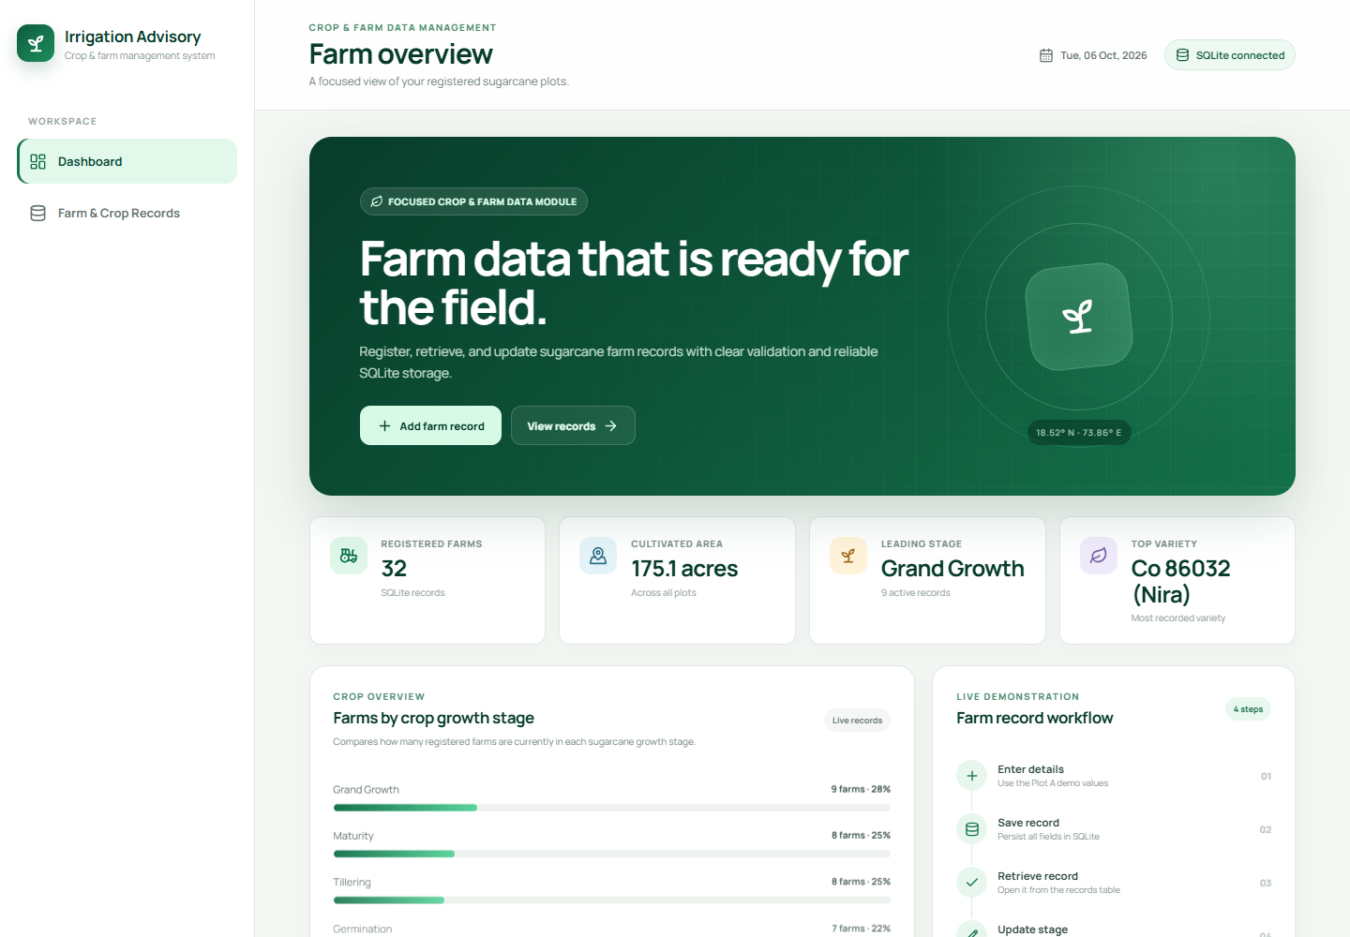
Figure 1: Dashboard showing 32 registered farms, cultivated area, crop-stage distribution, and the four-step live demonstration workflow.

Result screenshots continued

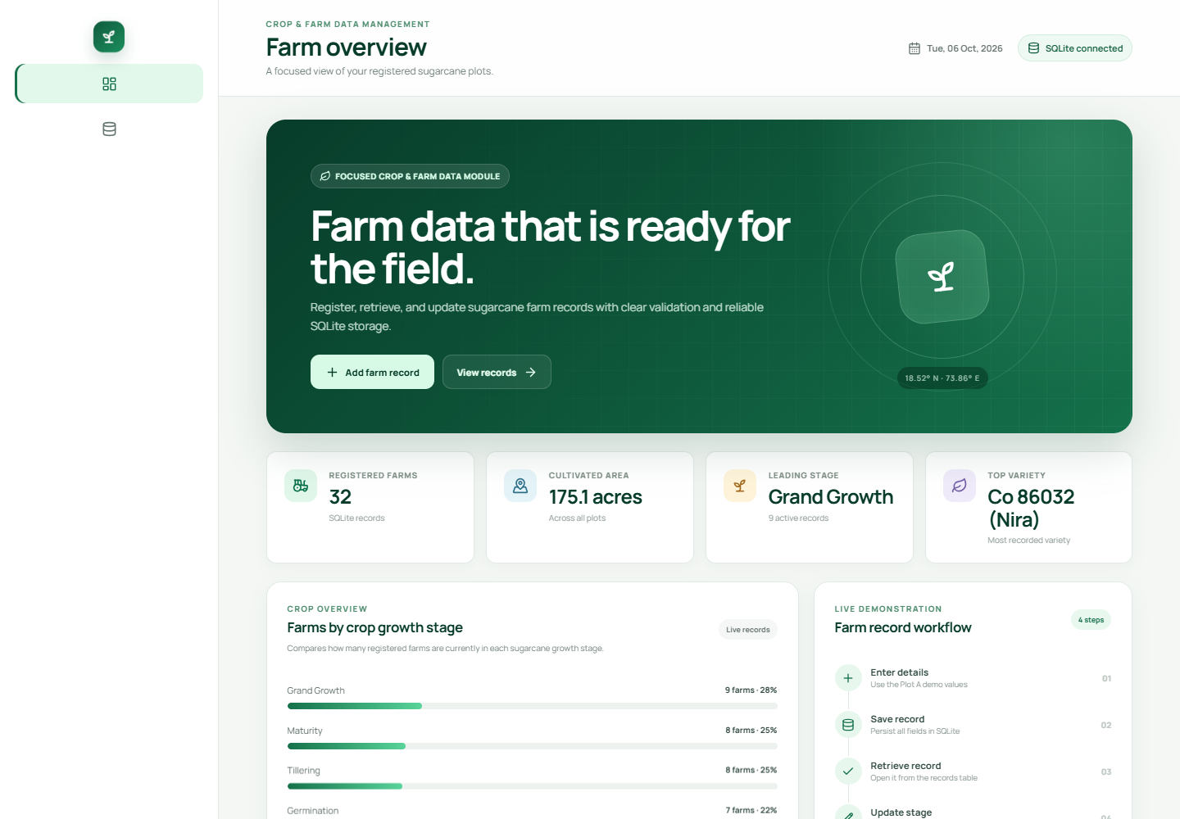
Figure 2: Collapsed navigation state. The project logo acts as the only sidebar toggle and removes the previous overlapping button.

Result screenshots continued

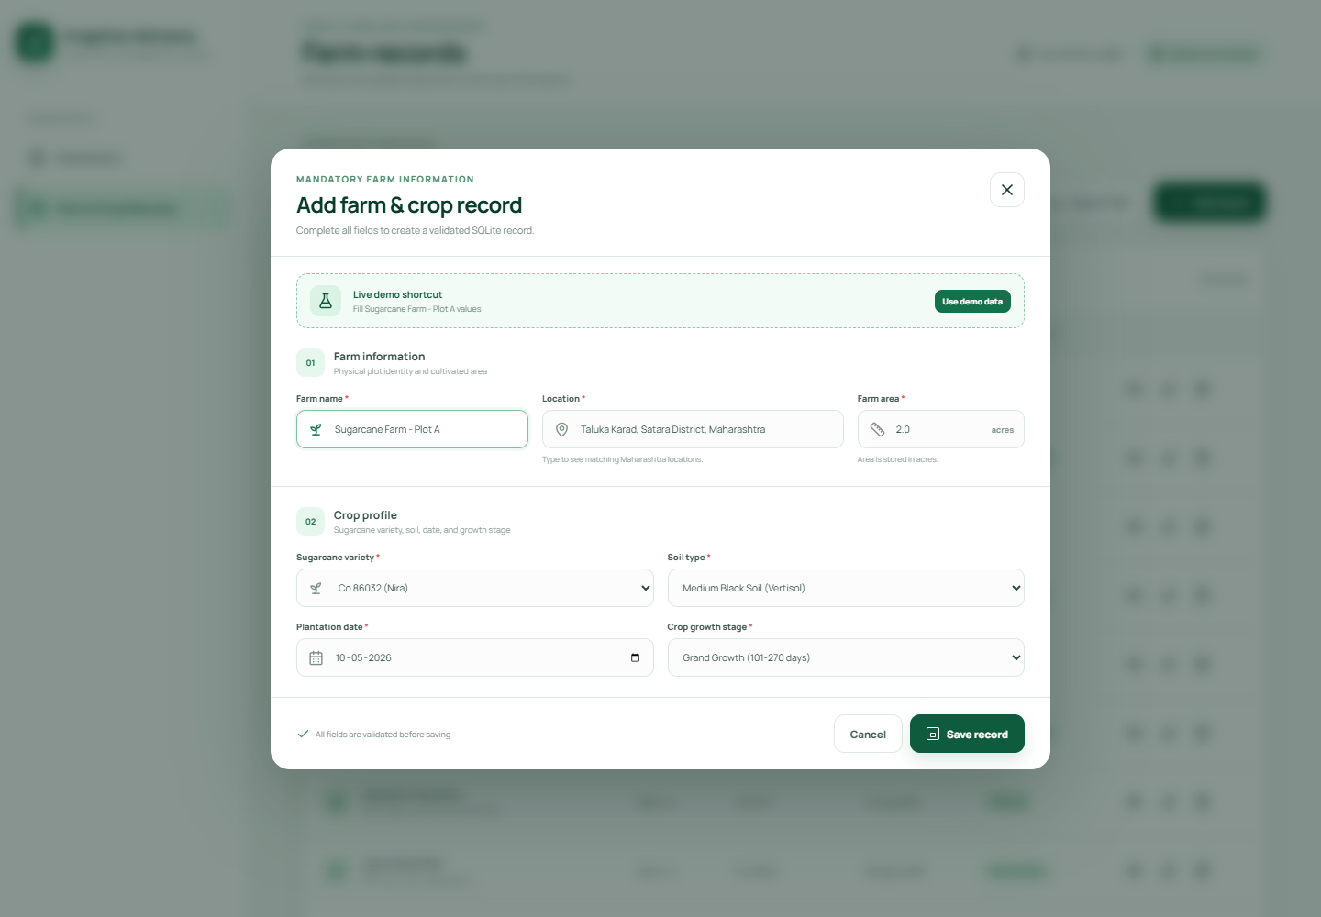
Figure 3: Mandatory farm and crop form populated with the Sugarcane Farm - Plot A demonstration values.

Result screenshots continued

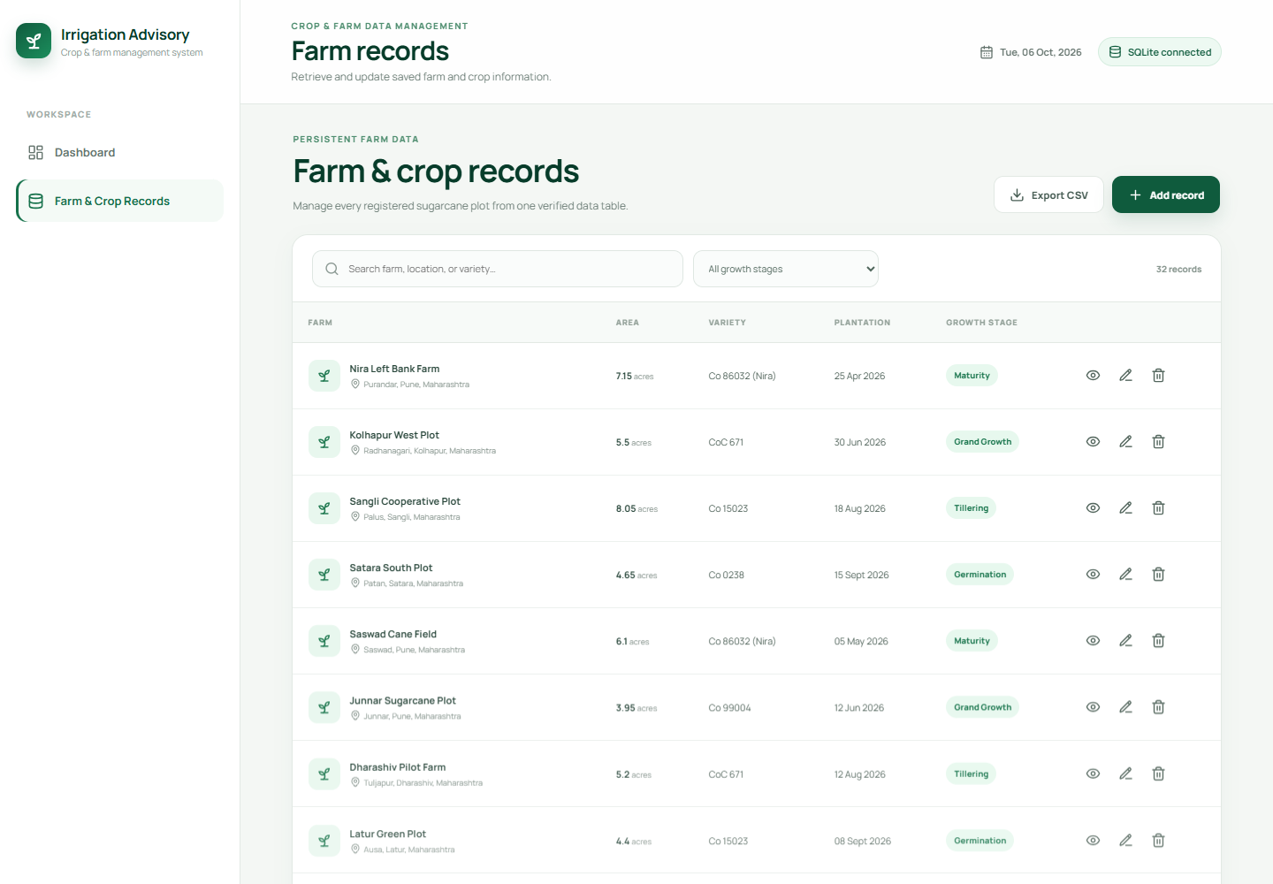
Figure 4: Farm and crop record workspace with search, growth-stage filtering, CSV export, and ten-record server pagination.

Result screenshots continued

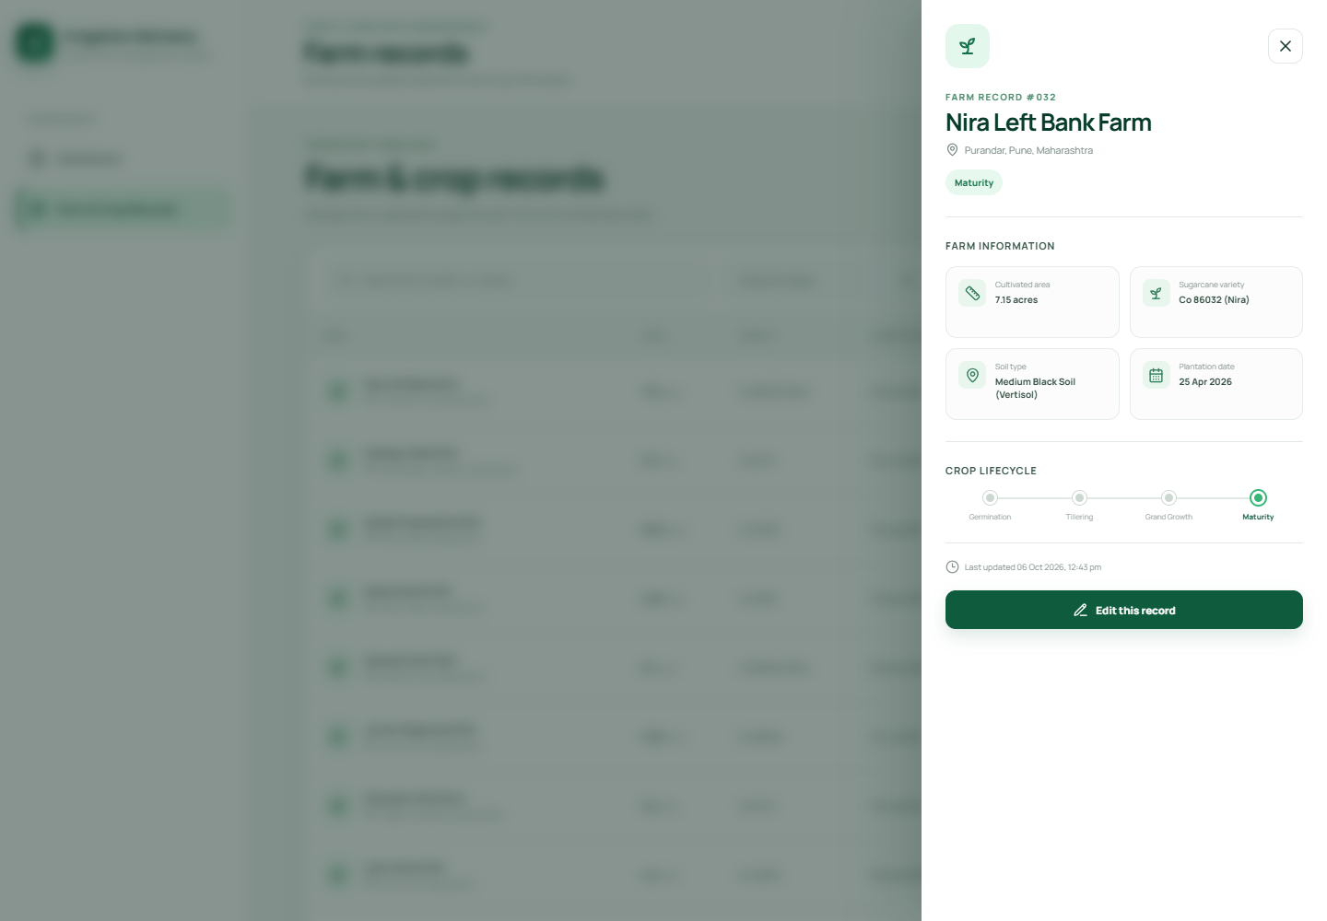
Figure 5: Retrieved farm record showing cultivated area, variety, soil, plantation date, growth stage, lifecycle, and the update action.

Exported data preview
The CSV export includes every saved farm record. The following representative rows show the field structure used in the exported file.
Farm | Area acres | Variety | Growth stage
Sugarcane Farm - Plot A | 2.00 | Co 86032 | Grand Growth
Koyna Valley Plot B | 3.50 | Co 86032 | Grand Growth
Krishna Riverside Plot | 4.20 | CoC 671 | Grand Growth
Baramati East Farm | 6.75 | Co 0238 | Tillering
Phaltan Green Fields | 5.10 | Co 15023 | Tillering
Kolhapur Cane Block | 3.80 | Co 86032 | Maturity
Solapur South Plot | 7.25 | Co 99004 | Germination
Nira Left Bank Farm | 7.15 | Co 86032 | Maturity
The delivered implementation satisfies the defined crop and field data requirement while remaining focused on the requested module. It provides a presentation-ready interface, reliable validation, persistent storage, record maintenance, and exportable evidence for the live demonstration.

