**VERİ TABANI YÖNETİM SİSTEMLERİ**

**1306190021**

**Ahmet Sühan Özmet**

**Ödev - 2 Sql**

PostreSQL de ödev yapıldı.

Kodum ilk başta create table ve insertler var ondan sonra cevaplar başlıyor.

DROP TABLE hasta;

DROP TABLE doctor;

DROP TABLE muayene;

DROP TABLE Ilac;

DROP TABLE Recete;

DROP TABLE Receteİlac;

DROP TABLE Teshis;

DROP TABLE bolum;

CREATE TABLE hasta (

    hastaNo int NOT NULL,

    hAd VARCHAR(30),

    htel VARCHAR(15),

    hDoğumTarihi VARCHAR(30),

    hAdress VARCHAR(30),

    ortalamaMuayeneUcreti float,

    PRIMARY KEY (hastaNo)

);

CREATE TABLE doctor (

    doctorNo int NOT NULL,

    dAd VARCHAR(30),

    dTel VARCHAR(30),

    bolumNo int,

    PRIMARY KEY(doctorNo)

);

CREATE TABLE muayene(

    hastaNo int NOT NULL,

    doctorNo int NOT NULL,

    tarih VARCHAR(30) NOT NULL,

    sikayetler VARCHAR(30),

    ucret int,

    teshisNO int,

    PRIMARY KEY(hastaNo,doctorNo,tarih)

);

CREATE TABLE Ilac(

    ilacNo int NOT NULL,

    iAdi VARCHAR(30),

    iİcerik VARCHAR(30),

    ifiyat int,

    PRIMARY KEY(ilacNo)

);

CREATE TABLE Recete(

    receneNO int NOT NULL,

    rTarih VARCHAR(30),

    rUcret int,

    hastaNo int,

    doctorNo int,

    tarih VARCHAR(30),

    PRIMARY KEY(receneNO)

);

CREATE TABLE Receteİlac(

    receneNO int NOT NULL,

    ilacNo int NOT NULL,

    riAdet int,

    riKullanımSekli VARCHAR(30),

    PRIMARY KEY(receneNO,ilacNo)

);

CREATE TABLE Teshis(

    teshisNO int NOT NULL,

    tAdi VARCHAR(30),

    PRIMARY KEY(teshisNO)

);

CREATE TABLE bolum(

    bolumNo int NOT NULL,

    bAdi VARCHAR(30),

    bTel VARCHAR(30),

    PRIMARY KEY(bolumNo)

);

INSERT INTO muayene (hastaNo,doctorNo,tarih,sikayetler,ucret,teshisNO)

VALUES (1,1,'01-01-22','Grip',10,1);

INSERT INTO muayene (hastaNo,doctorNo,tarih,sikayetler,ucret,teshisNO)

VALUES (1,1,'02-01-22','Aşı olma',20,1);

INSERT INTO muayene (hastaNo,doctorNo,tarih,sikayetler,ucret,teshisNO)

VALUES (1,2,'03-01-22','Baş Ağrısı',20,1);

INSERT INTO muayene (hastaNo,doctorNo,tarih,sikayetler,ucret,teshisNO)

VALUES (2,1,'01-01-22','Grip',20,2);

INSERT INTO muayene (hastaNo,doctorNo,tarih,sikayetler,ucret,teshisNO)

VALUES (1,4,'01-01-22','Grip',30,3);

INSERT INTO muayene (hastaNo,doctorNo,tarih,sikayetler,ucret,teshisNO)

VALUES (2,4,'01-01-22','Grip',50,4);

INSERT INTO muayene (hastaNo,doctorNo,tarih,sikayetler,ucret,teshisNO)

VALUES (2,4,'03-01-22','Korona',40,5);

INSERT INTO hasta (hastaNo,hAd,htel,hDoğumTarihi,hAdress)

VALUES (1,'Ayşe Kurt','0505670000','01-01-00','istanbul');

INSERT INTO hasta (hastaNo,hAd,htel,hDoğumTarihi,hAdress)

VALUES (2,'Ahmet Kaya','0505670001','01-02-00','istanbul');

INSERT INTO doctor (doctorNo,dAd,dTel,bolumNo)

VALUES (1,'Mehmet Akif','0505670002',1);

INSERT INTO doctor (doctorNo,dAd,dTel,bolumNo)

VALUES (2,'Melih Demir','0505670003',1);

INSERT INTO doctor (doctorNo,dAd,dTel,bolumNo)

VALUES (3,'Derya Demir','0505670004',2);

INSERT INTO doctor (doctorNo,dAd,dTel,bolumNo)

VALUES (4,'Ali Kurt','0505670005',2);

INSERT INTO bolum (bolumNo,bAdi,bTel)

Values (1,'KBB','0505670004');

INSERT INTO bolum (bolumNo,bAdi,bTel)

Values (2,'Çocuk HAStalıkları','0505670004');

INSERT INTO bolum (bolumNo,bAdi,bTel)

Values (3,'Kalp HAStalıkları','0505670004');

--Soru - 1

Update hasta

SET ortalamaMuayeneUcreti = (

    SELECT avg(ucret)

    FROM muayene

    GROUP BY hastaNo

    Having hasta.hastaNo = muayene.hastaNo

);

--Soru - 2

SELECT *

FROM hasta

WHERE NOT exists(

    SELECT *

    FROM

)

--Soru - 3

SELECT doctor.doctorNo,dAd,sayi,MuayeneUcretiToplami

FROM doctor,(

    SELECT avg(sayi) AS ortalamASayi

    FROM (

        SELECT doctorNo,count(*) AS sayi

        FROM muayene

        GROUP BY doctorNo

        ) AS muayeneSayisi

    ) AS ort,

    (

        SELECT doctorNo,count(*) AS sayi

        FROM muayene

        GROUP BY doctorNo

    ) AS muayeneSayisi,

    (

        SELECT doctorNo,sum(ucret) AS MuayeneUcretiToplami

        FROM muayene

        GROUP BY doctorNo

    ) AS toplam

WHERE muayeneSayisi.sayi > ort.ortalamASayi

AND doctor.doctorNo = muayeneSayisi.doctorNo

AND doctor.doctorNo = toplam.doctorNo

-- Soru - 4

SELECT DISTINCT hastaNo,doctorOrt,m.ucret

FROM muayene m,

    (SELECT doctorNo,avg(ucret) AS doctorOrt

    FROM muayene r

    GROUP BY doctorNo

    ) AS ort

WHERE m.ucret>ort.doctorOrt

AND ort.doctorNo = m.doctorNo

SELECT DISTINCT hastaNo,doctorOrt,m.ucret

FROM muayene m,

    (   SELECT doctorNo,avg(ucret) AS doctorOrt

        FROM

        (

            (

            SELECT *

            FROM muayene

            )

            EXCEPT

            (

            SELECT *

            FROM muayene

            WHERE muayene.hastaNo=m.hastaNo

            )

        ) AS doctorfarkı

        GROUP BY doctorNo

    ) AS ort

WHERE m.ucret>ort.doctorOrt

AND ort.doctorNo = m.doctorNo

--Soru -5

SELECT bolumNo,

    (

        SELECT count(doctorNo)

        FROM doctor

        WHERE bolum.bolumNo = doctor.bolumNo

        GROUP BY bolum

    ) AS doctorSayisi,

    (

        SELECT avg(ucret)

        FROM muayene,doctor

        WHERE doctor.doctorNo = muayene.doctorNo

        AND bolum.bolumNo = doctor.doctorNo

        GROUP BY bolumNo

    ) AS hastamuayeneUcretOrtalamASi

FROM bolum

--Soru - 6

SELECT *

FROM hasta

WHERE hastaNo IN(

    SELECT hastaNo

    FROM muayene,doctor

    WHERE muayene.doctorNo = muayene.doctorNo

    AND doctor.dAd = 'Ali Kurt'

)

--Soru - 7

SELECT *

FROM hasta

WHERE Exists (

    SELECT *

    FROM muayene

    WHERE sikayetler='Korona'

    AND hasta.hastaNo=muayene.hastaNo

)

--Soru - 8

SELECT DISTINCT h.*

FROM hasta h, muayene m

WHERE h.hastaNo = m.hastaNo

AND m.ucret >All(

    SELECT b.ucret

    FROM hasta a, muayene b

    WHERE a.hastaNo = b.hastaNo

    AND a.hAd = 'Ayşe Kurt'

    )

--Soru - 9

--A

SELECT DISTINCT bolum.* FROM doctor NATURAL INNER JOIN bolum

--B

SELECT * FROM bolum

WHERE bolumNO NOT IN (

SELECT DISTINCT bolum.bolumno FROM doctor,bolum

WHERE bolum.bolumno = doctor.bolumno

)

--C

SELECT *

FROM bolum

WHERE bolumno =Some(

    SELECT doctor.bolumNO

    FROM doctor

)

--D

SELECT *

FROM bolum a

WHERE Exists(

    SELECT DISTINCT bolum.*

    FROM doctor,bolum

    WHERE doctor.bolumno = bolum.bolumno

    AND a.bolumNO = bolum.bolumno

)

--Soru - 10

--A

(

    SELECT * FROM bolum

)

EXCEPT

(

    SELECT DISTINCT bolum.* FROM bolum NATURAL INNER JOIN doctor

)

--B

SELECT * FROM bolum

WHERE bolumNO NOT IN

(

    SELECT DISTINCT bolum.bolumno FROM bolum NATURAL INNER JOIN doctor

)

--C

SELECT * FROM bolum

WHERE bolumNO != All(

    SELECT DISTINCT bolum.bolumNO

    FROM doctor NATURAL INNER JOIN bolum

)

--D

SELECT r.* FROM bolum r

WHERE NOT EXISTS (

    SELECT DISTINCT bolum.*

    FROM doctor

    NATURAL INNER JOIN bolum

    WHERE r.bolumNO = doctor.bolumno

)

Sonuc - 1

UPDATE 2 Query returned successfully in 59 msec.

Sonuc - 2

Yapamadım.

Sonuc - 3

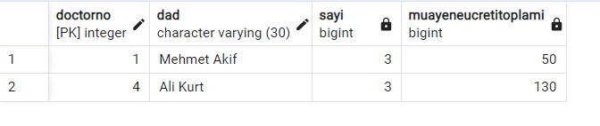

Sonuc - 4

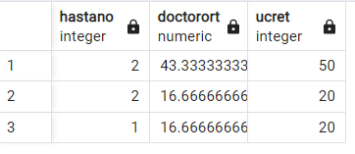

Sonuc - 5

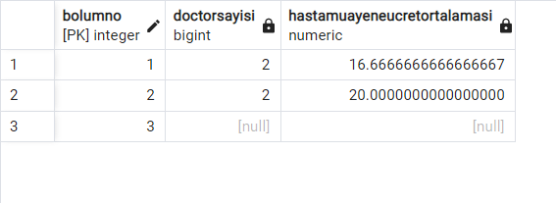

Sonuc - 6

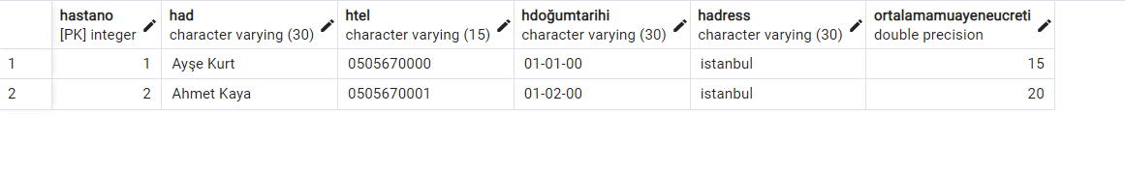

Sonuc - 7



Sonuc - 8

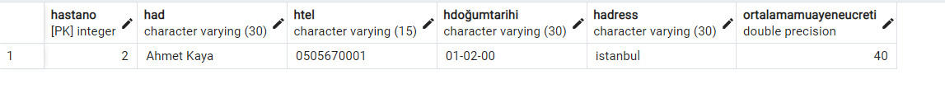

Sonuc - 9

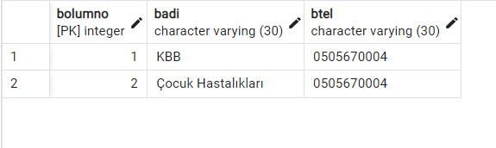

Sonuc - 10

