**部署KVM虚拟机**

**挂载2T数据磁盘**

|  |
| --- |
| Bash mkfs.xfs -f /dev/sdb /data #XFS和EXT4的区别 #RHEL/Centos7默认文件系统是XFS,Centos6为Ext4,Centos5为Ext3。 #XFS可扩展性和Scalability比较强，Ext4受限于磁盘结构和兼容问题。 #EXT4可支持单个文件的大小：16GB到16TB #XFS可支持单个文件的大小：16TB到16EB #XFS是64位文件系统，理论上最大支持8EB减1字节的单个文件系统。 #Ext4是32位文件系统，理论上最大支持1EB减1字节的单个文件系统。 |

**关闭防火墙和selinux**

|  |
| --- |
| Bash systemctl stop firewalld.service systemctl disable firewalld.service sed -i 's/SELINUX=enforcing/SELINUX=disabled/g' /etc/sysconfig/selinux |

**安装依赖环境**

|  |
| --- |
| Bash yum -y install epel-release vim wget net-tools unzip zip gcc gcc-c++ yum -y install qemu-kvm \  qemu-kvm-tools \  qemu-img \  virt-manager \  libvirt \  libvirt-python \  libvirt-client \  virt-install \  virt-viewer \  bridge-utils \  libguestfs-tools |

**KVM**

|  |
| --- |
| Bash systemctl start libvirtd systemctl enable libvirtd [root@kvm ~]# virsh -c qemu:///system list  Id 名称 状态 ---------------------------------------------------- |

**KVM web页面安装**

|  |
| --- |
| Bash [root@kvm ~]# yum -y install git python-pip libvirt-python libxml2-python python-websockify python-devel [root@kvm ~]# mkdir /data/kvm_server/kvm_web [root@kvm kvm_web]# git clone http://github.com/retspen/webvirtmgr.git  #检查sqlite3是否安装 [root@kvm kvm_web]# python Python 2.7.5 (default, Jun 20 2023, 11:36:40)  [GCC 4.8.5 20150623 (Red Hat 4.8.5-44)] on linux2 Type "help", "copyright", "credits" or "license" for more information. >>> import sqlite3 >>> exit() [root@kvm kvm_web]# python manage.py syncdb WARNING:root:No local_settings file found. Creating tables ... Creating table auth_permission Creating table auth_group_permissions Creating table auth_group Creating table auth_user_groups Creating table auth_user_user_permissions Creating table auth_user Creating table django_content_type Creating table django_session Creating table django_site Creating table servers_compute Creating table instance_instance Creating table create_flavor  You just installed Django's auth system, which means you don't have any superusers defined. Would you like to create one now? (yes/no): yes #是否创建管理员账号 Username (leave blank to use 'root'): #指定管理员账号，默认留空 Email address: admin@sjzn.com #管理员邮箱 Password: #管理员密码 这里输入1也可以 Password (again): #确认密码 Superuser created successfully. Installing custom SQL ... Installing indexes ... Installed 6 object(s) from 1 fixture(s)  #启动命令 nohup python manage.py runserver 0:8000 & |

**访问web控制面板**

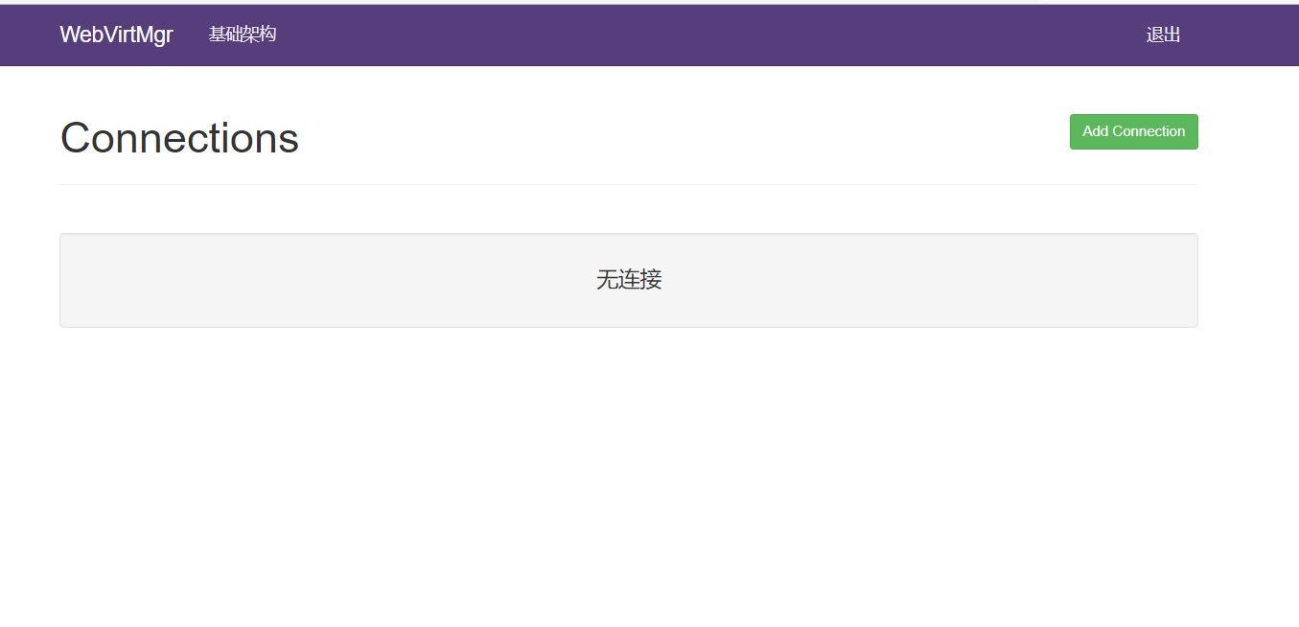

**KVM管理**

**添加KVM服务器**

点击右上角Add Connection 添加KVM服务器（需要做免密登录，如果是单机KVM，则需要把密钥发给自己）

|  |  |
| --- | --- |
|  |  |

**创建虚拟机**

|  |  |
| --- | --- |
|  |  |

**创建网络**

我们要实现所有网络互通，所以使用桥接网络

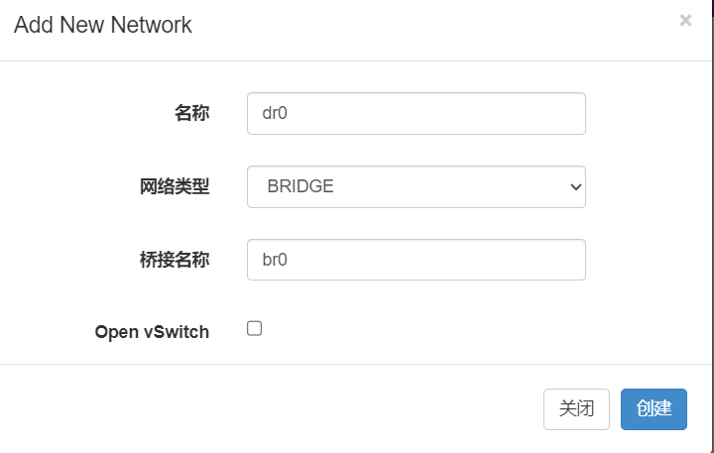

**导入镜像**

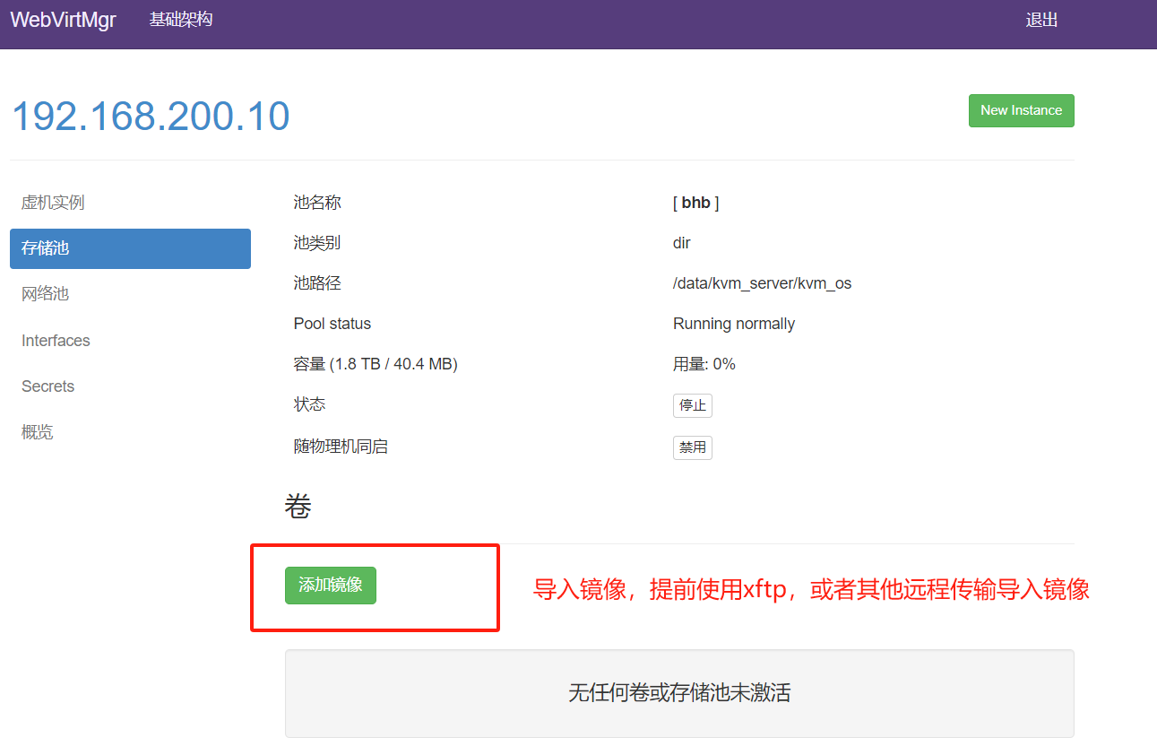

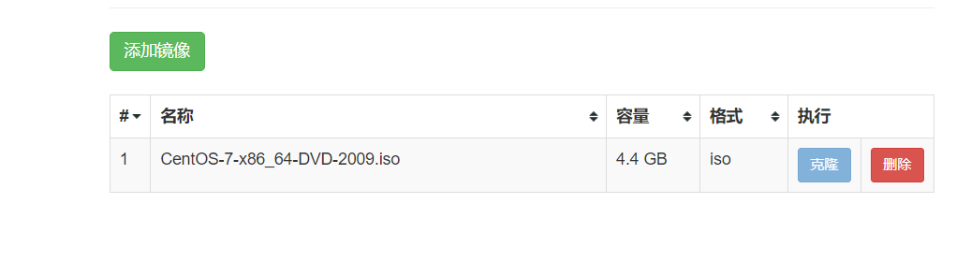

**添加虚拟机**

刚才只设置了存储，现在设置虚拟机

|  |  |
| --- | --- |
|  |  |

**选择镜像，网络，配置后确定**

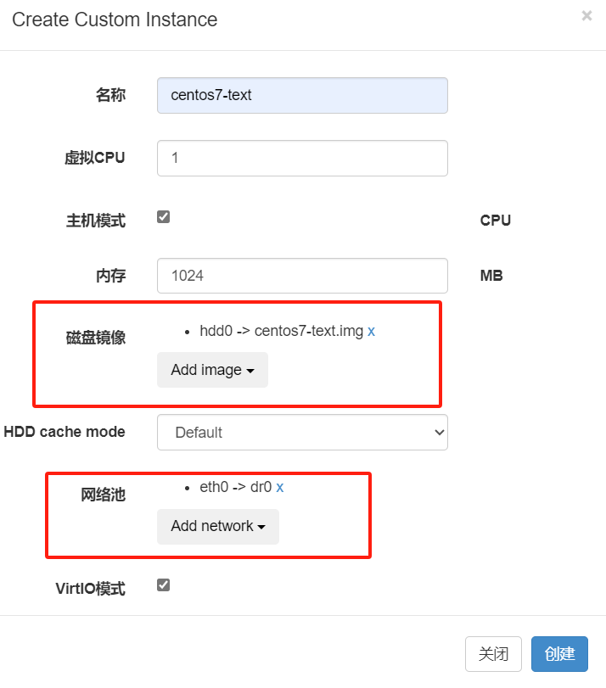

**连接镜像**

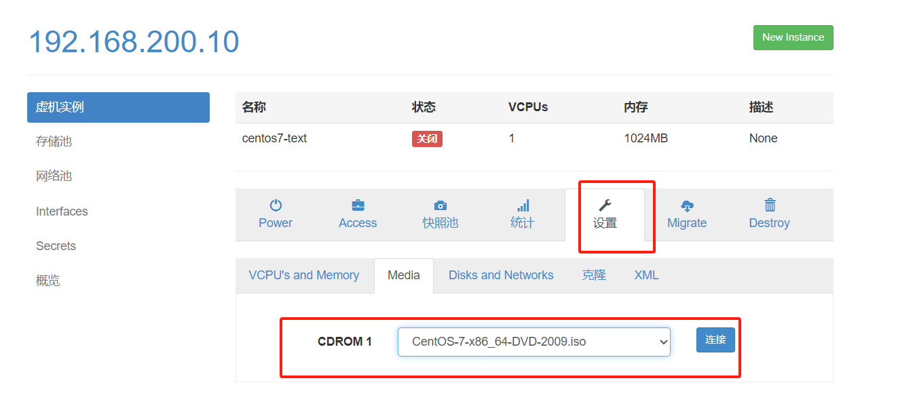

**生成密码**

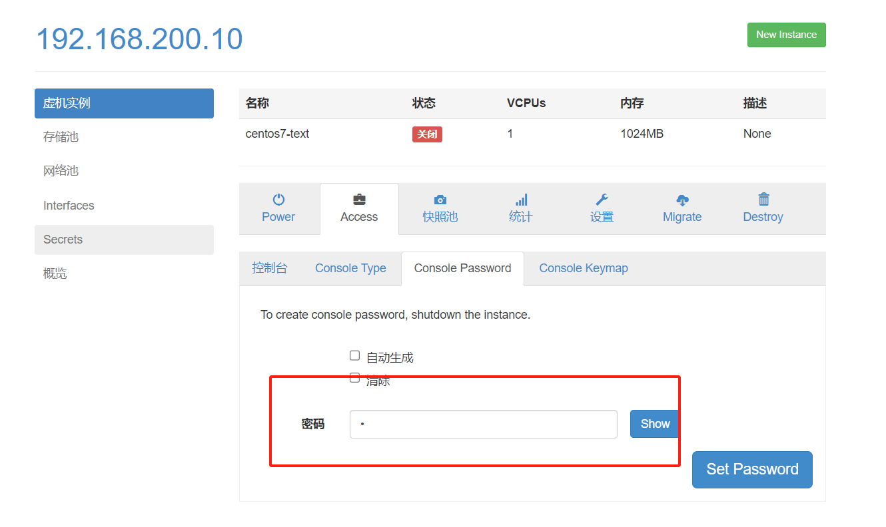

**启动成功**

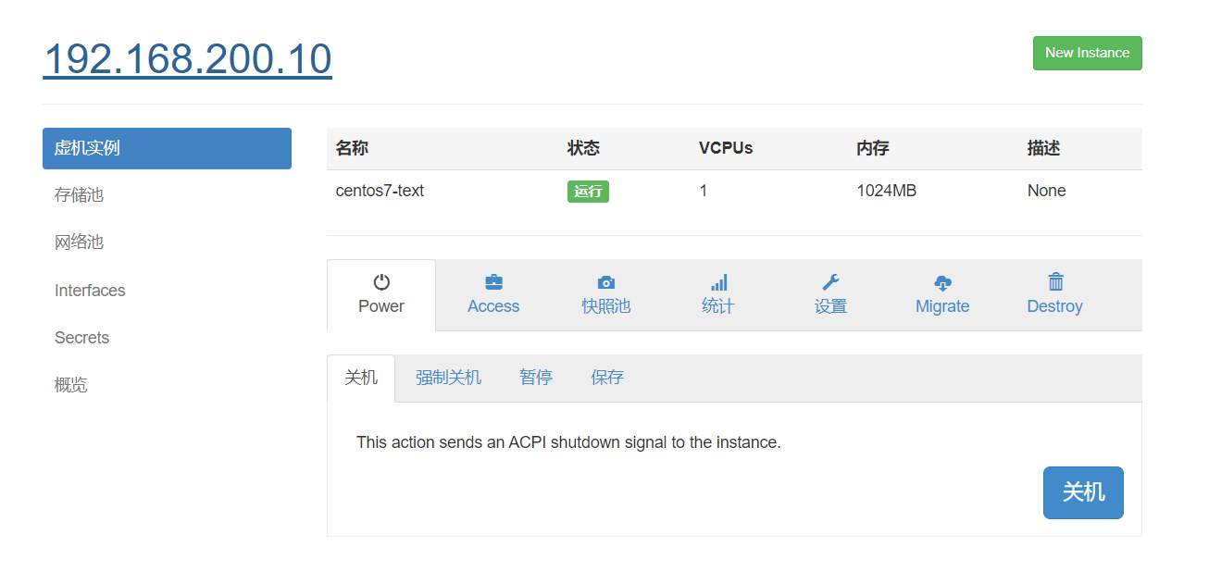

安装vnc工具

|  |
| --- |
| SQL [root@localhost ~]# yum -y install novnc [root@localhost ~]# vim /etc/rc.d/rc.local # Please note that you must run 'chmod +x /etc/rc.d/rc.local' to ensure # that this script will be executed during boot. touch /var/lock/subsys/local nohup novnc_server 192.168.200.15:5920 & 端口可以任意 [root@localhost ~]# . /etc/rc.d/rc.local |

