EDA大作业
卢家珺
2025-12-23

数据包导入
knitr::opts_chunk$set(echo = TRUE, message = FALSE, warning = FALSE)
library(tidyverse)
library(GGally)
library(dplyr)
library(visdat)
library(caret)
library(cluster)

1 melbcv2009数据集

1.1 基本结构
melb <- read.csv("melbcv2009.csv")
str(melb)
## 'data.frame': 5880 obs. of 18 variables:
## $ X : int 1 2 3 4 5 6 7 8 9 10 ...
## $ Date : chr "5/1/2009" "5/1/2009" "5/1/2009" "5/1/2009" ...
## $ Year : int 2009 2009 2009 2009 2009 2009 2009 2009 2009 2009 ...
## $ Month : int 5 5 5 5 5 5 5 5 5 5 ...
## $ Day : int 6 6 6 6 6 6 6 6 6 6 ...
## $ Hour : int 0 1 2 3 4 5 6 7 8 9 ...
## $ MDate : int 1 1 1 1 1 1 1 1 1 1 ...
## $ Weekday_End : int 10 10 10 10 10 10 10 10 10 10 ...
## $ Town.Hall.West : int 209 132 64 36 43 85 182 464 979 1364 ...
## $ Collins.Place.South : int 28 9 4 13 15 56 226 946 2068 1052 ...
## $ Collins.Place.North : int 36 16 15 26 26 68 259 918 2037 987 ...
## $ Bourke.Street.Mall.South: int 52 34 19 14 15 16 61 218 596 833 ...
## $ Bourke.Street.Mall.North: int 53 43 10 5 25 20 80 354 846 1096 ...
## $ Flagstaff.Station : int 17 0 1 8 0 79 610 2200 4875 2274 ...
## $ Melbourne.Central : int NA NA NA NA NA NA NA NA NA NA ...
## $ State.Library : int 124 35 26 16 10 28 71 291 744 641 ...
## $ Victoria.Point : int 8 22 4 4 4 22 162 423 937 473 ...
## $ Birrarung.Marr : int NA NA NA NA NA NA NA NA NA NA ...
#唯一值
sapply(melb, n_distinct)
## X Date Year
## 5880 245 1
## Month Day Hour
## 8 7 24
## MDate Weekday_End Town.Hall.West
## 31 2 2801
## Collins.Place.South Collins.Place.North Bourke.Street.Mall.South
## 1392 1262 2425
## Bourke.Street.Mall.North Flagstaff.Station Melbourne.Central
## 2280 1822 2226
## State.Library Victoria.Point Birrarung.Marr
## 1845 869 606
#缺失值
sapply(melb, function(x) sum(is.na(x)))
## X Date Year
## 0 0 0
## Month Day Hour
## 0 0 0
## MDate Weekday_End Town.Hall.West
## 0 0 0
## Collins.Place.South Collins.Place.North Bourke.Street.Mall.South
## 0 0 0
## Bourke.Street.Mall.North Flagstaff.Station Melbourne.Central
## 0 0 432
## State.Library Victoria.Point Birrarung.Marr
## 0 0 3528
答：数据集有5880条记录，18种变量，其中变量”X”、“Date”、“Year”、“Month”、“Day”、“Hour”、“MDate”、“Weekday_End”为时间编号变量”Town.Hall.West”、“Collins.Place.South”、“Collins.Place.North”、“Bourke.Street.Mall.South”、“Bourke.Street.Mall.North”、“Flagstaff.Station”、“Melbourne.Central”、“State.Library”、“Victoria.Point”、“Birrarung.Marr”为人行道监控的数据，除了变量”Date”是char类型外其他变量为int类型，有缺失值，变量” Melbourne.Central “有432个缺失值频率为432/5880，变量”Birrarung.Marr”有3528个缺失值频率为3528/5880

1.2 详细研究
答：变量”Year”可以省略，全为”2009”.变量Weekday_End，其有2个唯一取值的，为”10”和”20”，应该一个表示周末一个表示工作日

1.3 描述统计量和直方图
#描述统计量
summary(melb)
## X Date Year Month Day
## Min. : 1 Length:5880 Min. :2009 Min. : 5.000 Min. :1
## 1st Qu.:1471 Class :character 1st Qu.:2009 1st Qu.: 7.000 1st Qu.:2
## Median :2940 Mode :character Median :2009 Median : 8.000 Median :4
## Mean :2940 Mean :2009 Mean : 8.498 Mean :4
## 3rd Qu.:4410 3rd Qu.:2009 3rd Qu.:10.000 3rd Qu.:6
## Max. :5880 Max. :2009 Max. :12.000 Max. :7
##
## Hour MDate Weekday_End Town.Hall.West
## Min. : 0.00 Min. : 1.00 Min. :10.00 Min. : 2
## 1st Qu.: 5.75 1st Qu.: 8.00 1st Qu.:10.00 1st Qu.: 245
## Median :11.50 Median :16.00 Median :10.00 Median :1126
## Mean :11.50 Mean :15.82 Mean :12.86 Mean :1465
## 3rd Qu.:17.25 3rd Qu.:23.00 3rd Qu.:20.00 3rd Qu.:2574
## Max. :23.00 Max. :31.00 Max. :20.00 Max. :6822
##
## Collins.Place.South Collins.Place.North Bourke.Street.Mall.South
## Min. : 0.0 Min. : 0.0 Min. : 0.0
## 1st Qu.: 52.0 1st Qu.: 33.0 1st Qu.: 87.0
## Median : 213.5 Median : 142.0 Median : 444.5
## Mean : 453.3 Mean : 372.5 Mean :1104.2
## 3rd Qu.: 748.0 3rd Qu.: 627.0 3rd Qu.:2001.5
## Max. :3370.0 Max. :3286.0 Max. :7035.0
##
## Bourke.Street.Mall.North Flagstaff.Station Melbourne.Central State.Library
## Min. : 0.0 Min. : 0 Min. : 1.0 Min. : 0.0
## 1st Qu.: 66.0 1st Qu.: 23 1st Qu.: 190.0 1st Qu.: 82.0
## Median : 399.0 Median : 88 Median : 859.5 Median : 566.5
## Mean : 929.3 Mean : 721 Mean :1071.1 Mean : 700.9
## 3rd Qu.:1672.5 3rd Qu.:1052 3rd Qu.:1937.0 3rd Qu.:1225.2
## Max. :5178.0 Max. :7510 Max. :4558.0 Max. :3671.0
## NA's :432
## Victoria.Point Birrarung.Marr
## Min. : 0.0 Min. : 0
## 1st Qu.: 23.0 1st Qu.: 22
## Median : 110.0 Median : 130
## Mean : 210.5 Mean : 222
## 3rd Qu.: 294.0 3rd Qu.: 269
## Max. :1380.0 Max. :6510
## NA's :3528
vars <- c("Town.Hall.West","Collins.Place.South","Collins.Place.North",
"Bourke.Street.Mall.South","Bourke.Street.Mall.North",
"Flagstaff.Station","Melbourne.Central","State.Library",
"Victoria.Point","Birrarung.Marr")
melb %>%
select(vars) %>%
pivot_longer(everything(), names_to = "Location", values_to = "Count") %>%
ggplot(aes(x = Count)) +
geom_histogram(bins = 30) +
facet_wrap(~Location, scales = "free") +
labs(x = "行人数量", y = "频数")
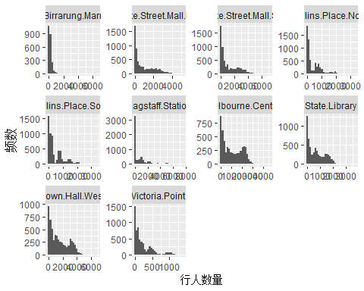

1.4 散点矩阵
pdf("melb_scatter.pdf")
ggpairs(melb %>% select(where(is.numeric)))
dev.off()
## png
## 2
相关系数
cor(melb %>% select(where(is.numeric)), use = "complete.obs")
## X Year Month Day Hour
## X 1.00000000 NA 0.94878543 -0.017673989 0.01019522
## Year NA 1 NA NA NA
## Month 0.94878543 NA 1.00000000 -0.021974042 0.00000000
## Day -0.01767399 NA -0.02197404 1.000000000 0.00000000
## Hour 0.01019522 NA 0.00000000 0.000000000 1.00000000
## MDate 0.15996297 NA -0.15981033 0.015250275 0.00000000
## Weekday_End -0.03353404 NA -0.03821841 0.000000000 0.00000000
## Town.Hall.West 0.05593177 NA 0.05059621 0.092527622 0.47043423
## Collins.Place.South -0.04021822 NA -0.02937374 0.036602290 0.13095315
## Collins.Place.North -0.04232027 NA -0.03064600 0.026405878 0.12461738
## Bourke.Street.Mall.South 0.05911104 NA 0.05366922 0.083887488 0.30122753
## Bourke.Street.Mall.North 0.15291268 NA 0.14517870 0.085453157 0.35076942
## Flagstaff.Station -0.04285373 NA -0.02867661 0.001037916 0.05684713
## Melbourne.Central 0.03463211 NA 0.02797208 0.102171036 0.61862367
## State.Library -0.08824373 NA -0.08340212 0.077577312 0.50212249
## Victoria.Point -0.04129822 NA -0.03506761 0.040262178 0.20692635
## Birrarung.Marr -0.06699859 NA -0.06078725 0.067458900 0.22845087
## MDate Weekday_End Town.Hall.West
## X 0.1599629668 -0.03353404 0.055931768
## Year NA NA NA
## Month -0.1598103276 -0.03821841 0.050596210
## Day 0.0152502754 0.00000000 0.092527622
## Hour 0.0000000000 0.00000000 0.470434228
## MDate 1.0000000000 0.01393184 0.001720055
## Weekday_End 0.0139318415 1.00000000 -0.044846442
## Town.Hall.West 0.0017200547 -0.04484644 1.000000000
## Collins.Place.South -0.0381864015 -0.34328411 0.568321553
## Collins.Place.North -0.0405496229 -0.36465816 0.463265829
## Bourke.Street.Mall.South 0.0083292272 -0.04926476 0.937646794
## Bourke.Street.Mall.North 0.0125310385 -0.04224910 0.929026732
## Flagstaff.Station -0.0461602321 -0.36539289 0.294555570
## Melbourne.Central -0.0002102765 -0.03975936 0.898081790
## State.Library -0.0307979602 -0.09599485 0.872137819
## Victoria.Point -0.0261464834 -0.32326703 0.474393241
## Birrarung.Marr -0.0252321845 0.14404199 0.332932284
## Collins.Place.South Collins.Place.North
## X -0.04021822 -0.04232027
## Year NA NA
## Month -0.02937374 -0.03064600
## Day 0.03660229 0.02640588
## Hour 0.13095315 0.12461738
## MDate -0.03818640 -0.04054962
## Weekday_End -0.34328411 -0.36465816
## Town.Hall.West 0.56832155 0.46326583
## Collins.Place.South 1.00000000 0.92153997
## Collins.Place.North 0.92153997 1.00000000
## Bourke.Street.Mall.South 0.58078452 0.45464510
## Bourke.Street.Mall.North 0.53260558 0.40997568
## Flagstaff.Station 0.79824777 0.89917908
## Melbourne.Central 0.44104775 0.36792587
## State.Library 0.54812462 0.48180401
## Victoria.Point 0.80898035 0.87000504
## Birrarung.Marr 0.16024884 0.12390806
## Bourke.Street.Mall.South Bourke.Street.Mall.North
## X 0.059111040 0.15291268
## Year NA NA
## Month 0.053669219 0.14517870
## Day 0.083887488 0.08545316
## Hour 0.301227529 0.35076942
## MDate 0.008329227 0.01253104
## Weekday_End -0.049264757 -0.04224910
## Town.Hall.West 0.937646794 0.92902673
## Collins.Place.South 0.580784524 0.53260558
## Collins.Place.North 0.454645099 0.40997568
## Bourke.Street.Mall.South 1.000000000 0.94367819
## Bourke.Street.Mall.North 0.943678195 1.00000000
## Flagstaff.Station 0.289317150 0.29093167
## Melbourne.Central 0.796399568 0.83235161
## State.Library 0.807568583 0.80229088
## Victoria.Point 0.439921300 0.42104656
## Birrarung.Marr 0.281086786 0.25470802
## Flagstaff.Station Melbourne.Central State.Library
## X -0.042853729 0.0346321095 -0.08824373
## Year NA NA NA
## Month -0.028676612 0.0279720780 -0.08340212
## Day 0.001037916 0.1021710363 0.07757731
## Hour 0.056847133 0.6186236674 0.50212249
## MDate -0.046160232 -0.0002102765 -0.03079796
## Weekday_End -0.365392885 -0.0397593592 -0.09599485
## Town.Hall.West 0.294555570 0.8980817903 0.87213782
## Collins.Place.South 0.798247769 0.4410477451 0.54812462
## Collins.Place.North 0.899179080 0.3679258715 0.48180401
## Bourke.Street.Mall.South 0.289317150 0.7963995677 0.80756858
## Bourke.Street.Mall.North 0.290931666 0.8323516058 0.80229088
## Flagstaff.Station 1.000000000 0.2421337813 0.35766008
## Melbourne.Central 0.242133781 1.0000000000 0.86516643
## State.Library 0.357660082 0.8651664297 1.00000000
## Victoria.Point 0.863109517 0.4319368007 0.50430066
## Birrarung.Marr 0.066025648 0.3440259664 0.31213812
## Victoria.Point Birrarung.Marr
## X -0.04129822 -0.06699859
## Year NA NA
## Month -0.03506761 -0.06078725
## Day 0.04026218 0.06745890
## Hour 0.20692635 0.22845087
## MDate -0.02614648 -0.02523218
## Weekday_End -0.32326703 0.14404199
## Town.Hall.West 0.47439324 0.33293228
## Collins.Place.South 0.80898035 0.16024884
## Collins.Place.North 0.87000504 0.12390806
## Bourke.Street.Mall.South 0.43992130 0.28108679
## Bourke.Street.Mall.North 0.42104656 0.25470802
## Flagstaff.Station 0.86310952 0.06602565
## Melbourne.Central 0.43193680 0.34402597
## State.Library 0.50430066 0.31213812
## Victoria.Point 1.00000000 0.16035713
## Birrarung.Marr 0.16035713 1.00000000
答：Melbourne.Central 和 Birrarung.Marr正相关，Bourke St Mall和Collins Place正相关，Town Hall 与 Bourke St Mall 正相关。

1.5 监控人流量
melb_long <- melb %>%
select(Date, Hour,vars) %>%
pivot_longer(
cols = -c(Date, Hour),
names_to = "Location",
values_to = "Count"
)
summary_15 <- melb_long %>%
group_by(Location) %>%
summarise(
Peak_Hour = Hour[which.max(tapply(Count, Hour, mean, na.rm = TRUE))],
Total_Flow = sum(Count, na.rm = TRUE),
Max_Flow = max(Count, na.rm = TRUE),
Max_Date = Date[which.max(Count)],
Max_Hour = Hour[which.max(Count)],
.groups = "drop"
)
summary_15
## # A tibble: 10 × 6
## Location Peak_Hour Total_Flow Max_Flow Max_Date Max_Hour
## <chr> <int> <int> <int> <chr> <int>
## 1 Birrarung.Marr 18 522234 6510 9/26/2009 18
## 2 Bourke.Street.Mall.North 13 5464331 5178 11/2/2009 12
## 3 Bourke.Street.Mall.South 13 6492917 7035 10/7/2009 13
## 4 Collins.Place.North 8 2190101 3286 12/8/2009 8
## 5 Collins.Place.South 8 2665522 3370 10/22/2009 12
## 6 Flagstaff.Station 8 4239661 7510 10/7/2009 8
## 7 Melbourne.Central 13 5835513 4558 10/13/2009 12
## 8 State.Library 13 4121201 3671 10/19/2009 12
## 9 Town.Hall.West 13 8615882 6822 10/20/2009 12
## 10 Victoria.Point 17 1237564 1380 6/3/2009 17
答：存在一致的高峰8点、13点和17点Bourke.Street.Mall的人流量最大，依据人流量总计，最大值出现在Flagstaff.Station监控点的10/7/2009的8点时段。

1.6 缺失值和插补
melb$Melbourne.Central[is.na(melb$Melbourne.Central)] <-
mean(melb$Melbourne.Central, na.rm = TRUE)
melb$Birrarung.Marr[is.na(melb$Birrarung.Marr)] <-
mean(melb$Birrarung.Marr, na.rm = TRUE)
答：根据1.1 变量” Melbourne.Central “和变量”Birrarung.Marr”存在缺失值，因为是监控的关键数据不能忽略，采取平均数插补的方法。

1.7 异常值的探索
melb_long <- melb %>%
select(vars) %>%
pivot_longer(everything(),
names_to = "Location",
values_to = "Count")
boxplot(Count ~ Location, data = melb_long)
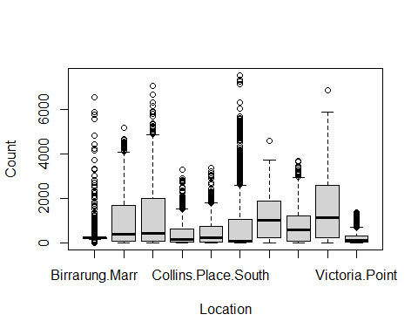
答：使用箱线图离群值规则，监控变量存在异常高值，应该是高峰时段。相关的变量详见1.4。

1.8 统计模型
fit <- lm(Melbourne.Central ~ Birrarung.Marr, data = melb)
summary(fit)
##
## Call:
## lm(formula = Melbourne.Central ~ Birrarung.Marr, data = melb)
##
## Residuals:
## Min 1Q Median 3Q Max
## -3582.1 -799.2 -50.9 753.9 3489.7
##
## Coefficients:
## Estimate Std. Error t value Pr(>|t|)
## (Intercept) 913.14642 14.15279 64.52 <2e-16 ***
## Birrarung.Marr 0.71151 0.04056 17.54 <2e-16 ***
## ---
## Signif. codes: 0 '***' 0.001 '**' 0.01 '*' 0.05 '.' 0.1 ' ' 1
##
## Residual standard error: 837.2 on 5878 degrees of freedom
## Multiple R-squared: 0.04976, Adjusted R-squared: 0.0496
## F-statistic: 307.8 on 1 and 5878 DF, p-value: < 2.2e-16
par(mfrow = c(2, 2))
plot(fit, which = 1:4)
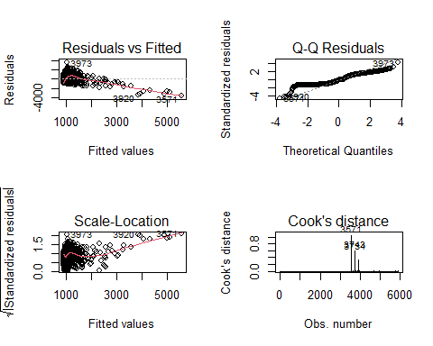
答：针对具有明显相关性的变量 Melbourne.Central 和 Birrarung.Marr，建立线性回归模型。模型结果表明 Birrarung.Marr 对 Melbourne.Central 正相关。残差诊断图未显示明显异方差或系统性偏差，模型拟合较为合理。

2 coronavirus.csv数据集

2.1 基础结构
covid <- read.csv("coronavirus.csv")
str(covid)
## 'data.frame': 973836 obs. of 15 variables:
## $ date : chr "2020-01-22" "2020-01-23" "2020-01-24" "2020-01-25" ...
## $ province : chr "Alberta" "Alberta" "Alberta" "Alberta" ...
## $ country : chr "Canada" "Canada" "Canada" "Canada" ...
## $ lat : num 53.9 53.9 53.9 53.9 53.9 ...
## $ long : num -117 -117 -117 -117 -117 ...
## $ type : chr "confirmed" "confirmed" "confirmed" "confirmed" ...
## $ cases : int 0 0 0 0 0 0 0 0 0 0 ...
## $ uid : int 12401 12401 12401 12401 12401 12401 12401 12401 12401 12401 ...
## $ iso2 : chr "CA" "CA" "CA" "CA" ...
## $ iso3 : chr "CAN" "CAN" "CAN" "CAN" ...
## $ code3 : int 124 124 124 124 124 124 124 124 124 124 ...
## $ combined_key : chr "Alberta, Canada" "Alberta, Canada" "Alberta, Canada" "Alberta, Canada" ...
## $ population : int 4413146 4413146 4413146 4413146 4413146 4413146 4413146 4413146 4413146 4413146 ...
## $ continent_name: chr "North America" "North America" "North America" "North America" ...
## $ continent_code: chr NA NA NA NA ...
答：有973836条记录。

2.2 汇总与排序
#国家个数
n_distinct(covid$country)
## [1] 201
covid %>%
filter(type == "confirmed") %>%
group_by(country) %>%
summarise(total_confirmed = sum(cases, na.rm = TRUE)) %>%
arrange(desc(total_confirmed))
## # A tibble: 201 × 2
## country total_confirmed
## <chr> <int>
## 1 US 103802702
## 2 India 44690738
## 3 France 39866718
## 4 Germany 38249060
## 5 Brazil 37076053
## 6 Japan 33320438
## 7 Korea, South 30615522
## 8 Italy 25603510
## 9 United Kingdom 24658705
## 10 Russia 22075858

2.3 缺失值探索
sapply(covid, function(x) sum(is.na(x)))
## date province country lat long
## 0 680085 0 5715 5715
## type cases uid iso2 iso3
## 0 0 36576 50292 46863
## code3 combined_key population continent_name continent_code
## 46863 36576 54864 46863 212598
答：变量”continent_code”、“province”、“population”缺失值较多，跟人口地区相关影响后续分析。

2.4 中国的数据分析
china <- covid %>% filter(country == "China")
#确诊病例的前五
china %>%
filter(type == "confirmed") %>%
group_by(province) %>%
summarise(total = sum(cases, na.rm = TRUE)) %>%
arrange(desc(total)) %>%
head(5)
## # A tibble: 5 × 2
## province total
## <chr> <int>
## 1 Hong Kong 2876106
## 2 Unknown 1521816
## 3 Guangdong 103248
## 4 Hubei 72131
## 5 Shanghai 67040
#死亡病例的前五
china %>%
filter(type == "death") %>%
group_by(province) %>%
summarise(total = sum(cases, na.rm = TRUE)) %>%
arrange(desc(total)) %>%
head(5)
## # A tibble: 5 × 2
## province total
## <chr> <int>
## 1 Unknown 82195
## 2 Hong Kong 13467
## 3 Hubei 4515
## 4 Shanghai 595
## 5 Macau 121
答：Hong Kong，Unknown，Hubei，Shanghai的确诊和死亡案例均在前五。

2.5 Unknown的数据特征
china_unknown <- china %>% filter(province == "Unknown")
vis_dat(china_unknown)
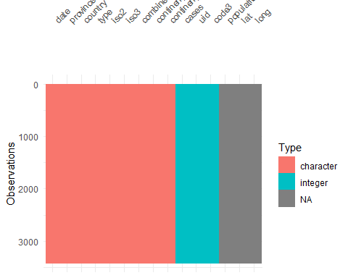
答：可以看出，Unknown 省份在部分变量”lat”、“long”、“population”上存在缺失，说明该部分记录多为早期或未明确归属省份的数据。

2.6 Unknown 省份确诊病例时间变化
china_unknown %>%
filter(type == "confirmed") %>%
ggplot(aes(x = as.Date(date), y = cases)) +
geom_line() +
labs(x = "日期", y = "确诊病例数")
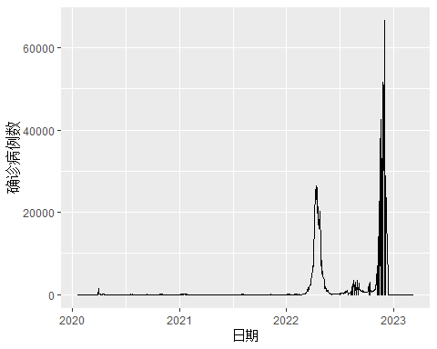

3 music.csv数据集

3.1 基本结构
music <- read.csv("music.csv")
str(melb)
## 'data.frame': 5880 obs. of 18 variables:
## $ X : int 1 2 3 4 5 6 7 8 9 10 ...
## $ Date : chr "5/1/2009" "5/1/2009" "5/1/2009" "5/1/2009" ...
## $ Year : int 2009 2009 2009 2009 2009 2009 2009 2009 2009 2009 ...
## $ Month : int 5 5 5 5 5 5 5 5 5 5 ...
## $ Day : int 6 6 6 6 6 6 6 6 6 6 ...
## $ Hour : int 0 1 2 3 4 5 6 7 8 9 ...
## $ MDate : int 1 1 1 1 1 1 1 1 1 1 ...
## $ Weekday_End : int 10 10 10 10 10 10 10 10 10 10 ...
## $ Town.Hall.West : int 209 132 64 36 43 85 182 464 979 1364 ...
## $ Collins.Place.South : int 28 9 4 13 15 56 226 946 2068 1052 ...
## $ Collins.Place.North : int 36 16 15 26 26 68 259 918 2037 987 ...
## $ Bourke.Street.Mall.South: int 52 34 19 14 15 16 61 218 596 833 ...
## $ Bourke.Street.Mall.North: int 53 43 10 5 25 20 80 354 846 1096 ...
## $ Flagstaff.Station : int 17 0 1 8 0 79 610 2200 4875 2274 ...
## $ Melbourne.Central : num 1071 1071 1071 1071 1071 ...
## $ State.Library : int 124 35 26 16 10 28 71 291 744 641 ...
## $ Victoria.Point : int 8 22 4 4 4 22 162 423 937 473 ...
## $ Birrarung.Marr : num 222 222 222 222 222 ...

3.2 构建分类器

3.2.1 选取候选变量
music <- read.csv("music.csv") %>% mutate(id = 1:n())
music$type <- factor(music$type)
#选取缺失率少的
X <- music %>% select(where(is.numeric))
na_rate <- colMeans(is.na(X))
vars_sel <- names(sort(na_rate))[1:9]
music_sel <- cbind(type = music$type, X[, vars_sel])
vars_sel
## [1] "lvar" "lave" "lmax" "lper1" "lper2" "lper3" "lper4" "lper5" "lper6"

3.2.2 训练样本
set.seed(123)
idx <- createDataPartition(music_sel$type, p = 2/3, list = FALSE)
train <- music_sel[idx, ]
test <- music_sel[-idx, ]
rownames(train)
## [1] "3" "4" "5" "7" "8" "9" "10" "13" "14" "15" "16" "19" "20" "21" "24"
## [16] "25" "27" "28" "29" "30" "33" "35" "38" "39" "40" "41" "44" "45" "46" "47"
## [31] "48" "49" "50" "51" "52" "53" "55" "57" "58" "59" "60" "62"
rownames(test)
## [1] "1" "2" "6" "11" "12" "17" "18" "22" "23" "26" "31" "32" "34" "36" "37"
## [16] "42" "43" "54" "56" "61"

3.2.3 建立最好的分类器
model <- train(
type ~ .,
data = train,
method = "lda",
na.action = na.omit
)
pred <- predict(model, test)
confusionMatrix(pred, test$type)
## Confusion Matrix and Statistics
##
## Reference
## Prediction Classical New wave Rock Unknown
## Classical 7 0 1 1
## New wave 0 0 0 0
## Rock 1 1 9 0
## Unknown 0 0 0 0
##
## Overall Statistics
##
## Accuracy : 0.8
## 95% CI : (0.5634, 0.9427)
## No Information Rate : 0.5
## P-Value [Acc > NIR] : 0.005909
##
## Kappa : 0.633
##
## Mcnemar's Test P-Value : NA
##
## Statistics by Class:
##
## Class: Classical Class: New wave Class: Rock
## Sensitivity 0.8750 0.00 0.9000
## Specificity 0.8333 1.00 0.8000
## Pos Pred Value 0.7778 NaN 0.8182
## Neg Pred Value 0.9091 0.95 0.8889
## Prevalence 0.4000 0.05 0.5000
## Detection Rate 0.3500 0.00 0.4500
## Detection Prevalence 0.4500 0.00 0.5500
## Balanced Accuracy 0.8542 0.50 0.8500
## Class: Unknown
## Sensitivity 0.00
## Specificity 1.00
## Pos Pred Value NaN
## Neg Pred Value 0.95
## Prevalence 0.05
## Detection Rate 0.00
## Detection Prevalence 0.00
## Balanced Accuracy 0.50

3.2.4 预测五个新音轨
predict(model, test[1:5, ])
## [1] Rock Rock Rock Classical Classical
## Levels: Classical New wave Rock Unknown

3.3 聚类分析
X <- scale(music_sel[, -1])
set.seed(123)
km <- kmeans(X, centers = 5)
hc <- hclust(dist(X), method = "ward.D2")
hc_cut <- cutree(hc, k = 5)

3.3.1 在俩之间不同的
which(km$cluster != hc_cut)
## [1] 1 2 3 4 5 6 7 8 9 10 11 13 14 15 16 17 18 19 21 26 28 31 35 36 37
## [26] 38 39 42 43 46 49 50 51 53 54 55 56 58 61

3.3.2 k-means 与 Ward 层次聚类在单例簇划分上的差异
# k-means 中形成单例簇的音轨
single_track <- which(km$size == 1)
single_track
## integer(0)
# 该音轨在 Ward 聚类中的簇规模
table(hc_cut[km$cluster == single_track])
## < table of extent 0 >
答：在将 type 变量纳入聚类后，k-means 未产生单例簇，因此不存在 k-means 与 Ward 层次聚类在单例簇划分上的差异。

4 wage.csv数据集

4.1 薪资随经验增长而稳步提升的员工
wage <- read.csv("wage.csv")
steady_person <- wage %>%
group_by(id) %>%
filter(sum(!is.na(exper) & !is.na(lnw)) >= 2) %>% # 防止 cor 报错
summarise(cor_le = cor(exper, lnw, use = "complete.obs")) %>%
arrange(desc(cor_le)) %>%
slice(1)
steady_person
## # A tibble: 1 × 2
## id cor_le
## <int> <dbl>
## 1 518 1

4.2 薪资波动剧烈的员工
volatile_person <- wage %>%
group_by(id) %>%
summarise(sd_lnw = sd(lnw, na.rm = TRUE)) %>%
arrange(desc(sd_lnw)) %>%
slice(1)
volatile_person
## # A tibble: 1 × 2
## id sd_lnw
## <int> <dbl>
## 1 12455 1.43

4.3 极差分析
range_df <- wage %>%
group_by(id) %>%
summarise(
min_lnw = min(lnw, na.rm = TRUE),
max_lnw = max(lnw, na.rm = TRUE),
range_lnw = max_lnw - min_lnw
) %>%
arrange(desc(range_lnw)) %>%
slice(1:10)
wage %>%
filter(id %in% range_df$id) %>%
ggplot(aes(lnw, color = factor(id))) +
geom_density() +
labs(color = "ID")
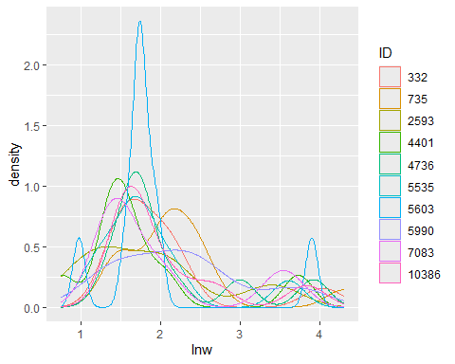

4.4 工资与失业率
cor_df <- wage %>%
group_by(id) %>%
filter(sum(!is.na(lnw) & !is.na(uerate)) >= 2) %>%
summarise(cor_lnw_uerate = cor(lnw, uerate, use = "complete.obs")) %>%
arrange(desc(abs(cor_lnw_uerate)))
#最强个体
strongest_person <- cor_df %>% slice(1)
strongest_person
## # A tibble: 1 × 2
## id cor_lnw_uerate
## <int> <dbl>
## 1 2178 1
wage %>%
filter(id == strongest_person$id) %>%
ggplot(aes(exper)) +
geom_line(aes(y = lnw, color = "lnw")) +
geom_line(aes(y = uerate, color = "uerate")) +
labs(color = "Variable")
