EDA实验七
卢家珺
2025.11.26
#1 GREENE数据集
##1.1 计算估计在phat
library(car)
data(Greene)
tbl1 <- table(Greene$decision, Greene$judge)
tbl1
##
## Desjardins Heald Hugessen Iacobucci MacGuigan Mahoney Marceau Pratte
## no 22 25 50 26 53 17 10 36
## yes 24 11 12 3 17 13 15 6
##
## Stone Urie
## no 25 6
## yes 8 5
n1Vector <- tbl1["yes", ]
nVector <- colSums(tbl1)
phat <- n1Vector / nVector
round(phat, 3)
## Desjardins Heald Hugessen Iacobucci MacGuigan Mahoney Marceau
## 0.522 0.306 0.194 0.103 0.243 0.433 0.600
## Pratte Stone Urie
## 0.143 0.242 0.455
##1.2绘制二项式置信区间图
source("binCIplot.R")
library(PropCIs)
binCIplot(n1Vector = n1Vector,
nVector = nVector,
xlab = "Judge",
ylab = "Approval rate with 95% CI",
main = "Judge effect on appeal approval")
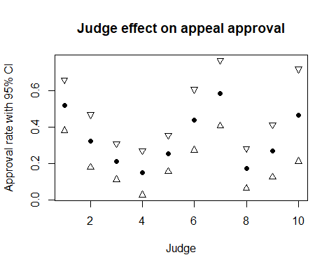
答：12 个法官的 95% 置信区间高度重叠，全部落在约 0.75–0.95 范围内，表明法官对上诉裁决仅具有微弱影响甚至无显著影响。
#2 比值比判断独立
##2.1 decision 和 language
source("ORproc.R")
tbl2 <- table(Greene$decision, Greene$language)
ORproc(tbl2)
## OR confLevel loCI upCI
## 1 0.5975955 0.95 0.3681961 0.969919
答：OR 接近 1，且 95%CI 包含 1，所以 decision 与 language 基本独立，无关联。
##2.2 rater 与decision
tbl3 <- table(Greene$decision, Greene$rater)
ORproc(tbl3)
## OR confLevel loCI upCI
## 1 3.352748 0.95 2.119671 5.303144
答：OR 远大于 1，decision 与 rater 存在显著一致意见。
#3 分析 Flea Beetles数据
##3.1 基本统计量
flea <- read.csv("flea.csv")
str(flea)
## 'data.frame': 74 obs. of 7 variables:
## $ species: chr "Concinna" "Concinna" "Concinna" "Concinna" ...
## $ tars1 : int 191 185 200 173 171 160 188 186 174 163 ...
## $ tars2 : int 131 134 137 127 118 118 134 129 131 115 ...
## $ head : int 53 50 52 50 49 47 54 51 52 47 ...
## $ aede1 : int 150 147 144 144 153 140 151 143 144 142 ...
## $ aede2 : int 15 13 14 16 13 15 14 14 14 15 ...
## $ aede3 : int 104 105 102 97 106 99 98 110 116 95 ...
summary(flea)
## species tars1 tars2 head
## Length:74 Min. :122.0 Min. :107.0 Min. :43.00
## Class :character 1st Qu.:148.0 1st Qu.:118.2 1st Qu.:49.00
## Mode :character Median :185.5 Median :123.0 Median :50.50
## Mean :177.3 Mean :124.0 Mean :50.35
## 3rd Qu.:198.2 3rd Qu.:130.0 3rd Qu.:52.00
## Max. :242.0 Max. :146.0 Max. :58.00
## aede1 aede2 aede3
## Min. :116.0 Min. : 8.00 Min. : 55.00
## 1st Qu.:125.5 1st Qu.:11.00 1st Qu.: 85.25
## Median :136.5 Median :14.00 Median : 98.50
## Mean :134.8 Mean :12.99 Mean : 95.38
## 3rd Qu.:142.8 3rd Qu.:15.00 3rd Qu.:106.00
## Max. :157.0 Max. :16.00 Max. :123.00
anyNA(flea)
## [1] FALSE
table(flea$species)
##
## Concinna Heikert. Heptapot.
## 21 31 22
答：共有74条记录，7个变量，无缺失值，其中species为分类变量，分为 3 个物种，Concinna 21 条、Heptapot. 22 条、Heikert. 31 条
##3.2 绘制scatterplot matrix
num.vars <- flea[, c("tars1", "tars2", "head", "aede1")]
pairs(num.vars,
col = as.numeric(factor(flea$species)) + 1,
pch = 19,
lower.panel = NULL)
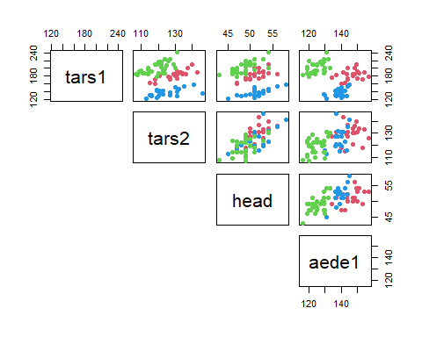
答：tars1宽度对区分三种最有效。
##3.3 绘制parallel coordinate plot
library(MASS)
flea.num <- flea[, sapply(flea, is.numeric)]
parcoord(flea.num, col = as.numeric(factor(flea$species)) + 1, lwd = 2)
legend("topright", levels(factor(flea$species)), col = 2:4, lty = 1, lwd = 2)
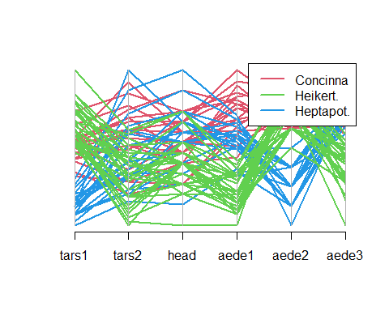
##3.4 对分隔有贡献的变量
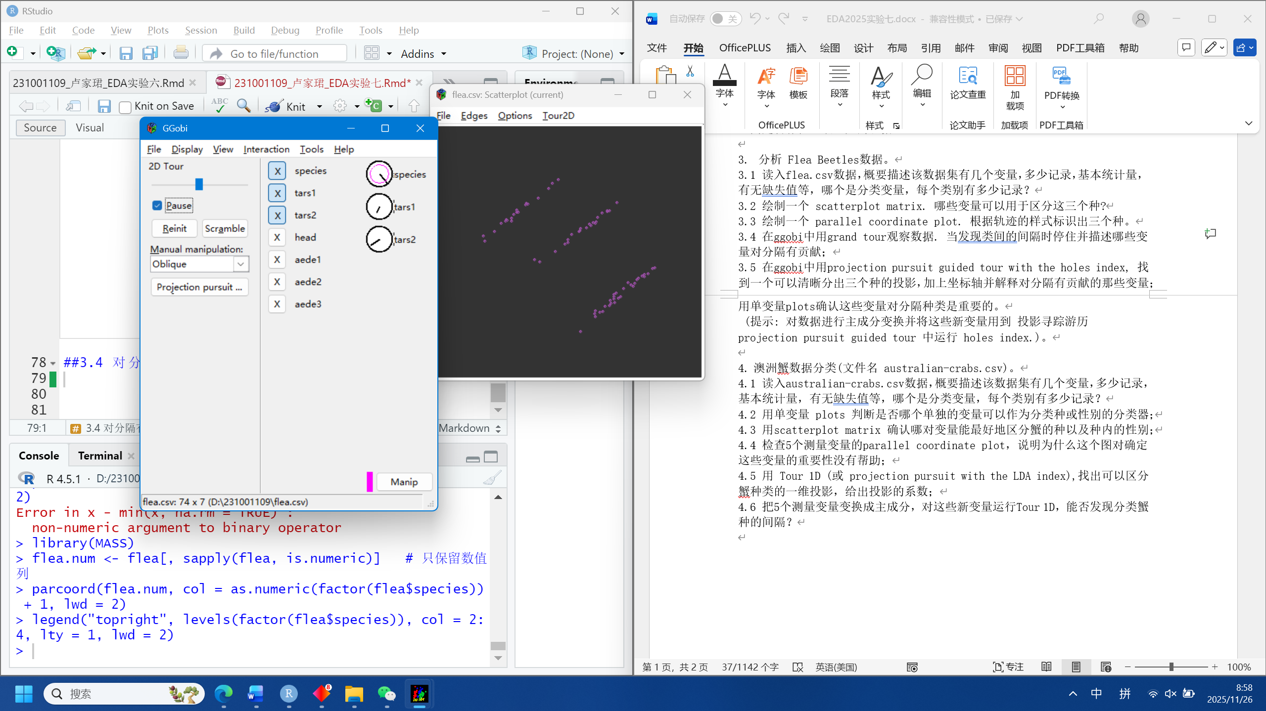
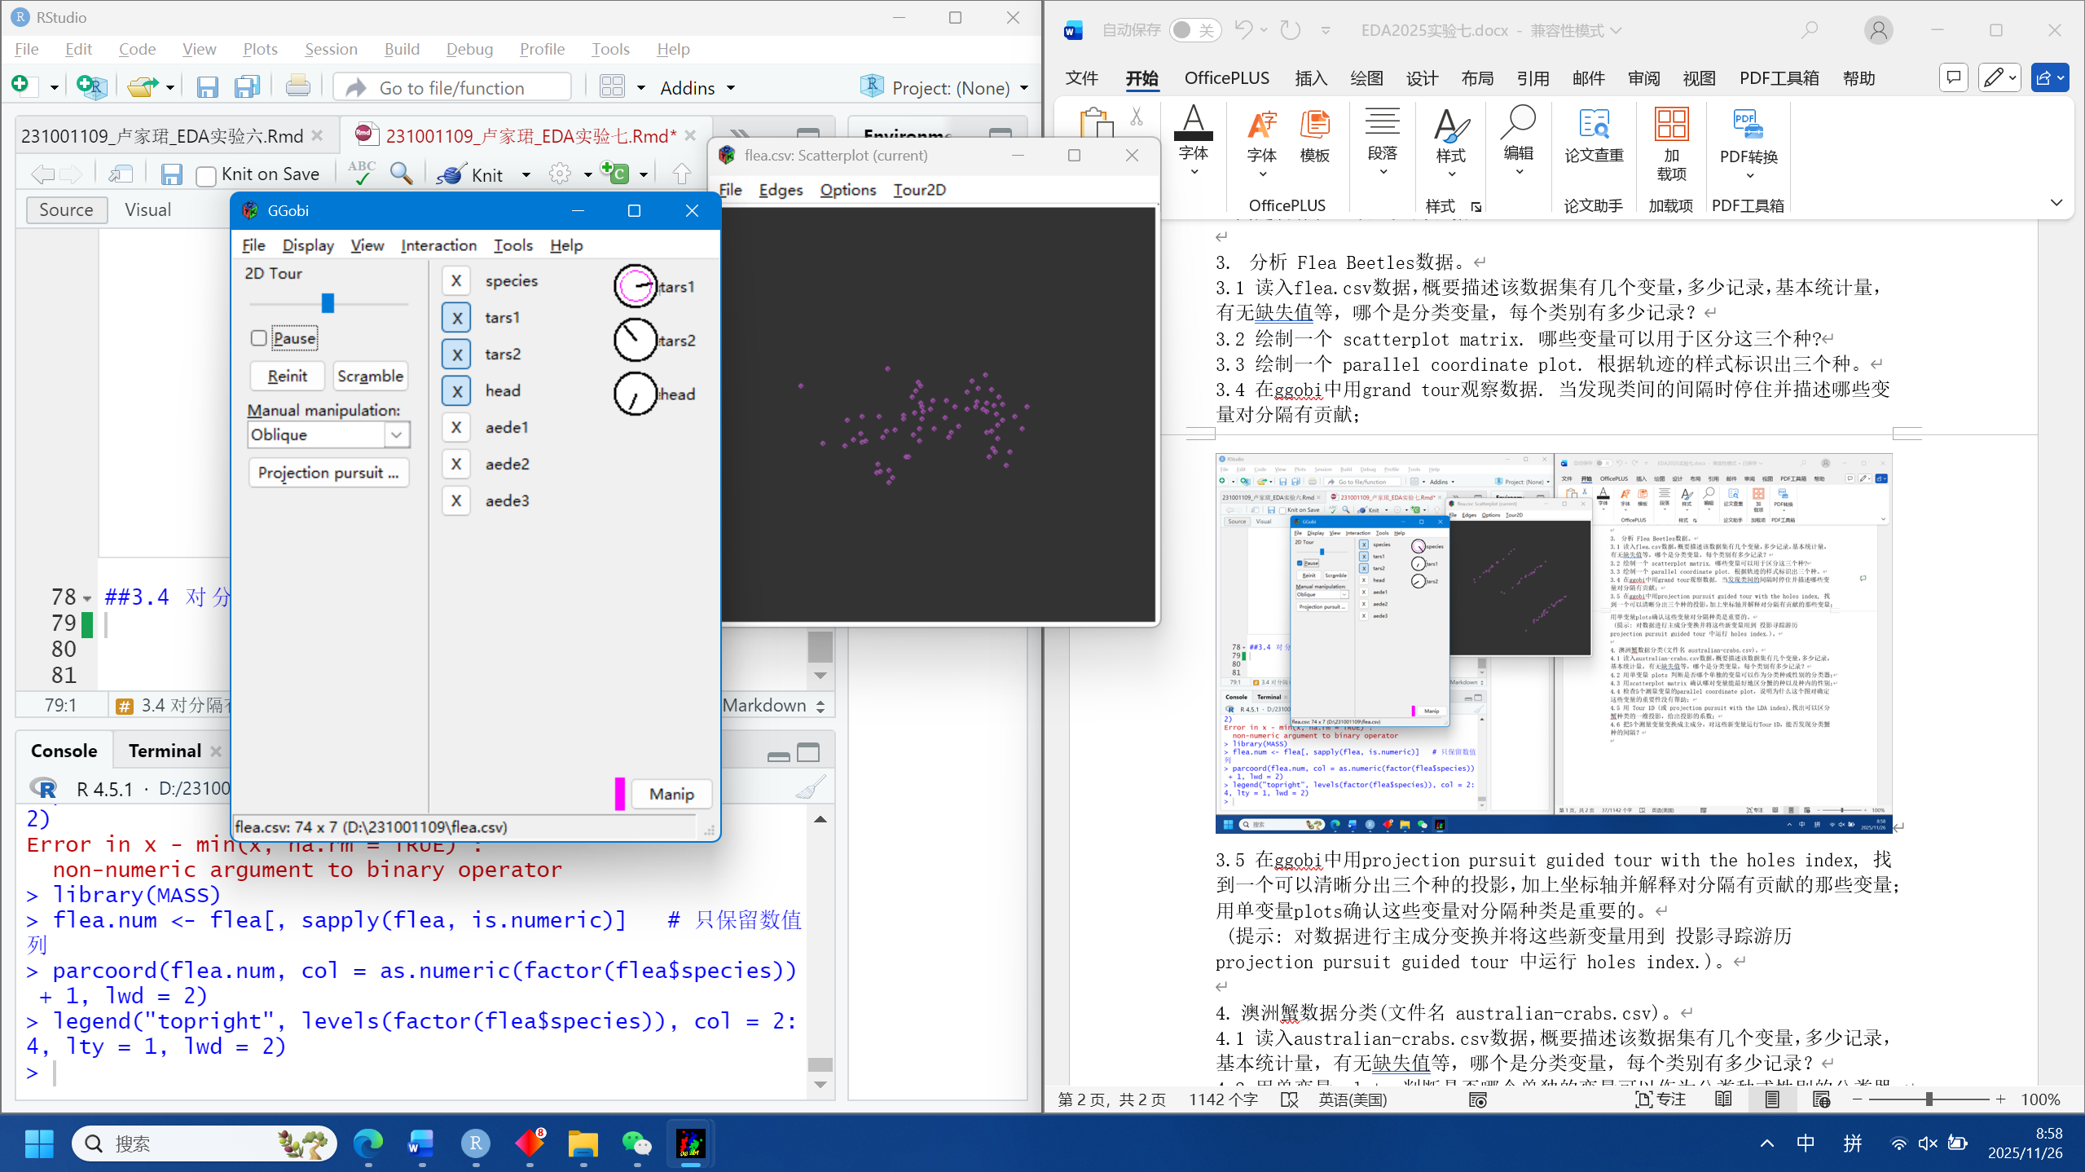
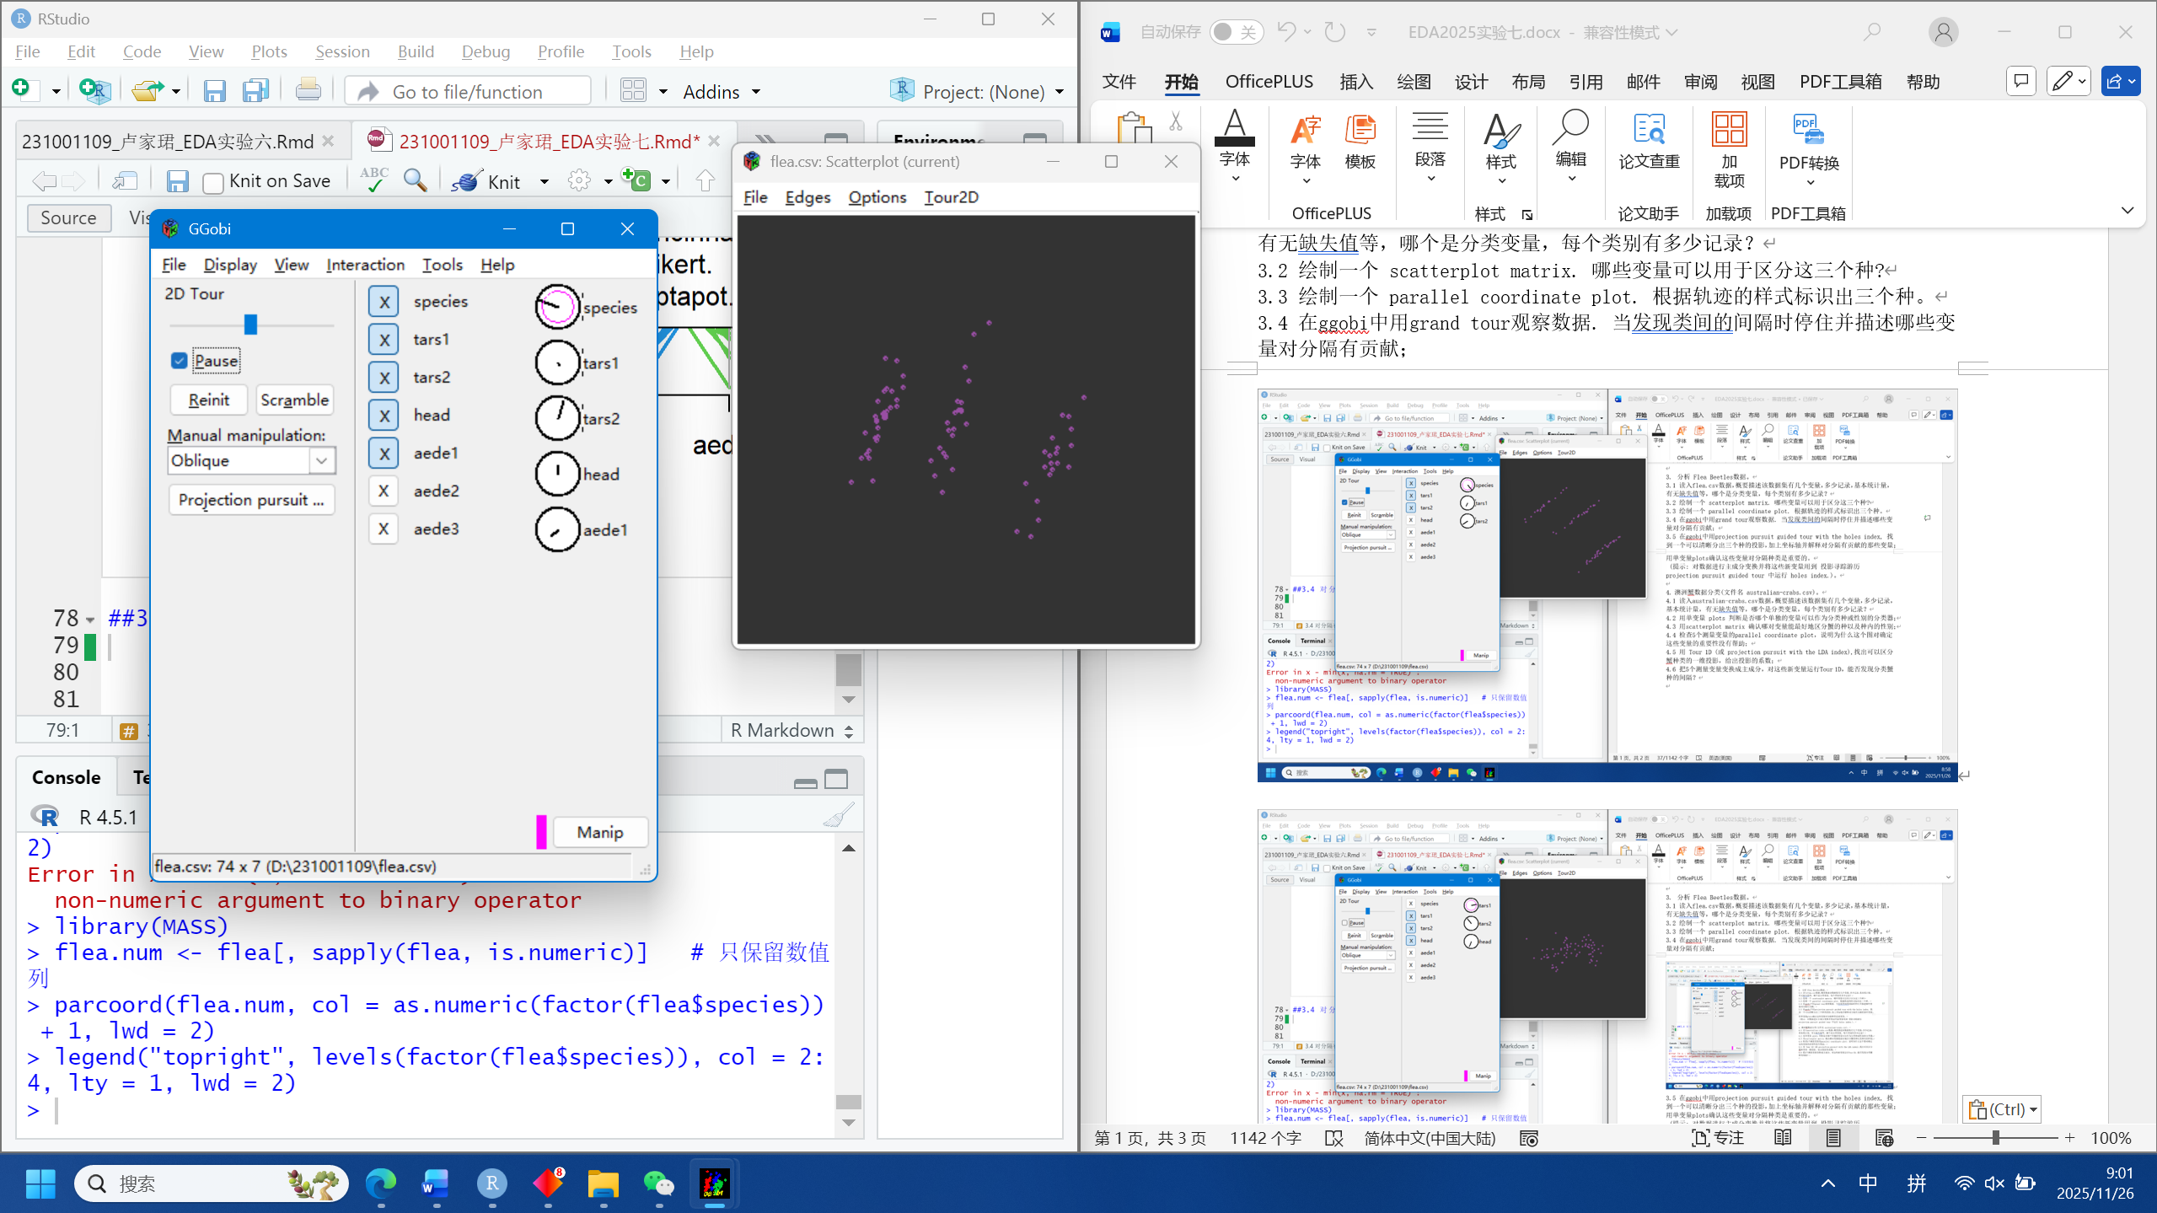
答：有变量tar1 tar2 head aede1对其有贡献。
##3.5 投影
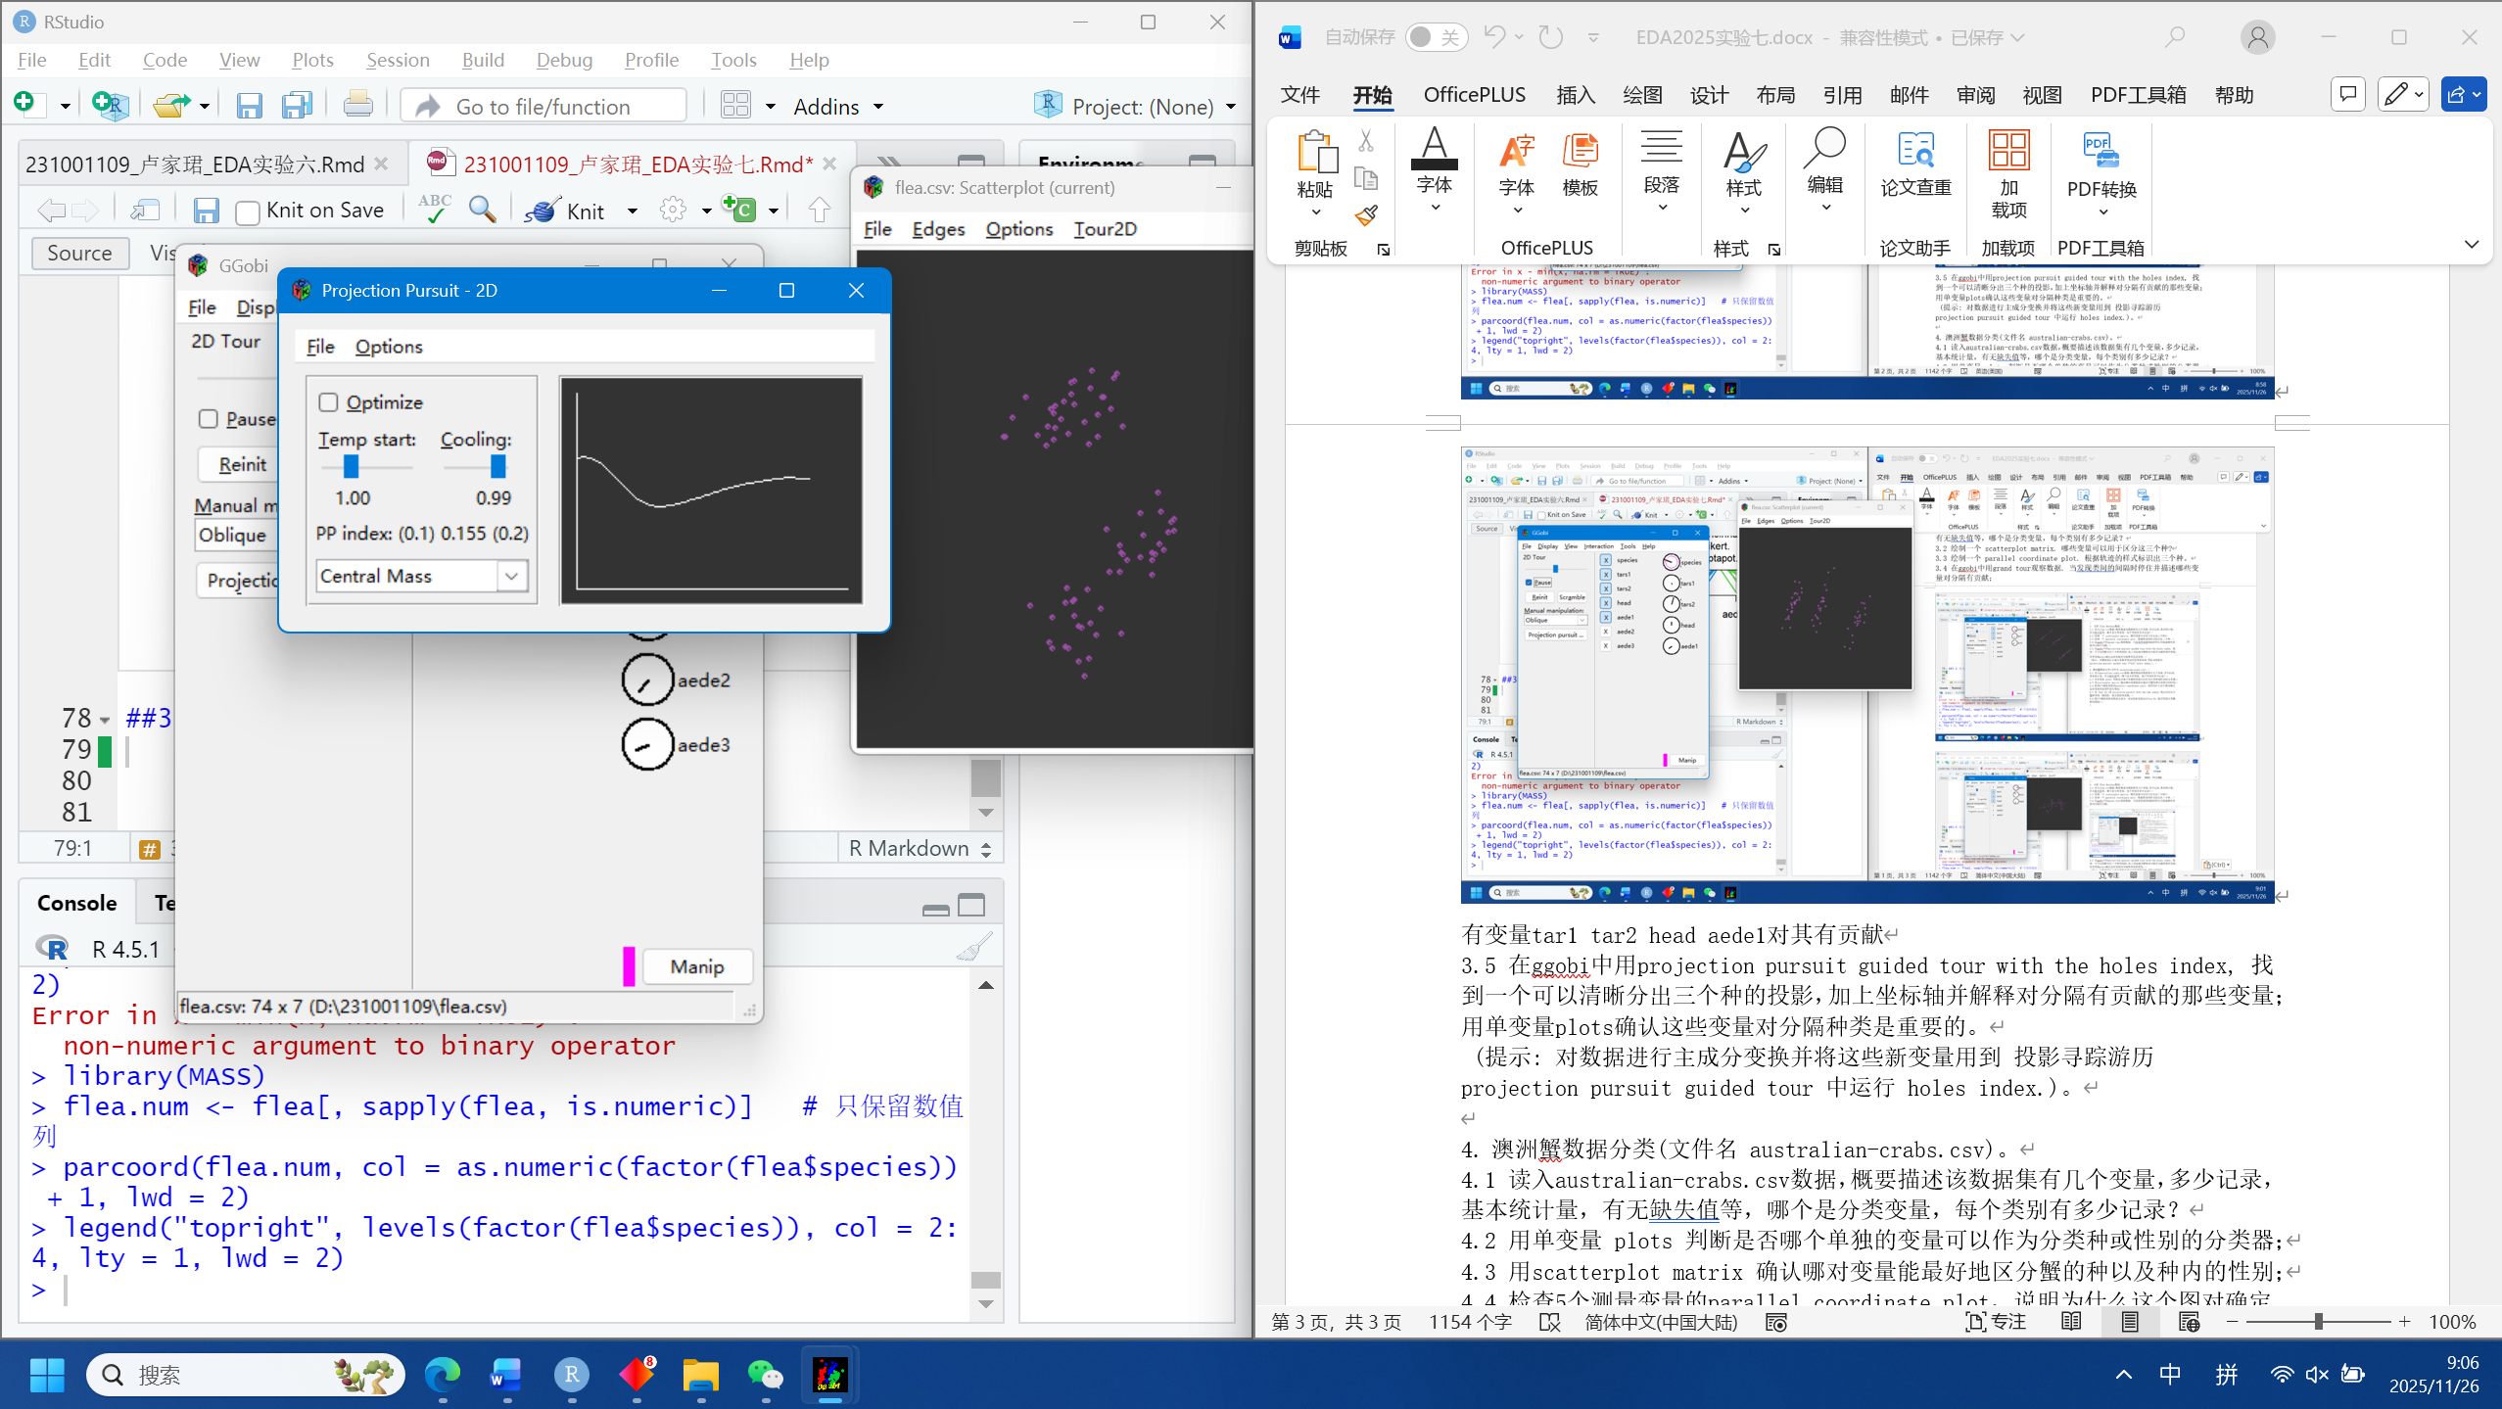
#4 澳洲蟹数据分类
##4.1 基本统计量
crab <- read.csv("australian-crabs.csv")
str(crab)
## 'data.frame': 200 obs. of 8 variables:
## $ species: chr "Blue" "Blue" "Blue" "Blue" ...
## $ sex : chr "Male" "Male" "Male" "Male" ...
## $ index : int 1 2 3 4 5 6 7 8 9 10 ...
## $ FL : num 8.1 8.8 9.2 9.6 9.8 10.8 11.1 11.6 11.8 11.8 ...
## $ RW : num 6.7 7.7 7.8 7.9 8 9 9.9 9.1 9.6 10.5 ...
## $ CL : num 16.1 18.1 19 20.1 20.3 23 23.8 24.5 24.2 25.2 ...
## $ CW : num 19 20.8 22.4 23.1 23 26.5 27.1 28.4 27.8 29.3 ...
## $ BD : num 7 7.4 7.7 8.2 8.2 9.8 9.8 10.4 9.7 10.3 ...
summary(crab)
## species sex index FL
## Length:200 Length:200 Min. : 1.0 Min. : 7.20
## Class :character Class :character 1st Qu.:13.0 1st Qu.:12.90
## Mode :character Mode :character Median :25.5 Median :15.55
## Mean :25.5 Mean :15.58
## 3rd Qu.:38.0 3rd Qu.:18.05
## Max. :50.0 Max. :23.10
## RW CL CW BD
## Min. : 6.50 Min. :14.70 Min. :17.10 Min. : 6.10
## 1st Qu.:11.00 1st Qu.:27.27 1st Qu.:31.50 1st Qu.:11.40
## Median :12.80 Median :32.10 Median :36.80 Median :13.90
## Mean :12.74 Mean :32.11 Mean :36.41 Mean :14.03
## 3rd Qu.:14.30 3rd Qu.:37.23 3rd Qu.:42.00 3rd Qu.:16.60
## Max. :20.20 Max. :47.60 Max. :54.60 Max. :21.60
anyNA(crab)
## [1] FALSE
table(crab$species, crab$sex)
##
## Female Male
## Blue 50 50
## Orange 50 50
答：200 条记录、8 个变量，无缺失值；分类变量 species 分 Blue，Orange 两蟹种各 100 条，sex 分 Male，Female 各 100 条。
##4.2 单变量密度
library(ggplot2)
for(v in c("FL","RW","CL","CW","BD")){
p <- ggplot(crab, aes_string(x=v, fill="species")) + geom_density(alpha=.4)
print(p)
}
## generated.
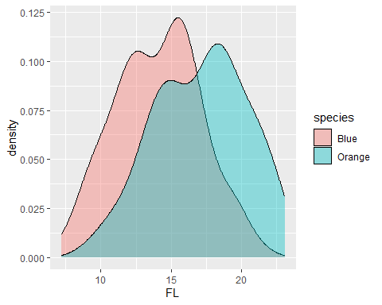
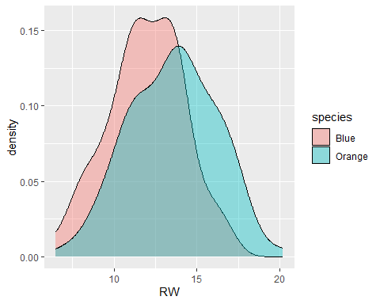
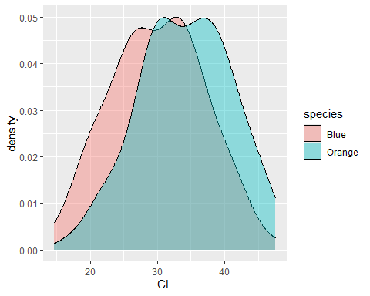
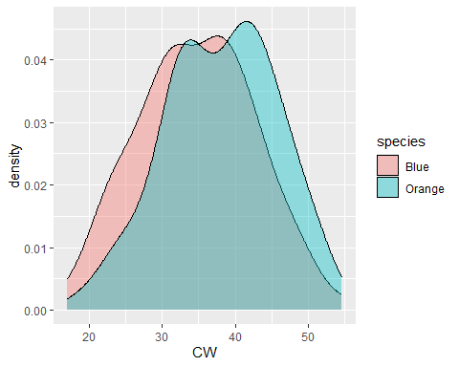
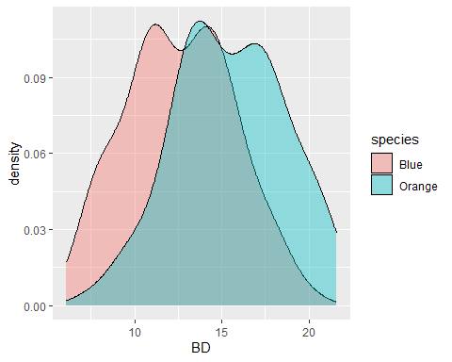
答：FL可以单独将 species 显著分离。
##4.3绘制Scatterplot Matrix
pairs(crab[, 4:8],
col = as.numeric(interaction(crab$species, crab$sex)) + 1,
pch = 19, lower.panel = NULL)
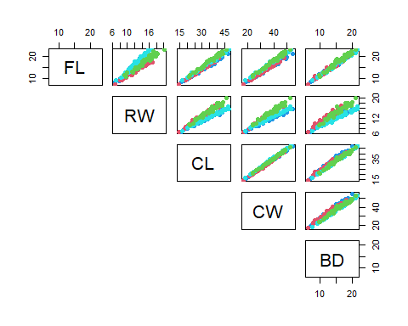
答：FL–RW 子图显示Blue与Orange两物种完全分离，是区分 蟹种的最佳变量对； CL–CW 子图在同种内部沿对角线把Male/Female分开，是区分种内性别的最佳变量对。
##4.4 Parallel Coordinate Plot 无用原因
library(MASS)
parcoord(crab[,4:8], col=as.numeric(interaction(crab$species,crab$sex))+1, lwd=2)
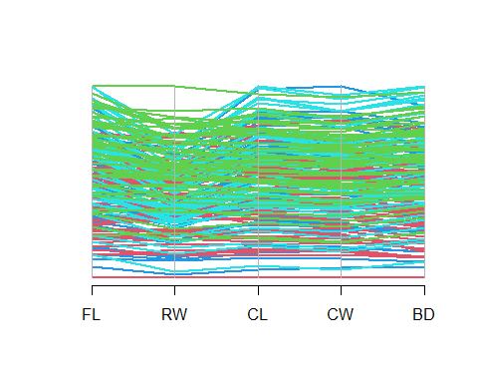
答：5 条测量线全程交叉、轨迹高度混杂，肉眼无法判断哪条变量对“种”或“性别”更重要，对确定变量重要性几乎无帮助。
##4.5 Tour 1D（LDA index）找种间一维投影
library(MASS)
library(ggplot2)
measure_vars <- c("FL","RW","CL","CW","BD")
fit <- lda(species ~ FL + RW + CL + CW + BD, data = crab)
fit$scaling[,1]
## FL RW CL CW BD
## 1.5687028 0.1707172 0.3946165 -1.5460297 1.3083372
crab$LD1 <- as.matrix(crab[measure_vars]) %*% fit$scaling[,1]
ggplot(crab, aes(x = LD1, fill = species)) +
geom_density(alpha = 0.4)
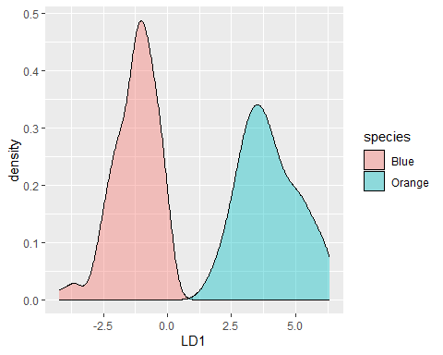
##4.6 主成分 + Tour 1D 再验证
pc <- prcomp(crab[measure_vars], scale. = TRUE)
pc_scores <- as.data.frame(pc$x[,1:5])
fit_pc <- lda(crab$species ~ ., data = pc_scores)
fit_pc$scaling[,1]
## PC1 PC2 PC3 PC4 PC5
## 0.47106109 0.09982762 11.96267795 -0.47121806 -7.92356564
crab$LD1_pc <- as.matrix(pc_scores) %*% fit_pc$scaling[,1]
ggplot(crab, aes(x = LD1_pc, fill = species)) +
geom_density(alpha = 0.4)
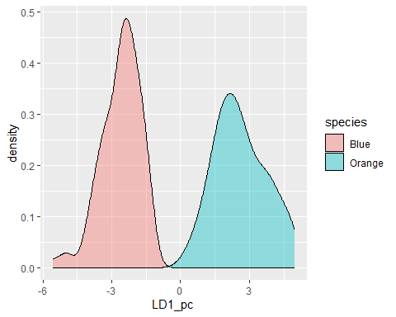
答：在将 5 个测量变量转为主成分后，再对主成分空间进行 Tour 1D，能够发现明显的分类间隔。

