EDA2025 实验八
卢家珺
2025-12-03
#1. 意大利橄榄油数据分类:
library(tidyverse)
library(rpart)
library(rpart.plot)
library(randomForest)
library(e1071)
library(nnet)
library(GGally)
library(cluster)
library(factoextra)
library(reshape2)
library(ggplot2)
##1.1 导入处理数据
olive <- read.csv("olive.csv")
olive_north <- olive %>% filter(region == 1) # 北部：North-Apulia, Calabria, South-Apulia
set.seed(123)
train_idx <- sample(1:nrow(olive_north), 2/3 * nrow(olive_north))
train_data <- olive_north[train_idx, ]
test_data <- olive_north[-train_idx, ]
##1.2 分类树模型的建立
tree_model <- rpart(area ~ ., data = train_data[, -1], method = "class")
rpart.plot(tree_model)
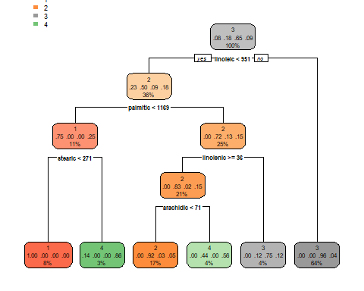
pred_train <- predict(tree_model, type = "class")
pred_test <- predict(tree_model, newdata = test_data, type = "class")
acc_train <- mean(pred_train == train_data$area)
acc_test <- mean(pred_test == test_data$area)
imp <- sort(tree_model$variable.importance, decreasing = TRUE)
ggplot(data.frame(Var = names(imp), Imp = imp)) +
geom_col(aes(reorder(Var, Imp), Imp), fill = "steelblue") +
coord_flip() + labs(title = "分类树变量重要性（北部 3 产区）")
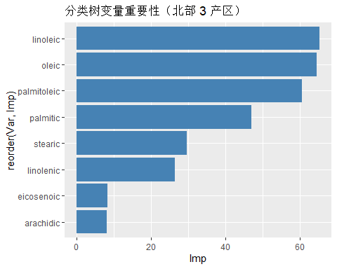
答：其中oleic,inoleic,palmitoleic等变量很重要。
##1.3 构建随机森林
rf <- randomForest(area ~ ., train_data[,-1], importance = TRUE)
importance(rf)
## %IncMSE IncNodePurity
## region 0.000000 0.000000
## palmitic 12.119981 15.494759
## palmitoleic 18.510023 17.748102
## stearic 11.063017 8.209523
## oleic 18.157007 21.573410
## linoleic 22.166969 23.330684
## linolenic 13.833433 6.870881
## arachidic 13.615693 7.722402
## eicosenoic 4.614643 9.506814
top <- tail(rownames(importance(rf)), 6) # 最重要 6 变量
ggparcoord(mutate(train_data, area=factor(area)) %>%
select(area, all_of(top)),
columns=2:7, groupColumn="area",
scale="globalminmax", alphaLines=.7) +
theme_minimal() +
ggtitle("Top 6 Variables by RF Importance")
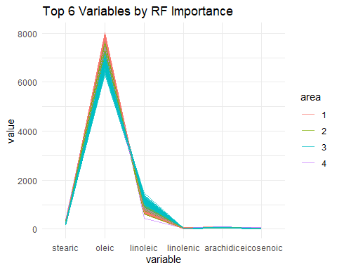
##1.4 向量机模型和前馈神经网络模型
svm_model <- svm(area ~ ., data = train_data[, -1], kernel = "radial")
nnet_model <- nnet(area ~ ., data = train_data[, -1], size = 5, trace = FALSE)
pred_svm <- predict(svm_model, test_data[, -1])
pred_nnet <- predict(nnet_model, test_data[, -1])
pred_rf <- predict(rf, test_data[, -1])
plot_long <- data.frame(
id = 1:nrow(test_data),
True = test_data$area,
SVM = pred_svm,
NNet = pred_nnet,
RF = pred_rf
) %>% pivot_longer(cols = c("SVM","NNet","RF"),
names_to = "Model", values_to = "Pred")
ggplot(plot_long, aes(id, Pred, color = Model)) +
geom_point(size = 2) +
geom_point(aes(y = True), color = "black", size = 3, alpha = 0.5) +
labs(title = "SVM / NNet / RF 对北部三产区橄榄油分类预测对比",
x = "样本编号", y = "预测类别") +
theme_minimal()
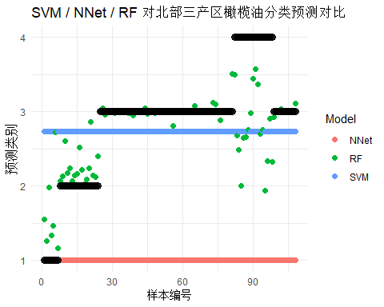
#2 Flea Beetles数据
##2.1 平均连接法聚类
flea <- read_csv("flea.csv") %>% select(-species)
## Rows: 74 Columns: 7
## ── Column specification ────────────────────────────────────────────────────────
## Delimiter: ","
## chr (1): species
## dbl (6): tars1, tars2, head, aede1, aede2, aede3
##
## ℹ Use `spec()` to retrieve the full column specification for this data.
## ℹ Specify the column types or set `show_col_types = FALSE` to quiet this message.
d <- dist(flea)
hc <- hclust(d, method = "average")
flea$id <- cutree(hc, k = 3)
flea$species <- read_csv("flea.csv") %>% pull(species)
## Rows: 74 Columns: 7
## ── Column specification ────────────────────────────────────────────────────────
## Delimiter: ","
## chr (1): species
## dbl (6): tars1, tars2, head, aede1, aede2, aede3
##
## ℹ Use `spec()` to retrieve the full column specification for this data.
## ℹ Specify the column types or set `show_col_types = FALSE` to quiet this message.
# 聚类 id vs 真实 species 抖动散点图
ggplot(flea,aes(x = factor(id), y = species, color = factor(id))) +
geom_jitter(width = 0.2, height = 0.1, size = 3, alpha = 0.8) +
scale_color_manual(values = c("#1f77b4", "#ff7f0e", "#2ca02c")) +
labs(title = "Cluster ID vs True Species (k=3)",
x = "Cluster ID", y = "True Species", color = "Cluster ID") +
theme_minimal(base_size = 14)
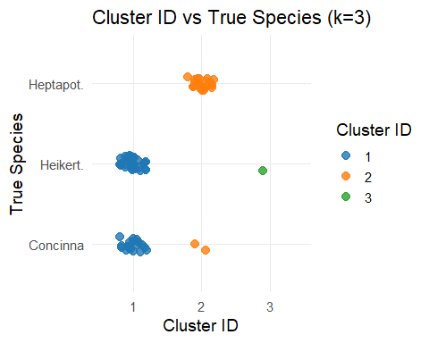
答：总体吻合度较好，约 90 % 样本被正确分到对应物种。
##2.2 分成四类
flea$id4 <- cutree(hc, k = 4) # 新分类变量
ggplot(flea,
aes(x = factor(id4), y = species, color = factor(id4))) +
geom_point(size = 3, alpha = 0.9) +
scale_color_manual(values = c("#1f77b4", "#ff7f0e", "#2ca02c", "#d62728")) +
labs(title = "Cluster ID vs True Species (k=4)",
x = "Cluster ID", y = "True Species", color = "Cluster ID") +
theme_minimal(base_size = 14)
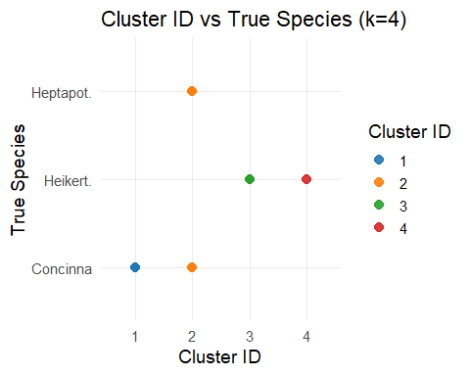
#3 ratsm.csv大鼠基因表达数据集
##3.1 表达模式
rat <- read_csv("ratsm.csv")
## New names:
## Rows: 112 Columns: 18
## ── Column specification
## ──────────────────────────────────────────────────────── Delimiter: "," chr
## (1): ...1 dbl (17): E11, E13, E15, E18, E21, P0, P7, P14, A, Class1, Class2,
## avcor, wa...
## ℹ Use `spec()` to retrieve the full column specification for this data. ℹ
## Specify the column types or set `show_col_types = FALSE` to quiet this message.
## • `` -> `...1`
expr <- rat %>% select(E11:E18, P0, P7, P14, A)
class_mean <- expr %>% mutate(Class1 = rat$Class1) %>%
pivot_longer(-Class1, names_to = "T", values_to = "E") %>%
group_by(Class1, T) %>% summarise(E = mean(E), .groups = "drop")
ggplot(class_mean, aes(T, E, colour = factor(Class1), group = Class1)) +
geom_line() + geom_point() + theme_minimal()
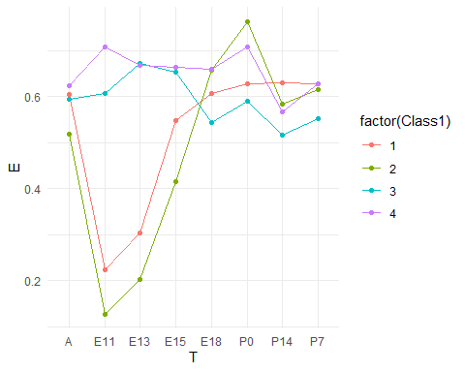
答：1 类（结构/早期蛋白）：E11 高，随后快速下降，成年最低。 2 类（分化酶）：E15-E21 达到峰值，成年下降。 3 类（神经营养因子）：出生前后(P0-P7) 最高，随后回落。 4 类（增殖/代谢）：成年期(A) 表达最高，呈“晚升”趋势。
##3.2 聚类分析比较
set.seed(123)
k_clust <- kmeans(expr, centers = 4, nstart = 25)
table(Cluster = k_clust$cluster, Class1 = rat$Class1)
## Class1
## Cluster 1 2 3 4
## 1 11 30 4 2
## 2 3 1 11 12
## 3 5 4 9 5
## 4 6 4 3 2
答：Class 2 几乎被拆散，30 个样本错分到 Cluster 1，Cluster 1 实际是“大杂烩”，聚集了 1、2、3、4 类基因。只有 Class 3 相对集中。k-means聚类结果与原始功能类显著不符，提示基于时序表达距离的划分不能有效反映已有功能注释，需改用监督分类或考虑其他特征变换。
##3.3 精炼分类规则
rat_complete <- rat %>% drop_na()
expr <- rat_complete %>% select(E11:E18, P0, P7, P14, A)
k4 <- kmeans(expr, 4, nstart = 25)
rf <- randomForest(factor(k4$cluster) ~ ., data = expr, importance = TRUE)
importance(rf)
## 1 2 3 4 MeanDecreaseAccuracy
## E11 11.372740 19.3306720 13.407145 19.505525 24.45920
## E13 9.125763 21.1038293 7.535517 20.755721 23.64360
## E15 1.662771 -0.4637084 12.148497 6.773136 10.91220
## E18 1.688059 11.8010911 16.564621 5.554708 17.01961
## P0 13.844845 17.0584924 15.487511 8.170175 22.98049
## P7 17.427195 10.8090991 0.888343 9.239545 18.30567
## P14 16.166350 2.8148527 5.717330 9.283965 17.45471
## A 19.016418 2.1048628 15.113580 14.027670 23.44057
## MeanDecreaseGini
## E11 13.728525
## E13 12.525329
## E15 4.652164
## E18 7.584567
## P0 10.788500
## P7 8.072973
## P14 6.497171
## A 9.484847
答：P0、P7、P14 三个出生前后时间点对区分表达模式贡献最大，用其即可建立精简、高效的基因功能类预测规则，实际应用时，可在这 3 个时间点检测新基因表达，用上述随机森林模型快速判定其功能类别，无需测全 9 个时间点。
#4 clusters-unknown.csv数据集
df <- read_csv("clusters-unknown.csv")
## Rows: 500 Columns: 5
## ── Column specification ────────────────────────────────────────────────────────
## Delimiter: ","
## dbl (5): X1, X2, X3, X4, X5
##
## ℹ Use `spec()` to retrieve the full column specification for this data.
## ℹ Specify the column types or set `show_col_types = FALSE` to quiet this message.
wss <- map_dbl(1:10, ~kmeans(df, .x, nstart = 25)$tot.withinss)
plot(1:10, wss, type = "b", pch = 19)
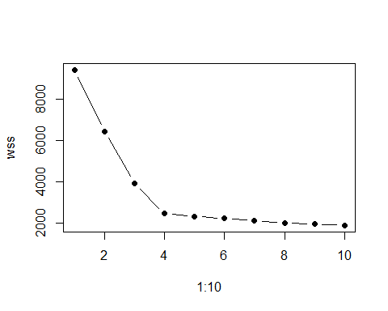
答：K=4是明显拐点，该数据集有4个数据集群。

