231001109 卢家珺 EDA实验六
卢家珺
2025-11-19
#导入数据包
library(rcompanion)
## Warning: 程序包'rcompanion'是用R版本4.5.2 来建造的
library(GGally)
## Warning: 程序包'GGally'是用R版本4.5.2 来建造的
## 载入需要的程序包：ggplot2
library(naniar)
## Warning: 程序包'naniar'是用R版本4.5.2 来建造的
library(car)
## 载入需要的程序包：carData
library(ggplot2)
library(dplyr)
##
## 载入程序包：'dplyr'
## The following object is masked from 'package:car':
##
## recode
## The following objects are masked from 'package:stats':
##
## filter, lag
## The following objects are masked from 'package:base':
##
## intersect, setdiff, setequal, union
library(tidyr)
#1 正态分布的检验
##导入数据
pbc <- read.csv("D:/231001109/data/PBC.csv") %>%
select(chol, copper, trig, platelet)
##(1) plotNormalHistogram函数的检验
vars <- c("chol","copper","trig","platelet")
par(mfrow=c(2,2))
for(v in vars) plotNormalHistogram(pbc[[v]], main=v, col="skyblue")
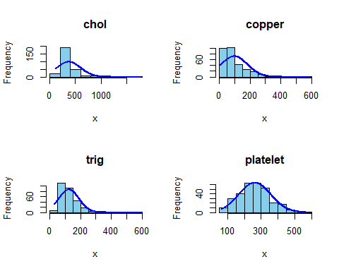
par(mfrow=c(1,1))
##(2) blom函数正态转换，生成新变量
pbc <- pbc %>% mutate(
cholNST = blom(chol),
copperNST = blom(copper),
trigNST = blom(trig),
plateletNST = blom(platelet))
##(3) 散点矩阵图
ggpairs(pbc, columns = paste0(vars, "NST"),
lower = list(continuous = "points"),
diag = list(continuous = "densityDiag"),
upper = list(continuous = "cor"))
## Warning: Removed 28 rows containing non-finite outside the scale range
## (`stat_density()`).
## Warning: Removed 30 rows containing missing values
## Removed 30 rows containing missing values
## Warning: Removed 32 rows containing missing values
## Warning: Removed 30 rows containing missing values or values outside the scale range
## (`geom_point()`).
## Warning: Removed 2 rows containing non-finite outside the scale range
## (`stat_density()`).
## Warning: Removed 32 rows containing missing values
## Warning: Removed 6 rows containing missing values
## Warning: Removed 30 rows containing missing values or values outside the scale range
## (`geom_point()`).
## Warning: Removed 32 rows containing missing values or values outside the scale range
## (`geom_point()`).
## Warning: Removed 30 rows containing non-finite outside the scale range
## (`stat_density()`).
## Warning: Removed 34 rows containing missing values
## Warning: Removed 32 rows containing missing values or values outside the scale range
## (`geom_point()`).
## Warning: Removed 6 rows containing missing values or values outside the scale range
## (`geom_point()`).
## Warning: Removed 34 rows containing missing values or values outside the scale range
## (`geom_point()`).
## Warning: Removed 4 rows containing non-finite outside the scale range
## (`stat_density()`).
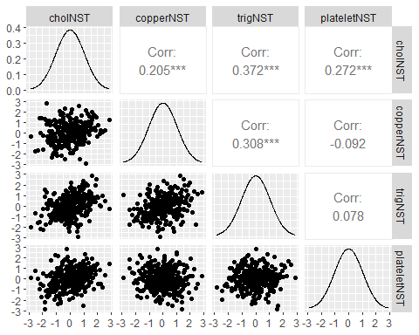
##(4) 绘制QQ图
qq_pl <- function(x,title){
d <- tibble(y=x) %>% drop_na()
ggplot(d, aes(sample=y)) +
stat_qq(distribution=qnorm, color="steelblue") +
stat_qq_line(distribution=qnorm, color="red", size=1) +
labs(title=title,x="Theoretical quantiles",y="Sample quantiles")
}
qq_pl(pbc$chol, "QQ: chol (original)")
## Warning: Using `size` aesthetic for lines was deprecated in ggplot2 3.4.0.
## ℹ Please use `linewidth` instead.
## This warning is displayed once every 8 hours.
## Call `lifecycle::last_lifecycle_warnings()` to see where this warning was
## generated.
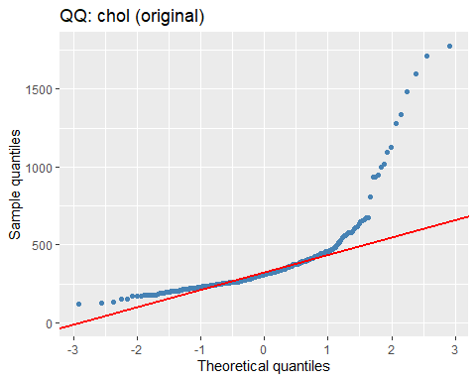
qq_pl(pbc$cholNST, "QQ: cholNST (Blom)")
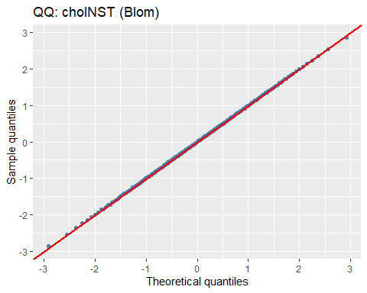
#2 pbc文件的创建
pdf("PBC.pdf", width=10, height=8)
print(gg_miss_var(pbc))
print(gg_miss_case(pbc))
print(vis_miss(pbc))
print(ggplot(pbc, aes(chol, trig)) + geom_miss_point())
dev.off()
## png
## 2
#3 渐进正态模拟
##(1) 绘制正态QQ图
set.seed(79)
gammaList <- lapply(1:100, function(i) rgamma(200, shape=3))
gammaMeans <- unlist(lapply(gammaList, mean))
car::qqPlot(gammaMeans, distribution="norm",
main="渐近正态：Gamma(3)样本均值n=200")
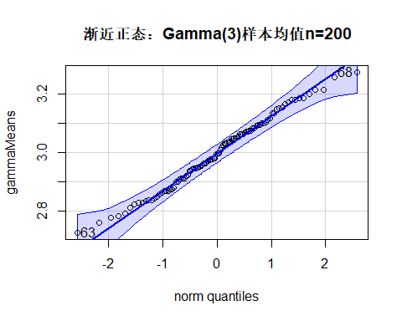
## [1] 68 63
答：满足渐近正态性假设
##(2) 生成模拟数据BinomSamples
BinomSamples <- replicate(100, rbinom(200, 10, 0.5))
BinomMeans <- apply(BinomSamples, 2, mean)
car::qqPlot(BinomMeans, distribution="norm",
main="渐近正态：Binom(10,0.5)样本均值n=200")
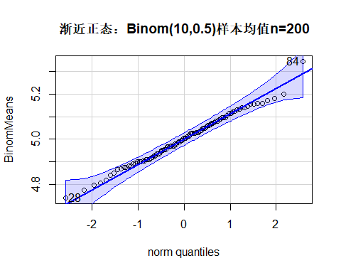
## [1] 84 28
答：满足渐近正态性假设
##(3)使用指数分布
ExpSamples <- replicate(100, rexp(200, rate=1))
ExpMeans <- apply(ExpSamples, 2, mean)
car::qqPlot(ExpMeans, distribution="norm",
main="渐近正态：Exp(1)样本均值n=200")
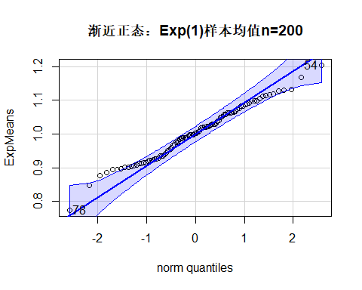
## [1] 78 54
答：满足渐近正态性假设
##(4) 使用柯西分布
CauchySamples <- replicate(100, rt(200, df=1))
CauchyMeans <- apply(CauchySamples, 2, mean)
car::qqPlot(CauchyMeans, distribution="norm",
main="柯西样本均值（无期望）")
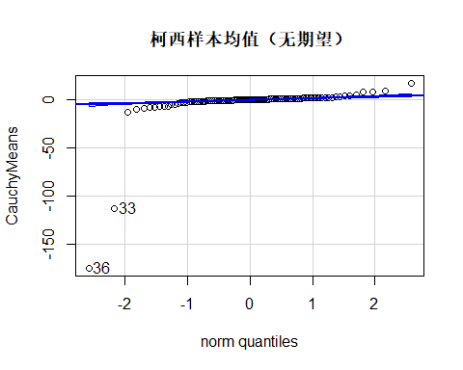
## [1] 36 33
答：不满足渐近正态性假设
##(5) 使用柯西中位数
CauchyMedians <- apply(CauchySamples, 2, median)
car::qqPlot(CauchyMedians, distribution="norm",
main="柯西样本中位数（渐近正态）")
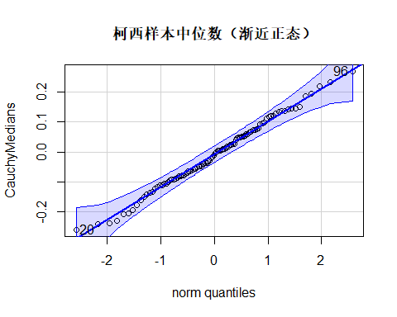
## [1] 96 20
答：满足渐近正态性假设
#4 标准正态分布和置信区间
##(1)t分布的临界值
n <- 100
set.seed(79)
sampledata <- rnorm(n) # 真实总体 N(0,1)
xbar <- mean(sampledata)
s <- sd(sampledata)
se <- s / sqrt(n)
t_crit <- qt(0.975, df=n-1)
CILower <- xbar - t_crit*se
CIUpper <- xbar + t_crit*se
data.frame(
Method = "手工(t临界)",
Mean = xbar,
SD = s,
SE = se,
CI_lower = CILower,
CI_upper = CIUpper
)
## Method Mean SD SE CI_lower CI_upper
## 1 手工(t临界) -0.04864857 1.133112 0.1133112 -0.2734826 0.1761854
##(2)直接使用检验函数
t.test(sampledata, conf.level=0.95)
##
## One Sample t-test
##
## data: sampledata
## t = -0.42934, df = 99, p-value = 0.6686
## alternative hypothesis: true mean is not equal to 0
## 95 percent confidence interval:
## -0.2734826 0.1761854
## sample estimates:
## mean of x
## -0.04864857

