231001109卢家珺EDA实验一
231001109卢家珺
2025-10-15
#EDA实验一
##一、airquality数据集 #安装导入程序包
library(tidyverse)
## ── Attaching core tidyverse packages ──────────────────────── tidyverse 2.0.0 ──
## ✔ dplyr 1.1.4 ✔ readr 2.1.5
## ✔ forcats 1.0.1 ✔ stringr 1.5.2
## ✔ ggplot2 4.0.0 ✔ tibble 3.3.0
## ✔ lubridate 1.9.4 ✔ tidyr 1.3.1
## ✔ purrr 1.1.0
## ── Conflicts ────────────────────────────────────────── tidyverse_conflicts() ──
## ✖ dplyr::filter() masks stats::filter()
## ✖ dplyr::lag() masks stats::lag()
## ℹ Use the conflicted package (<http://conflicted.r-lib.org/>) to force all conflicts to become errors
data(airquality)
#(a)查看数据记录，变量类型和含义
glimpse(airquality)
## Rows: 153
## Columns: 6
## $ Ozone <int> 41, 36, 12, 18, NA, 28, 23, 19, 8, NA, 7, 16, 11, 14, 18, 14, …
## $ Solar.R <int> 190, 118, 149, 313, NA, NA, 299, 99, 19, 194, NA, 256, 290, 27…
## $ Wind <dbl> 7.4, 8.0, 12.6, 11.5, 14.3, 14.9, 8.6, 13.8, 20.1, 8.6, 6.9, 9…
## $ Temp <int> 67, 72, 74, 62, 56, 66, 65, 59, 61, 69, 74, 69, 66, 68, 58, 64…
## $ Month <int> 5, 5, 5, 5, 5, 5, 5, 5, 5, 5, 5, 5, 5, 5, 5, 5, 5, 5, 5, 5, 5,…
## $ Day <int> 1, 2, 3, 4, 5, 6, 7, 8, 9, 10, 11, 12, 13, 14, 15, 16, 17, 18,…
#(b)查看变量唯一值和频率
table(airquality$Ozone)
##
## 1 4 6 7 8 9 10 11 12 13 14 16 18 19 20 21 22 23 24 27
## 1 1 1 3 1 3 1 3 2 4 4 4 4 1 4 4 1 6 2 1
## 28 29 30 31 32 34 35 36 37 39 40 41 44 45 46 47 48 49 50 52
## 3 1 2 1 3 1 2 2 2 2 1 1 3 2 1 1 1 1 1 1
## 59 61 63 64 65 66 71 73 76 77 78 79 80 82 84 85 89 91 96 97
## 2 1 1 2 1 1 1 2 1 1 2 1 1 1 1 2 1 1 1 2
## 108 110 115 118 122 135 168
## 1 1 1 1 1 1 1
table(airquality$Solar.R)
##
## 7 8 13 14 19 20 24 25 27 31 36 37 44 47 48 49 51 59 64 65
## 1 1 1 1 1 1 2 1 1 1 1 1 1 1 1 1 1 1 1 1
## 66 71 77 78 81 82 83 91 92 95 98 99 101 112 115 118 120 127 131 135
## 1 1 1 1 1 1 1 1 2 1 1 1 1 1 1 1 1 2 1 1
## 137 138 139 145 148 149 150 153 157 167 175 183 186 187 188 189 190 191 192 193
## 2 1 2 1 1 1 1 1 1 1 3 1 1 1 1 1 2 2 1 1
## 194 197 201 203 207 212 213 215 220 222 223 224 225 229 230 236 237 238 242 244
## 1 1 1 1 1 1 1 1 3 1 3 1 1 1 1 2 2 4 1 1
## 248 250 252 253 254 255 256 258 259 260 264 266 267 269 272 273 274 275 276 279
## 1 2 2 1 1 2 1 1 4 1 2 1 1 1 1 2 2 1 1 1
## 284 285 286 287 290 291 294 295 299 307 313 314 320 322 323 332 334
## 1 1 1 1 1 2 1 1 1 1 1 1 1 2 1 1 1
table(airquality$Wind)
##
## 1.7 2.3 2.8 3.4 4 4.1 4.6 5.1 5.7 6.3 6.9 7.4 8 8.6 9.2 9.7
## 1 1 1 1 1 1 4 3 3 8 9 10 11 8 8 11
## 10.3 10.9 11.5 12 12.6 13.2 13.8 14.3 14.9 15.5 16.1 16.6 18.4 20.1 20.7
## 11 8 15 4 3 2 5 6 8 3 1 3 1 1 1
table(airquality$Temp)
##
## 56 57 58 59 61 62 63 64 65 66 67 68 69 70 71 72 73 74 75 76 77 78 79 80 81 82
## 1 3 2 2 3 2 1 2 2 3 4 4 3 1 3 3 5 4 4 9 7 6 6 5 11 9
## 83 84 85 86 87 88 89 90 91 92 93 94 96 97
## 4 5 5 7 5 3 2 3 2 5 3 2 1 1
#(c)查看变量缺失值和频率
summary(airquality)
## Ozone Solar.R Wind Temp
## Min. : 1.00 Min. : 7.0 Min. : 1.700 Min. :56.00
## 1st Qu.: 18.00 1st Qu.:115.8 1st Qu.: 7.400 1st Qu.:72.00
## Median : 31.50 Median :205.0 Median : 9.700 Median :79.00
## Mean : 42.13 Mean :185.9 Mean : 9.958 Mean :77.88
## 3rd Qu.: 63.25 3rd Qu.:258.8 3rd Qu.:11.500 3rd Qu.:85.00
## Max. :168.00 Max. :334.0 Max. :20.700 Max. :97.00
## NA's :37 NA's :7
## Month Day
## Min. :5.000 Min. : 1.0
## 1st Qu.:6.000 1st Qu.: 8.0
## Median :7.000 Median :16.0
## Mean :6.993 Mean :15.8
## 3rd Qu.:8.000 3rd Qu.:23.0
## Max. :9.000 Max. :31.0
##
sapply(airquality,function(x)length(which(is.na(x))))
## Ozone Solar.R Wind Temp Month Day
## 37 7 0 0 0 0
#(d)离群值检测
for(v in 1:4)
{
print(boxplot.stats(airquality[[v]])$out)
}
## [1] 135 168
## integer(0)
## [1] 20.1 18.4 20.7
## integer(0)
#(e)直方图
par(mfrow = c(2,2))
for(v in names(airquality)[1:4])
hist(airquality[[v]], main = paste("Histogram of", v), xlab = v, col = "skyblue")
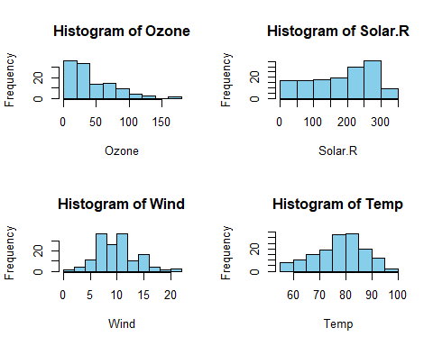
#(f)qq图
library(car)
## 载入需要的程序包：carData
##
## 载入程序包：'car'
## The following object is masked from 'package:dplyr':
##
## recode
## The following object is masked from 'package:purrr':
##
## some
par(mfrow = c(2,2))
for(v in names(airquality)[1:4])
qqPlot(airquality[[v]], main = paste("QQ plot of", v))
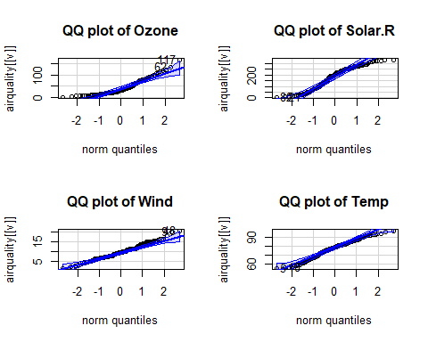
#(g)W检验
for(v in names(airquality)[1:4]){
cat("\n*** Variable:", v, "***\n")
print(shapiro.test(na.omit(airquality[[v]])))}
##
## *** Variable: Ozone ***
##
## Shapiro-Wilk normality test
##
## data: na.omit(airquality[[v]])
## W = 0.87867, p-value = 2.79e-08
##
##
## *** Variable: Solar.R ***
##
## Shapiro-Wilk normality test
##
## data: na.omit(airquality[[v]])
## W = 0.94183, p-value = 9.492e-06
##
##
## *** Variable: Wind ***
##
## Shapiro-Wilk normality test
##
## data: na.omit(airquality[[v]])
## W = 0.98575, p-value = 0.1178
##
##
## *** Variable: Temp ***
##
## Shapiro-Wilk normality test
##
## data: na.omit(airquality[[v]])
## W = 0.97617, p-value = 0.009319
#二、college.txt基本特征 #college文件的读取
college <- read.delim("college.txt", header = TRUE, sep = "\t", stringsAsFactors = FALSE)
str(college)
## 'data.frame': 260 obs. of 11 variables:
## $ School : chr "Harvard" "Princeton" "Yale" "Cal Tech" ...
## $ Enrollment : int 19230 7497 11446 2126 10299 17833 8855 23196 12386 14060 ...
## $ Tier : int 1 1 1 1 1 1 1 1 1 1 ...
## $ Retention : int 97 98 99 98 98 98 98 99 98 96 ...
## $ Grad.rate : int 98 96 97 88 94 94 95 95 92 95 ...
## $ Pct.20 : int 77 75 79 71 65 72 73 77 73 71 ...
## $ Pct.50 : num 8 9 7 6 13 12 7 8 5 5 ...
## $ Full.time : int 93 92 88 97 90 99 86 92 86 97 ...
## $ Top.10 : int 95 97 97 97 97 92 99 94 86 90 ...
## $ Accept.rate : int 8 10 9 17 12 9 17 10 28 22 ...
## $ Alumni.giving: int 40 61 41 31 37 35 39 36 33 39 ...
#(a)条形图的绘制
stripchart(college$Pct.20, method = "stack",
xlab="Pct.20", col="skyblue", pch=19)
#(c)垂直线的绘制
median_p20 <- median(college$Pct.20, na.rm = TRUE)
abline(v = median_p20, col = "red", lwd = 2, lty = 2)
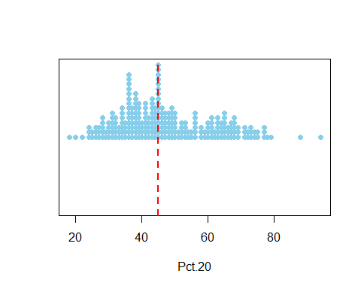
#(b)
#三、探索小班与大班百分比的关系 #(a)散点图的绘制
plot(college$Pct.20, college$Pct.50,
xlab = "小班比例(Pct.20)", ylab = "大班比例(Pct.50)",
main = "小班与大班比例关系", pch = 19, col = "darkblue")
#(b)回归线的添加
fit <- lm(Pct.50 ~ Pct.20, data = college)
abline(fit, col = "red", lwd = 2)
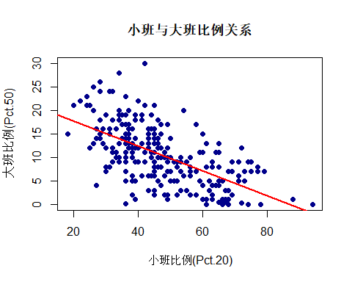
#(c)预测大班比例
predict(fit, newdata = data.frame(Pct.20 = 60))
## 1
## 7.158207
#(d)残差散点图的构建
clean_data <- na.omit(college[, c("Pct.20", "Pct.50", "School")])
# 建立线性模型
fit <- lm(Pct.50 ~ Pct.20, data = clean_data)
# 计算残差
res <- resid(fit)
# 绘制残差散点图
plot(clean_data$Pct.20, res,xlab = "Pct.20（小班授课比例）",ylab = "残差", main = "残差散点图",pch = 19, col = "blue")
abline(h=0, col="red", lwd=2)
#(f)
out_idx <- which(abs(res) > 10)
points(college$Pct.20[out_idx], res[out_idx], col = "orange", pch = 19)
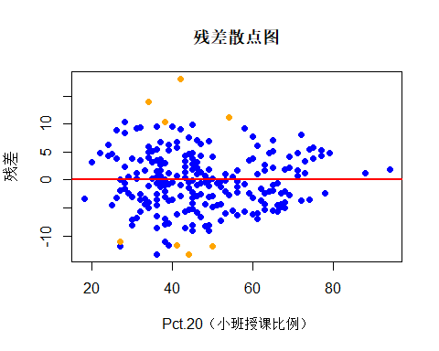
#(e)特别模式的识别
which(abs(res) > 10)
## 24 37 43 113 140 192 193 217
## 24 37 43 112 139 191 192 214
college[which(abs(res) > 10), ]
## School Enrollment Tier Retention Grad.rate Pct.20 Pct.50
## 24 UCLA 20743 1 97 89 54 20
## 37 Univ Calif San Diego 27520 1 94 85 42 30
## 43 Univ Calif Davis 30568 1 90 81 34 28
## 112 New Hampshire 14964 2 87 73 44 16
## 139 Bowling Green 17874 3 76 58 41 6
## 191 South Florida 46189 3 83 48 27 14
## 192 St. Thomas 10963 3 88 72 38 2
## 214 Indiana State 10457 4 67 43 50 5
## Full.time Top.10 Accept.rate Alumni.giving
## 24 90 97 23 14
## 37 93 100 42 7
## 43 94 98 53 11
## 112 84 24 65 10
## 139 94 12 87 9
## 191 97 25 46 15
## 192 73 20 81 15
## 214 87 10 66 13
id <- identify(college$Pct.20,res,labels=college$Name)
#四、全职教师比例分析
hist(college$Full.time, main="全职教师比例分布",
xlab="Full.time", col="lightgreen")
