# **第二次作业**

**银行家算法问题：**

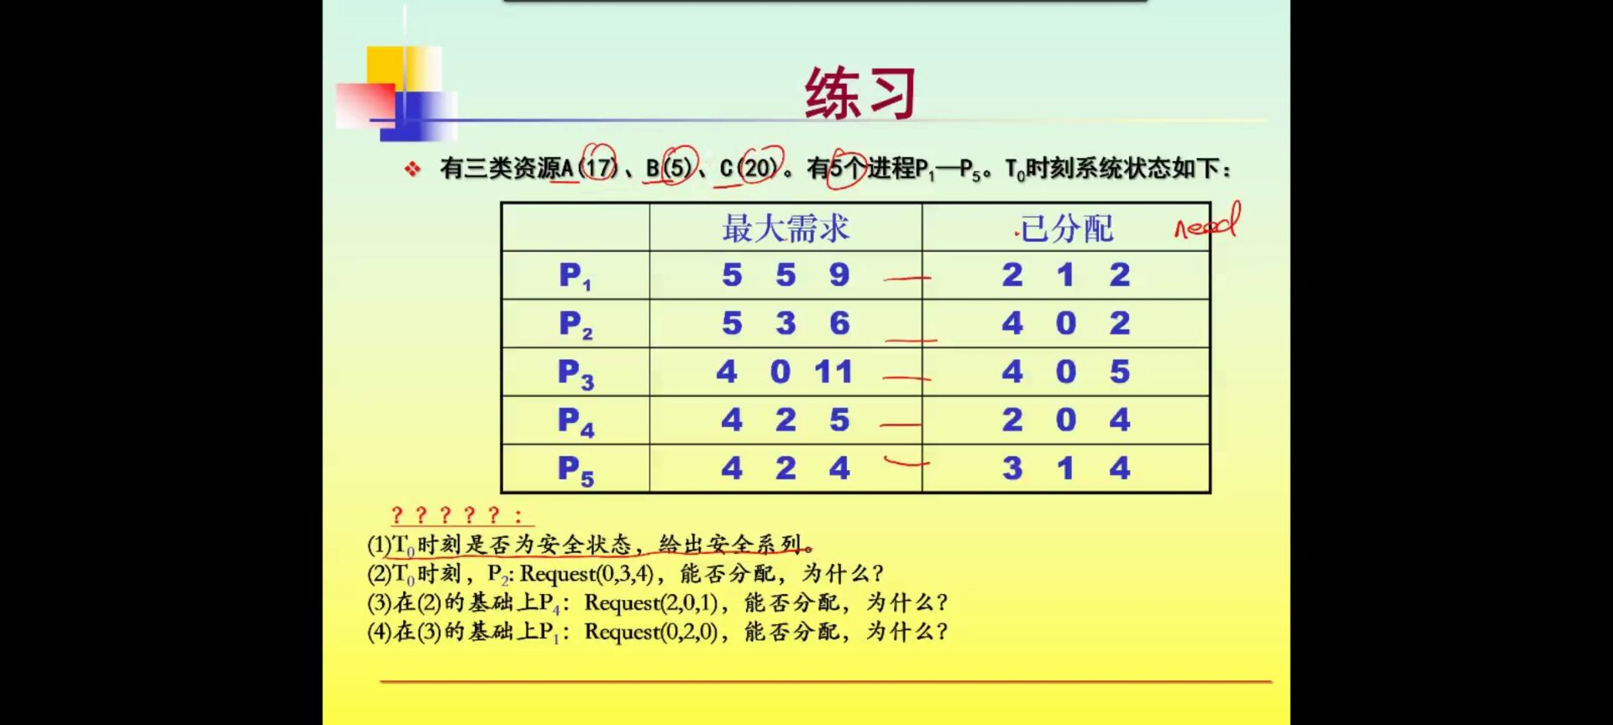

解：

1.是安全状态，安全系列为 P4->P5->P3->P1->P2

|  |  |  |  |  |  |  |  |  |  |  |  |  |
| --- | --- | --- | --- | --- | --- | --- | --- | --- | --- | --- | --- | --- |
|  | Max | | | Allocation | | | Need | | | Available | | |
| A | B | C | A | B | C | A | B | C | A | B | C |
| P1 | 5 | 5 | 9 | 2 | 1 | 2 | 3 | 4 | 7 | 2 | 3 | 3 |
| P2 | 5 | 3 | 6 | 4 | 0 | 2 | 1 | 3 | 4 |  |  |  |
| P3 | 4 | 0 | 11 | 4 | 0 | 5 | 0 | 0 | 6 |  |  |  |
| P4 | 4 | 2 | 5 | 2 | 0 | 4 | 2 | 2 | 1 |  |  |  |
| P5 | 4 | 2 | 4 | 3 | 1 | 4 | 1 | 1 | 0 |  |  |  |

开始安全性检查：

|  |  |  |  |
| --- | --- | --- | --- |
|  | Working | | |
|  | A | B | C |
|  | 2 | 3 | 3 |
| P4 | 4 | 3 | 7 |
| P5 | 7 | 4 | 11 |
| P3 | 11 | 4 | 16 |
| P1 | 13 | 5 | 18 |
| P2 | 17 | 5 | 20 |

2.不能分配

此时，Request(0,3,4)<=Need(1,3,4) 成立

但Request(0,3,4)<=Available(2,3,3) 不成立

系统可提供的资源不能满足request，所以不能分配

3.能分配，安全序列为P4->P2->P3->P1->P5

此时，P4进程为

Request(0,2,0)<=Need(2，2，1) 成立

Request(0,2,0)<=Available(2，3，3) 成立

满足条件，并进行安全检验

|  |  |  |  |
| --- | --- | --- | --- |
|  | Working | | |
|  | A | B | C |
|  | 2 | 3 | 3 |
| P4 | 4 | 3 | 7 |
| P2 | 8 | 3 | 9 |
| P3 | 12 | 3 | 14 |
| P1 | 14 | 4 | 6 |
| P5 | 17 | 5 | 20 |

1. 不能分配，

此时，P1的进程为：

Request(0,2,0)<=Need(3,4,7) 成立

Request(0,2,0)<=Available(0,3,2) 成立

满足条件，并进行安全检验

|  |  |  |  |
| --- | --- | --- | --- |
|  | Working | | |
|  | A | B | C |
|  | 0 | 3 | 2 |
| P1 | 0 | 1 | 2 |
|  |  |  |  |
|  |  |  |  |
|  |  |  |  |
|  |  |  |  |

分配完P1之后，Available（0，1，2）再也找不到需要的进程了，所以不满足资源分配