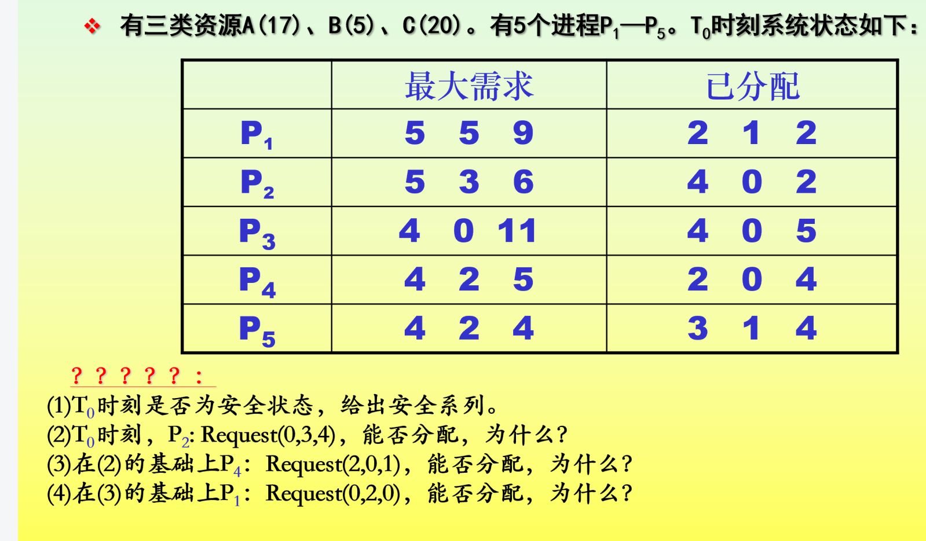

解：

1. 是安全状态

|  |  |  |  |  |
| --- | --- | --- | --- | --- |
|  | Max | Allocation | Need | Available |
|  | A B C | A B C | A B C | A B C |
| P1 | 5 5 9 | 2 1 2 | 1. 4 7 | 2 3 3 |
| P2 | 5 3 6 | 4 0 2 | 1 3 4 | 4 3 7 |
| P3 | 4 0 11 | 4 0 5 | 0 0 6 | 8 3 9 |
| P4 | 4 2 5 | 2 0 4 | 2 2 1 | 12 3 14 |
| P5 | 1. 2 4 | 1. 1 4 | 1. 1 0 | 15 4 18  17 5 20 |

安全序列为：P4🡪P2🡪P3🡪P5🡪P1

(2) Request(0,3,4)<Need(1,3,4)

Request(0,3,4)>Available(2,3,3)

故P2:Request(0,3,4)时不能分配。

1. P4:Request(2, 0,1)<Need(2,2,1)

Request(2,0,1)<Available(2,3,3)

|  |  |  |  |  |
| --- | --- | --- | --- | --- |
|  | Max | Allocation | Need | Available |
|  | A B C | A B C | A B C | A B C |
| P1 | 5 5 9 | 2 1 2 | 1. 4 7 | 2 3 3  (0 3 2) |
| P2 | 5 3 6 | 4 0 2 | 1 3 4 | 4 3 7 |
| P3 | 4 0 11 | 4 0 5 | 0 0 6 | 8 3 9 |
| P4 | 4 2 5 | 2 0 4  (2 0 1) | 2 2 1  (0 2 0) | 12 3 14 |
| P5 | 4 2 4 | 1. 1 4 | 1. 1 0 | 15 4 18  17 5 20 |

安全序列为P4🡪P2🡪P3🡪P5🡪P1

故P4:Request(2, 0,1)时可以分配

（4）P1:Request(0,2,0)<Need(5,4,7)

Request(0,2,0)<Available(0,3,2)

|  |  |  |  |  |
| --- | --- | --- | --- | --- |
|  | Max | Allocation | Need | Available |
|  | A B C | A B C | A B C | A B C |
| P1 | 5 5 9 | 2 1 2   1. 2 0) | 3 4 7  (3 2 7) | 0 3 2  (0 1 2) |
| P2 | 5 3 6 | 4 0 2 | 1 3 4 |  |
| P3 | 4 0 11 | 4 0 5 | 0 0 6 |  |
| P4 | 4 2 5 | 4 0 5 | 0 2 0 |  |
| P5 | 1. 2 4 | 3 1 4 | 1 1 0 |  |

此时Available=(0,1,2), P1-P5所有的Need都大于Available，已不能满足任何进程的需要，系统进入不安全状态，因此不能分配资源。