Titanic Dataset: Data Cleaning and EDA
Week 1 Internship Task | Data Acquisition, Cleaning and Exploratory Analysis

1. Objective
The objective is to acquire a public dataset, assess data quality, clean missing and duplicate records, explore distributions and relationships, and communicate findings using visualizations.

2. Dataset and Source
Dataset: Titanic passenger dataset
Source: DataScienceDojo public GitHub repository
URL: https://raw.githubusercontent.com/datasciencedojo/datasets/master/titanic.csv
Original rows: 891
Original columns: 12
The dataset contains passenger details such as age, sex, ticket class, fare, family members aboard, embarkation port and survival outcome.

3. Tools Used
Python, Pandas, NumPy, Matplotlib, Seaborn and python-docx.

4. Initial Data Assessment
Original dataset shape: (891, 12)
Exact duplicate rows: 0
Missing values by column:
PassengerId 0
Survived 0
Pclass 0
Name 0
Sex 0
Age 177
SibSp 0
Parch 0
Ticket 0
Fare 0
Cabin 687
Embarked 2

5. Data Cleaning and Rationale
- Removed exact duplicate rows to avoid counting identical records more than once.
- Checked PassengerId for duplicate identifiers and retained the first occurrence.
- Created HasCabin before dropping Cabin because Cabin has substantial missingness.
- Converted relevant numeric columns with errors coerced to missing values.
- Filled missing Age values using median age for the same passenger class and sex, then overall median as fallback.
- Filled missing Embarked values with the most frequent category.
- Filled missing Fare values with the median.
- Removed records missing essential Survived or Pclass values.
- Created FamilySize and IsAlone features to support further analysis.
Final cleaned shape: (891, 14)
Remaining missing values: 0

6. Visual Exploratory Analysis
Figure 1. Missing values before cleaning.
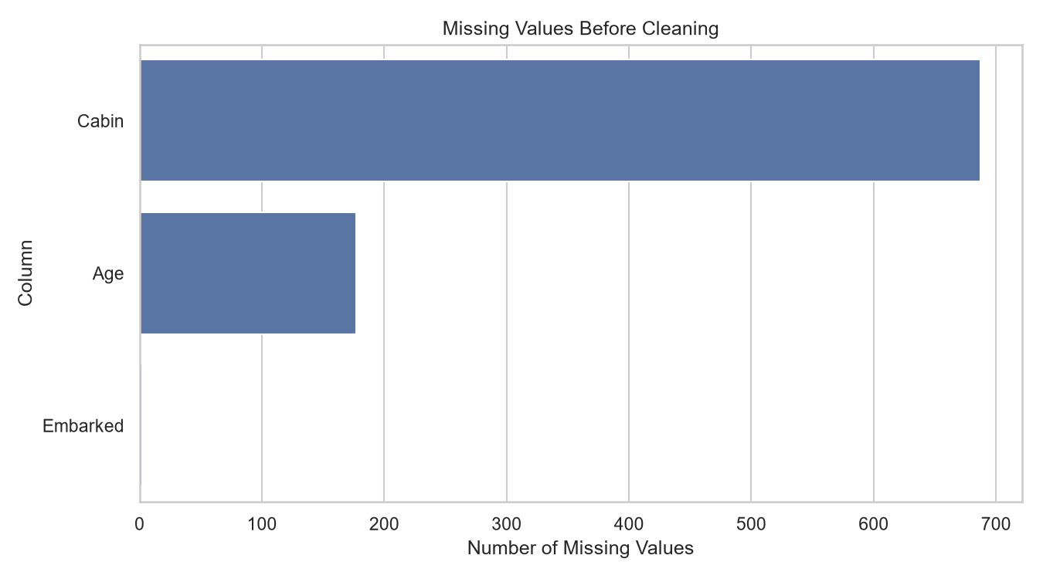
Figure 2. Distribution of survival outcomes.
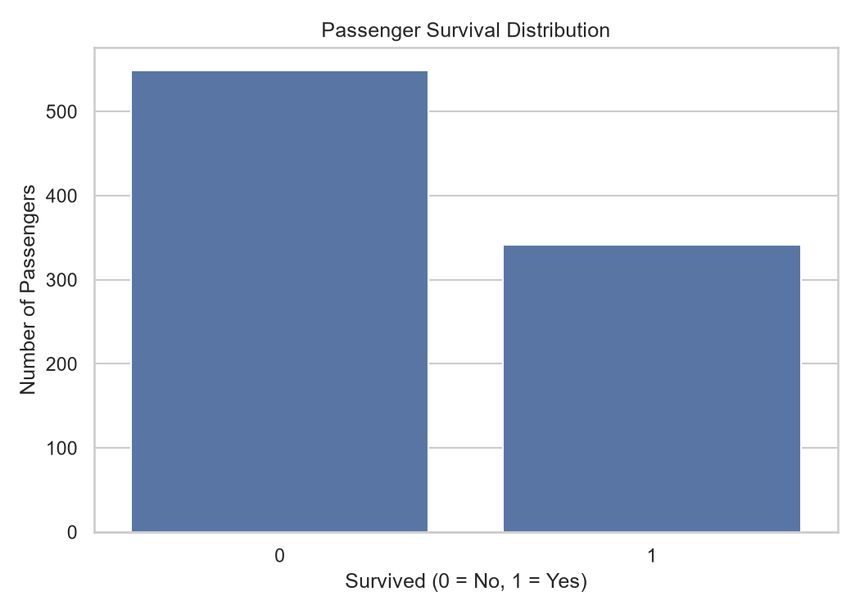
Figure 3. Survival rate by gender.
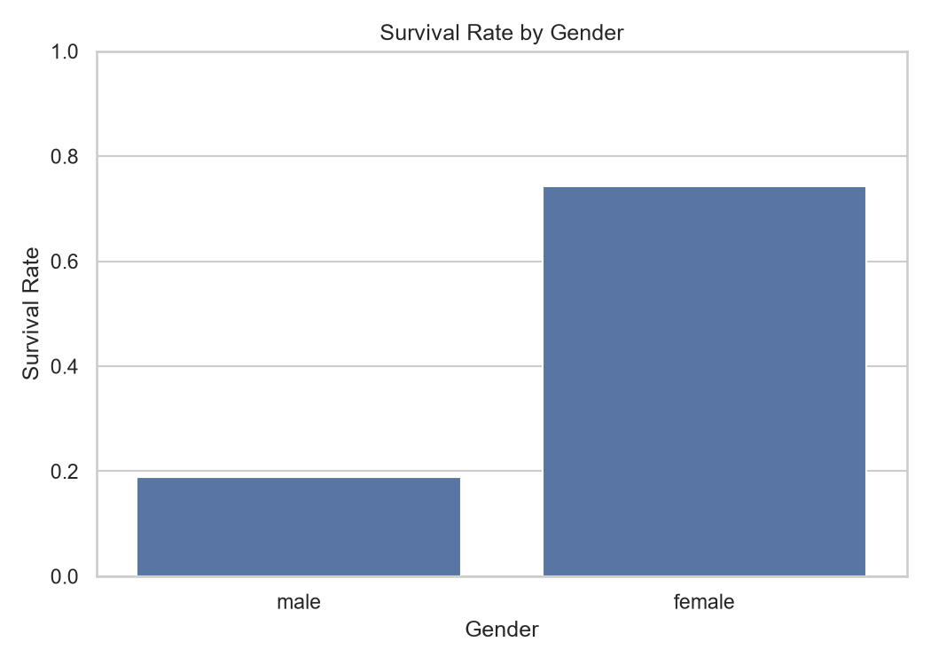
Figure 4. Survival rate by passenger class.
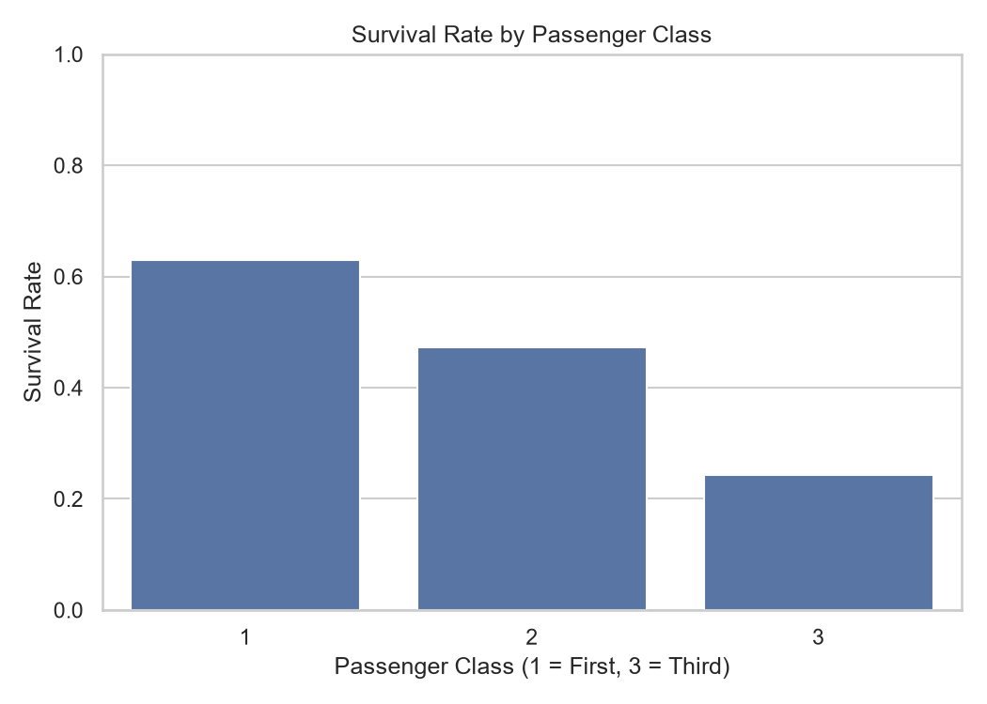
Figure 5. Passenger age distribution.
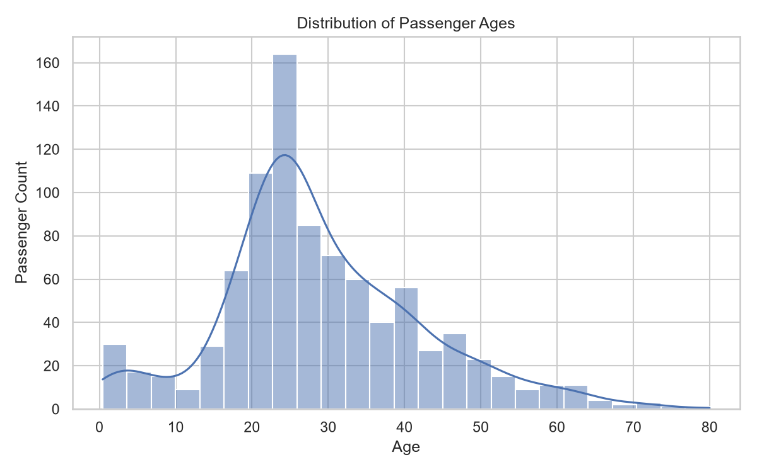
Figure 6. Correlations among numerical variables.
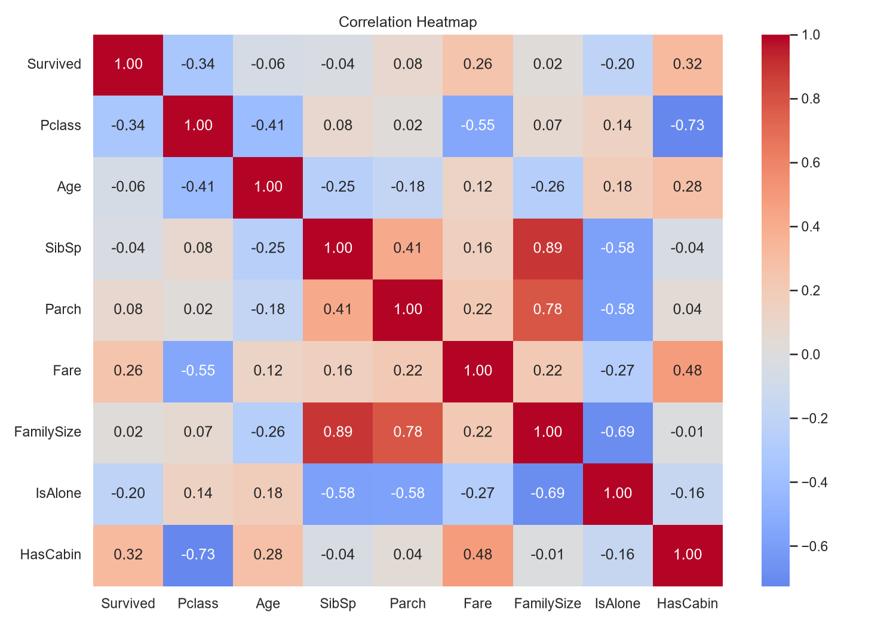

7. Key Findings
- Overall, 38.4% of passengers in this dataset survived.
- Median passenger age is 26.0 years.
- Median ticket fare is 14.45.
- Survival rate by gender:
Sex
female 74.2%
male 18.9%
- Survival rate by passenger class:
Pclass
1 63.0%
2 47.3%
3 24.2%
- 60.3% of passengers were travelling alone.
- These are observed associations, not proof that any single factor caused survival.

8. Limitations and Further Analysis
Median and mode imputation introduce assumptions into the data. Dropping Cabin loses individual cabin details, although HasCabin retains whether a cabin value was recorded. Correlation does not establish causation. Future work could investigate age groups, family size, ticket class and gender together, and test whether observed differences are statistically significant.

9. Conclusion
The dataset was inspected, cleaned and analyzed using descriptive statistics and visualizations. The resulting charts and insights provide an initial understanding of survival patterns and prepare the data for further analysis.

