YUVA INTERNSHIP SUBMISSION

Week 3: Statistical Analysis and Hypothesis Testing

Name: Asutosa Tiwari | College: National Institute of Technology (NIT), Durgapur | Branch: Electronics and Communication Engineering (ECE)
Advertising Spending and Sales
Dataset: Advertising.csv | Significance level: 0.05

1. Introduction and objective
This report studies whether advertising spending is related to product sales. TV spending is used for the main hypothesis test, while Radio and Newspaper spending are included in a regression model. The report also compares sales across different TV-spending groups.

2. Dataset and preparation
The dataset has 200 observations and four variables: TV, Radio, Newspaper and Sales. Any extra index column was removed. The data were checked for numeric values and missing entries, and all 200 observations were kept.
This is observational data. The tests show relationships and group differences, but they do not prove that advertising spending causes sales to change.

3. Research question and hypotheses
Research question: Is TV advertising spending linearly related to Sales?
H₀ (null hypothesis): The population Pearson correlation between TV spending and Sales is zero (ρ = 0).
H₁ (alternative hypothesis): The population Pearson correlation between TV spending and Sales is not zero (ρ ≠ 0).
The significance level used was α = 0.05.

4. Descriptive statistics
The average spending was 147.04 for TV, 23.26 for Radio, and 30.55 for Newspaper. Average Sales was 14.02, with a standard deviation of 5.22 and values from 1.60 to 27.00.
Variable | Mean | Std. dev. | Minimum | Maximum
TV | 147.04 | 85.85 | 0.70 | 296.40
Radio | 23.26 | 14.85 | 0.00 | 49.60
Newspaper | 30.55 | 21.78 | 0.30 | 114.00
Sales | 14.02 | 5.22 | 1.60 | 27.00

5. Pearson correlation test
The Pearson correlation between TV spending and Sales was r = 0.7822, p = 1.47e-42. The 95% confidence interval was [0.7218, 0.8308]. Since p < 0.05, the null hypothesis was rejected. This shows a strong positive relationship between TV spending and Sales.
A p-value shown as 0.000 after rounding is not exactly zero. It means the probability is extremely small under the null hypothesis.
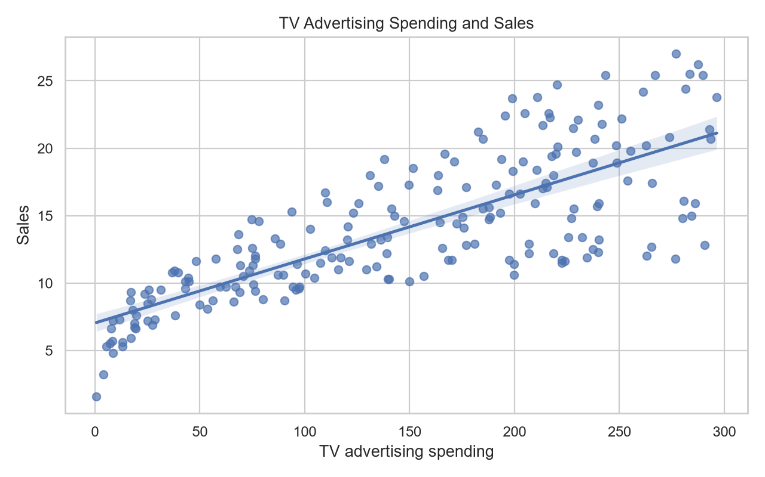
Figure 1. TV advertising spending versus Sales, with a fitted linear trend.

6. Welch's t-test
The observations were divided into low- and high-TV-spending groups using the median. Welch's t-test compared their average Sales without assuming equal variances. H₀: the group means are equal. H₁: the group means are different.
Average Sales was 10.54 in the low-spending group and 17.51 in the high-spending group. The difference was 6.97, with a 95% confidence interval of [5.88, 8.05]. The test gave t = 12.684 and p = 7.33e-27, so the difference was statistically significant.
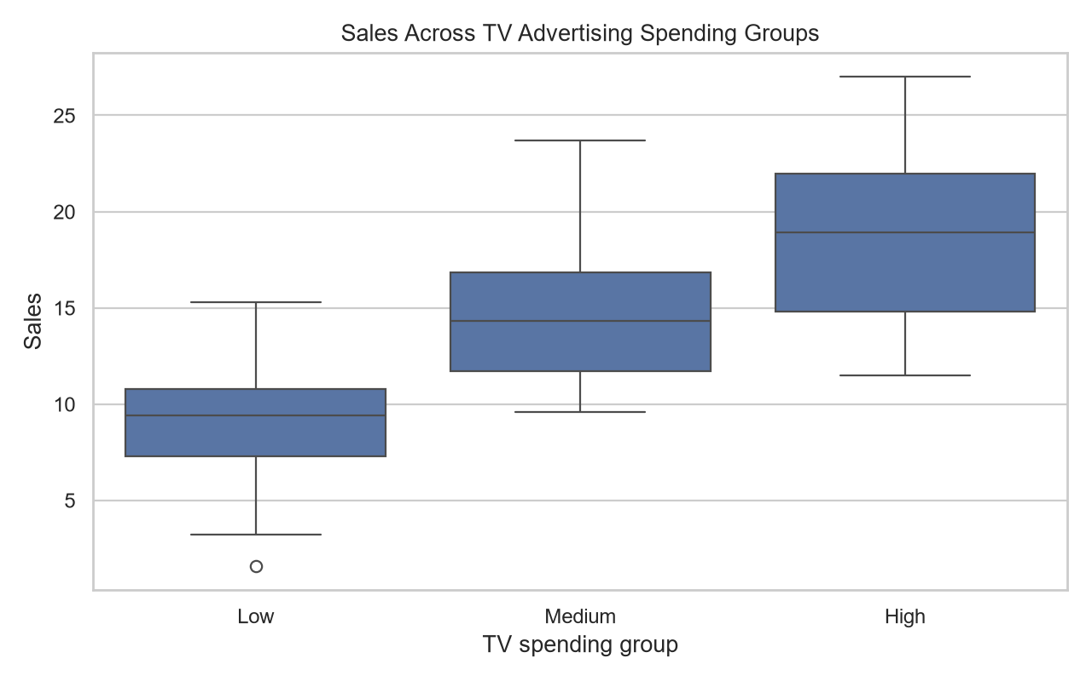
Figure 2. Sales distributions across low, medium and high TV-spending groups.

7. One-way ANOVA and Tukey HSD
One-way ANOVA compared average Sales across low, medium, and high TV-spending groups. H₀: all three means are equal. H₁: at least one mean is different.
The ANOVA result was F = 110.585, p = 6.34e-33. The null hypothesis was rejected, showing that the group means are not all equal.
Tukey's HSD test was then used to compare the groups in pairs while controlling the overall error rate. The results are shown below.
group1 | group2 | meandiff | p-adj | lower | upper | reject
High | Low | -9.212 | 0.000 | -10.681 | -7.743 | 1.000
High | Medium | -3.896 | 0.000 | -5.370 | -2.421 | 1.000
Low | Medium | 5.316 | 0.000 | 3.842 | 6.790 | 1.000
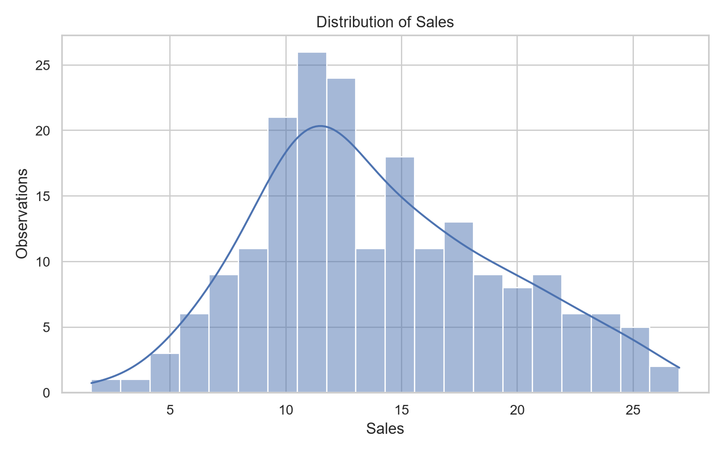
Figure 3. Distribution of Sales across the observations.

8. Multiple linear regression
A multiple linear regression model used TV, Radio, and Newspaper spending to predict Sales. It had R² = 0.897 and adjusted R² = 0.896, explaining about 89.7% of the variation in Sales. The overall model was statistically significant (F = 570.3, p = 1.58 × 10⁻⁹⁶).
After controlling for the other channels, TV had a coefficient of 0.0458 (95% CI: 0.043 to 0.049, p < 0.001), and Radio had a coefficient of 0.1885 (95% CI: 0.172 to 0.206, p < 0.001). Newspaper had a coefficient of -0.0010 (95% CI: -0.013 to 0.011, p = 0.860), so its independent association was not statistically significant in this model.
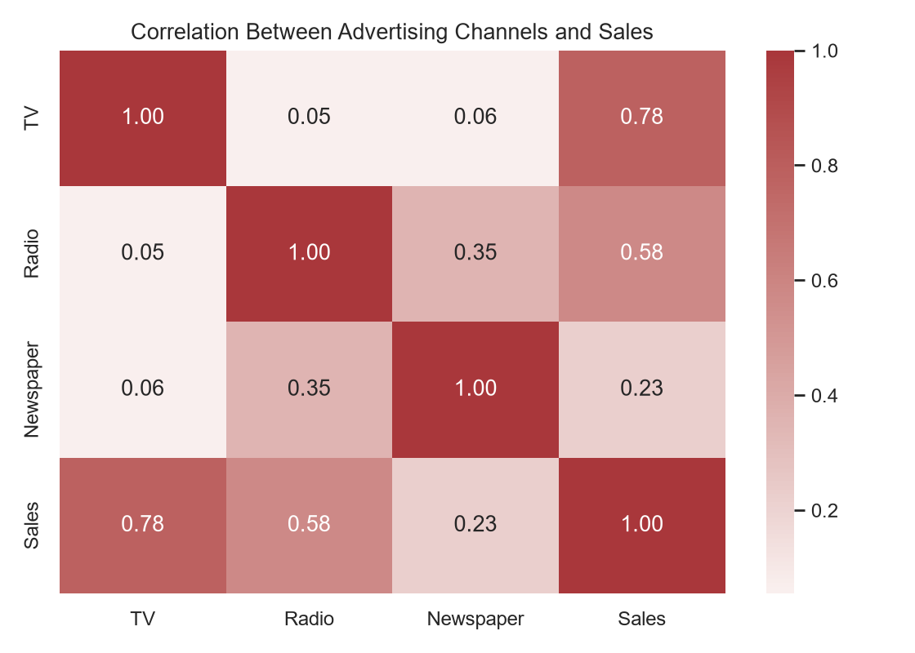
Figure 4. Correlation matrix for the advertising channels and Sales.
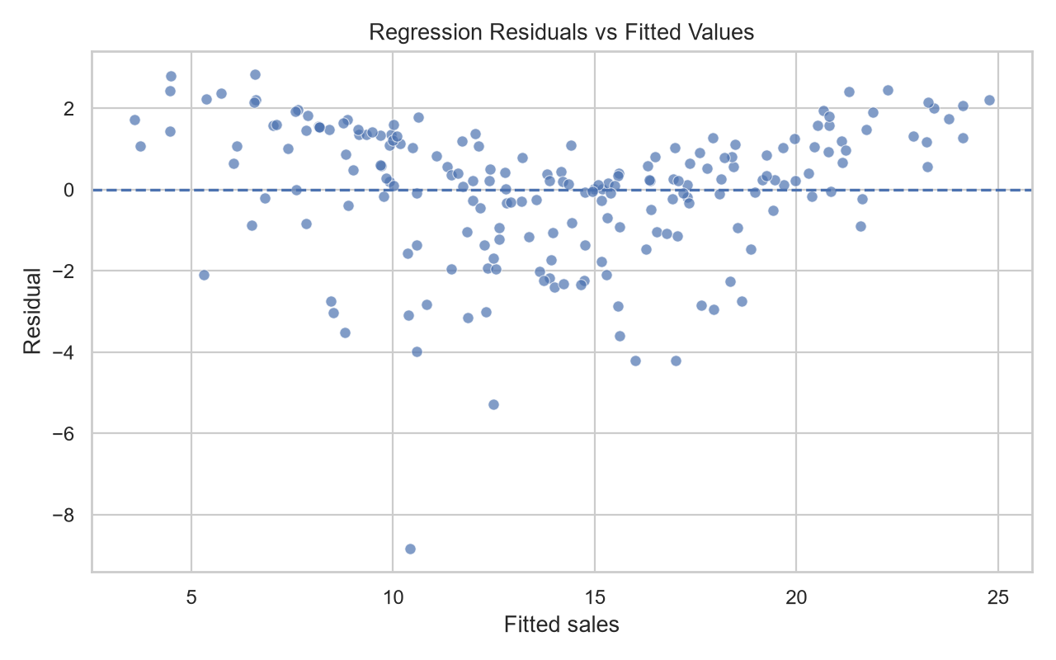
Figure 5. Residuals versus fitted values. The plot shows some structure and a few large residuals, so the regression assumptions should be checked rather than assumed to hold.

9. Regression diagnostics
Jarque-Bera residual normality test: statistic = 151.241, p = 1.44e-33. This suggests that the residuals are not normally distributed.
Breusch-Pagan test: statistic = 5.133, p = 0.1623. There is no significant evidence of non-constant error variance.
The Jarque–Bera result suggests that the residuals are not normal. The Breusch–Pagan result does not show a significant variance problem. These checks do not automatically invalidate the model, but the results should still be interpreted carefully.

10. Conclusion and limitations
The Pearson test found a strong positive relationship between TV spending and Sales (r = 0.7822, p = 1.47e-42). The Welch t-test and ANOVA also showed differences between the TV-spending groups. The regression model showed positive associations for TV and Radio, while Newspaper was not statistically significant after adjustment.
These results show association, not causation. The data were not from a randomized experiment, and other factors may affect Sales. Grouping a continuous variable also loses some information. Therefore, the results should not be treated as a guarantee that increasing an advertising budget will produce a fixed increase in Sales.

11. Tools and outputs
The analysis used Python with Pandas, NumPy, SciPy, Statsmodels, Matplotlib, and Seaborn. The script produced the statistics, test results, charts, and diagnostic outputs. This Word report was prepared separately from the analysis script.

