YUVA INTERN

Machine Learning Model
Development and Evaluation
Breast Cancer Classification using Python

Name | Asutosa Tiwari
College | National Institute of Technology (NIT), Durgapur
Branch | Electronics and Communication Engineering (ECE)
Python • Scikit-learn • Model Evaluation • Data Visualization

1. Introduction
This project shows a basic machine learning process in Python. It covers data loading, data preparation, model training, and model evaluation. The task is a binary classification problem, where the model predicts whether a breast tumour record is malignant or benign. I compared Logistic Regression with a Decision Tree and used more than just accuracy to judge the models.

2. Objective
The main aim of this project is to build and test classification models using a public dataset. I also compared their results on new test data, created visualizations, and discussed errors, overfitting, and possible improvements.

3. Dataset and Preparation
I used the Breast Cancer Wisconsin dataset that comes with scikit-learn. It has 569 records and 30 numerical features. There are two classes: malignant (label 0) and benign (label 1). Since the dataset is already available in scikit-learn, I did not need to download it separately.
First, I checked the feature data for missing values and duplicate rows. The data-quality check found 0 missing values and 0 duplicate rows. I split the data into 80% training data and 20% test data using stratification and random_state=42. This helped keep a similar class ratio in both parts.
For Logistic Regression, I used median imputation and StandardScaler before training the model. Keeping these steps inside a scikit-learn pipeline makes the evaluation fair because each cross-validation fold learns preprocessing values only from its training data. The Decision Tree also uses median imputation, but it does not need feature scaling.

4. Model Selection

Logistic Regression
I selected Logistic Regression as the main model because it is a common and easy-to-understand starting model for binary classification. I used feature scaling because the input features have different ranges.

Decision Tree
I used a Decision Tree as the comparison model. I limited its maximum depth to 4 so that the tree would not become too complex and learn noise from the training data. Using two different models gives a better comparison than using only one model.

5. Evaluation Method
I evaluated both models using five-fold StratifiedKFold cross-validation on the training data. After that, I trained each model on the full training set and tested it once on the separate test set. I recorded accuracy, precision, recall, F1-score, and ROC-AUC. In the comparison table, precision, recall, and F1-score are reported for the benign class (label 1). The classification reports also include results for both classes.
Accuracy tells us how many predictions were correct overall. Precision tells us how many of the selected-class predictions were correct. Recall tells us how many actual examples of that class were found. F1-score gives a balance between precision and recall. ROC-AUC shows how well the model separates the classes at different thresholds. A value closer to 1 is better.

6. Results
The results below were taken from the generated evaluation_metrics.csv and cross_validation_results.csv files.
Model | Train acc. | Test acc. | Precision* | Recall* | F1-score* | ROC-AUC
Logistic Regression | 0.989 | 0.982 | 0.986 | 0.986 | 0.986 | 0.9954
Decision Tree | 0.987 | 0.939 | 0.958 | 0.944 | 0.951 | 0.9342
*Precision, recall, and F1-score are shown for the benign class. The values are rounded for easier reading.

Cross-validation accuracy
Model | Mean accuracy | Standard deviation
Logistic Regression | 0.9780 | 0.0098
Decision Tree | 0.9297 | 0.0149
Logistic Regression got a test accuracy of 98.25% and a ROC-AUC of 0.9954. The Decision Tree got a test accuracy of 93.86% and a ROC-AUC of 0.9342. Overall, Logistic Regression performed better on the test results and also had a higher mean cross-validation accuracy (97.80% compared with 92.97%).

7. Visualizations

7.1 Model performance comparison
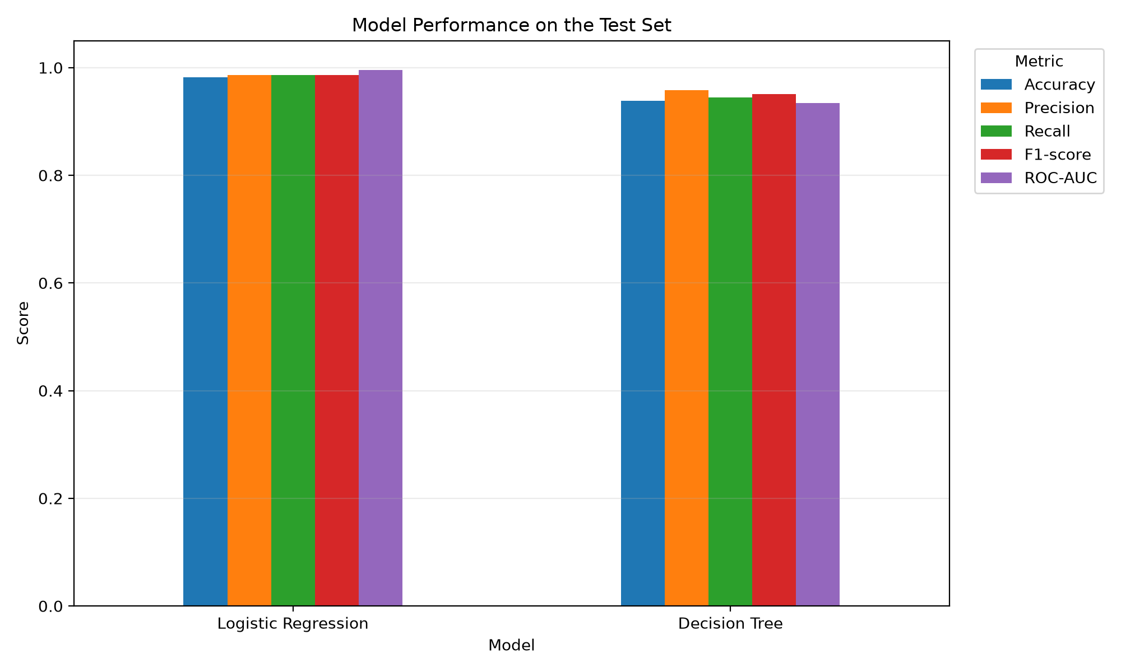
This chart compares test accuracy, benign-class precision, recall, F1-score, and ROC-AUC. In this evaluation, Logistic Regression has higher scores on all of these measures.

7.2 Confusion matrix
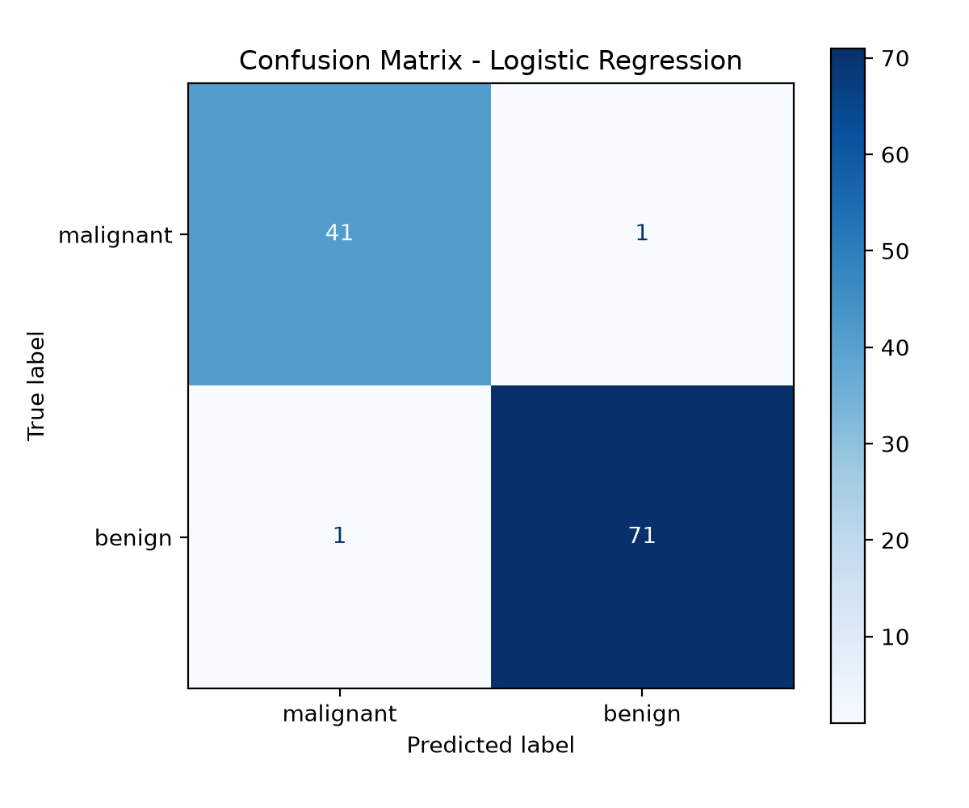
For Logistic Regression, 41 malignant records were correctly predicted as malignant. One malignant record was predicted as benign, and one benign record was predicted as malignant. The remaining 71 benign records were predicted correctly. So, 112 out of 114 test records were correct, giving about 98.25% accuracy.

7.3 ROC curves
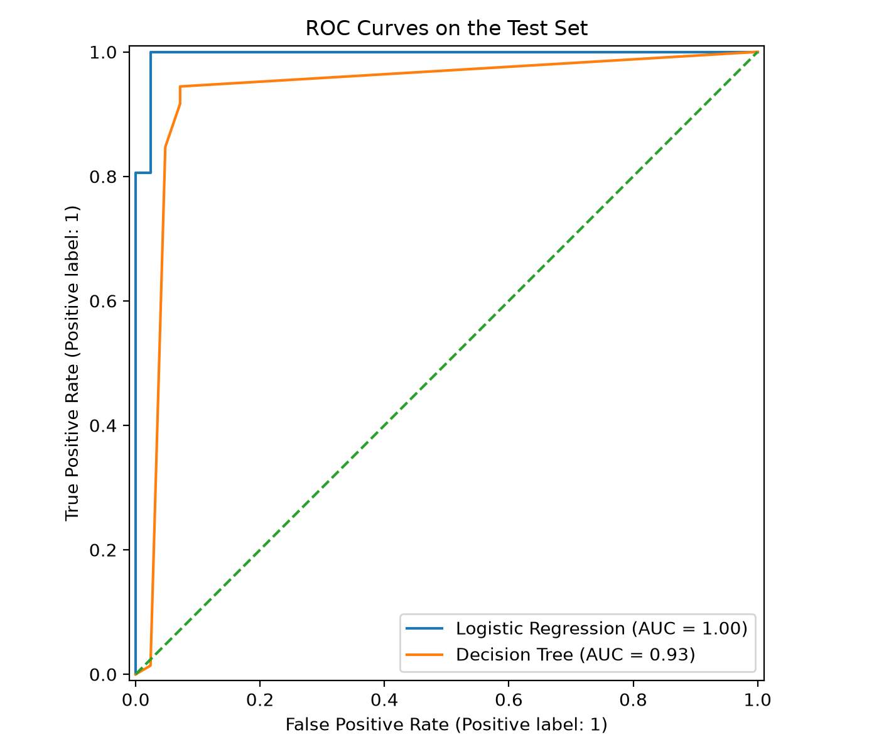
The ROC curves compare the true-positive rate and false-positive rate at different thresholds. Logistic Regression has an AUC of about 0.9954, while the Decision Tree has an AUC of about 0.9342. The graph shows Logistic Regression as AUC = 1.00 because the legend rounds the value to two decimal places. This does not mean the score is exactly perfect.

8. Overfitting, Errors, and Limitations
Logistic Regression has 98.90% training accuracy and 98.25% test accuracy, so the gap is 0.66%. The Decision Tree has 98.68% training accuracy and 93.86% test accuracy, giving a gap of 4.82%. These gaps do not prove overfitting by themselves, but the bigger gap for the Decision Tree suggests that it loses more performance on unseen data. Cross-validation gives another idea of how stable the models are.
The confusion matrix has one malignant case predicted as benign and one benign case predicted as malignant. The first one is a false negative when malignant is treated as the positive class. In a medical situation, these two errors may have different effects, so accuracy alone is not enough to decide whether a model is suitable.
- The dataset is fairly small and may not represent every population or medical setting.
- The results can change depending on the train-test split, selected features, and model settings.
- A high score on one test split does not guarantee the same result on future data.
- This comparison uses only two algorithms and one main train-test split.
- This dataset and model are used only for learning. The predictions must not be used for medical diagnosis.

9. Possible Improvements
- Try different model settings using cross-validation, but keep the test set separate until the final evaluation.
- Repeat the evaluation with different splits or use nested cross-validation to get a more reliable estimate.
- Compare more models and study the false positives and false negatives for each class.
- Consider recall for each class and the cost of mistakes when choosing the decision threshold.
- Test any future model on independent data before thinking about real-world use.

10. Conclusion
In this project, I completed a basic machine learning pipeline using scikit-learn. I prepared the data, selected the models, used cross-validation, tested the models, and created visualizations. Logistic Regression performed better than the limited-depth Decision Tree in this run, with 98.25% test accuracy and a ROC-AUC of 0.9954. This project showed me why it is important to use several metrics and look at classification errors instead of checking accuracy alone. More testing and careful medical review would be needed before using such a model in practice.

Tools and Libraries
Python, pandas, Matplotlib, scikit-learn, and python-docx were used in this project and for preparing the report.

