YUVA INTERN

Week 2: Advanced Data Visualization
and Storytelling with Python
World Development Indicators — A Global Development Story
Internship: Virtual Data Science with Python Apprentice Intern
Prepared by: Asutosa Tiwari
Dataset source: World Bank, World Development Indicators (WDI)

1. Executive Summary
This report uses World Bank data to look at development through income, health, internet access and infrastructure. It compares trends over time and differences between economies, with 2024 used for the main cross-country comparisons. The charts tell a simple story: countries are moving forward at different speeds, and no single indicator explains development on its own.

2. Research Questions
- How have GDP per capita, life expectancy and internet use changed since 2000?
- How has India’s trajectory changed across income, health and digital access?
- Do economies with higher GDP per capita tend to have higher life expectancy?
- How large is the regional gap in internet access?
- How have under-five mortality rates changed across selected countries?
- How are electricity access and internet use associated, and how do indicators correlate?

3. Data and Methodology
The data comes from the World Bank’s World Development Indicators. WDICSV.csv contains the yearly values, while WDICountry.csv and WDISeries.csv add country details and indicator descriptions. Aggregate rows were removed so the country comparisons focus on actual economies.
The analysis uses GDP per capita, life expectancy, internet use, population, unemployment, under-five mortality and electricity access. The data was reshaped into a tidy format and converted to numeric values. Missing values were kept as missing, so the number of countries can vary from one chart to another.
For the main comparison, the script chooses the latest year with good coverage across the three core indicators. It also exports cleaned data and summary tables so the work can be checked or reused.

4. Visualization Story

Figure 1. Global development trends since 2000
Each line starts at 100 in 2000, so the chart compares relative change rather than mixing dollars, years and percentages.
Quick takeaway: The chart makes it easy to see which indicators changed fastest.
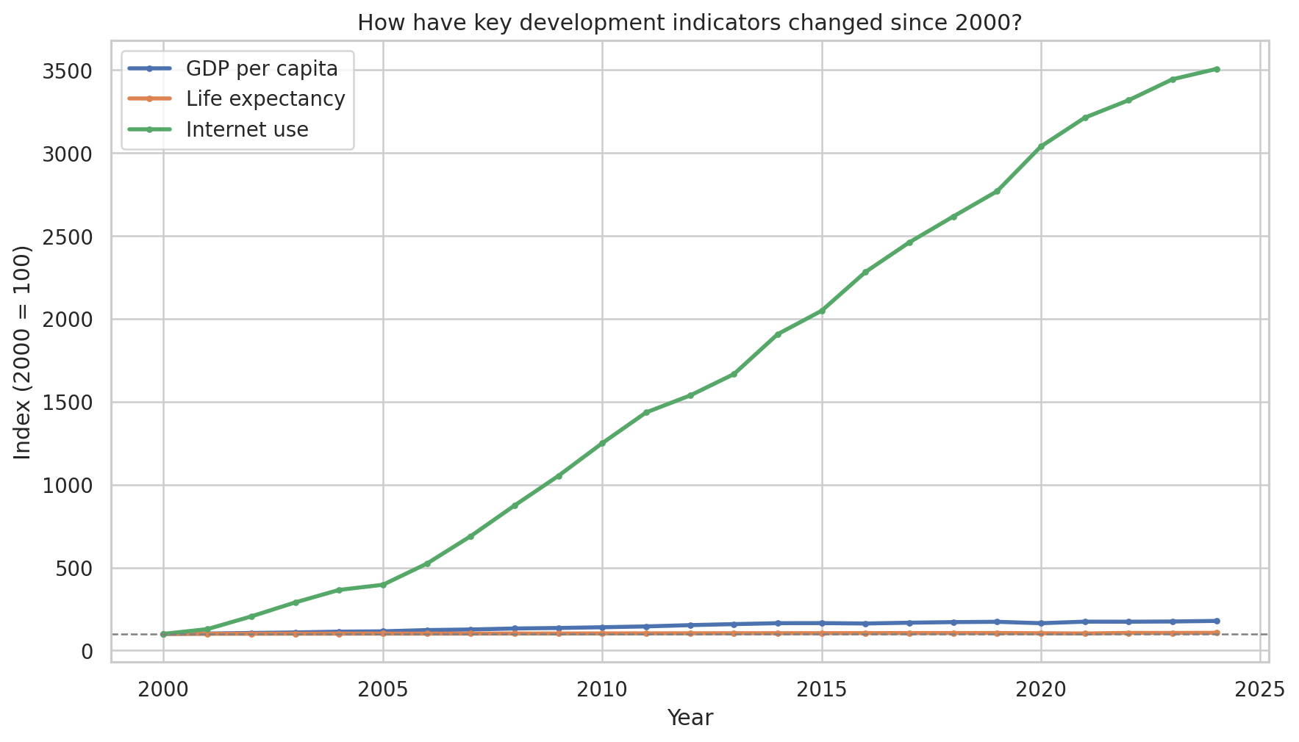

Figure 2. India’s development trajectory
Three panels track India’s income, health and internet access separately, making the direction of each trend easy to read.
Quick takeaway: India’s progress is clear, but the three indicators do not move at exactly the same pace.
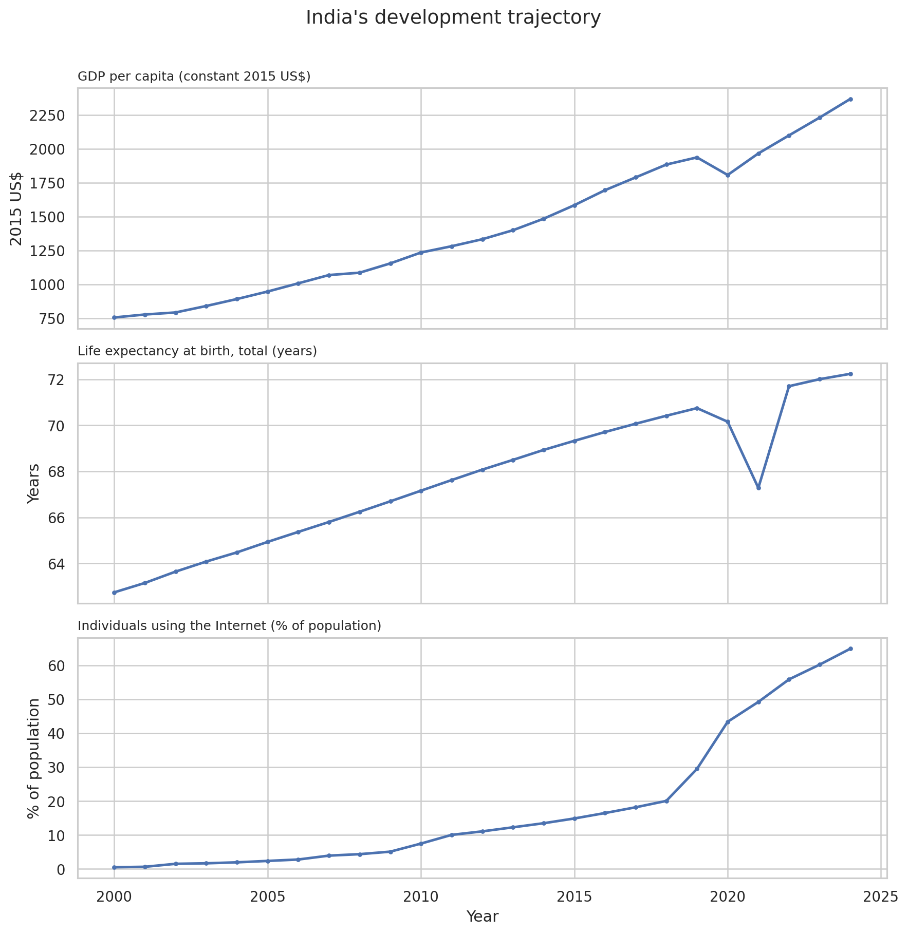

Figure 3. GDP per capita and life expectancy (2024)
Each dot is an economy. The chart compares GDP per capita with life expectancy, while color and size show internet use.
Quick takeaway: Richer economies generally sit higher on life expectancy, but the pattern is not perfect.
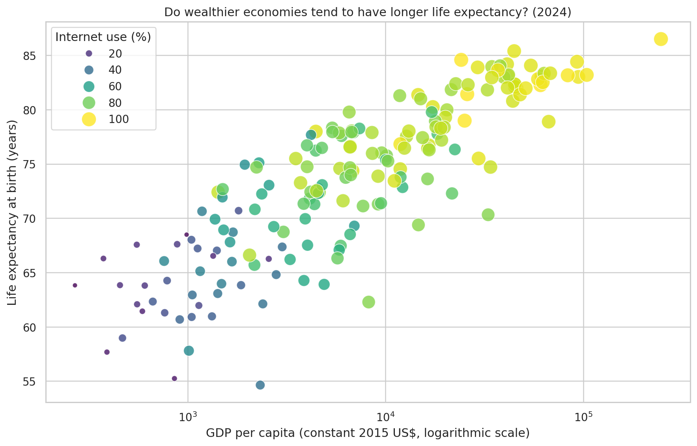

Figure 4. Annotated country comparison (2024)
Colors show income groups, and a few countries are labelled to make the overall pattern easier to follow.
Quick takeaway: The labels connect the broad pattern to familiar country examples.
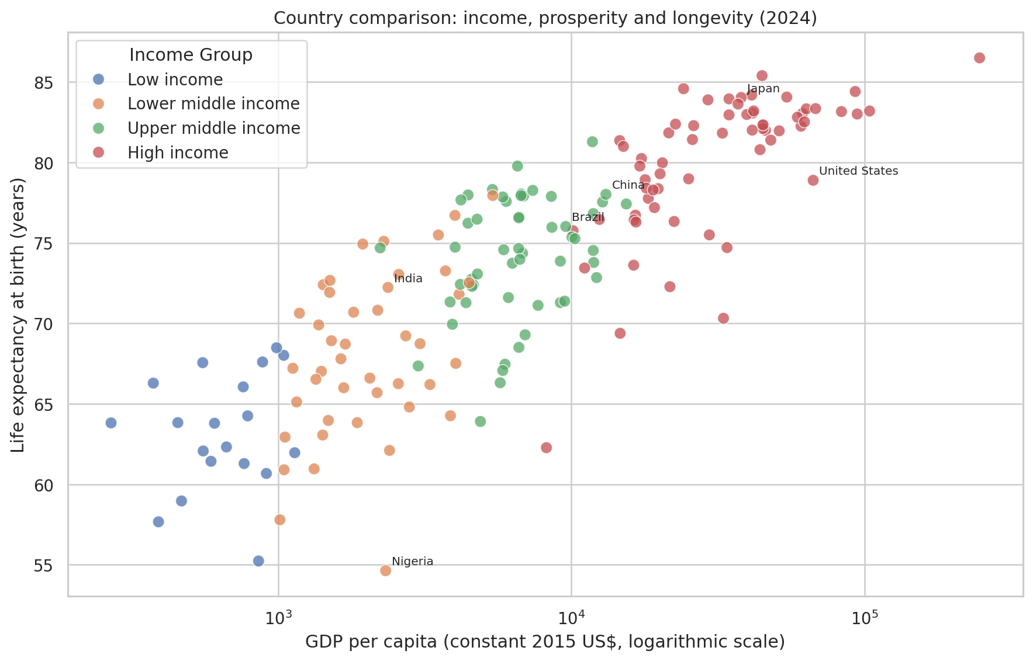

Figure 5. Regional digital divide (2024)
The bars compare the typical internet-use rate across World Bank regions using the regional median.
Quick takeaway: The gap is wide: North America records 94.5%, compared with 36.8% in Sub-Saharan Africa.
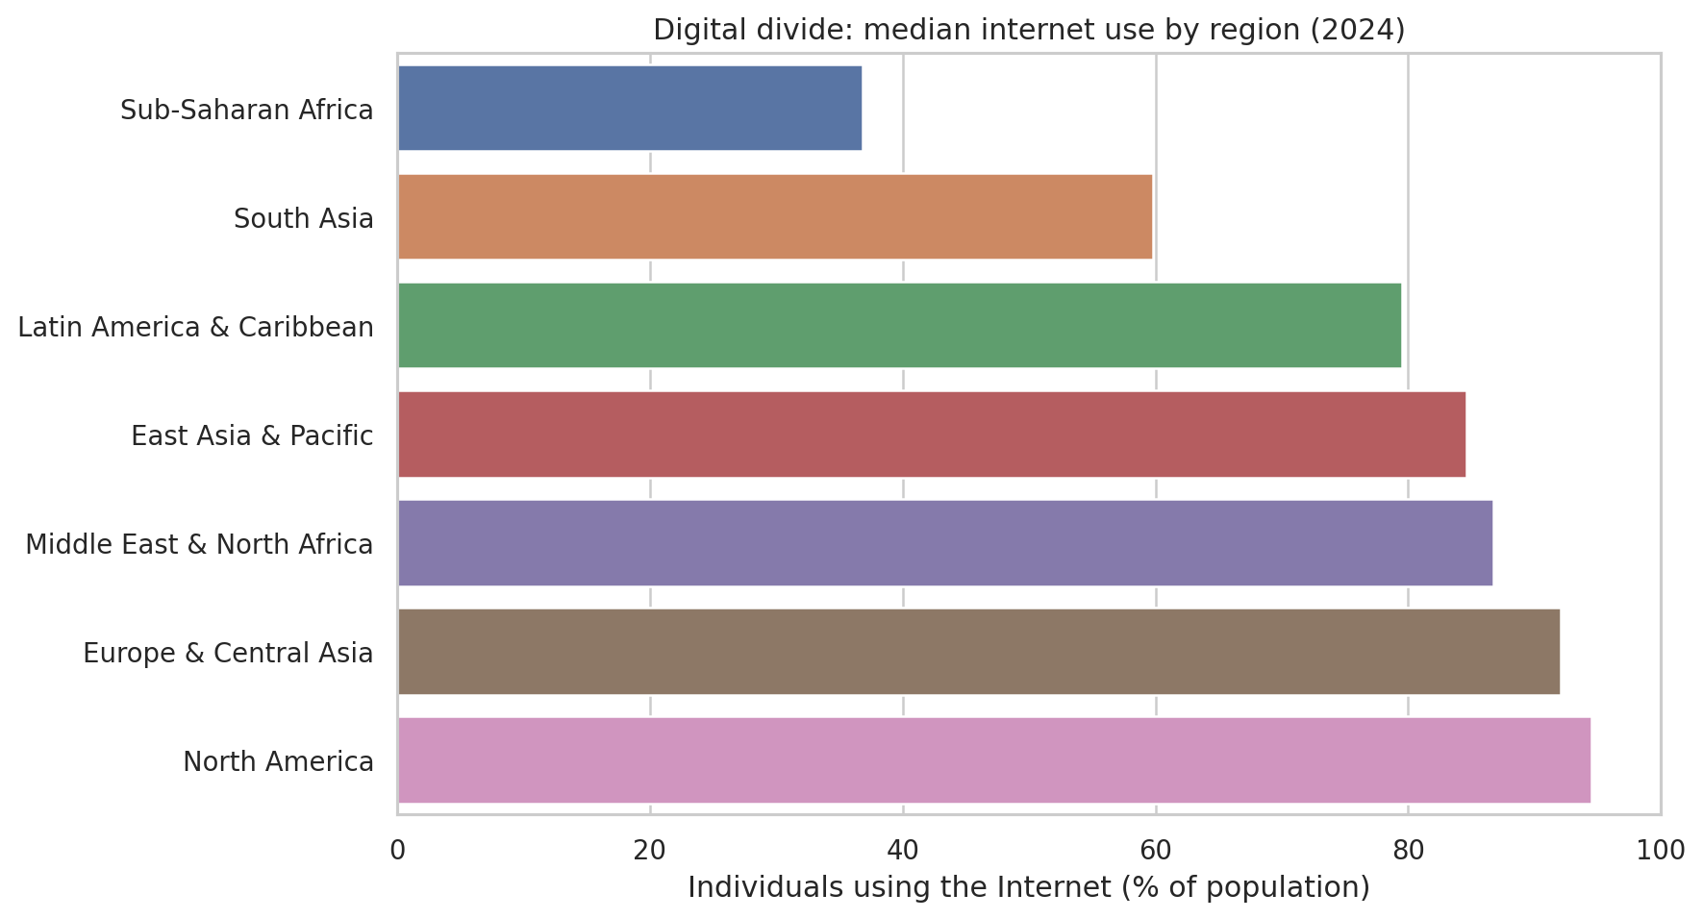

Figure 6. Under-five mortality over time
The lines track under-five deaths per 1,000 live births in selected countries from 2000 onward. Lower values mean better outcomes.
Quick takeaway: The chart highlights both long-term improvement and differences in pace between countries.
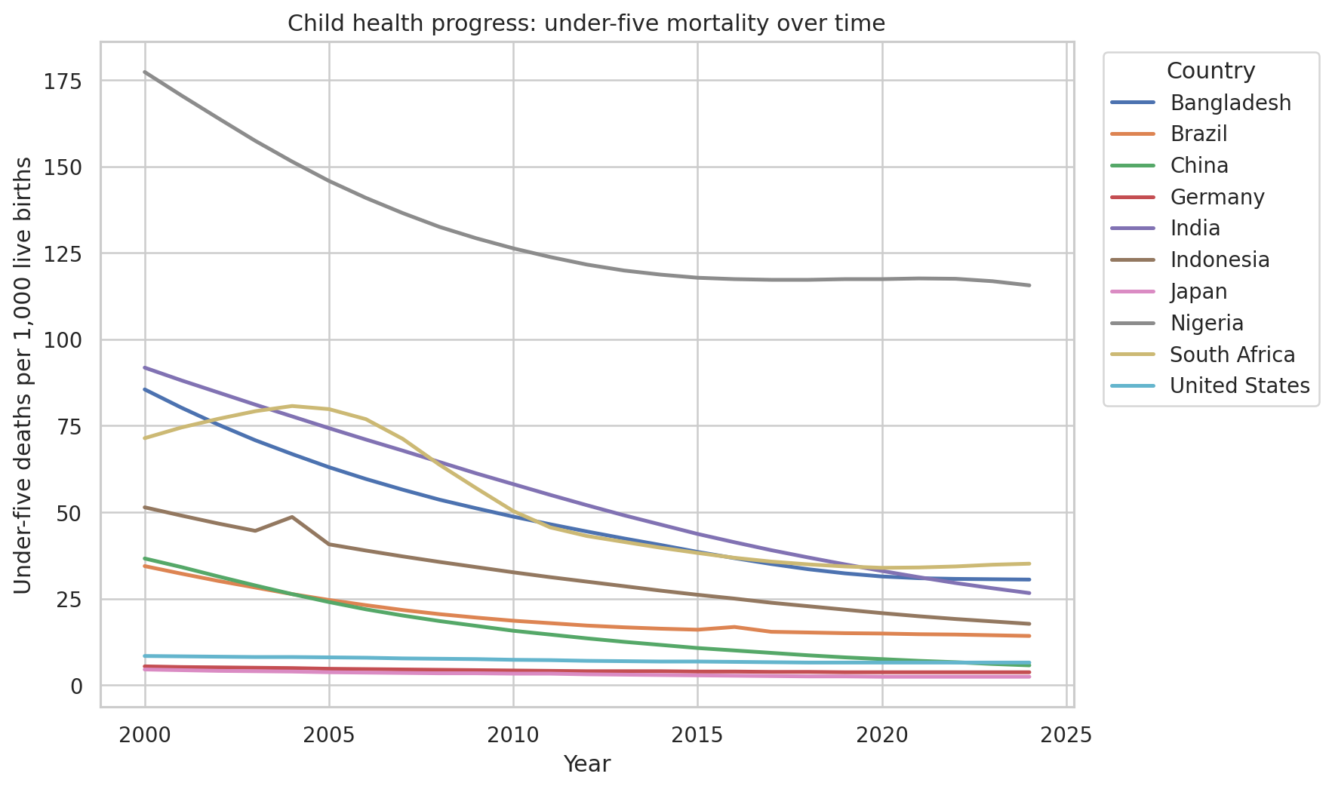

Figure 7. Electricity access and internet use (2024)
Each dot is an economy, with electricity access on one axis and internet use on the other. Colors identify regions.
Quick takeaway: Places with stronger electricity access often also have higher internet use, although other factors matter too.
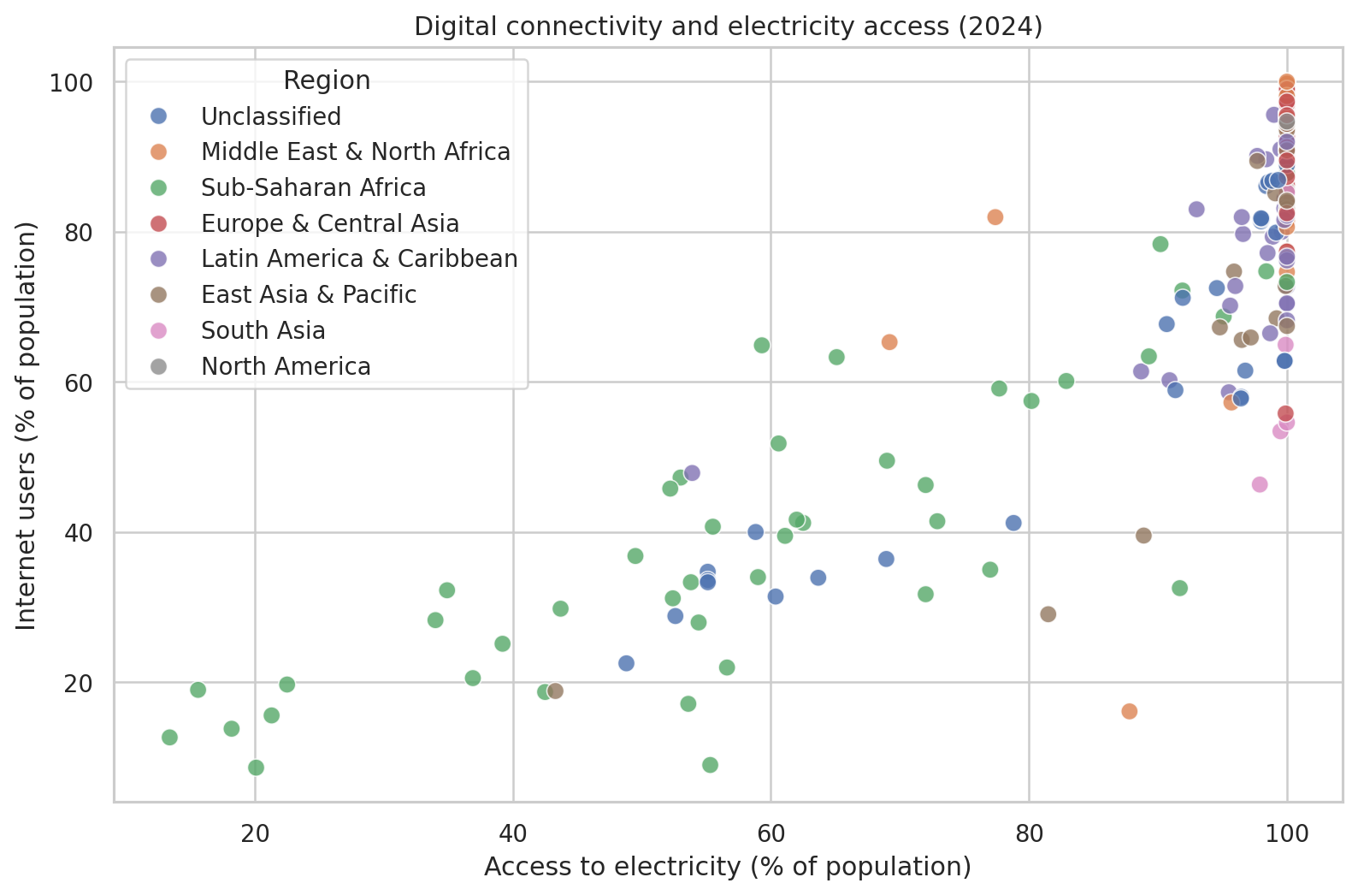

Figure 8. Correlations among development indicators (2024)
The heatmap shows how strongly the selected indicators move together across economies. Darker cells represent stronger relationships.
Quick takeaway: These are useful patterns to explore, not proof that one indicator causes another.
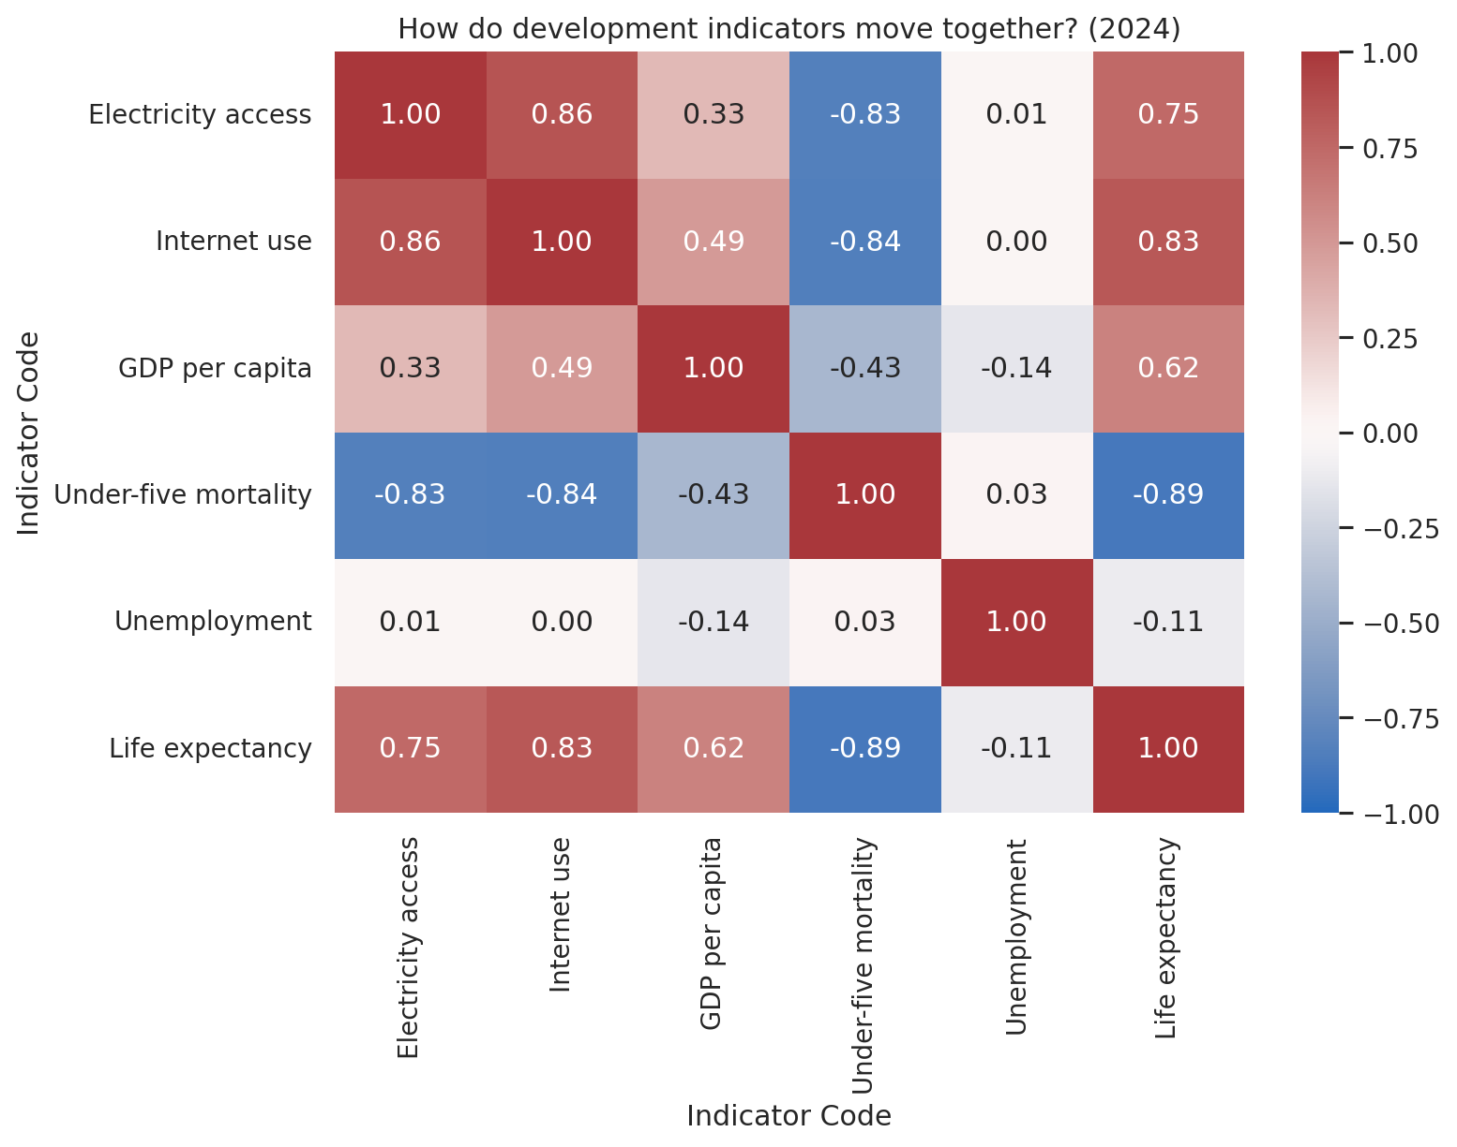

5. Findings to Highlight
India indicator changes across the full requested period (where reported):
- GDP per capita: 756.70 constant 2015 US$ in 2000 to 2,366.83 constant 2015 US$ in 2024.
- Life expectancy: 62.75 years in 2000 to 72.23 years in 2024.
- Internet use: 0.53% in 2000 to 64.94% in 2024.
- Under-five mortality: 91.80 deaths per 1,000 live births in 2000 to 26.60 deaths per 1,000 live births in 2024.
Across economies with data in 2024, the Pearson correlation between GDP per capita and life expectancy is 0.60. This describes a linear association in the selected sample; it does not establish causation.
The regional median internet-use comparison ranges from Sub-Saharan Africa (36.8%) to North America (94.5%). The exact values and country coverage are available in regional_internet_medians.csv.

6. Potential Scientific and Policy Implications
- Health and prosperity: if higher GDP per capita coincides with longer life expectancy, further work can investigate whether education, healthcare access, sanitation and inequality help explain differences.
- Digital inclusion: regional and country gaps in internet use can help identify where affordability, infrastructure, skills and reliable electricity deserve closer investigation.
- Child health: declines in under-five mortality can be used to describe progress, while differences in pace across countries may motivate more focused health-system research.
- Infrastructure: electricity and internet access may move together, but policy decisions should consider affordability, network quality, education and other factors as well.
- Use these charts as descriptive evidence, not as causal estimates or a ranking of country performance without considering context and data quality.

7. Limitations
- WDI indicators have different reporting coverage and update schedules; the newest year is not necessarily complete for every country.
- Country-level aggregates can hide differences within countries by income, gender, geography and age.
- The global trend chart uses median values across economies with data in each year, so the set of reporting economies may change over time.
- Correlations and scatter plots describe associations only. They do not show that one factor causes another.
- GDP per capita is an average and does not represent income distribution or the lived experience of every resident.
- Missing observations are not imputed; sample sizes may differ by indicator and chart.

8. Conclusion
Taken together, the charts show that development is multi-dimensional. Income, health, digital access and infrastructure often move in the same direction, but not at the same speed. The results are descriptive, so they show patterns rather than causes.

9. Reproducibility and Deliverables
This analysis was generated in Python with Pandas, NumPy, Matplotlib, Seaborn and python-docx. Run the script in the same directory as WDICSV.csv, WDICountry.csv and WDISeries.csv. The output_week2 folder contains the report, charts, selected-indicator long data and comparison tables.
Data source: World Bank, World Development Indicators. Dataset landing page: https://datatopics.worldbank.org/world-development-indicators/

