**SHOPPING SITE**

Introduction:

The aim of this project is on the online shopping application it is developed using HTML5, JAVA script, CSS, Angular. The application is very useful where the buyer can directly buy the products from home via internet on mobile or system.

Analysis:

The Current shopping System is critical toset up online shops, customers to browse through the shops, and a system administrator to approve and reject requests for new shops and maintain lists of shop categories**.** This is a small-scale project for Online shopping System. The basic idea is that the candidates can buy product from anywhere during any time by using their card number and password provided to them.

Business Objectives:

Following are the business objectives:

* Customer Convenience
* Customer/Vendor Profit
* Support of Local Vendors
* Variety of Products at a Single place

Design:

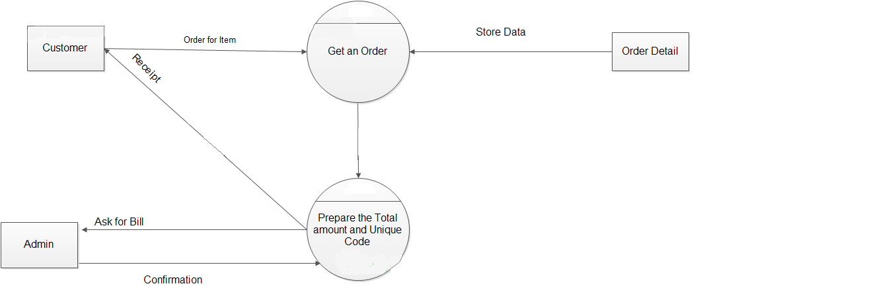

**Functional Requirements:**

**For Admin:**

The admin plays a vital role in the Online shopping system. The admin controls the entire database. The report of the product is generated by the admin itself. The main role of the admin is to safeguard the database and can add/delete the products from the database.

|  |  |
| --- | --- |
| **Req. Id** | **Description** |
| 1 | The system shall provide the facility for admin to approve view all vendor/user. |
| 2 | Admin can view all details of vendor/user/product. |
| 3 | The system shall provide the facility for admin to approve the vendor registration. |
| 4 | Admin can verify the vendor details and approve their registration. |
| 5 | The system shall provide the facility for admin to delete user/vendor/product |
| 6 | Admin can delete any vendor/user/product in case of any complaints |

**For Vendors:**

The Vendors need to register their shop in this site. After the registration they add or remove their product.

|  |  |
| --- | --- |
| **Req. Id** | **Description** |
| 1 | The system shall provide the facility for vendor to register. |
| 2 | Vendor can register their shop and ask for admin approval. |
| 3 | After admin approval, vendor can open their profile. |
| 4 | The system shall provide the facility for registered vendor to add their products. |
| **5** | Vendor can add/edit any product details of product available. |
| 6 | The system shall provide the facility for vendor to change status of their products. |
| **7** | Vendor can change number of product available. |
| 8 | The system shall provide the facility for registered vendor to view their orders. |

**For Users:**

The users can login to the System. He/she can view his/her product details and buy their product. The users can just view the information whereas he/she could not make changes in the database.

|  |  |
| --- | --- |
| **Req. Id** | **Description** |
| 1 | The System shall provide the facility for user signup/login |
| i | Any new user can sign up by giving necessary details. |
| ii | Already existing users can login directly. |
| 2 | The system shall provide the facility to view/edit user profile. |
| **3** | User can view/edit their personal details at any time. |
| 4 | The system shall provide the facility for user to view previous history. |
| **5** | User can view their order history at any time. |
| 6 | User can repeat their order (from the past) at any time. |
| 7 | The system shall provide the facility for user to add/edit address for delivery. |
| **8** | User can create new/ edit existing delivery address at any time. |
| 9 | The system shall provide the facility for users to search product. |
| **10** | Users can search products in the site with category along with many constraints as price range and product specifications. |
| 11 | The system shall provide the facility for users to sort product. |
| **12** | Users can sort the resulting products according to price, rating, delivery time, etc. |
| 13 | The system shall provide the facility for users to book product. |
| **14** | Users can book the product to be delivered to them at specific saved address. |
| 15 | The system shall provide the facility for users to track the delivery. |
| **16** | Users can track the status their delivery package. |
| 17 | The system shall provide the facility for users to rate/review the product. |
| 18 | Users can rate and review the products and the vendor of the product after purchase. |