Exploratory Data Analysis and Visualization of Student Dropout Risk
A MINI PROJECT REPORT
Data Exploration and Visualization – 24UAD512
Submitted by
[REGISTER NO. 1] – [STUDENT NAME 1]
[REGISTER NO. 2] – [STUDENT NAME 2]
[REGISTER NO. 3] – [STUDENT NAME 3]
[REGISTER NO. 4] – [STUDENT NAME 4]
in partial fulfillment for the award of the degree
of
BACHELOR OF TECHNOLOGY
in
ARTIFICIAL INTELLIGENCE AND DATA SCIENCE
KGiSL INSTITUTE OF TECHNOLOGY
[Insert college logo here]
ANNA UNIVERSITY: CHENNAI 600 025
Evaluation Rubrics
S.No | Criteria | Total marks | Marks Awarded
1. | Content & Technical Depth | 10
2. | Methodology & Implementation | 10
3. | Analysis, Results, & Discussion | 5
4. | Innovation & Creativity | 5
5. | Ethical & Societal Impact | 5
6. | Documentation & Presentation | 5
 | Total | 40

TABLE OF CONTENTS
Abstract 4
1. Introduction 4
1.1 Background and Motivation 4
1.2 Problem Statement 5
1.3 Objectives 5
1.4 Scope of the Project 5
1.5 Dataset Source and Supporting Document 5
1.6 Syllabus Coverage Matrix 6
2. Tools and Techniques 6
2.1 Hardware and Software Requirements 6
2.2 Programming Language and Libraries 6
2.3 EDA Goals, Process and Data Types 7
2.4 Key Techniques Used 7
3. Exploratory Data Analysis 7
3.1 Dataset Description 7
3.2 Loading and Initial Inspection 8
3.3 Missing Values, Duplicates and Encoding 9
3.4 Dataset Slicing 9
3.5 Transformation and Grouping 10
3.6 Classical and Bayesian Analysis 12
4. Visualizing Using Matplotlib 13
4.1 Line Plot and Basic Bar Plots 13
4.2 Scatter Plot with Legends, Colours and Annotation 14
4.3 Histogram, Density Plot and Contour Plot 14
4.4 Error Bars 15
4.5 Subplots 16
4.6 Three-Dimensional Plotting 16
4.7 Seaborn 17
4.8 Plotly and Bokeh (Interactive Visualization) 18
5. Univariate Analysis 19
5.1 Summary Statistics of the Numerical Variables 19
5.2 Histogram, Box Plot and Density Plot 20
5.3 Skewness and Outlier Detection 22
5.4 Single Categorical Variable: Bar Chart, Pie Chart and Frequency Table 23
6. Bivariate Analysis 25
6.1 Two Numerical Variables 25
6.2 Two Categorical Variables 27
6.3 Numerical and Categorical Variables 28
7. Multivariate Analysis and Insights 30
7.1 Pair Plot (Scatter Matrix) 30
7.2 Correlation Heatmaps 31
7.3 Grouped Multivariate Visualizations 33
7.4 Dimensionality Reduction using PCA 34
7.5 K-Means Clustering 35
7.6 Scikit-learn Model Development 36
7.7 Fairness Audit and Sensitive Attributes 39
8. Major Findings and Insights 40
8.1 Recommendations 40
8.2 Ethical and Societal Considerations 40
9. Results and Conclusion 41
9.1 Results Summary 41
9.2 Conclusion 41
9.3 Limitations 41
10. Future Scope 42
References 42

Abstract
Student dropout is one of the most costly problems in higher education, and the data that could explain it are usually messy, skewed and full of weak signals. This capstone project applies the complete Data Exploration and Visualization syllabus (Units 1 to 5) to a student-level dataset named student_dropout_risk_2026.csv. The dataset contains 100,000 students, 34 variables and a binary target, dropout, which equals 1 for 32.0% of the students (32,004 students).
The workflow follows the five units. Unit 1 covers loading, inspection, data-quality checks, slicing, transformation, grouping and a comparison of classical and Bayesian analysis. Unit 2 covers Matplotlib visualization (line, bar, scatter, histogram, density, contour, error-bar, subplot, annotation and 3D plots) together with Seaborn, Plotly and Bokeh. Unit 3 covers univariate analysis of numerical and categorical variables. Unit 4 covers bivariate analysis with Pearson and Spearman correlation, chi-square with Cramér's V, Welch t-test, Mann-Whitney, ANOVA and Kruskal-Wallis tests with effect sizes. Unit 5 covers multivariate analysis with pair plots, heatmaps, grouped visualizations, Principal Component Analysis (PCA), K-Means clustering and scikit-learn classification models with cross-validation, a fairness audit and a risk-decile (lift) analysis.
The main findings are: (1) the data are structurally clean, with no missing values and no duplicates; (2) academic performance is the strongest signal, because semester-1 GPA (r = -0.569), semester-2 GPA (r = -0.521) and the number of failed units (r = +0.467) are the three variables most related to dropout, each with a large effect size (Cohen's d from 1.13 to 1.48); (3) socio-economic and financial factors matter, with dropout of 42.9% among low-income students against 20.0% among high-income students, and 44.2% when tuition is not up to date against 28.6% when it is paid; (4) course type, gender, nationality, age and international status show essentially no association with dropout (Cramér's V below 0.01); (5) risk compounds sharply, since a student with attendance below 50% and GPA below 1.5 drops out 92.0% of the time against 1.5% for a student with high attendance and a GPA above 3.0; (6) PCA shows that the variables are not very redundant (17 of 27 components are needed for 80% of the variance); (7) K-Means separates four student segments whose dropout rates range from 3.3% to 80.8%; and (8) a logistic regression model reaches ROC-AUC 0.903 and accuracy 84.0% against a majority-class baseline of 68.0%, with a stable five-fold cross-validated AUC of 0.904. The students in the highest-risk decile drop out 94.2% of the time against 1.1% in the lowest decile. A fairness audit shows that the model is equally accurate across gender, origin and disability groups but flags a much larger share of low-income students, which is discussed in the ethics section. All code, figures, tables, interactive outputs and a trained model are organised in a GitHub-ready project folder.

1. Introduction

1.1 Background and Motivation
Every student who leaves a degree programme before finishing represents lost opportunity for the student and lost resources for the institution. Dropout is rarely caused by a single reason. Poor academic performance, financial pressure, heavy part-time work, low engagement, stress and a lack of family experience with university can all contribute, and they often interact. Universities increasingly collect data on grades, attendance, learning-platform activity and background in order to build early-warning systems that identify students who need support before they leave.
Exploratory Data Analysis (EDA), a term popularised by John Tukey, is the first and most decisive step in building such a system. EDA combines numerical summaries with visualization so that distributions, outliers, data-quality problems and relationships become visible before any model is trained. Python libraries such as Pandas, Matplotlib, Seaborn, Plotly, Bokeh, SciPy and scikit-learn make it possible to run a complete and reproducible EDA, and a script or notebook shared on GitHub allows every figure in this report to be regenerated.
This project chooses a large and analytically rich dataset: 100,000 students described by 32 predictors covering demographics, finances, study behaviour, academic results, engagement and wellbeing. It contains both strong and weak predictors, a mildly imbalanced target, skewed variables with real outliers, sensitive attributes that raise ethical questions, and enough rows for stable statistics. This makes it possible to demonstrate every technique in the syllabus meaningfully.

1.2 Problem Statement
Given a student-level dataset with a dropout label, the goal is to explore the data systematically and answer the following questions with Python code, statistics and visualizations: How common is dropout and how certain is that estimate? Is the data clean and which variables need transformation? Which academic, financial, behavioural and demographic factors are related to dropout, how strongly, and which are not? Do variables combine to create very high-risk or very low-risk groups? Can dropout be predicted reliably from the available variables, and is such a prediction fair to different groups of students?
A particular challenge is that with 100,000 observations almost every statistical test returns a p-value below 0.001, even for trivial differences. The analysis therefore reports effect sizes (Cohen's d, Cramér's V, eta-squared) next to p-values, so that statistical significance is not confused with practical importance.

1.3 Objectives
- To load, inspect and clean a real-world-style dataset using Python and Pandas, documenting missing values, duplicates, data types, encoding and logical consistency.
- To transform and group the data (derived performance and engagement features, log transformation, scaling, encoding, group summaries).
- To produce all visualization types listed in the syllabus using Matplotlib, Seaborn, Plotly and Bokeh.
- To perform univariate, bivariate and multivariate analysis with appropriate statistical measures, tests and effect sizes.
- To apply PCA for dimensionality reduction and K-Means for student segmentation.
- To develop, evaluate and critically assess scikit-learn classification models using a stratified train/test split, cross-validation, threshold analysis and a risk-decile (lift) analysis.
- To audit the model for fairness across gender, income, origin, disability and first-generation status, and to discuss ethical use.
- To communicate the findings through observations, conclusions and a reproducible GitHub repository with a runnable demo.

1.4 Scope of the Project
The project is descriptive and exploratory with a supervised prediction demonstration. It analyses one student-level CSV file; it does not use time-stamped histories, course-level records or free-text data, and it makes no causal claims. The classification model is an academic demonstration of the scikit-learn workflow and is not intended for operational decision-making without validation on real institutional data. All five units are covered, and the coverage matrix in Section 1.6 maps every syllabus topic to the section and figure where it is demonstrated.

1.5 Dataset Source and Supporting Document
The CSV supplied for this project (file name student_dropout_risk_2026.csv, 12.91 MB) does not embed a download URL, publisher or licence information, so this report does not invent an original download link. The column names and values indicate a student-retention dataset with demographic, financial, academic, behavioural and wellbeing variables. Several features of the data, such as the complete absence of any relationship between course type, gender or nationality and dropout, and the near-zero correlation between admission grade and previous qualification grade (r = 0.028), suggest that the file may be simulated or synthetically generated. The findings should therefore be read as a demonstration of analytical method rather than as claims about any real institution.
Supporting sources used for context and terminology are listed in the References section (student retention research, scikit-learn and SciPy documentation, and fairness-in-machine-learning literature). [Add the exact download link or the name of the faculty-provided source here before submission.]

1.6 Syllabus Coverage Matrix
Table 1: Syllabus topics and where they are demonstrated
Unit | Required topic | Where covered
1 | EDA goals, process, data types, Python libraries | Sections 2.3, 3.1, 3.2
1 | Loading, missing values, duplicates, encoding | Sections 3.2, 3.3
1 | Slicing, transformation, grouping | Sections 3.4, 3.5
1 | Classical vs Bayesian analysis | Section 3.6
2 | Line, scatter, error bar, density, contour, histogram | Sections 4.1 to 4.4
2 | Legends, colours, subplots, text and annotation | Sections 4.2, 4.5
2 | 3D plotting | Section 4.6
2 | Seaborn, Plotly, Bokeh | Sections 4.7, 4.8
3 | Histograms, box plots, density plots | Section 5.2
3 | Mean, median, SD, quartiles, skewness, outliers | Sections 5.1, 5.3
3 | Bar chart, pie chart, frequency table | Section 5.4
4 | Numerical-numerical: scatter, Pearson, Spearman | Section 6.1
4 | Categorical-categorical: stacked and grouped bars, chi-square | Section 6.2
4 | Numerical-categorical: box and violin plots, tests | Section 6.3
5 | Pair plots and heatmaps | Sections 7.1, 7.2
5 | Grouped multivariate visualizations | Section 7.3
5 | PCA dimensionality reduction (and K-Means) | Sections 7.4, 7.5
5 | Insights for machine learning (model, fairness) | Sections 7.6, 7.7

2. Tools and Techniques

2.1 Hardware and Software Requirements
Table 2: Hardware and software requirements
Component | Requirement
Processor | Any modern dual-core CPU (Intel Core i3 / AMD Ryzen 3 or higher); no GPU needed
RAM | 4 GB minimum, 8 GB recommended
Storage | Less than 500 MB (dataset is 13 MB; most space is for libraries)
Operating system | Windows 10/11, Linux or macOS
Python | Python 3.9 or later with a virtual environment
Editor / notebook | Visual Studio Code or Jupyter Notebook / JupyterLab
Version control | Git and GitHub

2.2 Programming Language and Libraries
Table 3: Libraries and their use in this project
Category | Tool / Library | Use in this project
Language | Python 3 | All analysis code
Data handling | Pandas, NumPy | Loading, cleaning, grouping, transformation
Static plots | Matplotlib, Seaborn | Units 2 to 5 figures
Interactive plots | Plotly, Bokeh | Hover-enabled scatter, heatmap and 3D plots (HTML)
Statistics | SciPy | Pearson, Spearman, chi-square, t-test, Mann-Whitney, ANOVA, Kruskal-Wallis, Beta posterior, KDE
Machine learning | scikit-learn | StandardScaler, OneHotEncoder, PCA, KMeans, LogisticRegression, RandomForest, HistGradientBoosting, cross-validation, metrics, permutation importance
Model storage | joblib | Saving the trained pipeline for the live demo

2.3 EDA Goals, Process and Data Types
The goals of EDA are to (a) understand the structure of the data, (b) detect errors, missing values and outliers, (c) summarise distributions and relationships, (d) generate hypotheses and (e) choose suitable transformations and models. The process followed in this project is iterative and consists of seven steps: define the question, load the data, inspect and clean, transform and group, visualize, analyse statistically, and communicate.
Variables are classified by measurement scale. Nominal categorical variables are gender, nationality, course_type and study_mode. Ordinal is family_income_level (Low < Middle < High). Binary variables (0/1) are first_generation, disability_status, scholarship_holder, tuition_up_to_date, part_time_job, international_student, extracurricular_activities, mental_health_support and the target dropout. Discrete numerical variables include age, semester, units_enrolled, units_passed, units_failed, missed_deadlines, library_visits_per_month, stress_level (1-10) and satisfaction_score (1-10). Continuous numerical variables include the grades, GPA values, attendance and assignment rates, LMS logins, commute time and sleep hours. Knowing the type decides which plots and statistics are valid: bar charts and frequency tables for categories, histograms and box plots for numbers, chi-square for two categories, and correlation only for numeric pairs.

2.4 Key Techniques Used
- Log transformation (log1p): compresses long right tails in counts such as missed deadlines, commute time and library visits.
- IQR rule: a value below Q1 - 1.5 x IQR or above Q3 + 1.5 x IQR is flagged as an outlier.
- Pearson and Spearman correlation: linear versus rank-based (monotonic) association between numeric pairs.
- Chi-square test and Cramér's V: significance and strength of association between two categorical variables.
- Welch t-test, Mann-Whitney U and Cohen's d: comparing a numeric variable between students who stayed and dropped out, with an effect size.
- ANOVA, Kruskal-Wallis and eta-squared: comparing a numeric variable across more than two groups.
- Beta-Binomial Bayesian inference: a posterior distribution for the dropout probability and for differences between groups.
- PCA and K-Means: dimensionality reduction and unsupervised segmentation on standardised features.
- Stratified train/test split and k-fold cross-validation: honest evaluation of classification models on an imbalanced target.
- Permutation importance, risk deciles and fairness audit: explaining the model, measuring its practical value and checking it for group disparities.

3. Exploratory Data Analysis

3.1 Dataset Description
Each row of the CSV represents one student, and the columns describe the student's background, finances, study pattern, academic results, engagement and wellbeing. The last column, dropout, is the target. The table below describes all 34 columns.
Table 4: Data dictionary
Column | Type | Meaning
person_id | Identifier | Unique student ID (1 to 100,000)
age | Numerical | Age in years (15 to 30)
gender | Categorical | Female, Male or Other
nationality | Categorical | Country of origin (15 countries)
first_generation | Binary | 1 = first in the family to attend university
disability_status | Binary | 1 = student has a registered disability
family_income_level | Ordinal | Low, Middle or High
scholarship_holder | Binary | 1 = receives a scholarship
tuition_up_to_date | Binary | 1 = tuition fees are paid up to date
part_time_job | Binary | 1 = has a part-time job
weekly_work_hours | Numerical | Hours worked per week (0 to 40)
course_type | Categorical | STEM, Business, Arts & Humanities, Health Sciences, Law & Social Sciences
study_mode | Categorical | Full-time, Part-time or Online
semester | Numerical | Current semester (1 to 8)
international_student | Binary | 1 = international student
admission_grade | Numerical | Admission grade on a 0-200 scale
previous_qualification_grade | Numerical | Previous qualification grade (0-200)
units_enrolled | Numerical | Course units enrolled in
units_passed | Numerical | Course units passed
units_failed | Numerical | Course units failed
gpa_semester_1 | Numerical | GPA of semester 1 (0 to 4)
gpa_semester_2 | Numerical | GPA of semester 2 (0 to 4)
attendance_rate | Numerical | Class attendance (%)
assignments_submitted_rate | Numerical | Assignments submitted (%)
library_visits_per_month | Numerical | Library visits per month
lms_logins_per_week | Numerical | Learning-platform logins per week
extracurricular_activities | Binary | 1 = takes part in extracurricular activities
missed_deadlines | Numerical | Number of missed deadlines
stress_level | Numerical | Self-reported stress (1 to 10)
mental_health_support | Binary | 1 = uses mental-health support services
satisfaction_score | Numerical | Satisfaction with the programme (1 to 10)
commute_time_mins | Numerical | Commute time in minutes
sleep_hours | Numerical | Average sleep per night (hours)
dropout | Binary (target) | 1 = student dropped out, 0 = stayed

3.2 Loading and Initial Inspection
The file is loaded with Pandas using UTF-8 encoding. The first checks are the shape, the data types, a preview of the rows and the summary statistics.
import pandas as pd, numpy as np
df = pd.read_csv("data/student_dropout_risk_2026.csv", encoding="utf-8")
print(df.shape) # (100000, 34)
print(df.dtypes.value_counts())
print(df.head())
print(df.describe().T)

The result is 100,000 rows and 34 columns: 21 integer columns, 8 floating-point columns and 5 text columns. The file is pure ASCII/UTF-8 and loads without any encoding error.
Table 5: First five rows (selected columns)
ID | Age | Gender | Income | Course | Mode | Failed | GPA S1 | GPA S2 | Attend. | Dropout
1 | 23 | Male | Low | STEM | Online | 0 | 3.44 | 2.55 | 77.3 | 0
2 | 18 | Other | High | Arts & Humanities | Full-time | 3 | 2.56 | 2.53 | 52.1 | 1
3 | 24 | Other | High | Arts & Humanities | Full-time | 3 | 3.43 | 2.73 | 100.0 | 0
4 | 25 | Female | Middle | Business | Full-time | 2 | 2.51 | 2.1 | 83.9 | 0
5 | 15 | Female | Low | Health Sciences | Part-time | 1 | 3.93 | 2.88 | 61.6 | 0

3.3 Missing Values, Duplicates and Encoding
The table below summarises the data-quality checks. The data are structurally very clean: there are no missing cells, no duplicate rows and no duplicate IDs. The logical rules also hold for every row: units_passed + units_failed equals units_enrolled, GPA values lie between 0 and 4, rates lie between 0 and 100, grades do not exceed 200, and weekly_work_hours is positive exactly when part_time_job is 1.
Table 6: Data-quality checks
Check | Result | Action / observation
Missing cells | 0 | None - no imputation needed
Duplicate rows | 0 | None dropped
Duplicate person_id | 0 | ID is a unique key
units_passed + units_failed != units_enrolled | 0 | Logic holds for all rows
GPA outside 0-4 | 0 | All valid
Rates outside 0-100% | 0 | All valid
Grades above 200 | 0 | All valid (0-200 scale)
part_time_job inconsistent with weekly_work_hours | 0 | Consistent
Students aged under 18 | 12,758 | "Kept - plausible early-entry/dual-enrolment
attendance_rate capped at 100 | 10,556 | Ceiling effect noted
admission_grade capped at 200 | 945 | Ceiling effect noted
gpa_semester_1 exactly 0.0 | 85 | Floor effect noted
print(df.isna().sum().sum()) # 0 missing cells
print(df.duplicated().sum(), df.person_id.duplicated().sum()) # 0 0
assert (df.units_passed + df.units_failed == df.units_enrolled).all()
assert df[["gpa_semester_1", "gpa_semester_2"]].between(0, 4).all().all()
print((df.age < 18).sum()) # 12,758 students under 18

Observation: The real data-quality issues are not missing cells but plausibility and ceiling effects. 12,758 students (12.8%) are younger than 18; the minimum age is 15. These could be early-entry or dual-enrolment students, so they were flagged and kept rather than deleted. 10,556 students (10.6%) have exactly 100% attendance and 945 have the maximum admission grade of 200, which shows that the variables are capped at their upper limits (a ceiling effect that will appear as a vertical stripe in scatter plots). 85 students have a semester-1 GPA of exactly 0.0 (a floor effect).

3.4 Dataset Slicing
Slicing selects the rows and columns relevant to a question. Pandas offers label-based selection (loc), position-based selection (iloc) and boolean masks. The table below shows seven slices with their size and dropout rate.
df.loc[:4, ["person_id", "course_type", "gpa_semester_1"]] # label slice
df.iloc[0:5, 11:15] # positional slice
stem = df[df["course_type"] == "STEM"] # boolean mask
risky = df[(df.units_failed >= 5) & (df.attendance_rate < 60)] # combined condition
poor = df[(df.family_income_level == "Low") & (df.scholarship_holder == 0)]

Table 7: Selected slices of the dataset
Slice | Students | Dropout % | Mean GPA S2 | Mean attendance %
STEM students | 30,141 | 32.1 | 1.98 | 75.1
Semester 1 students | 19,995 | 33.7 | 1.98 | 75.2
Online learners | 12,929 | 29.2 | 1.98 | 72.3
International students | 18,094 | 32.1 | 1.98 | 75.2
Low income and no scholarship | 10,393 | 49.1 | 1.83 | 73.7
Tuition not up to date | 21,514 | 44.2 | 1.94 | 74.8
>=5 failed units and attendance < 60% | 5,131 | 81.4 | 1.21 | 48.8
All students | 100,000 | 32.0 | 1.98 | 75.1
Observation: Slicing already reveals the main story. STEM students drop out at about the overall rate (32.1% against 32.0%), so the course does not matter. But students from low-income families without a scholarship drop out 49.1% of the time, students whose tuition is not up to date 44.2%, and the small group (5,131 students) with at least five failed units and attendance below 60% drops out 81.4% of the time.

3.5 Transformation and Grouping
15 derived variables were created without changing the raw columns: pass_rate, gpa_change, avg_gpa, binned versions of age, work hours, GPA, attendance and failed units, an ordinal income code, three log1p transforms, an engagement_index (the mean of the z-scores of attendance, assignment submission, LMS logins and log library visits) and risk_flags (the number of six warning conditions that apply to a student: at least 4 failed units, attendance below 60%, assignments below 50%, at least 4 missed deadlines, semester-2 GPA below 1.5, and unpaid tuition).
d["pass_rate"] = 100 * d.units_passed / d.units_enrolled
d["avg_gpa"] = (d.gpa_semester_1 + d.gpa_semester_2) / 2
d["log_missed_deadlines"] = np.log1p(d.missed_deadlines) # log transform
d["income_ord"] = d.family_income_level.map({"Low": 0, "Middle": 1, "High": 2}) # ordinal encoding
d["attendance_band"] = pd.cut(d.attendance_rate, [-.01, 50, 65, 80, 90, 100]) # binning
z = (d.attendance_rate - d.attendance_rate.mean()) / d.attendance_rate.std() # z-score
mm = (d.attendance_rate - d.attendance_rate.min()) / (d.attendance_rate.max() - d.attendance_rate.min())
ohe = pd.get_dummies(d[["gender", "nationality", "course_type", "study_mode", "family_income_level"]]) # 29 columns

Log transformation. Three count variables are strongly right-skewed: missed_deadlines (skewness 1.76), commute_time_mins (1.65) and library_visits_per_month (1.68). After log1p the skewness falls to 0.12, -0.59 and -0.30. Scaling. Z-score scaling gives mean 0.00 and standard deviation 1.00, and min-max scaling maps attendance to the range 0 to 1. Encoding. Family income is encoded as an ordinal variable, and one-hot encoding of the five categorical variables gives 29 indicator columns.
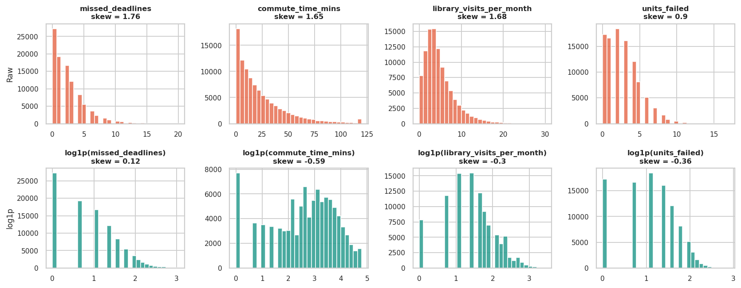
Figure 1: Effect of the log1p transformation on skewed count variables (top: raw, bottom: log1p)
Grouping. Grouping with groupby and aggregation summarises dropout, GPA, attendance and failed units for every level of the main categorical variables (table below).
d.groupby("family_income_level").agg(students=("dropout", "size"),
dropout_pct=("dropout", lambda s: 100 * s.mean()),
gpa_s2=("gpa_semester_2", "mean"), attendance=("attendance_rate", "mean"))
d.pivot_table(index="family_income_level", columns="study_mode", values="dropout", aggfunc="mean")

Table 8: Group summaries (dropout rate, GPA, attendance, failed units)
Grouped by | Level | Students | Dropout % | Mean GPA S2 | Attendance % | Failed units
Family income | Low | 34,809 | 42.9 | 1.83 | 73.8 | 2.97
Family income | Middle | 40,213 | 30.0 | 2.00 | 75.2 | 2.70
Family income | High | 24,978 | 20.0 | 2.16 | 76.7 | 2.39
Study mode | Full-time | 65,096 | 32.0 | 1.98 | 76.7 | 3.13
Study mode | Online | 12,929 | 29.2 | 1.98 | 72.3 | 2.08
Study mode | Part-time | 21,975 | 33.7 | 1.98 | 72.1 | 1.87
Course type | Arts & Humanities | 18,024 | 32.1 | 1.99 | 75.0 | 2.71
Course type | Business | 24,986 | 31.9 | 1.98 | 75.2 | 2.71
Course type | Health Sciences | 14,941 | 32.1 | 1.98 | 75.2 | 2.72
Course type | Law & Social Sciences | 11,908 | 31.7 | 1.98 | 74.8 | 2.71
Course type | STEM | 30,141 | 32.1 | 1.98 | 75.1 | 2.73
Tuition up to date (0/1) | 0 | 21,514 | 44.2 | 1.94 | 74.8 | 2.77
Tuition up to date (0/1) | 1 | 78,486 | 28.6 | 1.99 | 75.2 | 2.70
Scholarship (0/1) | 0 | 41,030 | 33.3 | 2.02 | 75.4 | 2.65
Scholarship (0/1) | 1 | 58,970 | 31.1 | 1.95 | 74.9 | 2.77

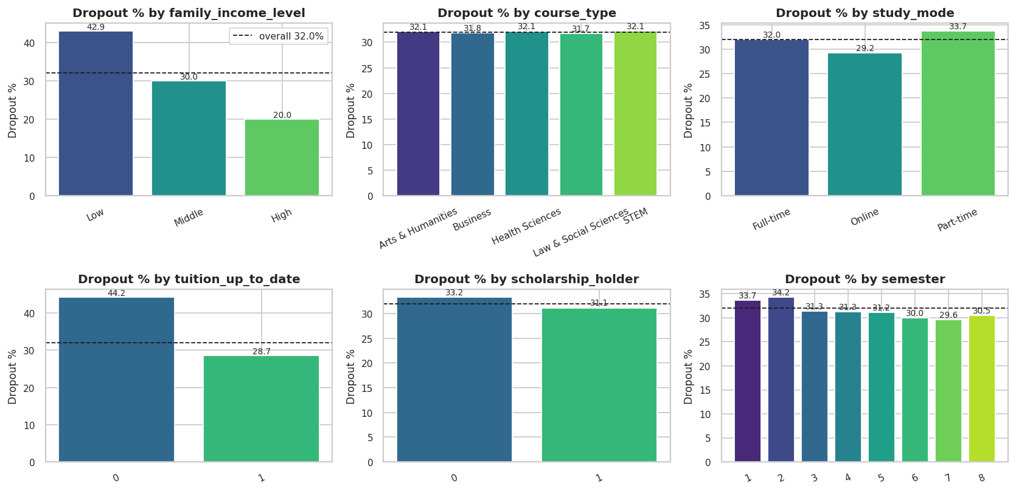
Figure 2: Dropout rate by group (dashed line = overall 32.0%)
Observation: Family income is the largest categorical gap (Low 42.9%, Middle 30.0%, High 20.0%), followed by unpaid tuition (44.2% against 28.7%). Course type is flat (31.7% to 32.1%). Online students drop out least (29.2%) and part-time students most (33.7%). Holding a scholarship lowers dropout only slightly (31.1% against 33.2%). Income and study mode combine additively: low-income part-time students reach 45.0%, high-income online students only 17.1%.

3.6 Classical and Bayesian Analysis
Classical (frequentist) view. The observed dropout proportion is p = 32,004 / 100,000 = 32.00%. A normal-approximation 95% confidence interval is 31.71% to 32.29%. It is interpreted through repeated sampling: 95% of intervals built this way would contain the true proportion. Bayesian view. The unknown dropout probability is given a uniform Beta(1, 1) prior. After observing 32,004 dropouts and 67,996 stayers, the posterior is Beta(32,005, 67,997), with posterior mean 32.00% and a 95% credible interval of 31.72% to 32.29%. This interval has a direct probability interpretation.
from scipy.stats import beta
s = df["dropout"].sum(); n = len(df)
posterior = beta(s + 1, (n - s) + 1) # Beta(32005, 67997)
print(posterior.mean() * 100) # 32.00
print(posterior.ppf([0.025, 0.975]) * 100) # [31.72, 32.29]
# P(dropout rate of group A > group B) by Monte Carlo
da = beta(sa + 1, na - sa + 1).rvs(200000); db = beta(sb + 1, nb - sb + 1).rvs(200000)
print((da > db).mean(), np.percentile(da - db, [2.5, 97.5]))

Table 9: Effect of sample size: classical confidence interval versus Bayesian credible interval
Sample size | Dropouts | Observed % | Classical 95% CI (%) | Posterior mean % | Bayesian 95% CrI (%)
10 | 5 | 50.0 | 19.0 - 81.0 | 50.0 | 23.4 - 76.6
50 | 15 | 30.0 | 17.3 - 42.7 | 30.77 | 19.1 - 43.8
500 | 164 | 32.8 | 28.7 - 36.9 | 32.87 | 28.8 - 37.0
5,000 | 1,604 | 32.08 | 30.8 - 33.4 | 32.09 | 30.8 - 33.4
100,000 | 32,004 | 32.0 | 31.7 - 32.3 | 32.0 | 31.7 - 32.3

Table 10: Bayesian and classical comparison of two groups
Comparison | Dropout rates | Posterior mean diff | 95% CrI of diff | P(first group higher) | Classical z-test p
Scholarship vs no scholarship | 31.1% vs 33.2% | -2.11 pp | "[-2.70 | -1.53]" | 0.0000
Low vs High family income | 42.9% vs 20.0% | +22.93 pp | "[+22.21 | +23.65]" | 1.0000
Tuition up to date vs not | 28.7% vs 44.2% | -15.57 pp | "[-16.30 | -14.83]" | 0.0000

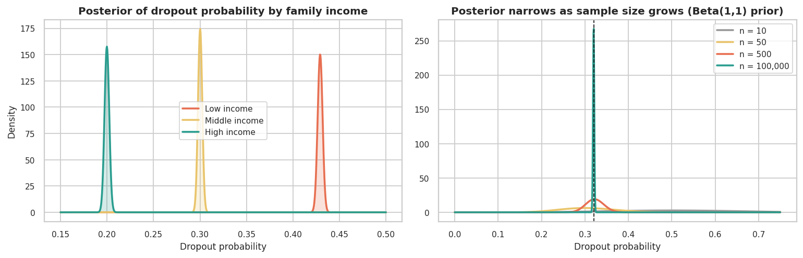
Figure 3: Posterior distributions: dropout probability by family income (left) and effect of sample size (right)
Observation: With 100,000 students the classical and Bayesian intervals are practically identical because the data overwhelm the weak prior. The difference shows only in small samples: with 10 students the classical interval is 19% to 81% while the Bayesian credible interval is somewhat narrower (23.4% to 76.6%), because the prior pulls the estimate gently toward 50%. For comparisons, the Bayesian answer is easier to communicate: the probability that low-income students have a higher dropout probability than high-income students is essentially 1.0, with a most plausible difference of about 22.9 percentage points (95% credible interval 22.2 to 23.7). Scholarship holders drop out 2.1 percentage points less (interval 1.5 to 2.7), a real but small effect. Students are not independent draws from one population (they share institutions, courses and years), so both kinds of interval are somewhat too narrow.

4. Visualizing Using Matplotlib

4.1 Line Plot and Basic Bar Plots
Matplotlib is the foundation of Python plotting. A figure is created with plt.subplots(), data are drawn on an Axes object, and titles, labels, legends and annotations are added. A line plot is best for ordered data; here the semester (1 to 8) provides the natural order.
sem = d.groupby("semester").agg(drop=("dropout", "mean"), g1=("gpa_semester_1", "mean"), g2=("gpa_semester_2", "mean"))
fig, ax = plt.subplots(1, 2, figsize=(11, 4))
ax[0].plot(sem.index, 100 * sem["drop"], marker="o", lw=2, color="#e76f51", label="Dropout %")
ax[0].annotate("Peak: semester 2", (2, 34.2), xytext=(3.2, 34.0), arrowprops=dict(arrowstyle="->"))
ax[1].plot(sem.index, sem.g1, marker="s", label="GPA semester 1")
ax[1].plot(sem.index, sem.g2, marker="^", ls="--", label="GPA semester 2"); ax[1].legend()

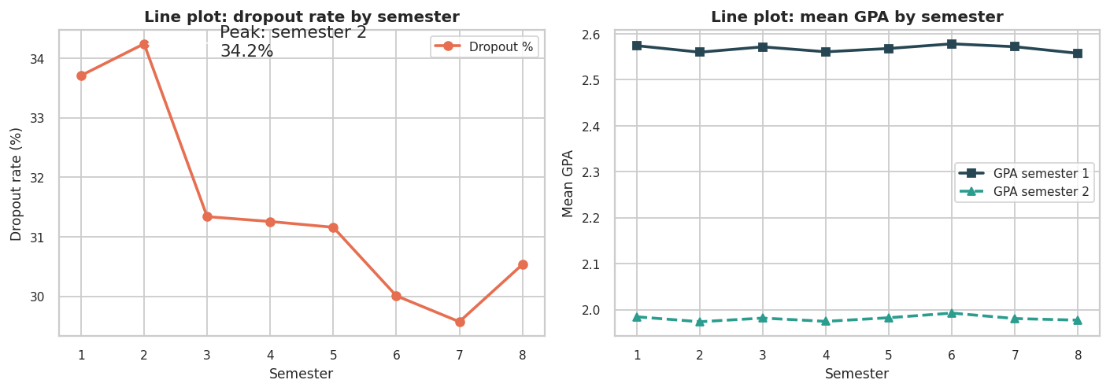
Figure 4: Line plots: dropout rate by semester (left) and mean GPA by semester (right)
Observation: The dropout rate peaks in semester 2 (34.2%) and then declines slowly to its lowest value in semester 7 (29.6%), which suggests that early semesters are the riskiest and that students who survive them are more likely to continue. The GPA lines are almost flat across semesters, but semester-2 GPA (mean 1.98) is far below semester-1 GPA (mean 2.57): semester-2 GPA is lower for 90.4% of students, by 0.59 grade points on average. The first-year transition therefore appears to be a systematic difficulty for students.
g = (d.groupby("family_income_level").dropout.mean() * 100).reindex(["Low", "Middle", "High"])
ax.bar(g.index, g.values, color=["#e76f51", "#e9c46a", "#2a9d8f"]); ax.bar_label(ax.containers[0], fmt="%.1f%%")
ax.barh(study_mode_rates.index, study_mode_rates.values) # horizontal bar

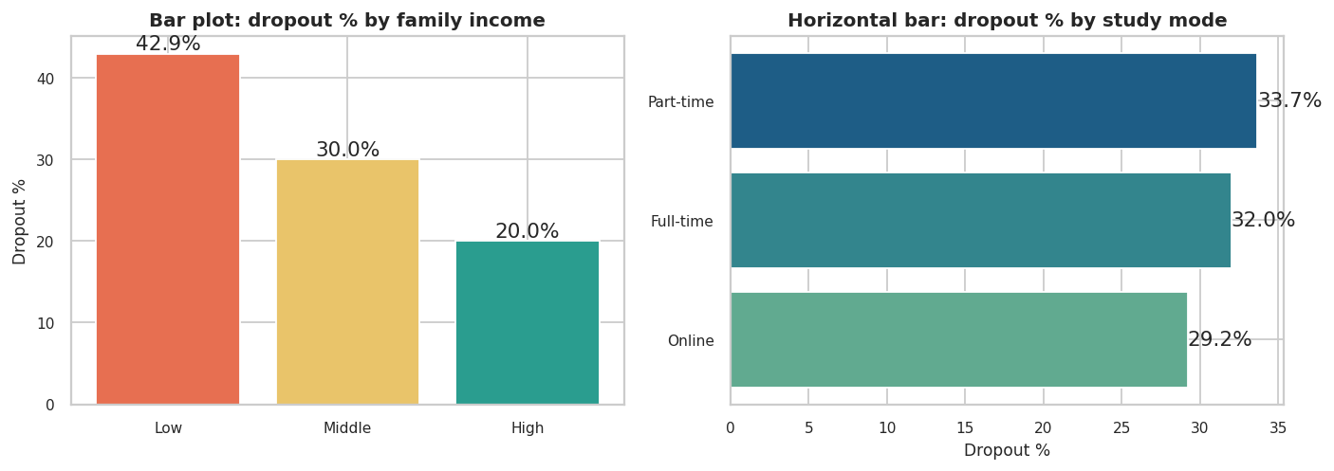
Figure 5: Basic bar plots: dropout rate by family income and by study mode

4.2 Scatter Plot with Legends, Colours and Annotation
A scatter plot shows the relationship between two numeric variables. Colours encode the outcome (green = stayed, orange = dropped out), a legend explains the colours, and ax.annotate() adds text with an arrow to point out zones of interest. A random sample of 3,000 students keeps the plot readable.
smp = d.sample(3000, random_state=42)
for k, colr in [(0, "#2a9d8f"), (1, "#e76f51")]:
s = smp[smp.dropout == k]
ax.scatter(s.attendance_rate, s.gpa_semester_2, s=14, alpha=.55, color=colr, label=["Stayed", "Dropped out"][k])
ax.annotate("High-risk zone:\nlow attendance + low GPA", xy=(52, .6), xytext=(4, 3.1), arrowprops=dict(arrowstyle="->"))
ax.legend(title="Outcome")

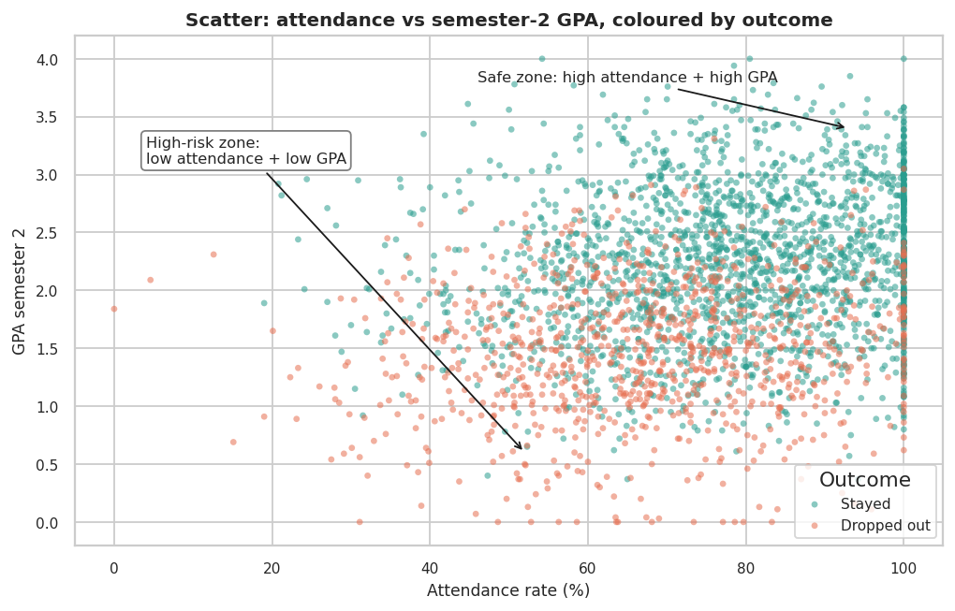
Figure 6: Scatter plot of attendance versus semester-2 GPA with legend, colours and annotations
Observation: The relationship is positive but diffuse (r = 0.222): attendance alone explains only 4.9% of the variation in GPA. Dropouts (orange) concentrate in the lower half of the plot, where GPA is below about 2.0, but they appear at every attendance level. The vertical stripe at 100% attendance is the ceiling effect noted in Section 3.3. The plot shows that GPA separates the outcomes better than attendance does.

4.3 Histogram, Density Plot and Contour Plot
A histogram counts how many students fall into each value range, a density plot (kernel density estimate, KDE) draws a smooth version of the same distribution, and a contour plot extends the density idea to two variables by drawing lines of equal joint density.
ax[0].hist(d[d.dropout == k].gpa_semester_2, bins=35, alpha=.6) # histogram
sns.kdeplot(d[d.dropout == k].attendance_rate, fill=True, clip=(0, 100)) # density
kde = gaussian_kde(np.vstack([x, y])) # joint density
zz = kde(np.vstack([xx.ravel(), yy.ravel()])).reshape(xx.shape)
plt.contourf(xx, yy, zz, levels=14, cmap="viridis"); plt.colorbar(label="Density")

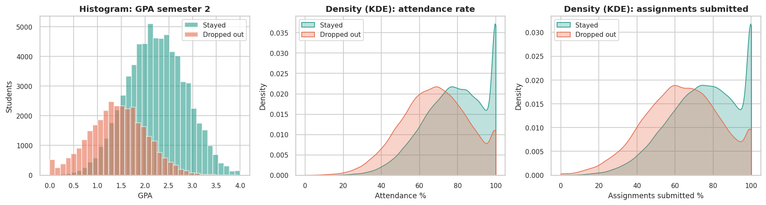
Figure 7: Histogram and density plots split by outcome
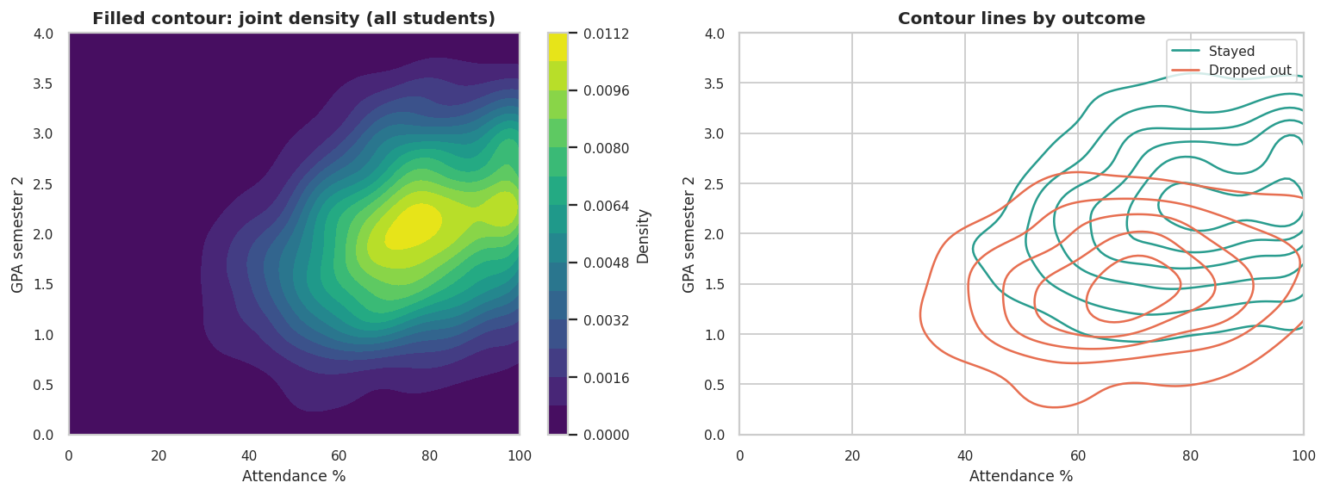
Figure 8: Filled contour plot of the joint density (left) and contour lines by outcome (right)
Observation: Semester-2 GPA is almost bell-shaped (skewness -0.08); dropouts are shifted to the left by about 0.8 grade points (medians 1.44 against 2.24). Attendance is bunched against the 100% ceiling for both groups, with a longer left tail for dropouts. In the contour plot the densest region for students who stayed sits at attendance of about 80-100% and GPA of about 2.3, while for dropouts it sits at a lower GPA of about 1.4. The two sets of contours overlap heavily, which explains why no single variable separates the groups perfectly.

4.4 Error Bars
Error bars show the uncertainty of an estimate. Here a 95% confidence interval is drawn around the dropout rate of each course type (a proportion) and around the mean semester-2 GPA of each income group (a mean).
p = s.mean(); se = np.sqrt(p * (1 - p) / len(s))
ax.errorbar(range(5), rates, yerr=1.96 * ses, fmt="o", capsize=5) # proportion CI
ax.errorbar(["Low", "Middle", "High"], means, yerr=1.96 * sem, fmt="s", capsize=5) # mean CI

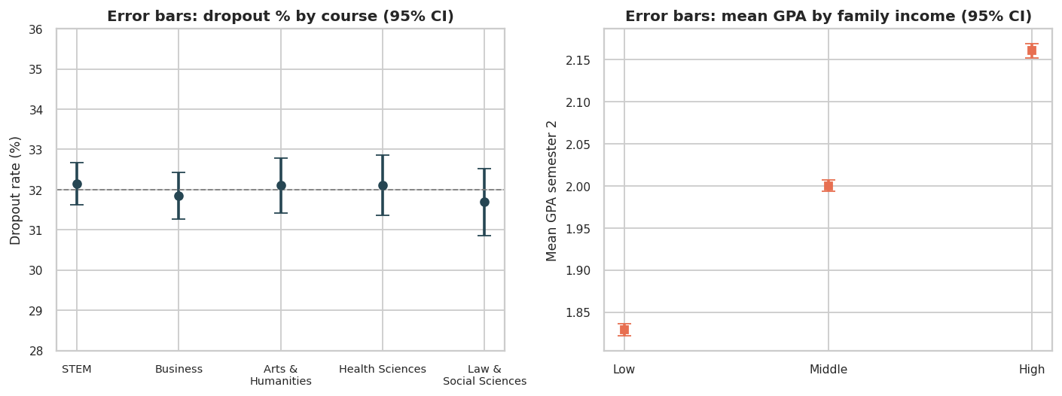
Figure 9: Error bars: dropout rate by course type (left) and mean GPA by family income (right), 95% CI
Observation: The five course types have dropout rates between 31.7% and 32.1% and their error bars overlap completely, so the course is not a risk factor. In contrast, the mean semester-2 GPA rises clearly with family income (Low 1.83, Middle 2.00, High 2.16) and the intervals are so narrow (n = 100,000) that they are barely visible.

4.5 Subplots
Subplots place several related views in one figure so that they can be compared directly. The figure below combines a bar chart, a line plot, a scatter plot and a histogram.
fig, axs = plt.subplots(2, 2, figsize=(11, 7.5))
axs[0, 0].bar(att_band.index.astype(str), att_band.values) # bar
axs[0, 1].plot(sem.index, sem.fail, marker="o") # line
axs[1, 0].scatter(smp.assignments_submitted_rate, smp.attendance_rate, s=8, alpha=.35) # scatter
axs[1, 1].hist(d.units_failed, bins=range(0, 18)) # histogram
fig.suptitle("Subplots: four views in one figure")

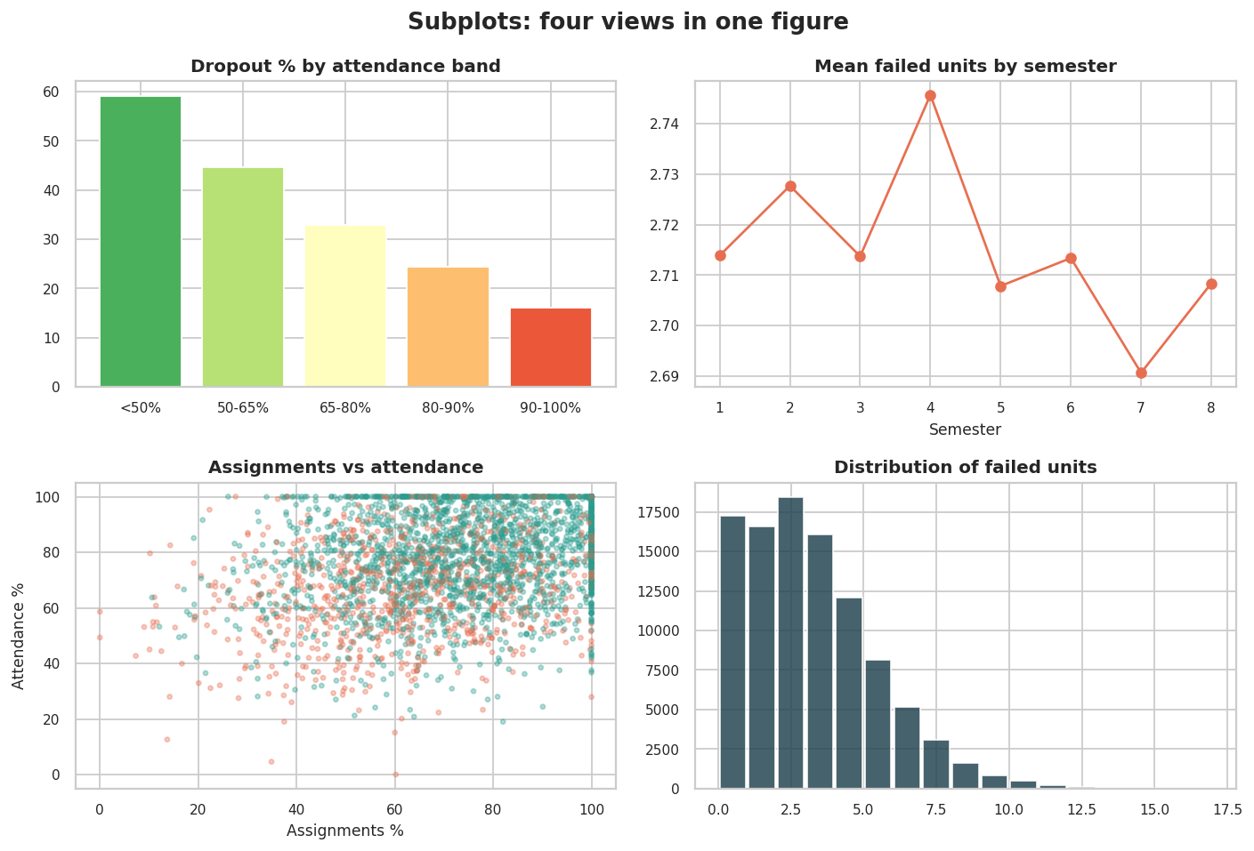
Figure 10: Subplot grid with bar, line, scatter and histogram
Observation: The bar chart shows that dropout falls steadily as attendance rises (59.2% below 50% attendance, 44.7%, 32.8%, 24.4% and 16.1% for 90-100%). Mean failed units are almost constant across semesters, and the number of failed units is right-skewed with most students failing 0 to 4 units. The scatter of assignments against attendance shows a weak positive relationship.

4.6 Three-Dimensional Plotting
A 3D scatter plot (mpl_toolkits.mplot3d) displays three numeric variables at once, and a 3D surface shows how a computed quantity, here the dropout rate, changes over two variables.
fig = plt.figure(figsize=(8, 6)); ax = fig.add_subplot(111, projection="3d")
ax.scatter(s.attendance_rate, s.gpa_semester_2, s.units_failed, c=s.dropout.map(colors), s=9)
ax.set_xlabel("Attendance %"); ax.set_ylabel("GPA sem 2"); ax.set_zlabel("Units failed")
ax.plot_surface(X, Y, dropout_pct_grid, cmap="RdYlGn_r") # surface of dropout %

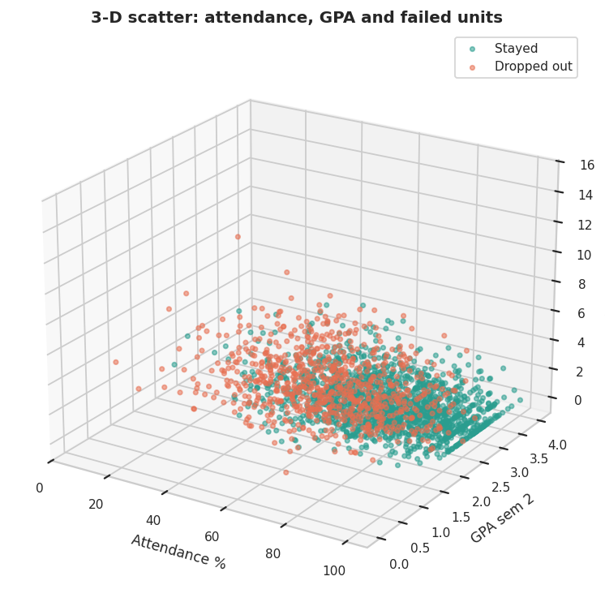
Figure 11: 3D scatter of attendance, semester-2 GPA and failed units
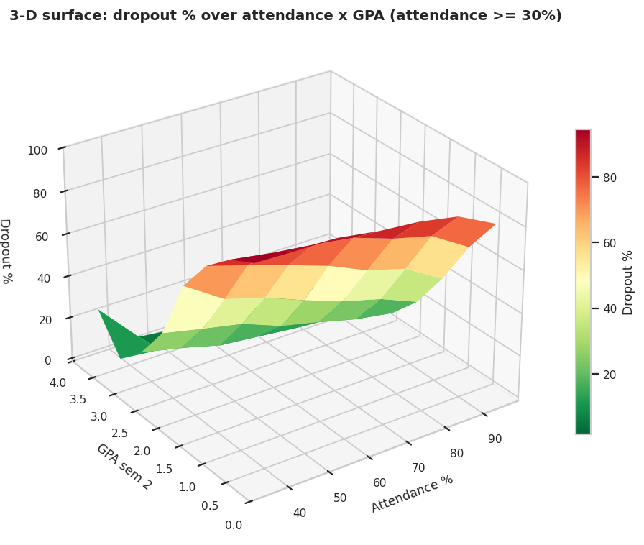
Figure 12: 3D surface of the dropout rate over attendance and GPA
Observation: In the 3D scatter the dropouts (orange) rise toward the upper part of the failed-units axis and the low-GPA side, forming a separate cloud from the students who stayed. The surface makes the interaction visible: the dropout rate is highest (above 90%) in the corner of very low attendance and very low GPA, falls smoothly toward the opposite corner, and is lowest (about 1.5%) where attendance is high and GPA is above 3.0.

4.7 Seaborn
Seaborn is a statistical visualization library built on Matplotlib. It produces attractive defaults and high-level plots such as histplot with a KDE overlay, regplot with a fitted regression line and confidence band, countplot, boxplot, violinplot, pairplot and heatmap, many of which are used throughout this report.
import seaborn as sns
sns.set_theme(style="whitegrid")
sns.histplot(data=d, x="gpa_semester_1", hue="dropout_label", kde=True)
sns.regplot(data=smp, x="attendance_rate", y="gpa_semester_2")
sns.countplot(data=d, x="study_mode", hue="dropout_label")

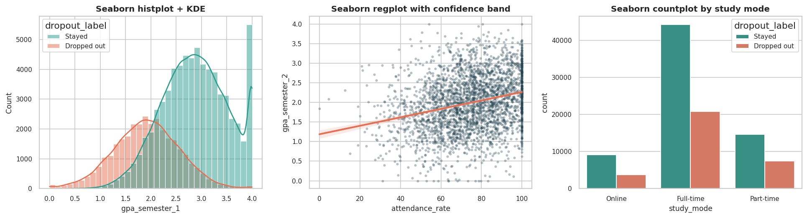
Figure 13: Seaborn histplot with KDE, regplot with confidence band and countplot
Observation: The Seaborn histogram shows two overlapping bell-shaped GPA distributions whose peaks are about one grade point apart. The regression line is shallow (slope 0.0092 GPA points per percentage point of attendance), which confirms the weak attendance-GPA link. The countplot shows that the majority of students in every study mode stay, but the share dropping out is slightly higher for part-time students.

4.8 Plotly and Bokeh (Interactive Visualization)
Plotly and Bokeh create interactive HTML graphics with hover tooltips, zooming and panning. The interactive files are saved in the interactive/ folder of the repository and can be opened in any browser. A random sample of 2,500 students is used so that the pages stay fast, and the tooltip shows the student ID, course, income level, study mode, failed units and missed deadlines.
import plotly.express as px
fig = px.scatter(s, x="attendance_rate", y="gpa_semester_2", color="dropout_label",
hover_data=["person_id", "course_type", "family_income_level", "units_failed"])
fig.write_html("interactive/plotly_attendance_vs_gpa.html")

from bokeh.plotting import figure, output_file, save
from bokeh.models import HoverTool, ColumnDataSource
src = ColumnDataSource(dict(x=s.attendance_rate, y=s.gpa_semester_2, color=s.dropout.map(PAL), pid=s.person_id))
p = figure(title="Attendance vs GPA", tools="pan,wheel_zoom,box_zoom,reset,save")
p.scatter("x", "y", source=src, size=6, color="color")
p.add_tools(HoverTool(tooltips=[("Student", "@pid"), ("Attendance", "@x{0.0}%"), ("GPA S2", "@y{0.00}")]))
output_file("interactive/bokeh_attendance_vs_gpa.html"); save(p)

Observation: Plotly produces a colour-coded scatter plot, a dropout-rate heatmap by income and course type, and a rotatable 3D scatter; Bokeh produces a hover-enabled scatter plot. Interactivity is valuable here because thousands of students overlap in the middle of the plot, and the user can zoom in and hover over a point to identify the student. A dependency-free HTML version (offline_interactive_scatter.html) is also provided so that the demonstration works even without Plotly or Bokeh installed. [Paste screenshots of the Plotly and Bokeh HTML outputs below this paragraph if the faculty requires static evidence.]

5. Univariate Analysis

5.1 Summary Statistics of the Numerical Variables
Univariate analysis studies one variable at a time. For numerical variables the key measures are the mean and median (central tendency), the standard deviation and variance (spread), the quartiles and IQR (robust spread), and skewness and kurtosis (shape).
s = df["gpa_semester_2"]
print(s.describe())
print("Skewness:", s.skew(), " Kurtosis:", s.kurt())
q1, q3 = s.quantile([0.25, 0.75]); iqr = q3 - q1
print("Fences:", q1 - 1.5 * iqr, q3 + 1.5 * iqr)

Table 11: Descriptive statistics of gpa_semester_2
Statistic | Value | Statistic | Value
Count | 100,000 | Minimum | 0.00
Mean | 1.981 | Q1 (25%) | 1.49
Median | 1.990 | Q3 (75%) | 2.49
Mode | 1.97 | IQR | 1.00
Standard deviation | 0.718 | Maximum | 4.00
Variance | 0.515 | Skewness | -0.081
Coefficient of variation | 36.2% | Kurtosis (excess) | -0.267
Mean (1.981) and median (1.990) are almost identical and skewness is close to zero, so semester-2 GPA is approximately symmetric and the mean and standard deviation are appropriate summaries. The slightly negative excess kurtosis (-0.27) means that the tails are slightly lighter than a normal distribution, which is expected for a variable bounded between 0 and 4.
Table 12: Descriptive statistics of all 19 numeric variables
Variable | Mean | Median | Std | Min | Q1 | Q3 | Max | Skew
age | 21.52 | 21.00 | 3.40 | 15.0 | 19.00 | 24.00 | 30.0 | 0.12
weekly_work_hours | 8.74 | 0.00 | 10.23 | 0.0 | 0.00 | 18.00 | 40.0 | 0.67
semester | 3.62 | 3.00 | 2.11 | 1.0 | 2.00 | 5.00 | 8.0 | 0.44
admission_grade | 133.15 | 133.10 | 28.26 | 5.5 | 114.10 | 152.50 | 200.0 | -0.06
previous_qualification_grade | 139.44 | 139.60 | 25.12 | 30.2 | 122.30 | 156.60 | 200.0 | -0.06
units_enrolled | 13.04 | 13.00 | 3.82 | 1.0 | 10.00 | 16.00 | 24.0 | 0.11
units_passed | 10.33 | 10.00 | 3.65 | 1.0 | 8.00 | 13.00 | 24.0 | 0.40
units_failed | 2.72 | 2.00 | 2.21 | 0.0 | 1.00 | 4.00 | 17.0 | 0.90
gpa_semester_1 | 2.57 | 2.58 | 0.79 | 0.0 | 2.03 | 3.13 | 4.0 | -0.20
gpa_semester_2 | 1.98 | 1.99 | 0.72 | 0.0 | 1.49 | 2.49 | 4.0 | -0.08
attendance_rate | 75.10 | 76.10 | 17.43 | 0.0 | 63.10 | 89.00 | 100.0 | -0.42
assignments_submitted_rate | 71.42 | 72.60 | 19.88 | 0.0 | 57.80 | 87.20 | 100.0 | -0.42
library_visits_per_month | 4.37 | 3.00 | 3.65 | 0.0 | 2.00 | 6.00 | 30.0 | 1.68
lms_logins_per_week | 7.27 | 7.10 | 3.94 | 0.0 | 4.50 | 9.80 | 29.6 | 0.36
missed_deadlines | 2.37 | 2.00 | 2.59 | 0.0 | 0.00 | 3.00 | 20.0 | 1.76
stress_level | 6.45 | 7.00 | 2.15 | 1.0 | 5.00 | 8.00 | 10.0 | -0.22
satisfaction_score | 6.32 | 6.00 | 2.08 | 1.0 | 5.00 | 8.00 | 10.0 | -0.17
commute_time_mins | 23.26 | 16.00 | 23.93 | 0.0 | 6.00 | 33.00 | 120.0 | 1.65
sleep_hours | 6.56 | 6.50 | 1.20 | 4.0 | 5.70 | 7.40 | 10.0 | 0.09
Observation: Only three variables are strongly skewed (skewness above 1): missed_deadlines (1.76), library_visits_per_month (1.68) and commute_time_mins (1.65). Their means are well above their medians (for example commute 23.3 against 16.0 minutes, weekly work hours 8.7 against 0), so the median describes a typical student better than the mean for these variables. All other variables, including both GPAs, attendance and grades, are roughly symmetric.

5.2 Histogram, Box Plot and Density Plot
Histograms with a KDE curve, box plots and Q-Q plots were drawn for all 19 numeric variables. Dashed red lines mark the mean and green lines mark the median.
sns.histplot(d[c], bins=30, kde=True) # histogram + density
sns.boxplot(x=d[c]) # box plot
stats.probplot(d[c].sample(5000), dist="norm", plot=ax) # Q-Q plot

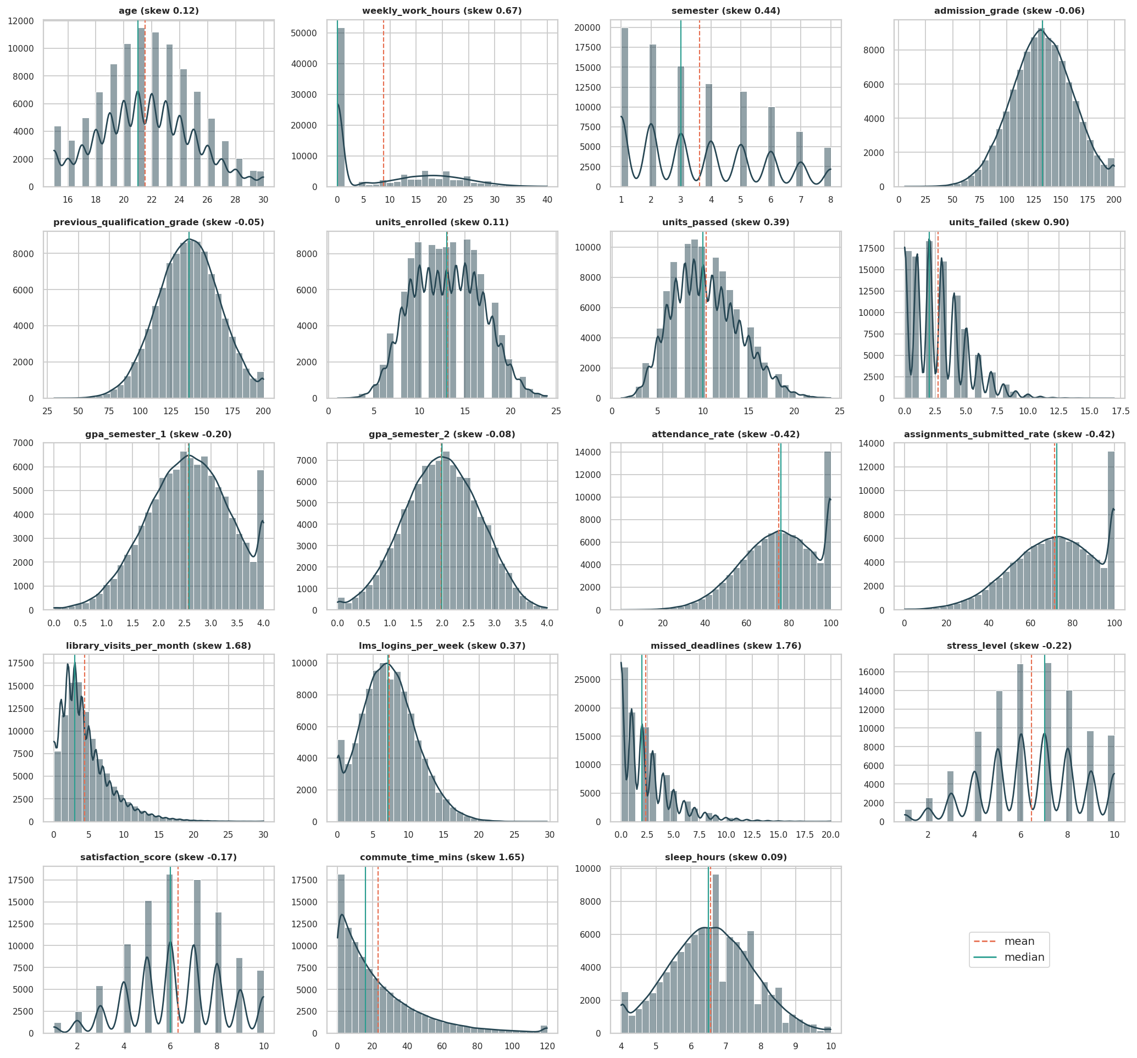
Figure 14: Histograms with density curves of all numeric variables (red dashed = mean, green = median)
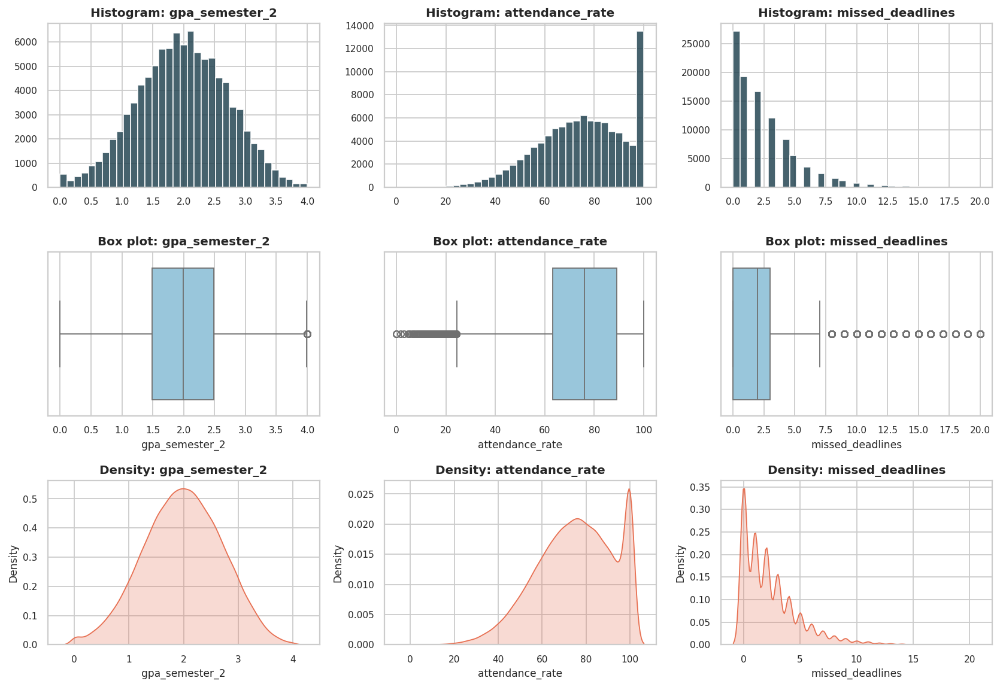
Figure 15: Histogram, box plot and density plot for GPA, attendance and missed deadlines
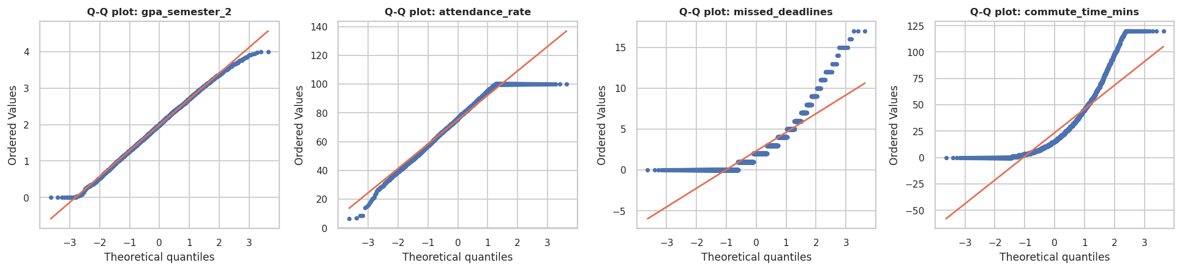
Figure 16: Q-Q plots against the normal distribution
Observation: GPA, grades, stress, satisfaction and sleep follow a bell shape and their Q-Q points lie close to the diagonal. Attendance and assignment submission are piled up at 100% (the ceiling effect) and have a longer left tail. Missed deadlines and commute time are right-skewed with many students at 0, and their Q-Q plots curve strongly upward, confirming departure from normality. Because of this, the non-parametric tests of Unit 4 are used alongside parametric ones.
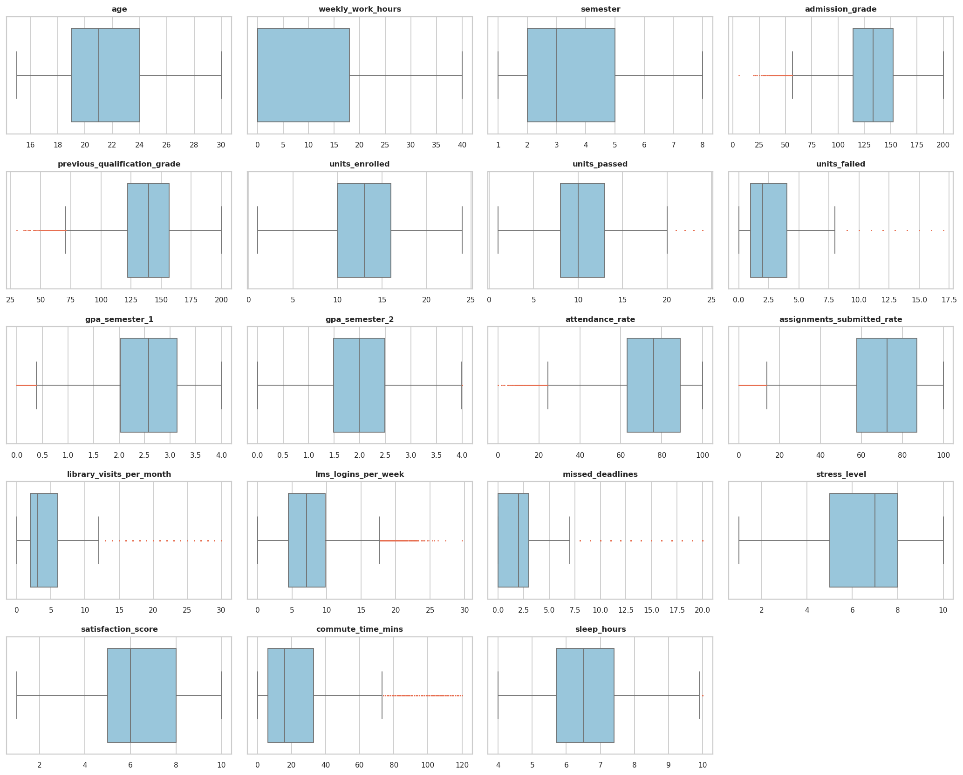
Figure 17: Box plots of all numeric variables

5.3 Skewness and Outlier Detection
Outliers were detected with the IQR rule: values below Q1 - 1.5 x IQR or above Q3 + 1.5 x IQR are flagged.
q1, q3 = s.quantile([.25, .75]); iqr = q3 - q1
lo, hi = q1 - 1.5 * iqr, q3 + 1.5 * iqr
n_out = ((s < lo) | (s > hi)).sum()

Table 13: Skewness and IQR outliers for every numeric variable
Variable | Skewness | Shape | Lower fence | Upper fence | Below | Above | Outlier %
age | 0.12 | Approx. symmetric | 11.5 | 31.5 | 0 | 0 | 0.0
weekly_work_hours | 0.67 | Moderate right skew | -27.0 | 45.0 | 0 | 0 | 0.0
semester | 0.44 | Approx. symmetric | -2.5 | 9.5 | 0 | 0 | 0.0
admission_grade | -0.06 | Approx. symmetric | 56.5 | 210.1 | 342 | 0 | 0.34
previous_qualification_grade | -0.05 | Approx. symmetric | 70.85 | 208.05 | 330 | 0 | 0.33
units_enrolled | 0.11 | Approx. symmetric | 1.0 | 25.0 | 0 | 0 | 0.0
units_passed | 0.39 | Approx. symmetric | 0.5 | 20.5 | 0 | 436 | 0.44
units_failed | 0.9 | Moderate right skew | -3.5 | 8.5 | 0 | 1,628 | 1.63
gpa_semester_1 | -0.2 | Approx. symmetric | 0.38 | 4.78 | 359 | 0 | 0.36
gpa_semester_2 | -0.08 | Approx. symmetric | -0.01 | 3.99 | 0 | 71 | 0.07
attendance_rate | -0.42 | Approx. symmetric | 24.25 | 127.85 | 335 | 0 | 0.34
assignments_submitted_rate | -0.42 | Approx. symmetric | 13.7 | 131.3 | 358 | 0 | 0.36
library_visits_per_month | 1.68 | Strong right skew | -4.0 | 12.0 | 0 | 3,756 | 3.76
lms_logins_per_week | 0.37 | Approx. symmetric | -3.45 | 17.75 | 0 | 823 | 0.82
missed_deadlines | 1.76 | Strong right skew | -4.5 | 7.5 | 0 | 4,903 | 4.9
stress_level | -0.22 | Approx. symmetric | 0.5 | 12.5 | 0 | 0 | 0.0
satisfaction_score | -0.17 | Approx. symmetric | 0.5 | 12.5 | 0 | 0 | 0.0
commute_time_mins | 1.65 | Strong right skew | -34.5 | 73.5 | 0 | 4,879 | 4.88
sleep_hours | 0.09 | Approx. symmetric | 3.15 | 9.95 | 0 | 275 | 0.28

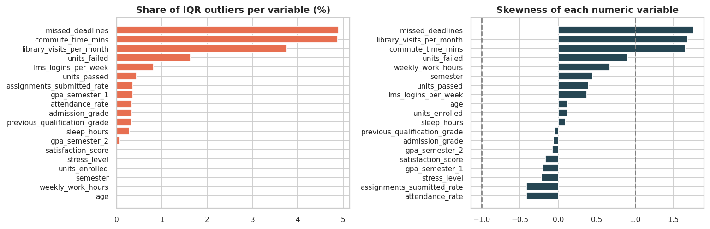
Figure 18: Share of IQR outliers (left) and skewness (right) per variable
Observation: 13 of the 19 variables contain IQR outliers, but the proportions are small: the largest is missed_deadlines with 4.9% of students above the fence of 7.5, followed by commute time (4.9%) and library visits (3.8%). Bounded variables behave differently: for attendance and assignment submission the lower fence flags a few hundred students (about 0.3%) with very low values and no values are flagged on the upper side. These outliers are not errors. A student who missed 15 deadlines or commutes for two hours is real, and for a dropout study such students are exactly the ones of interest, so none were removed. Winsorising missed_deadlines at its 99th percentile (11) would change its mean only from 2.37 to 2.34, so the influence of the outliers on summary statistics is small. Log transformation (Section 3.5) is used where a symmetric scale is needed.

5.4 Single Categorical Variable: Bar Chart, Pie Chart and Frequency Table
For a categorical variable the frequency table counts the occurrences of every category, the bar chart compares those counts accurately, and the pie chart shows each category's share of a whole.
freq = df["course_type"].value_counts()
rel = df["course_type"].value_counts(normalize=True) * 100
plt.bar(freq.index, freq.values)
plt.pie(freq, labels=freq.index, autopct="%1.1f%%")

Table 14: Frequency tables of the main categorical variables
Variable | Category | Count | Percent | Cumulative %
Course type | STEM | 30,141 | 30.14 | 30.14
Course type | Business | 24,986 | 24.99 | 55.13
Course type | Arts & Humanities | 18,024 | 18.02 | 73.15
Course type | Health Sciences | 14,941 | 14.94 | 88.09
Course type | Law & Social Sciences | 11,908 | 11.91 | 100.00
Study mode | Full-time | 65,096 | 65.10 | 65.10
Study mode | Part-time | 21,975 | 21.98 | 87.07
Study mode | Online | 12,929 | 12.93 | 100.00
Family income | Low | 34,809 | 34.81 | 75.02
Family income | Middle | 40,213 | 40.21 | 40.21
Family income | High | 24,978 | 24.98 | 100.00
Gender | Female | 50,731 | 50.73 | 50.73
Gender | Male | 47,224 | 47.22 | 97.96
Gender | Other | 2,045 | 2.04 | 100.00
Dropout (target) | Stayed | 67,996 | 68.00 | 68.00
Dropout (target) | Dropped out | 32,004 | 32.00 | 100.00

Table 15: Frequency table of nationality
Nationality | Count | Percent | Cumulative %
USA | 29,979 | 29.98 | 29.98
India | 11,994 | 11.99 | 41.97
China | 10,013 | 10.01 | 51.99
Brazil | 6,873 | 6.87 | 58.86
Mexico | 6,149 | 6.15 | 65.01
UK | 6,050 | 6.05 | 71.06
Nigeria | 5,921 | 5.92 | 76.98
Germany | 4,072 | 4.07 | 81.05
South Korea | 4,060 | 4.06 | 85.11
Philippines | 3,956 | 3.96 | 89.07
Pakistan | 3,030 | 3.03 | 92.1
Indonesia | 2,982 | 2.98 | 95.08
Egypt | 1,985 | 1.98 | 97.06
Canada | 1,967 | 1.97 | 99.03
Australia | 969 | 0.97 | 100.0

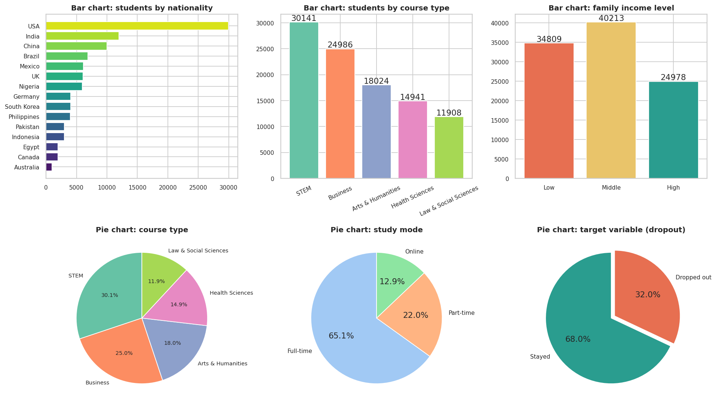
Figure 19: Bar charts (top) and pie charts (bottom) of the categorical variables
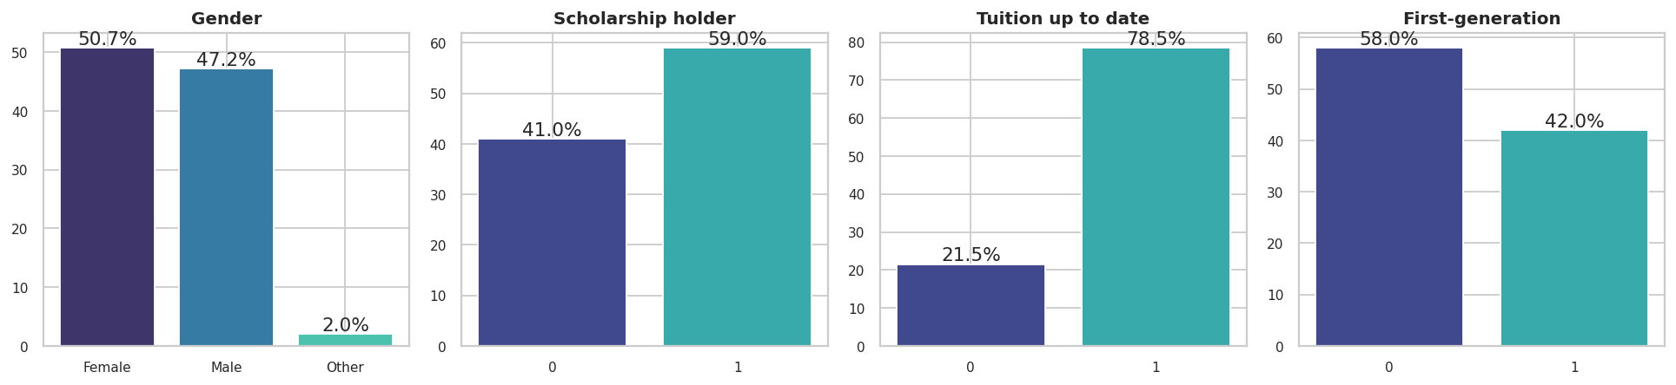
Figure 20: Bar charts of binary and small-category variables
Observation: Nationality is concentrated: the USA alone supplies 30.0% of students and the top three countries (USA, India, China) 52.0%. Course types are fairly balanced (STEM 30.1% to Law and Social Sciences 11.9%), study mode is dominated by full-time students (65.1%), and gender is almost evenly split (Female 50.7%, Male 47.2%, Other 2.0%). 34.8% of students come from low-income families, 59.0% hold a scholarship, 21.5% have unpaid tuition, 42.0% are first-generation and 20.9% have a registered disability. The target is moderately imbalanced (68.0% stayed, 32.0% dropped out), so accuracy alone will be a misleading metric and the model section also reports precision, recall, F1 and ROC-AUC. The pie chart of the target is easy to read because it has only two slices, whereas the bar chart is better than a pie for the 15 nationalities, whose small slices would be unreadable.

6. Bivariate Analysis

6.1 Two Numerical Variables
The relationship between pairs of numeric variables is studied with scatter plots, fitted regression lines and two correlation coefficients. Pearson's r measures linear association and is sensitive to outliers; Spearman's rho measures monotonic association from ranks and is robust to outliers.
from scipy import stats
r, p = stats.pearsonr(df["attendance_rate"], df["gpa_semester_2"])
rho, p = stats.spearmanr(df["attendance_rate"], df["gpa_semester_2"])
fit = stats.linregress(df["attendance_rate"], df["gpa_semester_2"])
print(r, rho, fit.slope, fit.intercept, fit.rvalue ** 2)

Table 16: Pearson and Spearman correlation for selected numeric pairs
Variable X | Variable Y | Pearson r | Spearman rho | Slope | Intercept | R-squared | p-value
attendance_rate | assignments_submitted_rate | 0.304 | 0.296 | 0.3474 | 45.332 | 0.093 | <0.001
gpa_semester_1 | gpa_semester_2 | 0.83 | 0.825 | 0.7558 | 0.04 | 0.69 | <0.001
attendance_rate | gpa_semester_2 | 0.222 | 0.218 | 0.0092 | 1.293 | 0.049 | <0.001
units_failed | gpa_semester_2 | -0.62 | -0.632 | -0.2008 | 2.526 | 0.384 | <0.001
admission_grade | previous_qualification_grade | 0.028 | 0.026 | 0.0246 | 136.163 | 0.001 | <0.001
admission_grade | gpa_semester_1 | 0.158 | 0.153 | 0.0044 | 1.979 | 0.025 | <0.001
stress_level | sleep_hours | -0.186 | -0.181 | -0.1041 | 7.228 | 0.035 | <0.001
weekly_work_hours | gpa_semester_2 | -0.091 | -0.09 | -0.0064 | 2.037 | 0.008 | <0.001
lms_logins_per_week | library_visits_per_month | 0.075 | 0.099 | 0.0699 | 3.859 | 0.006 | <0.001
missed_deadlines | assignments_submitted_rate | -0.108 | -0.137 | -0.8266 | 73.386 | 0.012 | <0.001

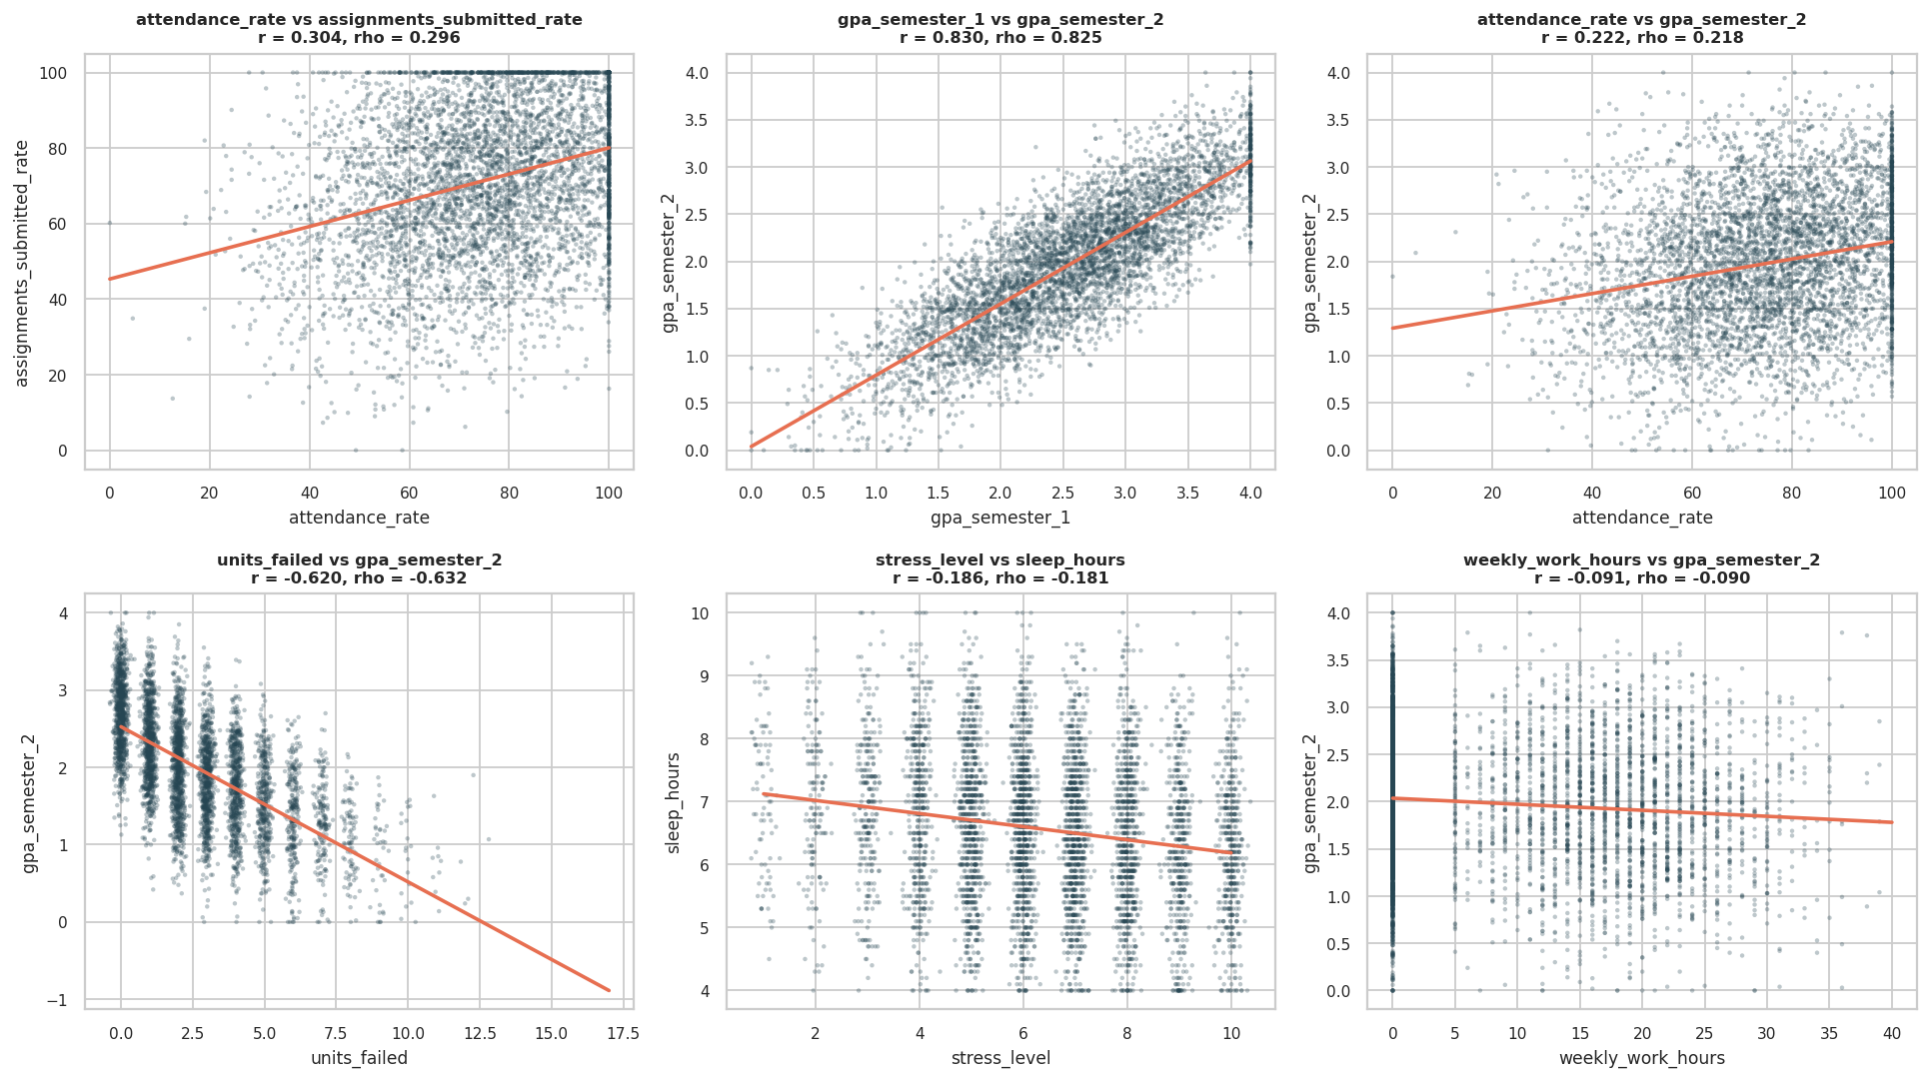
Figure 21: Scatter plots with fitted regression lines for six numeric pairs (5,000-student sample)
Observation: The strongest relationships are between the two GPAs (r = 0.830) and between failed units and GPA (r = -0.620); failing units lowers GPA directly. Attendance and assignment submission are only moderately related (r = 0.304), and attendance explains just 4.9% of the variance in GPA. Several pairs one might expect to be linked are almost independent: admission grade and previous qualification grade (r = 0.028), and LMS logins and library visits (r = 0.075). Pearson and Spearman agree closely for every pair because the variables are not heavily skewed. Working hours reduce GPA slightly (r = -0.091).
The most important numeric relationship for this project is between each variable and the target. For a binary target the Pearson correlation is the point-biserial correlation.
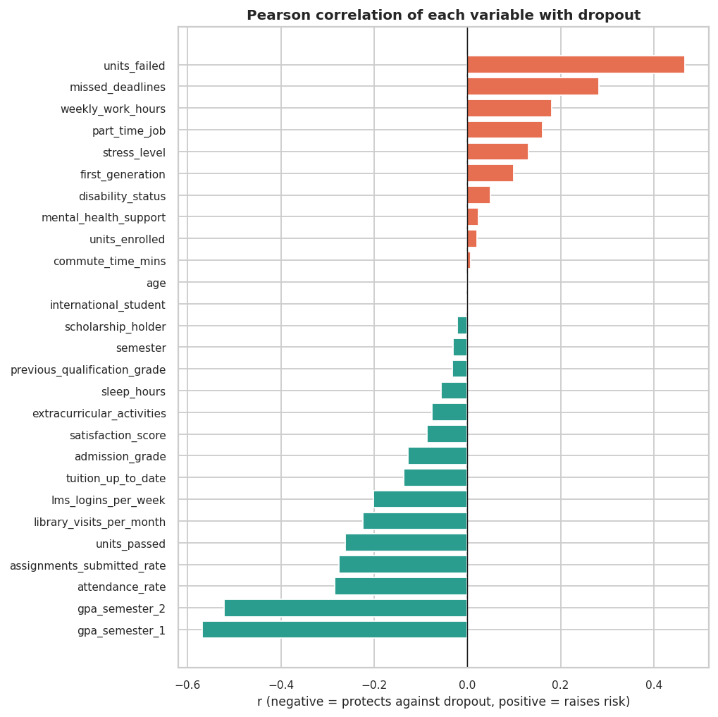
Figure 22: Correlation of every numeric variable with dropout
Observation: Protective factors (negative r) are semester-1 GPA (-0.569), semester-2 GPA (-0.521), attendance, assignment submission, units passed, library visits and LMS activity. Risk factors (positive r) are failed units (+0.467), missed deadlines (+0.282), weekly work hours (+0.181), part-time job, stress and first-generation status. Age (0.002), commute time (0.008) and international status (0.001) have essentially zero correlation with dropout. These correlations describe association, not causation: low GPA may cause dropout, but a student who is about to leave may also stop studying.

6.2 Two Categorical Variables
Two categorical variables are compared with a contingency table (cross-tab), grouped and stacked bar charts, the chi-square test of independence and Cramér's V, which rescales chi-square to a 0-1 strength measure (about 0.1 is small, 0.3 medium and 0.5 large).
ct = pd.crosstab(df["family_income_level"], df["dropout"])
chi2, p, dof, expected = stats.chi2_contingency(ct)
cramers_v = np.sqrt(chi2 / (ct.values.sum() * (min(ct.shape) - 1)))
pd.crosstab(df["family_income_level"], df["dropout"], normalize="index") * 100
ct_pct.plot(kind="bar", stacked=True) # stacked bar
ct.plot(kind="bar") # grouped bar

Table 17: Cross-tabulation of family income and dropout (counts and row percentages)
Family income | Dropped out | Stayed | Dropped out % | Stayed %
Low | 14,940 | 19,869 | 42.9 | 57.1
Middle | 12,071 | 28,142 | 30.0 | 70.0
High | 4,993 | 19,985 | 20.0 | 80.0

Table 18: Chi-square tests and Cramér's V of each categorical/binary variable against dropout
Variable | Chi-square | dof | p-value | Cramer's V
family_income_level | 3635.7 | 2 | <0.001 | 0.191
work_load | 3099.9 | 2 | <0.001 | 0.176
part_time_job | 2617.5 | 1 | <0.001 | 0.162
tuition_up_to_date | 1879.8 | 1 | <0.001 | 0.137
first_generation | 979.4 | 1 | <0.001 | 0.099
extracurricular_activities | 572.1 | 1 | <0.001 | 0.076
disability_status | 249.0 | 1 | <0.001 | 0.05
study_mode | 74.4 | 2 | <0.001 | 0.027
mental_health_support | 59.6 | 1 | <0.001 | 0.024
scholarship_holder | 49.4 | 1 | <0.001 | 0.022
nationality | 8.7 | 14 | 0.85 | 0.009
age_group | 2.1 | 3 | 0.544 | 0.005
gender | 2.0 | 2 | 0.363 | 0.005
course_type | 1.3 | 4 | 0.869 | 0.004
international_student | 0.1 | 1 | 0.769 | 0.001

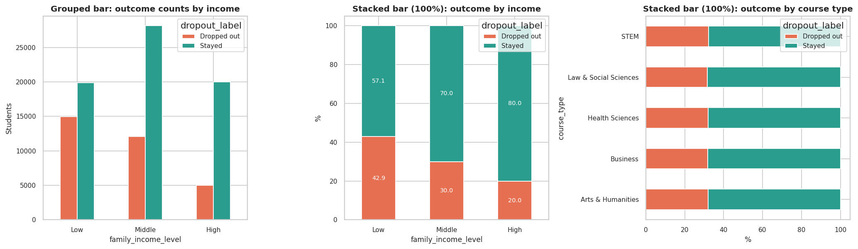
Figure 23: Grouped bar (left) and stacked 100% bars (middle, right) of outcome by income and course type
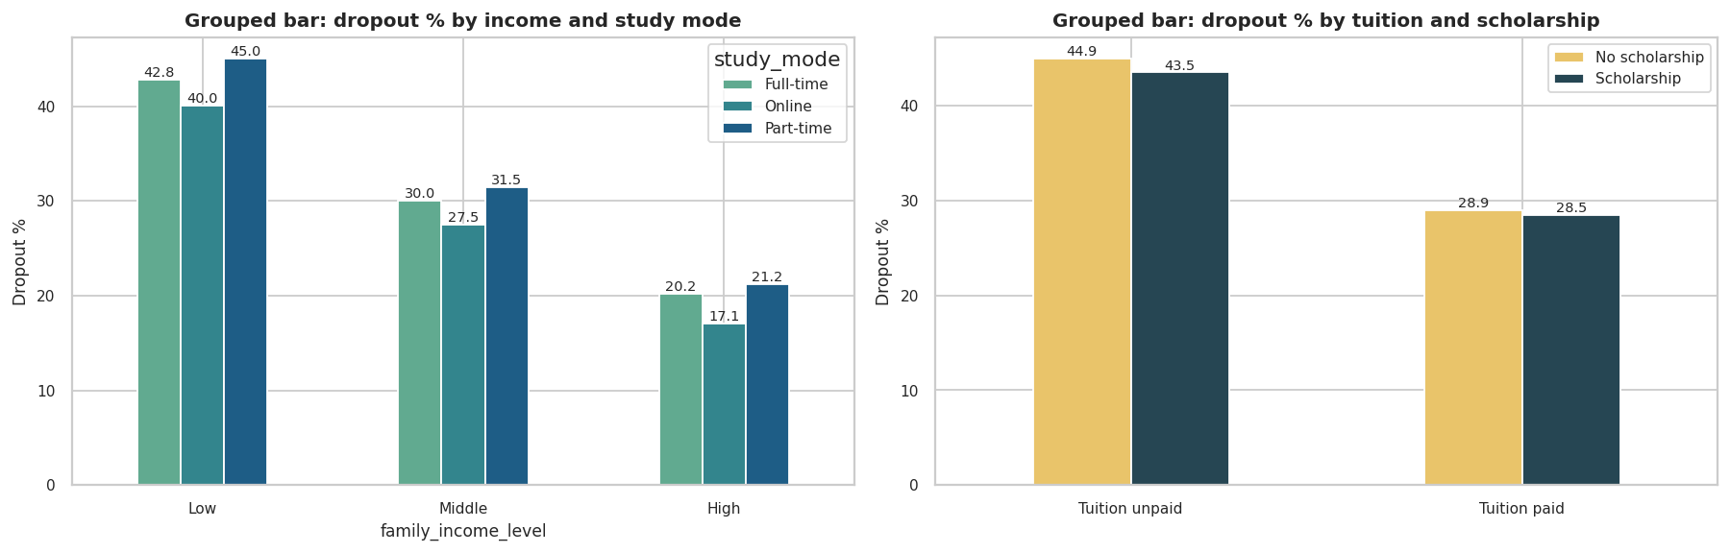
Figure 24: Grouped bars: dropout rate by income and study mode (left), and by tuition status and scholarship (right)
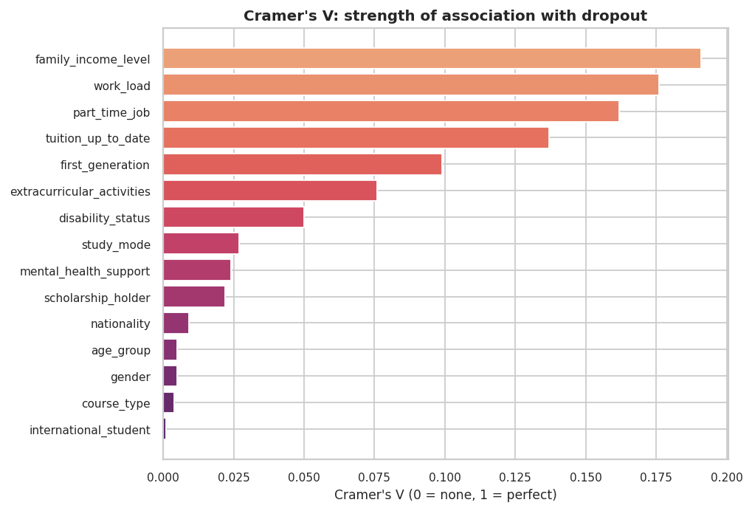
Figure 25: Cramér's V: strength of association of each variable with dropout
Observation: Family income gives chi-square = 3635.7 with 2 degrees of freedom and Cramér's V = 0.191, the largest association among the categorical variables, followed by work load (0.176), having a part-time job (0.162), unpaid tuition (0.137) and first-generation status (0.099). The variables with no association at all are course type (V = 0.004, p = 0.869), gender (V = 0.005, p = 0.363) and nationality (V = 0.009, p = 0.85), together with international status and age group. The grouped bars show that the income effect is the same in every study mode, and that tuition and scholarship effects are separate: unpaid-tuition students without a scholarship drop out most. Even the largest V is only about 0.19, which is a small-to-moderate effect, so no single categorical variable is a strong predictor on its own.

6.3 Numerical and Categorical Variables
Box plots and violin plots compare the distribution of a numeric variable across the groups of a categorical variable; a violin plot adds a kernel density outline to the box. Differences between two groups are tested with the Welch t-test and the non-parametric Mann-Whitney U test, and quantified with Cohen's d (0.2 small, 0.5 medium, 0.8 large). Differences across more than two groups use one-way ANOVA and Kruskal-Wallis with eta-squared as the effect size.
sns.boxplot(data=d, x="dropout_label", y="gpa_semester_2")
sns.violinplot(data=d, x="dropout_label", y="gpa_semester_2", inner="quartile", cut=0)
a, b = d[d.dropout == 1].gpa_semester_2, d[d.dropout == 0].gpa_semester_2
print(stats.ttest_ind(a, b, equal_var=False), stats.mannwhitneyu(a, b))
cohen_d = (a.mean() - b.mean()) / np.sqrt(((len(a)-1)*a.var() + (len(b)-1)*b.var()) / (len(a)+len(b)-2))
print(stats.f_oneway(*groups), stats.kruskal(*groups))

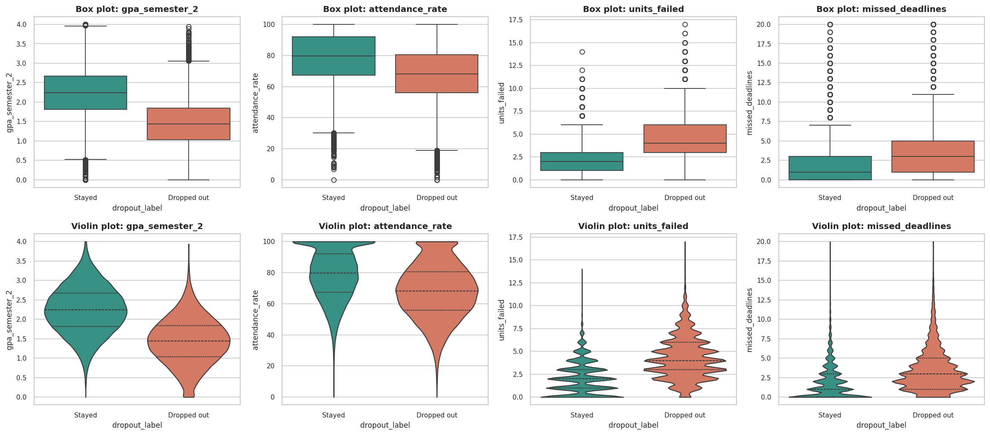
Figure 26: Box plots (top) and violin plots (bottom) of four variables by outcome
Table 19: Students who stayed versus dropped out: tests and effect sizes (top 12 by |Cohen's d|)
Variable | Mean (stayed) | Mean (dropped) | Welch t | t-test p | Mann-Whitney p | Cohen's d | Effect size
gpa_semester_1 | 2.88 | 1.91 | -218.6 | <0.001 | <0.001 | -1.48 | large
gpa_semester_2 | 2.24 | 1.44 | -195.1 | <0.001 | <0.001 | -1.31 | large
units_failed | 2.01 | 4.22 | 152.7 | <0.001 | <0.001 | 1.13 | large
attendance_rate | 78.5 | 67.87 | -91.1 | <0.001 | <0.001 | -0.64 | medium
missed_deadlines | 1.87 | 3.44 | 86.6 | <0.001 | <0.001 | 0.63 | medium
assignments_submitted_rate | 75.18 | 63.44 | -88.0 | <0.001 | <0.001 | -0.61 | medium
units_passed | 10.98 | 8.94 | -89.5 | <0.001 | <0.001 | -0.58 | medium
library_visits_per_month | 4.93 | 3.17 | -76.1 | <0.001 | <0.001 | -0.49 | small
lms_logins_per_week | 7.82 | 6.12 | -66.3 | <0.001 | <0.001 | -0.44 | small
weekly_work_hours | 7.47 | 11.45 | 56.2 | <0.001 | <0.001 | 0.39 | small
stress_level | 6.26 | 6.86 | 42.1 | <0.001 | <0.001 | 0.28 | small
admission_grade | 135.63 | 127.87 | -40.7 | <0.001 | <0.001 | -0.28 | small

Observation: 17 of the 19 variables differ significantly (p < 0.001) between the two groups, but significance is not importance: with 100,000 students even a difference of 0.4 units of units_enrolled is "significant". Cohen's d separates the variables clearly: 3 have a large effect (semester-1 GPA d = -1.48, semester-2 GPA d = -1.31, failed units d = +1.13), 4 medium (attendance, missed deadlines, assignment submission, units passed), 5 small and 7 negligible, including age, commute time and units enrolled. On average dropouts have a semester-2 GPA of 1.44 against 2.24, 4.22 failed units against 2.01, and attendance of 67.9% against 78.5%. The Mann-Whitney results agree with the t-tests, so the conclusions do not depend on normality.
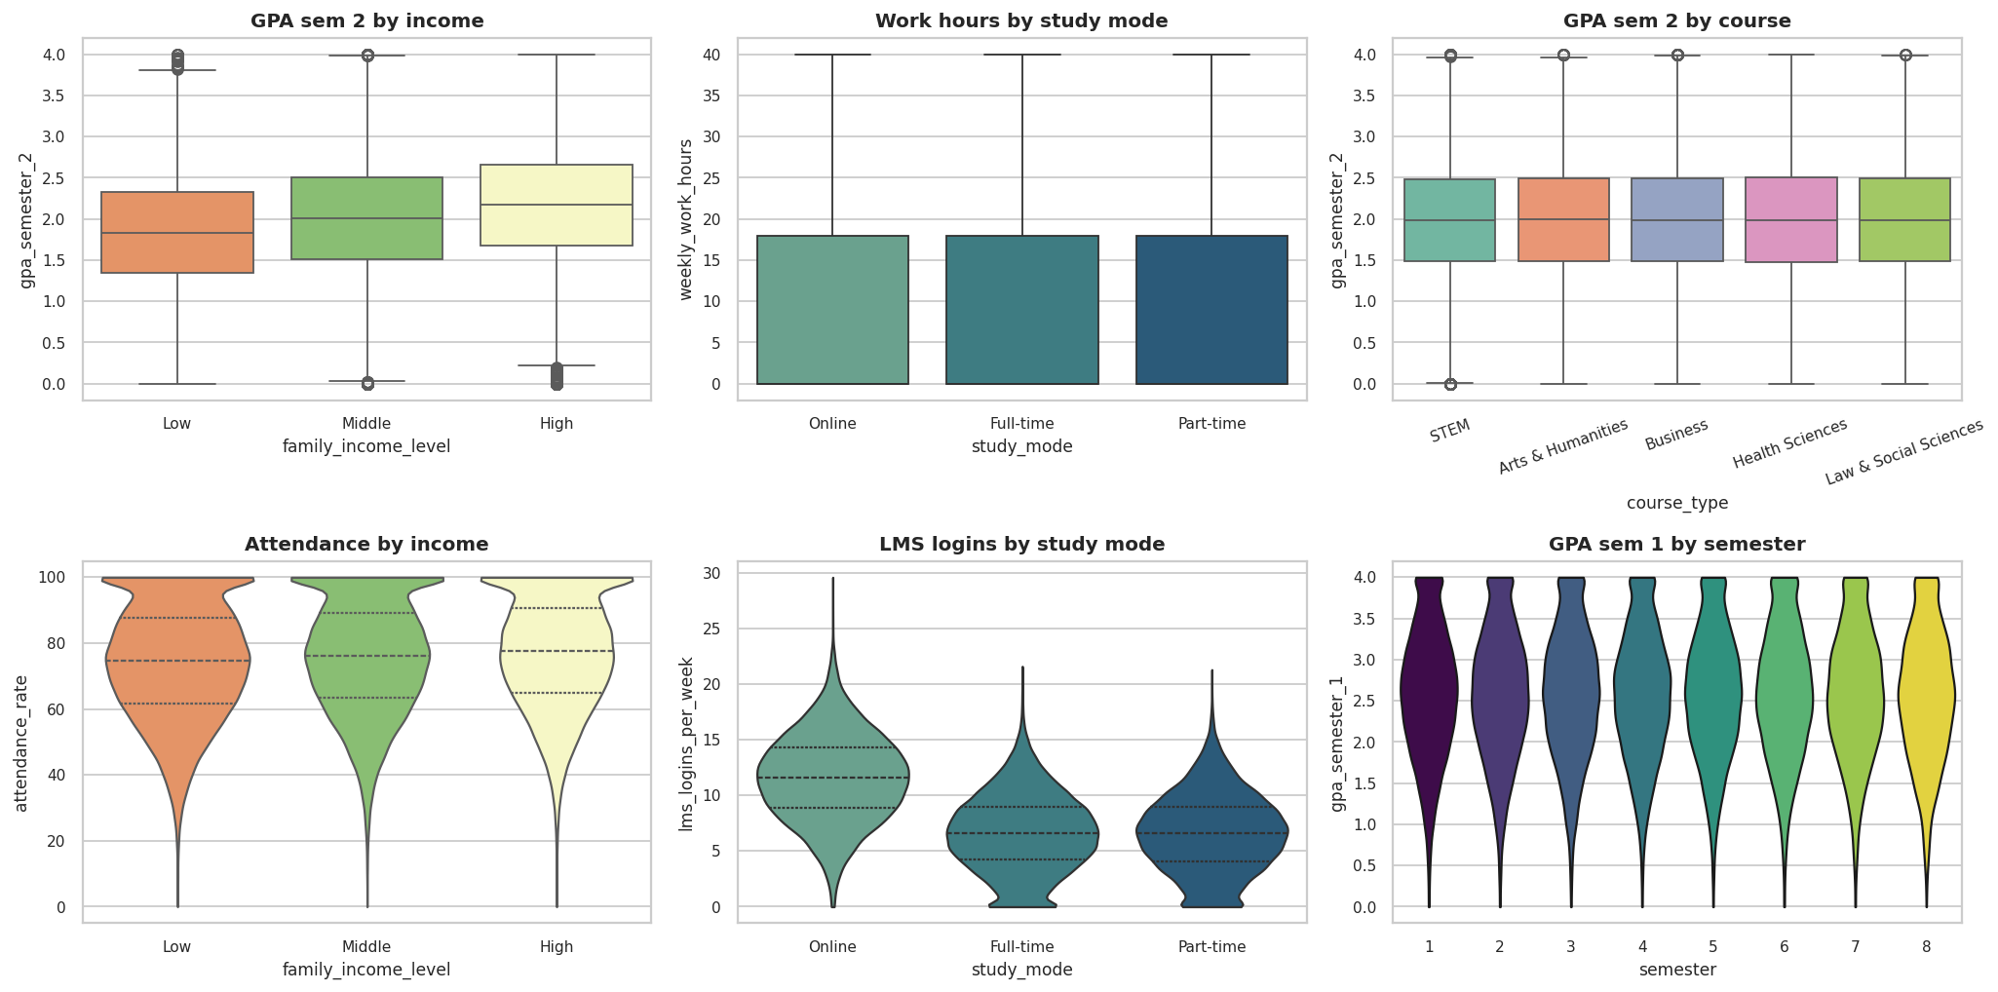
Figure 27: Box and violin plots of numeric variables across income, study mode, course and semester
Table 20: ANOVA and Kruskal-Wallis tests across groups
Numeric variable | Grouped by | ANOVA F | ANOVA p | Kruskal H | Kruskal p | Eta-squared
gpa_semester_2 | family_income_level | 1625.9 | <0.001 | 3008.5 | <0.001 | 0.0315
gpa_semester_2 | course_type | 0.5 | 0.748 | 1.6 | 0.815 | 0.0
attendance_rate | study_mode | 763.5 | <0.001 | 1451.7 | <0.001 | 0.015
weekly_work_hours | study_mode | 3.0 | 0.047 | 6.2 | 0.045 | 0.0001
gpa_semester_1 | semester | 1.0 | 0.413 | 7.0 | 0.433 | 0.0001
units_failed | family_income_level | 503.1 | <0.001 | 1063.7 | <0.001 | 0.01
admission_grade | course_type | 0.9 | 0.485 | 3.3 | 0.509 | 0.0
stress_level | work_load | 841.3 | <0.001 | 1631.7 | <0.001 | 0.0165

Observation: Semester-2 GPA differs strongly across income groups (F = 1,626, eta-squared = 0.0315, so income explains about 3% of GPA variance), but not at all across course types (p = 0.748, eta-squared = 0.0000) and admission grade does not differ by course. Attendance differs by study mode (eta-squared 0.015), and stress differs by work load (0.017). Both ANOVA and Kruskal-Wallis lead to the same conclusions. All eta-squared values are small (below 0.04): group membership explains little of the variation within any single variable.

7. Multivariate Analysis and Insights

7.1 Pair Plot (Scatter Matrix)
A pair plot draws all pairwise scatter plots of several variables and the distribution of each variable on the diagonal. Five key academic variables are plotted for a random sample of 1,500 students, coloured by outcome. Only the lower triangle is drawn (corner=True) because the matrix is symmetric.
s = d.sample(1500, random_state=42)[pp_vars + ["dropout_label"]]
sns.pairplot(s, hue="dropout_label", corner=True, diag_kind="kde", palette={"Stayed": "#2a9d8f", "Dropped out": "#e76f51"})

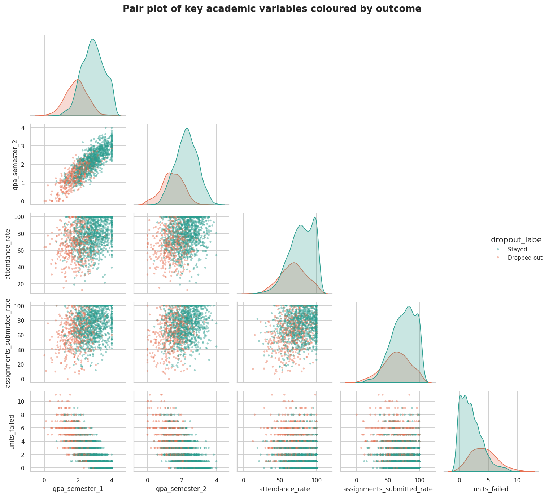
Figure 28: Pair plot of key academic variables coloured by outcome
Observation: The diagonal KDEs show that the two groups are best separated on GPA (both semesters) and failed units, and only partially on attendance and assignment submission. The GPA1-GPA2 panel shows a tight upward band and the failed-units panels show a downward trend. In every panel the orange (dropout) points occupy the lower-left or lower region but overlap heavily with the green points: dropout is a probabilistic outcome, not a deterministic one.

7.2 Correlation Heatmaps
A correlation heatmap summarises all pairwise correlations in a colour-coded matrix. The figures below show the full Pearson matrix of 27 variables plus the target, and a focused Pearson and Spearman comparison for 13 key variables.
corr = d[num_cols + ["dropout"]].corr()
sns.heatmap(corr, cmap="coolwarm", center=0, vmin=-1, vmax=1, annot=True, fmt=".2f")
sns.heatmap(d[focus].corr("spearman"), cmap="coolwarm", center=0, annot=True)

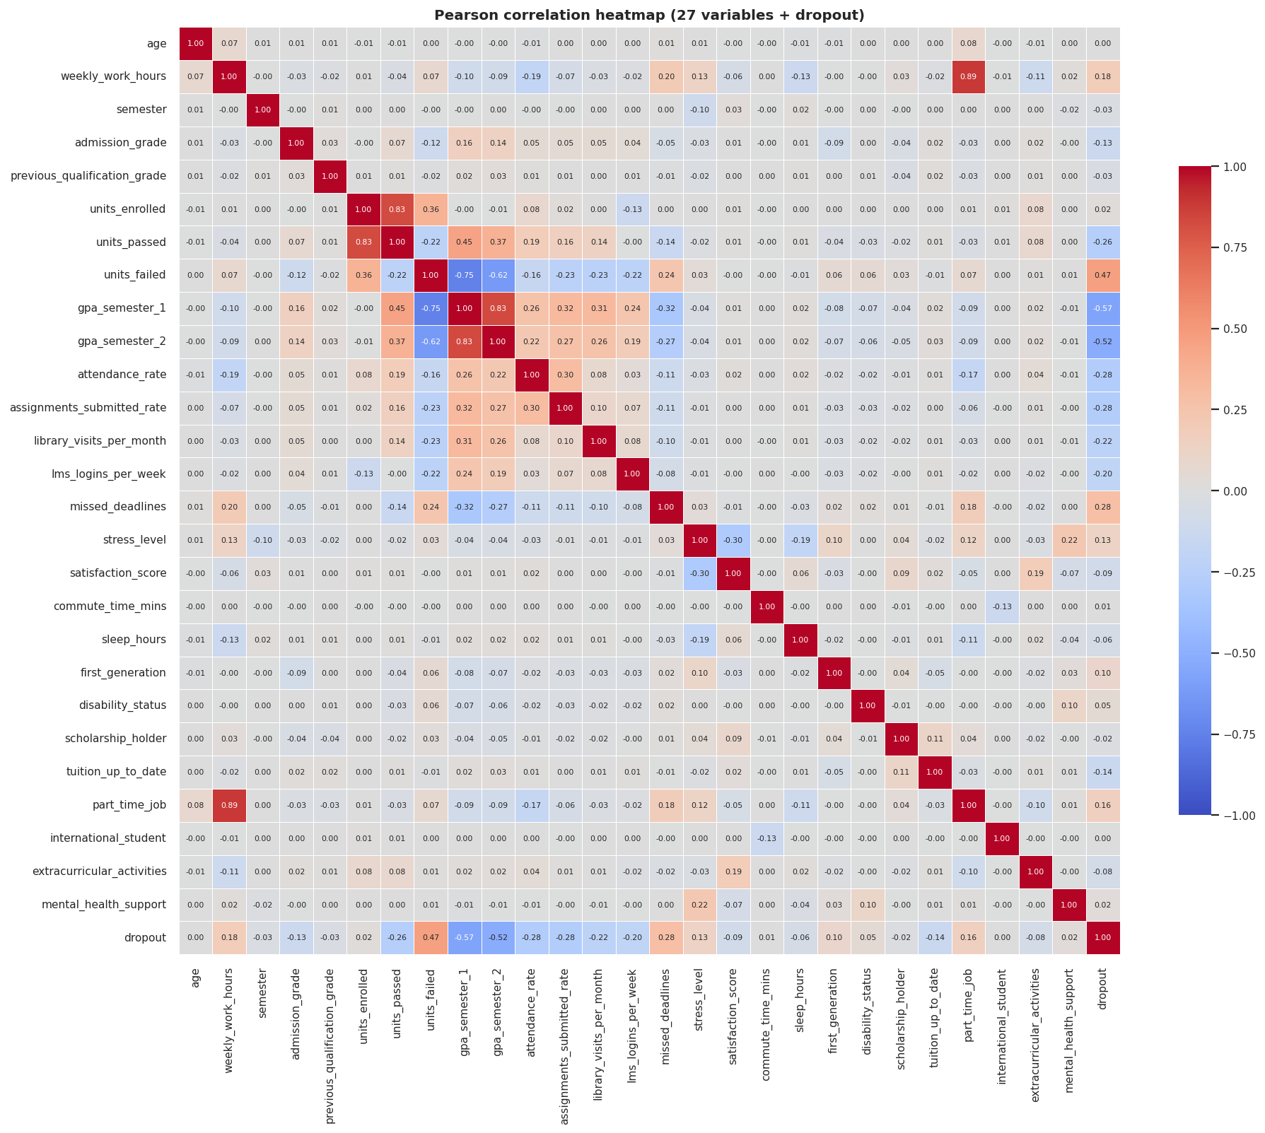
Figure 29: Full Pearson correlation heatmap (27 variables and dropout)
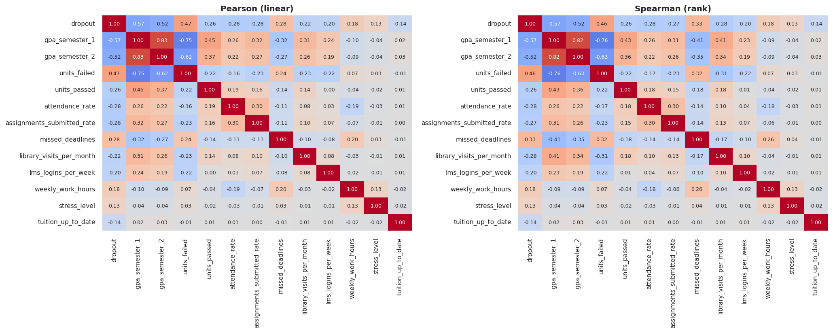
Figure 30: Pearson (left) and Spearman (right) correlation heatmaps of 13 key variables
Table 21: Strongest correlations in the dataset
Variable A | Variable B | Pearson r
weekly_work_hours | part_time_job | 0.886
gpa_semester_1 | gpa_semester_2 | 0.83
units_enrolled | units_passed | 0.825
units_failed | gpa_semester_1 | -0.746
units_failed | gpa_semester_2 | -0.62
gpa_semester_1 | dropout | -0.569
gpa_semester_2 | dropout | -0.521
units_failed | dropout | 0.467
units_passed | gpa_semester_1 | 0.449
units_passed | gpa_semester_2 | 0.37

Observation: Most variable pairs are only weakly correlated: only 5 of the 351 pairs of predictors exceed |r| = 0.5. The strongest are structural: weekly_work_hours with part_time_job (r = 0.886, because hours are 0 when there is no job) and units_enrolled with units_passed (0.825). The meaningful ones are GPA1 with GPA2 (0.830) and failed units with GPA1 (-0.746). The three strongest correlations with the target are semester-1 GPA, semester-2 GPA and failed units. Because predictor-predictor correlation is low apart from these academic variables, multicollinearity is only a mild concern for models, in contrast with datasets of nested counts. Spearman and Pearson matrices are nearly identical.

7.3 Grouped Multivariate Visualizations
Grouping by two or three variables at once reveals interactions that single-variable views hide. Heatmaps of the dropout rate over attendance band by GPA band, failed-unit band by work load, and income by study mode are shown below.
p2 = d.pivot_table(index="attendance_band", columns="gpa_band", values="dropout", aggfunc="mean") * 100
sns.heatmap(p2.iloc[::-1], annot=True, fmt=".0f", cmap="YlOrRd")
rf = d.groupby("risk_flags").dropout.agg(["size", "mean"])

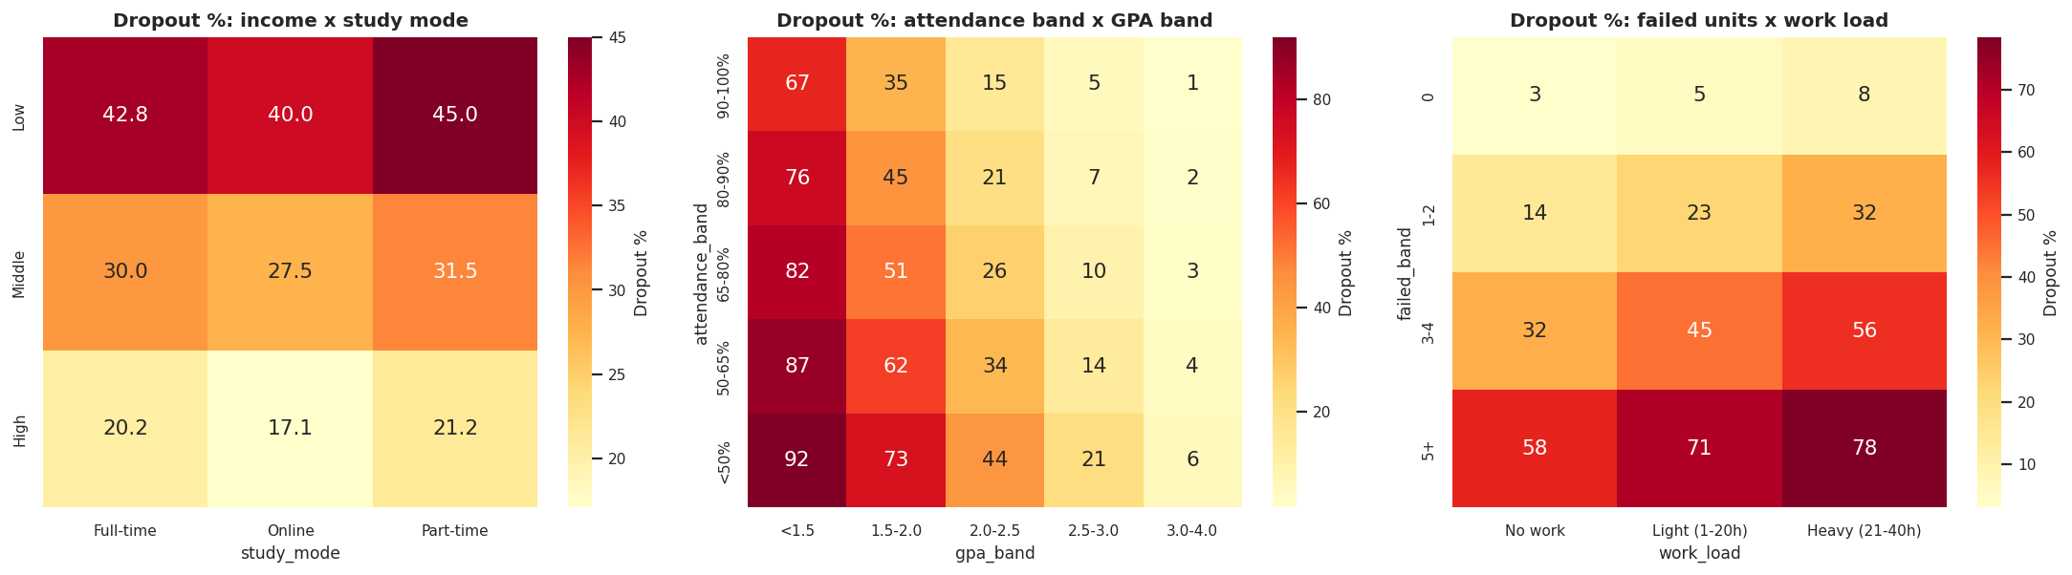
Figure 31: Dropout rate (%) over pairs of grouping variables
Observation: Risk compounds. Students with attendance below 50% and an average GPA below 1.5 drop out 92.0% of the time, while those with attendance of 90-100% and GPA of 3.0-4.0 drop out only 1.5% of the time. GPA dominates attendance: within the lowest GPA band even 90-100% attendance leaves a 67% dropout rate, but within the highest GPA band even attendance below 50% leaves only 5.7%. Failed units and work load add together: with no failed units a heavy workload raises dropout only from 3.1% to 8.4%, but with five or more failed units it raises it from 58.0% to 78.4%. Income and study mode simply add (no interaction).
Table 22: Dropout rate by number of risk flags (0-6)
Risk flags | Students | Dropout %
0 | 29,419 | 7.2
1 | 30,854 | 19.8
2 | 20,854 | 44.4
3 | 11,889 | 70.0
4 | 5,236 | 86.3
5 | 1,545 | 94.6
6 | 203 | 98.0

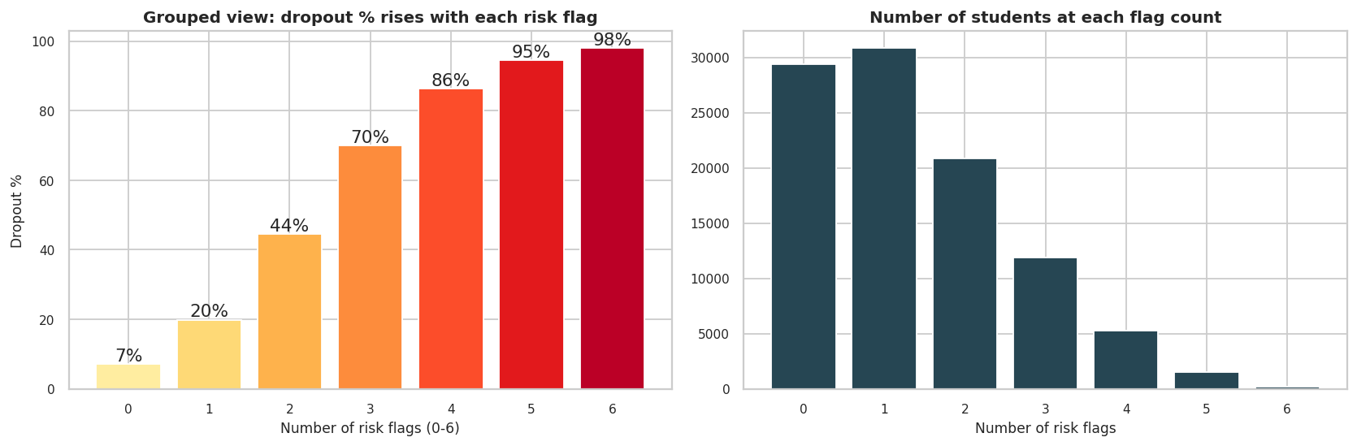
Figure 32: Dropout rate rises with each additional risk flag
Observation: A simple rule-based count of six warning signs (at least 4 failed units, attendance below 60%, assignments below 50%, at least 4 missed deadlines, semester-2 GPA below 1.5, unpaid tuition) already separates students very well: 7.2% dropout with no flags, 70.0% with three flags and 98.0% with all six. This is an interpretable early-warning rule that advisers could apply without any machine-learning model.
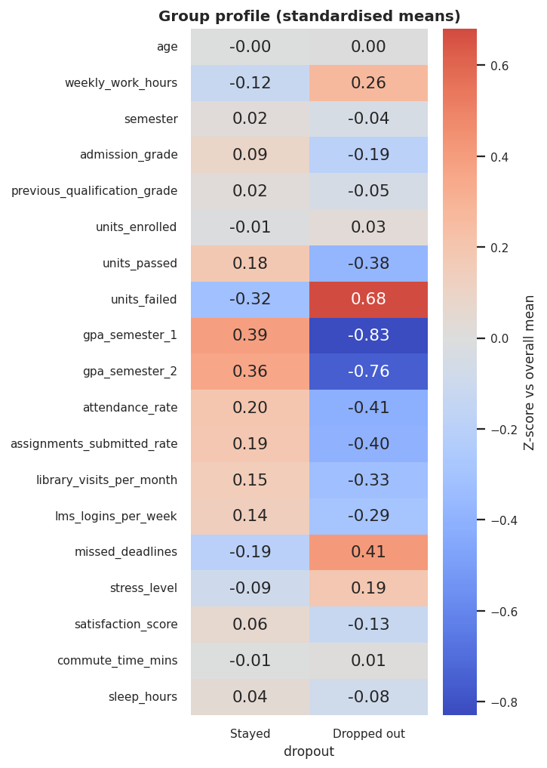
Figure 33: Standardised group profile: students who stayed versus dropped out

7.4 Dimensionality Reduction using PCA
Principal Component Analysis rotates the data into new, uncorrelated axes (principal components) ordered by the variance they explain. The 27 numeric and binary variables were standardised (mean 0, standard deviation 1) because PCA is sensitive to scale, and the target was excluded.
from sklearn.preprocessing import StandardScaler
from sklearn.decomposition import PCA
Xs = StandardScaler().fit_transform(d[num_cols]) # 27 features
pca = PCA().fit(Xs); print(pca.explained_variance_ratio_)
Z = PCA(n_components=2).fit_transform(Xs)

Table 23: Variance explained by the first ten principal components
Component | Explained % | Cumulative %
PC1 | 12.63 | 12.63
PC2 | 7.46 | 20.09
PC3 | 6.95 | 27.03
PC4 | 5.38 | 32.42
PC5 | 4.24 | 36.66
PC6 | 4.19 | 40.85
PC7 | 4.09 | 44.94
PC8 | 3.91 | 48.86
PC9 | 3.88 | 52.73
PC10 | 3.8 | 56.54

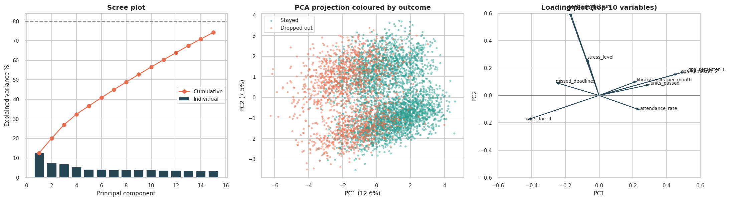
Figure 34: Scree plot, PCA projection coloured by outcome, and loading plot
Observation: PC1 explains only 12.6% and PC2 7.5% of the variance, 20.1% together, and 17 components are needed to reach 80% (20 for 90%). The variables are therefore not redundant, and PCA is of limited use for compressing this dataset. It is still informative: PC1 is an academic-performance axis (loadings: GPA1 0.49, GPA2 0.45, failed units -0.40) and correlates r = -0.62 with dropout, while PC2 is a work and stress axis (work hours 0.59, part-time job 0.59, stress 0.25) that is uncorrelated with dropout (r = 0.00). In the projection the two outcomes separate mainly along PC1 but overlap in the middle, which previews the limit of any classifier.

7.5 K-Means Clustering
K-Means groups observations into k clusters by minimising the distance to the cluster centres. It was applied to the eight standardised academic and engagement variables (both GPAs, attendance, assignment submission, failed units, missed deadlines, LMS logins, library visits). The outcome was not used for clustering, so dropout rates per cluster are an independent check.
from sklearn.cluster import KMeans
from sklearn.metrics import silhouette_score
for k in range(2, 9):
km = KMeans(n_clusters=k, n_init=5, random_state=42).fit(Xk)
inertia.append(km.inertia_); sil.append(silhouette_score(Xk[sub], km.labels_[sub]))
km = KMeans(n_clusters=4, n_init=10, random_state=42).fit(Xk)
d["cluster"] = km.labels_
d.groupby("cluster").dropout.agg(["size", "mean"])

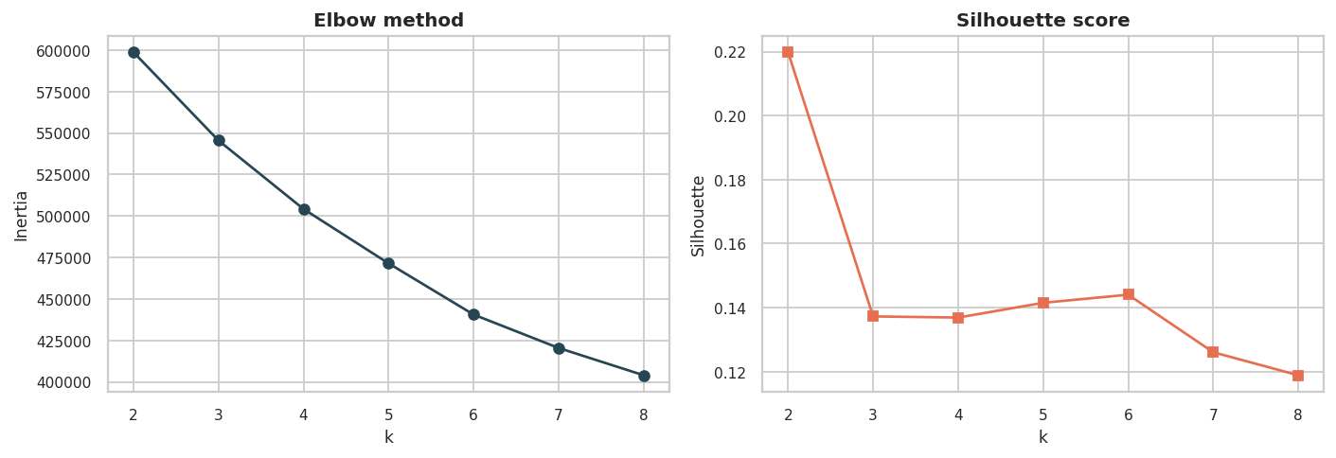
Figure 35: Elbow method and silhouette scores for k = 2 to 8
The elbow curve has no sharp bend and the silhouette score is highest for k = 2 (0.22) and low overall (0.14 for k = 4), which means that the students form a continuum rather than naturally separated groups. k = 4 was nevertheless chosen because it gives segments that are interpretable and useful for intervention; this is a pragmatic segmentation, not proof of four true groups.
Table 24: Profile of the four K-Means segments (sorted by dropout rate)
Segment | Students | Dropout % | GPA S1 | GPA S2 | Attend. % | Assign. % | Failed | Missed
High-risk | 19,878 | 80.75 | 1.53 | 1.12 | 65.83 | 58.29 | 5.51 | 4.18
At-risk | 23,560 | 31.06 | 2.59 | 2.01 | 61.11 | 58.27 | 2.24 | 2.15
Moderate | 27,683 | 27.75 | 2.4 | 1.82 | 84.72 | 80.78 | 3.12 | 2.43
Low-risk | 28,879 | 3.3 | 3.42 | 2.7 | 83.69 | 82.23 | 0.8 | 1.24

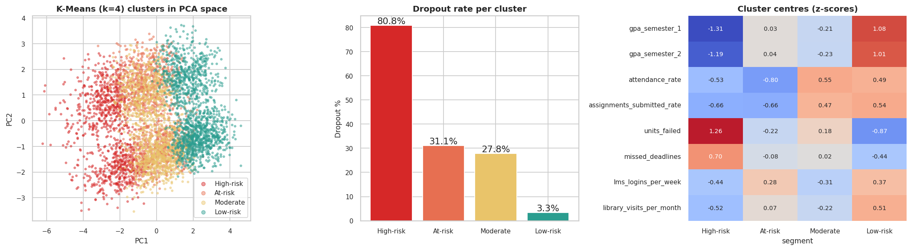
Figure 36: K-Means segments in PCA space, dropout rate per segment and standardised cluster centres
Observation: The segments differ greatly in outcome although the algorithm never saw the target. The high-risk segment (19,878 students, 80.8% dropout) has the lowest GPA, the most failed units and weak attendance. The low-risk segment (28,879 students, only 3.3% dropout) has high GPA, almost no failures and heavy use of the library and LMS. The two middle segments are the most interesting: the "at-risk" segment has acceptable grades but poor attendance (61%) and assignment submission (58%) with 31.1% dropout, while the "moderate" segment attends well but fails more units, with 27.8% dropout. They need different interventions: engagement support for the first, academic tutoring for the second.

7.6 Scikit-learn Model Development
Three classifiers were trained to predict dropout from the 32 predictors: logistic regression (scaled numerics, one-hot categoricals), a random forest (120 trees, depth 12) and a histogram gradient-boosting classifier. The data were split 80/20 with stratification on the target (80,000 training and 20,000 test students, random_state = 42). Because the target is imbalanced, models are judged on precision, recall, F1 and ROC-AUC as well as accuracy, with the majority-class baseline (68.0% accuracy) as reference. Five-fold stratified cross-validation of ROC-AUC on the training set checks stability.
from sklearn.model_selection import train_test_split, cross_val_score, StratifiedKFold
from sklearn.pipeline import Pipeline
from sklearn.compose import ColumnTransformer
from sklearn.linear_model import LogisticRegression
X_tr, X_te, y_tr, y_te = train_test_split(X, y, test_size=0.20, stratify=y, random_state=42)
model = Pipeline([("pre", ColumnTransformer([("cat", OneHotEncoder(handle_unknown="ignore"), cat_cols),
("num", StandardScaler(), num_cols)])),
("clf", LogisticRegression(max_iter=1000))]).fit(X_tr, y_tr)
proba = model.predict_proba(X_te)[:, 1]
print(roc_auc_score(y_te, proba), accuracy_score(y_te, proba >= .5))
skf = StratifiedKFold(5, shuffle=True, random_state=42)
print(cross_val_score(model, X_tr, y_tr, cv=skf, scoring="roc_auc"))

Table 25: Model results on the 20% test set and 5-fold cross-validation
Model | Accuracy | Precision | Recall | F1 | ROC-AUC | PR-AUC | CV AUC | CV std | Train AUC
Logistic Regression | 0.840 | 0.781 | 0.695 | 0.736 | 0.903 | 0.832 | 0.904 | 0.0017 | 0.904
Random Forest | 0.831 | 0.788 | 0.644 | 0.709 | 0.894 | 0.815 | 0.893 | 0.0020 | 0.922
Gradient Boosting | 0.839 | 0.779 | 0.692 | 0.733 | 0.900 | 0.826 | 0.900 | 0.0016 | 0.920
Majority-class baseline | 0.680 | 0.000 | 0.000 | 0.000 | 0.500 | 0.320

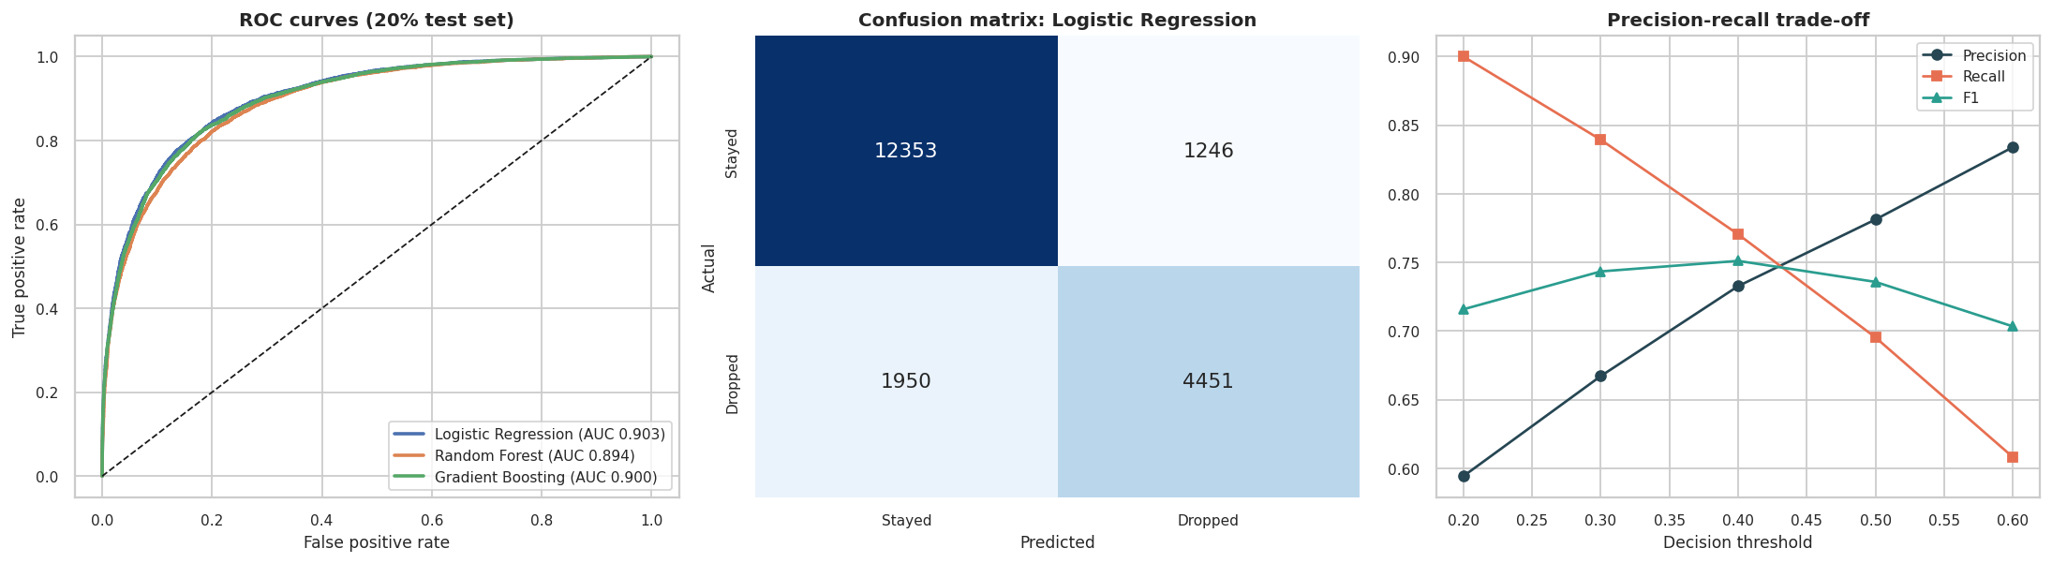
Figure 37: ROC curves, confusion matrix of the best model and precision-recall trade-off
Observation: All three models are far better than the baseline (accuracy 0.84 against 0.68) and very close to one another (AUC 0.894 to 0.903). The simplest model, logistic regression, is the best (AUC 0.903, accuracy 0.840, precision 0.781, recall 0.695, F1 0.736). The random forest and gradient boosting do no better and show a larger gap between training AUC (0.92) and test AUC (0.89-0.90), a sign of mild over-fitting, whereas for logistic regression train AUC (0.904) and test AUC match. This indicates that the relationships are largely additive and linear and that there are no strong hidden interactions to exploit. Cross-validation (0.904 +/- 0.0017) agrees with the test score, so the result is stable and not an accident of one split. Remaining errors (1,950 missed dropouts and 1,246 false alarms among 20,000 test students) reflect the heavy overlap seen in all earlier plots.
Table 26: Effect of the decision threshold (best model)
Threshold | Accuracy | Precision | Recall | F1
0.2 | 0.771 | 0.594 | 0.9 | 0.716
0.3 | 0.815 | 0.667 | 0.839 | 0.743
0.4 | 0.837 | 0.733 | 0.771 | 0.751
0.5 | 0.84 | 0.781 | 0.695 | 0.736
0.6 | 0.836 | 0.834 | 0.608 | 0.703

The default threshold of 0.5 gives recall of 69.5% at precision 78.1%. For an early-warning system, missing a student who will drop out is usually worse than a false alarm, so a lower threshold is sensible: at 0.3 recall rises to 83.9% while precision falls to 66.7%. The right threshold depends on the cost of support and the capacity of advisers.
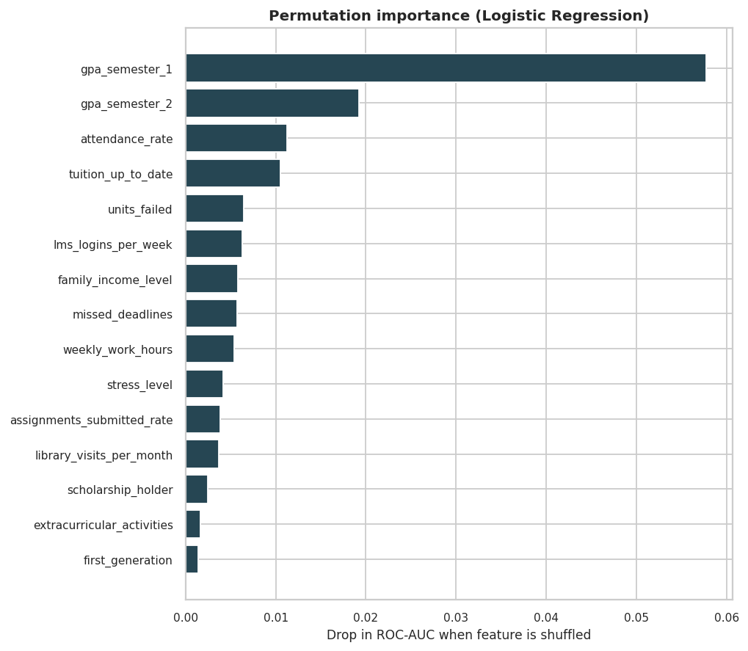
Figure 38: Permutation importance of the best model (drop in ROC-AUC when a feature is shuffled)
Observation: Semester-1 GPA is by far the most important feature (AUC falls by 0.058 when it is shuffled), followed by semester-2 GPA, attendance, tuition status, failed units, LMS logins, family income and missed deadlines. Permutation importance understates features that share information, such as the two GPAs and failed units, so the real weight of academic performance is larger than the individual bars suggest. The ranking agrees with the correlation and effect-size analysis of Unit 4.
Table 27: Risk deciles of the best model on the test set
Decile (10 = highest risk) | Students | Predicted risk % | Actual dropout %
1 | 2,000 | 0.48 | 1.15
2 | 2,000 | 1.69 | 1.9
3 | 2,000 | 3.99 | 4.05
4 | 2,000 | 7.73 | 8.1
5 | 2,000 | 14.0 | 14.0
6 | 2,000 | 24.09 | 23.1
7 | 2,000 | 38.09 | 37.5
8 | 2,000 | 56.81 | 57.15
9 | 2,000 | 77.36 | 78.9
10 | 2,000 | 94.12 | 94.2

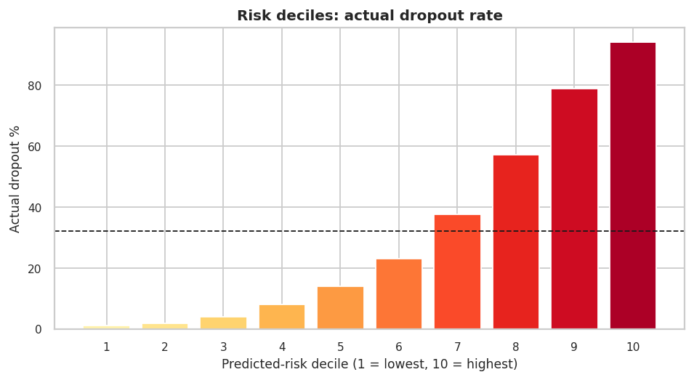
Figure 39: Actual dropout rate by predicted-risk decile
Observation: Ranking students by predicted risk works very well. Actual dropout rises from 1.1% in the lowest-risk decile to 94.2% in the highest, and the predicted risk is well calibrated (for example 57.2% observed against 56.8% predicted in decile 8). If advisers could contact only the 20% of students with the highest predicted risk, they would reach 54.1% of all students who actually drop out, against 20% by random selection (a lift of 2.7).

7.7 Fairness Audit and Sensitive Attributes
A model that is accurate on average can still treat groups differently. The best model's predictions on the test set were therefore compared across gender, family income, origin, disability and first-generation status. For each group the table reports the actual dropout rate, the share of students flagged, recall (true-positive rate) and false-positive rate.
Table 28: Fairness audit of the best model (threshold 0.5)
Attribute | Group | n | Actual dropout % | Flagged % | Recall % | False-pos. % | Accuracy %
gender | Female | 10,117 | 31.6 | 28.3 | 69.6 | 9.3 | 84.0
gender | Male | 9,530 | 32.4 | 28.7 | 69.4 | 9.2 | 83.9
gender | Other | 353 | 32.3 | 27.8 | 72.8 | 6.3 | 87.0
family_income_level | High | 4,975 | 19.8 | 15.0 | 55.7 | 5.0 | 87.2
family_income_level | Low | 6,932 | 42.9 | 41.0 | 76.8 | 14.1 | 82.0
family_income_level | Middle | 8,093 | 30.2 | 26.0 | 66.3 | 8.6 | 83.8
intl | Domestic | 16,409 | 31.8 | 28.5 | 69.8 | 9.3 | 84.1
intl | International | 3,591 | 33.1 | 28.3 | 68.4 | 8.5 | 83.8
dis | Disability | 4,187 | 36.4 | 33.8 | 73.8 | 10.8 | 83.6
dis | No disability | 15,813 | 30.8 | 27.1 | 68.2 | 8.8 | 84.1
fg | First-gen | 8,383 | 37.3 | 34.5 | 73.9 | 11.0 | 83.3
fg | Not first-gen | 11,617 | 28.2 | 24.2 | 65.4 | 8.0 | 84.5

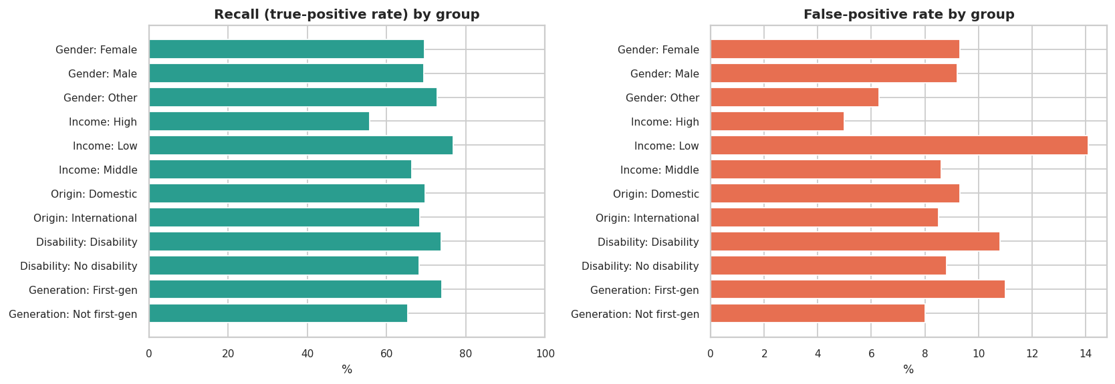
Figure 40: Recall and false-positive rate of the model by group
Table 29: Does removing sensitive attributes change the model?
Model | ROC-AUC | Accuracy | Recall (Low income) % | Recall (High income) %
With all 32 features | 0.9031 | 0.8402 | 76.8 | 55.7
Without 5 sensitive attributes | 0.9023 | 0.8400 | 76.5 | 55.2

Observation: Accuracy is almost identical for men, women and other genders (83.9% to 87.0%), domestic and international students and students with and without disabilities, and the recall for gender differs by only 3.4 points. Income is different: the model flags 41.0% of low-income students but only 15.0% of high-income students, catching 76.8% of low-income dropouts but only 55.7% of high-income dropouts, and it raises more false alarms for low-income students (14.1% against 5.0%). Part of this is legitimate because the real dropout rates differ (42.9% against 20.0%), but it means high-income students who are at risk are more likely to be overlooked. First-generation students and students with disabilities are also flagged more often. Removing the five most sensitive attributes (gender, nationality, international status, disability, first-generation) costs almost nothing (AUC 0.9031 to 0.9023) but does not remove the income gap, because income and finance carry real signal. Excluding sensitive attributes is therefore a free and sensible precaution but not a complete fairness solution.

8. Major Findings and Insights
- A clean but behaviour-rich dataset: 100,000 students, no missing values or duplicates; the only quality issues are ceiling effects (10.6% of students at 100% attendance) and 12,758 students under 18, which were flagged and kept.
- One in three students drops out: 32.00% (95% interval 31.71% to 32.29%), highest in semesters 1-2 (about 34%) and lowest in semester 7 (29.6%).
- Academic performance is the dominant signal: semester-1 GPA (r = -0.569), semester-2 GPA (r = -0.521) and failed units (r = +0.467) have large effect sizes (|d| = 1.1 to 1.5); dropouts average 1.44 against 2.24 GPA in semester 2.
- Money and work matter: dropout is 42.9% for low-income, 30.0% for middle-income and 20.0% for high-income students; 44.2% when tuition is unpaid against 28.7% when it is paid; 39.8% with a part-time job against 24.7% without.
- Many assumed factors do not matter: course type, gender, nationality, age, international status and commute time show no relationship with dropout (Cramér's V or |r| below 0.01). Scholarships help only slightly (31.1% against 33.2%).
- Risk compounds: from 1.5% (high attendance, GPA above 3.0) to 92.0% (attendance below 50%, GPA below 1.5); dropout rises from 7.2% with no risk flags to 98.0% with six.
- Four student segments (K-Means) range from 3.3% to 80.8% dropout and call for different interventions (tutoring versus engagement support).
- Prediction works and a simple model is enough: logistic regression reaches AUC 0.903 and accuracy 84.0% (baseline 68.0%), stable under 5-fold cross-validation; the top 20% highest-risk students contain 54.1% of all dropouts.
- Fairness needs attention: equal accuracy across gender, origin and disability, but recall of 76.8% for low-income against 55.7% for high-income students.

8.1 Recommendations
- Use GPA, failed units, attendance and assignment submission as the core of any early-warning dashboard, and trigger a review as soon as semester-1 results are known.
- Offer financial counselling and flexible payment plans, because unpaid tuition and low income are the strongest non-academic risk factors; support working students with flexible timetables.
- Use different interventions for different segments: academic tutoring for students who fail units, engagement coaching for students with good grades but low attendance and submission.
- Use a lower decision threshold (about 0.3) so that most at-risk students are reached, and size the programme to the capacity of advisers using the risk-decile table.
- Always report effect sizes with p-values when the sample is large, and report medians for skewed variables.
- Do not spend resources on course type, gender or nationality as risk indicators; they carry no signal in this dataset.

8.2 Ethical and Societal Considerations
Predicting which students may leave is useful only if it leads to support. The following points were considered in the design of this project and should be considered by anyone who deploys such a model.
- Purpose and human oversight. Predictions should open a supportive conversation, never trigger penalties, loss of scholarships or exclusion. A risk score is a probability, not a verdict: even in the highest-risk decile about 6% of students stay, and in the lowest decile about 1% leave. A human adviser must make the final decision.
- Privacy and data protection. The dataset contains sensitive personal information (disability, income, mental-health support, nationality). Real deployments need informed consent, data minimisation, access control, anonymised IDs and compliance with local data-protection law. This project uses only an ID and never any name or contact detail.
- Fairness. The audit in Section 7.7 shows that the model flags low-income students far more often and catches fewer high-income dropouts. Sensitive attributes that carry no signal (gender, nationality, international status) can be dropped at almost no cost and should be; disparities that remain should be monitored by group, and thresholds can be tuned per programme. The model should not be used to deny opportunities to any group.
- Avoiding stigma and self-fulfilling prophecies. Telling a student or staff member that a student is "high risk" can lower expectations and increase the very outcome it predicts. Risk labels should be confidential and framed as "may benefit from support".
- Correlation is not causation. Low GPA predicts dropout, but this analysis cannot show that raising GPA would prevent it, or that low income causes dropout. Interventions should be evaluated with controlled trials.
- Data provenance and generalisation. The file has no stated source and shows signs of being simulated. A model trained on it must never be applied to real students without validation on real, local data.
- Societal benefit. Used responsibly, early-warning analytics can direct limited advising and financial-aid resources to students who need them most and reduce inequality in completion rates.

9. Results and Conclusion

9.1 Results Summary
The project completed a full exploratory workflow on 100,000 students. Data loading, quality checks, slicing, transformation, grouping and Bayesian estimation (Unit 1) showed that the data are clean, that dropout is 32.0%, and that the log transform fixes the three skewed count variables. Matplotlib, Seaborn, Plotly and Bokeh visualizations (Unit 2) revealed the first-year peak in dropout, the weak role of attendance alone and the strong role of GPA, and the 3D surface showed how risk changes over two variables. Univariate analysis (Unit 3) described all variables, found outliers that are genuine behaviour, and showed a moderately imbalanced target. Bivariate analysis (Unit 4) ranked the factors by effect size and showed that income, finances and work matter while demographics do not. Multivariate analysis (Unit 5) showed compounding risk, limited redundancy among variables, four interpretable segments, and a well-calibrated logistic regression model (AUC 0.903), together with a fairness audit.

9.2 Conclusion
This capstone demonstrates a complete, reproducible pipeline from raw CSV loading through data-quality checks, transformation, visualization, statistical testing, dimensionality reduction, clustering, machine-learning evaluation and a fairness audit. All topics from the five units of Data Exploration and Visualization are represented with Python code, outputs and written observations. The most important lessons are methodological: with very large samples, effect sizes matter more than p-values; a simple model can match complex ones when the signal is additive; the accuracy of a model on an imbalanced target must be compared with a baseline; and a good model still has to be checked for fairness before it is used on real people.

9.3 Limitations
- The dataset has no stated source or collection date and appears to be simulated, so findings describe the data, not necessarily real institutions.
- The data are a single snapshot; there are no time-stamped records, so the order of events (for example when engagement dropped relative to leaving) is unknown, and no causal claims can be made.
- Semester-1 and semester-2 results may be partly consequences of the decision to leave, so the model is better described as identifying students who are dropping out than as forecasting from the start of the programme.
- Variables are capped at their limits (attendance at 100%), which distorts distributions slightly.
- The fairness audit uses one threshold and a handful of groups; intersectional groups were not examined.
- The Plotly and Bokeh outputs require those libraries to be installed; the repository includes a dependency-free HTML fallback.

10. Future Scope
- Use longitudinal data (week-by-week attendance and LMS activity) to build a true early-warning model and measure how early dropout can be predicted.
- Use survival analysis (Kaplan-Meier, Cox regression) to model the time to dropout by semester.
- Add calibration, cost-sensitive learning and per-group threshold tuning; explore SHAP values for explanations of individual predictions.
- Evaluate intersectional fairness (for example income by gender) and fairness constraints such as equalised odds.
- Build an interactive Streamlit or Dash dashboard from the Plotly and Bokeh components, with a risk calculator for advisers.
- Validate on real institutional data and run a controlled study of interventions guided by the model.
- Apply formal hierarchical Bayesian models to estimate dropout rates per programme and semester with uncertainty.

References
[1] J. W. Tukey, Exploratory Data Analysis, Addison-Wesley, 1977.
[2] W. McKinney, Python for Data Analysis, 3rd ed., O'Reilly Media, 2022.
[3] J. VanderPlas, Python Data Science Handbook, O'Reilly Media, 2016.
[4] J. D. Hunter, "Matplotlib: A 2D Graphics Environment," Computing in Science & Engineering, vol. 9, no. 3, 2007.
[5] M. Waskom, "seaborn: statistical data visualization," Journal of Open Source Software, vol. 6, no. 60, 2021.
[6] F. Pedregosa et al., "Scikit-learn: Machine Learning in Python," Journal of Machine Learning Research, vol. 12, 2011.
[7] P. Virtanen et al., "SciPy 1.0: fundamental algorithms for scientific computing in Python," Nature Methods, vol. 17, 2020.
[8] J. Cohen, Statistical Power Analysis for the Behavioral Sciences, 2nd ed., Lawrence Erlbaum Associates, 1988.
[9] V. Tinto, "Dropout from Higher Education: A Theoretical Synthesis of Recent Research," Review of Educational Research, vol. 45, no. 1, 1975.
[10] M. Hardt, E. Price and N. Srebro, "Equality of Opportunity in Supervised Learning," Advances in Neural Information Processing Systems 29, 2016.
[11] Plotly Technologies Inc., Plotly Python documentation, https://plotly.com/python/
[12] Bokeh Project, Bokeh documentation, https://docs.bokeh.org/
GITHUB REPO LINK: [paste your repository link here]

