**CDS3006 - Data analysis and visualization**

**Lab Program 3**

3. Conduct geographic analysis on sample data using map on tableau - Download New York city Airbnb data from kaggle and analyze the geographic information.

3.1 analyse relative difference in price and reviews among different areas.

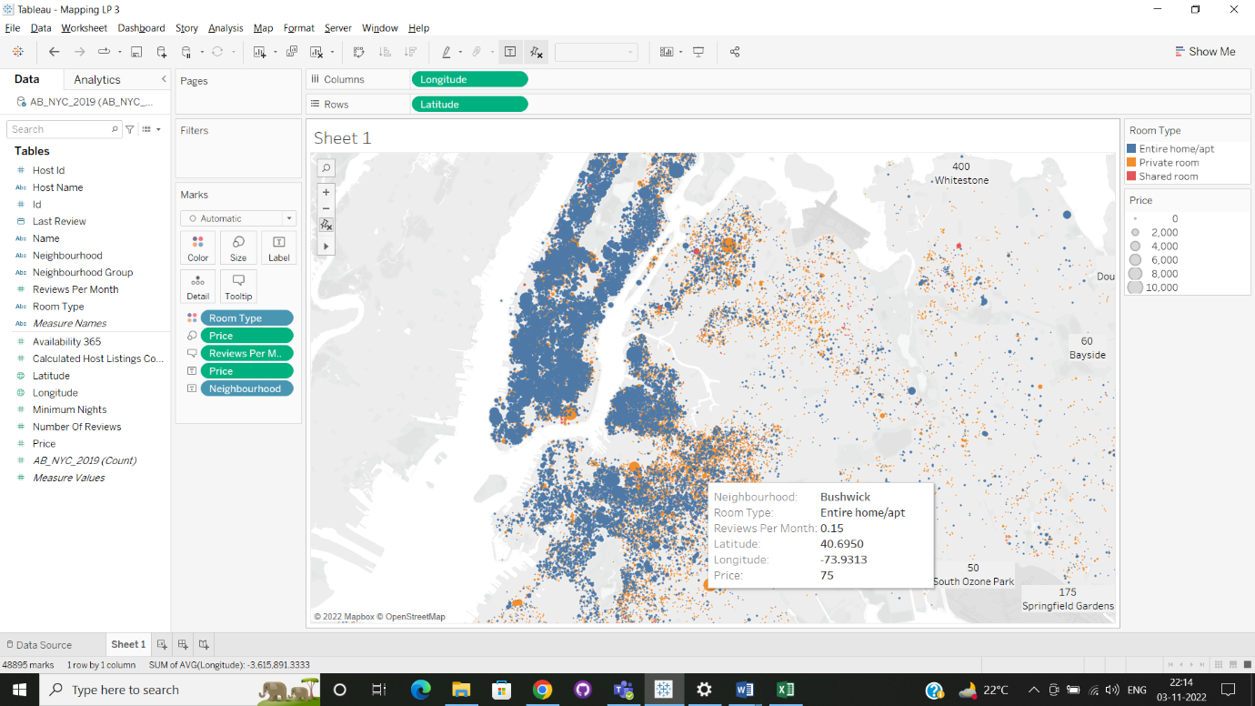

The data collected from New York city Airbnb had different data’s like reviews, price, neighbourhood, groups, last month reviews ect.. this analysis shows most number of neighbourhood has Entire home/apt and private room and the least number is shared room. From the analysis the relative difference in price and reviews among different area:

* This differentiates the room types Entire home/apt (blue), Private room ( orange ) and shared rooms ( red ).
* Size of the point increases as the price increase.
* Review is low for the highly priced room type when compared to low priced room types.