**CDS3006 - Data analysis and visualization**

**Lab Program 4**

1. Pattern analysis on sample data set using histogram on tableau
   1. Use the superstore dataset in Tableau and create a histogram chart for any measures.

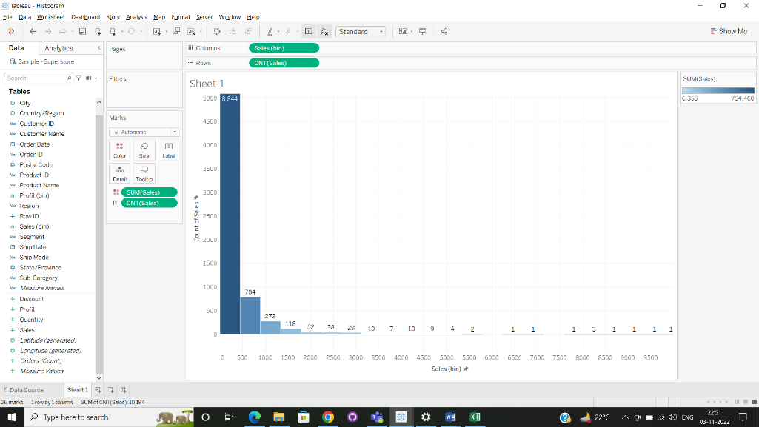

The histogram data has been created for sales in superstore dataset. This data shows the count of sales in different sales bin.

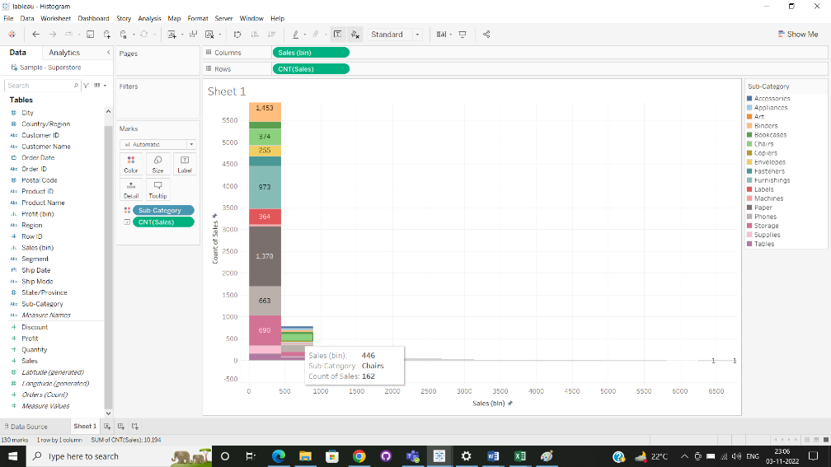

This histogram shows the different types of sub category and the count of the sales in each category.