**CDS3006 - Data analysis and visualization**

**Lab Program 5**

1. Establish the relationship between two variables of a data set using scatter plot on Tableau
   1. Use the insurance dataset and establish the relationship between BMI and charges. Apply smoker and sex dimension in colour to see the difference.

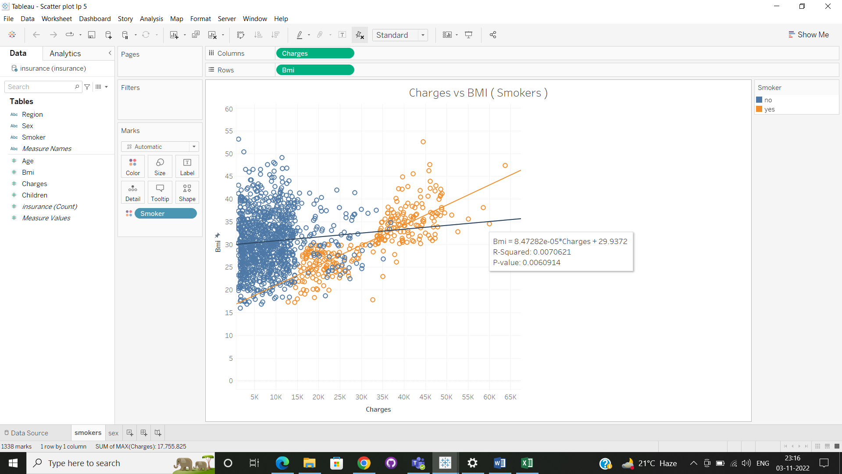

Using scatter plot on charge vs BMI for smoker analysis :

* Blue plots are non smokers
* Orange plots are smokers
* This plot shows that the persons with high BMI and has smokes his insurance charges high when compared to non smokers with high BMI

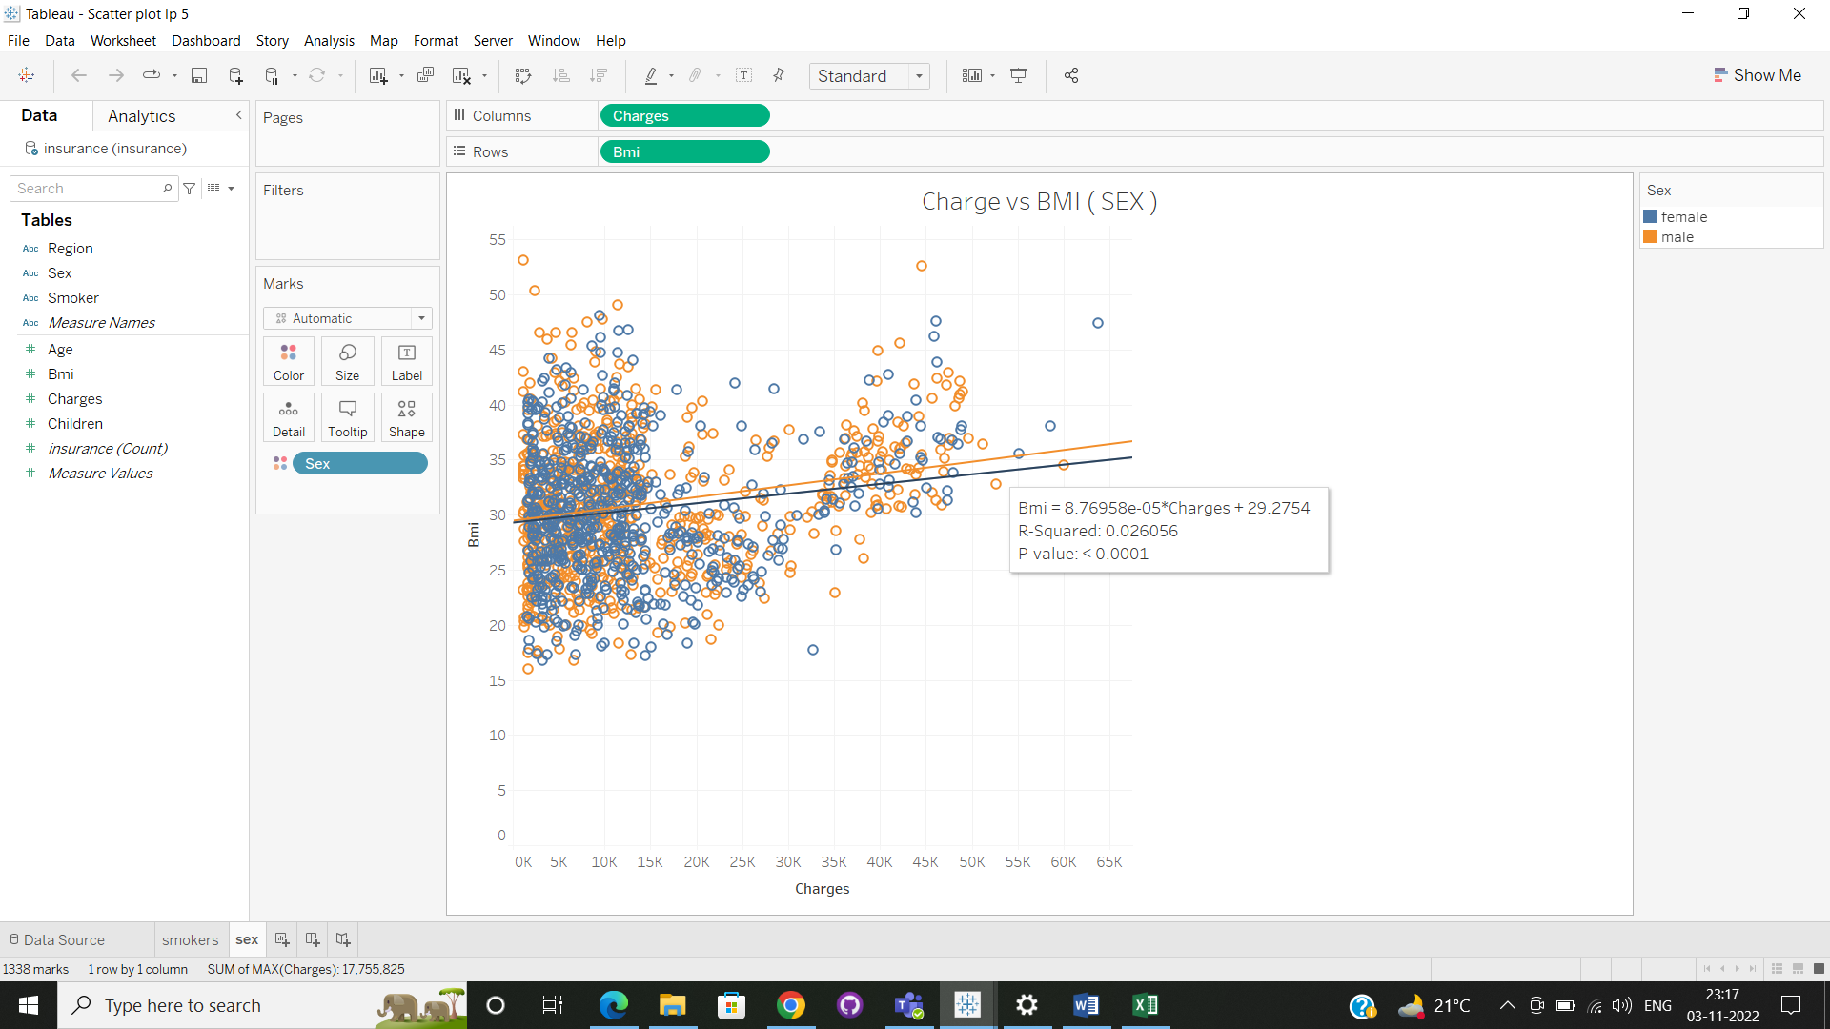

Using scatter plot on charge vs BMI based on the gender analysis :

* Blue plots are Female
* Orange plots are Male
* The linear line says that males with high BMI is charged high insurance when compared to females with high BMI.