**CDS3006 - Data analysis and visualization**

**Lab Program 6**

1. Implement the dashboard for Airline quality

Create separate sheet for the following questions:

1. Are there differences in arrival and departure delays by origin airport?

2. What are the most common causes of flight delays?

3. Is there a relationship between arrival and departure delay?

2. Implement the dashboard for the above set of questions.

1.

1. Differences in Arrival and Departure delays by origin airport

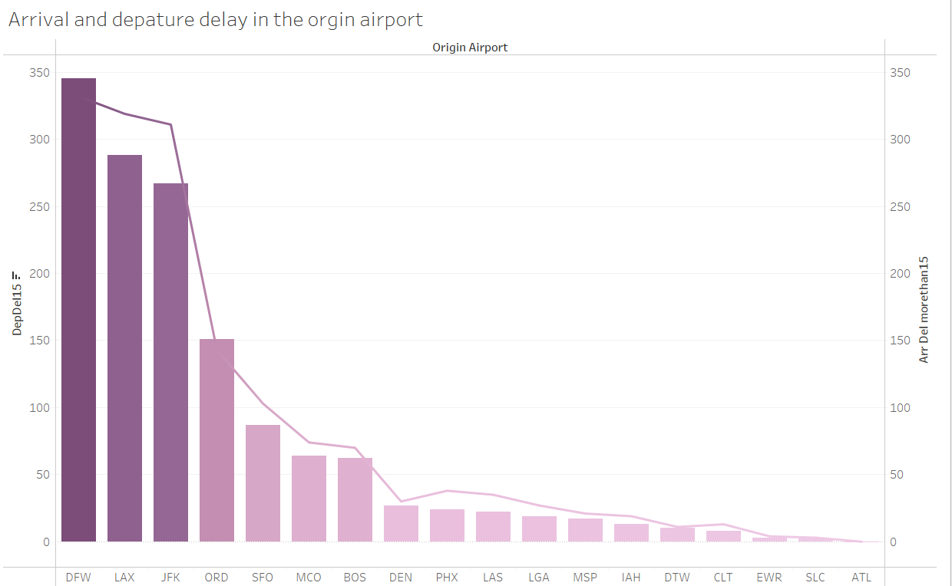

* The arrival and departure delay by more the 15 min on every airport
* The graph shows Dallas airport has the highest no of flight delays
* The Atlanta airport has the least no of flight delays
* The bar graphs shows the departure delay.
* The line graph shows the arrival delay

1. Most Common Causes of flight Delay

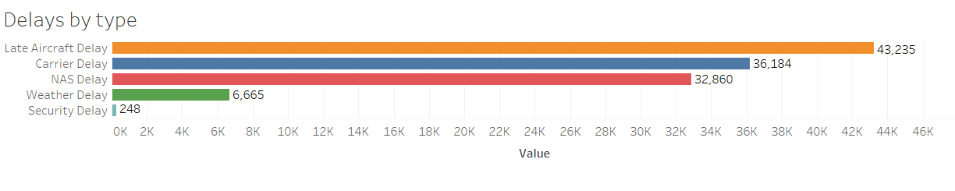

* There are mainly 5 types of delays
  + Late Aircraft Delay
  + Carrier Delay
  + NAS Delay
  + Weather Delay
  + Security Delay
* The most common cause of flight delay is late Aircraft Delay
* The least common cause of flight delay is Security Delay

1. Relationship between Arrival and Departure delay

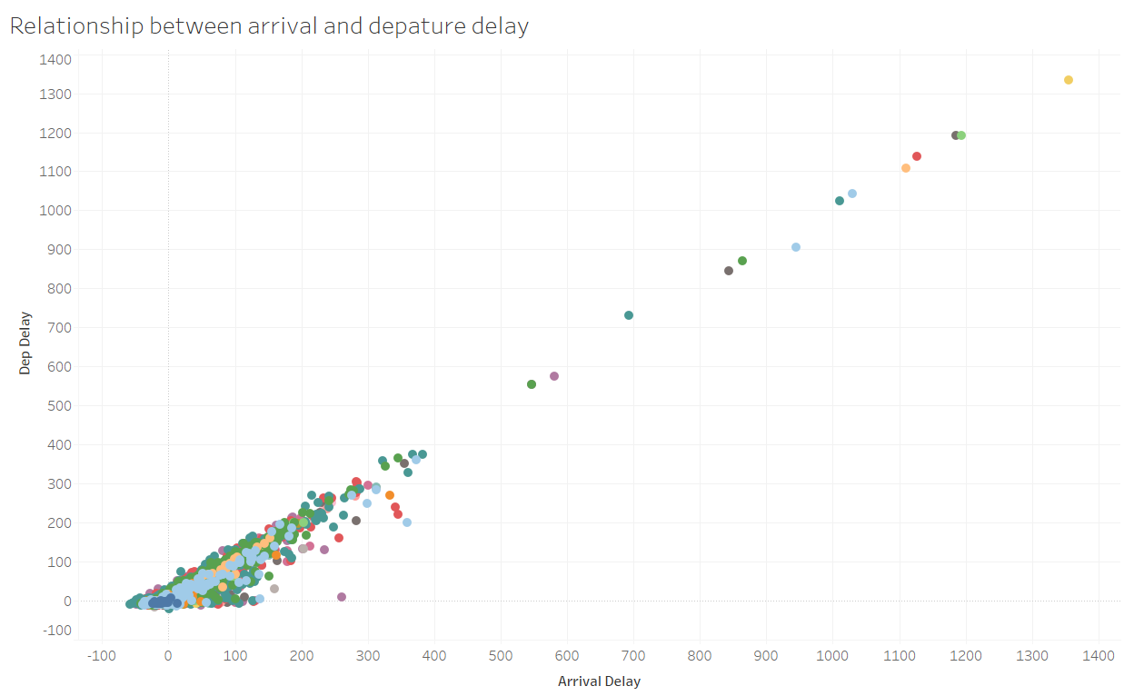

1. Dashboard of all the above sets

