**CDS3006 - Data analysis and visualization**

**Lab Program 7**

1. HEALTHCARE QUALITY DASHBOARD

Create separate sheet for the following questions:

1. Does SMS help to reduce the number of patient no-shows?

2. Is the pattern of no-show different by age?

3. Is the characteristics of no show affected by gender?

2. Implement the dashboard for the above set of questions.

1. Healthcare Quality Dashboard
2. SMS help to reduce the number of patient no-shows

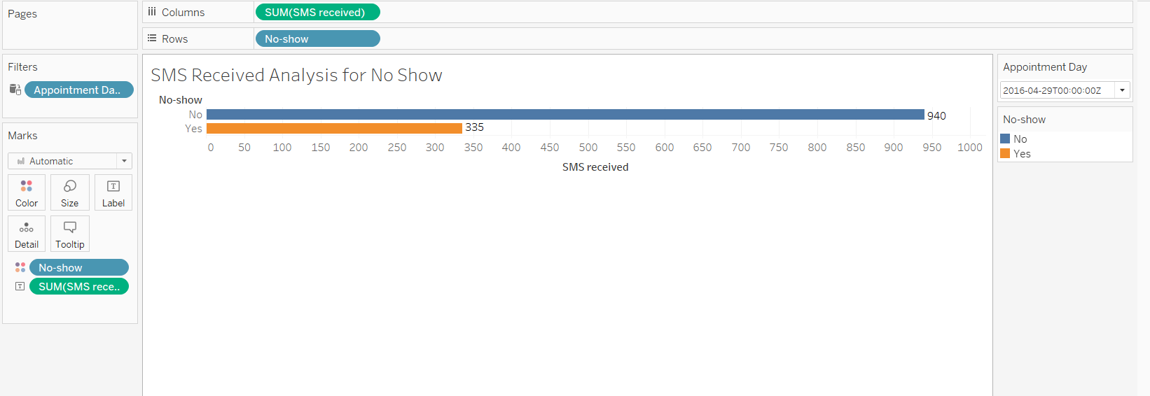

1. The pattern of no-show different by age

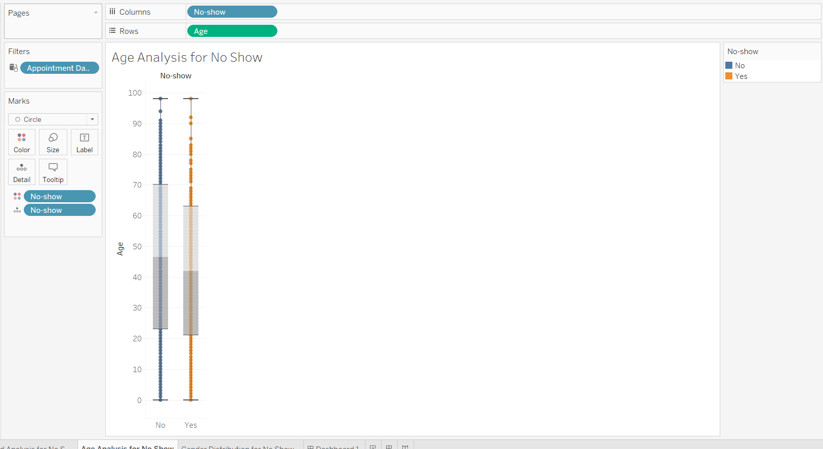

1. No show affected by gender.

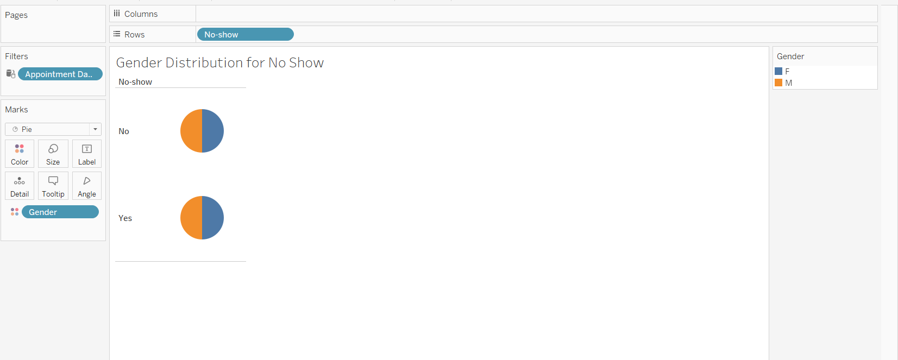

1. Implement the dashboard for the above set of questions

